Dynamics of the COVID-19 epidemic in Ireland under mitigation

Bernard Cazelles^{1,2,3}, Benjamin Nguyen Van Yen³, Clara Champagne^{4,5} and Catherine Comiskey⁶

¹ iGLOBES, UMI 3157, CNRS and Arizona University, Tucson, USA
² UMMISCO, Sorbonne Université, Paris, France
³ Eco-Evolution Mathématique, IBENS, UMR 8197, CNRS, Ecole Normale Supérieure, Paris, France
⁴ Swiss Tropical and Public Health Institute, Bassel, Switzerland
⁵ Universty of Basel, Basel, Switzerland
⁶ Professor in Healthcare Modelling and Statistics, School of Nursing and Midwifery, Trinity College Dublin, The University of Dublin, Dublin, Ireland.

Appendix

Model equation

Our model is an extended stochastic SEIR model also accounting for asymptomatic transmission and the hospital system. It includes the following variables the susceptibles S, the infected non-infectious E, the infectious I, the removed people R, and the hospital variables: hospitalized people H, people in intensive care unit ICU, cured people G, and deaths at hospital D. We have also introduced Erlang-distributed stage durations (with a shape parameter equals 2) for the E, I, A and H compartments, for not taking into account inappropriate exponential stage durations. The differential equations below describe the deterministic version of our model, however it is important to note that we have used its stochastic version:
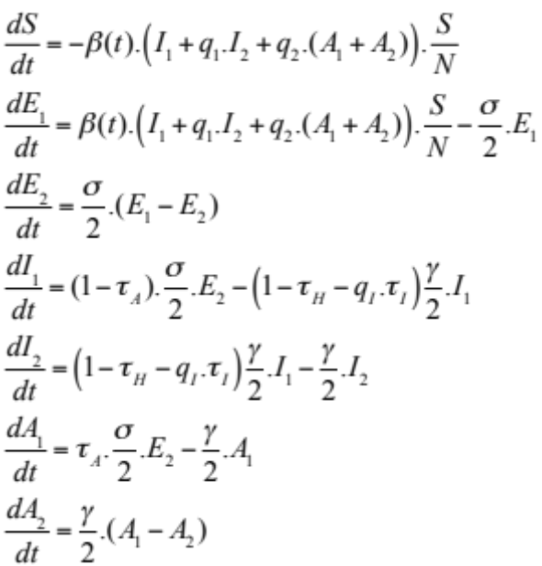
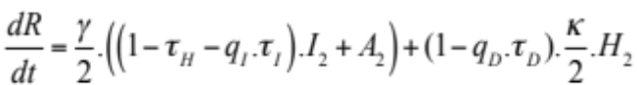 (A1)
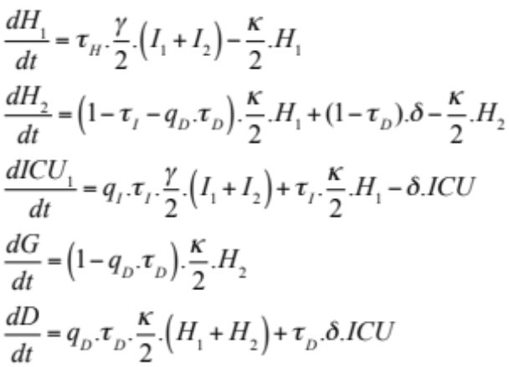
The main characteristic of our approach is the time-varying transmission rate β(t) that follows a Brownian diffusion process:
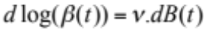 (A2)
where ν is the volatility of the Brownian process (dB) that will be estimated during the fitting process. The logarithm transformation avoids negative values, which have no biological meaning.

In the epidemiological model σ is the incubation rate, γ the recovery rate, 1/κ the average hospitalized period, 1/δ the average time spent in ICU, τ_{A} the fraction of asymptomatics, τ_{H} the fraction of infectious hospitalized, τ_{I} the fraction of ICU admission, τ_{D} the death rate, q₁ and q₂ reduction of transmissibility. As the peaks of those hospitalized and those admitted to ICU are concomitant we consider that a weak fraction, q_{I},.τ_{I} of infectious with severe symptoms go directly to ICU. Even if the majority of deaths occur in the ICU, a small fraction, q_{D}.τ_{D}, can occur in hospital but not in intensive care. Then q_{I} and q_{D} are the reduction of admission in ICU and of death rate respectively.

Bayesian inference

Our inference is mainly based on incidence observations. Incidences used are described by the following equations:
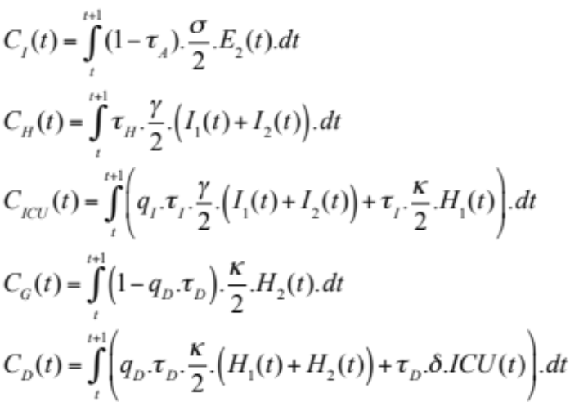 (A3)

Due to the use of a diffusion equation (A2) for the dynamic of the time-varying parameters, the model is stochastic. Thus equations (A1-A3) are considered in a stochastic framework solved with the Euler-Maruyama algorithm (Kloeden and Platen, 1999) implemented in the SSM platform (Dureau et al, 2013b).

Our model trajectories are related to the observed incidence using a negative binomial observation model, which is commonly used as observation model (Bretó et al, 2009). The observed incidences, C_{k,obs}(t), are assumed to be drawn from a negative binomial distribution with mean ρ_{k}.C_{k}(t) and variance ρ_{k}.C_{k}(t) + ϕ_{k}.(ρ_{k} .C_{k}(t))² where C_{k}(t) the incidence of the variable i simulated by the stochastic version of equations (A3), ρ_{i} the reporting rates quantifying the amount of non reported incidences (see Table 1) and ϕ_{i} are the overdispersion parameters.
Current hospital data, H_{obs}(t) (corresponding to H₁+H₂+ICU) and ICU_{obs}(t) (corresponding to ICU), are also available and therefore used to fit the model. We make the assumption that these variables X_{k,obs} follow a normal distribution with fixed standard deviation proportional to its estimated higher value and with mean equals to the predicted values by the model X_{k} (A2) times an observation rate ρ_{k} (see Table 1)

For inference we have used Bayesian technics that need the computation of the likelihood. Since our epidemiological model is considered in a stochastic framework, their likelihood is intractable and it is estimated with particle filtering methods (Sequential Monte Carlo, SMC). With a given set of parameters, the SMC algorithm reconstructs sequentially the trajectory of the state variables and the time-varying parameters, and computes the associated likelihood. Firstly, the distribution of the initial conditions of the system is approximated with a sample of particles. Then, at each iteration, the particles are projected according to the propagation model up to the next observation point, they receive a weight reflecting the quality of their prediction compared to the observation, and the total likelihood is updated. A resampling step using the weights is performed before the next iteration, in order to discard the trajectories associated with low weight particles.

In order to estimate the parameters of the system, the particle filter is embedded in a Markov Chain Monte Carlo framework, leading to the PMCMC algorithm (Andrieu et al, 2010). More precisely, the likelihood estimated by SMC is used in a Metropolis Hasting scheme (particle marginal Metropolis Hastings) (Andrieu et al, 2010). The proposal distribution is a Gaussian whose co-variance matrix is adapted following the framework described in Dureau et al (2013).

With this PMCMC algorithm we have used uniform and truncated gaussian priors based on the current literature. The priors of the inferred parameters are in Table 1 and Fig. A1.

Prior and Posterior distributions

The Figure A1 displays prior and posterior distributions involved in our inference process.

References

Andrieu, C., Doucet, A., Holenstein, R. (2010). Particle Markov chain Monte Carlo methods. Journal of the Royal Statistical Society: Series B, 72, 269–342.
Bretó, C., He, D., Ionides, E.L., King, A.A. (2009). Time Series Analysis via Mechanistic Models. The Annals of Applied Statistics, 3, 319-348.
Dureau, J., Ballesteros, S., Bogich, T. (2013). SSM: Inference for time series analysis with State Space Models. https://github.com/JDureau/ssm/blob/master/doc/doc.pdf.
Kloeden, P. & Platen, E. (1999). Numerical Solution to Stochastic Differential Equations. Springer.

Figure A1. Prior and posterior distributions for the model inferences presented Fig. 2. I₁(0) initial value of infectious, ν is the volatility of the Brownian process of β(t), 1/σ the average duration of the incubation, 1/γ the average duration of infectious period, 1/κ the average hospitalized period, 1/δ the average time spent in ICU, τ_{A} the fraction of asymptomatics, τ_{H} the fraction of infectious hospitalized, τ_{I} the fraction of ICU admission, τ_{D} the death rate, ρ_{I} the reporting rate for the infectious, ρ_{H} the reporting rate for the hospitalized people. The blue distributions are the priors and the discrete histograms are the posteriors.

