Supplementary Materials: Case Study Accounts

S1 (Amazon rainforest, Brazil) - Communicating Climate Change: What's the forest worth?
From 2011 to 2016, the German-Brazilian research consortium Carbiocial investigated the interdependencies of land use and climate change using the case of the 4,476 km highway BR 163 crossing the Brazilian Cerrado and connecting this Brazilian hotspot of soybean and cattle production with the Amazon and its big river port Santarem. Universities from Germany, Austria and Brazil participated in this inter- and transdisciplinary endeavour. One example was the collaboration between the soil science project comparing soil carbon turnovers of the different land use formats (mainly forest, fields, and pasture) and the social scientists researching challenges and chances of social transformation for GHG-optimised land- and natural resource management strategies. Jointly, the two sub-projects entered in collaboration with the local indigenous organisation at one of the research hotspots in the Northern part of the highway. The collaboration aimed at researching soil carbon stocks in the indigenous territories, the last pristine forest areas in a region with fast-changing land-use patterns and growing cattle and soybean cultivation (Gerold et al., 2018). The research team consisted of several soil science researchers (PhDs, master students, and PostDocs), two social scientists, a local well builder, and several indigenous representatives. Jointly, they organised two expeditions to sample several smaller pits in the forest area in addition to a 10-meter deep hole to analyze nutrients and carbon stocks. Part of the collaboration with the indigenous representatives was a presentation and handover of the research results afterwards. On the presentation day, we met with around 20 indigenous leaders from the diverse subgroups of the indigenous people and several members of the local representative institute the indigenous people had set up.
After some discussions among the scientific team, we decided to picture carbon as energy, starting the interaction by asking people where to find energy in their surroundings and taking the example of eating food for illustrating the transformation of carbon into energy. We then argued that energy would constantly change forms to refer to the carbon cycle and developed the narrative that balance was an ideal state for a cyclic system to be maintained. The effect of humankind disturbing the natural cycle and pushing things out of balance was a common narrative among indigenous representations of the present-day reality (ISA 2016). This was confirmed when we asked if people perceived a disbalance in their environment, which was widely confirmed, and examples like “drought” and “fires” were given by the indigenous leaders. This topic has acquired a sad continuity in the global news about Amazonia. To the natural scientists, it was imperative to stress that imbalance was the effect to be expected, which can mean heavy rains and droughts.
To contextualise the scientific findings, we decided to introduce the debate on carbon emissions and carbon emission trade, respectively its tool REDD+ to explain the utility of the collected data for the indigenous leaders. As had become clear from preparatory conversations with their local institute and conversations with the local NGO organisations, this had by far not been the first discussion on REDD+. Rumours were growing fast about money to be made, information and contacts to people dealing with these issues were considered necessary since the United Nations Conference on Sustainable Development (Rio+20) had taken place just in the previous year in Rio de Janeiro and brought global focus on the options for climate change mitigation in the Brazilian Amazon. Several Brazil-wide NGOs had previously given talks and workshops on REDD+ for the indigenous groups in and around the small Amazonian town. There was even an initiative to set up an indigenous program called REDDindígena, a program led by the Coordinator of Indigenous Organisations of the Amazon River Basin (COICA) to join payments for ecological services with participatory long term land management plans set up by the indigenous communities. This is only one example of the attempts of global forest dweller representations to take the debate on the use and value of their territories back into their hands.
One common critique of REDD+ mechanisms is the unfair negotiation resources between indigenous communities and international corporations acquiring certifications and the doorkeeper role that support organisations such as NGOs play in these negotiations. Therefore, a critical concern for us was to distance ourselves from the NGOs that were coming to the remote town over and over, setting up projects involving participation and planning while providing only little results. The related budgets and daily payments for participation in workshops were, of course, a coveted currency. In this heated field, we struggled to maintain a “neutral”, scientific identity by positioning ourselves as carriers of information and facts rather than opinions and plans.
We tried to explain the global REDD+ mechanism as a contract between who pays for the right to emit and somebody who concedes that right in exchange for monetary compensation. How much should be spent led to the question that seemed to be far more interesting than the theory: how much carbon was in the indigenous territory? We explained that the numbers presented were projections based on the samples, and also tried to explain how these results were reached (debating calculations via satellite images versus soil analysis), and even tried to make the argument that current calculations were considering way too short a layer of the soil - 50% of the soil carbon had been found in the layers below the 1m layer that is taken as the basis for the common carbon stock calculation schemes (Strey et al., 2017).
From a scientific point of view, these debates were interesting. However, for our audience, questions of how the carbon price was determined, who decides it, and whom to sell to naturally mattered much more. This hints at the often discussed problem that research interests do not always meet stakeholder needs – a challenging element of transdisciplinary projects (Schmidt et al., 2018). In the end, a ceremonial handover of the results finalised the meeting. Later on, a YouTube video was produced to keep information about the collaboration alive, but it has still very few clicks as of today. Enquiries during Q&A also showed the difficulties of linking the concrete with the abstract, for example there were questions of whether emission trade had anything to do with selling dead leaves. What we suppose can be learned from this example about the global politics of climate change, is how difficult a debate “on equal terms” about these questions actually is. On the one side, there is an information overkill, including much fake news on the potential and reality of REDD+ mechanisms. On the other hand, information is always filtered as per the interest of the informer, which makes communities in remote areas with little access even less prone or empowered to participate in the global debates on climate change and possible mitigation.

S2 (Colombia) - Co-producing and co-learning climate adaptation strategies in biodiversity conservation: lessons from Colombian protected areas
How do you conserve a glacial mountain when the glaciers are no longer there? How do you protect the habitat of an endangered species when the rainforest it depends upon transforms into a drier woodland? Conservation has traditionally been concerned with preserving, maintaining and restoring biodiversity, ecosystem services, and special landscapes with scenic or cultural values for society. Climate change brings new and inevitable ecological transformations, where preserving, maintaining, and restoring ecosystems may no longer be possible. In a rapidly changing world, where biodiversity in protected areas, and social-ecological systems are under pressure, traditional approaches to conservation are fundamentally challenged. Managers not only need to learn new knowledge, but also new skills and ways of thinking as old certainties fall apart and new types of challenges emerge.
Context of communication
The Future-proofing Conservation project, based in Colombia, developed processes that enabled protected area managers to rethink the nature of conservation and management strategies in the context of climate change. The project successfully brought together different actors to ‘rethink’ protected areas management and governance and to move away from conserving particular ecological attributes (e.g. species) towards conserving values and benefits generated by social-ecological systems managed through protected areas, while accommodating inevitable ecological changes.
This change sees climate adaptation focus more on how groups of actors –public, private, non-profit, community, business sectors – make decisions managing changes in the protected area and surrounding landscapes, rather than primarily on the biophysical aspects of climate change. This provides a better understanding of how decisions flow from on-site management actions (e.g. planning for declining water resources) to high-level objectives, such as maintaining a nationally representative system of protected areas.
This collaboration developed the ‘future-proofing process’ to help managers think differently about these complex challenges by considering future conservation goals and exploring ways to adapt protected area management.
Stakeholders involved in the communication process
Future-proofing Conservation was a collaboration between academic partners (Australian National University, Commonwealth Scientific and Industrial Research Organisation), advocacy partners (World Wildlife Fund Colombia), and practitioner partners (Parques Nacionales Naturales Colombia), along with professional conservation advisers (Equilibrium Research) and a brokering organisation that sought to facilitate collaboration across sectors (The Luc Hoffmann Institute). The process was tested in two pilot sites, the Alto Fragua National Park in the Amazon Piedmont and the Otun Quimbaya Flora and Fauna Sanctuary, located in the Coffee Growing Region.
Challenges in communicating the concepts
Adapting protected areas to climate change require changes in how we think about management. For the implementation team, the first challenge was translating academic language into something relatable to managers. This was increased by the need to translate between English – Spanish (Fig 1). The collaborative process focused on overcoming some barriers that prevent action in the context of managing protected areas under climate change:
1. The science and narratives supporting conservation goals in protected areas, tend to focus on maintaining ecological attributes and prevent change. The language and concepts of accommodating ecological change are unfamiliar, and often not well received
2. By definition, protected areas have a geographical restriction that limits discourse, governance, and action to certain boundaries
3. People think about climate change more as a technical problem, where scientific information is most relevant than a governance problem, where understanding how people make decisions that affect the future is critical
4. Climate projections are often used as a primary input in conservation adaptation planning. Such scenarios can be disempowering for managers and limit their capacity to identify adaptation options
5. This affects how people identify and use knowledge for making decisions and influence the rules for managing protected areas.
Overcoming the communication challenge
The process was a multi-step, interactive, dialogue-based series of activities that encouraged conservation practitioners to anticipate ecosystem transformation, anticipate potential impacts on benefits and values, and explore alternative management approaches.
By drawing together consideration of what people value about the protected areas, knowledge about possible ecological transformations based on climate projections, and institutional management options, participants identified what can be done now to prepare for uncertain futures.
In both case studies, the process included five stages, with varying levels of stakeholder involvement:
Stage 1: draw together local experience, knowledge about, and perception of climate change and adaptation through workshops with protected area managers and practitioners to learn together, and start building a shared narrative;
Stage 2: identify benefits from protected areas through a workshop with representatives from the local community, local stakeholders and managers from the protected area;
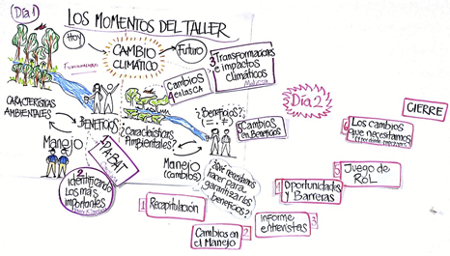
Figure 2. Cartoons designed by artists during the Colombia case study
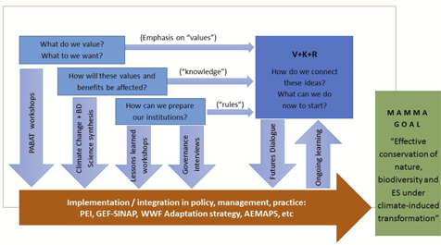
Figure 3. Conceptual framework used for the project in the Colombia case study. Source: van Kerkhoff et al. 2018
Stage 3: understand the decision making and governance context through in-depth interviews with managers and practitioners;
Stage 4: synthesise knowledge about potential ecological responses to climate change in the protected areas for academics, practitioners and managers;
Stage 5: a final stage called the ‘Futures Dialogue’, a workshop for exploration and reflection on ecological transformation, values, and management options, with managers, local communities’ representatives and practitioners.
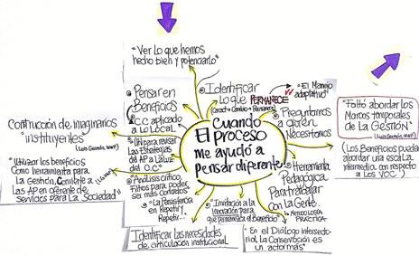
The design and implementation of the workshops depended on the time, situation, and context. Simple diagrams illustrating values with photos and words or phrases helped (see Figure 4).
Figure 4. Illustration of the participants’ contributions and key findings in the Colombia case study

S3 (Mousuni Island, India) - Communicating Climate change in the Indian Sundarbans
The Sundarbans, one of the largest mangrove forests in the world, lies on the delta formed by a confluence of 3 rivers flowing into the Bay of Bengal, spanning the neighbouring countries of India and Bangladesh. It was declared as a “World Heritage Site” by UNESCO in 1985. The Indian Sundarbans comprises 106 islands, of which 52 are inhabited.
Context of communication
Climatic events like cyclones and floods have adversely affected Sundarbans, causing increased food insecurity and loss of livelihoods for islanders (Masum 2012). Consistent sea level rise and river-bank erosion result in loss of land, driving inhabitants to out-migrate. Saline water inundations following storm surges in a cyclone, like the one caused by super-cyclone Amphan on 20th May 2020, have left thousands homeless, submerging villages for miles. While national and international stakeholders have been engaged in humanitarian relief work in post-disaster situations, communicating climate change processes and increasing awareness about the need for protecting mangroves and biodiversity have been largely left to academics, NGOs, and community-based organisations.
During 2016 and 2017, as part of my Master thesis research, I conducted a primary survey on Mousuni Island, one of the 52 inhabited islands in Indian Sundarbans. The sample included 120 respondents, selected through multiple stages of sampling, and data was collected in various ways, including Focussed Group Discussions (FGDs), Key Informant Interviews, and Participatory Rural Appraisal (PRA) techniques. The primary objective of the research was to understand how water-related hazards like riverbank erosion and rising sea levels increase the vulnerability of the island dwellers and result in decreased resilience to future climatic events. The survey aimed at understanding the role that socio-economic characteristics of a community play in determining vulnerability to climate change and analyse the adequacy of different forms of institutional support available to the inhabitants.
Stakeholders involved in the Communication process
The entire process of conducting interviews, collecting data, and disseminating information happened in three stages with three stakeholder groups successively.
a) Local NGOs: The NGOs, which have been working in Sundarbans for a long time and have built trust with the local communities, were approached and informed about the project, since having their support is crucial to reach the villagers.
b) Local Government officials: The Indian democracy works with a three-tier system, in which local governments are the lowest tier of governance, and any climate policy intervention would need their sanction and support.
c) Villagers: Having the NGOs and local government members on board, the villagers were more open to conversing and attending seminars and workshops, in which information regarding climate change impacts and coping techniques were discussed.
The NGOs working in Mousuni are well informed about climate change and the resulting increase in sea levels, which cause a greater influx of saline water into the mangroves. This not only harms the mangroves but also decreases the productivity of the island soils. Regular sessions on salt-resistant farming practices and livelihood diversification are conducted by these NGOs, which have adequately informed the stakeholders about concepts on climate change and resilience, making it easier to de-construct and use climate-related terminologies during the research project.
Challenges in communicating about the concepts
The project was purely academic and aimed at collecting evidence to inform future policy decision. Therefore, it was essential to emphasise to all stakeholders that there are no associated grants, benefits, or allowances to be gained on taking part in the discussions. This is especially important for conducting ethical research in vulnerable contexts.
Years of living in abject poverty and lack of institutional support in reaching sustainable solutions have made the islanders lose faith in the government. With limited agency and options available, some villagers have been felling trees to rebuild their own houses and embankments, causing a depletion of the mangrove cover. However, initiating discussions on these topics was challenging, since no one from the community wanted to take responsibility for such actions.
Challenge Resolution techniques and rationale
Repeated discussions and assurance of no legal consequences helped identify the local lobbies involved in deforestation in the villages. Several awareness-raising sessions by using videos, documentaries, and pamphlets in local languages helped create an atmosphere of understanding the need to protect the Sundarbans mangrove forests, one of the richest biodiversity hotspots in the world. A very effective technique to raise this community consciousness was conducting interactive sessions using PRA techniques which involved two important exercises-
a) Using the ground as a canvas, the villagers were asked to use locally available materials, like sticks, stones, leaves to denote different resources that the island is endowed with and then cross out the different resources now lost due to cyclones or floods.
b) Similarly, the villagers were also asked to create a timeline of the different climatic events that have affected the island over the last 70 years. Mapping of different events and associated destruction helped in clearly visualizing how depletion of the mangroves directly impacted the increased exposure of island inhabitants.
Results from both the exercises were then transferred on paper and shown to everyone in the community to raise awareness about the importance of forests, consequences of deforestation and its relation to increasing climate extremes, and possible solutions and options.
All the materials used for the exercises, including videos, questionnaires and resource materials, were selected to be location sensitive and relevant. While discussing concepts regarding the linkages between biodiversity loss (depletion of the mangrove cover) and increased intensity of climatic hazards, taking examples of individuals living within those communities and involving them in the exercises helped to establish trust, communicate openly and identify the actual challenges with which local policy implementation is faced.
The project recognised that local communities are aware and protective of their surroundings; however, locals may have to use natural resources to save themselves when it comes to survival. Thus, maladaptation practices often result from the absence of agency and options. A key takeaway from the project was the understanding that local community knowledge needs to be better documented and well-represented during broad climate change policy frameworks. This will enable better implementation of long-term resilience policies globally, with the local communities feeling more involved and accountable.
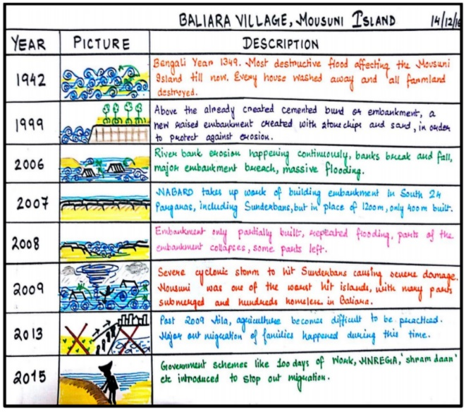
Figure 5. Timeline chart made by the villagers of Baliara in the Indian case study

S4 (Shyamnagar Upazila, Bangladesh) - Communicating grassroot stakeholders: Climate change and biodiversity crisis in coastal Bangladesh
Context of communication
Bangladesh is a leading country with millions of people with vulnerable livelihoods dependent on aquatic systems that are impacted by climate and anthropogenic change and where fishing and aquaculture have evolved rapidly in the last decades with significant consequences for sustainability (Hossaain, 2010; Faruque et al., 2017). The country's coast is vulnerable to a range of climate change impacts, from extreme events like cyclones to slow-onset processes like sea-level rise (Hossain et al., 2012). It was hit by a number of high impact cyclones, causing extensive damage to life and property over the years. Events and processes like cyclone, flooding, riverbank erosion, sea-level rise and salinity intrusion in the coast of the country have long been affecting the coastal margin by altering erosion rates, causing saline waters to intrude further inland, shrinking protective barriers and increasing flooding by cyclone and storm surges (Hossain and Hasan, 2017). In addition, directly human-induced impacts from aquaculture, chemical pollution, overfishing, and destructive fishing adversely impact fish biodiversity and catches and causing high fish seed mortality.
Under this study, we explored the recent trends in aquatic ecosystems of the coast of Bangladesh by looking at its aquatic diversity, aquaculture practices and productivity, and a number of associated livelihood changes. We used FGDs and household surveys in the Shyamnagar Upazila (sub-district) under Satkhira district, southwest coast of Bangladesh. The investigation covered the period of 2002–2012. It aimed at identifying the community perceptions on the changes in biodiversity in the aquatic production systems, their productivity and livelihood dependence, the main perceived impacts from climate and human activities, and the adaptation responses from the aquatic system livelihoods.
Stakeholders involved
The study included stakeholders emphasising and prioritising the interest of the community. It encompassed communications with gher (prawn/shrimp) farmers/labours, post-larvae (PL) collectors, crab fatteners and riverine fishers, fish traders, and earth (in gher) workers alongside people whose livelihoods do not directly dependent on aquatic systems but on other pertinent sectors. The data and information were complemented with interviews with four key informants -a high school teacher, a female NGO worker, an Upazila fisheries officer and a Union Parishad (UP) member.
Through the authors' experience and consultation with researchers, a reconnaissance survey was made to select the study area, study participants, and the key informants and build rapport with the study participants. The study area we selected is a disaster-prone area. Some projects and programmes run by governmental organisations and NGOs have been ongoing mainly using a top-down approach and a few cases involving grass-root level stakeholders at different degrees. Nonetheless, the community was familiar with the terms ‘climate change’, ‘livelihood’, ‘adaptability’ despite a somewhat fuzzy understanding and indulgence. The terms ‘biodiversity’, ‘loss and value of biodiversity’, and ‘conservation’ were unfamiliar concepts for the stakeholders.
Challenges faced
Even after all the preparatory works, the facilitators had difficulties making the FGD participants understand the concepts of biodiversity, value of biodiversity, the loss of biodiversity, effects of loss of biodiversity on livelihood, and the major causes of the loss of biodiversity. The participants also asked the data collectors/facilitators four major questions – 1. Why are you collecting these data/information, 2. Are you planning a project/programme, 3. Do you have any plan to slow down or stop the biodiversity loss in our area, and 4. Do you have any plans to improve the socioeconomic status of the biodiversity dependent community.
Addressing the challenges
At the beginning of every FGD session, an interactive half-hour session was arranged to make the biodiversity concept familiar to the participant. The facilitators strategically started this session with a very familiar notion, using local dialect and on their very own ecosystems and flora and fauna of past and present. It did not take long for the participants to catch up, and, within ten minutes, they stepped on familiar territory. Then, all participants became very interactive with much information on the biodiversity issues to share with the facilitators.
We used the simple way to deconstruct science: aquatic fauna. We asked the participants what they had in the past, what they have now, what they lost over the year, how this happened, and what they considered to be the causes. In the beginning, we took an interactive storytelling approach using the local dialect and examples from the surrounding ecosystems. At every stage of that story, we asked the participants for their ideas and similar examples, before engaging them in a deeper dialogue. Eventually, the participants grasped the concepts of biodiversity and completed their story – based on their own scenarios.
During the FGDs, HH surveys, and meetings, the facilitators ensured the participants that the study was not a development project but a research project of academic nature without an (non-)monetary benefits for the participants involved.
Take-away-messages
There is a significant gap between the scientific understanding of climate change and practical issues for the disaster torn, poor, and marginalised coastal community of Bangladesh. This gap can only be bridged through a thorough understanding of the community perspective and by unearthing their knowledge-base, i.e. their way of problem identification and their thought process regarding the possible adaptive measures – using their language. This approach can be effectively and practically used in other similar locations where communities are affected by climate change issues and looking for a sustainable adaptive strategy.

S5 (Aswan, Egypt) - The Aswan DESIRE Workshop on socio-economic impacts of RES in MENA countries
Background of case study
Countries of the Middle East and North Africa (MENA) are experiencing political, social and economic changes that are impacting the future design of domestic energy systems. With its sizable renewable resource potentials and the global trend toward decarbonisation, the region is gradually pivoting towards a post-fossil fuel economy. This transformation process is associated with various socio-economic opportunities and challenges. Against this background, the Erasmus Plus-funded project on the 'Development of higher education teaching modules on the socio-economic impacts of the renewable energy implementation’ (DESIRE) was launched in 2015 with ten different academic institutions from Europe and MENA countries (Figure 6).
The project aims to create and implement teaching for MENA universities and support young professionals in evaluating the deployment of renewable energies (RES) and energy efficiency measures in the context of socio-economic impacts. The project incorporated local stakeholder workshops with representatives from regional authorities, industries and academia to promote project outcomes and engage stakeholders in discourse about capacity deficits. The following summarises communication-related challenges that emerged during the stakeholder workshop organised in Aswan.
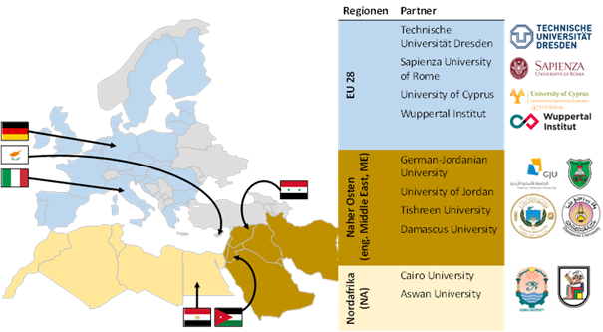
Figure 6: Overview of DESIRE project partners as part of the Egyptian case study
Stakeholders involved in the Aswan dissemination workshop
Public participation in sustainability research is important as a means of engaging stakeholders and facilitating solutions to societal challenges associated with accepting new modes of sustainable management. Dissemination workshops present a common form of such engagement. The Aswan dissemination workshop was held in February 2017 (DESIRE, 2017). About 60 representatives from civil society organisations, local leaders, journalists and business owners participated in the workshop. The conference took place in the Helnan Hotel in Aswan. The agenda included talks on renewable energy sources (RES) and their socio-economic impact, e.g., health and job creation, in the morning session and a discussion on overcoming challenges associated with their introduction with all participants during the afternoon session. The workshop was well received at the local level, and the local news station reported on the workshop.
During the workshop, communication-related challenges of an organisational, cultural and conceptual nature were encountered.
Organisational challenges in planning the workshop
The scheduling of the dissemination workshop was decided upon by the DESIRE project team at their semi-annual meeting in the summer of 2016. The workshop was led by the Egyptian project partners. Due to the physical distance between partners, on-site support could not be provided in the preparatory stage. This hindered the European partners from assuming more active involvement in the event. For example, the workshop was held exclusively in Arabic, which posed a language barrier for the European partners. An active discussion among Arabic speaking participants took place, which was well-received by those attending. A feedback survey indicated that more than 70% of attendees evaluated the workshop as “very good” and “good”. However, more extensive coordination amongst the partners in the planning process would have been helpful in facilitating a more inclusive event that exploited the experience and expertise of all partners.
Cultural challenges in the execution of the workshop
The workshop served to make the public aware of the project objectives while also being used to facilitate input for the project, namely, the socio-economic benefits and associated challenges of distributed RES installations in local communities. Regarding the latter, the frontal nature of the workshop and lack of interaction, e.g., discussions in small groups to pool a diverse set of experiences and input, limited the effectiveness of this portion of the event. While assumed to be quite customary for the region, this more managerial format, in which most participants absorbed the information in a passive manner, hindered effective communication and exchange among the participants. This was partially caused by different perceptions regarding the workshop’s objective amongst the project partners. The local partners perceived the workshop as an opportunity to highlight the project outputs, while the European partners were more interested in utilising the workshop to advance project goals. Eventually, the expectations of the workshop should have been addressed more explicitly beforehand.
Conceptual challenges in the exploitation of the workshop
As the socio-economic impacts of RES constituted the workshop's main focus, a lack of a common conceptual understanding amongst participants limited its effective exploitation. Many participants from the MENA region had a strong technical background. A narrow perspective limited to the technical deployment of RES that does not incorporate a shared interdisciplinary language hinders a contextualised discussion of socio-economic opportunities and challenges. This challenge is linked to the strong engineering focus in higher education systems in the field of RES in the MENA region. It would have been valuable to selectively invite a more diverse set of stakeholders to ensure a more comprehensive discussion of the project's interdisciplinary character.
The set of communication challenges faced in the dissemination workshop in Aswan was diverse. The experience gained points to the need for awareness about these potential challenges, especially in an intercultural context, and making a concerted effort to address them explicitly at the outset of the project.

S6 (Lake Manyara Basin, Tanzania) - Ecosystem Services as a rallying concept in multi-stakeholder workshops on biodiversity management and conservation around Lake Manyara, Tanzania
Where?
Lake Manyara is a saline lake in Northern Tanzania. It is the centrepiece of a national park teeming with iconic wildlife and a UNESCO Biosphere Reserve. The national park and surrounding areas provide much-needed revenues to the local economy through wildlife-viewing tourism, revenue-sharing schemes organised by the park authorities, and co-management ranches. Despite these positive examples, cattle of the Maasai pastoralists competes with wildlife and creates overgrazing and erosion. Further, irrigation agriculture depletes the scarce freshwater. Erosion, combined with heavy storm surges, provokes catastrophic mud and rockslides, creating sedimentation of the lake, while prolonged periods of drought threaten the whole basin with water scarcity. This precarious situation is exacerbated by a galloping demography, climate change, the limited carrying capacity of this semi-arid region, and complex governance. The multitude and diversity of stakeholders depending on ecosystem services provided by the biodiversity and aquatic systems of the Manyara Basin hold a variety of interests and opinions. Consensus on management decisions is uncertain.
Context of communication
We organised two participative workshops to achieve several outcomes: increased understanding of conservation policy and practice, capacity-building of stakeholders, co-creation of inputs for a Decision Support System, and identification of research gaps.
Stakeholders in the communication process
A range of judgement elicitation methods were used in participatory workshops with representatives from authorities, NGOs, pastoralists, smallholder farmers and scientists (details in Janssens de Bisthoven et al., 2020). This “evidence-informed” approach inspired by Jahn et al. (2012) is based on drawing information from literature on the one hand and by stakeholder knowledge about ecosystem services (ES) on the other hand (focus groups and interviews). It aims at integrating the best available and socially robust evidence into decision-making. We used facilitated brainstorming within the focus groups by presenting own work as an ice breaker and introduction, a collective stakeholder analysis (interest-influence matrix), problem/solution trees, drawings of community-specific maps of the region (Figure 7, Table 3), and prioritisation of ES. The flows of prioritised ecosystem services (Figure 8) were then further documented, in different groups, according to their background. Climate change and erosion control were addressed by authorities and scientists, food from agriculture was documented by farmers, and water by pastoralists.
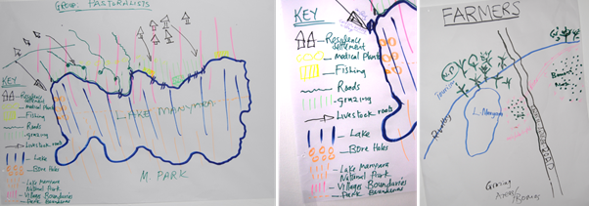
Figure. 7. Examples of drawings from a community mapping exercise; left by representatives of the Maasai community (pastoralists), middle detail of the legend of the pastoralists’ map, and right by representatives of smallholder farmers, illustrating very different perceptions of the same landscape as part of the Tanzanian case study (after Janssens de Bisthoven et al., 2020).

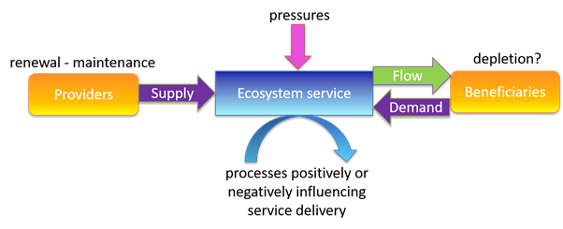
Figure. 8. Scheme for focus groups to understand ecosystem services dynamics as part of the Tanzanian case study (after Janssens de Bisthoven et al., 2020)
As an illustration, we present in Table 1 the main differences between maps drawn by respectively the farmers and the pastoralists. This ‘community mapping’ is an excellent method to highlight different perceptions of the same landscape from different stakeholders in a participatory way. This can be important to understand the respective opinions and positions related to ecosystem services. Hence, formulating management recommendations for decision support, which are to a certain extent inclusive of the ‘world views’ of different land users, will contribute to reconcile or at least mitigate conflictual issues.
Moreover, collective field visits to projects facilitated by NGOs illustrated the challenges related to land use and natural resource requirements of farmers and pastoralists.
Table 4. Summary of main differences in the community maps drawn by farmers and pastoralists in the Manyara as part of the Tanzanian case study
Feature | Pastoralists | Farmers
Format | Landscape | Portrait
Point of reference | Eastern shore of LM | Road (left and right of the road)
First 5 elements mentioned during oral presentation of the map | 1. Eastern shore of LM is drawn on top of the map (only map drawn in landscape format)  2. Lake Manyara  3. East of LM: 3 coastal villages: Oldukai, Losilwa, Esilalei; borders between those villages are indicated; each village has its own access to LM  4. In between, also on Eastern shore: natural vegetation from which people gather medicinal plants at a small scale  5. In between, also on Eastern shore: fishing camps – use of dugout canoes | 1. Main road Karatu-Arusha  2. Rift Valley  3. Lake Manyara  4. Small plots for rice, between LM and the main road. In between: agriculture-water conflicts because the lake is depleting  5. South of LM: grazing areas, bomas (a village called Esilalei)  Crop fields are indicated larger than in reality. Big plantations are however not mentioned.
Proportion of lake within map (estimation) | 50% | 8%
Elements only mentioned by one group | Medicinal plants, boreholes, village boundaries, better quality of grass at lakeside, livestock movements | Bananas, maize, rice
Conflict areas | · Erosion at the sides of the lake, close to the shore of the lake, not at the grazing site. A dumping site next the lake (in the North). | · Conflict between banana farms and rice farms.  · Under LM: grazing areas and bomas.  · On the other side of the road: farming also (maize...).  · Water use conflicts.
Missing elements | Agriculture | No legend for grazing area
LM sub-basin highlights | Highlighting the Eastern grassland shores | Highlighting the road
Challenges in communicating
Biodiversity-related challenges are often presented as international and national targets and the indicators that go with them. This highly technical and standardised approach proposed by, e.g., the Convention on Biological Diversity (CBD) or the Biodiversity Indicators Partnership (BIP, 2011) often does not match the limited awareness of these concepts among stakeholders involved in participatory workshops. Here we deconstructed biodiversity into ecosystem services (ES) as one main ‘rallying concept’: ES for a given protected area and its buffer zone, their perceived and observed trends, stakeholders and processes being affected by or affecting their delivery and value (Figure 2). ES were approached through the benefits of understandable concepts such as land fertility, access to water or erosion control. Regulating ES such as water balance regulation, climate mitigation and air purification needed more explanation during the exercises. It is essential to find local examples that are close to participants’ everyday life. Besides the terminologies used, the communication process during the workshop may impact the comprehension of concepts and the willingness to participate. Small working groups communicating their results to the plenary were more efficient than direct communication in plenary where some people would not dare to talk or ask questions.
Moreover, it was important to have a simultaneous translation from English to Kiswahili as well as a local partner guiding the different group exercises, e.g. explaining the different ecosystem services and making sure the group exercises were well-understood. Generally, our experience shows that mediation, moderation and facilitation of workshops in partner countries is often better understood by local communities when done by locally respected stakeholders, such as local civil society or a local expert, civil servant or academic. We identified hick-ups with the communication towards local stakeholders during such workshops: expert jargon ill-adapted to the public, ill-defined target audiences that vary unpredictably between workshops, overly complex social-ecological systems (SES) to tackle in a few workshops, or too high ambitions for 'quick solutions' and overly high expectations (“we expect our livelihoods to be better after this workshop”, see video above).
The next step: translating to decision support and policy
In the Manyara case, the focus on ES renders the language tangible and applicable for decision-making across governance levels, geographical and disciplinary boundaries. We usually co-produce policy briefs (PB) as the first step to policy outreach based on such participatory workshops (still to be done in Manyara). Cross-sectoral co-creation of knowledge, translated into a PB, incorporates local relevance and ownership to a higher decision level.
Take-aways
We plead for a ‘package’ of methods to customise communication amongst stakeholders of complex SES (e.g. stakeholder analysis, problem tree, community mapping, focus group etc...). A rallying concept like ES is key to mobilise stakeholders from various cultural and sectoral backgrounds in a constructive dialogue around biodiversity goals. More attention for biodiversity stakeholders will generate better-informed policies in which communities are visibly recognised and involved. Co-created PBs are, in that respect, promising tools. Multi-stakeholder participative workshops are also conducive for effectively translating the SDGs and (post-)Aichi CBD targets to local communities and conservation stakeholders.

S7 (Baltic Sea, Germany) - Dissidence and sabotage to redress scientific bias in communicating desirable coastal land management futures
Context
The COMTESS project (funded by the German Federal Ministry for Education and Research 2011-2015) modelled coastal land adaptation strategies on the German coast in the face of climate change, focussing on Managed Realignment (MR) as an approach to promote more resilient coasts compared to classical hard defence. MR restores natural coastal dynamics and buffers via the controlled removal of coastal dikes or their relocation inland.
The State of Mecklenburg–Western Pomerania is responsible for maintaining and upgrading first order dikes (that protect settlements). However, it is not legally obliged to maintain second-order dikes (that protect agricultural areas). MR on coastal agricultural land is per law possible but highly controversial at a societal level because it implies yielding land and control to the sea.
Stakeholders involved in the Communication process
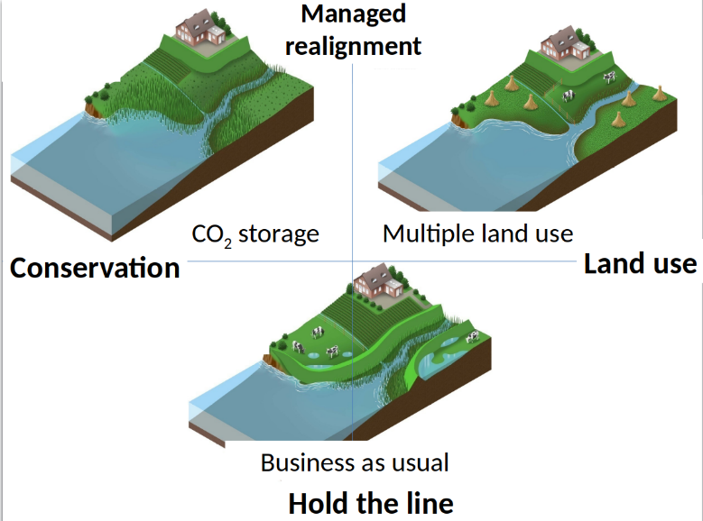
Figure 9. The three science-based COMTESS scenarios as part of the German case study
The modelling exercise included a participatory component in a 4-steps approach:
- Three science-based land-use scenarios were produced: i.e. two based on MR: a) In “CO₂ Storage”, coastal land use is discontinued, and wetlands are restored, and b) “Land Use Mosaic” promotes ecological rich land uses that cope with temporary flooding, to be contrasted with c) a control “Hold the Line” Business-as-usual scenario, where coastal dikes are upgraded and maintained.
- The evaluation exercise was designed in a top-down manner. Selected experts were invited to discuss the congruence and plausibility of the three COMTESS scenarios and suggest alternatives for a fourth, “expert-based” scenario. This round of consultation involved semi-structured interviews with experts from different perspectives on coastal defence, land planning policy, natural resource management, flood hazard rescue, conservation, agriculture, and tourism.
- The scientific team analysed the interviews searching for common trends that departed from the COMTESS scenarios to produce a fourth alternative “stakeholder-based” scenario.
- The four scenarios were evaluated by a bigger group of experts and members of the public during a world café.
Challenges in negotiating how to communicate on / evaluate coastal futures
Climate change and its impacts were communicated as non-questionable
Effectively, no deconstruction of the concepts “climate change” or “biodiversity” was performed. The term “managed realignment” was used carefully or avoided, as the notion of removing dikes generally raises negative associations. The term “land management” was preferred to shift the focus away from coastal defence.
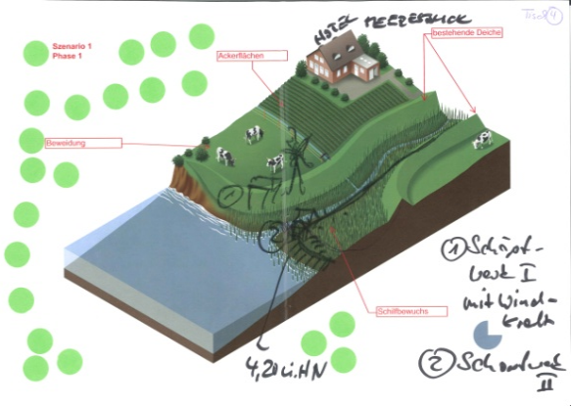
Figure 10. Dissident participants turn the given rules of evaluation around as part of the German case study
A participatory exercise fully framed and controlled by the scientific team
The project embedded little flexibility to incorporate stakeholders’ preferences.
- The scientists worked with narrow, pre-defined and non-negotiable assumptions related to coastal adaptation: i.e. adaptation is needed and should involve MR. The ‘Hard Defence’ scenario was only envisaged as a control scenario to assess the gains and losses of the “real” options based on MR.
- Experts could suggest alternatives but could not create their own scenario, as the scientific team had selected the most “promising” expert contributions and collated them into a “stakeholder-based” scenario.
- At the world café, participants were to: 1) comment on visualisations of the four land-use scenarios and 2) mark the desirable outcomes (with green dots) or those to be avoided (with red dots). Participants were given an unequal number of green and red dots (3:1), the intent being to focus negative responses on one scenario (rather than all) to understand the stakeholders’ argumentation behind the rejection better.
Bottom-up response
Some World Café participants openly questioned the rationale of the project and evaluation exercise:
- The scenarios focused on specific aspects of a complex situation, which diminished their relevance
- While a clear scientific prognosis for future impacts was requested, the future impacts visualised in the scenarios were questioned
- Visualisations were abstract, difficult to understand intuitively, to differentiate or to relate to
- The description of the scenarios steered participant’s opinion and, thus, evaluation
- The evaluation method steered responses towards an apparent acceptance of MR
- Group dynamics could influence the evaluation in either way
Critical participants reclaimed some control over the process by:
- questioning the basic assumption on climate change impacts and the desirability of MR
- producing their own future: e.g. one where the highest standards in hard coastal defence would allow avoiding any climate change impacts completely
- producing their own visualisation (e.g. by adding/removing elements)
- combining and distributing their red dots to dismiss all scenarios
- not allocating any green dots on the proposed alternatives to visualise their refusal of these options
By “sabotaging” the prescriptive evaluation process, critical participants voiced their disagreement with the future options proposed by the project and made room for their own. While the project explicitly aimed at a participatory evaluation, it implicitly mainstreamed “Managed Realignment.” This inherent contradiction is common in top-down, nature-science dominated modelling projects, where scientists feel “forced” into a co-design approach (e.g. by funding requirements). Collaborating social scientists often find themselves in an impossible conundrum: they must deliver a participation process when effectively they are expected to manufacture “societal” legitimation. Fortunately, in our case, “dissident” participants refused to endorse the project’s implicit strategy.
This case study provides valuable lessons towards true transdisciplinary modelling. Projects should:
- recognise and acknowledge perception, preference and rationalisation gaps between science, policy and society,
- accept the value of and accommodate departures from science-based assumptions,
- yield control in the research process to enable true exchange and co-learning.

S8 (Isles of Scilly, United Kingdom) - Communicating climate change: Fieldwork experiences from the Isles of Scilly
Context of communication
The project on social capital, resilience, and adaptation to climate change on the Isles of Scilly took place between 2013 and 2016 (Petzold, 2016; 2017). The project’s objective was to analyse the role of social capital and community resilience in the context of climate change and was carried out by one PhD researcher from the University of Hamburg. On the Isles of Scilly, climate change manifests itself mainly through storm surges and sea-level rise, associated with coastal erosion, flooding, damage of coastal infrastructure, and disruption of transport. Due to the relative isolation and peripheral setting of the five islands that constitute the Isles of Scilly at 45km off the southwest coast of the United Kingdom, I was interested primarily in how self-organised community action can help to deal with the challenges posed by climate change. After a first preparatory field visit including a couple of scoping interviews and field observations in December 2013, the first full fieldwork phase of my project (February/March 2014) took place when the strongest storms in recent decades hit the islands, followed by a second fieldwork phase in July 2014 and wrap-up/discussion phase in September 2014.
My research consisted of a mixed-methods approach. The quantitative part included a survey entitled ‘Communities and the sea’. Besides a section on indicators of social capital, the survey included a section with 11eleven questions about people’s general perception of climatic change, as well as specific experiences of coastal risks, coastal management and participation in coastal protection. The qualitative part of the research involved participant observation, expert and stakeholder interviews. In addition, media analysis was undertaken by systematically searching local magazines and websites.
Stakeholders involved in the communication process
The different stakeholders’ understandings and perceptions of climate change, its impacts on the community, and potential adaptation measures were central concerns of the project. Stakeholders in the study included, amongst others, the local population, media, local council, non-governmental organisations, and the landholder.
Climate change is an issue of which the local stakeholders were very aware. Due to their low-lying topography, the media has been dubbing the islands the ‘Maldives of the Atlantic’, and the local council employed a ‘climate change officer’ at the time of research. A local NGO was raising awareness about climate change concerns within the population and the local council. The local administration considered plans to develop wave energy instead of relying on a coal-fired power plant. Many islanders were aware that the archipelago was one island once and that incremental sea-level changes over the past millennia created the archipelago’s today’s shape. Notably, the publication ‘Exploration of a drowned landscape’ (Thomas, 1985) made this fact commonly known. Also, indicators of submergence, such as coastal archaeological findings, submerged fields and artefacts, reveal the long history of sea-level rise. Therefore, exposure to climate-related hazards, such as storm surges and sea-level rise, make up part of the islands’ identity.
Challenges in communicating about the concepts
The coincidental timing of my research during the severe storm events helped facilitate dialogue about climate change with locals. Building on these hazards as a proxy for climate change was both reasonable and unavoidable. However, the general risk perception might have been overly shaped and potentially exaggerated due to those recent experiences.
A certain scepticism towards external ‘experts’ (e.g., from the UK Environment Agency) was often raised during interviews. While I did not perceive that people were sceptical towards my research, this attitude may have influenced how people talked to me and what they revealed to me about their risk perception and community life.
The diverse group of stakeholders involved different experiences and conflicting interests concerning the community and the environment and its stewardship. For example, the conservation and heritage aspect, involving minimal interference in the landscape, was pushed forward, especially by landholders and non-governmental organisations. On the other hand, residents and businesses were concerned with employment, tourism, habitability, and coastal protection on the islands.
Challenge resolution techniques and rationale
An essential element to overcome a biased perspective due to seasonal weather conditions was to spread the fieldwork over various seasons (i.e., autumn, winter, summer) when partly different people live on the islands and weather conditions are different.
I approached the local people through their main local communication channels early in the research design. To overcome the scepticism towards me as an external researcher, I announced my research project via the local Radio Scilly, the main news website ScillyToday, and talked about my activities in a follow-up interview with the radio station. Therefore, when I started my research activities, many islanders were already aware of my intentions and very open to contribute their perspectives.
In order to gain local people’s trust and acknowledge their perception of climate concerns as a ‘counter-narrative’ to the influential voices by council, landholder, and NGOs, participant observation, personal distribution of the questionnaires, and ‘walking interviews’ were essential – that is, letting people show me their sites of interest concerning potential climate change hazards, on their own terms.
Generally, explicit reference to climate change was only mentioned in expert interviews and interviews with stakeholders directly involved in adaptation planning. With other stakeholders and laypeople, climate change was deconstructed in terms of climate-related hazards and impacts, such as storm surges, shoreline change, erosion, and flooding.
Finally, a report back of the research results and my interpretation of them to the community served as a tool to critically reflect on my findings and involve different stakeholders again.
Conclusions
In sum, three elements were crucial for communication during the research project:
1) A critical understanding of local awareness of and experiences with climate concerns and narratives about the local environment (e.g., sea-level rise) was key for deconstructing climate change and developing my research tools.
2) The combination of including different voices and over different seasons was a critical element to reduce a biased representation of climate risk – both concerning the influence of dominant stakeholders and seasonal variability.
3) Being transparent about the research approach, its aims and results by using the most common local communication channels greatly increased local trust and participation.
4) Participant observation and open-minded informal exchange with local community members allowed for building trust, an in-depth understanding of the diversity of local concerns (also apart from climate change) and the representation of otherwise marginalised voices.

Additional References
Biodiversity Indicators Partnership (BIP) 2011 Guidance for National Biodiversity Indicator Development and Use (Cambridge: UNEPWorld Conservation Monitoring Centre), p40.
Faruque, G., Sarwer, R.H., Karim, M., Phillips, M., Collis, W.J., Belton, B., Kassam, L. (2017). The evolution of aquatic agricultural systems in Southwest Bangladesh in response to salinity and other drivers of change. Int. J. Agric. Sustain. 15 (2), 185–207.
Hossain, M. A., Reza, M. I., Rahman, S., & Kayes, I. (2012). Climate change and its impacts on the livelihoods of the vulnerable people in the southwestern coastal zone in Bangladesh. In Climate change and the sustainable use of water resources (pp. 237-259). Springer, Berlin, Heidelberg.
Hossain, M.A.R., (2010). Inland fisheries resource enhancement and conservation in Bangladesh. RAP publication 2010/22. In: Miao, Silva, Davy (Eds.), Inland Fisheries Enhancement and Conservation in Asia. FAO Regional Office for the Asia and the Pacific, Bangkok, Thailand, pp. 1–17.
Masum, S. Jahangir Hasan. (2012). Climate Change Impact on the Poor People of the Sundarbans Community in Bangladesh. CDP.
Schmidt, Laura; Korbinian Hartberger, Susanne Kobbe, Thomas Falk, Maren Wesselow, Charlotte Schumann (2018): Stakeholder Involvement in Transdisciplinary Research: Lessons from Three Projects on Sustainable Land Management in a North-South Setting. In: Gaia - Ecological Perspectives for Science and Society. Vol 27, Nr.3, pp.312-320(9).

