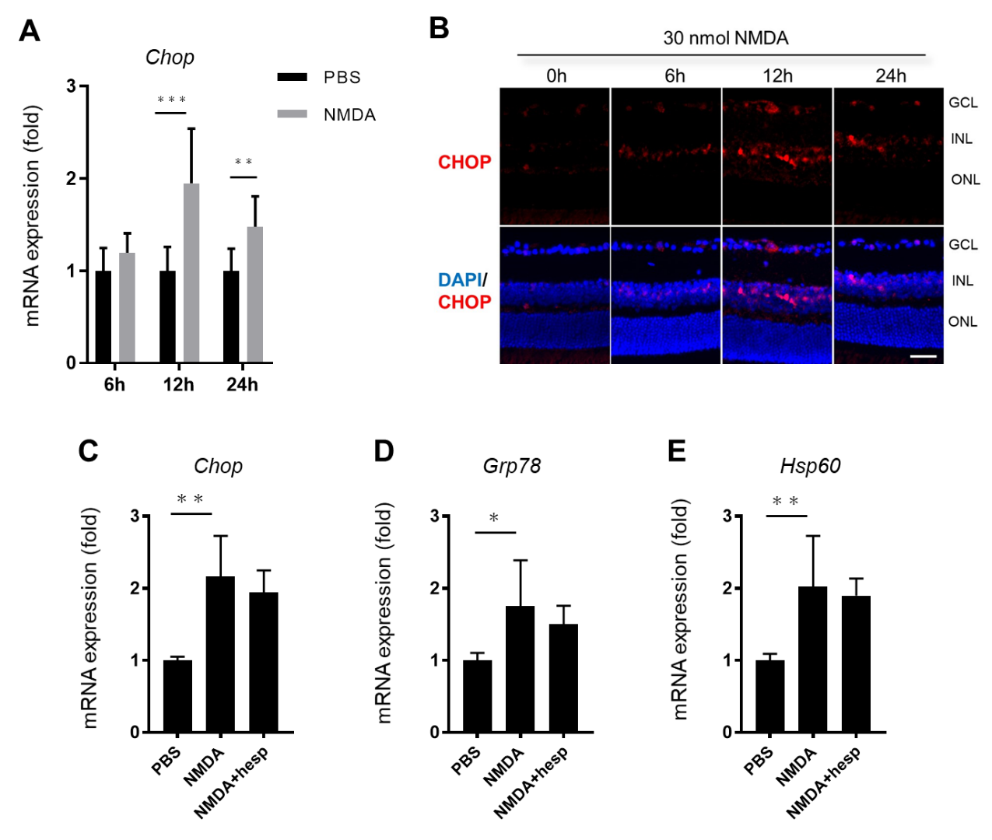
Supplementary Figure 1

Supplementary Figure 1
Hesperidin treatment did not suppress ER stress in the retina of mice after NMDA injury. (A) Relative expression levels of CHOP mRNA in the retinas of mice were determined at the indicated time after NMDA injection with qPCR (N=6). (D) Representative immunohistochemistry image showing the increased expression level of CHOP in the GCL and INL in the mouse retinas. Transcription levels of ER stress-related genes, such as CHOP (C), Grp78 (D), and Hsp60 (E), were measured in mouse retinas treated with hesperidin 12 h after NMDA injury (N=6). Error bars denote SD. This statistical analysis used the Tukey-Kramer test. ＊P < 0.05,＊＊P < 0.01,＊＊＊P < 0.001.

