Title: Machine learning guided postnatal gestational age assessment using newborn screening metabolomic data in South Asia and Sub-Saharan Africa

Running title: Gestational age estimation using Machine Learning

Sunil Sazawal*¹, Kelli K. Ryckman³*, Sayan Das^{1*}, Rasheda Khanam⁴, Imran Nisar⁵, Elizabeth Jasper³, Arup Dutta¹, Sayedur Rahman⁶, Usma Mehmood⁵, Bruce Bedell³, Saikat Deb², Nabidul Haque Chowdhury⁶, Amina Barkat⁵, Harshita Mittal¹, Salahuddin Ahmed⁶, Farah Khalid⁵, Rubhana Raqib⁷, Alexander Manu⁸, Sachiyo Yoshida⁸, Muhammad Ilyas⁵, Ambreen Nizar⁵, Said Mohammed Ali², Abdullah H. Baqui⁴**, Fyezah Jehan⁵**, Usha Dhingra¹**, Rajiv Bahl⁸**
*joint first author **joint last author
- Center for Public Health Kinetics, Global Division, 214 A, LGL Vinoba Puri, Lajpat Nagar II, New Delhi, India
- Public Health Laboratory-IDC, Chake Chake, Pemba,Tanzania
- University of Iowa, College of Public Health, Department of Epidemiology, 145 N. Riverside Dr. , S435, Iowa City, IA 52242,
- Department of International Health, Johns Hopkins Bloomberg School for Public Health, 615 N. Wolfe Street, Baltimore, Maryland 21205
- Aga Khan University, Department of Paediatrics and Child Health, Karachi, Sindh, Pakistan
- PROJAHNMO Research Foundation, Abanti, Flat # 5B & 5D, House # 37, Road # 27, Banani, Dhaka-1213, Bangladesh
- International Center for Diarrheal Disease Research, Mohakhali, Dhaka 1212, Bangladesh
- World Health Organization (MCA/MRD), Geneva, Switzerland

Corresponding author
Sunil Sazawal PhD;
Center for Public Health Kinetics, Global Division, 214 A, LGL Vinoba Puri, Lajpat Nagar II, New Delhi, India. E-mail; ssazawal@jhu.edu ; Tel +91-11-41724902

Rajiv Bahl MD;
World Health Organization (MCA/MRD), Avenue Appia 20, 1211 Geneva, Switzerland: e-mail: bahlr@who.int, Tel: +41-22-7912111

Supplementary Figure 1 : Pregnancy cohort and Study design
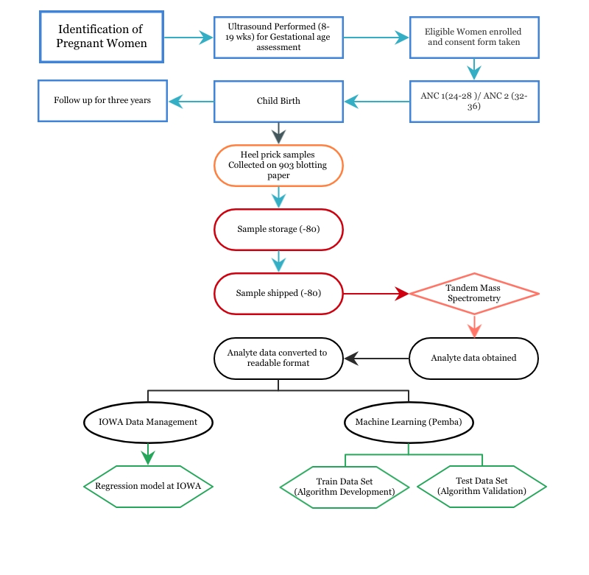

Supplementary Table 1: RMSE and Mean Abs Error in weeks obtained in three comparative models
*Model 1. Using all analytes (our data) + birthweight + gender + removed all women with multiple births
Training Dataset : 50% Pemba Samples (358) + 50% Asian samples (284) |  | Mean Abs Error ( 95% C.I) (in weeks) | RMSE (in weeks)
Test Data (1) : | Combined : 50% rem Pemba Samples (357) + 50% rem Asian samples (284) | 1.10 (1.03-1.17) | 1.48
Test Data (2) : | Africa : 50% remaining Pemba Samples (357) | 1.25 (1.10-1.29) | 1.67
Test Data (3) : | Asia : 50% remaining Asian Samples (284) | 1.01 (0.98-1.12) | 1.38
*Model 2. Using Rykman et al’s analytes (linear,squared,cubic) + removed all women with multiple births
Training Dataset : 50% Pemba Samples (358) + 50% Asian samples (284) |  | Mean Abs Error ( 95% C.I) (in weeks) | RMSE (in weeks)
Test Data (1) : | Combined : 50% rem Pemba Samples (357) + 50% rem Asian samples (284) | 1.02 (0.92-1.07) | 1.38
Test Data (2) : | Africa : 50% remaining Pemba Samples (357) | 1.22 (1.14-1.31) | 1.52
Test Data (3) : | Asia : 50% remaining Asian Samples (284) | 0.84 (0.76-0.93) | 1.27
*Model 3. Using Murphy et al’s (linear + squared + cubic + combinations + gender + birthweight + removed all women with multiple birth status
Training Dataset : 50% Pemba Samples (358) + 50% Asian samples (284) |  | Mean Abs Error ( 95% C.I) (in weeks) | RMSE (in weeks)
Test Data (1) : | Combined : 50% rem Pemba Samples (357) + 50% rem Asian samples (284) | 0.97 (0.89-1.08) | 1.28
Test Data (2) : | Africa : 50% remaining Pemba Samples (357) | 1.20 (1.09-1.30) | 1.40
Test Data (3) : | Asia : 50% remaining Asian Samples (284) | 0.75 (0.7-0.88) | 1.17

Supplementary Figure 2: ROC analysis comparing discriminatory ability of four models evaluated
Model | AUC | SE | 95% CI
Model_3 | 0.923 | 0.0219 | 0.900 to 0.943
Model_4 | 0.926 | 0.0221 | 0.903 to 0.945

Model | AUC | SE | 95% CI
Model_1 | 0.868 | 0.0253 | 0.839 to 0.893
Model_2 | 0.918 | 0.0216 | 0.894 to 0.938

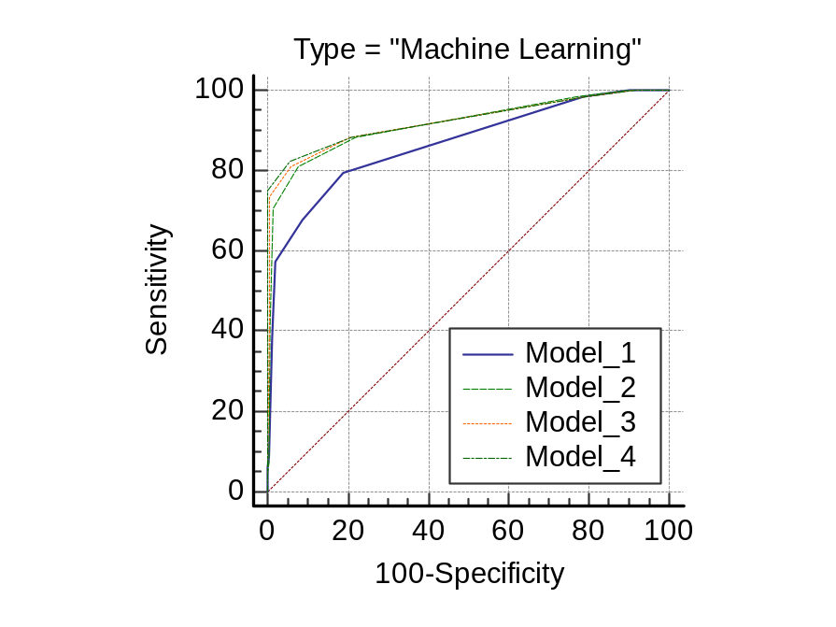 | ª DeLong et al., 1988, ^{b} Binomial exact
  Model_4 ~ Model_1
  Difference between areas | 0.0580
  Standard Error ª | 0.0171
  95% Confidence Interval | 0.0244 to 0.0916
  z statistic ; P value | 3.382; P = 0.0007
  Model_4 ~ Model_2
  Difference between areas | 0.0083
  Standard Error ª | 0.0035
  95% Confidence Interval | 0.0015 to 0.0152
  z statistic; P value | 2.377; P = 0.0174
  Model_4 ~ Model_3
  Difference between areas | 0.00259
  Standard Error ª | 0.00224
  95% Confidence Interval | -0.0018 to 0.0069
  z statistic; P value | 1.156; P = 0.2476

Supplementary Table 2 : New born screening metabolomic analytes estimated
Amino Acids | Alanine, Arginine, Leucine, Methionine, Ornithine, Phenylalanine, Tyrosine, Valine, Citruline, Glutamate, Arginine:Onithine, Citruline:Arginine, Leucine:Alanine, Leucine:Phenylalanine, Methionine:Phenylalanine, Phenylalanine:Tyrosine, Tyrosine:Phenylalanine
Acylcarnitines | Carnitine (C0), C0:C16, C0:C18, C10, Decenoyl carnitine (C10:1), C12, C12:1, Tetradecanoylcarnitine (C14), Hydroxytetradecanoylcarnitine (C14:1OH), Tetradecenoyl carnitine (C14:1),C14:1:C12:1, C14:1:C16, C14:2, Palmitoylcarnitine (C16), 3 hydroxyhexadecenoyl carnitine (C16:1OH), Palmitoleylcarnitine (C16:1), 3- Hydroxypalmitoleylcarnitine (C16:1:1OH), C16:1OH:C16, Stearoyl carnitine (C18), C18:1OH, Oleoylcarnitine (C18:1), 3 -Hydroxyoleoylcarnitine (C18:1:1OH), Linoleoylcarnitine (C18:2), Acetylcarnitine (C2), Propionylcarnitine (C3), Malonylcarnitine (C3DC), C3C2, C4, Methylmalonylcarnitine (C4DC), C4:1OH, C4C2, C4C3, Isovalerylcarnitine + Methylbutyrylcarnitine (C5), Glutarylcarnitine (C5DC), C5DC:C16, C5DC:C8, C5:1OH, Tiglylcarnitine (C5:1), C5:C2, C5:C3, C6, Methylglutarylcarnitine (C6DC), Octanoylcarnitine (C8), Octenoylcarnitine (C8:1), C8:C10
Endocrine  markers | Hydroxyprogestrone, Thyroid Stimulating Hormone
Enzyme and  Coenzyme markers | Galactose-1 phosphate uridylyl transferase, Succinyl lactone

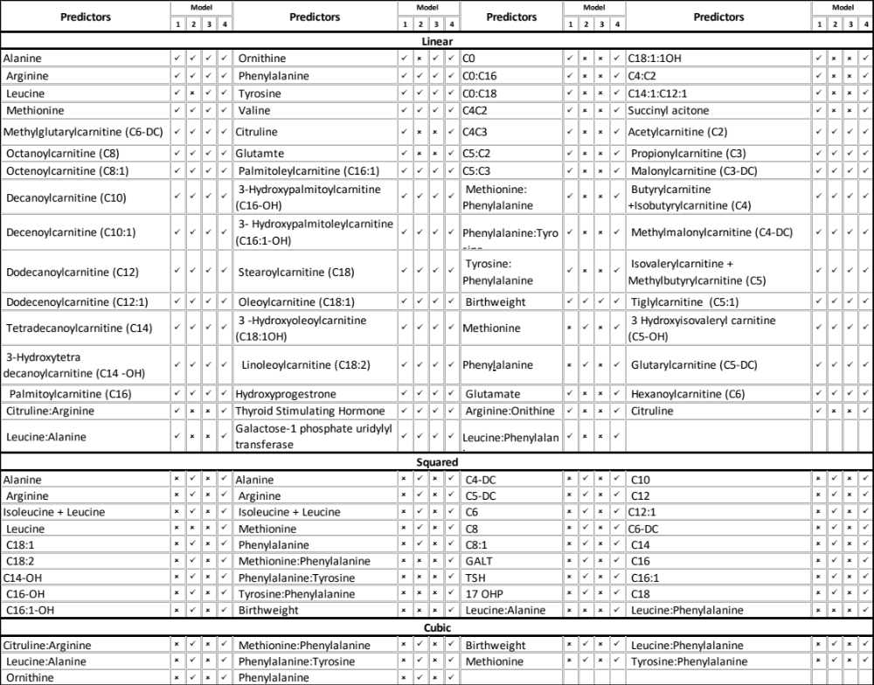
Supplementary Table 3A: Description of the model

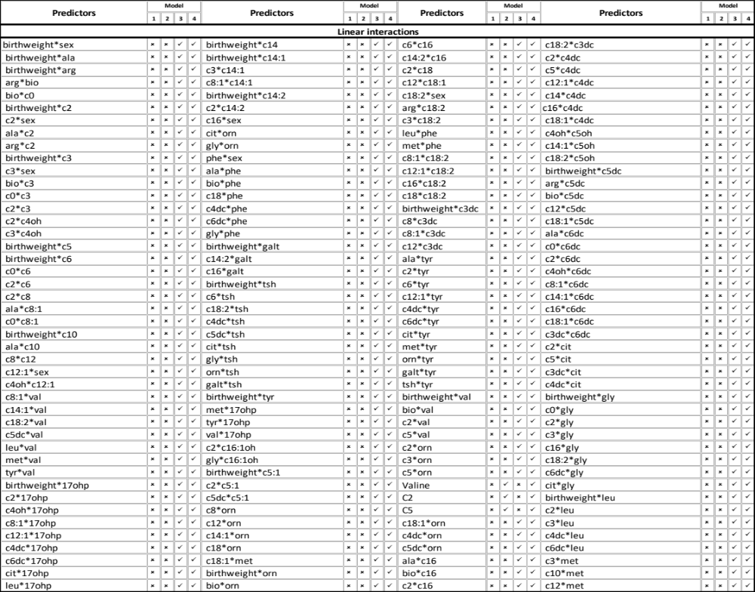
Supplementary Table 3B: Description of the model (…continued)

