Slowing deforestation in Indonesia follows declining oil palm expansion and lower oil prices

David L.A. Gaveau^{1*} Bruno Locatelli², Mohammad A. Salim¹, Husnayaen¹, Timer Manurung³, Adria Descals⁴, Arild Angelsen⁵, Erik Meijaard^{6,7}, Douglas Sheil^{8,9}

¹ TheTreeMap, Bagadou Bas, 46600 Martel, France
² CIRAD Forests and Societies, Univ Montpellier, 34398 Montpellier, France
³ AURIGA, Jakarta, Indonesia
⁴ CREAF, Centre de Recerca Ecològica i Aplicacions Forestals, E08193 Bellaterra (Cerdanyola de Vallès), Catalonia, Spain
⁵ School of Economics and Business, Norwegian University of Life Sciences (NMBU), PO Box 5003, 1432 Ås, Norway
⁶ Borneo Futures, Bandar Seri Begawan, Brunei Darussalam
⁷ Durrell Institute of Conservation and Ecology, University of Kent, Canterbury, UK
⁸ Department of Ecology and Natural Resource Management (INA), Norwegian University of Life Science (NMBU), Box 5003, 1432 Ås, Norway.
⁹ Forest Ecology and Forest Management Group, Wageningen University & Research, PO Box 47, 6700 AA, Wageningen, The Netherlands.

Supplementary Tables

Table S1 │ Results of assessment to validate the 2019 oil palm plantation map. Error matrix with user, producer and overall accuracies.

 |  | Reference
 |  | Industrial | Smallholder | Other | Total | User’s
Map | Industrial | 605 | 14 | 16 | 635 | 95%
Map | Smallholder | 7 | 348 | 43 | 398 | 87%
Map | Other | 8 | 24 | 2144 | 2176 | 98
Map | Total | 620 | 386 | 2203 | 3209
 | Producer’s | 98% | 90% | 97%
Overall accuracy: 96.4%

Table S2 │ Forest loss, and share of forest loss caused by oil palm and industrial pulp&paper plantations 2001-2019

Areas (in Ha) | Indonesia | Sumatra | Kalimantan | Papua | Sulawesi | Java Maluku
Landmass | 189,130,128 | 47,467,842 | 53,498,290 | 41,227,232 | 18,627,593 | 21,135,660
2019 Oil Palm  Indus/small (%) | 16,237,047  64/36 | 9,486,516  49/51 | 6,044,517  84/16 | 272,808  99/1 | 374,686  55/45 | 58,520  83/17
2019 pulp&paper | 2,966,181 | 2,016,570 | 939,874 | 9,737 | 0 | 0
Forest area  2019 | 82,590,327 | 12,063,230 | 25,742,162 | 34,289,462 | 9,114,005 | 5,658,137
Forest loss  2001-2019 | 9,789,448  (11%) | 4,075,312  (25%) | 4,023,971  (14%) | 748,640  (2%) | 715,737  (7%) | 213,487  (4%)
Forest converted to pulp& paper and oil palm | 4,093,479  (42%) | 2,007,419  (49%) | 1,817,807  (45%) | 208,842  (28%) | 46,782  (7%) | 12,629  (6%)
Forest converted to Oil Palm | 3,094,882  (32%) | 1,242,345  (31%) | 1,593,260 (40%) | 200,161  (27%) | 46,782  (7%) | 12,629  (6%)
Rapid conversion to oil palm | 2,849,796  (29%) | 1,166,806 (29%) | 1,434,493 (36%) | 194,996 (26%) | 43,319  (6%) | 10,181  (5%)
Rapid conversion to industrial oil palm | 2,129,301  (22%) | 553,480  (14%) | 1,341,610 (33%) | 194,671 (26%) | 29,807  (4%) | 9,733  (4.5%)
Rapid conversion to smallholder oil palm | 720,495  (7%) | 613,326  (15%) | 92,884  (2%) | 325  (0.0004%) | 13,512  (2%) | 448  (0.002%)
Rapid conversion to Pulp&paper | 959,774  (10%) | 742,911  (18%) | 208,331  (5%) | 8,532  (1.14%) | 0 | 0

Supplementary Figures

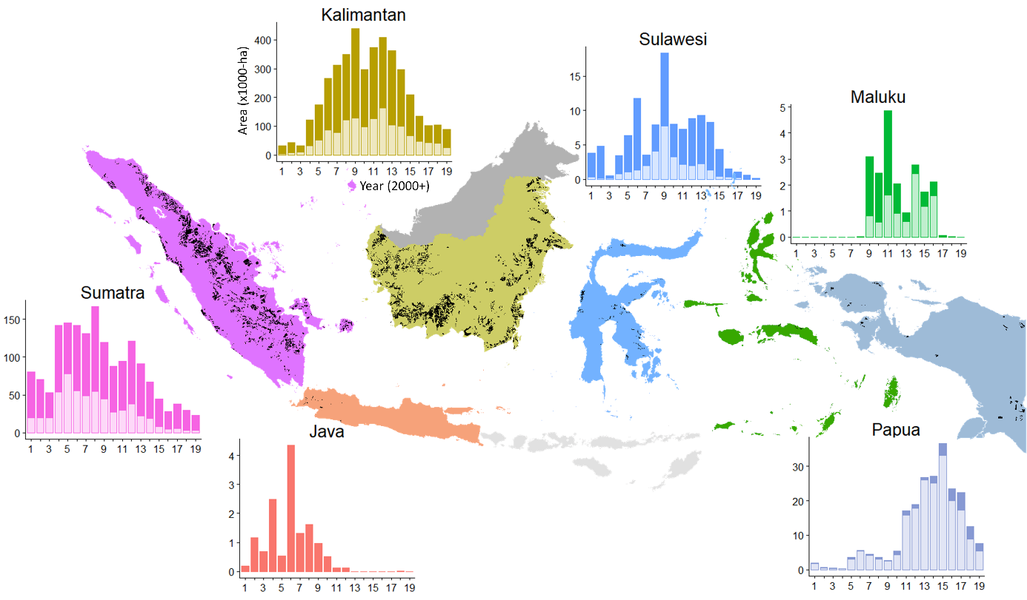
Figure S1 │ Industrial oil palm expansion by region across Indonesia from 2001 to 2019. Y-axis represent areas (in 1000-ha, note different scales) of the total area of plantations added each year between by directly clearing forests (light bars, below), or by using areas already cleared (dark bars, above). Black areas on the map represent the total area of industrial oil palm plantations in 2019.

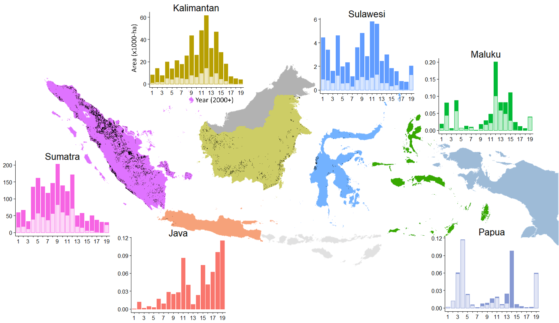
Figure S2 │ Smallholder oil palm expansion by region across Indonesia from 2001 to 2019. Y-axis represent areas (in 1000-ha, note different scales) of the total area of plantations added each year between by directly clearing forests (light bars, below), or by using areas already cleared (dark bars, above). Black areas on the map represent the total area of smallholder oil palm plantations in 2019.

Our results support those of (Austin et al. 2019) who used a sample-based approach to estimate how much industrial plantations expanded into forests between 2001 and 2016. We report 1.97 Mha rapid forest conversion to industrial oil palm, while Austin et al. report 2.08 Mha. Both datasets show a decline in industrial oil palm driven deforestation since 2011-12 (Figure S6).

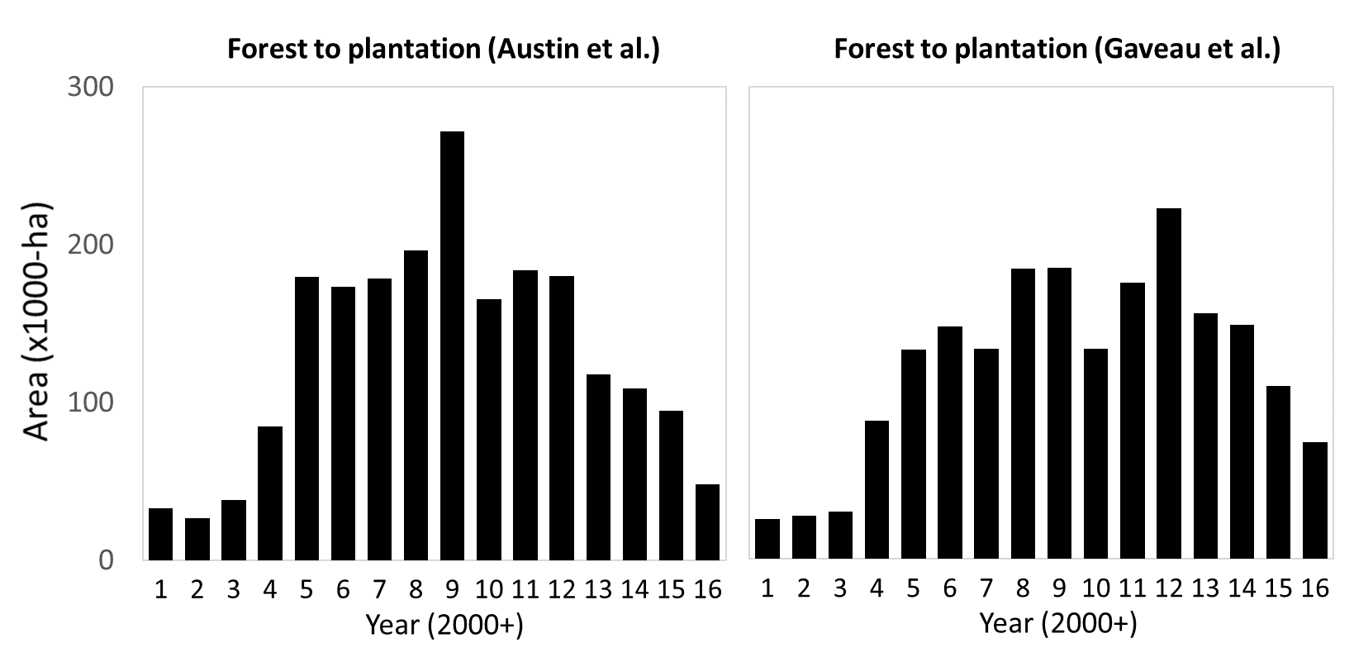
Figure S3 │ Forest converted each year to industrial oil palm plantations in Indonesia from 2001 to 2016 based on samples (Austin et al. 2019) and wall-to-wall mapping (this study).

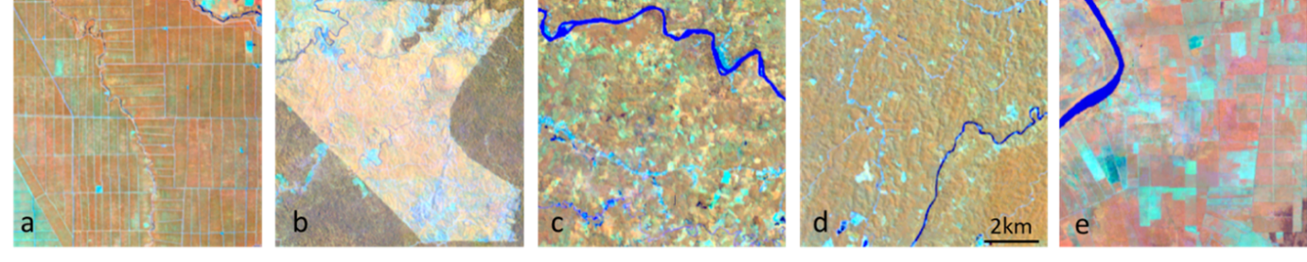
Figure S4 │ Examples of industrial and smallholder oil palm plantations seen by LANDSAT imagery (in 1:50,000 scale). Imagery displayed in false colors (RGB: Near infrared; Short-wave infrared; Red). Here, closed canopy oil palm appears brown, open-canopy oil palm has different shades of yellow/orange. forest is dark brown. Recently cleared areas and newly planted areas appear bright cyan. (a) industrial plantations on a flat surface, with harvesting trails built in straight lines and thus forming rectilinear grids. (b) Young industrial plantation on hilly terrain. (c) and (d) smallholder plantations. (e) Sometimes smallholder plantations resemble the linear structures of industrial plantations, although with less structure.

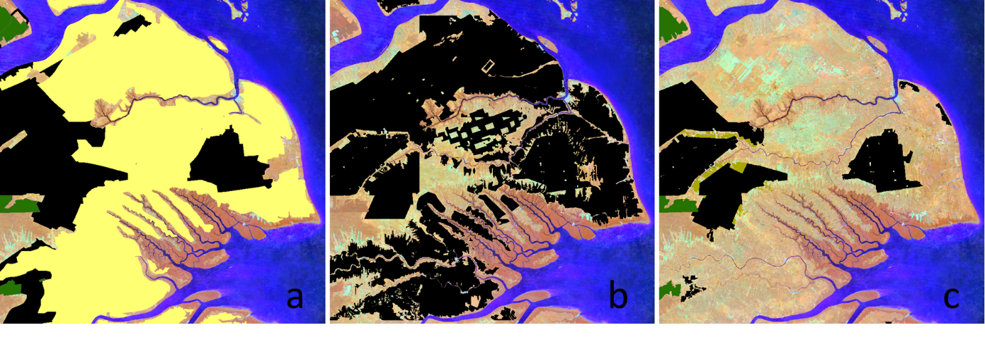
Figure S5 │ An area in Riau, Sumatra, where coconut plantations dominate the landscape, and have been misclassified as oil palm. (a) provincial government map of oil palm (black) coconut (yellow), and acacia (green). (b) Auriga oil palm base map. (c) In the final map the areas misclassified as oil palm have been removed.

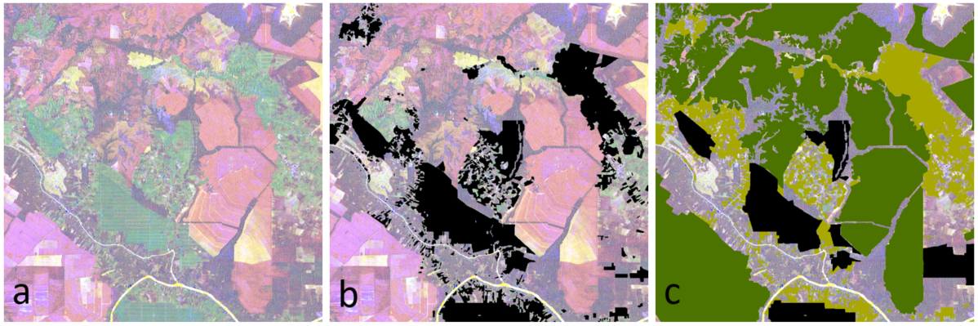
Figure S6 │ Composite Radar image for year 2019. Imagery displayed in false color composite (RGB: VV,VH,Red). (a) On this composite oil palm plantations are green because of the higher backscatter than other vegetation types in the dual cross-polarization bands (VH). (b) Auriga’s oil palm base map (black) misses several plantations (green). (c) In the final map, those missed plantations are captured after correction: industrial oil palm (black); smallholder oil palm (light green); industrial acacia plantations (dark green).

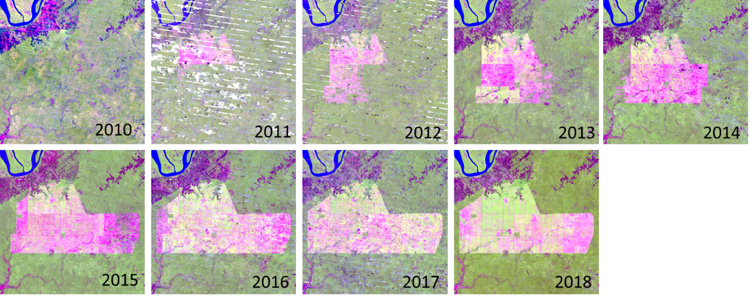
Figure S7 │ A sequence of cloud-free annual composite LANDSAT image snapshots revealing the annual expansion of an industrial plantation in Papua province, Indonesian New Guinea. Imagery displayed in false colors (RGB: Short-wave infrared: band 5; Near infrared: band 6; Red: band 4). Here, forest appears green, while recently cleared areas appear pink.

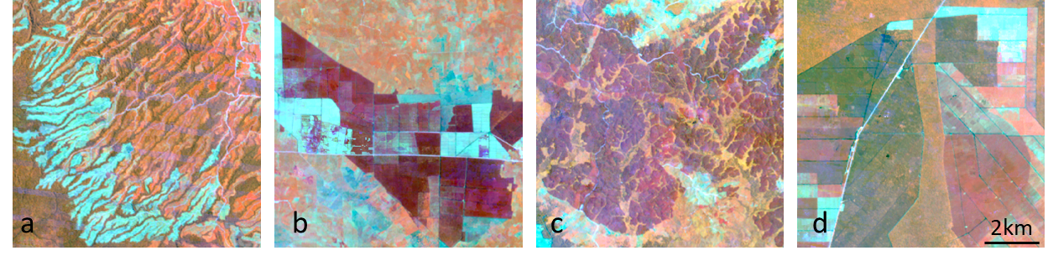
Figure S8 │ Examples of industrial pulp&paper (acacia) plantations seen by Landsat (in 1:50,000 scale). Imagery displayed in false colors (RGB: Near infrared; Short-wave infrared; Red). Closed-canopy acacia stands appear red to dark red. Recently harvested stands appear bright cyan. forest is dark brown. (a) Network of riparian forest in an acacia plantation on steep terrain. (b) a plantation on flat surface with rectilinear network of roads and canals. (c) a plantation on steep terrain with fewer forest corridors. (d) a plantation of flat peat swamps, with acacia stands of varying age, and rectilinear network of canals and roads.

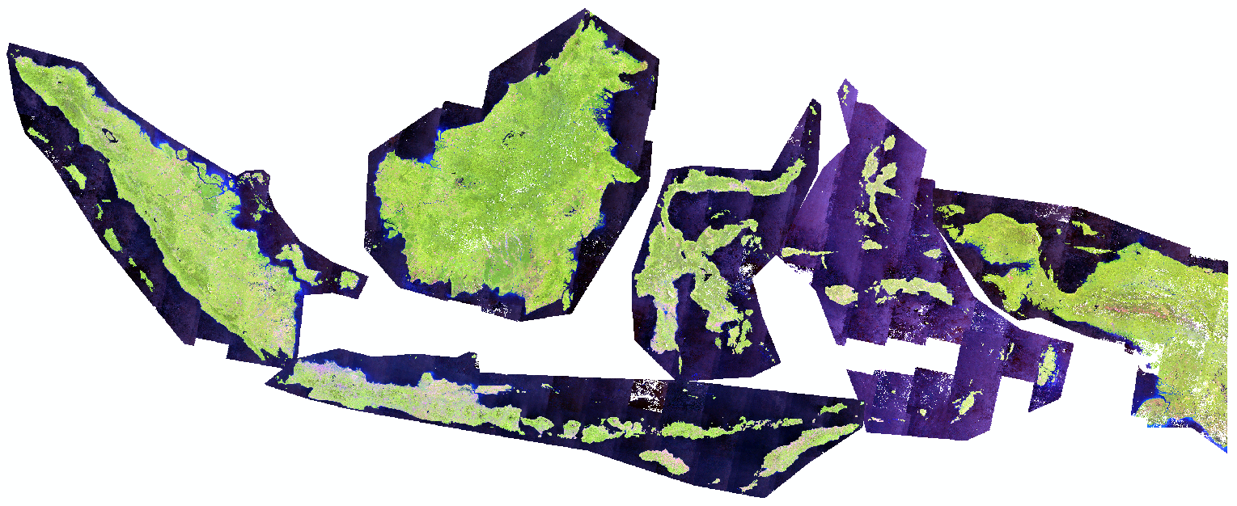
Figure S9. Cloud-free Landsat composite for year 2019, reconstructed using the median approach. Imagery displayed in false colors (RGB: Short-wave infrared: band 5; Near infrared: band 6; Red: band 4). Here, vegetation appears green, while bare land areas are pink.

