Extended Data Fig. 1 Agarose gel electrophoresis characterization for stability, binding affinity and cleavage activity of dCas9/Cas9-gRNA complexes. a, Degradation of three gRNAs (sgRNA, egRNA and fgRNA) with extended stem-loop structures (1 μM) under RNase A (20 μg/mL) treatment at 37ºC for 0.5 h. All gRNAs are highly unstable and degraded upon RNase A treatment. b, Cas9 (1 μM) mediated protection of three gRNAs (1 μM) from RNase A treatment (20 μg/mL) for different times. sgRNA exhibits the fastest degradation rate, followed by egRNA, and fgRNA, showing that Cas9 has the strongest protection for fgRNA. c, Binding of three gRNAs (200 nM) to Cas9 of different concentrations (Lane 1-7: 0, 2, 20, 200 and 300 nM, 1 and 2 μM). fgRNA has the strongest binding affinity (estimated Kd, ~88 nM) with Cas9, followed by egRNA (estimated Kd, ~127 nM) and sgRNA (estimated Kd, ~216 nM). d, Target cleavage activity for different gRNA-Cas9 complexes. Cleaved products of linearized target DNA plasmid (10 kb, 100 ng) are analyzed at different times (Lane 1-6: 0, 15, 30, 45, 60 and 120 min). fRNA-Cas9 complex has the fastest cleavage rate (complete cleavage in 30 min), followed by egRNA-Cas9 (complete cleavage in 60 min) and sgRNA-Cas9 (complete cleavage in 120 min).
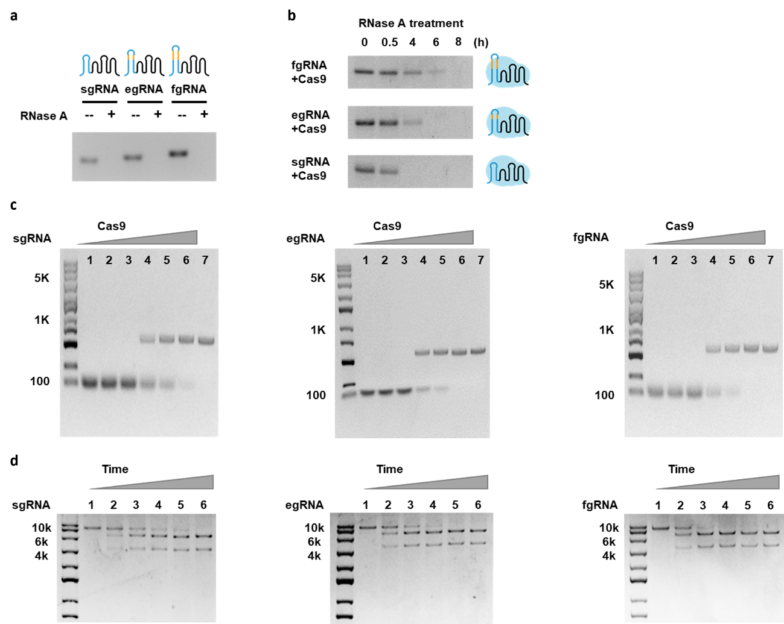

Extended Data Fig. 2 Expression levels of gRNAs in live cells. a, Schematic for three gRNAs with 3×SRB2 embedded in the tetra-loop. b, Flow cytometry profiles for MCF-7 cells in Fig. 1b. c, Comparison of flow cytometry data in b. d, ΔCt and relative expression (2^{-ΔΔCt}) obtained in qRT-PCR for three gRNAs using GAPDH as a reference with and without dCas9 co-expression. Under dCas9 co-expression, fgRNA shows the highest expression. e, Half-life of gRNAs in MCF-7 cells with dCas9 upon transcription inhibition with Act D (5 μg/mL). Fluorescence intensities (normalized by the mean intensity for fgRNA and dCas9) are shown as mean ± s.d. (n = 15 cells from three independent experiments). c,d,e, Statistical comparison is performed by two-tailed t-test, ****p < 0.0001, ***p < 0.001, **p < 0.01, *p < 0.05, n.s., not significant.
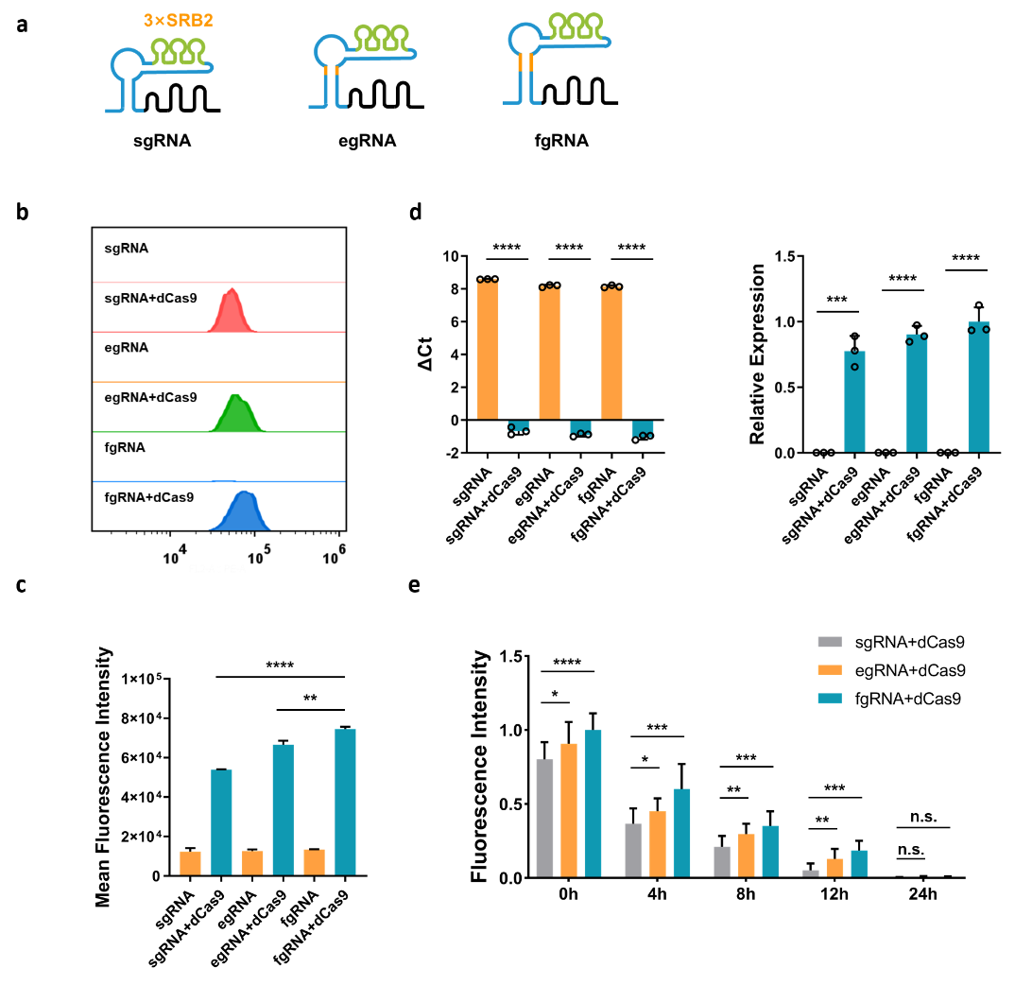

Extended Data Fig. 3 Gel electrophoresis for complex of the optimal agRNA with Cas9. a, Binding of Cas9 (200 nM) to the optimal agRNA (stem loop 2 having 13 bp complementary to the tetra loop, 200 nM). Lane 1, agRNA−Cas9 without TK1; Lane 2, agRNA−Cas9 with TK1 (200 nM). b, Degradation of agRNA (1 µM) under different conditions upon treatment with RNase A (20 μg/mL) at 37 ºC for 0.5 h. The agRNA only showed high stability in the presence of TK1 (1 µM) and Cas9 (1 µM). c, Cleavage of linearized target plasmid (10 kb into two fragments, 100 ng) by Cas9−agRNA complex versus increasing TK1 concentrations (0, 20, 40, 60, 80, 100, and 120 nM). d, Specificity of Cas9-agRNA complex to TK1 (100 nM). Lane 1, agRNA (100 nM) plus a random RNA target (100 nM); Lane 2, scrambled agRNA (stem loop 2 also having 13 bp complementary to the tetra loop, 100 nM) plus TK1; Lane 3, correctly folded gRNA without 13-bp complementation; Lane 4, agRNA plus TK1.
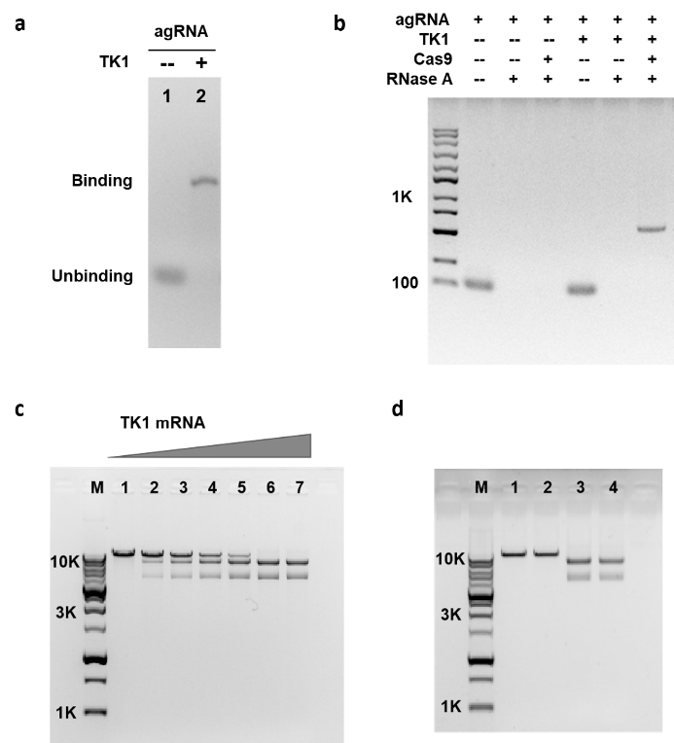

Extended Data Fig. 4 LUSTER system for subcellular RNA targeting. a, Live cell fluorescence images for MCF-7 cells transfected with the LUSTER system and target RNAs with different subcellular localizations. (i) 5S-tagged RNA localized in cytosol; (ii) ER-targeting RNA encoding a CytERM-tagged GFP; (iii) 7SK-tagged RNA localized in nucleus. Fluorescence staining of nucleus with Hoechst 33342 or coexpression of KDEL-iRFP confirmed the cytosolic, nucleic or ER localization of 5S-, 7SK-, and CytERM-labeled RNAs, respectively. A GFP protein is used as cellular interior indicator in imaging of 5S-tagged and 7SK-tagged RNAs, and this indicator is removed in imaging of ER-targeting RNA encoding the CytERM-tagged GFP. Scale bar, 5 µm. b, Specificity for the LUSTER system in imaging target RNAs with different localizations in fixed MCF-7 cells as verified by FISH probes. Scale bar, 5 µm. c, Scatter plots for SRB2 fluorescence and Cy5 fluorescence from FISH probes. PCC values between SRB2 fluorescence and Cy5 signals are all over 0.86.
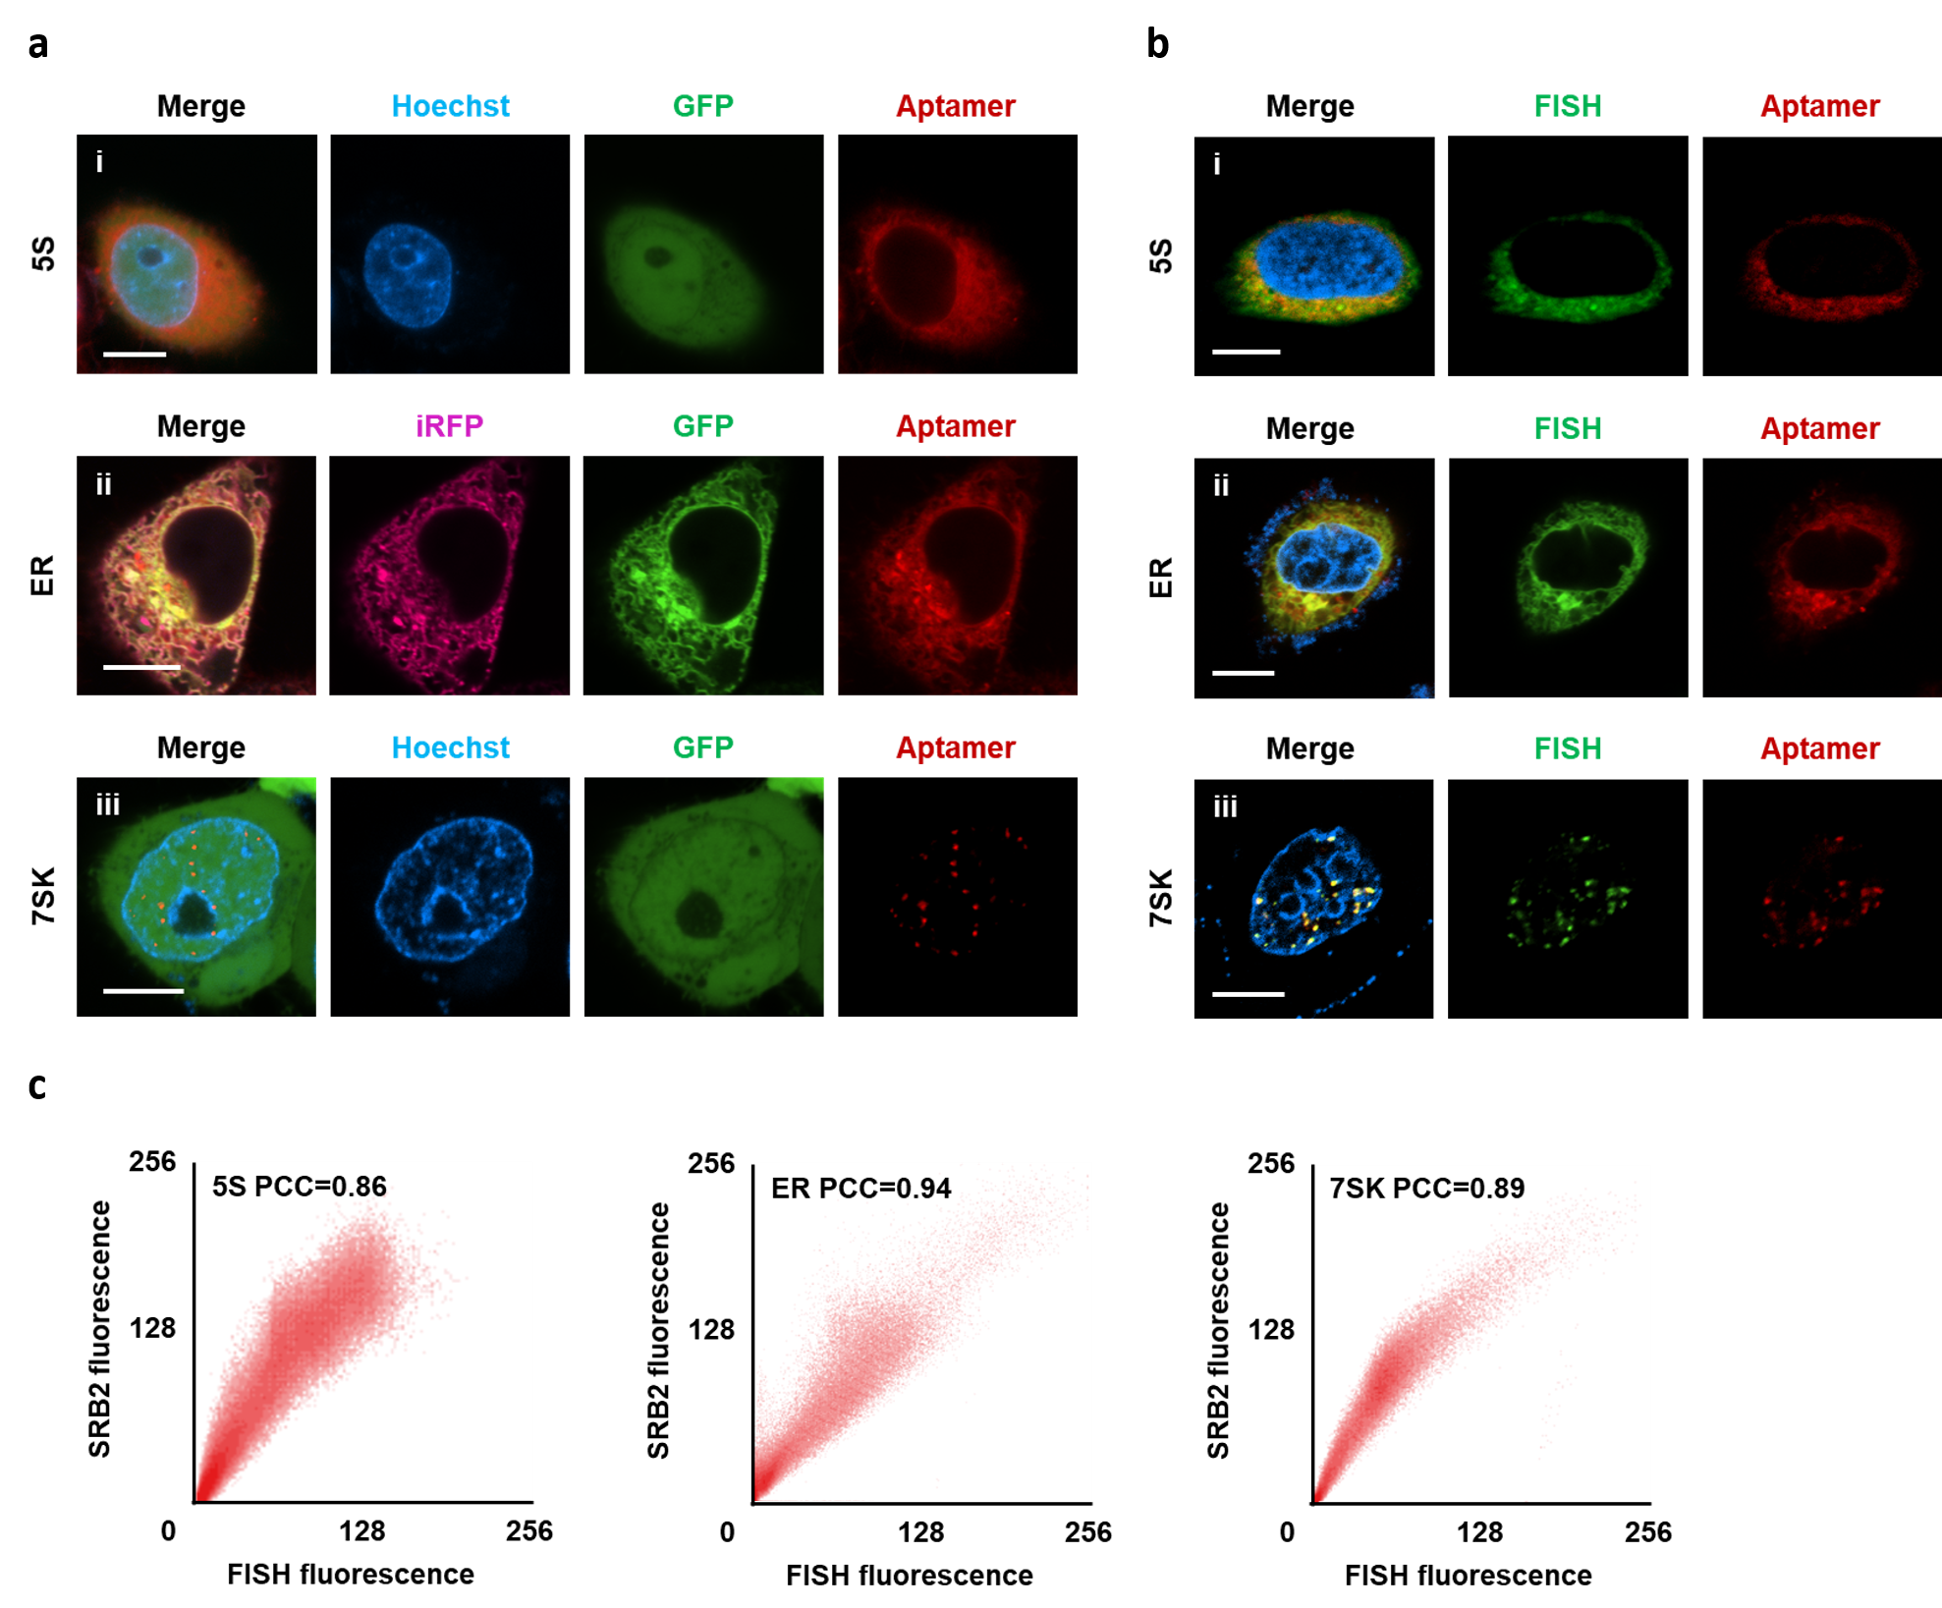

Extended Data Fig. 5 LUSTER system for triplexed RNA imaging. a, Relative expressions of c-myc and GalNAc-T mRNA in different cell lines determined by qRT-PCR using GAPDH as a reference. b, Live cell fluorescence images for different cell lines co-expressing dCas9 and agRNAs embedded with various light-up aptamers (c-myc responsive agRNA-3×Mango, TK1 responsive agRNA-3×SRB2 and GalNAc-T responsive agRNA-3×Pepper). c, Fluorescence intensities for cells in b. d, Relative expressions of c-myc, TK1 and GalNAc-T mRNAs in MCF-7 cells treated with different siRNA determined by qRT-PCR using GAPDH as a reference. e, Live cell confocal images for MCF-7 cells co-expressing dCas9 and different agRNAs (c-myc responsive agRNA-3×Mango, TK1 responsive agRNA-3×SRB2, GalNAc-T responsive agRNA-3×Pepper) under siRNA treatment. (i) c-myc siRNA; (ii) TK1 siRNA; (iii) GalNAc-T siRNA. f, Fluorescence intensities for cells in e. b,e, Representative data from three independent experiments. Scale bar, 10 µm. c,f, Intensities are shown as mean ± s.d. (n = 10 cells from three independent experiments).
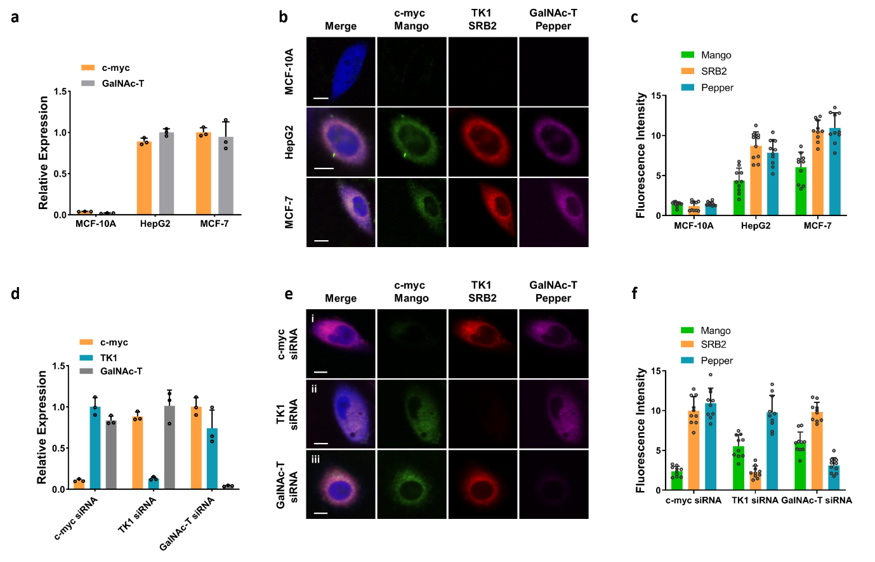

Extended Data Fig. 6 LUSTER system for signal-amplified RNA imaging. a, Live cell fluorescence images for MCF-7 cells with co-expression of dCas9 and TK1-responsive agRNA-n×SRB2 (n = 3, 6, 12, 24) for 24 h. Scale bar, 10 µm. b, Comparison of SRB2 fluorescence for cells in a. ‘-’ represents MCF-10A cells, ‘+’ represents MCF-7 cells. Intensities are shown as mean ± s.d. (n = 25 cells from three independent experiments). Fluorescence increased linearly as the number of SRB2 repeats increased from 3× to 12× followed by a gradual increase for 24×SRB2. Statistical comparison is performed by two-tailed t-test, ****p < 0.0001, ***p < 0.001. c, Flow cytometry data of MCF-7 cells transfected with dCas9 and TK1-responsive agRNA-n×SRB2 (n = 3, 6, 12, 24). The SRB2 fluorescence of individual cells was plotted against forward scattering area (FSC-A). SRB2 fluorescence gating was performed by selecting the cell subsets within black diagonal line. d, Histograms of gated SRB2 fluorescence versus cell count for MCF-7 cells analyzed in c. e, Comparison of SRB2 fluorescence in flow cytometry data in d. Statistical comparison is performed by two-tailed t-test, ****p < 0.0001, ***p < 0.001.
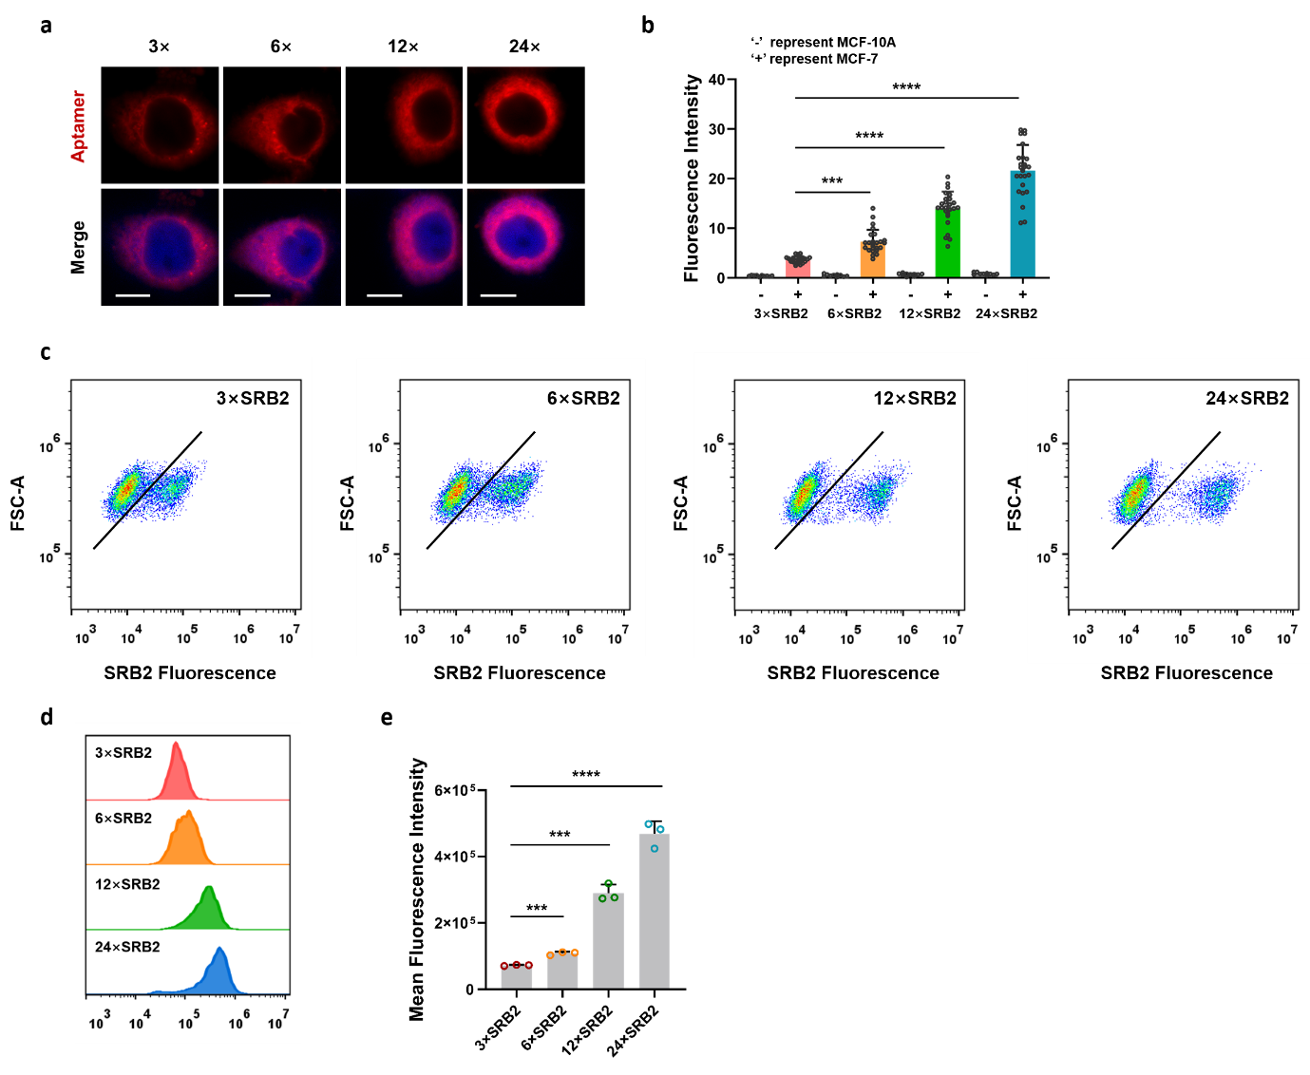

Extended Data Fig. 7 LUSTER system for exogenous RNA imaging. a, Schematic of LUSTER system for single-molecule imaging of exogenous RNA in comparison to smFISH. smFISH probes are labelled with two Cy5 fluorophores. Plasmid constructs, one for expressing exogenous RNA with complementary sequences for primary smFISH probe hybridization and the other for expressing agRNA-24×SRB2. b, Confocal and merged images for fixed MCF-7 cells expressing LUSTER systems responsive to exogenous RNA, and colocalization analysis of the SRB2 and Cy5 signals. SRB2 puncta (50 ± 9) and Cy5 puncta (58 ± 12), 10 cells from three independent experiments. White dotted lines delineate the cellular boundaries and nuclei. Zoom of selected region in the yellow box. c, Normalized fluorescence intensity profiles for SRB2 and Cy5 puncta, yielding a full width at half maximum (FWHM) of 278 ± 4 nm for SRB2 puncta and 236 ± 2 nm for Cy5 puncta, respectively. Histogram analysis for SRB2 puncta diameter (Left) and Cy5 puncta diameter (Right).
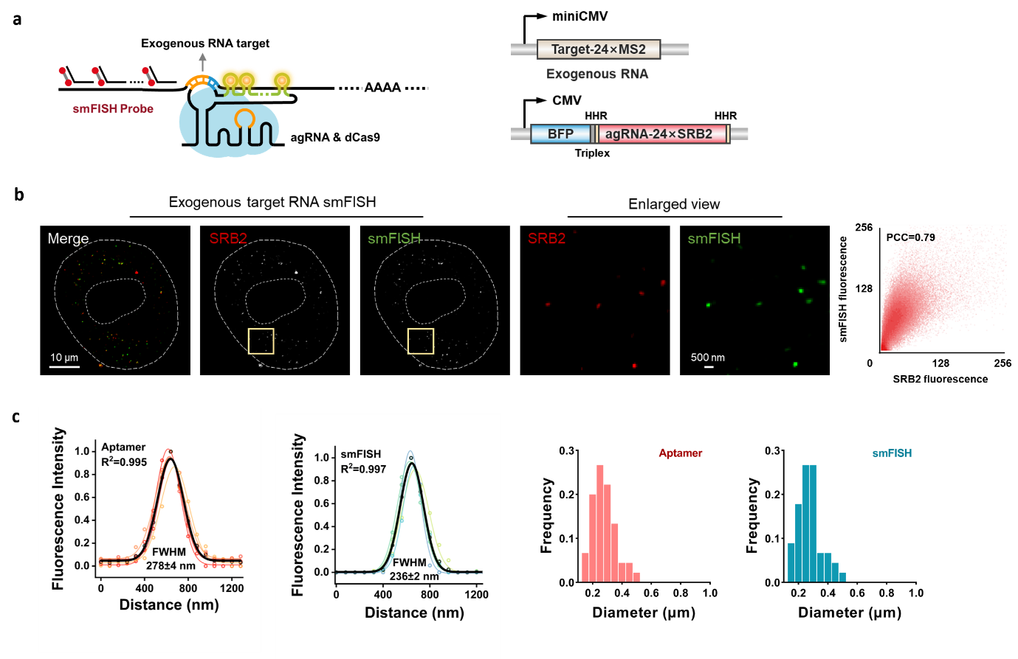

Extended Data Fig. 8 Time-lapse imaging of β-actin translocation to SGs upon stress induction. a, MCF-7 cells were cotransfected with LUSTER system and G3BP1-GFP for 24 h followed by treatment with 500 µM arsenite to induce SG formation. Live cell fluorescence images were collected at 0, 20, 30, 45, 60, 90, 120 and 150 min. Representative data from three independent experiments. Scale bar, 10 µm. b, Quantitative analysis for sizes and fluorescence intensities of SRB2 foci upon treatment with arsenite at different times. The size and intensity of SGs became stabilized at ~120 min with a typical size of 3.4 µm for SGs and ~10.8-fold fluorescence enhancement.
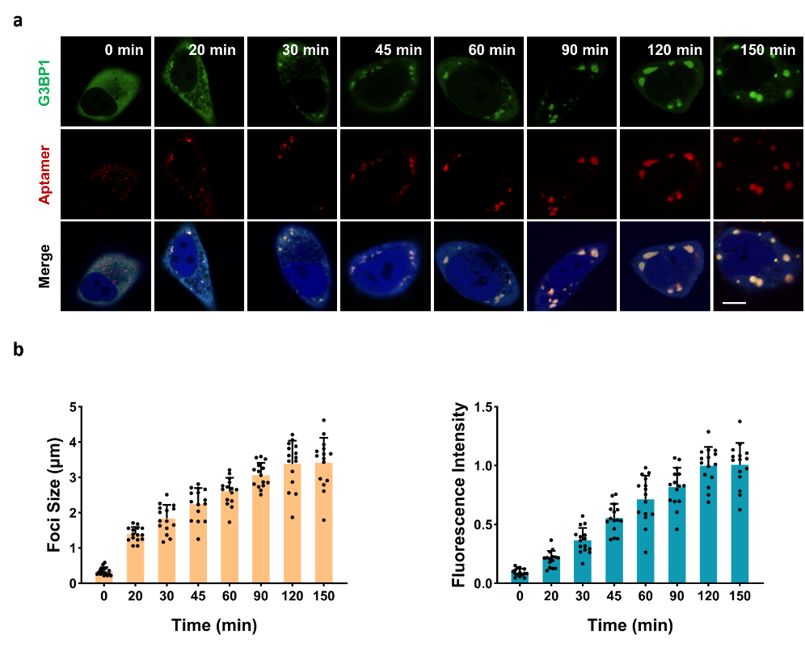

Extended Data Fig. 9 LUSTER system for NEAT1 imaging. a, Live cell images of MCF-7 cells expressing NEAT1-responsive agRNA-24×SRB2. (i) without dCas9, (ii) with dCas9 coexpression, (iii) with dCas9 coexpression and NEAT1 knockdown by siRNA. NONO-GFP is used as the paraspeckle marker. b, Quantification of NONO-GFP fluorescence and SRB2 fluorescence for cells in a. Fluorescence intensity is normalized for cells expressing NEAT1-responsive LUSTER system and shown as mean ± s.d. (n = 15 cells from three independent experiments). Statistical comparison was performed by two-tailed t-test, ****p < 0.0001, n.s., not significant. c, Z-sliced images for live MCF-7 cells cotransfected with NEAT1-responsive LUSTER system and NONO-GFP. Images are obtained through z-axis with 1 μm intervals. PCCs between GFP and SRB2 puncta are over 0.83 for all the slices. Scale bar, 10 µm. d, PCCs for different Z slices. e, Z-stacked image for c. For paraspeckle detection, each sliced images are subtracted with 2-fold of the background signal and the number of GFP-labeled paraspeckles is counted to be 20 ± 3 throughout the Z-staked images (n = 10 cells from three independent experiments). a,c,e, Representative data from three independent experiments.
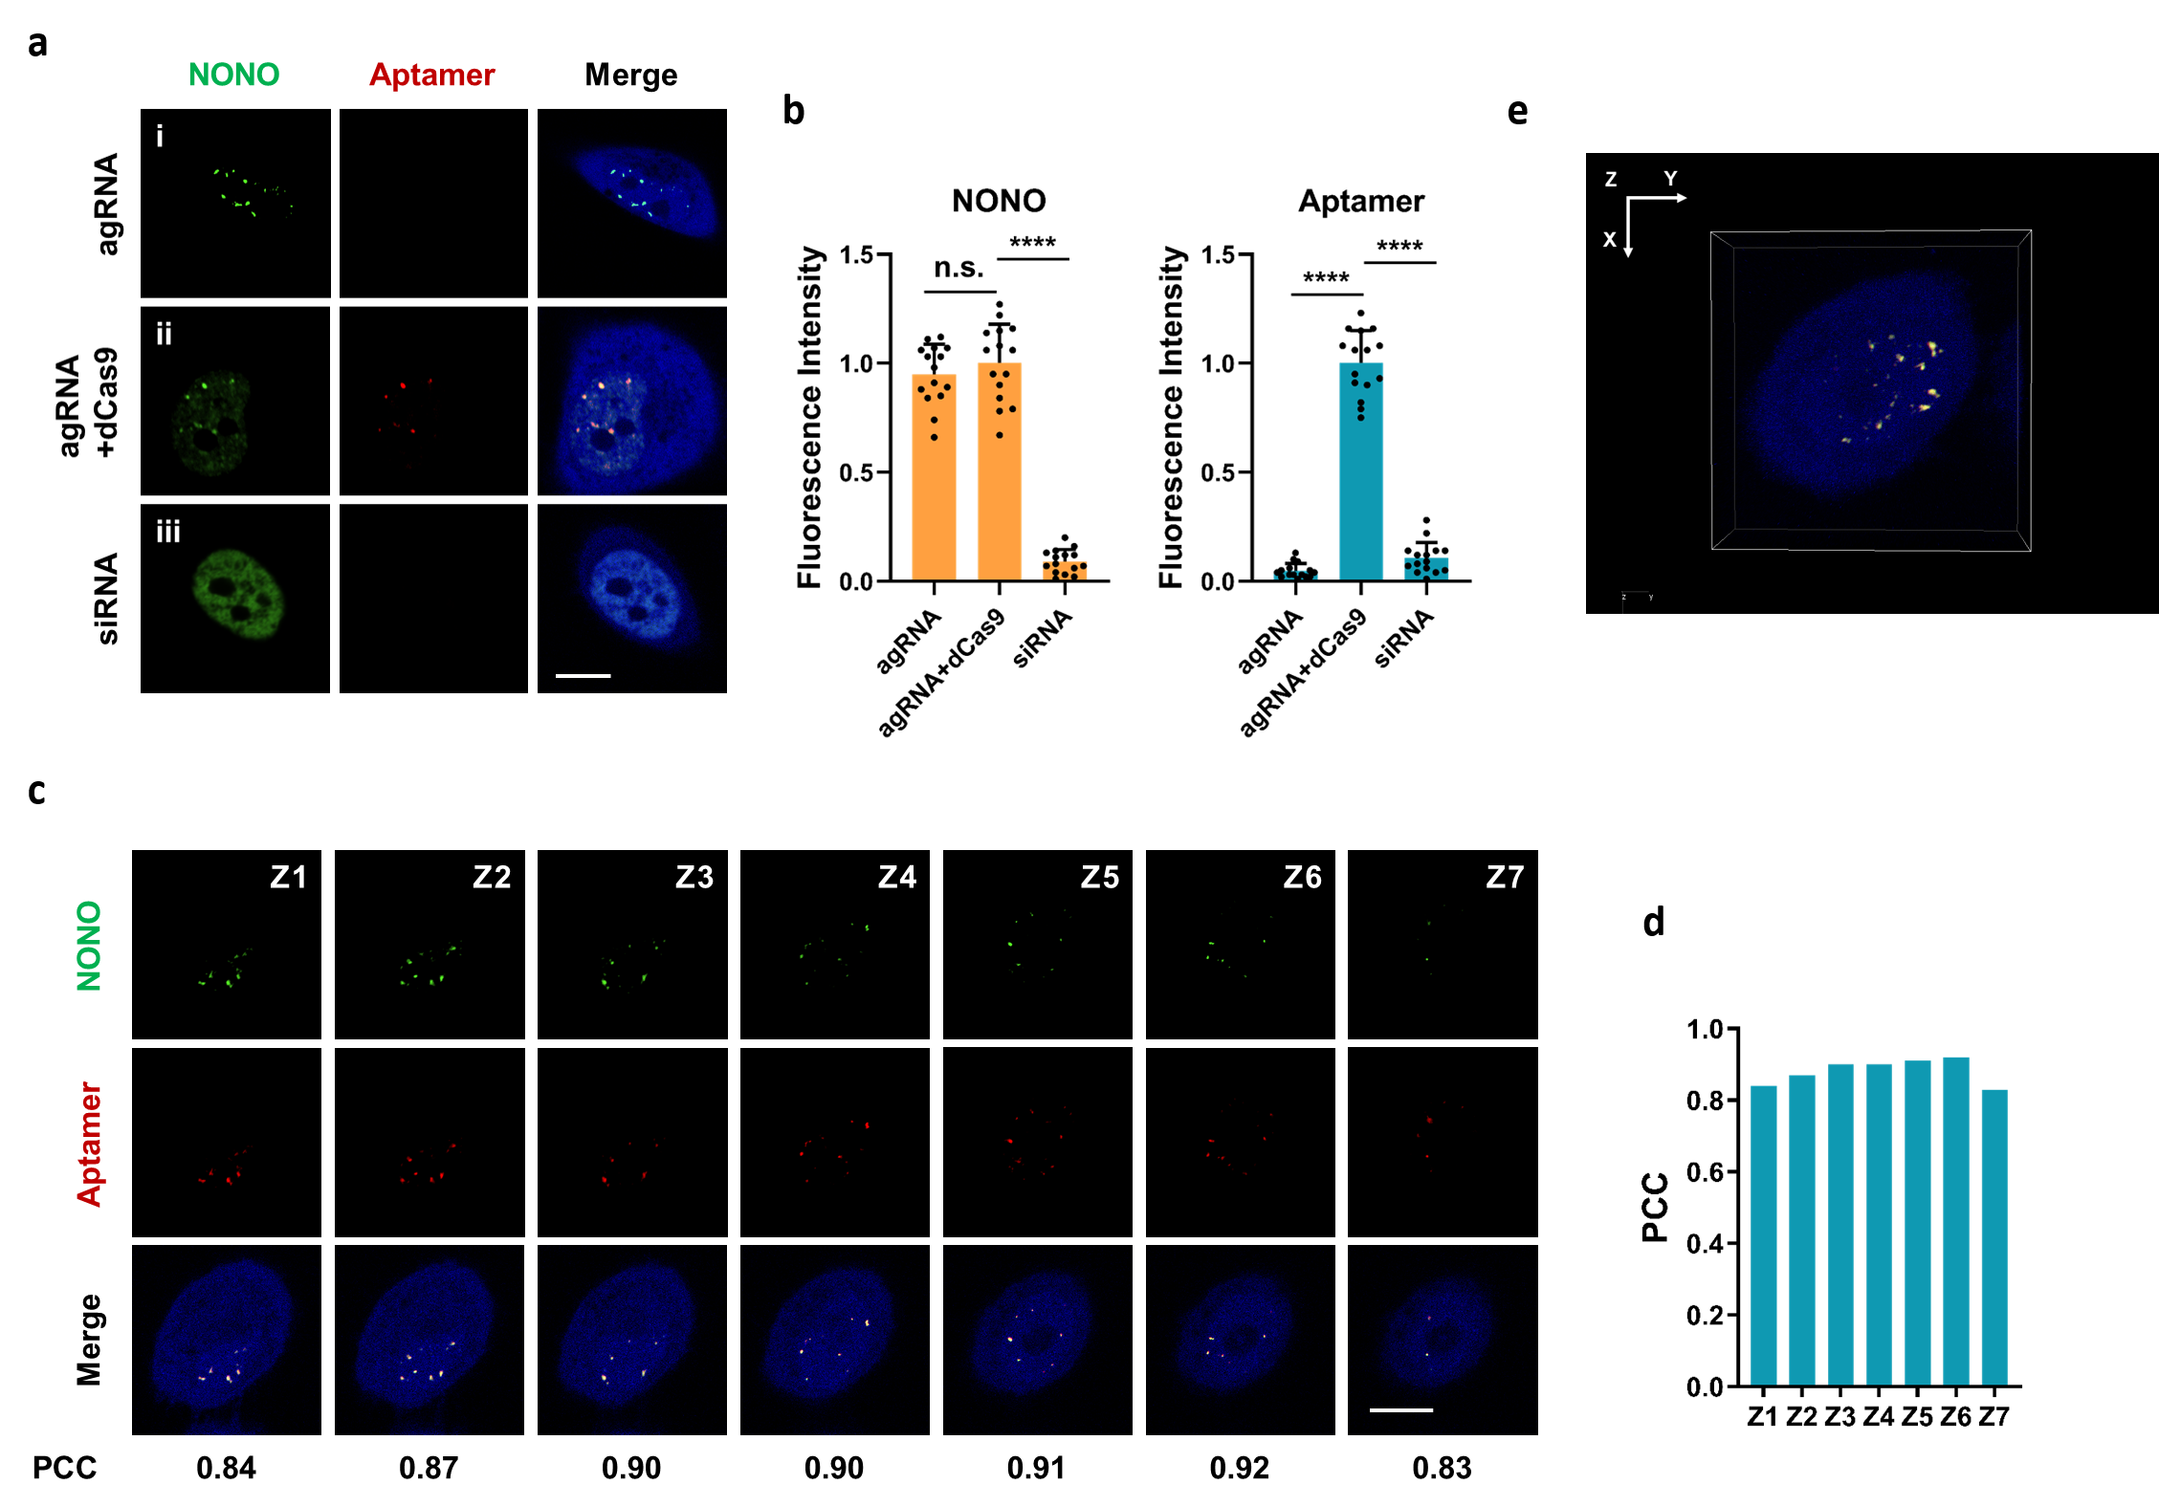

Extended Data Fig. 10 LUSTER system for imaging NEAT1 dynamics in live cells. a, Relative expressions of NEAT1 after treated for 4 h with arsenite (500 μM) or DRB (50 μM) as determined by qRT-PCR using GAPDH as a reference. Statistical comparison was performed by two-tailed t-test, *p < 0.05, n.s., not significant. b, Typical qRT-PCR amplification curves in a. c, Time-lapse images upon arsenite (500 µM) or DRB (50 μM) treatment. Representative data from three independent experiments. Scale bar, 10 µm. d, Quantitative analysis for SRB2 foci number upon treatment with arsenite or DRB at different times.
