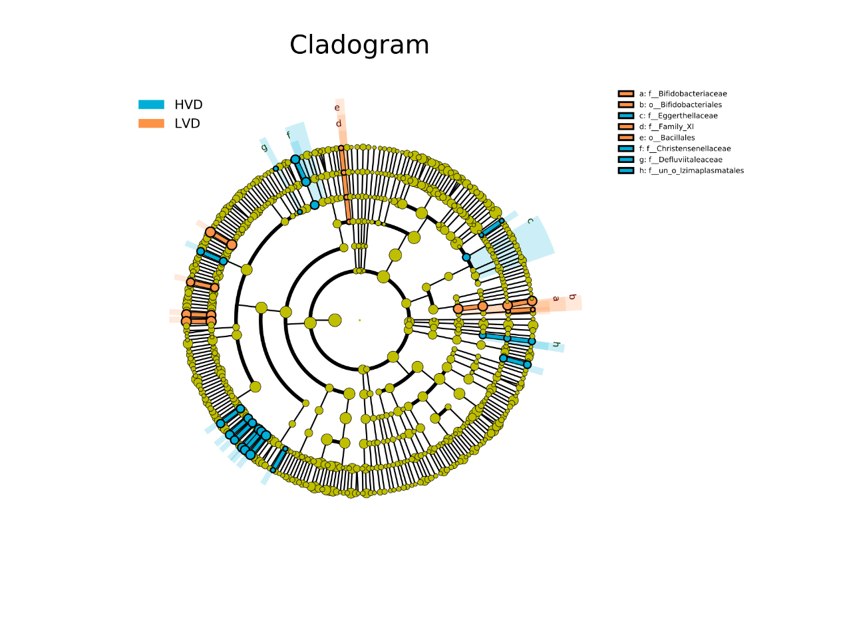
Supplementary Figure 2. The taxonomic representation of statistically and biologically differences between High 25(OH)D group and Low 25(OH)D group. The color of discriminative taxa represents the taxa is more abundant in the corresponding group (High 25(OH)D group in blue, Low 25(OH)D group in orange).

