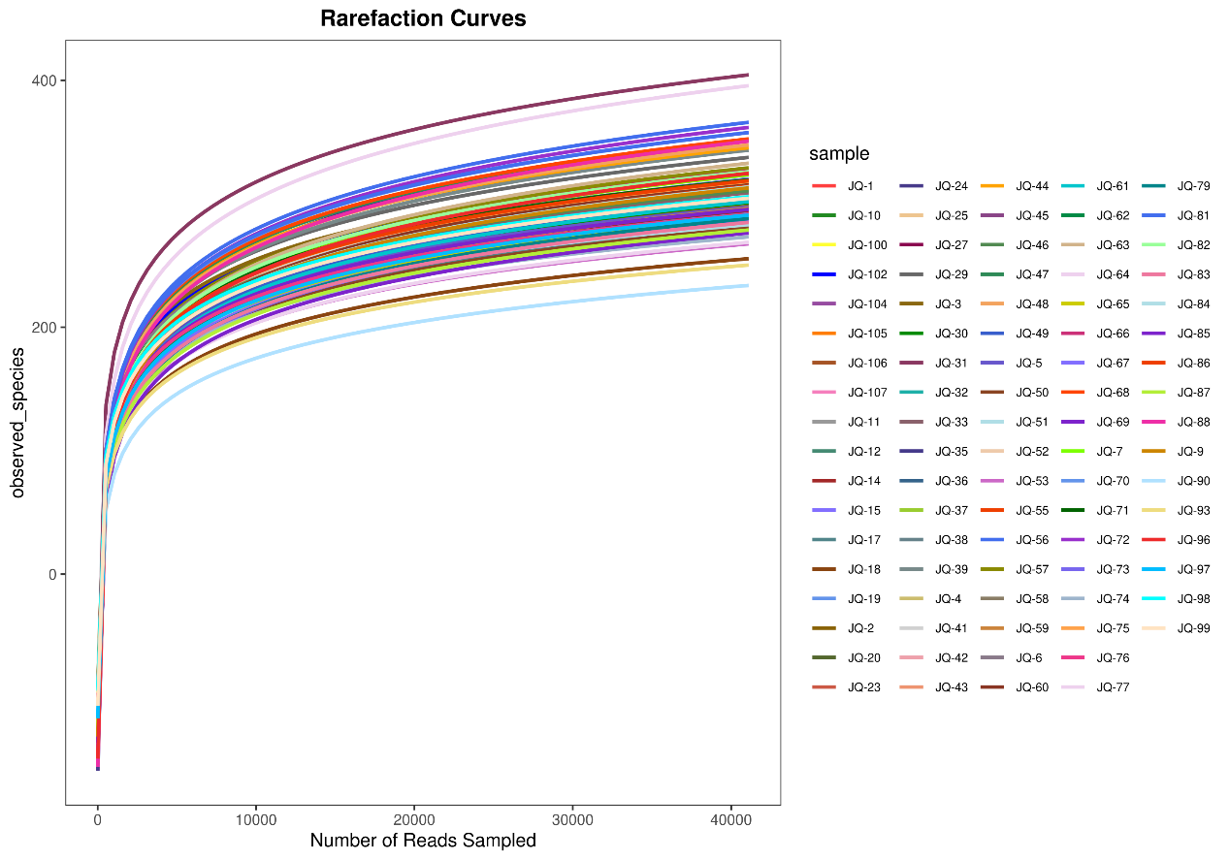
Supplementary Figure 1. Rarefaction curves in observed_species of all the samples. The rarefaction curves constructed from the sequenced data has been basically stable, indicating that the sequenced data has benn basically stable at this sequencing depth.

