Additional file 2

Additional Materials and Methods

Parameters for in vitro magnetic resonance imaging
The following acquisitions were obtained:
- T1-map (RARE VTR, TR = 15000, 8000, 4000, 2000, 1000, 600, 400, 300, 200, 120, 100, 80, 60, 40, 35, 30.6 ms, TE = 12ms, Nex1, FOV 19.2mm, Mtx 192, Slice Thickness 1mm).
- T2-map (MSME, TR = 3000ms, TE = 7.1, 14.1, 21.2, 28.3, 35.3, 42.4, 49.5 56.5 63.6 70.7 77.7 84.8 91.9 98.9 106 113.1 120.1 127.2 134.3 141.3 148.4 155.5 162.5 169.6 176.7 183.7 190.8 197.9 204.9 212 219.1 226.1 233.2 240.3 247.3 254.4 261.5 268.5 275.6 282.7, Nex 1, FOV 19.2mm, Mtx 192, Slice Thickness 1mm).
- T2*-map (MGE, TR = 100ms, TE = 2.5 5 7.5 10 12.5 15 17.5 20 22.5 25 27.5 30 32.5 35 37.5 40 42.5 45 47.5 50 52.5 55ms, Nex16, FOV 19.2mm, Mtx 192, Slice Thickness 1mm).
- T2*WI for illustration (FLASH-3D axial, TR 20ms, TE 5ms, FA 15, FOV 19.2mm x 19.2mm x 9.6mm, Matrix 384 x 384 x 182, Nex12), T2*WI (FLASH-3D horizontal, TR 20ms, TE 5ms, FA 15, FOV 19.2mm x 19.2mm x 12.8mm, Matrix 384 x 384 x 256, Nex12).

Parameters for in vivo magnetic resonance imaging
The following acquisitions were obtained:
- 3D-T2*WI (FLASH-3D: (48min, 28sek), TR 40ms, TE 5 ms, Averages: 1, FlipAngle 10, Matrix 320 x 256 x 256, FOV 40mm x 32mm x 32mm).
- 2D-T2*WI (FLASH-2D: (1min, 42sek), TR 400ms, TE 4 ms, Averages: 1, FlipAngle 10, Matrix 256 x 256, FOV 64mm x 64mm, Slices: 20, thickness: 1mm).
- 3D-FISP ((26min 24sek), TR 10.0ms, TE 5.0ms, Average: 1, Repetitions: 2, FlipAngle 16.3, Matrix 320x256x256, FOV 40mm x 32mm x 32mm, Scan Repetition time: 1380ms).
- 2D-RARE (TurboRARE-2D: (5min 20 sek), TR 5000ms, TE 16.86ms, Average: 1, Matrix 320x256, FOV 40mm x 32mm, 40 slices 0.5mm slice thickness, Scan Repetition time: 467ms, RARE factor: 4, Echo spacing: 8.431ms).
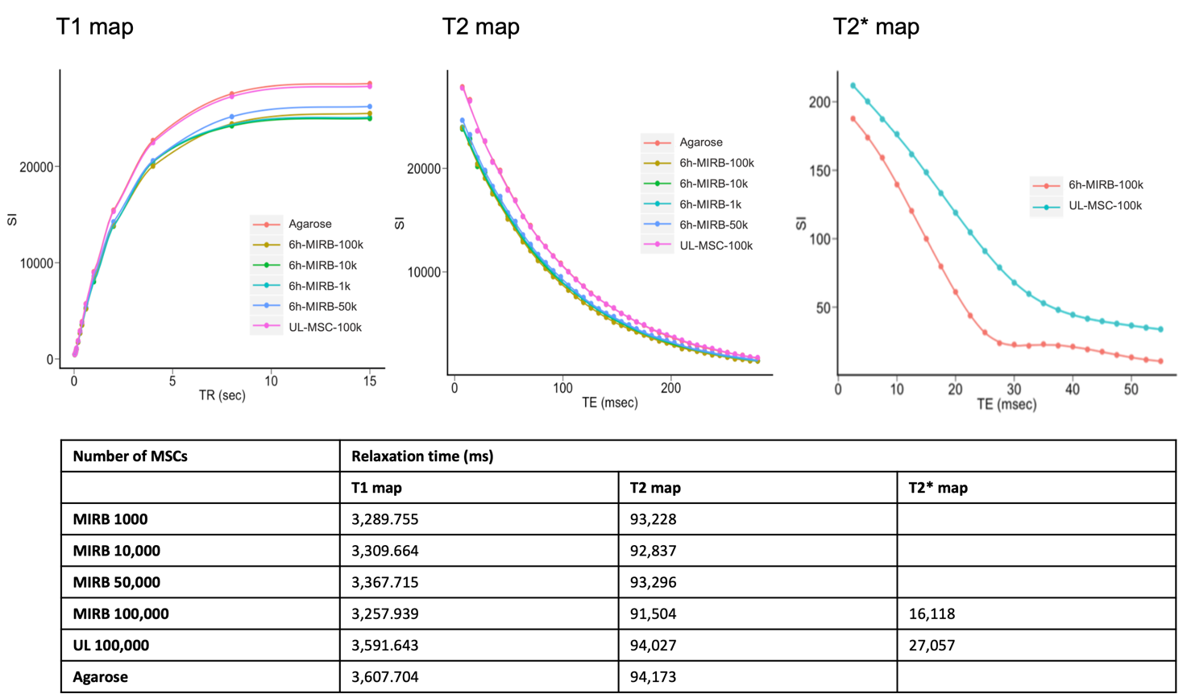

Supplementary figure 2: T1 map, T2 map and T2* map MRI of agarose phantoms containing different concentrations of MIRB-labeled integrin α10-MSC. The T2* sequence produced the greatest contrast between labeled and unlabeled integrin α10-MSCs, whereas T1W and T2W sequences produced very little contrast.

