Supplementary Information

Evolutionary analyses of Georgian Rabies Lyssavirus strains and their genetically most closely related conspecifics from elsewhere provide evidence suggesting risks for dog-to-cattle rabies transmission as well as this disease coinfections and transborder transmission

Leila Tabatadze ¹, Ekaterine Gabashvili ^{1, 2†}, Saba Kobakhidze ^{1, 2}, George Lomidze ³, Jimsher Loladze⁴, Levan Tsitskishvili ⁵, Mamuka Kotetishvili ^{6*}.

¹Division of Risk Assessment, Scientific-Research Center of Agriculture, 6 Marshal Gelovani ave. 0159, Tbilisi, Georgia.
²Bioinformatics core, Scientific-Research Center of Agriculture, 6 Marshal Gelovani ave. 0159, Tbilisi, Georgia.
³Scientific-Research Group, Scientific-Research Center of Agriculture, 6 Marshal Gelovani ave. 0159, Tbilisi, Georgia.
⁴Department of Livestock Breeding, Veterinary and Forage Production, Scientific-Research Center of Agriculture, 6 Marshal Gelovani ave. 0159, Tbilisi, Georgia.
⁵Division of Veterinary Research, Department of Livestock Breeding, Veterinary and Forage Production, Scientific-Research Center of Agriculture, 6 Marshal Gelovani ave. 0159, Tbilisi, Georgia.
⁶G. Natadze Scientific-Research Institute of Sanitary, Hygiene and Medical Ecology, 78 D. Uznadze St. 0102, Tbilisi, Georgia.
*Corresponding author: m.kotetishvili@hygienege.onmicrosoft.com
ORCID #: 0000-0002-3882-0878

Table S1. The GenBank accession numbers, designations, the STs, as well as the hosts and the regions of isolation of the Georgia RABV strains
# | GenBank accession No. | Strain | ST | Isolation source | Country region | Collection date
1 | MT079904.1 | A163209 | ST1 | Dog | Imereti | 18-Mar-2015
2 | MT079891.1 | A16-3196 | ST1 | Dog | Imereti | 7-Oct-15
3 | MT079920.1 | A16-3225 | ST1 | Dog | Imereti | 9-Jul-2015
4 | MT079921.1 | A16-3226 | ST1 | Dog | Imereti | 14-Jul-2015
5 | MT079947.1 | A17-2338 | ST1 | Cattle | Imereti | 8-Jun-2015
6 | MT079952.1 | A17-2343 | ST1 | Cattle | Imereti | 8-Feb-2016
7 | MW055110.1 | A16-3225 | ST1 | Dog | N/A | 2016
8 | MT079948.1 | A17-2339 | ST2 | Cattle | Imereti | 8-Jun-2015
9 | MT079941.1 | A17-2332 | ST3 | Cattle | Samegrelo-Zemo Svaneti | 16-May-2015
10 | MT079938.1 | A17-2329 | ST4 | Cattle | Guria | 2-Nov-2015
11 | MT079946.1 | A17-2337 | ST4 | Cattle | Imereti | 20-May-2015
12 | MT079945.1 | A17-2336 | ST4 | Cattle | Guria | 20-May-2015
13 | MT079943.1 | A17-2334 | ST4 | Cattle | Guria | 20-May-2015
14 | MT079944.1 | A17-2335 | ST4 | Cattle | Guria | 20-May-2015
15 | MT079942.1 | A17-2333 | ST4 | Cattle | Samegrelo-Zemo Svaneti | 16-May-2015
16 | MT079937.1 | A17-2328 | ST5 | Cattle | Samegrelo-Zemo Svaneti | 13-May-2015
17 | MT079929.1 | A17-2320 | ST6 | Cattle | Samegrelo-Zemo Svaneti | 2-Mar-2015
18 | MT079934.1 | A17-2325 | ST7 | Cattle | Guria | 29-Apr-2015
19 | MT079933.1 | A17-2324 | ST7 | Cattle | Guria | 7-Oct-2015
20 | MT079916.1 | A16-3221 | ST7 | Dog | Imereti | 8-Jun-2015
21 | MT079925.1 | A16-3230 | ST7 | Dog | Imereti | 25-Aug-2015
22 | MT079895.1 | A16-3200 | ST7 | Dog | Imereti | 11-Nov-2015
23 | MT079936.1 | A17-2327 | ST7 | Cattle | Guria | 6-May-2015
24 | MT079914.1 | A16-3219 | ST7 | Dog | Imereti | 19-May-2015
25 | MT079931.1 | A17-2322 | ST7 | Cattle | Samegrelo-Zemo Svaneti | 20-Apr-2015
26 | MT079953.1 | A17-2344 | ST8 | Cattle | Guria | 19-Jun-2016
27 | MT079922.1 | A16-3227 | ST9 | Dog | Imereti | 14-Jul-2015
28 | MT079911.1 | A16-3216 | ST10 | Dog | Imereti | 27-Apr-2015
29 | MT079910.1 | A16-3215 | ST11 | Dog | Shida Kartli | 22-Apr-2015
30 | MT079939.1 | A17-2330 | ST11 | Cattle | Mtskheta-mtianeti | 3-Nov-2015
31 | MT079889.1 | A16-3194 | ST11 | Dog | Kvemo Kartli | 25-Sep-15
32 | MT079893.1 | A16-3198 | ST12 | Dog | Tbilisi | 28-Oct-15
33 | MT079913.1 | A16-3218 | ST13 | Dog | Shida Kartli | 11-May-2015
34 | MT079912.1 | A16-3217 | ST13 | Dog | Shida Kartli | 28-Apr-2015
35 | MT079932.1 | A17-2323 | ST14 | Cattle | Kakheti | 23-Apr-2015
36 | MT079915.1 | A16-3220 | ST15 | Dog | Kakheti | 29-May-2015
37 | MT079897.1 | A16-3202 | ST16 | Dog | Kvemo Kartli | 16-Dec-2015
38 | MT079894.1 | A16-3199 | ST17 | Dog | Tbilisi | 9-Nov-2015
39 | MT079927.1 | A16-3232 | ST18 | Dog | Kvemo Kartli | 4-Sep-2015
40 | MT079898.1 | A16-3203 | ST19 | Dog | Tbilisi | 1-Feb-2016
41 | MT079892.1 | A16-3197 | ST20 | Dog | Guria | 16-Oct-2015
42 | MT079955.1 | A17-2346 | ST21 | Cattle | Kvemo Kartli | 20-Jul-2016
43 | MT079902.1 | A16-3207 | ST22 | Dog | Kvemo Kartli | 12-Mar-2015
44 | MW055109.1 | A16-3193 | ST22 | Golden jackal | N/A | 2016
45 | MT079888.1 | A16-3193 | ST22 | Jackal | Tbilisi | 24-Nov-2015
46 | MT079890.1 | A16-3195 | ST23 | Dog | Kvemo Kartli | 1-Jan-2015
47 | MT079950.1 | A17-2341 | ST24 | Cattle | Kakheti | 2-Feb-2016
48 | MT079896.1 | A16-3201 | ST25 | Dog | Kakheti | 10-Dec-2015
49 | MT079928.1 | A16-3233 | ST26 | Dog | Kakheti | 7-Sep-2015
50 | MT079905.1 | A16-3210 | ST27 | Dog | Tbilisi | 23-Mar-2015
51 | MT079909.1 | A16-3214 | ST27 | Dog | Kakheti | 16-Apr-2015
52 | MT079907.1 | A16-3212 | ST28 | Dog | Imereti | 31-Mar-2015
53 | MT079930.1 | A17-2321 | ST29 | Cattle | Adjara | 20-Apr-2015
54 | MT079903.1 | A16-3208 | ST29 | Dog | Guria | 16-Mar-2015
55 | MT079901.1 | A16-3206 | ST29 | Dog | Adjara | 24-Feb-2015
56 | MT079924.1 | A16-3229 | ST30 | Dog | Adjara | 31-Jul-2015
57 | MT079919.1 | A16-3224 | ST30 | Dog | Adjara | 2-Jul-2015
58 | MW055111.1 | A16-3224 | ST30 | Dog | N/A | 2016
59 | MT079923.1 | A16-3228 | ST31 | Dog | Adjara | 16-Jul-2015
60 | MT079917.1 | A16-3222 | ST32 | Dog | Shida Kartli | 23-Jun-2015
61 | MT079954.1 | A17-2345 | ST33 | Cattle | Guria | 22-Jun-2016
62 | MT079951.1 | A17-2342 | ST34 | Cattle | Samegrelo-Zemo Svaneti | 2-Feb-2016
63 | MT079906.1 | A16-3211 | ST35 | Dog | Samegrelo-Zemo Svaneti | 24-Mar-2015
64 | MT079926.1 | A16-3231 | ST35 | Dog | Samegrelo-Zemo Svaneti | 31-Aug-2015
65 | MT079900.1 | A16-3205 | ST36 | Dog | Samegrelo-Zemo Svaneti | 2-Mar-2016
66 | MT079940.1 | A17-2331 | ST37 | Cattle | Samegrelo-Zemo Svaneti | 15-May-2015
67 | MT079899.1 | A16-3204 | ST37 | Dog | Samegrelo-Zemo Svaneti | 16-Feb-2016
68 | MT079908.1 | A16-3213 | ST38 | Dog | Kakheti | 14-Apr-2015
69 | MT079918.1 | A16-3223 | ST39 | Dog | Kakheti | 26-Jun-2015
70 | MT079949.1 | A17-2340 | ST40 | Cattle | Kakheti | 15-Jun-2015
71 | MT079935.1 | A17-2326 | ST40 | Cattle | Kakheti | 6-May-2015
72 | MW055108.1 | A16-3223 | ST41 | Dog | N/A | 2016

Table S2. The designation of strains most closely related to the RABV STs determined for the isolates from Georgia, their isolation sources and regions, as well as their N gene loci DNA identity values determined using the BLAST analysis.

 | Strain GenBank acc. # | Strain designation | Source of strain isolation | Country of strain isolation | DNA-DNA identity %
ST1 | KY860610.1 | RV1133 | Dog | Turkey | 99.63
ST1 | AY352497.1 | RV308 | Human | N/A | 99.63
ST2 | KY860610.1 | RV1133 | Dog | Turkey | 99.56
ST2 | AY352497.1 | RV308 | Human | N/A | 99.56
ST3 | KY860610.1 | RV1133 | Dog | Turkey | 99.63
ST3 | AY352497.1 | RV308 | Human | N/A | 99.63
ST4 | KY860610.1 | RV1133 | Dog | Turkey | 99.70
ST4 | AY352497.1 | RV308 | Human | N/A | 99.70
ST5 | KY860610.1 | RV1133 | Dog | Turkey | 99.41
ST5 | AY352497.1 | RV308 | Human | N/A | 99.41
ST6 | KY860610.1 | RV1133 | Dog | Turkey | 99.48
ST6 | AY352497.1 | RV308 | Human | N/A | 99.48
ST7 | KY860610.1 | RV1133 | Dog | Turkey | 99.70
ST7 | AY352497.1 | RV308 | Human | N/A | 99.70
ST8 | AY352497.1 | RV308 | Human | N/A | 99.78
ST8 | KY860610.1 | RV1133 | Dog | Turkey | 99.63
ST9 | KY860610.1 | RV1133 | Dog | Turkey | 99.33
ST9 | AY352497.1 | RV308 | Human | N/A | 99.33
ST10 | KY860610.1 | RV1133 | Dog | Turkey | 99.41
ST10 | AY352497.1 | RV308 | Human | N/A | 99.41
ST11 | KY860610.1 | RV1133 | Dog | Turkey | 99.26
ST11 | AY352497.1 | RV308 | Human | N/A | 99.26
ST12 | KY860610.1 | RV1133 | Dog | Turkey | 99.19
ST12 | AY352497.1 | RV308 | Human | N/A | 99.19
ST13 | KY860610.1 | RV1133 | Dog | Turkey | 99.19
ST13 | AY352497.1 | RV308 | Human | N/A | 99.19
ST14 | KY860610.1 | RV1133 | Dog | Turkey | 99.56
ST14 | AY352497.1 | RV308 | Human | N/A | 99.56
ST15 | KY860610.1 | RV1133 | Dog | Turkey | 99.41
ST15 | AY352497.1 | RV308 | Human | N/A | 99.41
ST16 | KY860610.1 | RV1133 | Dog | Turkey | 99.33
ST16 | AY352497.1 | RV308 | Human | N/A | 99.33
ST17 | KY860610.1 | RV1133 | Dog | Turkey | 99.26
ST17 | AY352497.1 | RV308 | Human | N/A | 99.26
ST18 | KY860610.1 | RV1133 | Dog | Turkey | 99.41
ST18 | AY352497.1 | RV308 | Human | N/A | 99.41
ST19 | KY860610.1 | RV1133 | Dog | Turkey | 99.26
ST19 | AY352497.1 | RV308 | Human | N/A | 99.26
ST20 | KY860610.1 | RV1133 | Dog | Turkey | 99.33
ST20 | AY352497.1 | RV308 | Human | N/A | 99.33
ST21 | KY860610.1 | RV1133 | Dog | Turkey | 99.11
ST21 | AY352497.1 | RV308 | Human | N/A | 99.11
ST22 | KY860610.1 | RV1133 | Dog | Turkey | 99.41
ST22 | AY352497.1 | RV308 | Human | N/A | 99.41
ST23 | KY860610.1 | RV1133 | Dog | Turkey | 99.48
ST23 | AY352497.1 | RV308 | Human | N/A | 99.48
ST24 | KY860610.1 | RV1133 | Dog | Turkey | 99.48
ST24 | AY352497.1 | RV308 | Human | N/A | 99.48
ST25 | KY860610.1 | RV1133 | Dog | Turkey | 99.41
ST25 | AY352497.1 | RV308 | Human | N/A | 99.41
ST26 | KY860610.1 | RV1133 | Dog | Turkey | 99.56
ST26 | AY352497.1 | RV308 | Human | N/A | 99.56
ST27 | KY860610.1 | RV1133 | Dog | Turkey | 99.48
ST27 | AY352497.1 | RV308 | Human | N/A | 99.48
ST28 | KY860610.1 | RV1133 | Dog | Turkey | 99.41
ST28 | AY352497.1 | RV308 | Human | N/A | 99.41
ST29 | KY860610.1 | RV1133 | Dog | Turkey | 99.85
ST29 | AY352497.1 | RV308 | Human | N/A | 99.70
ST30 | KY860610.1 | RV1133 | Dog | Turkey | 99.70
ST30 | AY352497.1 | RV308 | Human | N/A | 99.56
ST31 | KY860610.1 | RV1133 | Dog | Turkey | 99.70
ST31 | AY352497.1 | RV308 | Human | N/A | 99.56
ST32 | KY860610.1 | RV1133 | Dog | Turkey | 99.78
ST32 | AY352497.1 | RV308 | Human | N/A | 99.63
ST33 | KY860610.1 | RV1133 | Dog | Turkey | 99.78
ST33 | AY352497.1 | RV308 | Human | N/A | 99.63
ST34 | AY352497.1 | RV308 | Human | N/A | 99.85
ST34 | KY860610.1 | RV1133 | Dog | Turkey | 99.70
ST35 | AY352497.1 | RV308 | Human | N/A | 99.93
ST35 | KY860610.1 | RV1133 | Dog | Turkey | 99.78
ST35 | JQ944706.1 | 1352KRA | Dog | Russia | 99.78
ST35 | KF155000.1 | RV2516 | Cow | Iraq | 99.04
ST35 | MK760760.1 | 93-A-45 | Dog | Iran | 98.89
ST35 | MK760690.1 | 88-331 | Dog | Iran | 98.89
ST35 | KX148212.1 | 93019IRA | Jackal | Iran | 98.30
ST35 | JX987746.1 | 9319IRA | jackal | Iran | 98.30
ST35 | MK760766.1 | 94-A-29 | Dog | Iran | 97.85
ST35 | DQ837474.1 | cow/T1/2000 | Cow | Turkey | 98.89
ST35 | MK760676.1 | 87-375 | Dog | Iran | 98.67
ST35 | MK760757.1 | 93-A-311 | Dog | Iran | 98.67
ST35 | MK760679.1 | 87-44 | Dog | Iran | 98.81
ST35 | MK760682.1 | 88-13 | Dog | Iran | 98.81
ST35 | MK760675.1 | 87-327 | Dog | Iran | 99.04
ST35 | MK760684.1 | 88-2 | Dog | Iran | 98.89
ST35 | MK760756.1 | 93-A-305 | Dog | Iran | 98.89
ST35 | MK760747.1 | 93-A-182 | Wolf | Iran | 98.81
ST36 | AY352497.1 | RV308 | Human | N/A | 99.85
ST36 | KY860610.1 | RV1133 | Dog | Turkey | 99.70
ST37 | AY352497.1 | RV308 | Human | N/A | 99.78
ST37 | KY860610.1 | RV1133 | Dog | Turkey | 99.63
ST38 | LN879480.1 | 5989/lib205/12 | Dog | Azerbaijan | 99.56
ST38 | KY765901.1 | Tajik FTA | Dog | Tajikistan | 98.07
ST39 | LN879480.1 | 5989/lib205/12 | Dog | Azerbaijan | 99.56
ST39 | KY765901.1 | Tajik FTA | Dog | Tajikistan | 98.07
ST39 | MK598340.1 | 12496 | Red fox | Hungary | 96.74
ST40 | LN879480.1 | 5989/lib205/12 | Dog | Azerbaijan | 99.33
ST40 | KY765901.1 | Tajik FTA | Dog | Tajikistan | 97.93
ST41 | LN879480.1 | 5989/lib205/12 | Dog | Azerbaijan | 99.33
ST41 | KY765901.1 | Tajik FTA | Dog | Tajikistan | 97.93

Table S3. The maximum composite likelihood estimates of the pattern of nucleotide substitutions determined for the RABV N gene loci

 | A | T (U) | C | G
A | - | 1.78 | 1.39 | 14.35
T (U) | 2.01 | - | 23.71 | 1.59
C | 2.01 | 30.3 | - | 1.59
G | 18.09 | 1.78 | 1.39 | -
For simplicity, the sum of r values is made equal to 100. Rates of different ti substitutions are shown in bold and those of tv substitutions are shown in italics.

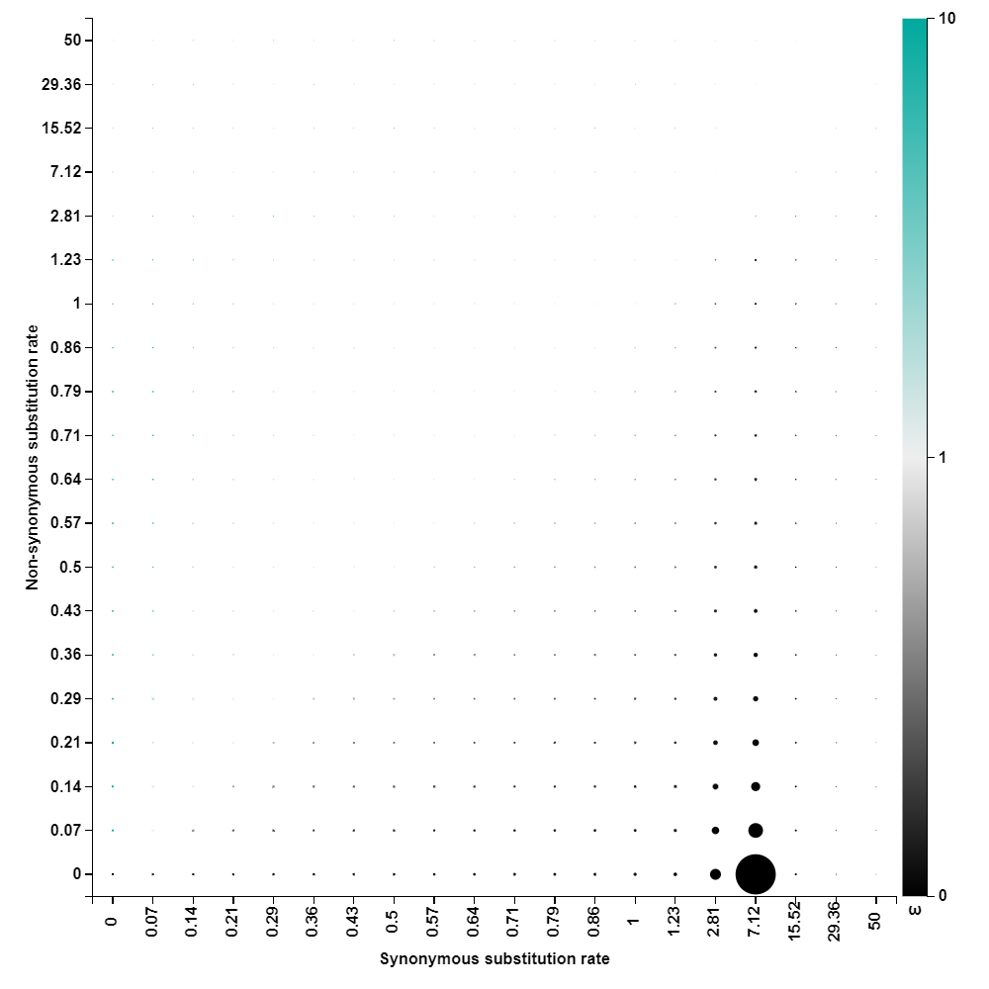

Fig. S1. The FUBAR-generated plot of the d_{N} versus d_{S} substitutions rates separately, as well as the d_{N}/d_{S} ratios (ա), determined for the N gene loci of the RABV populations.

Fig. S2. The SimPlot-determined genetic recombination hotspots across the N gene loci of the local RABV strains and those of their conspecifics recovered elsewhere
The genetic recombination hotspots identified across the targeted N gene loci when we analyzed collectively: (a) ST21 (reference), ST15, ST17, and ST40; (b) MK760682.1 (reference), MK760757.1, KF155000.1, and MK760766.1; (c) MK760682.1 (reference), ST34, MK760757.1, KF155000.1, and MK760766.1; (d) MK760682.1, ST23, ST9, and KF155000.1.

