Figure-S1-A: Begg’s Funnel plot for the relationship between PDE4D SNP45 gene Polymorphism with the Risk of Ischemic Stroke
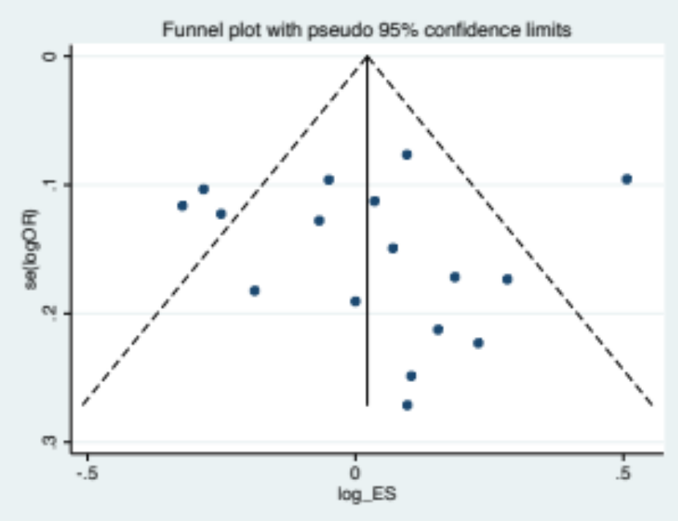
Figure-S1-B: Sensitivity Analysis for the relationship between PDE4D SNP45 gene Polymorphism with the Risk of Ischemic Stroke
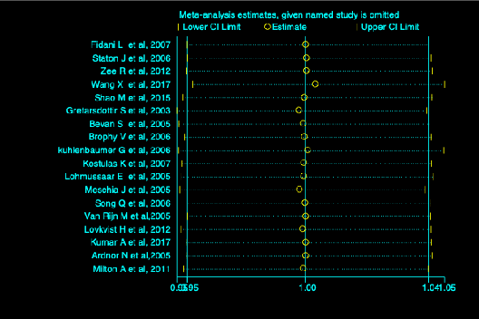

Figure-S1-C: Meta-regression plot for the association of PDE4D SNP 45 gene polymorphisms with the risk of Ischemic stroke

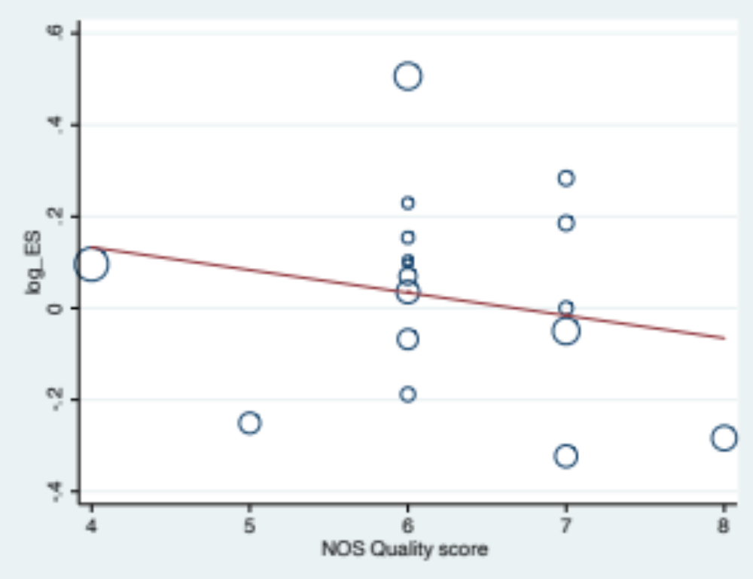

Figure-S2-A: Begg’s Funnel plot for the relationship between PDE4D SNP 56 gene Polymorphism with the Risk of Ischemic Stroke
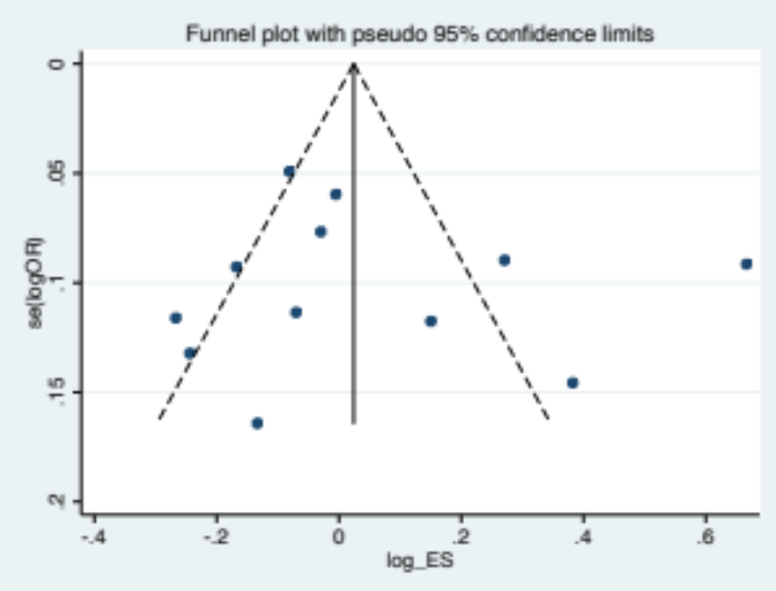
Figure-S2-B: Sensitivity Analysis for the relationship between PDE4D SNP 56 gene Polymorphism with the Risk of Ischemic Stroke
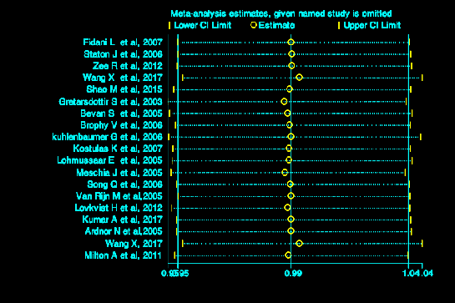

Figure-S2-C: Meta-regression plot for the association of PDE4D SNP 56 gene polymorphisms with the risk of Ischemic stroke

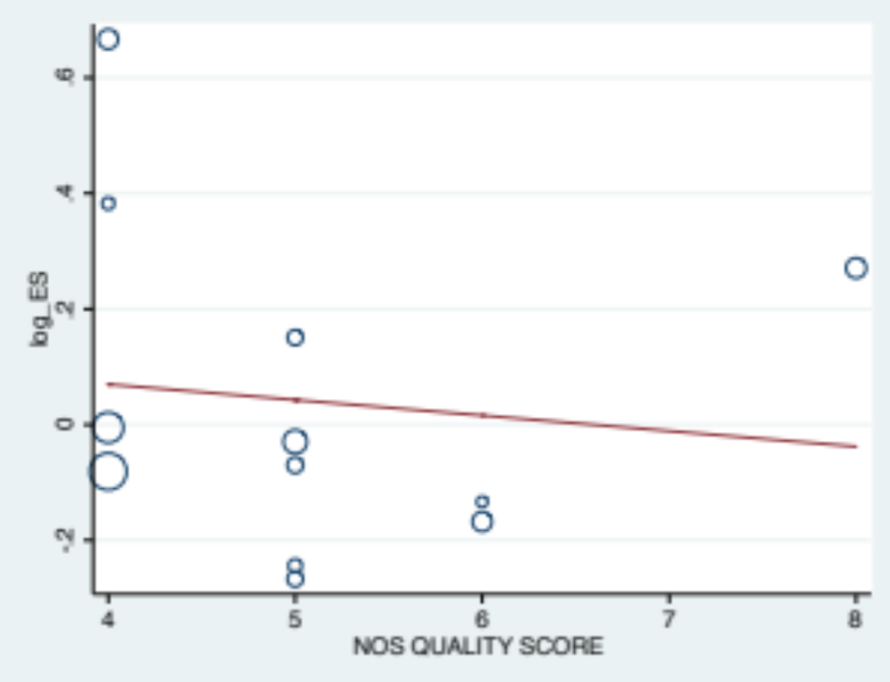

Figure-S3-A: Begg’s Funnel plot for the relationship between PDE4D SNP 87 gene Polymorphism with the Risk of Ischemic Stroke

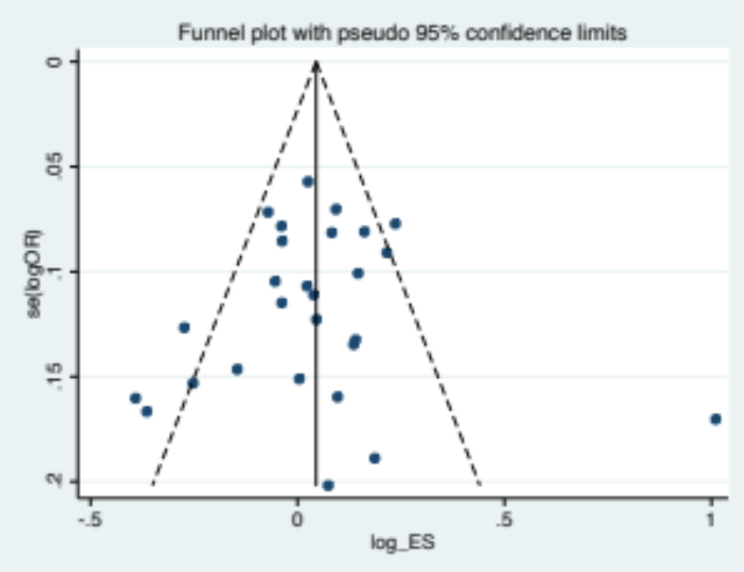

Figure-S3-B: Sensitivity Analysis for the relationship between PDE4D SNP 87 gene Polymorphism with the Risk of Ischemic Stroke

Figure-S3-C: Meta-regression plot for the association of PDE4D SNP 87 gene polymorphisms with the risk of Ischemic stroke

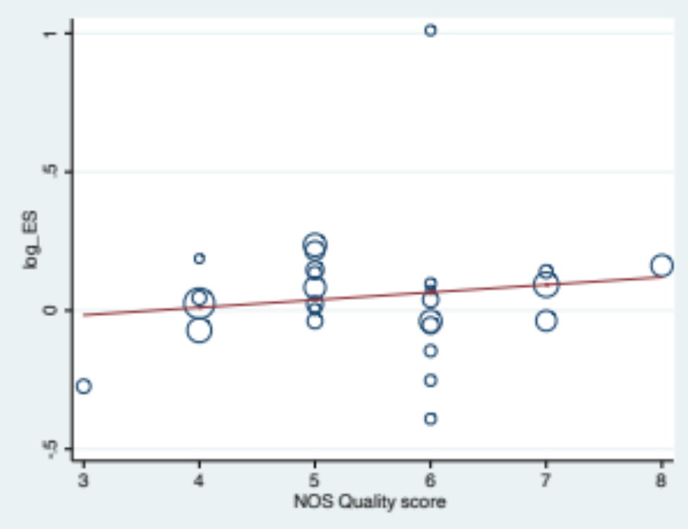

Figure-S4-A: Begg’s Funnel plot for the relationship between PDE4D SNP 83 gene Polymorphism with the Risk of Ischemic Stroke

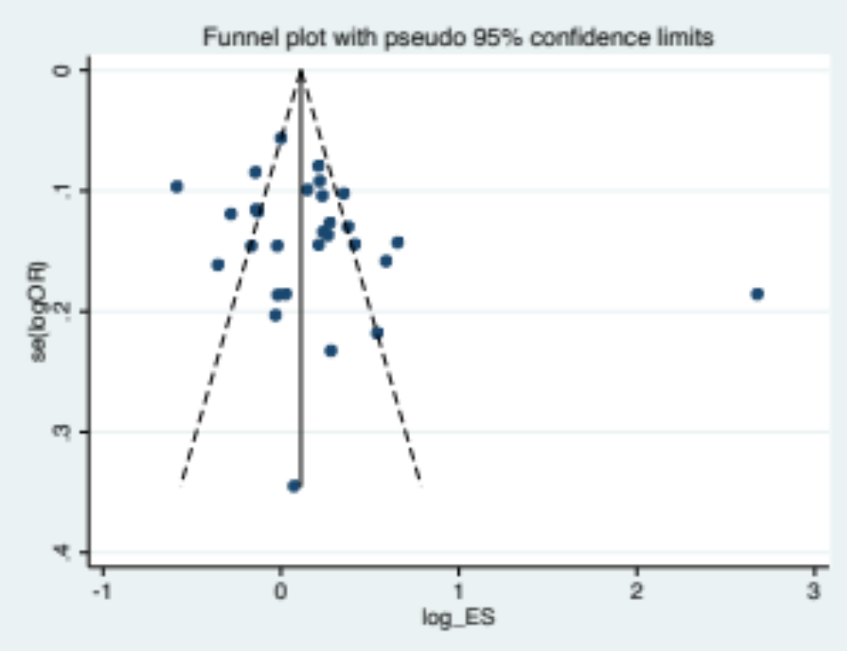

Figure-S4-B: Sensitivity Analysis for the relationship between PDE4D SNP 83 gene Polymorphism with the Risk of Ischemic Stroke

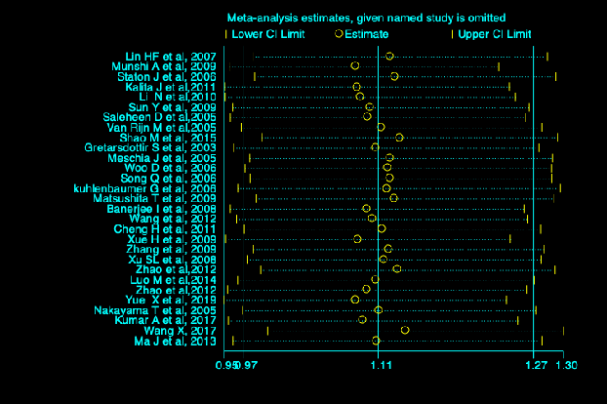

Figure-S4-C: Meta-regression plot for the association of PDE4D SNP 83 gene polymorphisms with the risk of Ischemic stroke

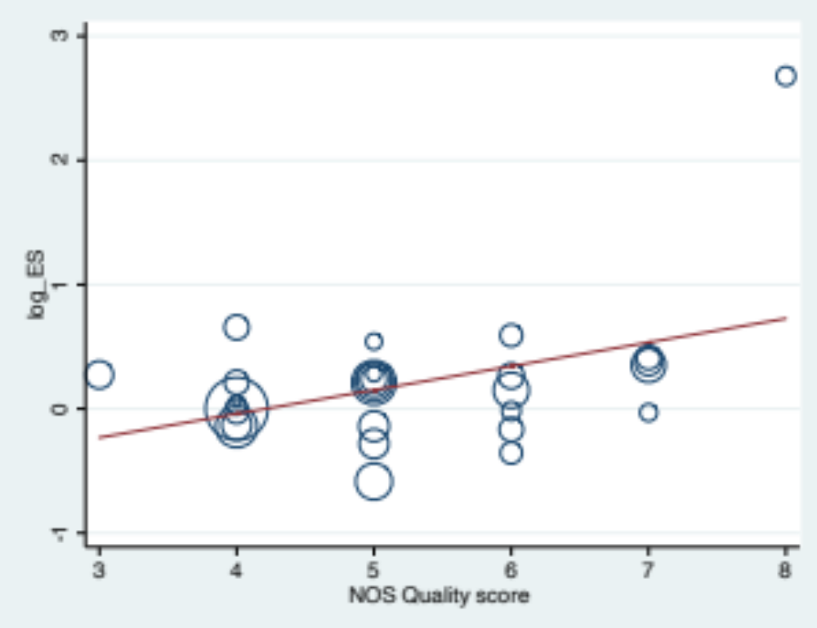

Figure-S5-A: Begg’s Funnel plot for the relationship between PDE4D SNP 89 gene Polymorphism with the Risk of Ischemic Stroke
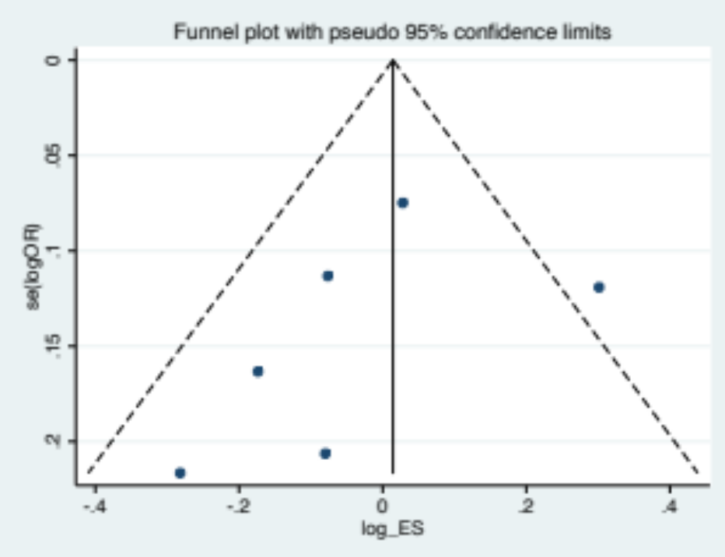

Figure-S5-B: Sensitivity Analysis for the relationship between PDE4D SNP 89 gene Polymorphism with the Risk of Ischemic Stroke

Figure-S5-C: Meta-regression plot for the association of PDE4D SNP 87 gene polymorphisms with the risk of Ischemic stroke

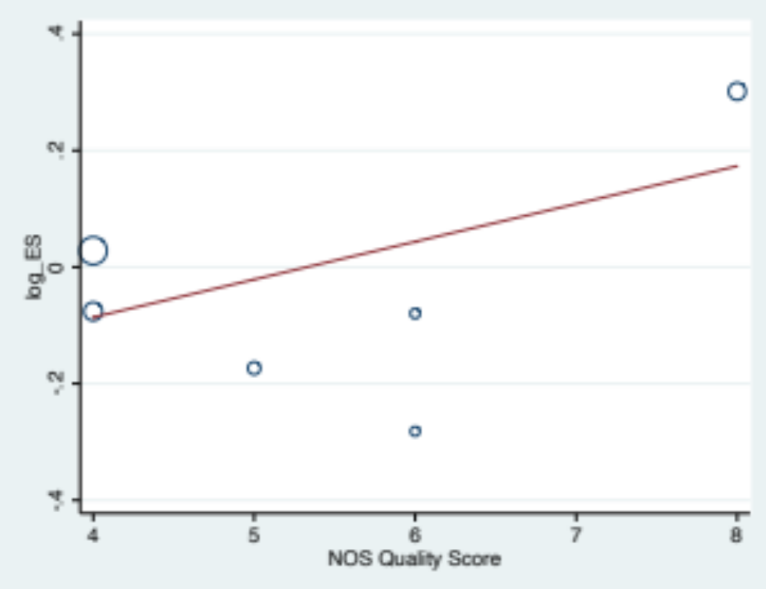

Figure-S6-A: Begg’s Funnel plot for the relationship between PDE4D SNP 26 gene Polymorphism with the Risk of Ischemic Stroke

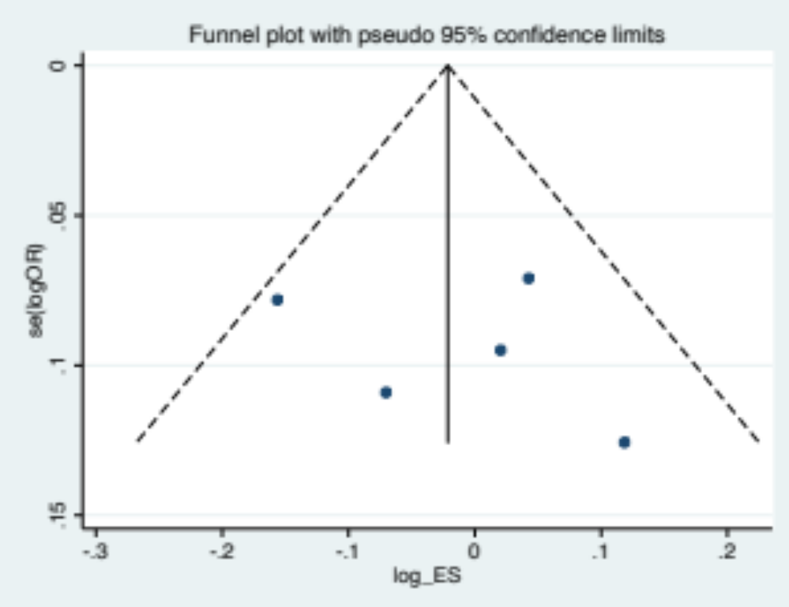

Figure-S6-B: Sensitivity Analysis for the relationship between PDE4D SNP 26 gene Polymorphism with the Risk of Ischemic Stroke

Figure-S6-C: Meta-regression plot for the association of PDE4D SNP 26 gene polymorphisms with the risk of Ischemic stroke

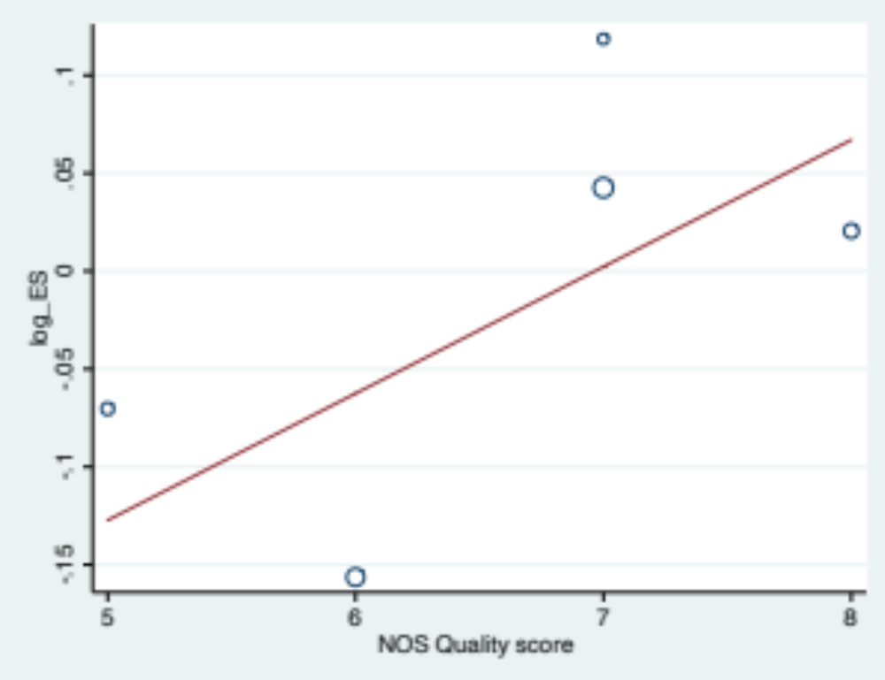

Figure-S7-A: Begg’s Funnel plot for the relationship between PDE4D SNP 41 gene Polymorphism with the Risk of Ischemic Stroke

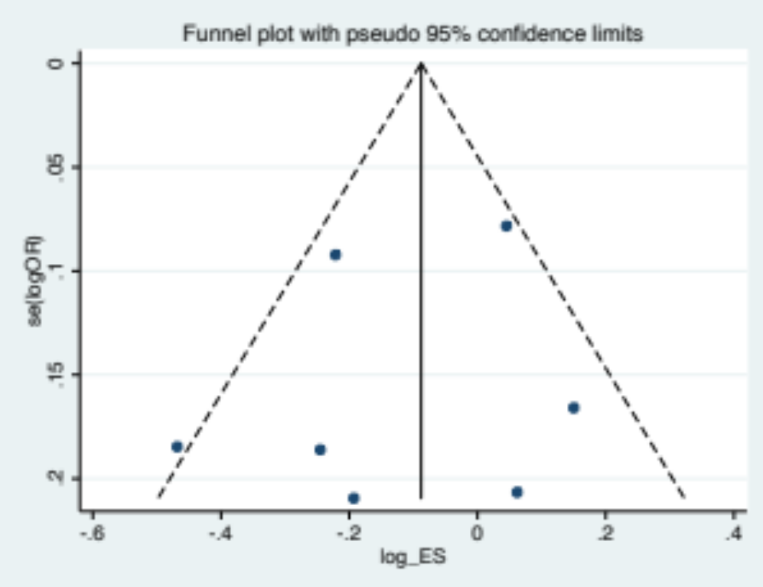

Figure-S7-B: Sensitivity Analysis for the relationship between PDE4D SNP 41 gene Polymorphism with the Risk of Ischemic Stroke

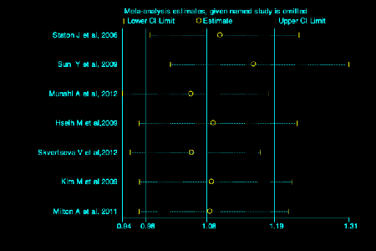

Figure-S7-C: Meta-regression plot for the association of PDE4D SNP 41 gene polymorphisms with the risk of Ischemic stroke

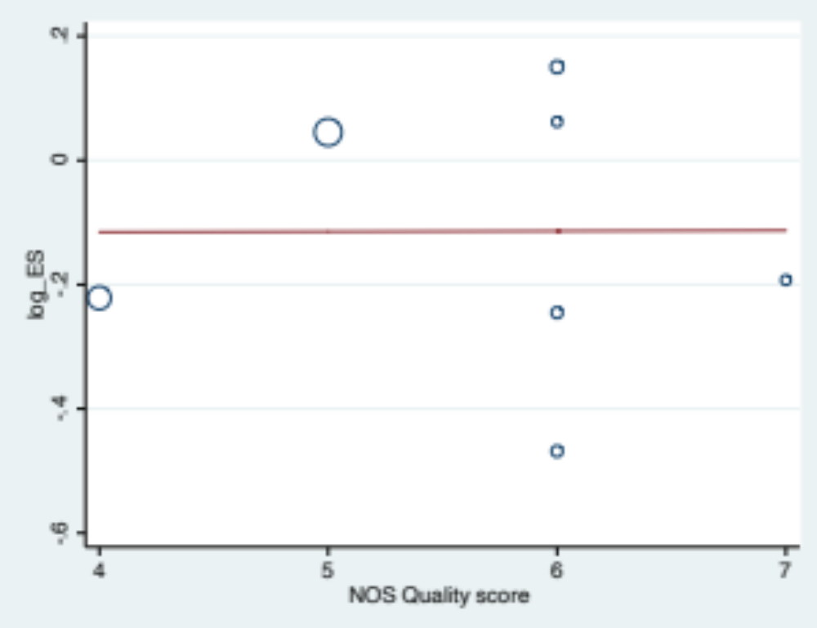

Figure-S8-A: Begg’s Funnel plot for the relationship between PDE4D SNP 32 gene Polymorphism with the Risk of Ischemic Stroke

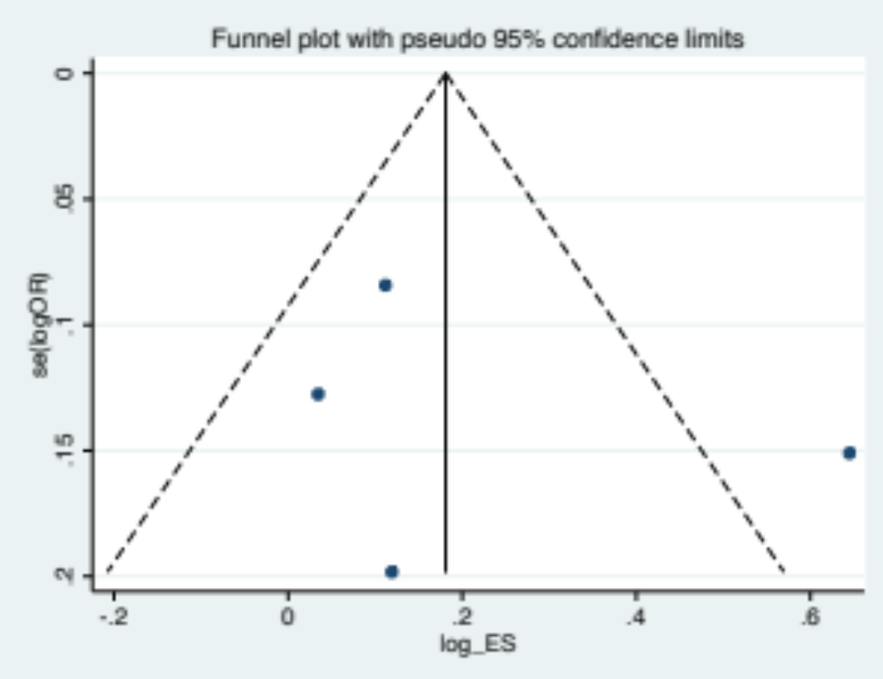

Figure-S8-B: Meta-regression plot for the association of PDE4D SNP 32 gene polymorphisms with the risk of Ischemic stroke

