SUPPLEMENTS
Fig. S1: Visual impression of the mesocosm experiment.
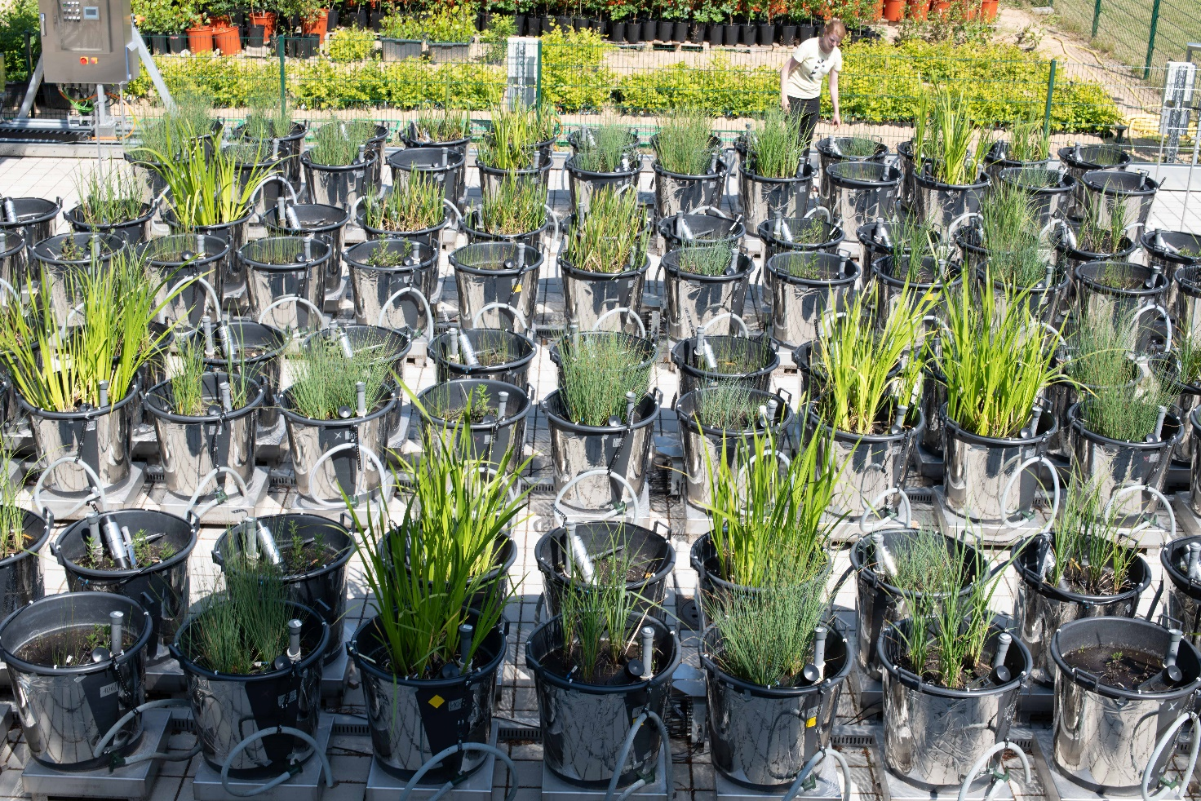

Fig. S2: Visual impressions of the different wetland types covered in the field study, including a) a sedge-dominated percolation fen, b) a coastal flood fen and c) an alder (Alnus glutinosa) forest. The minirhizotrons are visible in b) as silver tubes at 45° angles with their aboveground part covered by opaque silver tape preventing the entry of light.
a) 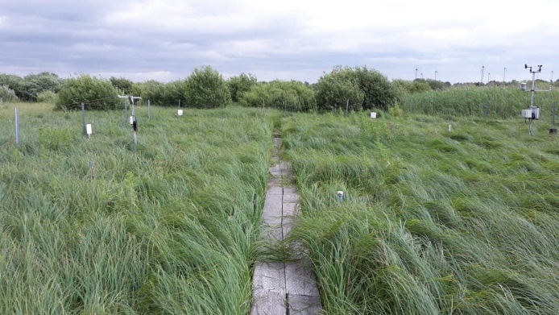 | c) 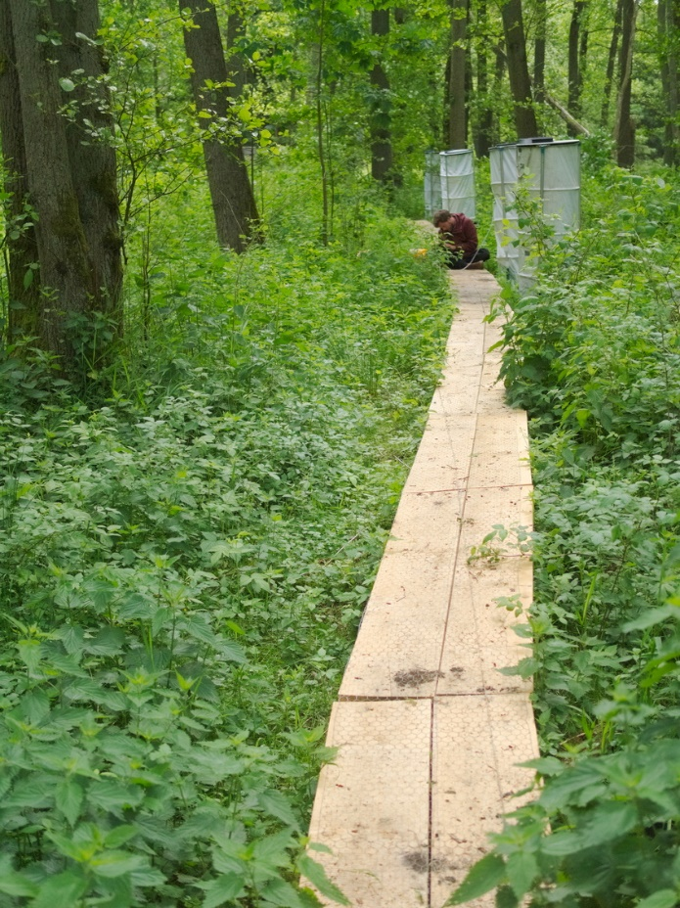
b) 

