Supplementary Figures

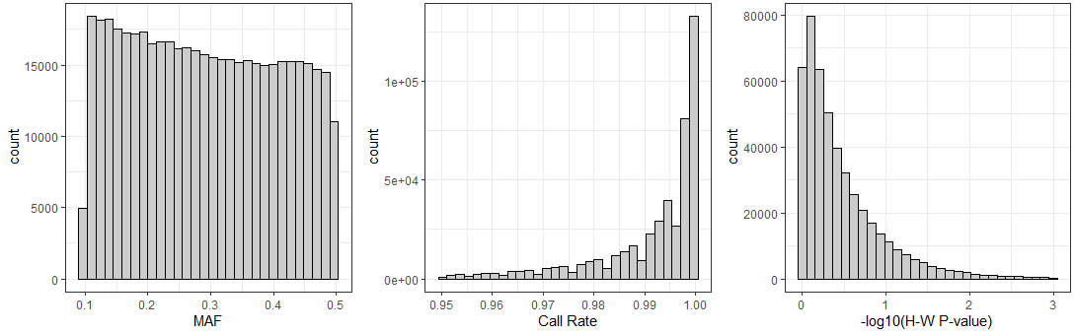
Figure S1: The summary of final SNPs characteristic, including MAF, call rate, and p-value of Hardy-Weinberg equilibrium test.

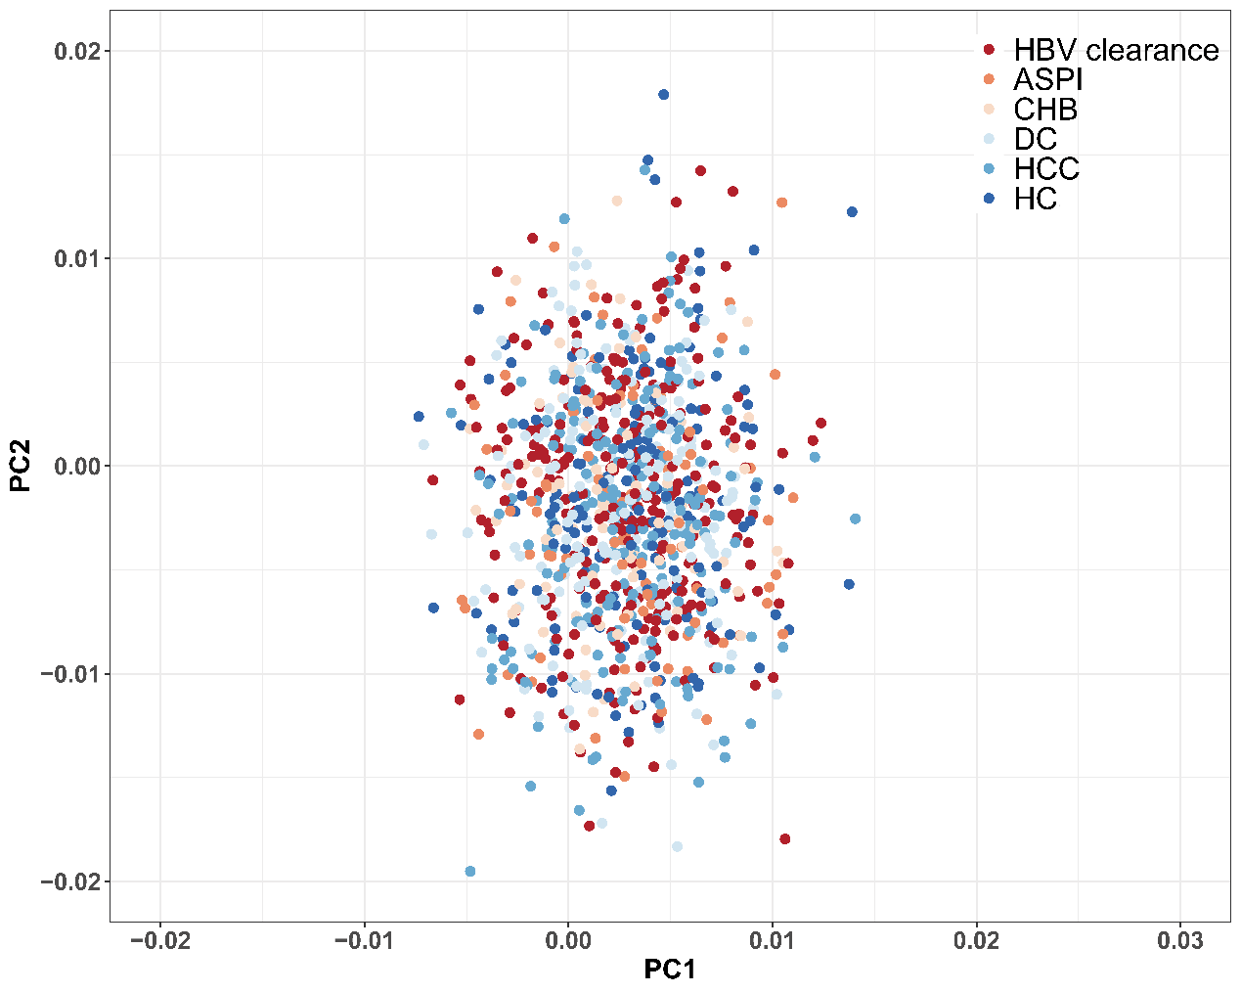
Figure S2: Principal component analyses indicated there are no population stratification among 6 subgroups. Abbreviation: ASPI, asymptomatic persistence infection; CHB, chronic hepatitis B; DC, decompensated cirrhosis; HC: healthy controls; HCC, hepatocellular carcinoma.
Figure S3: Effective population sizes inferred using Related-package across all individuals of each population in two loci (HLA-DPA1, HLA-DPB1). Recentsize histories (26000 years ago) in European (purple) population showed modest difference compared with East Asian (red) population. Abbreviation: EUR, European; AMR, American; SAS, South Asian; AFR, African.

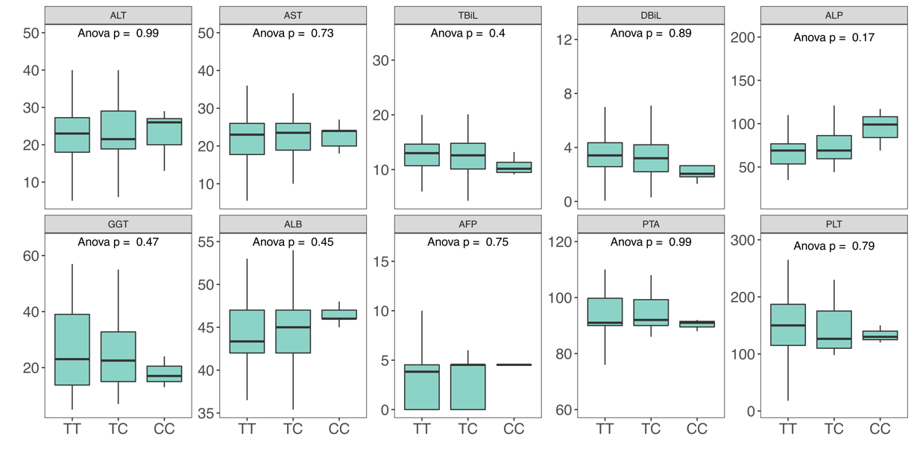
Figure S4: Boxplots of rs2395166 genotype and serum liver enzyme levels in HC.

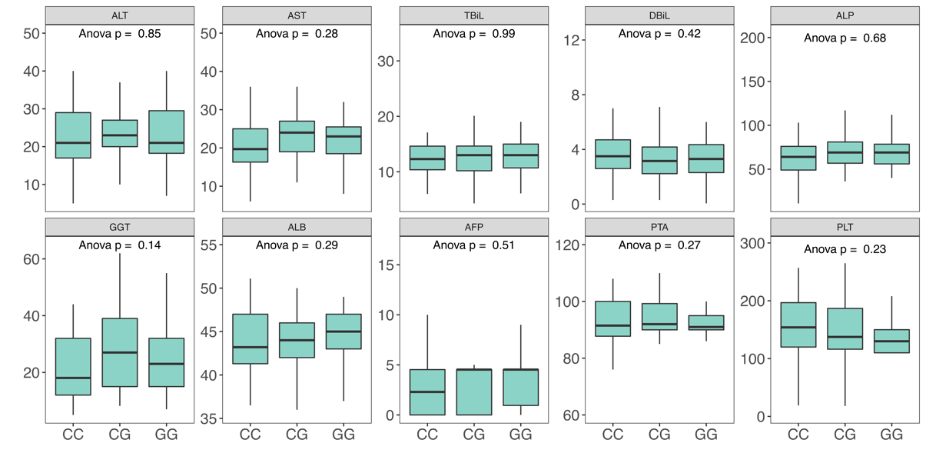
Figure S5: Boxplots of rs615672 genotype and serum liver enzyme levels in HC.

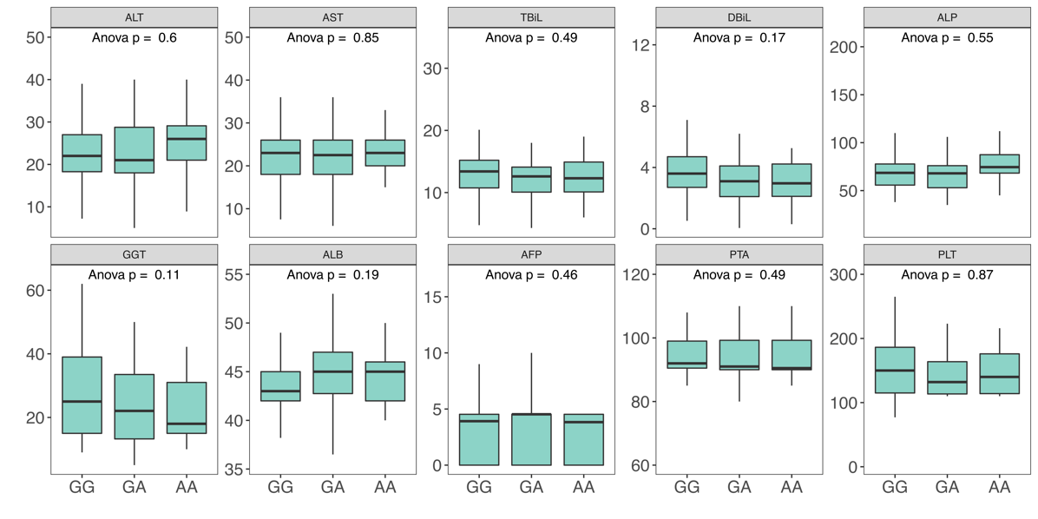
Figure S6: Boxplots of rs3077 genotype and serum liver enzyme levels in HC.
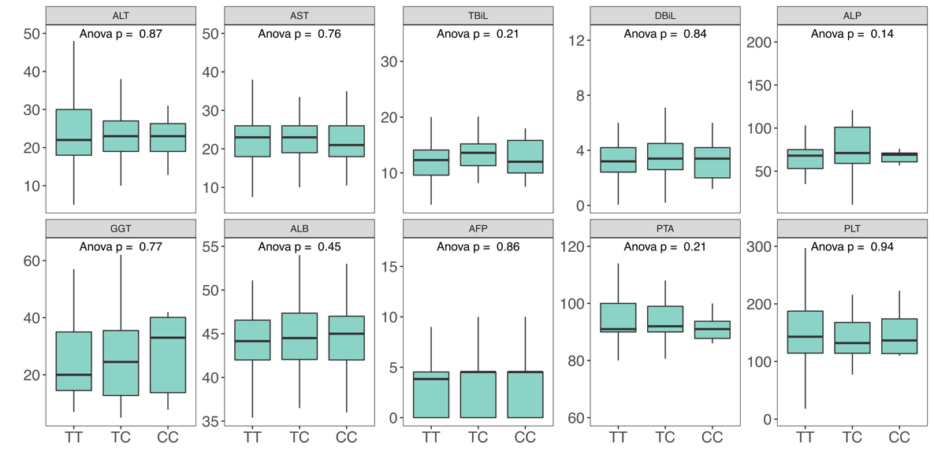
Figure S7: Boxplots of rs1264473 genotype and serum liver enzyme levels in HC.

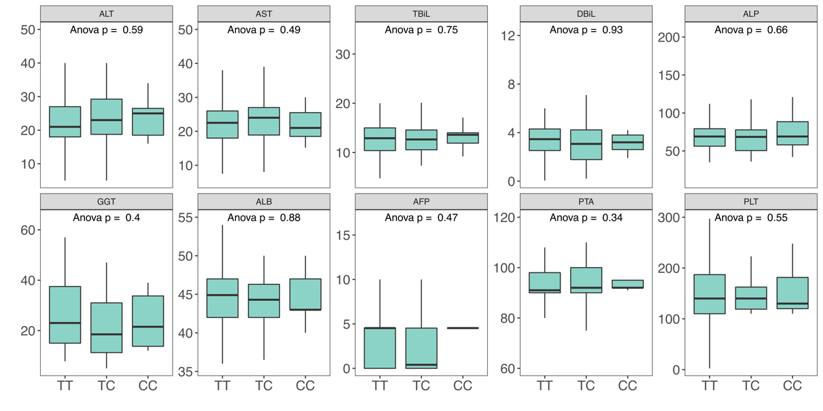
Figure S8: Boxplots of rs2833856 genotype and serum liver enzyme levels in HC.

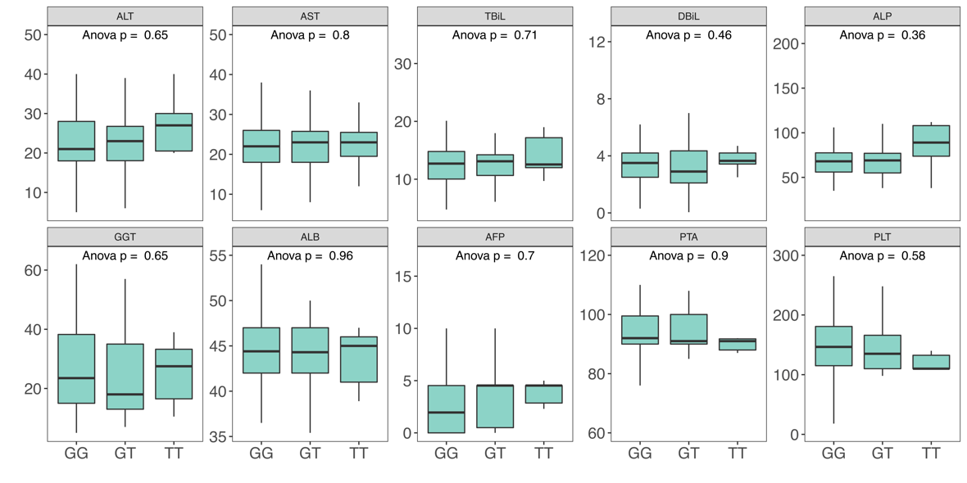
Figure S9: Boxplots of rs6942409 genotype and serum liver enzyme levels in HC.
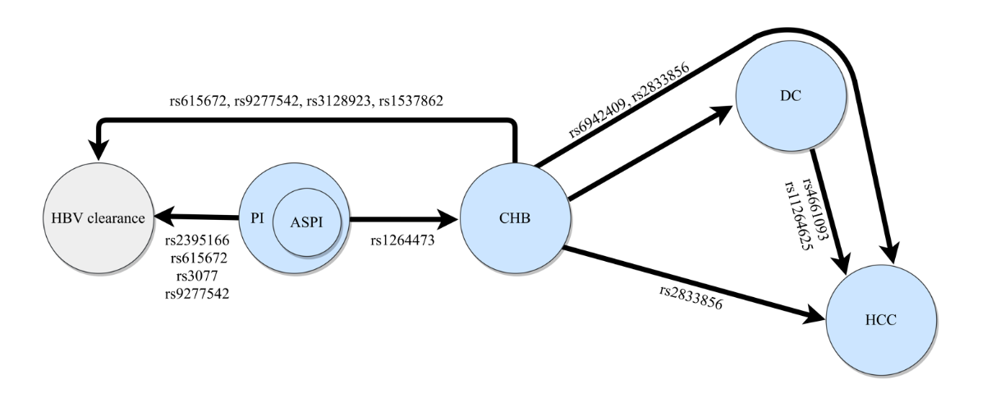
Figure S10: The summary of associated SNPs contributed to HBV-related outcomes and the progression. Abbreviation: PI, persistence infection; ASPI, asymptomatic persistence infection; CHB, chronic hepatitis B; DC, decompensated cirrhosis; HCC, hepatocellular carcinoma.

