Development of hybrid titania/polybenzoxazine composite for enhance thermo-mechanical, flame retardancy and dielectric properties
Shakila Parveen Asrafali^{a1}, Thirukumaran Periyasamy^{a1}, Chaitany Jayprakash Raoraneª, Ramkumar Vanarajª, Seong-Cheol Kim^{a,}*
¹Authors contributed equally to this work.
ªSchool of Chemical Engineering, Yeungnam University, Gyeongsan 38541, Republic of Korea.
Supporting Information
Materials
2,6-dichloro benzonitrile was purchased from Spectrochem Pvt. Ltd., India; 4-amino phenol, and TiO₂ nanoparticles were purchased from Alfa Aesar (Johnson Mathew Company), India, Pvt. Ltd.; Pd/C, dimethylsulphoxide (DMSO), sodium hydroxide (NaOH), conc. HCl, isopropyl alcohol and NH₃ solution were purchased from Sisco Research Laboratories (SRL), Pvt. Ltd., India. Paraformaldehyde, aniline, tetrahydrofuran (THF), N,N-dimethylformamide (DMF) and ethanol were purchased from E-Merck Limited, India; potassium carbonate (K₂CO₃), sodium nitrite (NaNO₂) and phenol were purchased from SD Fine Chemicals Limited, India.
Instrumentation
ABB Bomem (Model MB3000) FT-IR spectrometer was used to examine the structure of the monomers and their curing behavior. The solid samples were recorded by making pellets with potassium bromide (E-Merck, IR Grade). All the spectra were recorded at a resolution of 4 cm⁻¹ with a maximum of 10 scans. ¹H and ¹³C-NMR spectra were recorded on a Jeol Ex-400 instrument at 500 MHz. Samples were dissolved in deuterated chloroform (Aldrich, CDCl₃, 99.8% containing 0.03% v/v tetramethylsilane TMS) at a concentration of 2-10% solid. Differential scanning calorimetry was used to determine the T_{m} and T_{g} and heat of curing of the monomers using TA instruments Q₁₀ series. The experiments were carried out in nitrogen atmosphere at a heating rate of 10 °C/min from ambient to 400 °C with a nitrogen flow of 60 ml/min. Thermograms were obtained using TA instruments SDT Q₆₀₀ series thermogravimetric analyzer. All the runs were carried out under nitrogen atmosphere with a gas flow rate of 30 ml/min. All the experiments were carried out at a heating rate of 20 °C/min. The dynamic mechanical properties of the polybenzoxazine and its composites were obtained using a NETZSCH DMA 242 dynamic mechanical analyzer in a tensile mode. Rectangular specimens of 55 mm length, 10 mm width and 3 mm thickness were used. Each specimen was heated from room temperature to 300 °C under different frequencies namely 2, 5, 10 and 20 Hz. The storage modulus ɛ' and the mechanical loss factor (damping) tan δ were recorded as a function of temperature. The glass transition temperature (T_{g}) of the blends were obtained from the peak maximum of loss factor tan δ curves. Morphological studies were conducted by using scanning electron microscopy (JEOL, JSM 6460). The dielectric constant and dielectric loss measurements were carried out with the help of impedance analyzer (Solartron impedance/gain phase analyzer 1260) at room temperature using platinum (Pt) electrode at 30 °C at a frequency range of 1 MHz. This experiment was repeated four times at the same condition. The polymer samples were made in the form of pellets (1mm thickness * 8mm dia.) the dielectric constant and dielectric losses of samples were determined using ɛ' and ɛ" as the standard relations.
Synthesis of precursors
Synthesis of 4-(phenyl diazenyl) phenol [PAP]
Concentrated HCl (8 mL) and deionized water (8 mL) were added to a three-necked round-bottomed flask with a magnetic stirrer. This solution was cooled to 0 °C and aniline (2.5 g, 2.7 mmol) was added. NaNO2 (2.0 g, 2.9 mmol) in 10 mL of water was then added to the cooled solution under thermal control, keeping the temperature of the solution below 10 °C. After complete addition, the solution was allowed to stir in an ice bath for 20 min. Phenol (2.5 g, 2.7 mmol) was then dissolved separately in 25 mL of 10% NaOH solution. This prepared solution was slowly added to the solution containing diazonium salt with stirring, keeping the temperature below 15 °C, and stirred for another 45 minutes. The yellow-orange solid [PAP] formed was filtered and washed with water-ethanol mixture yield 80%. (Scheme S1)
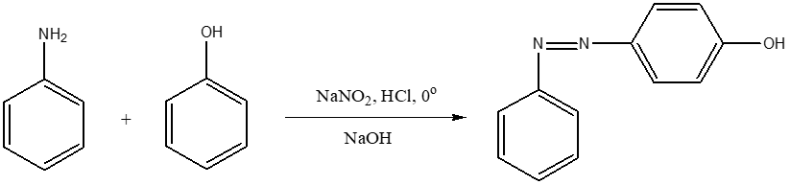

Scheme S1 Synthesis of 4-phenyl diazenyl phenol [PAP]

Synthesis of 4,4’ bis(4-aminophenoxy) benzonitrile [APBN]
4-Aminophenol (21.8 g, 0.2 mol), NMP (150 mL), and toluene (130 mL) were charged into a 500 mL three-necked round bottomed flask equipped with a Dean–Stark trap. Powdered anhydrous K₂CO₃ (13.8 g, 0.1 mol) was added and water was removed by azeotropic distillation with toluene by refluxing the mixture with stirring under nitrogen atmosphere at 140–150 ºC. After complete dehydration (3 h), the remaining toluene was removed until the flask temperature reached 160 ºC. The temperature of the reaction mixture was then decreased to 130 ºC, and then solid 2,6-dichloro benzonitrile (17.2 g, 0.1 mol) was added in portions and the temperature was further increased to 195 ºC, maintained at this temperature for 4 h under nitrogen atmosphere. The mixture was allowed to cool and then poured into a large excess of water to precipitate the product, which was then collected by filtration and dried under vacuum to obtain APBN [Scheme 2.3]. Yield: 75%.
FT-IR (KBr, cm⁻¹): 3424 & 3340 (asymmetric and symmetric stretching vibrations of NH₂), 1618 (C-O stretching), 2232 (-CN stretching), 1451 and 3048 (C=C and C-H stretching vibrations of the aromatic ring), 781 (bending vibrations of C-H); ¹H-NMR (CDCl₃, ppm): 4.2 (s, H_{a ,}4H), 6.2 (d, H_{b,} 4H), 6.6 (d, H_{c,} 4H), 6.8 (d, H_{d,} 2H) and 7.6 (m, H_{e,} 1H); ¹³C-NMR (CDCl₃, ppm): 144 (C₁), 123 (C₂), 130 (C₃), 147 (C₄), 164 (C₅), 117 (C₆), 125 (C₇), 96 (C₈) and 115 (C₉).

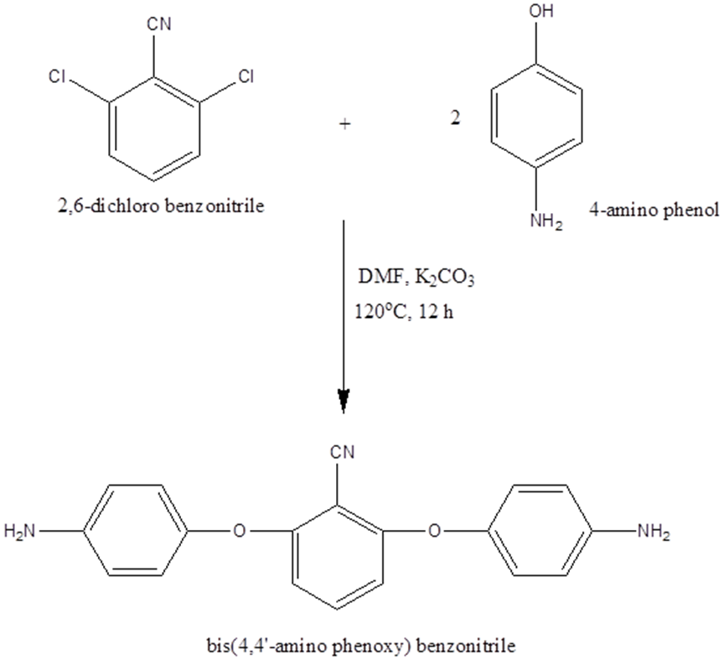

Scheme S2 Synthesis of bis(4,4'-aminophenoxy)benzophenone [APBP]

Structure analysis of precursors
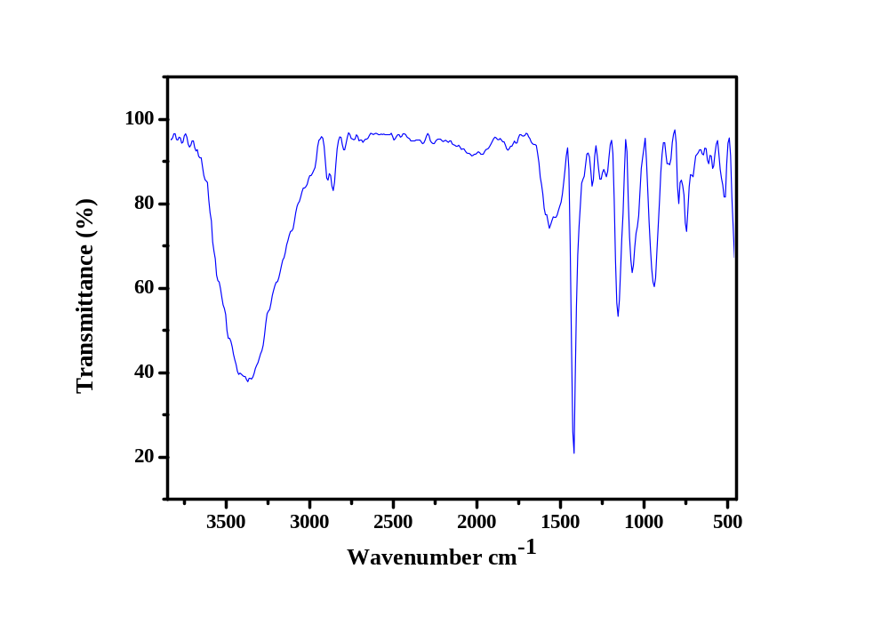Figure S1 shows the FT-IR spectrum of 4-phenyl diazenyl phenol. The spectrum shows a broad absorption at 3468 cm⁻¹, due to the presence of –OH group. The stretching vibrations of the N=N bond of the azo group gave a band at 1458 cm⁻¹. Whereas, the absorption bands of C-O and CN bonds attached to the benzene ring are observed at 1373 and 1281 cm⁻¹, respectively. Moreover, the characteristic frequencies of the aromatic ring (C-H stretching, C=C stretching and C-C bending vibrations) are observed at 3070, 1589 and 848 cm⁻¹, respectively. Figure S2 show the ¹H- and ¹³C-NMR spectra of PAP. In the figure, a singlet is observed at 3.8 ppm, due to the presence of –OH proton. The aromatic protons appear in the range of 6.5 - 7.0 ppm. The peak at 7.2 ppm is due to the solvent (CDCl₃). The ¹³C-NMR spectrum shows a peak at 164 ppm, due to the aromatic carbon attached to the hydroxyl group. Whereas, the carbons attached to the azo group resonate at 145 and 147 ppm. All the other aromatic carbons resonate between 115 - 135 ppm, respectively

Figure S1 FT-IR spectrum of PAP

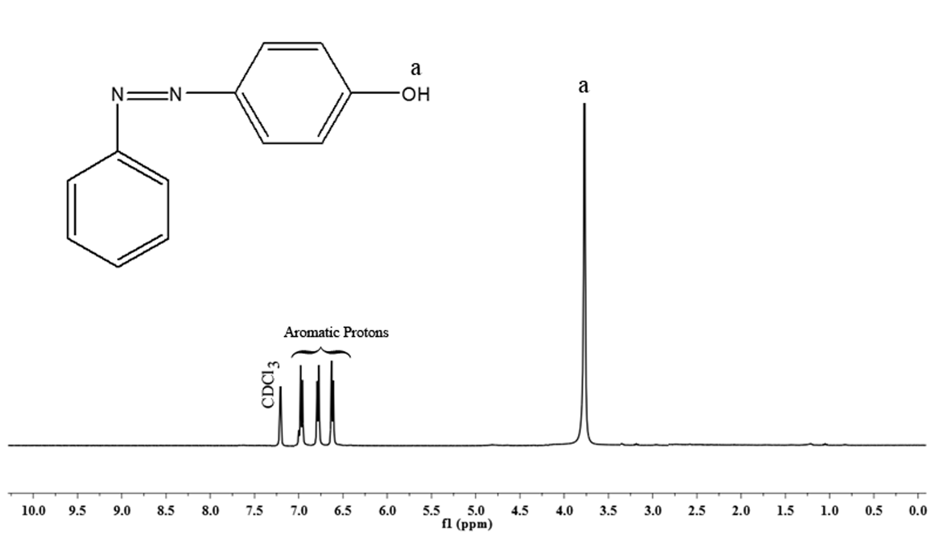
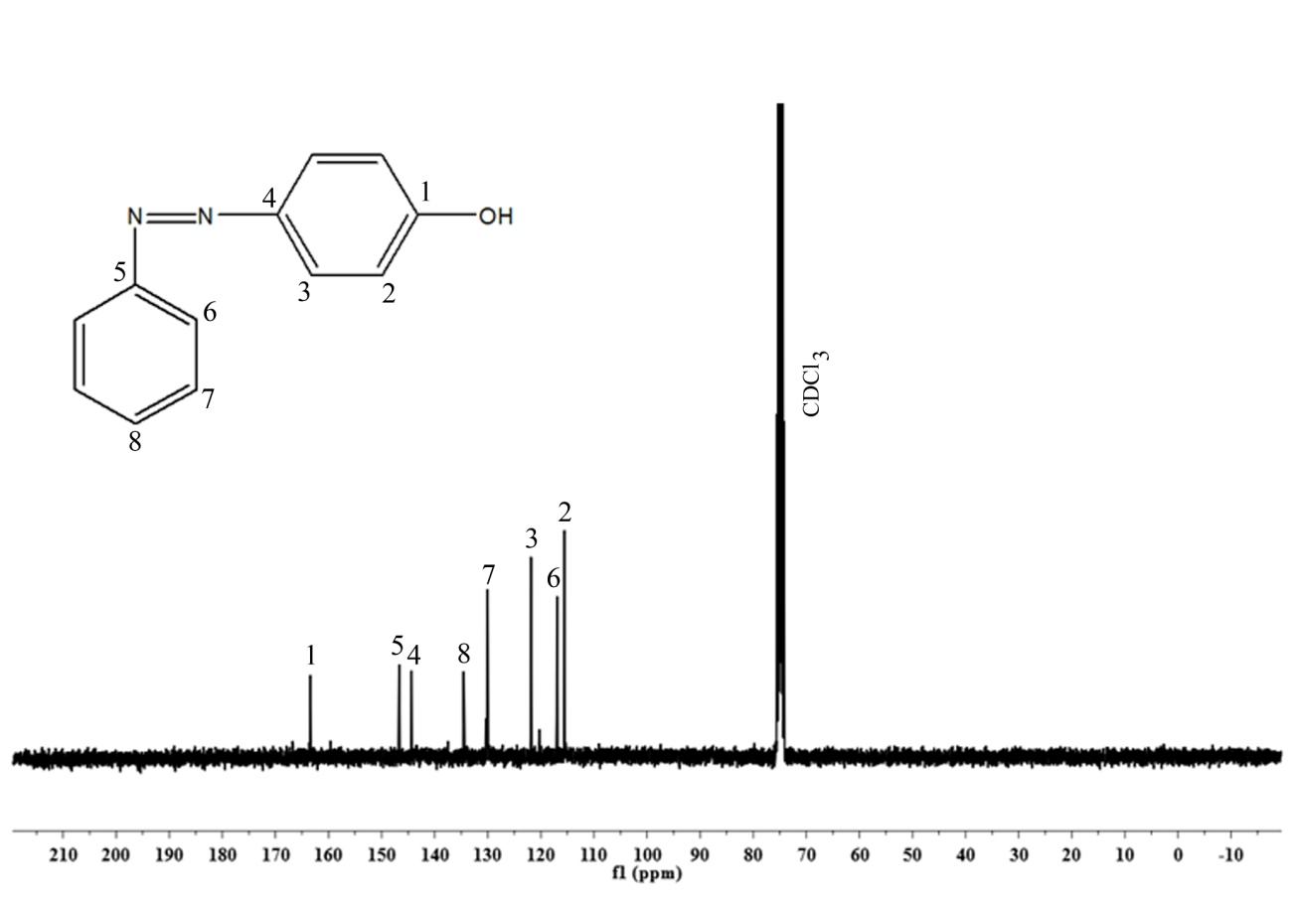

Figure S2 ¹H- and ¹³C-NMR of PAP

Figure S3 shows the FT-IR spectra of the synthesized diamines. For APBN the asymmetric and symmetric stretching vibrations of the diamine are located between 3348 - 3432 cm⁻¹ and 3279 - 3349 cm⁻¹, respectively. The stretching vibrations of the -CN and C-O bonds are found at 2232 and 1618 cm⁻¹, respectively. The aromatic ring vibrations give rise to absorption bands between 1450 - 1458 cm⁻¹, 3070 - 3048 cm⁻¹ and 779 - 787 cm⁻¹ due to the stretching vibrations of the C=C and C-H bonds and the bending vibrations of the C-H bonds.
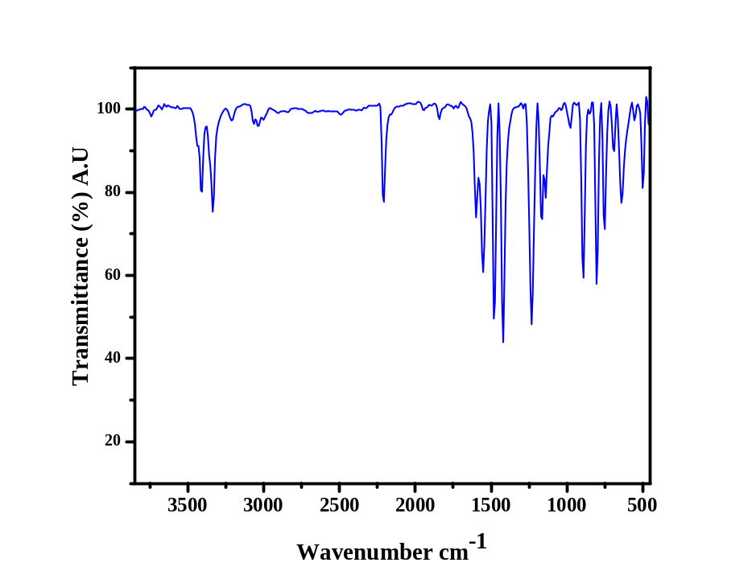
The ¹H- and ¹³C-NMR spectra of the diamine [APBN] are shown in figure S4. A singlet at 4.2 ppm corresponds to the amino protons, whereas the aromatic protons appear between 6.2 and 7.6 ppm. The peak at 115 ppm, due to the -CN carbon. The aromatic carbons attached to the amino group resonate at 144 ppm, whereas the aromatic carbon attached to the nitrile group resonates at 96 ppm. All other aromatic carbons show peaks between 117 and 164 ppm respectively.
Figure S3 FT-IR spectrum of APBN
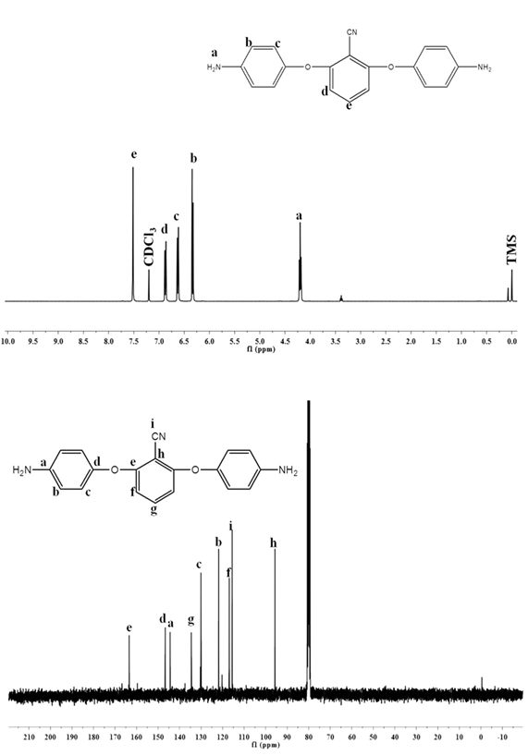

Figure S4 ¹H- and ¹³C-NMR spectra of APBN

