Supplementary Information

A genome-wide association study identifies a novel susceptibility locus at the DLGAP1 gene for resistant hypertension in the Japanese population

Yasuo Takahashi¹
Keiko Yamazaki^{1, 2}
Yoichiro Kamatani³
Michiaki Kubo⁴
Koichi Matsuda³
Satoshi Asai^{1, 5}

¹Division of Genomic Epidemiology and Clinical Trials, Clinical Trials Research Center, Nihon University School of Medicine, Tokyo, Japan.
²Laboratory for Genotyping Development, RIKEN Center for Integrative Medical Sciences, Yokohama, Japan.
³Graduate School of Frontier Sciences, The University of Tokyo, Tokyo, Japan.
⁴RIKEN Center for Integrative Medical Sciences, Yokohama, Japan.
⁵Division of Pharmacology, Department of Biomedical Sciences, Nihon University School of Medicine, Tokyo, Japan.

Correspondence should be addressed to:
Yasuo Takahashi, M.D., Ph.D.
E-mail: yasuo.takahashi@nihon-u.ac.jp
Division of Genomic Epidemiology and Clinical Trials, Clinical Trials Research Center, Nihon University School of Medicine, Tokyo, Japan
or
Satoshi Asai, M.D., Ph.D.
E-mail: asai.satoshi@nihon-u.ac.jp
Division of Pharmacology, Department of Biomedical Sciences, Nihon University School of Medicine, Tokyo, Japan.

Supplementary Figures
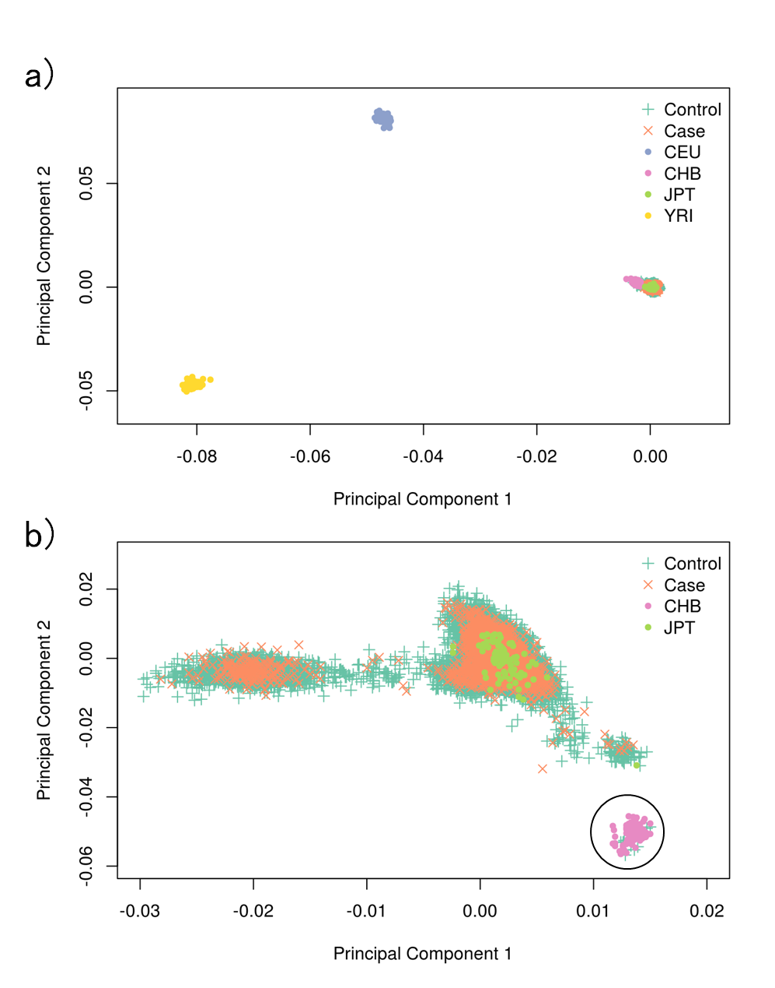
Supplementary Figure S1. Results of principal components analysis of population in genome-wide association study.
(a) The relatedness among cases and controls for GWAS along with European (CEU), African (YRI), and East-Asian (JPT and CHB) data from the HapMap project was analyzed. (b) Relatedness, along with the East-Asian (JPT and CHB) data from the HapMap project, was analyzed. Samples clustered in the Chinese population (within the black circle) were omitted from further analysis.

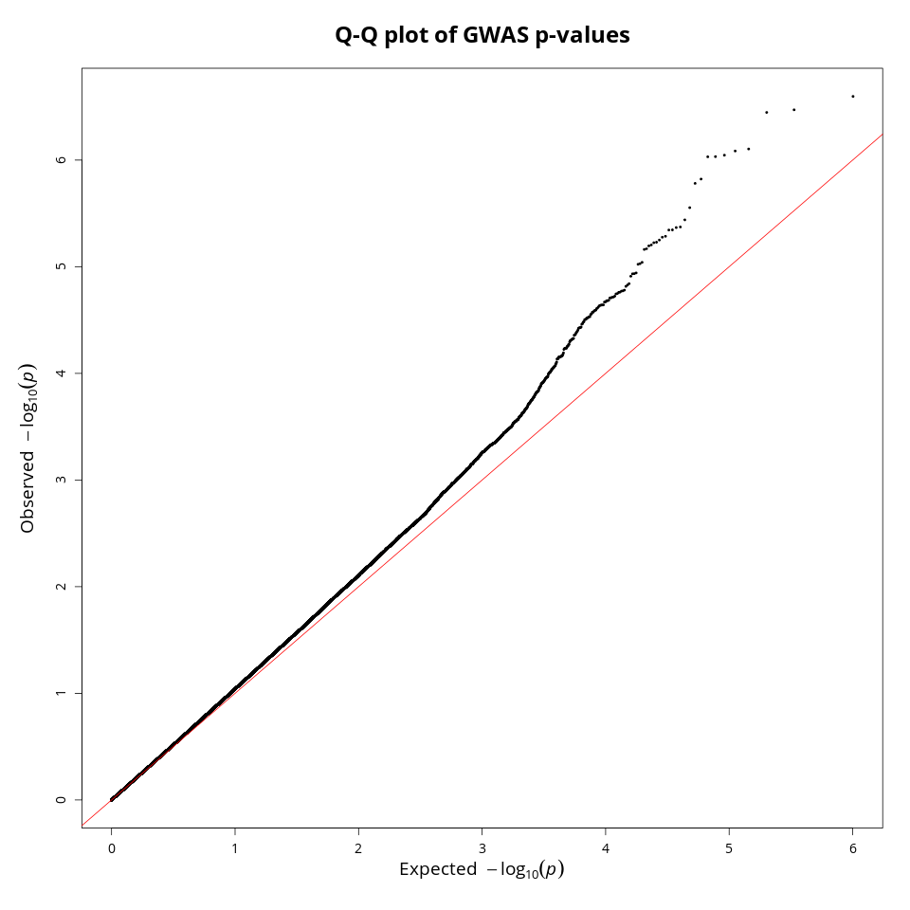
Supplementary Figure S2. Quantile-quantile (Q-Q) plot of P values for genome-wide association study of resistant hypertension in Japanese population.
The genomic inflation factor (lambda) value is 1.057.

