Marvin R. Maechler¹, Vassiki S. Chauhan¹, Natalia A. McLaren¹, Samantha M. Norton¹, Jae S. Hong¹, M. Ida Gobbini^{2,3,*}

1 Department of Psychological and Brain Sciences
HB 6207 Moore Hall, Dartmouth College
Hanover, NH 03755
USA

2 Dipartimento di Medicina Specialistica, Diagnostica e Sperimentale (DIMES)
Medical School
University of Bologna
Bologna
Italy

3 Cognitive Science Program
Dartmouth College
Hanover, NH 03755
USA

*To whom correspondence should be sent:
mariaida.gobbini@unibo.it

​​It's not all Black and White: implicit racial bias extends to other races as well

Supplementary Materials
Table S1
Proportion of answers to the prompt: “I identify my race as …”
Racial Identity | Experiment 1 | Experiment 2
Asian | 19.4% | 22.1%
Black | 13.4% | 2.9%
Hawaiian | 1.5% | -
Hispanic | - | 1%
Indian | 4.5% | 1%
Latino | 4.5% | -
Mixed | 1.5% | 8.7%
Native American | - | 1.9%
White/Caucasian | 50.7% | 62.5%
White-Hispanic | 4.5% | -
Note. Detailed breakdown of participants’ self-identified race.

Table S2
Correlation of implicit bias and trait rating bias by traits
Trait | r | df | p | R²
Aggression | -.118 | 98 | .121 | .014
Attractiveness | .217 | 98 | .015 | .047
Competence | .197 | 98 | .025 | .039
Likeability | .185 | 98 | .033 | .034
Trustworthiness | .191 | 98 | .028 | .036
Note. Correlations of trait judgement biases with implicit bias split by trait for experiment two. These were excluded from the main analysis to avoid the problem of multiple comparisons.

Figure S3
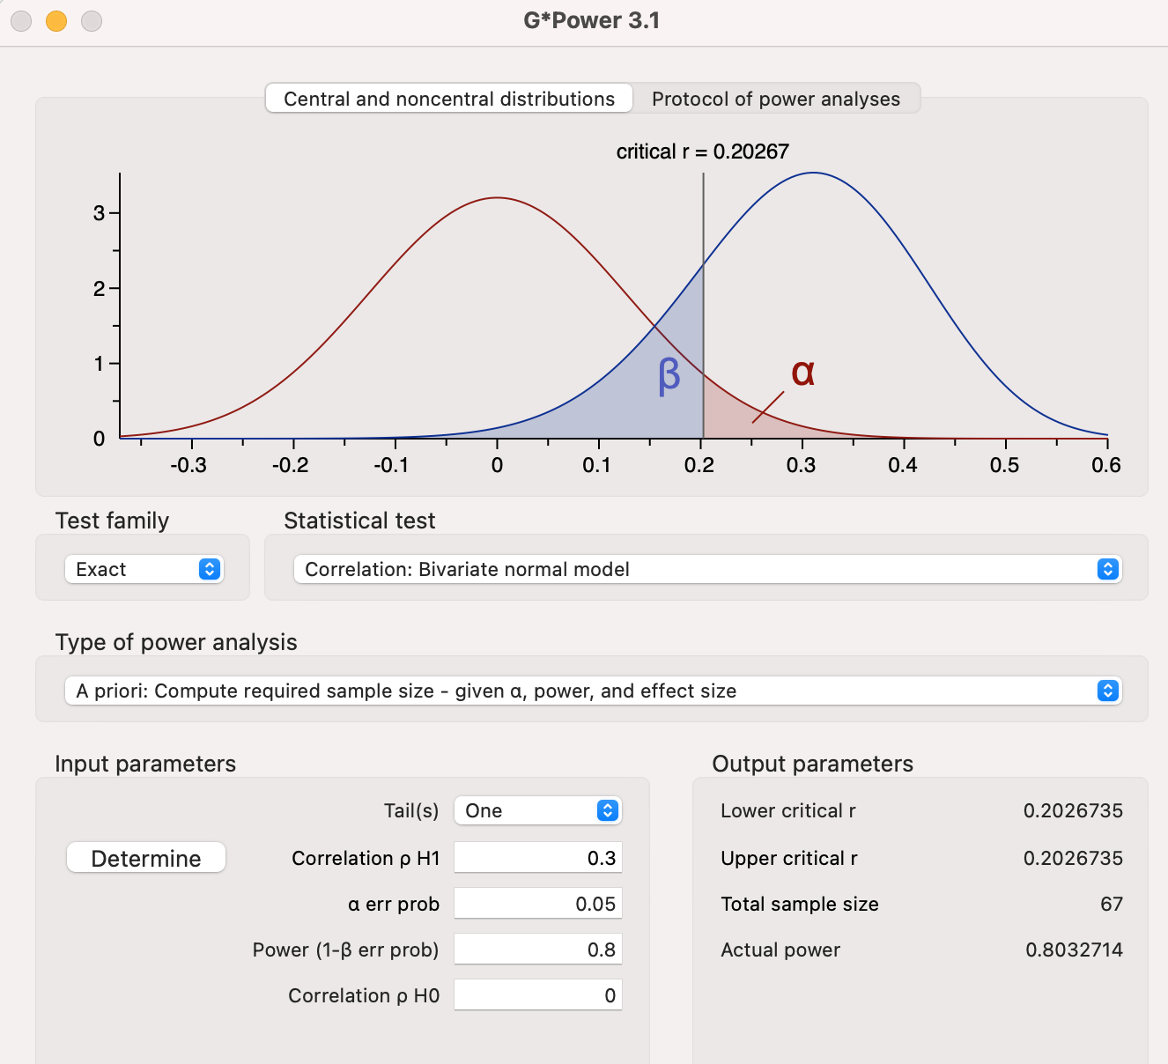
According to G*Power 3.1 we needed 67 participants to achieve 80% power, assuming a moderate correlation. This assumption was based on a pilot sample that was not included in any other analyses.

Figure S4
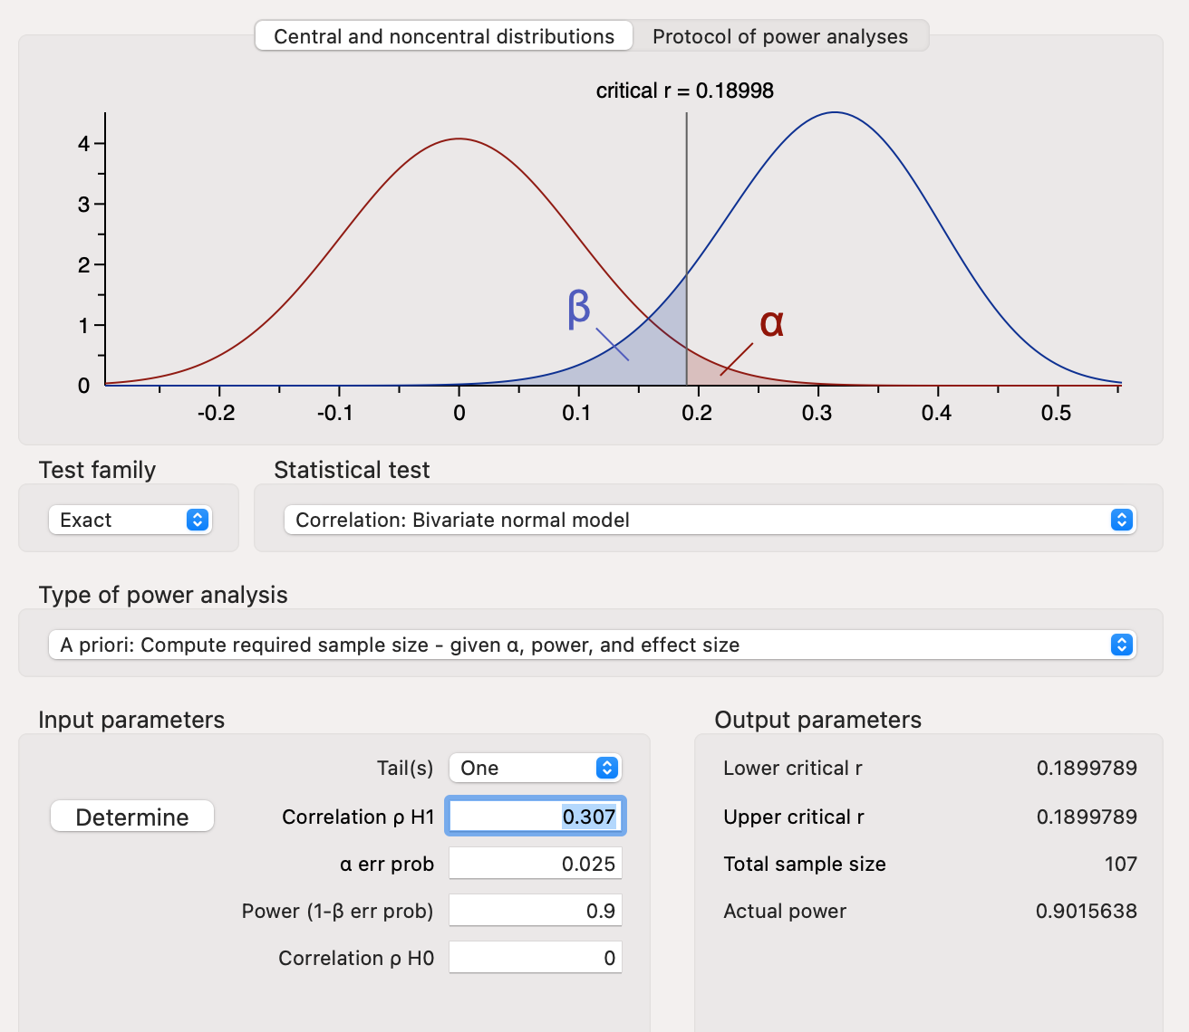
Assumptions for experiment 2 were based on the results of experiment 1. We expected an r of .307 and since we wanted to look at two factors, we corrected the alpha to .025. Due to the onset of the Covid 19 pandemic we collected data from only 104 participants instead of the target of 107 participants.

