Appendix: Methods and Supplemental Information
Table of Contents
Methods 1
Responsive Deep Brain Stimulation system 2
Behavioral Assessments 3
Analyses 5
Clinical Measures 9
Supplemental Figures and Tables 10
References. 14

Methods

Study Design
Implantation→Recording phase (6 months)→Stimulation phase (12 months; see Figure 1A)

Subjects
As previously described, the clinical trial is a multi-stage early feasibility study with staggered enrollment (Figure 1A, see protocol paper for more details¹). All participant information, magnetic resonance (MR), computed topography (CT) imaging, LFP, and behavior data were collected under Stanford University institutional review board (IRB)-approved protocol (IRB #46563, NCT03868670). The first participant (Subject 1), a 45 year-old Caucasian woman with a body mass index (BMI) of 46 kg/m², underwent Roux-en-Y gastric bypass (RYGB) in 2005 and experienced an initial weight loss of 115 lbs. However, the participant gradually regained the weight. At the time of enrollment, she was back to her pre-RYGB weight and met DSM-5 criteria for binge eating disorder, reporting at least 5 LOC eating bouts per week, with 3 LOC eating events per week as well. At the time of enrollment, she had co-morbities of Neoplasm, lower back pain, kyphoscoliosis/scoliosis, hypertension, esophageal reflux, dyslipidemia, complicated migraine, and anxiety. The second participant (Subject 2), a 56 year-old Caucasian woman with a BMI of 47 kg/m², underwent RYGB in 2005 and initially lost 152 lbs. Subject 2 maintained this weight loss for 6 years; however, she regained the weight in 2009 while both caring for an ill family member and recovering from a car accident. At the time of study enrollment, she was within 9% of her pre-RYGB weight and she reported LOC eating 4 times a week and met criteria for binge eating disorder as well. At the time of enrollment, she had a migraine co-morbity. Both subjects reported severe cravings related to emotional and/or stress-related triggers that led to LOC eating. In addition to the RYGB, both subjects tried numerous other weight loss strategies including exercise, dieting, support groups, and medication as was required by our enrollment criteria.

Responsive Deep Brain Stimulation system
The closed-loop intracranial stimulation system used here for responsive deep brain stimulation (rDBS) was a brain-responsive neurostimulation system (RNS System, NeuroPace, Inc) currently approved by the U.S. F.D.A. for the treatment of adults with medically refractory focal onset seizures. The system consists of two intracranial recording and stimulating electrodes connected to a neurostimulator implanted in the skull. The neurostimulator continuously monitors electrographic signals and detects abnormal electrophysiological activity to trigger brief bursts electrical stimulation. The RNS system stores hourly counts of detected events as well as multiple 1-3 minute snapshots of local field potential (LFP) activity which is uploaded to a computer and server where it can be analyzed and reviewed. This system allows the opportunity to collect and examine electrographic activity of the NAc in a subject’s naturalistic environment during vulnerable periods of craving that precede LOC eating events.

Stereotactic Targeting, Device Implantation and Recording Configuration
Following screening by a multi-disciplinary team, the subjects underwent surgical placement of the cranial neurostimulator attached to two depth leads (4 contacts each, 3.5mm electrode spacing) (NeuroPace, Inc) targeting the NAc bilaterally (Figure 1B).² Direct targeting of the NAc using Fast Gray Matter Acquisition T1 Inversion Recovery magnetic resonance imaging was implemented. Due to the investigative nature of this study, the neurostimulator (250Hz sampling rate) was programmed with the high-pass filter set to 1Hz and the low-pass filter set to 90Hz; the widest range available on the device. From each hemisphere, the neurostimulator stores two channels of differential recordings each made up of one NAc electrode pair (contacts 1 and 2) and another electrode pair in the white-matter of the anterior limb of the internal capsule (contacts 3 and 4) to make up a ventral NAc (contact 1 and 3) and dorsal NAc (contact 2 and 4) recording. Implantation was performed for Subject 1 on January 31 2020, and for Subject 2 on July 17 2020.

rDBS – Recording Phase
During the end of the recording phase of the study and after optimization of signal detection, both subjects underwent a day of monopolar survey testing of all the electrode contacts to screen for any acute stimulation effects. One week following this survey testing, each subject was randomized in a single-blind fashion to receive a week of active or sham rDBS unilaterally to assess initial tolerability and optimize stimulation parameters. One subject was randomized to active stimulation and the other sham stimulation. For Subject 1, stimulation was administered at 3mA unilateral for a week, off for a week, 5mA unilateral for 4 weeks. Subjects were unblinded after these four weeks and transitioned to open-label stimulation. For Subject 2, stimulation was administered at 0.5mA unilateral for a week, off for a week, 1mA bilateral (split between two leads) for 4 weeks. Subjects were unblinded after these four weeks and transitioned to open-label stimulation. The subject randomized to sham stimulation, underwent a week of active stimulation testing before transitioning into the open-label phase. Stimulation was well tolerated throughout this protocol with no adverse effects.

rDBS – Stimulation Phase
During the stimulation phase of this study, rDBS was delivered using a bipolar electrode configuration composed of the two ventral contacts on the lead (contacts 1 and 2) on each left and right electrode positioned within the NAc (Figure 1B). rDBS was initiated in both subjects using an alternating 1 mA current with a pulse width of 80 𝜇s delivered at 125 Hz for 10 seconds at a charge density of 0.5 𝜇C/cm². Current was incrementally increased over 6 months in both subjects resulting in a stimulation charge density of 1.5 𝜇C/cm². Detections and stimulations occurred approximately 400 times each day, and stimulation was limited to no more than 700/day. Stimulation parameters were similar to those used in epilepsy and thought to have an inhibitory effect⁷⁻⁹. We started with lower currents (and charge densities) to target the NAc and minimize potential off target side effects.

Behavioral Assessments
All behavioral assessments were collected during the recording phase (see Figure 1A).

Multi-Item Buffet. Subjects participated in a modified multi-item buffet designed to provoke LOC eating in a more naturalistic setting (developed by W. Stuart Agras³). This buffet of preferred foods was intended to model the at-risk environment of LOC in a controlled setting where real-time brain recordings could be synchronized to video monitoring. For this task, subjects spent the day in this behavioral lab where they were served a breakfast and lunch (~1000 kcal total). Following a mood provocation protocol with an eating disorder psychiatrist (DS), the subjects were presented with a 5000 kcal calorie buffet of preferred foods. The mood provocation was administered based on researching showing that negative affective states, compared to neutral mood provocations, are more likely to trigger loss of control/disinhibited eating in patients who binge eat³. During the buffet, real-time video (with eye-tracking (Pupil Lab Pupil Core Eyetracker (https://pupil-labs.com/products/core/) and room video) and NAc LFP activity were recorded to capture bites (see Figure 1C picture insert^{4,5}]. Subjects reported their level of LOC prior, during and after the presentation of the foods. The buffet was stopped 15 minutes after subject would verbalize they were experiencing LOC per FDA safety guidelines.
Ambulatory Assessment. Due to storage capacity limitations, the neurostimulator does not store continuous LFP activity, however, it does record multiple LFP snapshots of activity when an event is detected, based on time-of-day, or when the subject triggers storage (by swiping a magnet over the device). To assess LOC in the real-world, subjects were instructed to trigger LFP activity storage (180s for Subject 1, 90s for Subject 2) whenever they had a craving and were about to eat. The storage time was different for each subject based on understanding the subject LOC behavior (for example, Subject 2’s LOC revolved around multiple snacking events so they would report LOC more frequently) and how many events we could store without losing data. The subjects noted the day and time of the events in a diary and also provided Likert ratings of LOC severity, craving, and hunger during these times. In addition to swiping the magnet for cravings, subjects were asked to swipe the magnet when they felt relaxed/”normal” to timestamp control periods. Detections were also scheduled to be stored during a randomly selected time of the day during awake (awake detections) and sleep (sleep detections) hours. Our primary analyses were designed to compare NAc LFP activity recorded during reported LOC versus control period magnet swipes. For both subjects, LOC was identified early on to frequently be associated with events of craving in the absence of hunger. In fact, both subjects noted qualitative differences in craving severity with higher severity cravings (referred to as high craving) being associated with LOC-related binges historically. Thus, for our study purposes, the presence of high craving with no hunger (i.e., subjects felt at risk to lose control even though they were not hungry) was defined as an at-risk moment, and are referred to as “LOC eating events”. In contrast, events of hunger sensations even in the context of craving (potentially closer to “typical eating” behavior in the presence of metabolic need) were not associated with reported LOC. To our knowledge, subject reporting of LOC using the magnet swipe feature is the first of its kind, and a very novel method for assessing ambulatory, real-world conditions.

Analyses

Local Field Potential (LFP) Analyses
All LFP data analyses were performed in MATLAB (R2014b, The Mathworks Inc., MA) using custom scripts built upon the FieldTrip Toolbox (⁶; Donders Institute for Brain, Cognition and Behaviour, Radboud University, the Netherlands. See http://fieldtriptoolbox.org).

Electrophysiological data were recorded at 250Hz, and bipolar re-referenced online. The recorded LFP data were cleaned offline, using the following steps: 1) De-trending raw LFP data 2) 60Hz (and harmonics: 120Hz, 180Hz) notch filters 3) 1-90Hz bandpass filter. The cleaned data was then epoched with respect to the trial onset or in the case of ambulatory data, centered at the time of the magnet swipe. LFP data recorded during stimulation trials were not analyzed due to the high-frequency nature of the stimulation and associated artifact in the recording.

All spectral analyses were computed at each channel. Data underwent morlet wavelet time frequency transformation, and then the power was averaged within the four canonical frequencies: delta (2-4Hz), theta (4-8Hz), alpha (8-12Hz), beta (13-30Hz), and gamma (31-50Hz), high gamma (50-90Hz) frequency bands. In some cases, we analyzed low-frequency power combining delta-theta (2-8 Hz). Average estimates of bandpower were derived by taking the mean power across the frequencies within each predefined canonical frequency band with standard error reported. Ambulatory: Data epoch were extracted in the pre-magnet swipe time (1-2min) before undergoing above spectral analysis. Multi Item Buffet: Data epochs were extracted 2-seconds prior to the time-locked bite within each task condition - standard eating and LOC eating. Bites were defined as the moment food entered the subject’s mouth, as defined by visual inspection of synchronized eye-tracking (Pupil Lab Pupil Core Eye-tracker (https://pupil-labs.com/products/core/)) and video captured during the task. 2-second windows were chosen based on our previous pre-clinical mouse work looking at the same window with mice approaching the high fat food⁵ and 2) examining time-locked eye-tracking and video per bite examining time lingering on food in hand/spoon or food coming to mouth. LFP data was captured using the neurostimulator’s magnet feature for storing which was wireless controlled by the research team in an adjacent room with a field of view on the subject behind a one-way mirror window.

Statistical analysis
Statistical analysis (Minitab Data and Statistical Toolbox) was performed using Student’s t-test to compare bandpower means during clinical tasks. One-way analysis of variance (ANOVA) followed by Student’s t-test was performed comparing mean power during ambulatory recordings under 3 conditions (control, craving, hunger). Chi-square test was performed on the rDBS detection count for each subject. A statistical significance criterion of alpha = 0.05 was used for all tests. Results are shown as a mean +/- standard error unless otherwise noted.

Signal Detection
For each subject, we programmed the device to detect brief increases in low-frequency activity in both the left and right ventral NAc. In order to help differentiate the brief bursts of low-frequency activity associated with LOC from the longer periods of delta activity observed during sleep, we selected the RNS System “Area” detector. This detector measures the total Area Under the Curve (AUC) in a programmable short-term window (2 seconds) and compares it to the average AUC measured over a programmable longer-term window (2 minutes). In order for a detection to be made, the AUC in the short-term window must exceed the AUC in the longer-term window by a selectable threshold. Since, the low-frequency activity observed during sleep increases the longer-term AUC, it is difficult for the short-term AUC measurement to exceed the longer-term AUC value by the specified threshold, thereby reducing the amount of activity detected during sleep. Since we observed increases in low frequency power during real-world LOC in both the left and right ventral NAc, we also required the activity to be present simultaneously in both the left and right NAc in order for the detection to trigger rDBS delivery.

Sensitivity and Specificity of Signal Detection
We investigated the sensitivity and specificity of our low-frequency detector by reviewing stored LFP recordings collected by the RNS System (Figure S2A). The NeuroPace RNS System has a limited storage capacity (12.5 minutes of 4 channel recordings), and this storage bandwidth can only be cleared by a user-initiated transfer of the data off the neurostimulator, triggered by an external remote monitor. For the sensitivity/specificity analysis, we visually reviewed (Figure S1): 1-LFP recordings for LOC reported events that also had a detection (True Positive, TP); 2-LOC reported events that did not have a detection (False Negative, FN); 3-awake LFP recordings where detections were observed (False Positive, FP); 4-awake LFP recordings where no detections were observed (True Negative, TN). All specificity, sensitivity and accuracy analyses excluded detections during sleep.
Sensitivity = TP/(TP +FN)
Specificity = TN/(TN + FP)
Accuracy = (TP+TN) / (TP+TN+FN+FP)
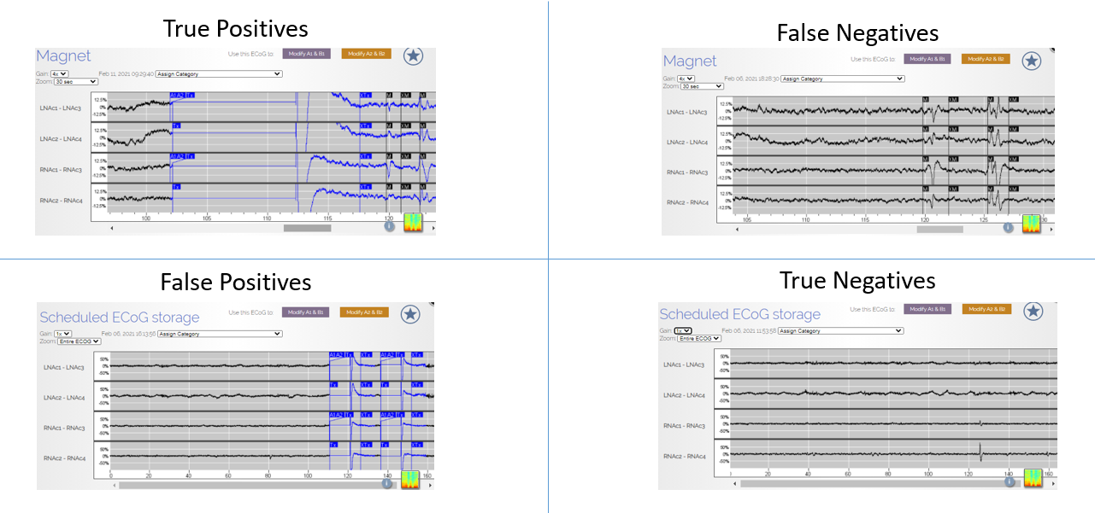
Figure S1 – Example electrographic recordings showing how sensitivity and specificity of our detector was calculated.
To examine the sensitivity and specificity of low-frequency power fluctuations to LOC eating behavior, we first visually reviewed LFP recordings for LOC reported events that also had a detection (True Positive), LOC reported events that did not have a detection (False Negative), awake LFP recordings where detections were observed (False Positive), and awake LFP recordings where no detections were observed (True Negative). Analysis of the sensitivity and specificity of the detector revealed Subject 1’s sensitivity of 82.4% (71.2-90.5% for 95% Confidence Interval) and specificity of 48.3% (42.6-54.1%, 95% CI). For Subject 2, the programmed detector had a sensitivity of 67.8% (54.4-79.4% for 95% CI) and specificity of 58.8% (54.1-63.3%, 95% CI). The accuracy of LOC detection using these more longitudinal recordings of low-frequency was 54.6% for Subject 1 and 59.7% for Subject 2. In general, for both subjects, the sensitivity of detection was high, however, the specificity was lower (Figure S3). This indicates that the neurostimulator detected low-frequency activity associated with the majority of reported LOC events, but that the device also detected increased low-frequency activity during awake LFP recordings. As there were no clear side effects of NAc stimulation, and stimulation bouts were not perceived by these patients, lower specificity for this proof-of-concept study was not deemed a risk factor.
A critical limitation of the above analysis is that it only includes the subset of detections successfully stored. LFP time-locked to user-initiated or scheduled events were always recorded. However, depending on the neurostimulator storage bandwidth, LFP data time-locked to detections may not be stored. Therefore, while all detection timestamps were stored for offline analyses, only a subset of detection-locked LFP data could be saved due to the limited storage capacity of the NeuroPace RNS System (12.5 minutes of 4 channel recordings) prior to subject-initiated transfer of data. As such, LFP analyses during detections is limited to the subgroup successfully stored. Since this is a limitation to the reported sensitivity/specificity analysis, we also compared the number of detections in the minutes to hours around a self-reported LOC versus non-LOC (scheduled, normal, etc) reported events for each subject (Figure S2B). All detections were timestamped and recorded for offline analyses, but the LFP data time-locked to each detection may not have been. Therefore, by quantifying the percentage of detections surrounding LOC eating events vs non-LOC events, we can more comprehensively examine specificity. In both subjects, we observed a significant increase in the number of detections in the hour and minutes before and after LOC eating event was reported compared (determined by magnet swipe t = 0) to non-LOC detections (Figure S2B, Subject 1: 1) LOC event detections (60-30min prior to reporting LOC: 60.75±23.18 detections, 30-60min after reporting LOC: 60.13±26.81 detections) vs. non-LOC detection per 30min window (8.75±1.11 detections), Student’s t-test comparing mean detections, *p<0.05; 2) LOC event detections (30-15min prior to reporting LOC: 31.25±12.10 detections, 15-0min prior to reporting LOC: 32.63±12.5 detections, 0-15min after reporting LOC: 29.25±13.94 detections, 15-30min after reporting LOC: 29±15.57 detections ) vs. non-LOC detection per 15min window (4.38±0.56 detections), Student’s t-test comparing mean detections, *p<0.05. Subject 2: 1) LOC event detections (60-30min prior to reporting LOC: 24±11. detections, 30-60min after reporting LOC: 23.5±14.41 detections) vs. non-LOC detection per 30min window (8.32±3.41 detections), Student’s t-test comparing mean detections, *p<0.05; 2) LOC event detections (30-15min prior to reporting LOC: 14.33±9.14 detections, 15-0min prior to reporting LOC: 15.83±4.22 detections, 0-15min after reporting LOC: 7.5±3.30 detections, 15-30min after reporting LOC: 9.33±4.11 detections) vs. non-LOC detection per 15min window (4.16±1.71 detections), Student’s t-test comparing mean detections, *p<0.05).

Figure S2 – Sensitivity/Specificity Analyses. A) Analysis of the sensitivity and specificity of the detector revealed Subject 1’s sensitivity of 82.4% (71.2-90.5% for 95% Confidence Interval) and specificity of 48.3% (42.6-54.1%, 95% CI). For Subject 2, the programmed detector had a sensitivity of 67.8% (54.4-79.4% for 95% CI) and specificity of 58.8% (54.1-63.3%, 95% CI). B) In addition, we analyzed the number of low-frequency detections throughout the day and observed an increase in the number of detections in the hour, and minutes before and after a reported LOC eating event. Magnet swipe for reporting LOC eating event defined as t = 0.

Clinical Measures

The primary study endpoint is at least 50% of subjects exhibiting a decrease in the number of LOC eating events per week, utilizing the Ecological Momentary Assessment (EMA). Reported below is preliminary EMA data from Subject 1 and 2, as well as additional support from the monthly surveys, and Eating Loss of Control Survey (ELOCS).

1) Ecological Momentary Assessment (EMA): one week out of every month, participants receive a survey at two semi-random times per day (morning and evening) that asks about eating behaviors, including frequency and severity of loss of control. Figures S3.1 and S3.3 display the number LOC eating events per 28 days, which is the endpoint for the study (any reduction in LOC from baseline), for Subject 1 and 2, respectively.

2) Eating Loss of Control Survery (ELOCS): a retrospective survey assessed once per month targeting loss of control frequency and severity. Figures S3.2 and S3.4 for Subjects 1 and 2 display the LOC frequency score and LOC frequency severity based on this 18 item assessment.

Supplemental Figures and Tables

Figure S3.1 - Ecological Momentary Assessment Ratings – Subject 1
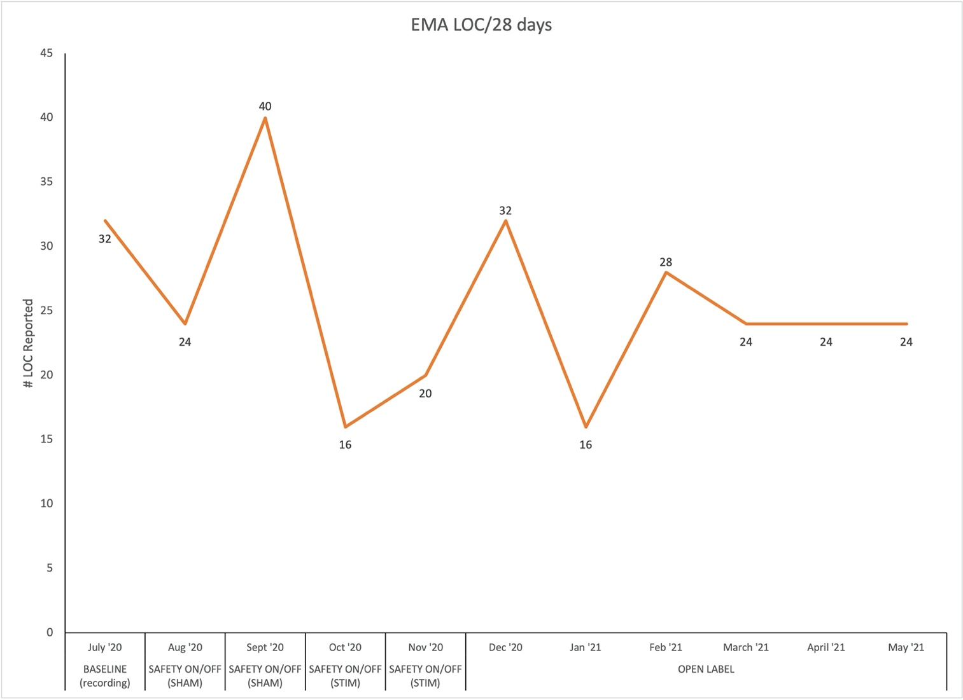
Figure S3.2 - Eating Loss of Control Scale – Subject 1
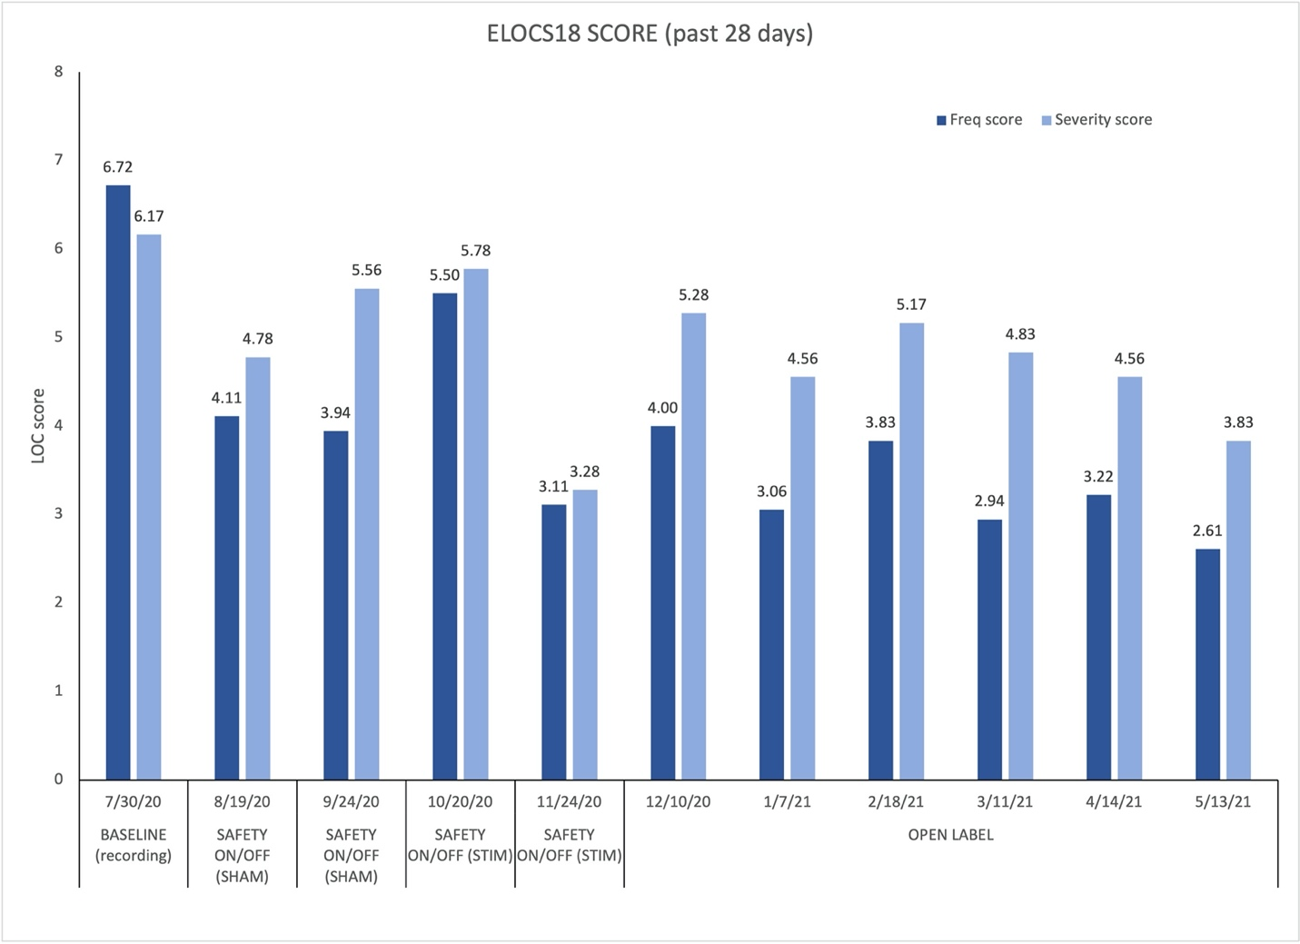

Figure S3.3 - Ecological Momentary Assessment Ratings – Subject 2
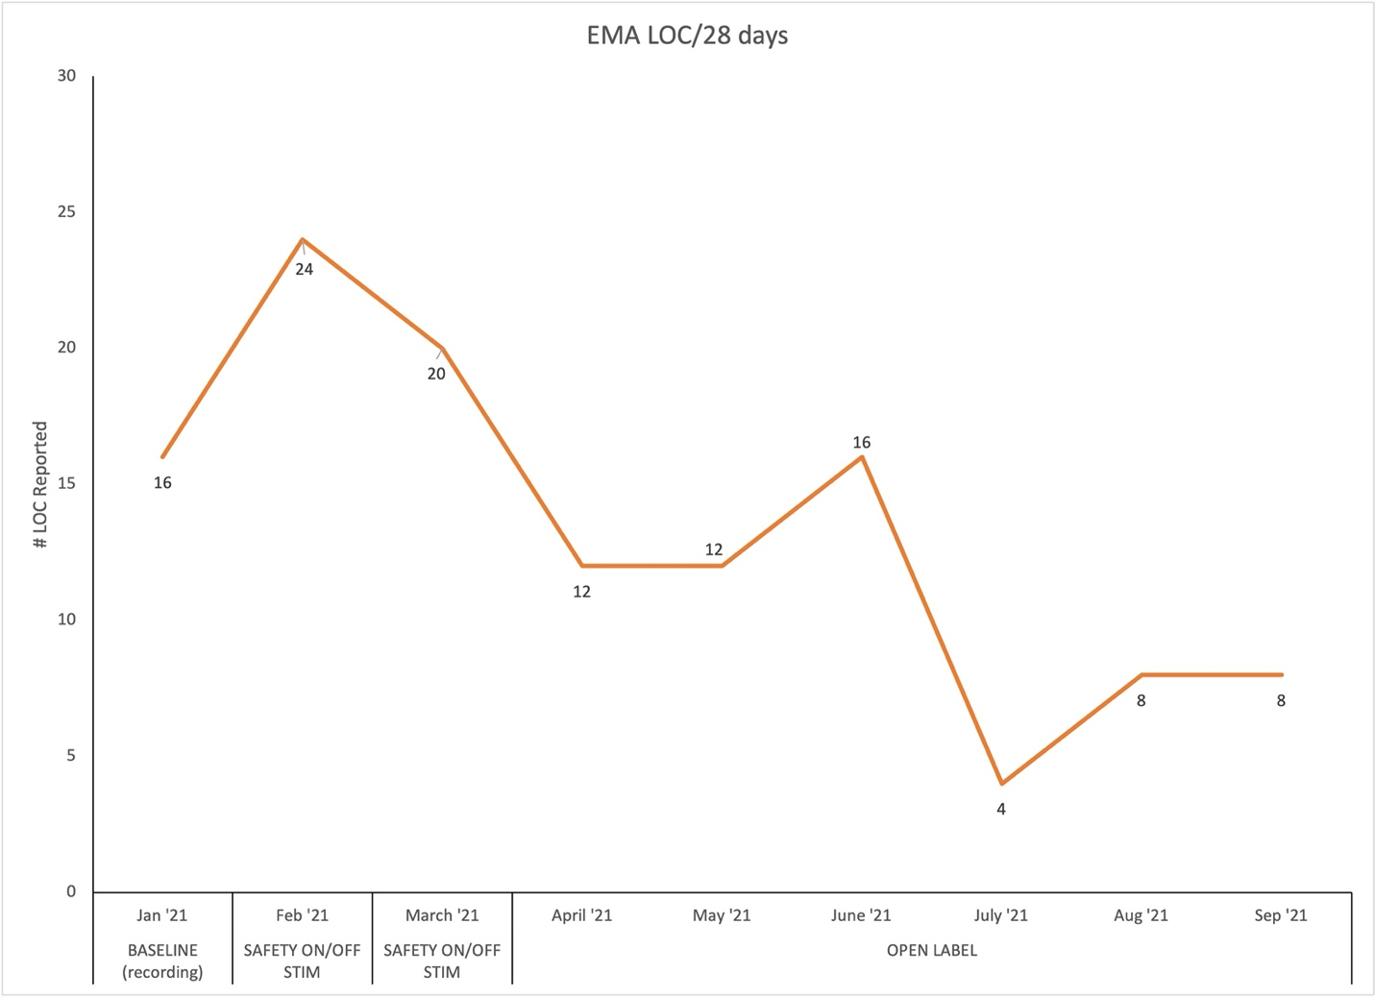

Figure S3.4 - Eating Loss of Control Scale – Subject 2
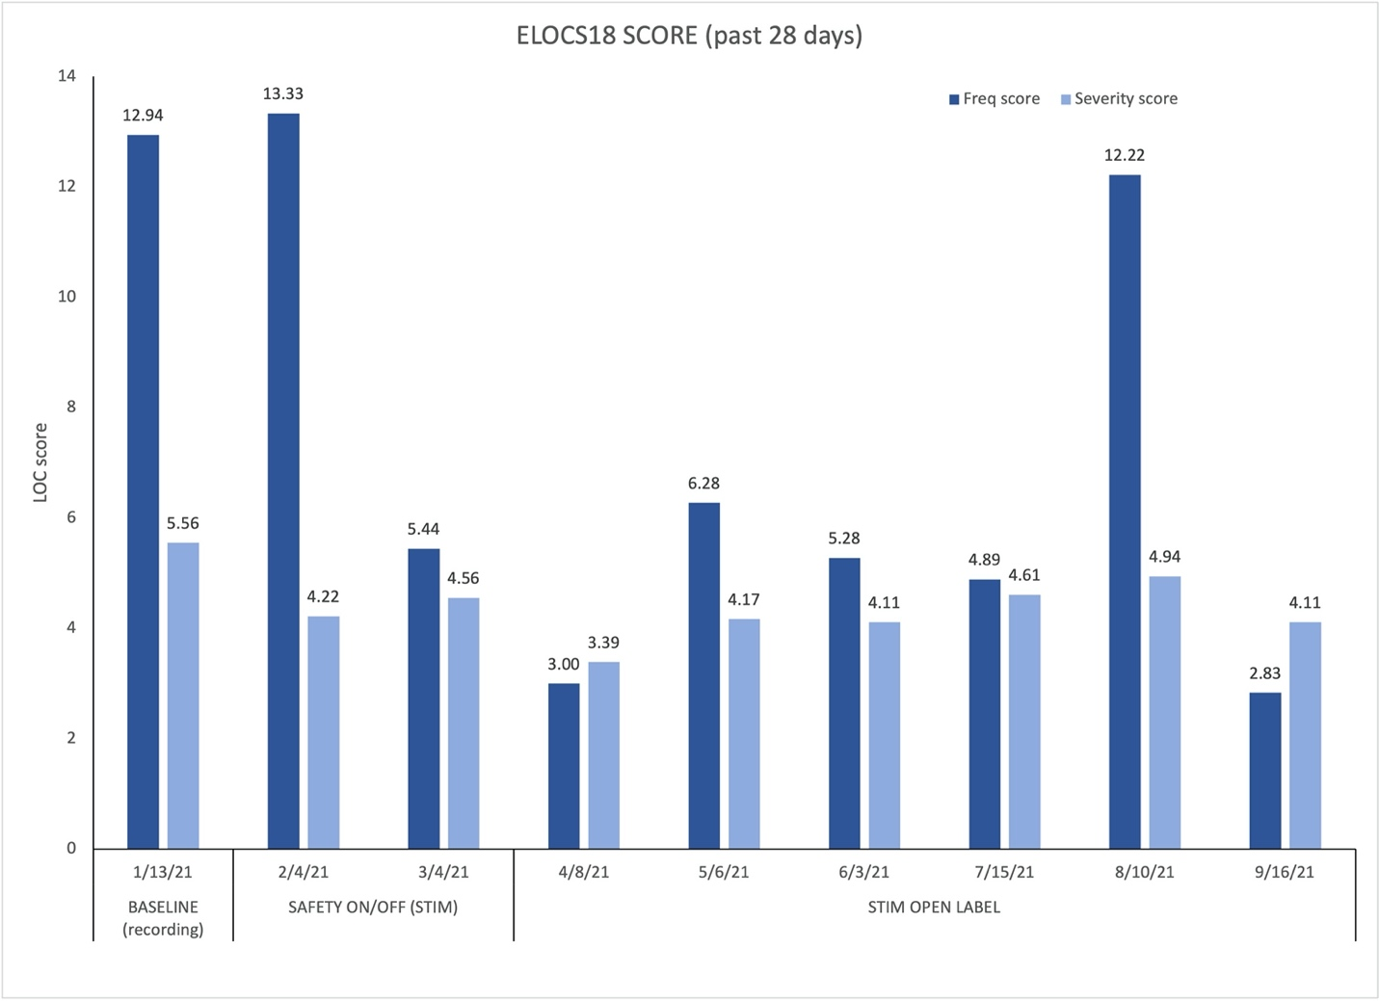

Table S4- Stimulation-Related Adverse Events
Subject # | Days on Intervention | Adverse Event | Relationship to Intervention* | Severity | Serious (Y/N) | Outcome**
1 | 0 | Headache | Definite (surgery) | Moderate | N | RWT
1 | 0 | Incision pain | Definite (surgery) | Moderate | N | RWT
1 | 0 | Edema | Definite (surgery) | Mild | N | RWT
1 | 0 | Anxiety | Possible (surgery) | Moderate | N | RWOT
1 | 8 | Sadness | Not related | Mild | N | RWOT
1 | 20 | Pain behind ear/jaw | Not related | Moderate | N | RWT
1 | 27 | Zoning out | Not related | Mild | N | RWOT
1 | 30 | Insomnia | Possible | Mild | N | RWOT
1 | 102 | "Fluttering"/anxiety | Not related | Mild | N | RWOT
2 | 0 | Headache | Definite (surgery) | Moderate | N | RWT
2 | 0 | Incision pain | Definite (surgery) | Mild | N | RWT
2 | 0 | Edema | Definite (surgery) | Moderate | N | RWT
2 | 1 | Lightheaded | Possible | Mild | N | RWOT
2 | 77 | Swelling legs/feet | Not related | Mild | N | RWT
2 | 84 | Insomnia | Not related | Mild | N | RWOT
* | Definite, Possible, Not Related
** | Outcome: Recovered, without treatment (RWOT); Recovered, with treatment (RWT)

References.

1. Wu H, Adler S, Azagury DE, et al. Brain-Responsive Neurostimulation for Loss of Control Eating: Early Feasibility Study. Neurosurgery 2020;87:1277-88.
2. Barbosa D, Kuijper F, Duda J, et al. The obese state is associated with a perturbed impulsivity circuit in binge-prone females. Under Review 2021.
3. Telch CF, Agras WS. Do emotional states influence binge eating in the obese? Int J Eat Disord 1996;20:271-9.
4. Parker JJ, Rolle CE, Shivacharan R, et al. First-in-human implantation protocol and ambulatory nucleus accumbens region electrophysiologic surveillance paradigm for patient-tailored responsive closed-loop deep brain stimulation for loss of control eating disorder. Under Review 2022.
5. Topalovic U, Aghajan ZM, Villaroman D, et al. Wireless Programmable Recording and Stimulation of Deep Brain Activity in Freely Moving Humans. Neuron 2020;108:322-34 e9.
6. Oostenveld R, Fries P, Maris E, Schoffelen JM. FieldTrip: Open source software for advanced analysis of MEG, EEG, and invasive electrophysiological data. Comput Intell Neurosci 2011;2011:156869.
7. Chiken S, Nambu A. Mechanism of Deep Brain Stimulation: Inhibition, Excitation, or Disruption? Neuroscientist 2016;22:313-22.
8. Ramasubbu R, Lang S, Kiss ZHT. Dosing of Electrical Parameters in Deep Brain Stimulation (DBS) for Intractable Depression: A Review of Clinical Studies. Front Psychiatry 2018;9:302.
9. Thomas GP, Jobst BC. Critical review of the responsive neurostimulator system for epilepsy. Med Devices (Auckl) 2015;8:405-11.

