Supplementary Information

Hyperhomogeneity of hydrogen-disordered ice and its origin: the residual entropy compatible with the disparity in hydrogen bond energy
Masakazu Matsumoto, Takuma Yagasaki, and Hideki Tanaka

In the interest of verifiable research, the data and code used to generate all Figures in both the main text and the supplementary information are available at https://github.com/vitroid/hyperhomogeneity. (Full disclosure will be made after acceptance of the manuscript.)

S1. Distribution of the cumulative interaction of a CO-like crystal
The dipole moment of a carbon monoxide molecule is small and the atomic radii of carbon and oxygen are close to each other, and therefore the CO molecules can invert their orientations in the crystal unless the temperature is very low. The residual entropy of the CO crystal is k_{B}N ln 1.74.[Clayton and Giauque 1932] We here approximate a CO-like molecule as a dipole and place them on the lattice points of the fcc crystal. Orientation of each dipole is randomly chosen from two possible orientations at each lattice point with the constraint of vanishing net polarization. The distance and energy are normalized so that both the nearest-neighbor distance between molecules and the Coulombic interaction at that distance are unity. Figure S1 shows that the standard deviation (SD) of the cumulative Coulombic interaction does not decrease with increasing the distance.

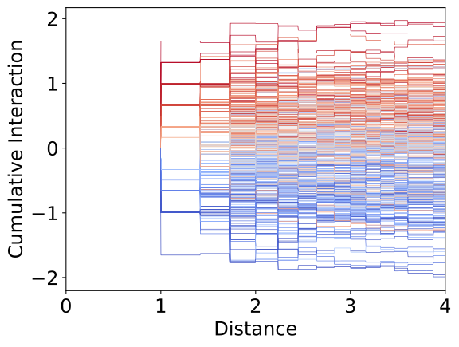

Figure S1. Cumulative Coulombic interaction energy of a CO molecule in the model crystal. The color of each curve is determined by the value at a distance of 1.1.

S2. Cycles passing through a water molecule
In Figure S2, all cycles with n ≤ 12 that pass through the red-colored central molecule in ice Ih are shown. The color of an edge indicates the sum of weights (Eq. 3) of the cycles that the edge belongs to.

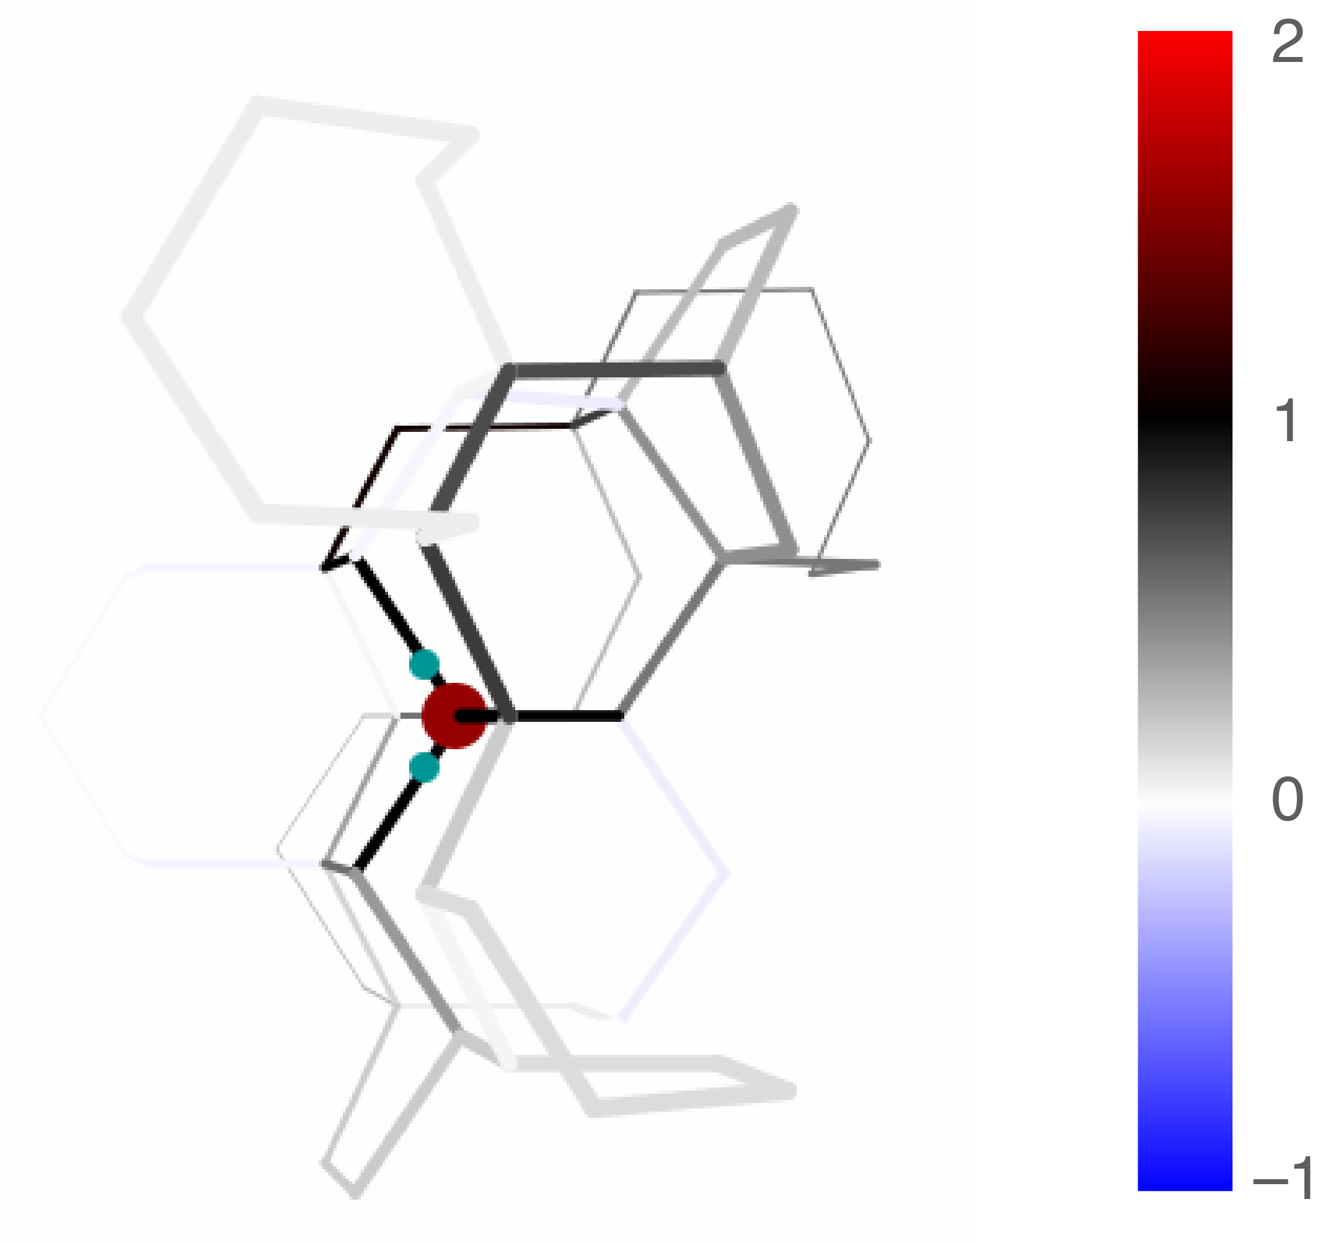
Figure S2. An example of the spatial arrangement of cycles that pass through the central water molecule in ice Ih.

S3. Weighted sum of interactions with cycles
The interactions of a water molecule with the cycles of three types (classified in the main text) are plotted in Figure S3.

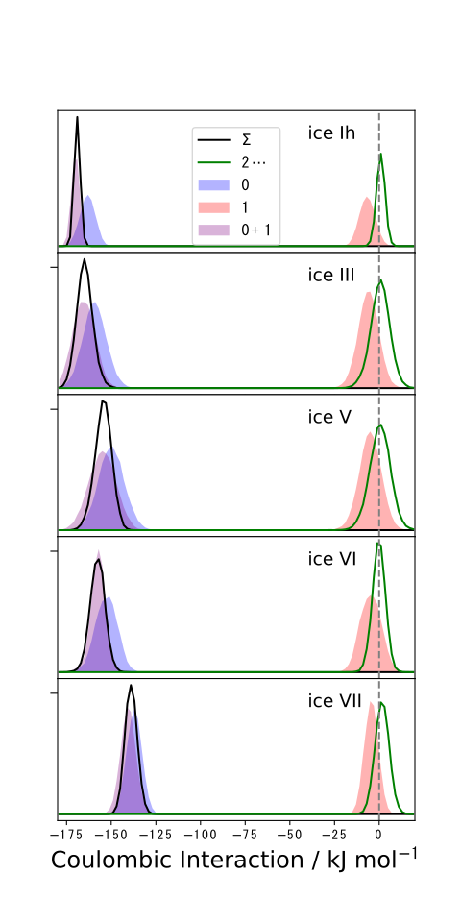

Figure S3. Distribution of the weighted sum of the Coulombic interaction energies between the central molecule and three types of cycles; (a) those incorporating the central molecule in blue, (b) those incorporating the first neighbor molecules of the central molecule in red, and (c) the others with green curves. Violet is the union of (a) and (b). The black curve is the distribution of the binding energy.
S4. Interaction energies of a water molecule with cycles of different sizes
The distributions of the cumulative interaction energy between a water molecule and type (a) cycles with different sizes are plotted in Figure S4. The mean value and the width of the distribution are insensitive to the size of cycles.

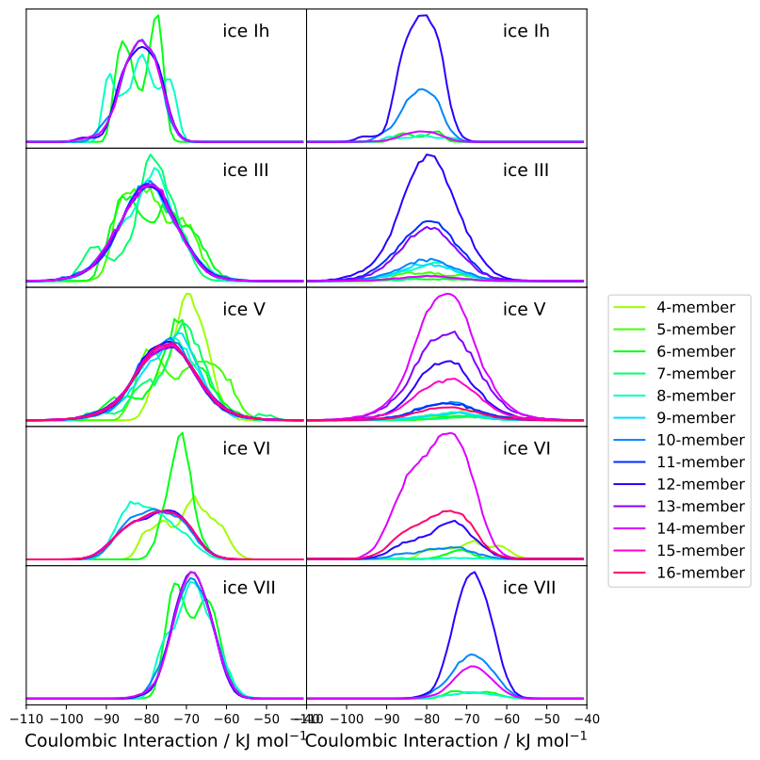
Figure S4. Coulombic interactions of a water molecule with cycles that pass through the molecule are classified by cycle size. Left column is a normalized distribution for each size. In the right column, the weight is multiplied to the frequency of occurrence of each cycle so that the simple accumulation of all the distribution recovers the blue distribution in Figure S3. (The energy must be doubled because a water molecule consists of two dipoles.)

S5. Cumulative molecule-cycle interaction energies for molecules in different environments
The cumulative Coulombic interaction energies of a water molecule with cycles for several ice phases are classified into groups according to the crystallographic arrangements of the molecule. The large variation in interaction energy of the central molecule of a group at the short distance is reduced by the disordered orientations of the intervening molecules but the split of the interaction energy between groups remains at long distances. The bottom panels display the cumulative interaction energy of two-dimensional bilayer ice.[Koga, Zeng, & Tanaka 1997] MD simulations have shown that this ice forms in a narrow space between two walls spontaneously satisfying the ice rules. The width of the distribution of the cumulative interaction energy of the two-dimensional ice phase is comparable to those of three-dimensional ice phases.

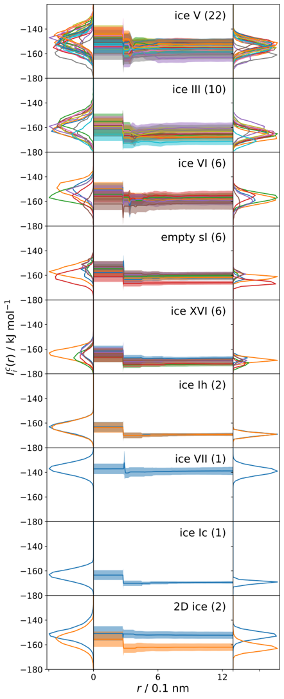
Figure S5. Cumulative Coulombic interaction energies of a water molecule with cycles for several ice phases classified by the crystallographic arrangements of the molecule. The left and right panels are the distributions of the cumulative energies at r = 0 and 1.3 nm. The number of crystallographically different arrangements is shown in parenthesis.

S6. Tessellation of a directed graph of ice into cycles
A graph of the hydrogen-bond network of ice that satisfies the ice rules can be easily tessellated so that every edge belongs to any one of the cycles. This means that the sum of the interactions between a water molecule and surrounding dipoles can be replaced with the simple sum of the interactions with surrounding cycles. This is another way of expressing a directed graph of ice as a set of cycles where all the weights are unity, but we did not adopt it.
There had been no method to tessellate the graph of ice into cycles without huge cycles such as those consisting of more than 30 vertices. This may lead to the misconception that the long-range correlations in ice are the result of such huge cycles. Another problem is that a graph can be tessellated in many different ways. The method presented in the main text overcomes both problems.

