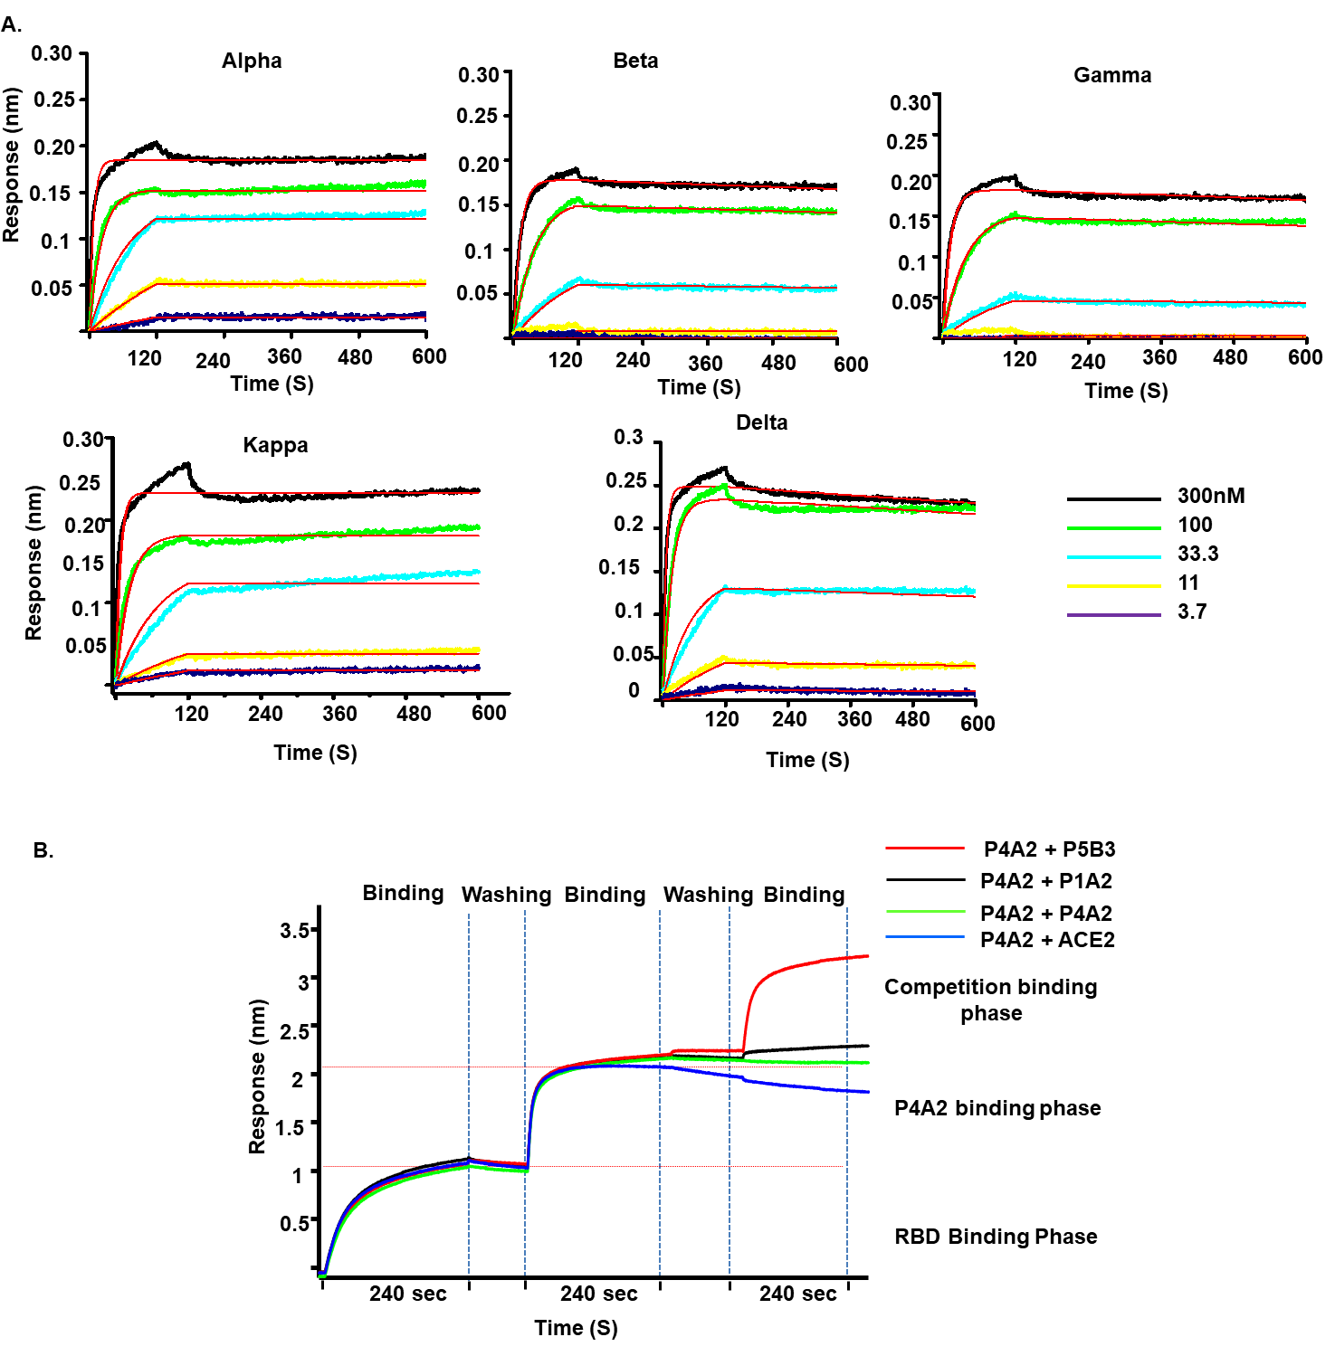
Figure S1. Binding kinetics of mAb P4A2 to RBDs from various VOC by biolayer interferometry (BLI). (A), P4A2 was immobilized on anti-mouse Fc biosensors and was tested using three fold serial dilutions of RBD (starting with 300 nM and going down to 3.3 nM; the five different concentrations were tested are indicated). Data shown is after the reference was subtracted and aligned using Octet Data Analysis software v11.1 (Forte Bio). Curve fitting was done with a 1:1 binding model, and K_{on}, K_{off}, and K_{d} values were calculated using a global fit. (B), The epitope specificity of P4A2 was evaluated for epitope competition using BLI. RBD-Fc was captured using anti-human Fc biosensor and saturated with P4A2 indicated mAbs at a concentration of 40 μg/ml and unbound P4A2 was washed, followed by incubation with 20 μg/ml of ACE2, P4A2 and P5B3 (binds to a topologically distinct, non-competing epitope and served as a control). No binding signal was observed for P4A2 and ACE2.

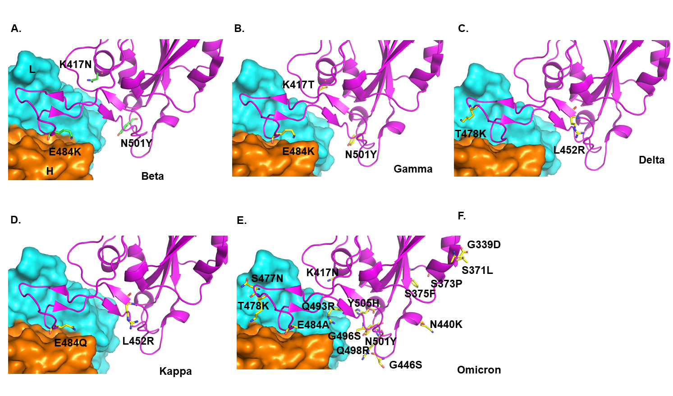

Figure S2. Mutations in RBD associated with different VOC do not affect binding to P4A2 Fab. Using the crystal structure, computational models of P4A2 Fab in complex with the RBD from (A) Beta (B) Gamma (C) Delta (D) Kappa and (E) Omicron VOC were generated. These models show that, for all the VOCs, there are no mutations in the residues that interact with the P4A2 through their side-chain and hence these mutations will not adversely impact P4A2 binding. E484 is mutated to Lys, Gln or Ala in some of the VOCs, but it forms interactions with the P4A2 Fab paratoope through the backbone atoms and not through the side chain.

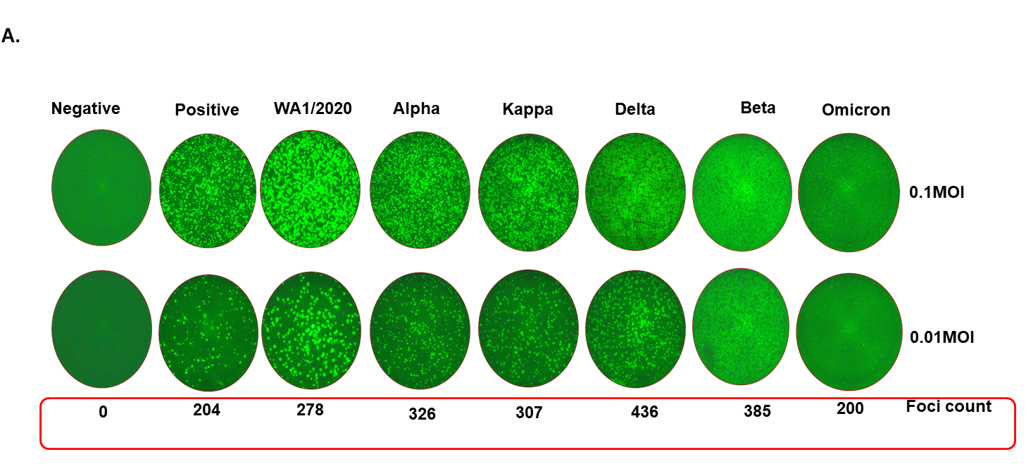
Figure S3. Immunofluorescence intensity of P4A2 binding to live virus infected VERO E6 cells The binding of P4A2 to the spike proteins expressed on the surface of Vero E6 cell infected with various VOC was assessed by immunofluorescence microscopy. Vero E6 cells were infected at MOI of 0.1 and 0.01. The number of foci at 0.1 MOI were too numerous to be counted. The foci count for the MOI 0.01 are indicated. P4A2 were used as the primary antibody (diluted 1 in 2000) followed by anti-mouse Alexa 488 as the secondary antibody. The foci were counted using AID ELISPOT 8.0 software.

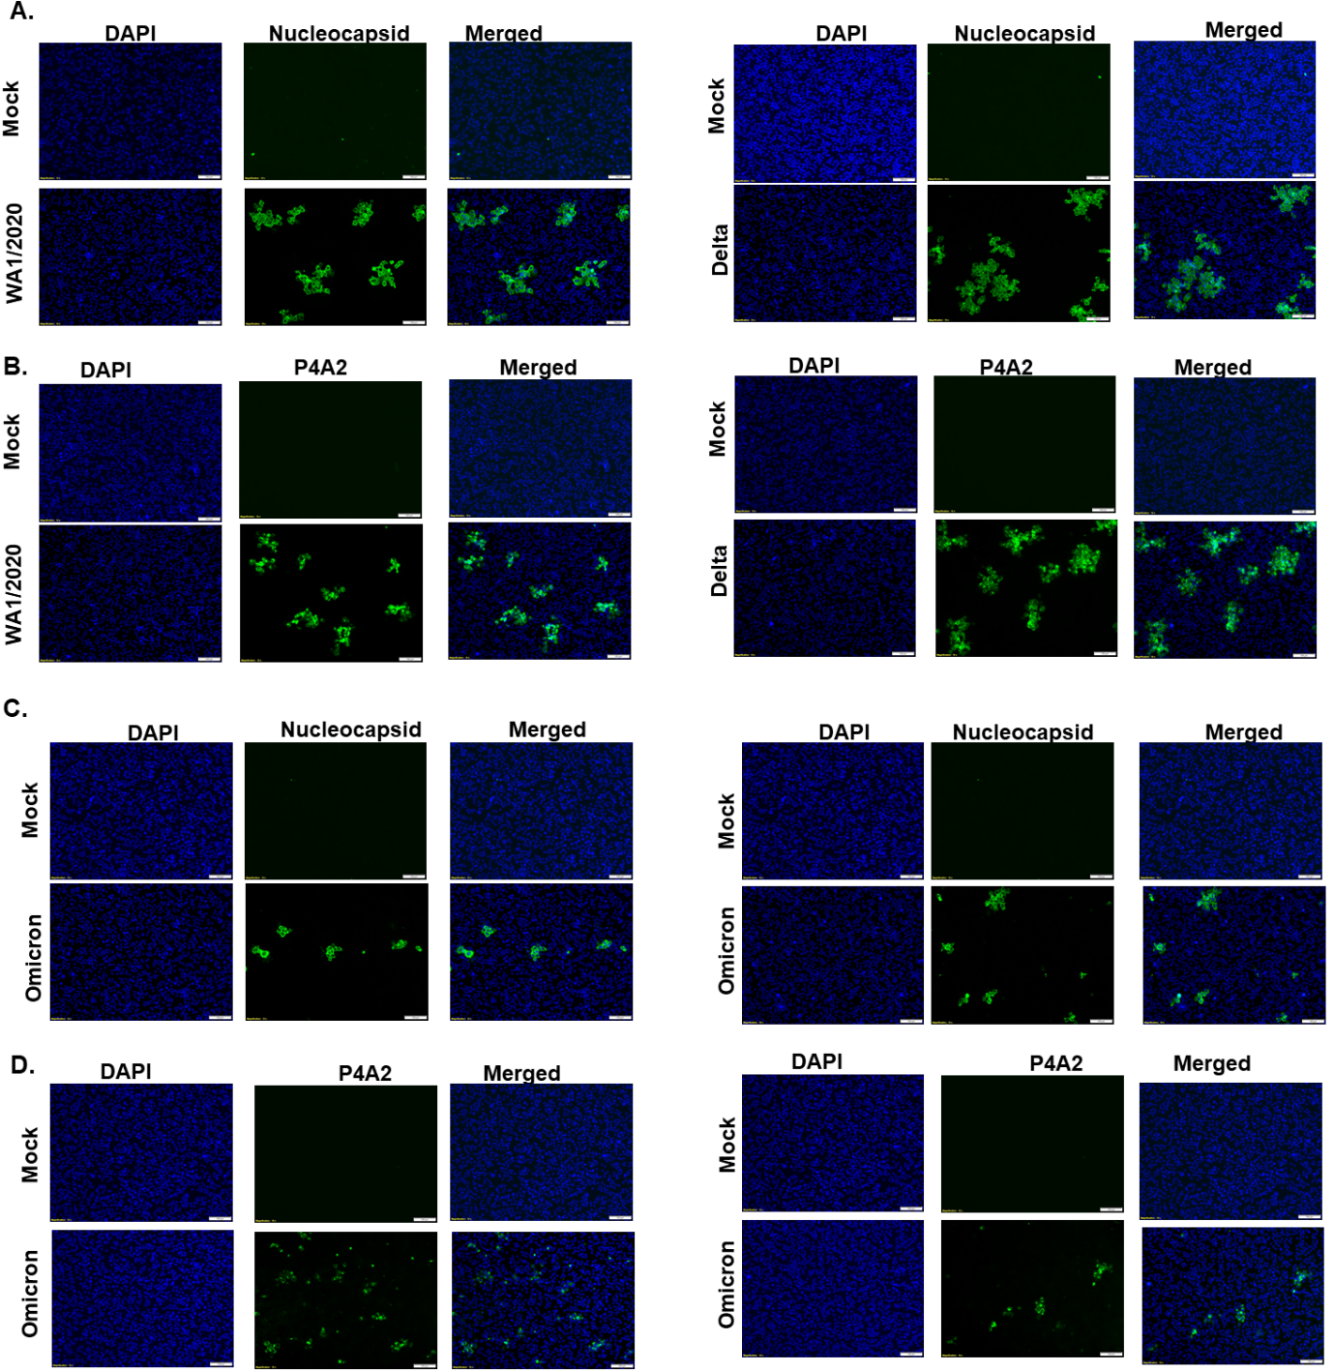
Figure S4. Immunofluorescence staining of P4A2 binding to live virus infected VERO E6 cells Vero E6 cells were infected with Omicron variant of SARS CoV-2 at MOIs 0.1 and 0.01. Cells were fixed with 7.4% formaldehyde 32 hours following infection with Omicron, stained with mAb P4A2 and observed under an immunofluorescence microscope. DAPI was used to stain nuclei. Images were captured at 10× magnification. (A) Representative image of Wuhan strain stained with nucleocapsid antibody and P4A2 antibody, (B) Delta strain stained with nucleocapsid antibody and P4A2 antibody, (C) Omicron infection at 0.1 MOI stained with nucleocapsid antibody and P4A2 antibody and (D) Omicron infection at 0.01 MOI stained with nucleocapsid antibody and P4A2 antibody. Scale bar is 100 µm.

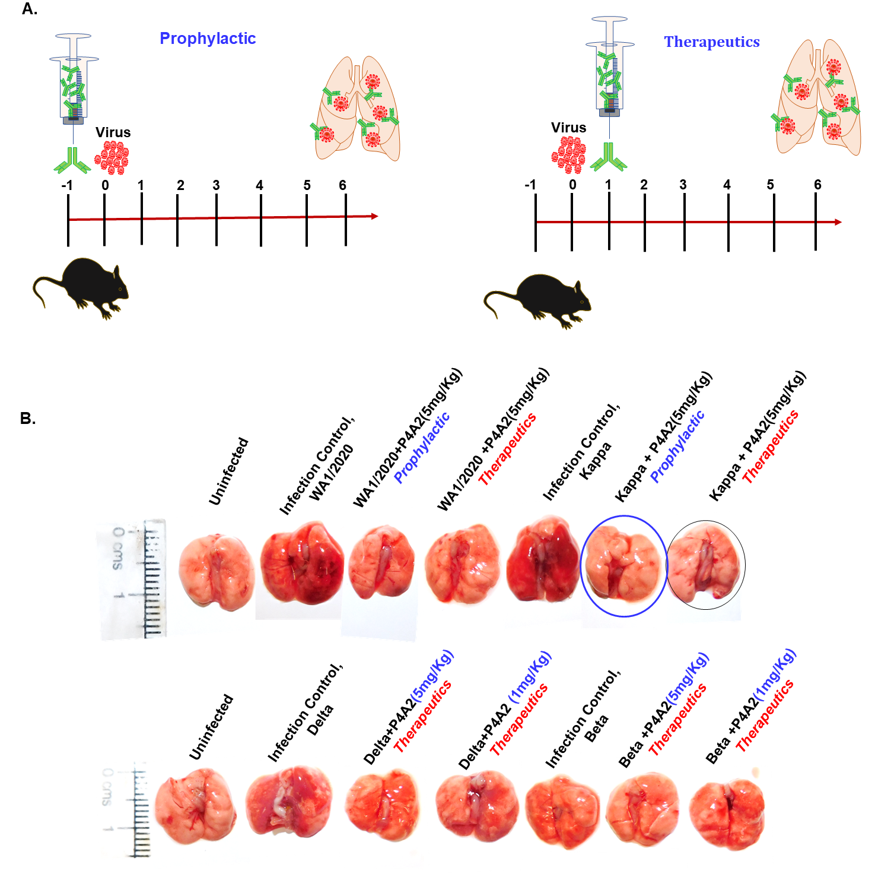

Figure S5. Gross morphology of lungs excised from uninfected or infected mice showing pneumonitis and inflammation. (A) Schematic representation of the animal challenge experiment performed with prophylactic or therapeutic intervention of P4A2 antibody. Briefly, animals challenged with Wuhan, Kappa, Delta or Beta SARS-CoV-2 strain (10⁵ pfu/ mice) were given prophylactic (1 day prior to challenge) or therapeutic dose (6-12 hours post challenge). (B) Representative images of the excised lung showing inflammation and pneumonitis.

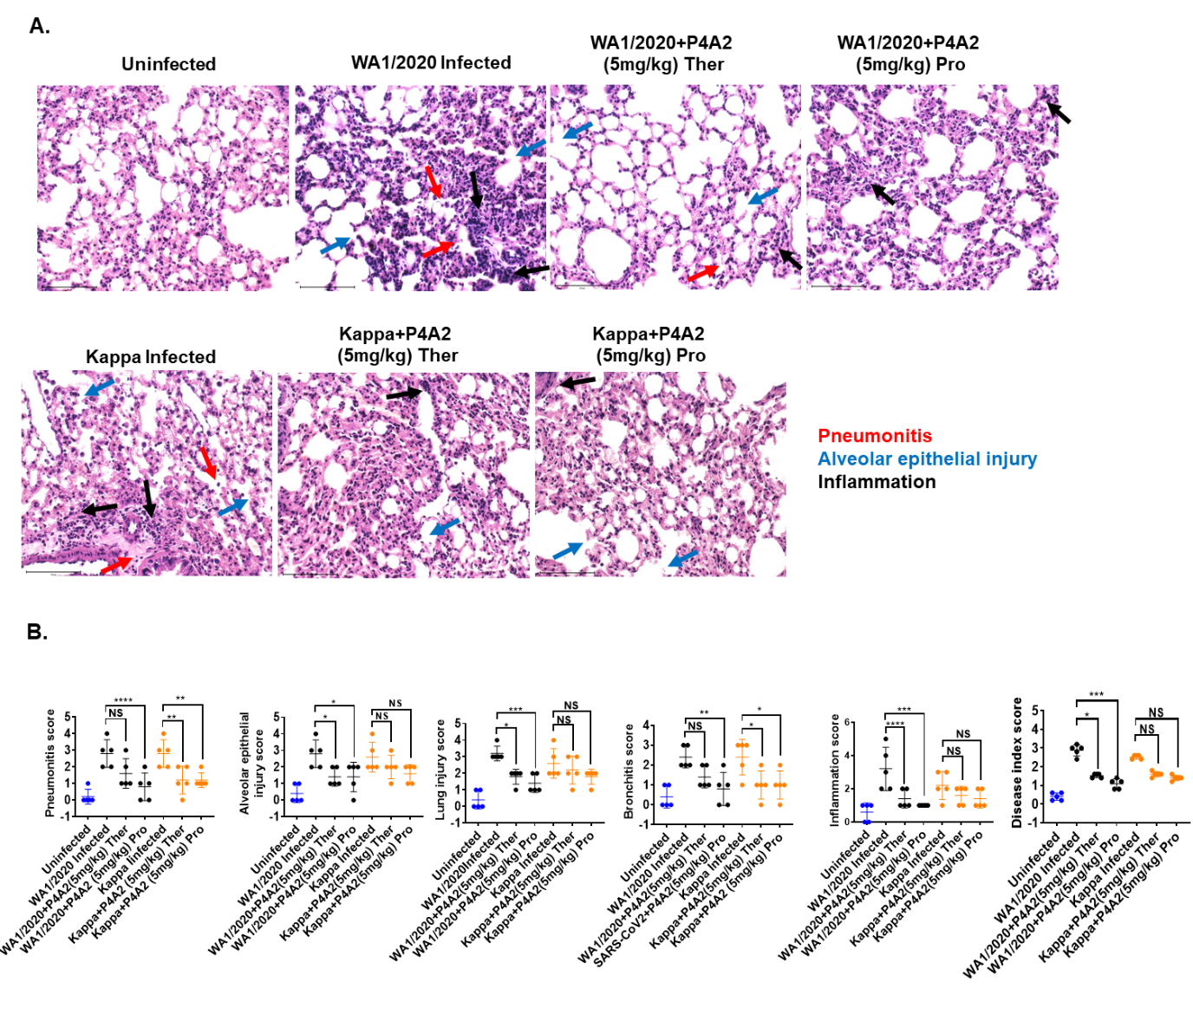
Figure S6. Pulmonary pathology of SARS-CoV-2 infected hACE2 mice in prophylactic treatment. Animals challenged with SARS-CoV-2 with or without P4A2 antibody were euthanized on day 6 post infection and their left lower lobe of their lung were fixed in 10% formalin solution and used for H & E staining. (A) Representative transverse section of the lung. Images at 40 X showing pneumonitis (red arrow), alveolar epithelial injury (blue arrow) and inflammation (black arrow). The stained sections were assessed by blinded-trained histologist on the scale of 0-5 (where 0 represents no feature, while 5 represents the maximum score). (B) The histological scores for each pulmonary pathology was plotted as bar graph with mean ± SEM. The disease index score was calculated by taking the average score of all pulmonary pathologies (pneumonitis, alveolar epithelial injury and inflammation). Ther, therapeutic; Pro, prophylactic. NS, not statistically significant.

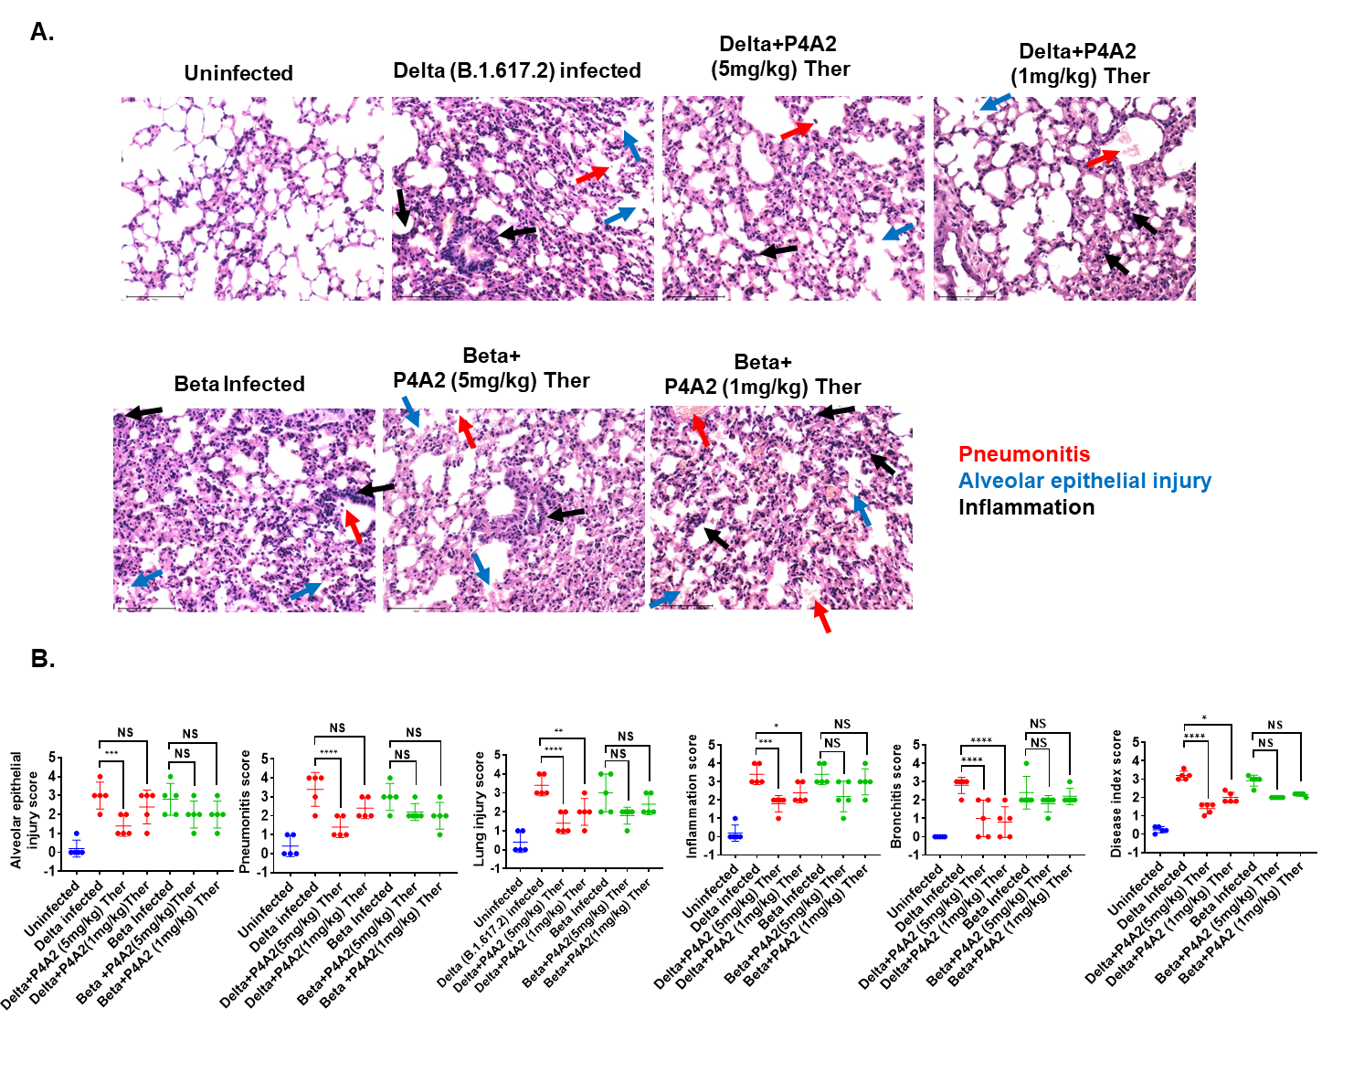
Figure S7. Pulmonary pathology of SARS-CoV-2 infected hACE2 mice in therapeutic group. Lung samples from euthanized animals 6 days post challenge were fixed in 10% formalin solution and stained with H & E. (A) Representative transverse section of the H & E stained lung images at 40 X showing pneumonitis (red arrow), alveolar epithelial injury (blue arrow) and inflammation (black arrow). The stained sections were assessed by blinded-trained histologist on the scale of 0-5 (where 0 represents no feature, while 5 represents the maximum score). (B) The histological scores for each pulmonary pathology was plotted as bar graph with mean ± SEM. The disease index score was calculated by taking the average score of all pulmonary pathologies. Ther, therapeutic; NS, not statistically significant.

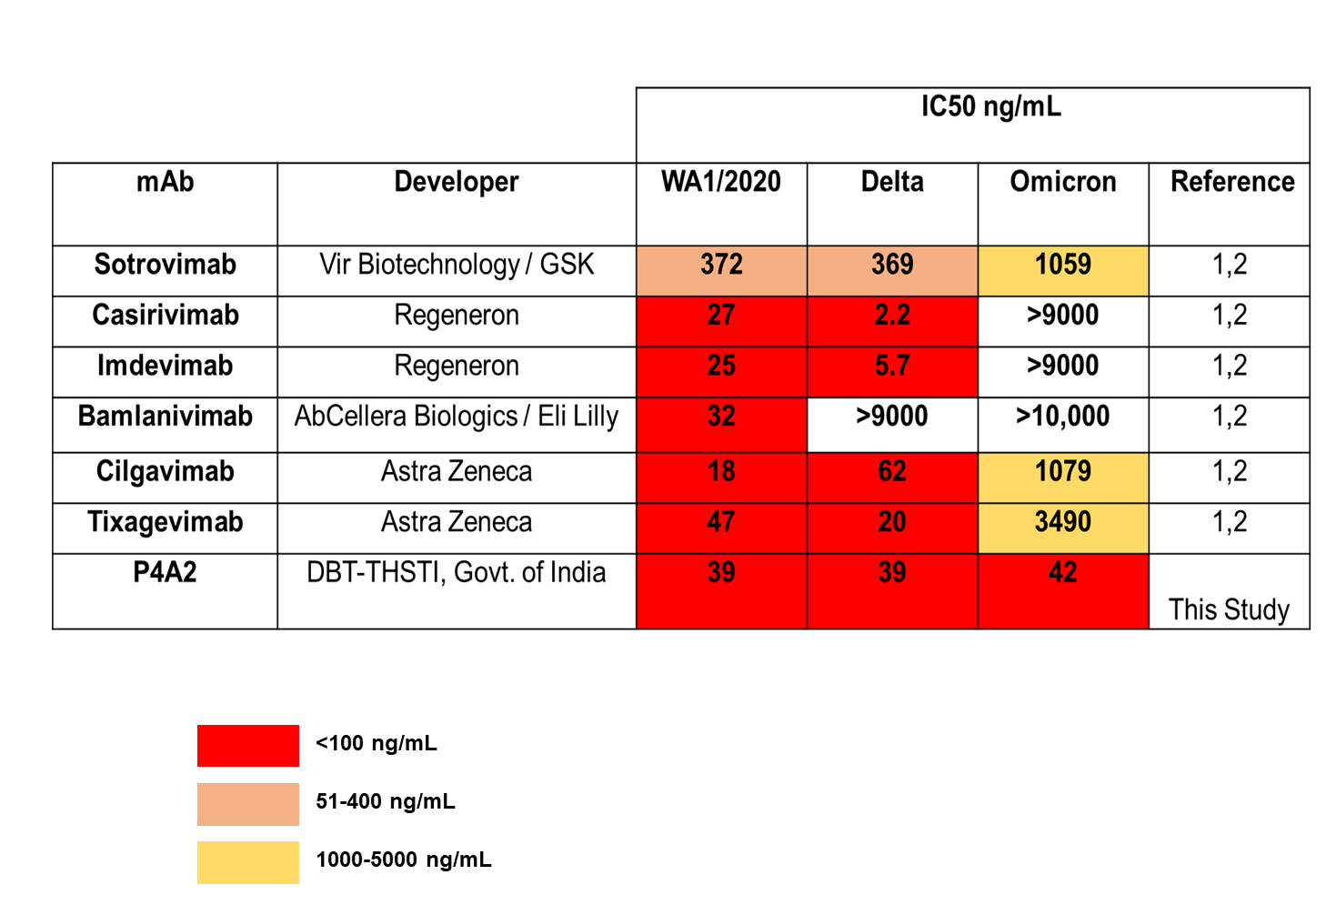
Figure S8. Comparative neutralization potential of P4A2 mAb with the FDA approved mAbs. Data of FDA approved mAbs was taken from VanBlargan et al; 2022¹, Aggarwal et al; 2022². Different color coding shows their differential neutralization potential against tested VOCs.

Supplementary Table 1. Crystallographic data and refinement statistics for P4A2 Fab:Spike-RBD complex.
Data collection statistics
Wavelength (Å) | 0.97926
Space Group | P3₁2₁
Cell Constants (Å) | 85.3 85.3 205.2
Resolution (Å) | 3.0 Å (3.24-3.0)ª
R_{merge}^{b} | 9.4 (69.6)
I/σI | 7.3 (2.1)
Completeness (%) | 100 (100)
Redundancy | 9.1 (9.1)
CC(1/2) | 0.975 (0.79)
Refinement
Resolution (Å) | 73.88-3.0 Å
No. of Reflections | 17972
R_{work}^{c}/R_{free} | 23.0/28.2
No. of atoms
Protein | 4567
Water | 92
R. M. S. deviations
Bond lengths (Å) | 0.004
Bond angles (°) | 0.722
ªValues in parentheses are for the highest resolution shell.
^{b}R_{merge} = Σ|I–〈I〉|/ΣI, where I is the integrated intensity of a given reflection.
^{c}R_{work} = Σ||F_{obs}| – |F_{calc}||/Σ |F_{obs}|. R_{free} was calculated using 7% of data excluded from refinement.

