Supplementary information
Table 1 Subordinate to the industry, full names and abbreviations of sectors
Subordinate to the industry | Full name | Abbreviations
Primary industry | Agricultural, forestry, animal husbandry and fishery products and services | AGR
Secondary industry | Coal mining and selection products | COL
Secondary industry | Oil and gas extraction products | OLM
Secondary industry | Metal mining and dressing products | MET
Secondary industry | Nonmetallic ore and other mineral mining and dressing products | NMT
Secondary industry | Food and tobacco | FOD
Secondary industry | Textile | TXT
Secondary industry | Textile, clothing, shoes, hats, leather, down and their products | LEA
Secondary industry | Wood products and furniture | WOD
Secondary industry | Paper printing and cultural and educational sports goods | PAP
Secondary industry | Petroleum, coking products and processed nuclear fuel products | OIL
Secondary industry | Chemical products | CHM
Secondary industry | Nonmetallic mineral products | NMF
Secondary industry | Metal smelting and calendering products | MSR
Secondary industry | Metal products | MTF
Secondary industry | General equipment | GNE
Secondary industry | Special equipment | SPE
Secondary industry | Traffic and transportation equipment | TRE
Secondary industry | Electrical machinery and equipment | ETE
Secondary industry | Communication equipment, computers and other electronic equipment | CME
Secondary industry | Instrument and metre | IST
Secondary industry | Other manufactured products | OTE
Secondary industry | Scrap waste | WST
Secondary industry | Metalwork, machinery and equipment repair services | RPR
Secondary industry | Production and supply of electricity and heat | ELT
Secondary industry | Gas production and supply | HET
Secondary industry | Water production and supply | WAT
Secondary industry | Construction | CON
Tertiary industry | Wholesale and Retail | SAL
Tertiary industry | Transportation, warehousing and postal services | TSP
Tertiary industry | Accommodation and Meals | ACC
Tertiary industry | Information transmission, software and information technology services | INF
Tertiary industry | Financial | FIN
Tertiary industry | The real estate | RLE
Tertiary industry | Rental and commercial services | RNT
Tertiary industry | Scientific research and technical services | RES
Tertiary industry | Water conservancy, environment and public facilities management | PUB
Tertiary industry | Resident services, repairs and other services | RSS
Tertiary industry | Education | EDU
Tertiary industry | Health and social work | HLT
Tertiary industry | Culture, sports and entertainment | CLT
Tertiary industry | Public administration, social security and social organization | ADM
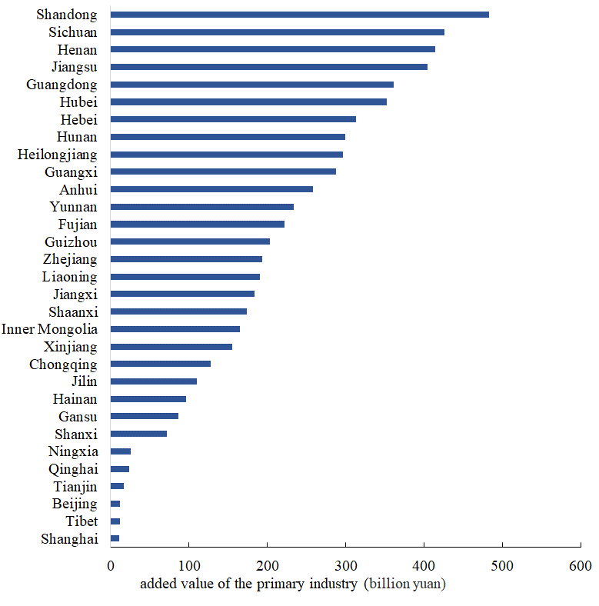
Fig. 1 Added value of the primary industry in China in 2017 (billion yuan)
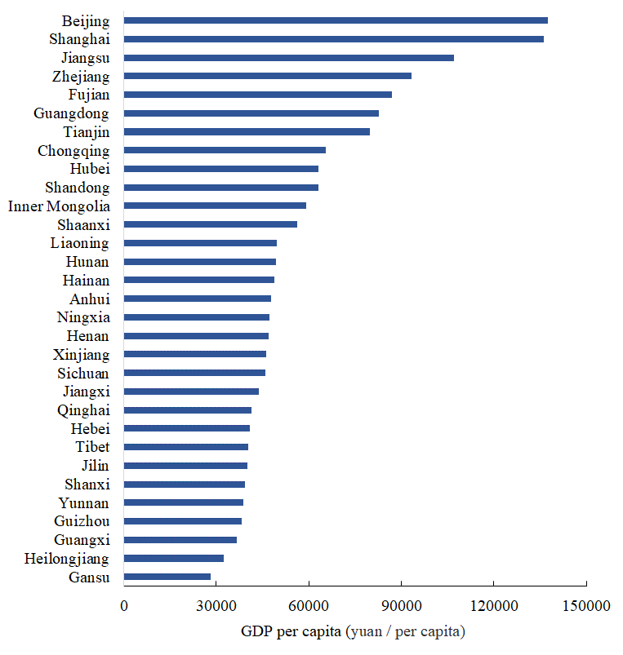
Fig. 2. GDP per capita in China in 2017 (yuan/per capita)

Fig. 3 Region-specific sector telecoupling in 2012 and 2015

