Growth and autolysis of Kluyveromyces marxianus stimulated with lactate provides insights into symbiosis
Shou-Chen Lo^{1*}, Chia-Yin Yang¹, Dony Chacko Mathew², and Chieh-Chen Huang^{1,3,4*}
¹Department of Life Sciences, National Chung Hsing University, Taichung, 402, Taiwan
² Washington Senior High School, Taichung, 406, Taiwan
³ Program in Microbial Genomics, National Chung Hsing University, Taichung, 402, Taiwan
⁴Innovation and Development Center of Sustainable Agriculture, National Chung Hsing University, Taichung, 402, Taiwan
*Cocorresponding authors: Chieh-Chen Huang, Ph.D., and Shou-Chen Lo, Ph.D.
E-mail addresses: cchuang@dragon.nchu.edu.tw (C.C.H.) and scl@dragon.nchu.edu.tw (S.C.L.)
Mailing address: Life Sciences Building 4F. R.403, No.145, Xingda Rd., Taichung
402, Taiwan
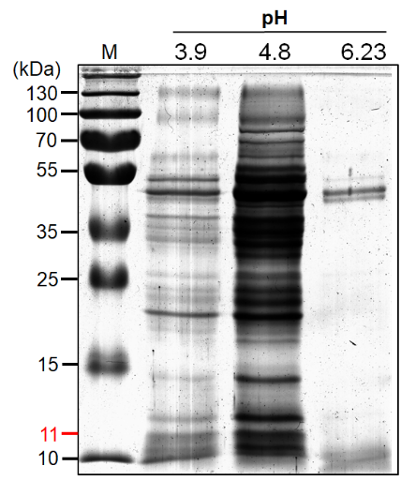
Figure S1. The SDS-PAGE analysis of 20 folds concentrated proteins from YNL culture filtrate at pH 3.9, pH 4.8 and pH 6.23.

Supplementary Table S1. LC-MS/MS analysis of the 37 kDa and 27 kDa proteins from SDS-PAGE.
Molecular weightª | Protein name^{b} | Matched sequences^{c}
37 kDa | Glyceraldehyde 3-phosphate dehydrogenase 1 in Kluyveromyces marxianus (P84998) | 1 MVSIAINGFG RIGRLVLRIA LERKNIDVVA INDPFISVDY AAYMFKYDST  51 HGKYKGEVSH DGSNLIINGK KVAVFQEKDP ATLPWGKLGV DIAVDSTGVF  101 KELDSAQKHI DAGAKKVVIT APSKTAPMFV VGVNEDKYNG EKIVSNASCT  151 TNCLAPIAKI INDEFGIEEG LMTTVHSITA TQKTVDGPSH KDWRGGRTAS  201 GNIIPSSTGA AKAVGKVLPE LQGKLTGMAF RVPTTDVSVV DLTVKLVKAA  251 TYDEIKAAVK KVSEGKLKDV VGYTEDAVVS SDFLGDTHST IFDAAAGIQL  301 SPKFVKLVAW YDNEYGYSTR VVDLVEHVA
27 kDa | Glyceraldehyde 3-phosphate dehydrogenase 1 in Kluyveromyces marxianus (P84998) | 1 MVSIAINGFG RIGRLVLRIA LERKNIDVVA INDPFISVDY AAYMFKYDST  51 HGKYKGEVSH DGSNLIINGK KVAVFQEKDP ATLPWGKLGV DIAVDSTGVF  101 KELDSAQKHI DAGAKKVVIT APSKTAPMFV VGVNEDKYNG EKIVSNASCT  151 TNCLAPIAKI INDEFGIEEG LMTTVHSITA TQKTVDGPSH KDWRGGRTAS  201 GNIIPSSTGA AKAVGKVLPE LQGKLTGMAF RVPTTDVSVV DLTVKLVKAA  251 TYDEIKAAVK KVSEGKLKDV VGYTEDAVVS SDFLGDTHST IFDAAAGIQL  301 SPKFVKLVAW YDNEYGYSTR VVDLVEHVA
ªThe protein bands that were excised from the SDS-PAGE gel.
^{b}The names and accession numbers of the matched proteins in NBCI are presented.
^{c}The matched peptides are shown in bold, and the acid cleavage sites (aspartic acid-proline, D-P) are underlined.

Supplementary Table S2. The identified proteins from lactate cultured Kluyveromyces marxianus medium by LC-MS/MS analysis.
Metabolism | UniProt accession number | Protein name | Gene Ontology (Biological process)
Tricarboxylic acid cycle | W0TEG9 | Malate dehydrogenase (EC 1.1.1.37) | carbohydrate metabolic process [GO:0005975]; malate metabolic process [GO:0006108]; tricarboxylic acid cycle [GO:0006099]
 | W0TAI6 | Malate dehydrogenase (EC 1.1.1.37) | carboxylic acid metabolic process [GO:0019752]; gluconeogenesis [GO:0006094]; protein import into peroxisome matrix [GO:0016558]; tricarboxylic acid cycle [GO:0006099]
 | W0TJM6 | Fumarate hydratase (EC 4.2.1.2) | double-strand break repair [GO:0006302]; fumarate metabolic process [GO:0006106]; tricarboxylic acid cycle [GO:0006099]
 | W0THE4 | Malate synthase (EC 2.3.3.9) | glyoxylate cycle [GO:0006097]; tricarboxylic acid cycle [GO:0006099]
 | W0TBI1 | Isocitrate dehydrogenase [NADP] (EC 1.1.1.42) | isocitrate metabolic process [GO:0006102]; tricarboxylic acid cycle [GO:0006099]
 | W0TGG7 | Isocitrate dehydrogenase [NAD] subunit, mitochondrial | isocitrate metabolic process [GO:0006102]; tricarboxylic acid cycle [GO:0006099]
 | W0T7K6 | Aconitate hydratase, mitochondrial (Aconitase) (EC 4.2.1.-) | mitochondrial genome maintenance [GO:0000002]; tricarboxylic acid cycle [GO:0006099]
 | W0TFA8 | Citrate synthase | propionate catabolic process, 2-methylcitrate cycle [GO:0019629]; tricarboxylic acid cycle [GO:0006099]
 | W0T883 | Succinate--CoA ligase [ADP-forming] subunit alpha, mitochondrial (EC 6.2.1.5) (Succinyl-CoA synthetase subunit alpha) (SCS-alpha) | succinyl-CoA metabolic process [GO:0006104]; tricarboxylic acid cycle [GO:0006099]
 | W0T4J0 | Succinate--CoA ligase [ADP-forming] subunit beta, mitochondrial (EC 6.2.1.5) (Succinyl-CoA synthetase beta chain) (SCS-beta) | succinyl-CoA metabolic process [GO:0006104]; tricarboxylic acid cycle [GO:0006099]
 | W0TKL8 | Succinate dehydrogenase [ubiquinone] iron-sulfur subunit, mitochondrial (EC 1.3.5.1) | tricarboxylic acid cycle [GO:0006099]
 | W0T7K3 | Isocitrate dehydrogenase [NAD] subunit, mitochondrial | tricarboxylic acid cycle [GO:0006099]
 | W0TDY2 | 2-oxoglutarate dehydrogenase E1 component | tricarboxylic acid cycle [GO:0006099]
Glycolysis/gluconeogenesis | W0TAI6 | Malate dehydrogenase (EC 1.1.1.37) | carboxylic acid metabolic process [GO:0019752]; gluconeogenesis [GO:0006094]; protein import into peroxisome matrix [GO:0016558]; tricarboxylic acid cycle [GO:0006099]
 | W0TF96 | Fructose-bisphosphatase (EC 3.1.3.11) | cellular response to glucose starvation [GO:0042149]; gluconeogenesis [GO:0006094]; reactive oxygen species metabolic process [GO:0072593]
 | W0TD31 | Phosphoenolpyruvate carboxykinase (ATP) (EC 4.1.1.49) | gluconeogenesis [GO:0006094]
 | W0T3B0 | Pyruvate carboxylase (EC 6.4.1.1) | gluconeogenesis [GO:0006094]; pyruvate metabolic process [GO:0006090]
 | W0T3P9 | Phosphotransferase (EC 2.7.1.-) | cellular glucose homeostasis [GO:0001678]; fructose 6-phosphate metabolic process [GO:0006002]; glycolytic fermentation [GO:0019660]; glycolytic process [GO:0006096]; mannose metabolic process [GO:0006013]
 | W0TF55 | Phosphotransferase (EC 2.7.1.-) | cellular glucose homeostasis [GO:0001678]; glycolytic process [GO:0006096]
 | W0T3H5 | Phosphoglycerate kinase (EC 2.7.2.3) | gluconeogenesis [GO:0006094]; glycolytic process [GO:0006096]
 | W0T9W3 | Fructose-bisphosphate aldolase (FBP aldolase) (EC 4.1.2.13) | gluconeogenesis [GO:0006094]; glycolytic process [GO:0006096]
 | W0T4R5 | Glucose-6-phosphate isomerase (EC 5.3.1.9) | gluconeogenesis [GO:0006094]; glycolytic process [GO:0006096]
 | P84998 | Glyceraldehyde-3-phosphate dehydrogenase 1 (GAPDH 1) (EC 1.2.1.12) | glucose metabolic process [GO:0006006]; glycolytic process [GO:0006096]
 | A4ZGQ9 | Glyceraldehyde-3-phosphate dehydrogenase (EC 1.2.1.12) | glucose metabolic process [GO:0006006]; glycolytic process [GO:0006096]
 | W0T7K9 | Phosphopyruvate hydratase (EC 4.2.1.11) | glycolytic process [GO:0006096]
 | W0T6W0 | Phosphoglycerate mutase 3 | glycolytic process [GO:0006096]
Pentose-phosphate pathway | W0TCV6 | Transaldolase (EC 2.2.1.2) | carbohydrate metabolic process [GO:0005975]; pentose-phosphate shunt [GO:0006098]
 | W0T4I6 | 6-phosphogluconolactonase-like protein | carbohydrate metabolic process [GO:0005975]; pentose-phosphate shunt [GO:0006098]
 | W0TD99 | Ribulose-phosphate 3-epimerase (EC 5.1.3.1) | carbohydrate metabolic process [GO:0005975]; pentose-phosphate shunt [GO:0006098]
 | W0T3V9 | 6-phosphogluconate dehydrogenase, decarboxylating (EC 1.1.1.44) | D-gluconate metabolic process [GO:0019521]; pentose-phosphate shunt [GO:0006098]
 | W0TCY6 | Glucose-6-phosphate 1-dehydrogenase (EC 1.1.1.49) | glucose metabolic process [GO:0006006]; pentose-phosphate shunt [GO:0006098]
Galactose metabolism | W0T4K1 | NAD(P)H-dependent D-xylose reductase | arabinose catabolic process [GO:0019568]; cellular response to osmotic stress [GO:0071470]; cellular response to oxidative stress [GO:0034599]; D-xylose catabolic process [GO:0042843]; galactose catabolic process [GO:0019388]
 | W0T9M7 | Galactose-1-phosphate uridylyltransferase (EC 2.7.7.12) | galactose catabolic process via UDP-galactose [GO:0033499]
 | S5WA50 | UDP-glucose 4-epimerase | galactose metabolic process [GO:0006012]
 | S5VNV2 | Galactokinase (EC 2.7.1.6) (Galactose kinase) | galactose metabolic process [GO:0006012]
Other carbohydrate metabolism | W0TBD3 | Phosphoglucomutase-2 | carbohydrate metabolic process [GO:0005975]
 | W0TDC6 | Uncharacterized glycosyl hydrolase YBR056W | carbohydrate metabolic process [GO:0005975]
 | W0TK22 | Probable family 17 glucosidase SCW4 | carbohydrate metabolic process [GO:0005975]
 | B3GQU5 | Exo-inulinase (EC 3.2.1.7) (Inulinase) | carbohydrate metabolic process [GO:0005975]
 | W0TC08 | Glycosidase (EC 3.2.-.-) | carbohydrate metabolic process [GO:0005975]; cell wall chitin metabolic process [GO:0006037]; fungal-type cell wall organization [GO:0031505]
 | W0T4T5 | Glycerol-3-phosphate dehydrogenase [NAD(+)] (EC 1.1.1.8) | carbohydrate metabolic process [GO:0005975]; glycerol-3-phosphate catabolic process [GO:0046168]
Lactate metabolism | W0TFC1 | D-lactate dehydrogenase [cytochrome] 2 | lactate catabolic process [GO:1903457]
 | W0T5A6 | Cytochrome b2 | lactate metabolic process [GO:0006089]
Stress response
Starvation | W0T855 | cAMP-dependent protein kinase regulatory subunit | cAMP-mediated signaling [GO:0019933]; negative regulation of meiotic cell cycle [GO:0051447]; negative regulation of Ras protein signal transduction [GO:0046580]; positive regulation of adenylate cyclase activity [GO:0045762]; positive regulation of protein export from nucleus [GO:0046827]; positive regulation of transcription from RNA polymerase II promoter in response to glucose starvation [GO:0061406]; positive regulation of transcription from RNA polymerase II promoter in response to nitrogen starvation [GO:0036278]; protein localization to bud neck [GO:0097271]; regulation of cytoplasmic mRNA processing body assembly [GO:0010603]
 | W0TF96 | Fructose-bisphosphatase (EC 3.1.3.11) | cellular response to glucose starvation [GO:0042149]; gluconeogenesis [GO:0006094]; reactive oxygen species metabolic process [GO:0072593]
 | W0T2R7 | Protein SDS23 | cellular response to glucose starvation [GO:0042149]; regulation of mitotic metaphase/anaphase transition [GO:0030071]
 | W0TCL5 | Zinc finger protein ZPR1 | cellular response to starvation [GO:0009267]; G2/M transition of mitotic cell cycle [GO:0000086]; response to glucose [GO:0009749]
 | W0TG70 | Proteinase YSCB | cellular response to starvation [GO:0009267]; pexophagy [GO:0000425]; protein catabolic process in the vacuole [GO:0007039]; sporulation resulting in formation of a cellular spore [GO:0030435]
Osmotic | W0T4K1 | NAD(P)H-dependent D-xylose reductase | arabinose catabolic process [GO:0019568]; cellular response to osmotic stress [GO:0071470]; cellular response to oxidative stress [GO:0034599]; D-xylose catabolic process [GO:0042843]; galactose catabolic process [GO:0019388]
 | W0T9D0 | Serine/threonine-protein phosphatase 2A activator (EC 5.2.1.8) (Phosphotyrosyl phosphatase activator) | autophagy [GO:0006914]; DNA repair [GO:0006281]; G1/S transition of mitotic cell cycle [GO:0000082]; mitotic spindle organization [GO:0007052]; regulation of transcription from RNA polymerase II promoter in response to stress [GO:0043618]; response to osmotic stress [GO:0006970]
 | W0TAV4 | 12 kDa heat shock protein | cell adhesion [GO:0007155]; cellular response to heat [GO:0034605]; cellular response to osmotic stress [GO:0071470]; cellular response to oxidative stress [GO:0034599]; plasma membrane organization [GO:0007009]
 | W0TGP2 | Glutamine synthetase (EC 6.3.1.2) | cellular response to osmotic stress [GO:0071470]; glutamine biosynthetic process [GO:0006542]
 | W0TDZ5 | Clustered mitochondria protein homolog (Protein TIF31 homolog) | cellular response to osmotic stress [GO:0071470]; intracellular distribution of mitochondria [GO:0048312]
 | W0T7Z4 | Ankyrin repeat-containing protein YAR1 | cellular response to oxidative stress [GO:0034599]; regulation of protein localization [GO:0032880]; response to osmotic stress [GO:0006970]; ribosomal small subunit biogenesis [GO:0042274]; ribosomal small subunit export from nucleus [GO:0000056]
 | W0T9K6 | Nuclear cap-binding protein complex subunit 1 | mRNA cis splicing, via spliceosome [GO:0045292]; mRNA transport [GO:0051028]; nuclear-transcribed mRNA catabolic process, nonsense-mediated decay [GO:0000184]; response to osmotic stress [GO:0006970]
 | W0TAQ8 | Heat shock protein 104 | cellular heat acclimation [GO:0070370]; cellular response to osmotic stress [GO:0071470]; chaperone cofactor-dependent protein refolding [GO:0051085]; inheritance of oxidatively modified proteins involved in replicative cell aging [GO:0001319]; protein folding in endoplasmic reticulum [GO:0034975]; protein unfolding [GO:0043335]; stress granule disassembly [GO:0035617]; trehalose metabolism in response to heat stress [GO:0070414]
Oxidative stress | W0TF05 | Superoxide dismutase [Cu-Zn] (EC 1.15.1.1) | age-dependent response to reactive oxygen species involved in chronological cell aging [GO:0001320]; cellular copper ion homeostasis [GO:0006878]; cellular zinc ion homeostasis [GO:0006882]; fungal-type cell wall organization [GO:0031505]; negative regulation of cellular respiration [GO:1901856]; positive regulation of DNA-binding transcription factor activity [GO:0051091]; positive regulation of transcription from RNA polymerase II promoter in response to oxidative stress [GO:0036091]; protein stabilization [GO:0050821]
 | W0T4K1 | NAD(P)H-dependent D-xylose reductase | arabinose catabolic process [GO:0019568]; cellular response to osmotic stress [GO:0071470]; cellular response to oxidative stress [GO:0034599]; D-xylose catabolic process [GO:0042843]; galactose catabolic process [GO:0019388]
 | W0TIE1 | Actin | ascospore wall assembly [GO:0030476]; cellular response to oxidative stress [GO:0034599]; DNA repair [GO:0006281]; endocytosis [GO:0006897]; establishment of cell polarity [GO:0030010]; mitotic actomyosin contractile ring contraction [GO:1902404]; protein secretion [GO:0009306]; vacuole inheritance [GO:0000011]
 | W0TAV4 | 12 kDa heat shock protein | cell adhesion [GO:0007155]; cellular response to heat [GO:0034605]; cellular response to osmotic stress [GO:0071470]; cellular response to oxidative stress [GO:0034599]; plasma membrane organization [GO:0007009]
 | W0TC44 | Peroxiredoxin TSA1 | cell redox homeostasis [GO:0045454]; cellular detoxification of hydrogen peroxide [GO:0061692]; hydrogen peroxide catabolic process [GO:0042744]; negative regulation of DNA-binding transcription factor activity [GO:0043433]; positive regulation of transcription from RNA polymerase II promoter in response to oxidative stress [GO:0036091]
 | W0T8K0 | Glutathione reductase (EC 1.8.1.7) | cell redox homeostasis [GO:0045454]; cellular response to menadione [GO:0036245]; cellular response to oxidative stress [GO:0034599]; glutathione metabolic process [GO:0006749]; protein glutathionylation [GO:0010731]
 | W0TCC1 | Peroxiredoxin DOT5 | cell redox homeostasis [GO:0045454]; cellular response to oxidative stress [GO:0034599]
 | W0TKG9 | Mitochondrial peroxiredoxin PRX1 | cell redox homeostasis [GO:0045454]; cellular response to oxidative stress [GO:0034599]; regulation of hydrogen peroxide-induced cell death [GO:1903205]; response to cadmium ion [GO:0046686]
 | W0TFP1 | Peroxidase (EC 1.11.1.-) | cellular response to oxidative stress [GO:0034599]
 | W0T647 | Glutathione peroxidase | cellular response to oxidative stress [GO:0034599]
 | W0T7R5 | Alcohol dehydrogenase (EC 1.1.1.1) | cellular response to oxidative stress [GO:0034599]
 | W0TFY8 | Survival factor 1 | cellular response to oxidative stress [GO:0034599]
 | W0TG01 | Translationally-controlled tumor protein homolog | cellular response to oxidative stress [GO:0034599]; cytoplasmic translation [GO:0002181]; negative regulation of autophagy [GO:0010507]; negative regulation of microtubule depolymerization [GO:0007026]
 | W0T804 | NADH-cytochrome b5 reductase (EC 1.6.2.2) | cellular response to oxidative stress [GO:0034599]; ergosterol biosynthetic process [GO:0006696]
 | W0TAN7 | Glutamate decarboxylase (EC 4.1.1.15) | cellular response to oxidative stress [GO:0034599]; glutamate catabolic process [GO:0006538]
 | W0T7Z4 | Ankyrin repeat-containing protein YAR1 | cellular response to oxidative stress [GO:0034599]; regulation of protein localization [GO:0032880]; response to osmotic stress [GO:0006970]; ribosomal small subunit biogenesis [GO:0042274]; ribosomal small subunit export from nucleus [GO:0000056]
 | W0T3L1 | RNA polymerase II subunit A C-terminal domain phosphatase (EC 3.1.3.16) | dephosphorylation of RNA polymerase II C-terminal domain [GO:0070940]; response to oxidative stress [GO:0006979]
Protein folding | W0TD70 | ATP-dependent molecular chaperone HSC82 | adenylate cyclase-activating glucose-activated G protein-coupled receptor signaling pathway [GO:0010619]; chaperone-mediated protein folding [GO:0061077]; heterochromatin assembly by small RNA [GO:0031048]
 | W0TBY6 | Peptidyl-prolyl cis-trans isomerase (PPIase) (EC 5.2.1.8) | apoptotic process [GO:0006915]; protein folding [GO:0006457]
 | W0TCK6 | Peptidyl-prolyl cis-trans isomerase (PPIase) (EC 5.2.1.8) | ascospore formation [GO:0030437]; histone deacetylation [GO:0016575]; positive regulation of meiotic nuclear division [GO:0045836]; protein folding [GO:0006457]
 | W0T7S8 | ATPase GET3 (EC 3.6.-.-) (Arsenical pump-driving ATPase) (Arsenite-stimulated ATPase) (Golgi to ER traffic protein 3) (Guided entry of tail-anchored proteins 3) | ATP-independent chaperone mediated protein folding [GO:1990507]; pheromone-dependent signal transduction involved in conjugation with cellular fusion [GO:0000750]; posttranslational protein targeting to endoplasmic reticulum membrane [GO:0006620]; protein insertion into ER membrane [GO:0045048]; response to heat [GO:0009408]; response to metal ion [GO:0010038]; retrograde vesicle-mediated transport, Golgi to endoplasmic reticulum [GO:0006890]
 | W0T4W1 | Heat shock protein homolog SSE1 | autophagy [GO:0006914]; proteasomal ubiquitin-independent protein catabolic process [GO:0010499]; proteasome-mediated ubiquitin-dependent protein catabolic process [GO:0043161]; protein refolding [GO:0042026]
 | W0T4B9 | Protein disulfide-isomerase (EC 5.3.4.1) | cell redox homeostasis [GO:0045454]; mannose trimming involved in glycoprotein ERAD pathway [GO:1904382]; protein folding [GO:0006457]
 | W0TAQ8 | Heat shock protein 104 | cellular heat acclimation [GO:0070370]; cellular response to osmotic stress [GO:0071470]; chaperone cofactor-dependent protein refolding [GO:0051085]; inheritance of oxidatively modified proteins involved in replicative cell aging [GO:0001319]; protein folding in endoplasmic reticulum [GO:0034975]; protein unfolding [GO:0043335]; stress granule disassembly [GO:0035617]; trehalose metabolism in response to heat stress [GO:0070414]
 | W0TCL3 | Hsp90 co-chaperone AHA1 | cellular response to heat [GO:0034605]; protein folding [GO:0006457]
 | W0THY0 | Heat shock protein SSA3 | cellular response to heat [GO:0034605]; protein folding [GO:0006457]; SRP-dependent cotranslational protein targeting to membrane, translocation [GO:0006616]
 | W0TIR2 | Putative aspartyl aminopeptidase | chaperone-mediated protein folding [GO:0061077]
 | W0TH33 | Peptidylprolyl isomerase (EC 5.2.1.8) | chromatin organization [GO:0006325]; protein folding [GO:0006457]; regulation of homoserine biosynthetic process [GO:1901710]
 | W0T5P3 | Heat shock protein 60 | 'de novo' protein folding [GO:0006458]; chaperone-mediated protein complex assembly [GO:0051131]; protein import into mitochondrial intermembrane space [GO:0045041]; protein maturation [GO:0051604]; protein refolding [GO:0042026]; protein stabilization [GO:0050821]
 | W0TDW0 | Peptidyl-prolyl cis-trans isomerase D | protein refolding [GO:0042026]

Supplementary Table S3. All primer sequences for qPCR analysis.
Gene | Forward primer | Reverse primer
HSP12 | CCAGACTCCCAAAAGAGCACTC | CCTTACCCTGTTGAGCACTGTC
GAP1 | CCAAGAAAAGGACCCAGCTACC | GGTCTTGGAAGGAGTAATC
ENO | GGTAAGGGTGTCTTGAAGGCTG | AGCACCCAACTTGGACTTGTTT
PGU1 | GTCGGGCAGGTTACCTTTGATT | CGACATCTGAGTTGCCAGTCAA
INU1 | AACACTCCAAACGAGAAGGACG | CGGAGTTAGGGTTTGTGCTGAA
ACT | GGGGCTTCGGTCAACAAAAC | TGGTCGGTATGGGTCAAAAGG

The uncropped gel in Figure 2b.
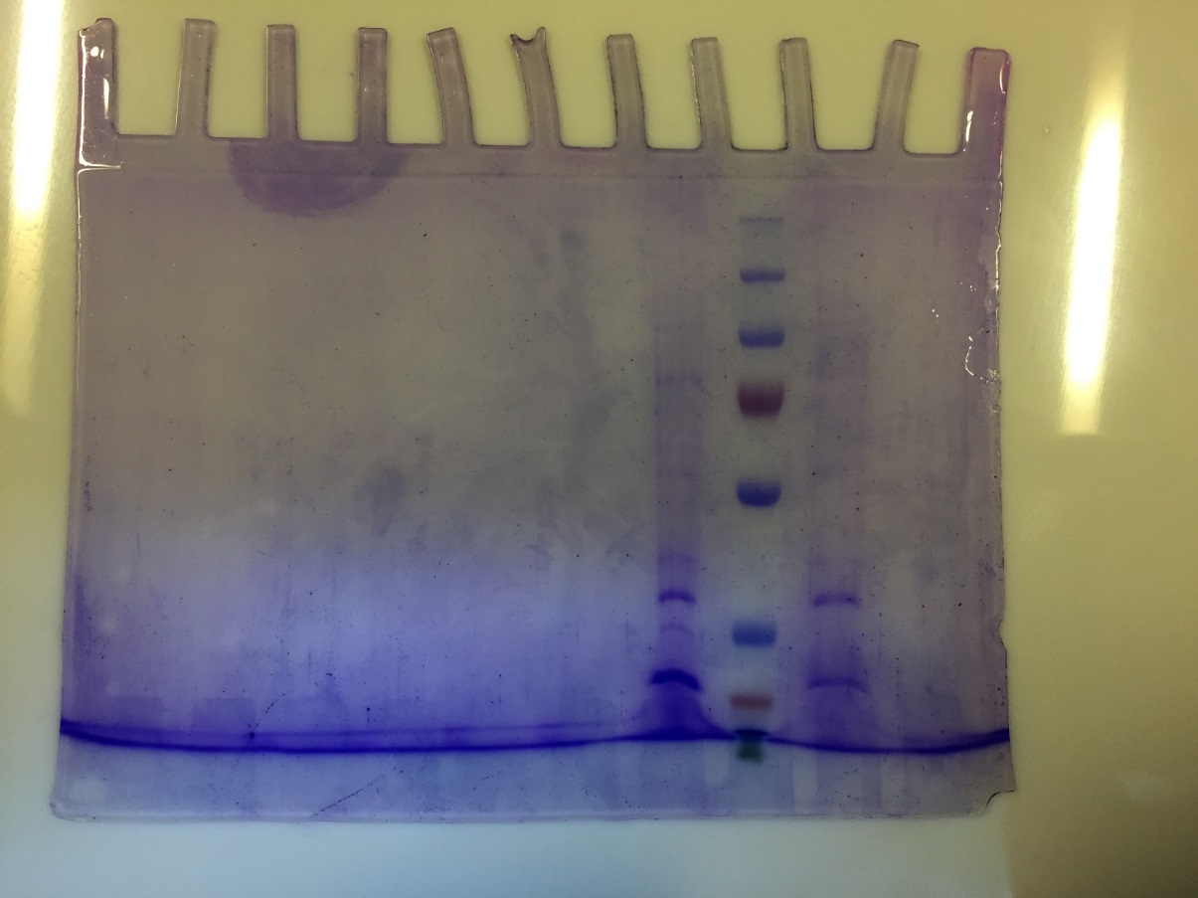

The uncropped gel in Figure S1.

