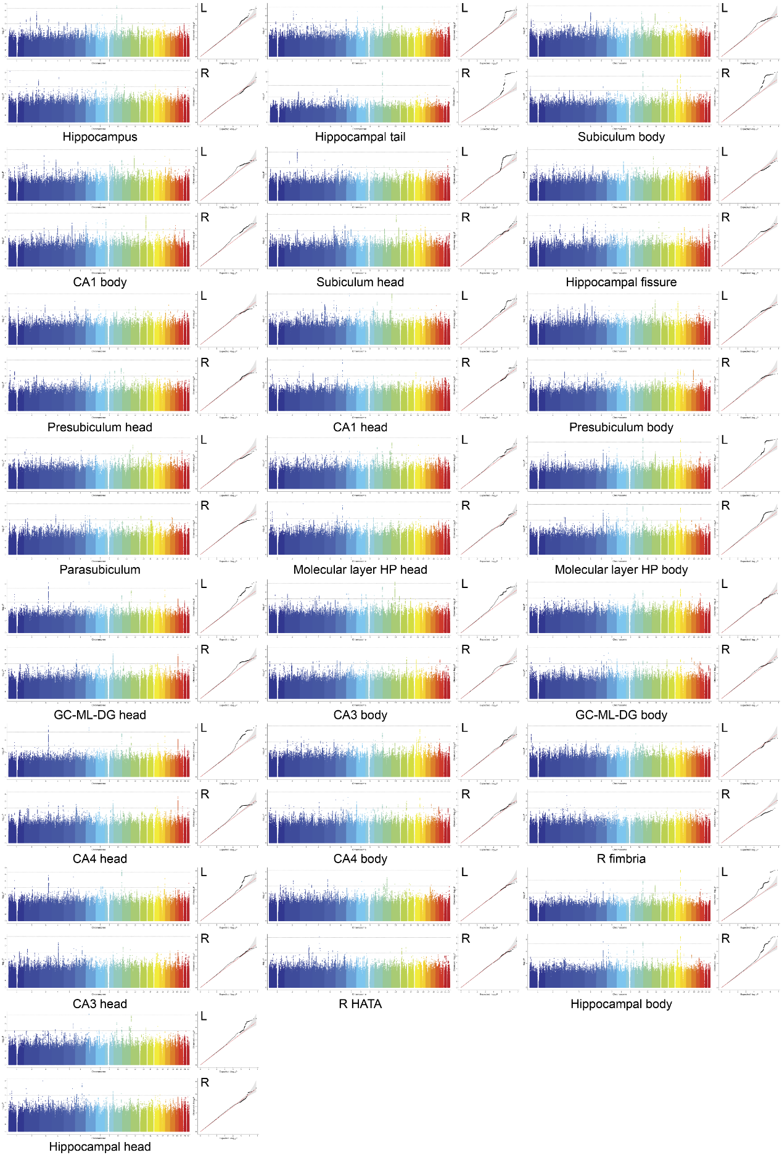
Extended Data Fig. 1 | Manhattan plots and quantile-quantile plots for all genome-wide association analyses of hippocampal and subfield volumes in CHIMGEN (EAS).
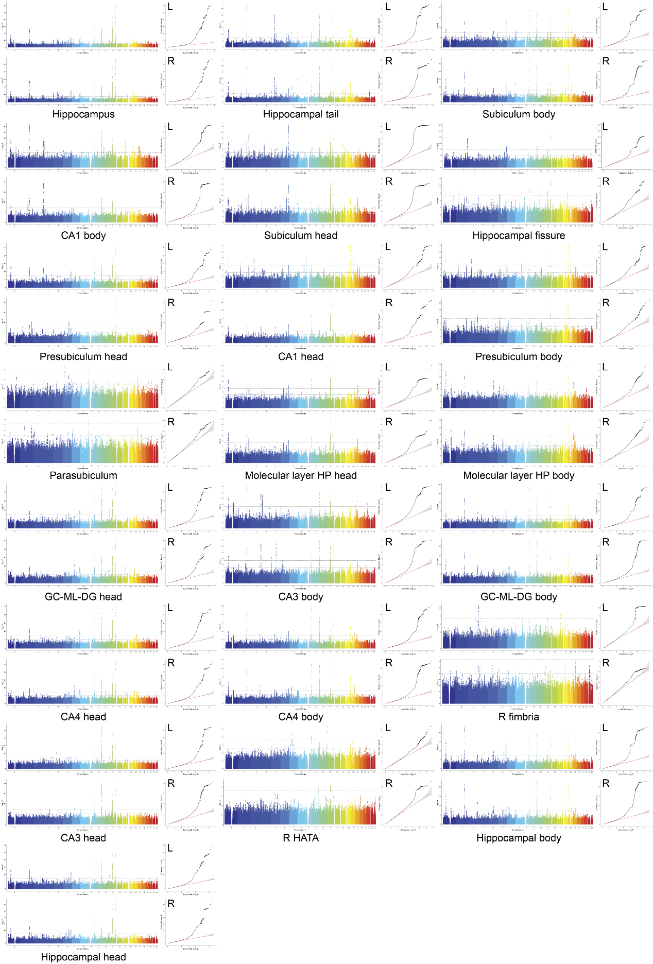
Extended Data Fig. 2 | Manhattan plots and quantile-quantile plots for trans-ancestry meta-analyses of hippocampal and subfield volumes.
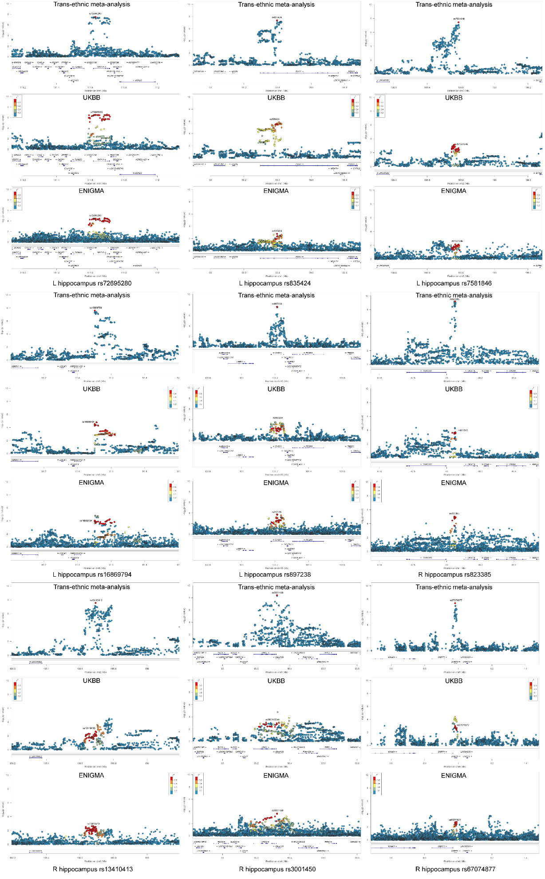
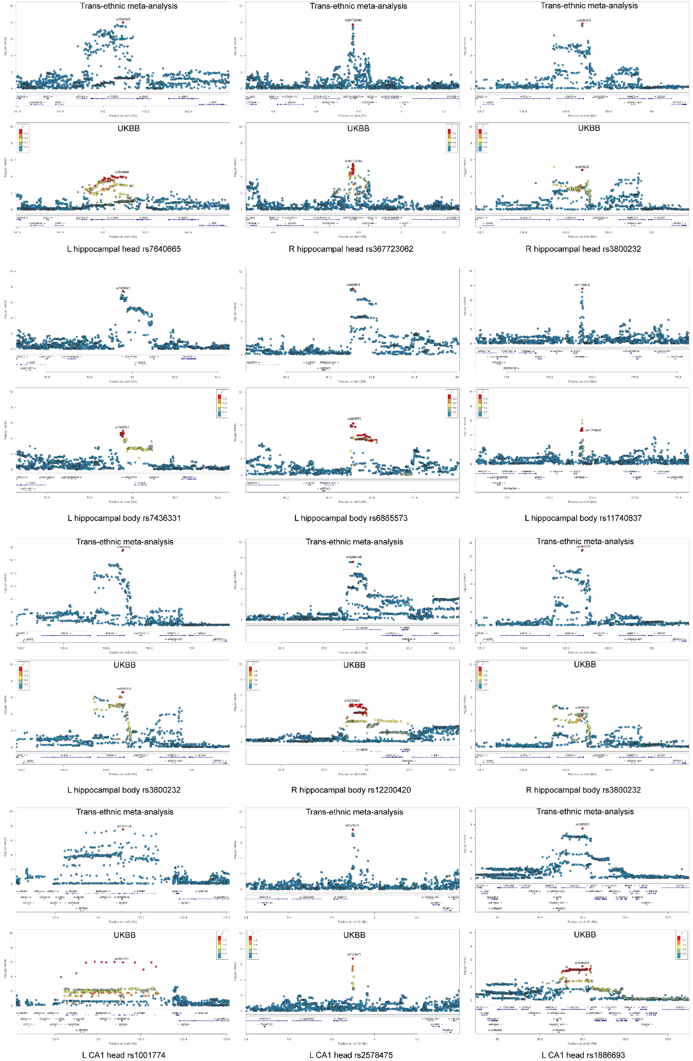
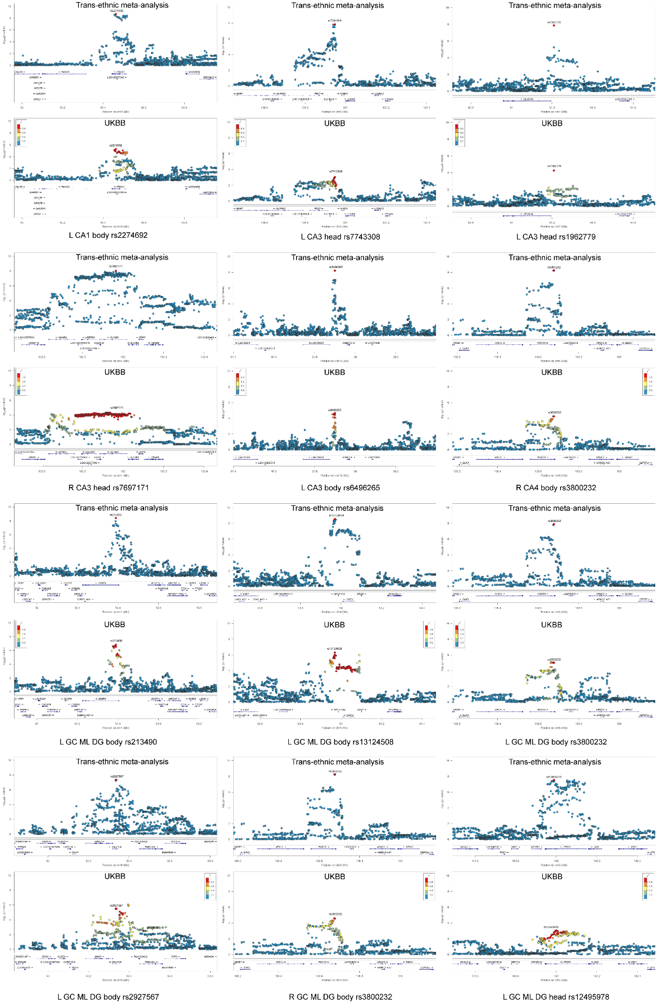
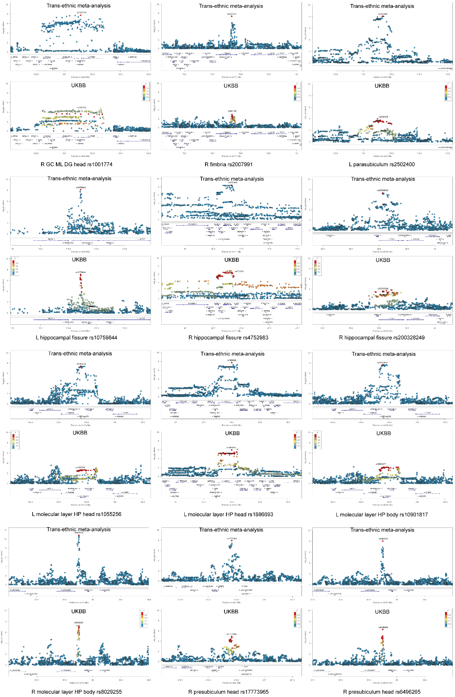
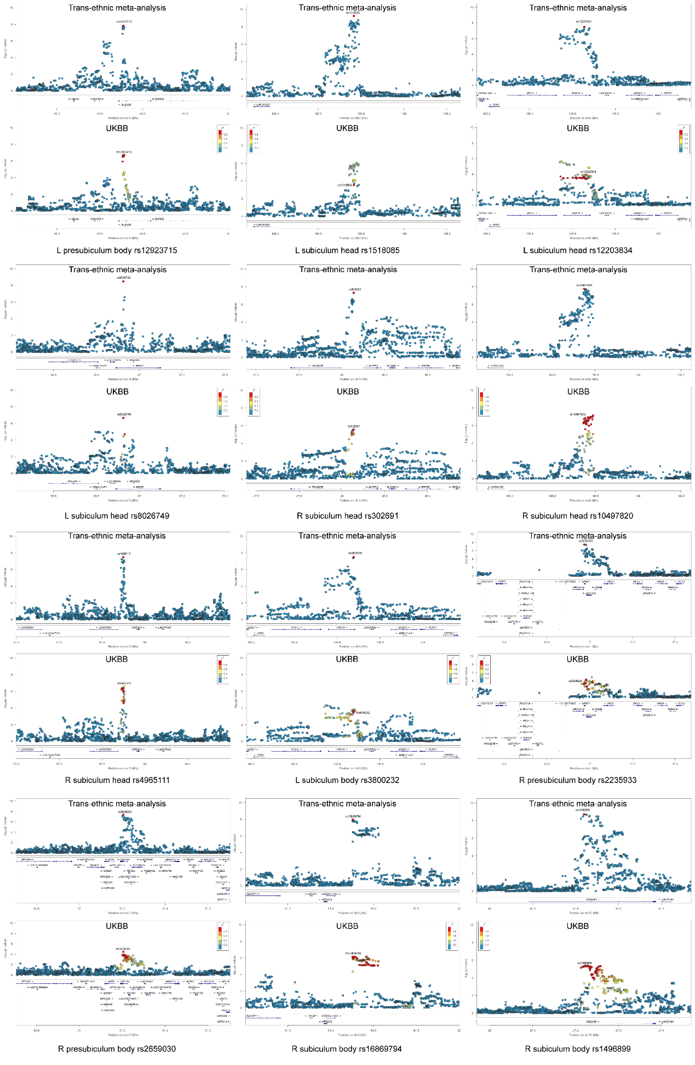
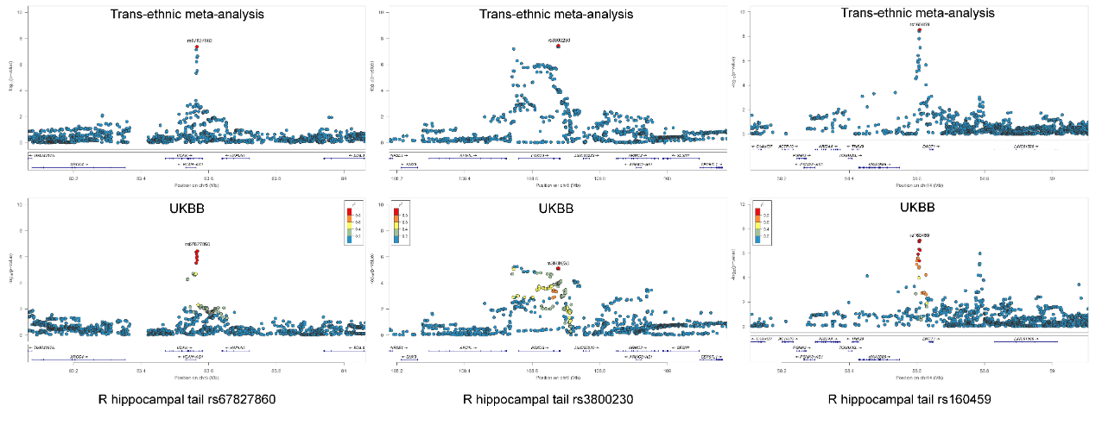
Extended Data Fig. 3 | Locuszoom plots for 60 locus-trait associations identified in trans-ancestry meta-analyses of hippocampal and subfield volumes.

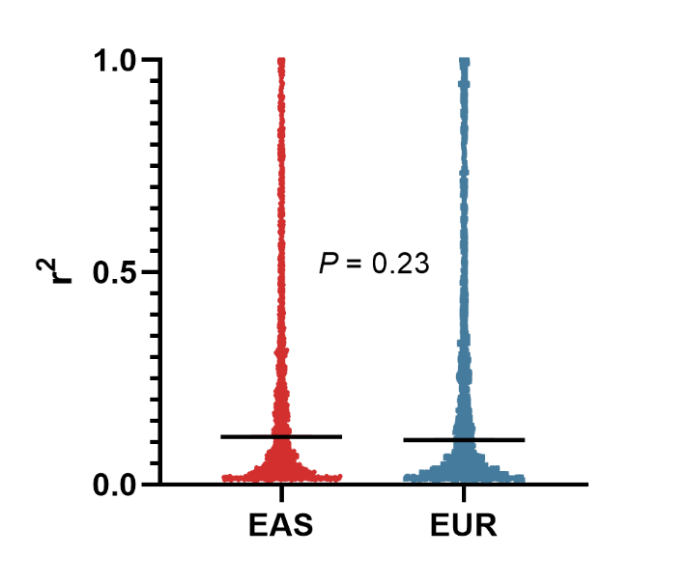
Extended Data Fig. 4 | Comparison of the LD of the 50 lead SNPs between EAS and EUR by Wilcoxon rank-sum test. The lead SNPs are derived from 60 locus-trait associations identified by trans-ancestry meta-analyses. The black horizontal lines represent the medians. EAS, East Asian ancestry; EUR, European ancestry; LD, linkage disequilibrium; SNP, single nucleotide polymorphism.

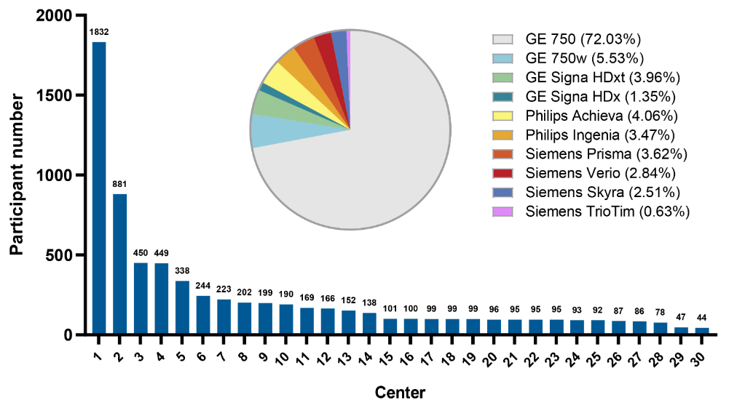
Extended Data Fig. 5 | Distributions of the included 7,039 participants obtained by 30 3.0-Tesla MR scanners with ten types.

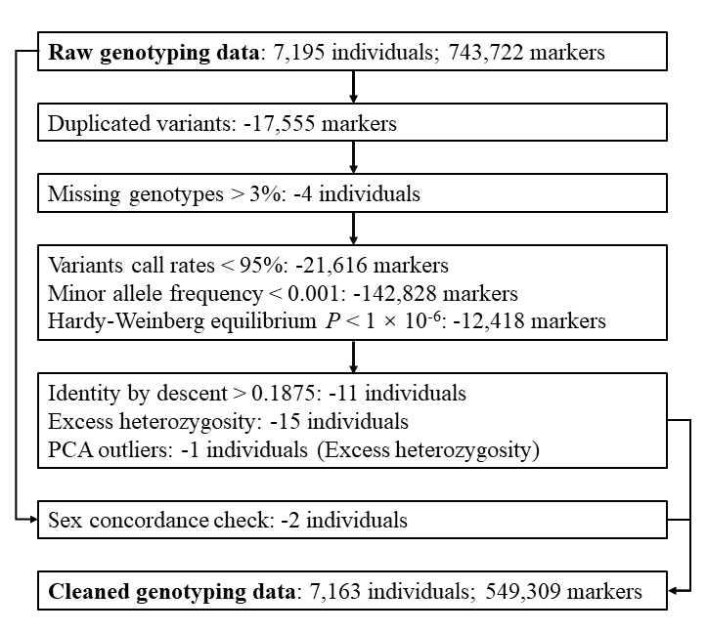
Extended Data Fig. 6 | Quality control (QC) procedures for genotyping data. PCA, principal components analysis. Note: one individual satisfies the criteria of both PCA outlier and excess heterozygosity.

