A landscape-level assessment of composition, structural heterogeneity and distribution pattern of trees in temperate forest of Kashmir Himalaya, India
Table S1. Tree species richness, abundance and family importance value (FIV) by family in low-level blue pine (BP), mixed conifer (MC) and subalpine (SA) forests in temperate Kashmir Himalaya, India.
 | BP forest |  |  |  | MC forest |  |  |  | SA forest |  |  |  | Total landscape scale
Family | Species count | Abundance | FIV |  | Species count | Abundance | FIV |  | Species count | Abundance | FIV |  | Species count | Abundance | FIV
Pinaceae | 4 | 1521 | 293.59 |  | 3 | 4362 | 278.75 |  | 3 | 1878 | 284.57 |  | 4 | 7761 | 280.69
Betulaceae | – | – | – |  | 1 | 11 | 5.53 |  | 1 | 24 | 14.4 |  | 2 | 35 | 6.26
Sapindaceae | – | – | – |  | 2 | 24 | 6.9 |  | 1 | 17 | 1.03 |  | 2 | 41 | 6.92
Cupressaceae | – | – | – |  | 1 | 35 | 2.91 |  | – | – | – |  | 1 | 35 | 1.61
Fabaceae | – | – | – |  | 1 | 1 | 1.08 |  | – | – | – |  | 1 | 1 | 0.59
Juglandaceae | 1 | 2 | 3.07 |  | 1 | 1 | 1.08 |  | – | – | – |  | 1 | 3 | 1.2
Salicaceae | 1 | 6 | 3.33 |  | – | – | – |  | – | – | – |  | 1 | 6 | 0.66
Taxaceae | – | – | – |  | 1 | 26 | 3.76 |  | – | – | – |  | 1 | 26 | 2.07
Total | 6 | 1529 |  |  | 10 | 4460 |  |  | 5 | 1919 |  |  | 13 | 7908

Table S2. Density (stems ha⁻¹), species count (Shannon-Wiener Index (H՛)), species occurrence rate (number of species/stem density), and dominant species (abundance-based), by diameter class in low-level blue pine (BP), mixed conifer (MC) and subalpine (SA) forests of temperate Kashmir Himalaya, India.
 | BP |  |  |  | MC |  |  |  | SA |  |  |  | Landscape-level
Diameter class (cm) | Density | Species count (H') | Species occurrence rate | Dominant species (% abundance) | Density | Species count (H') | Species occurrence rate | Dominant species (% abundance) | Density | Species count (H') | Species occurrence rate | Dominant species (% abundance) | Density | Species count (H') | Species occurrence rate | Dominant species (% abundance)
10-30 | 74.13 | 4 (1.04) | 0.05 | Pin. wall. (48) & Ced. deo. (39) | 52.05 | 10 (1.20) | 0.19 | Abi. pin. (55) | 57.09 | 5 (0.64) | 0.09 | Abi. pin. (82) | 58.15 | 12 (1.36) | 0.21 | Abi. pin. (47) & Pin. wall. (25)
30-50 | 28.25 | 5 (0.97) | 0.18 | Pin. wall. (56) | 59.69 | 8 (1.11) | 0.13 | Pin. wall. (44) & Abi. pin. (40) | 56.61 | 4 (0.67) | 0.07 | Abi. pin. (79) | 51.94 | 11 (1.21) | 0.21 | Abi. pin. (45) & Pin. wall. (37)
50-70 | 42.25 | 5 (0.75) | 0.12 | Pin. wall. (77) | 59.74 | 7 (1.00) | 0.12 | Pin. wall. (50) | 50.79 | 5 (0.85) | 0.1 | Abi. pin. (69) | 53.76 | 11 (1.04) | 0.2 | Pin. wall. (49) & Abi. pin. (40)
70-90 | 36.13 | 4 (0.87) | 0.11 | Pin. wall. (73) | 38.25 | 6 (0.96) | 0.16 | Pin. wall. (49) & Abi. pin. (40) | 32.73 | 5 (0.85) | 0.15 | Abi. pin. (68) | 36.5 | 8 (1.05) | 0.22 | Abi. pin. (45) & Pin. wall. (44)
90-110 | 7.63 | 4 (1.27) | 0.52 | Pin. wall. (42) & Abi. pin. (26) | 13.43 | 4 (1.00) | 0.3 | Abi. pin. (54) | 22.3 | 4 (0.69) | 0.18 | Abi. pin. (75) | 14.18 | 5 (1.02) | 0.35 | Abi. pin. (58)
110-130 | 2 | 4 (1.10) | 2 | Abi. pin. (56) | 3.43 | 3 (0.86) | 0.87 | Abi. pin. (67) | 7.39 | 3 (0.65) | 0.41 | Abi. pin. (78) | 4.03 | 4 (0.87) | 0.99 | Abi. pin. (70)
130-150 | 0.63 | 3 (1.06) | 4.8 | Abi. pin. (40) & Pic. smi. (40) | 1.64 | 3 (0.73) | 1.83 | Abi. pin. (75) | 4.12 | 3 (0.59) | 0.73 | Abi. pin. (79) | 1.99 | 3 (0.74) | 1.51 | Abi. pin. (74)
150-170 | - | - | - | - | 0.1 | 1 (0.00) | 10 | Abi. pin. (100) | 1.09 | 3 (0.68) | 2.75 | Abi. pin. (77) | 0.31 | 3 (0.60) | 9.75 | Abi. pin. (74)
170-190 | - | - | - | - | 0.05 | 1 (0.00) | 20 | Pic. smi. (100) | 0.36 | 1 (0.00) | 2.75 | Abi. pin. (100) | 0.11 | 2 (0.38) | 17.88 | Abi. pin. (81)
190-210 | 0.13 | 1 (0.00) | 8 | Pin. wall. (100) | 0.15 | 2 (0.56) | 13.33 | Pic. smi. (75) | - | - | - | - | 0.14 | 3 (0.95) | 21.45 | Abi. pin. (75)
210-230 | - | - | - | - | 0.1 | 1 (0.00) | 10 | Pic. smi. (100) | - | - | - | - | 0.06 | 1 (0.00) | 17.88 | Pic. smi. (60)
230-250 | - | - | - | - | - | - | - | - | - | - | - | - | - | - | - | Pic. smi. (100)
250-270 | - | - | - | - | - | - | - | - | 0.12 | 1 (0.00) | 8.25 | Abi. pin. (100) | 0.03 | 1 (0.00) | 35.75 | Abi. pin. (100)
Abi. pin.; Abies pindrow, Ced. deo.; Cedrus deodara, Pic. Smi; Picea smithiana and Pin. wall.; Pinus wallichiana.

Figure captions
Figure S1. Analysis of Similarity (ANOSIM) test of Blue pine (BP), mixed conifer (MC) and sub-alpine (SA) forests of temperate Kashmir Himalaya, India.

Figure S2. Species accumulation curve of (a) low-level blue pine (BP), (b) mixed conifer (MC) and (c) subalpine (SA) forests of temperate Kashmir Himalaya.

Figure S3. Box plots depicting (a) basal area distribution among the forest types (b) & (c) distribution of individuals and basal area to various diameter classes in three forest types.

Figure S4. Abundance (Ab) and basal area (BA) by diameter class of top three dominant tree species in (a) low-level blue pine (BP), (b) mixed conifer (MC) and (c) subalpine (SA) forests of temperate Kashmir Himalaya, India.

Figure S1.
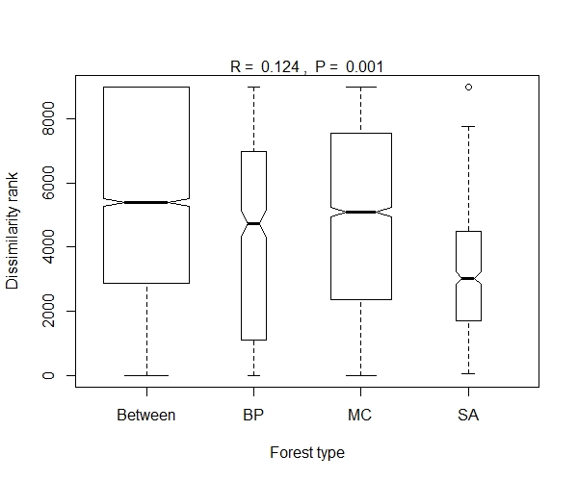

Figure S2.
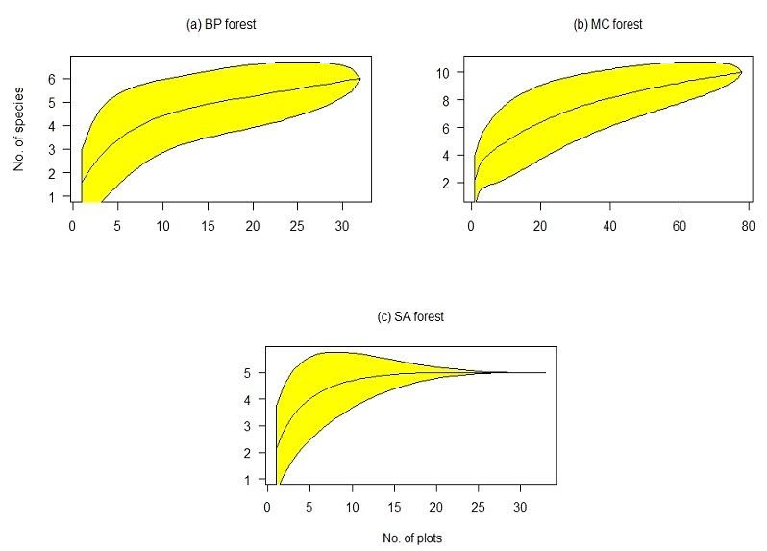

Figure S3.
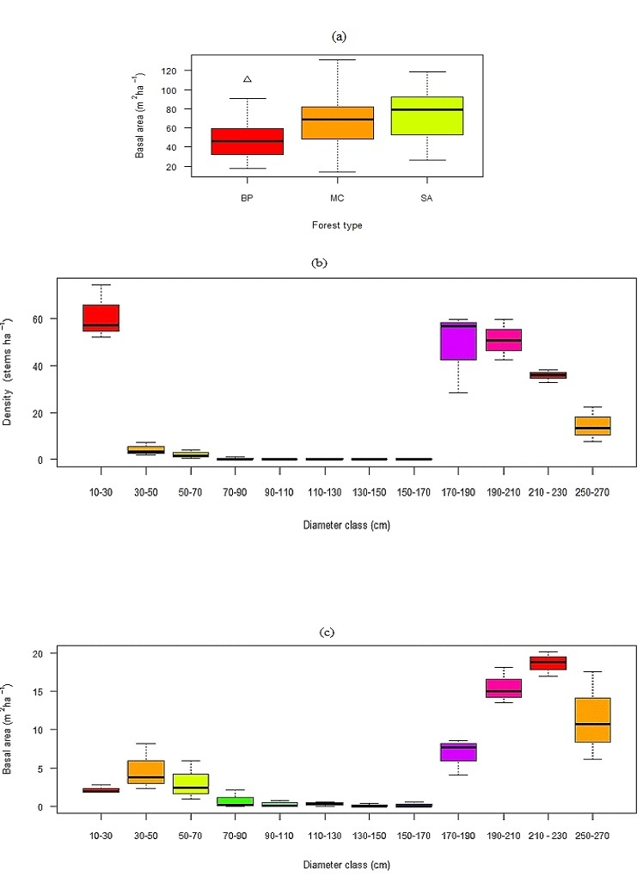
Figure S4.
