Supplementary information

Mitochondria-targeting graphene oxide nanocomposites for fluorescence imaging-guided synergistic phototherapy of drug-resistant osteosarcoma

Wei-Nan Zeng ^{1,2}, Qiu-Ping Yu ³, Duan Wang ¹, Jun-Li Liu ², Qing-Jun Yang ^{2, *}, Zong-Ke Zhou ^{1, *}, Yi-Ping Zeng ^{2, *}

¹ Department of Orthopedics, West China Hospital/West China School of Medicine, Sichuan University, Chengdu, 610041, China
² Department of Orthopedics, Chongqing General Hospital, University of Chinese Academy of Sciences, Chongqing, 400014, China.
³ Health Management Center, West China Hospital/West China School of Medicine, Sichuan University, Chengdu, 610041, China
*Corresponding author.
E-mail address: zongkehx@163.com (Z.K. Zhou); qingjunyang_cgh@163.com (Q.J. Yang); zyp860625@126.com (Y.P. Zeng)

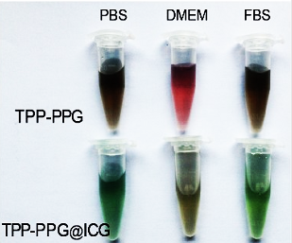
Fig. S1. The TPP-PPG and the TPP-PPG@ICG showed good stabilities in PBS (pH 7.4), in DMEM, or in 10% fetal bovine serum (FBS).

Fig. S2. The effect of weight ratio of ICG and TPP-PPG on the ICG loading efficiency.

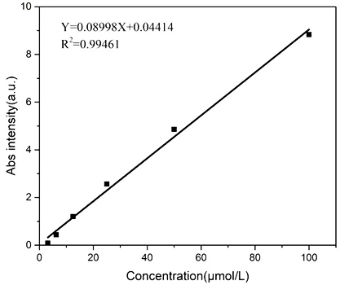
Fig. S3. The calibration curve of ICG in PBS with absorption at 781 nm.

Fig. S4. The MG63/Dox cells showed resistance to Dox.

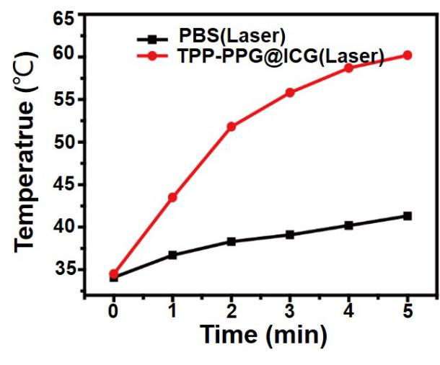
Fig. S5. The temperature variation of tumors after laser exposure.

Fig. S6. Negligible injury to the heart, the liver, the spleen, the lungs, and the kidneys after treatment with the TPP-PPG@ICG.

Fig. S7. TUNEL staining of tumor sections of group Control, group TPP-PPG@ICG+No laser and group TPP-PPG+laser.

Table 1 Comparison between PBS and TPP-PPG@ICG groups of treatment on whole blood cell count.
Group | WBC (10^9/L) | RBC (10^12/L) | HGB (g/L) | HCT (%) | MCV (FL) | MCH (pg) | MCHC (g/L) | PLT (10^9/L)
PBS | 5.116± 0.567 | 9.596± 0.370 | 159± 5.34 | 51.56± 0.937 | 51.36± 1.379 | 17.72± 0.828 | 338.6± 10.41 | 415± 15.03
TPP-PPG@ICG | 5.592± 0.472 | 10.356± 0.298 | 156.6± 5.94 | 54.38± 1.642 | 50.96± 3.111 | 18.54± 1.026 | 341.2± 13.24 | 421.4± 23.09
Values are mean±SEM

Table 2 Comparison between PBS and TPP-PPG@ICG groups of treatment on liver function and kidney function indicators
Group | ALT (IU/L) | ALP (IU/L) | AST(IU/L) | CREA(μmol/L) | BUN (mmol/L)
PBS | 55.68±5.634 | 143.24±8.452 | 155.6±13.212 | 47.28±3.237 | 8.735±0.392
TPP-PPG@ICG | 46.68±6.247 | 153.65±7.425 | 143.2±10.256 | 52.76±2.832 | 7.478±0.582
Values are mean±SEM

