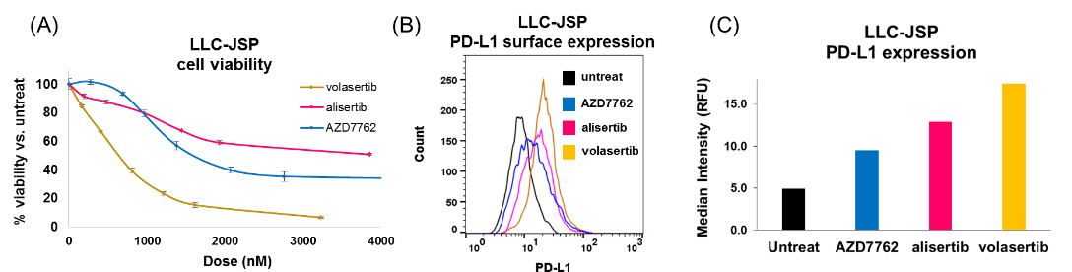
SUPPLEMENTARY FIGURES
Supplementary Fig. 1 Treatment effects of MKIs on (A) 3-day viability of LLC-JSP treated with volasertib, alisertib, or AZD7762 with indicated doses, (B) PD-L1 expression levels of cells post treatment with 500 ng/ml of each drug, by flow cytometry and (C) their quantification.

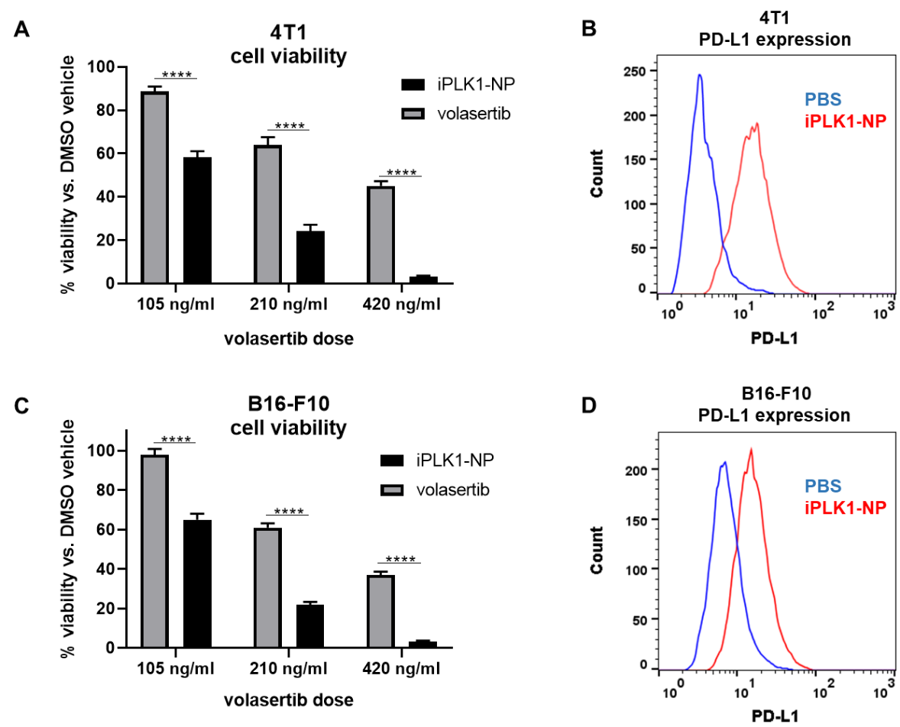

Supplementary Fig. 2 Nanoparticle delivery of PLK1 inhibitor volasertib (iPLK1-NP). Viability of (A) 4T1 breast cancer or (C) B16-F10 melanoma cells treated with volasertib (in 1%DMSO/PBS), iPLK1-NP (in PBS), or 1%DMSO/PBS for 3 days. Data presented as mean ± SD from 4 independent samples; ****P<0.0001. PD-L1 surface expression of (B) 4T1 or (D) B16-F10 cells treated with PBS or iPLK1-NP (42 μg/ml NP, 210 ng/ml volasertib).

