Supplementary information: Utilizing ferrorestorable polarization in energy storage ceramic capacitors

Hiroki Matsuo^{1,*} Masashi Utsunomiya² and Yuji Noguchi^{3,*}

¹ International Research Organization for Advanced Science & Technology (IROAST), Kumamoto University, 2-39-1, Kurokami, Chuo-ku, Kumamoto 860-8555, Japan
² Monozukuri R&D Laboratory, KYOCERA Corporation, 1-4 Kokubuyamashita-cho, Kirishima-shi, Kagoshima 899-4312, Japan
³ Division of Information and Energy, Faculty of Advanced Science and Technology, Kumamoto University, 2-39-1, Kurokami, Chuo-ku, Kumamoto 860-8555, Japan

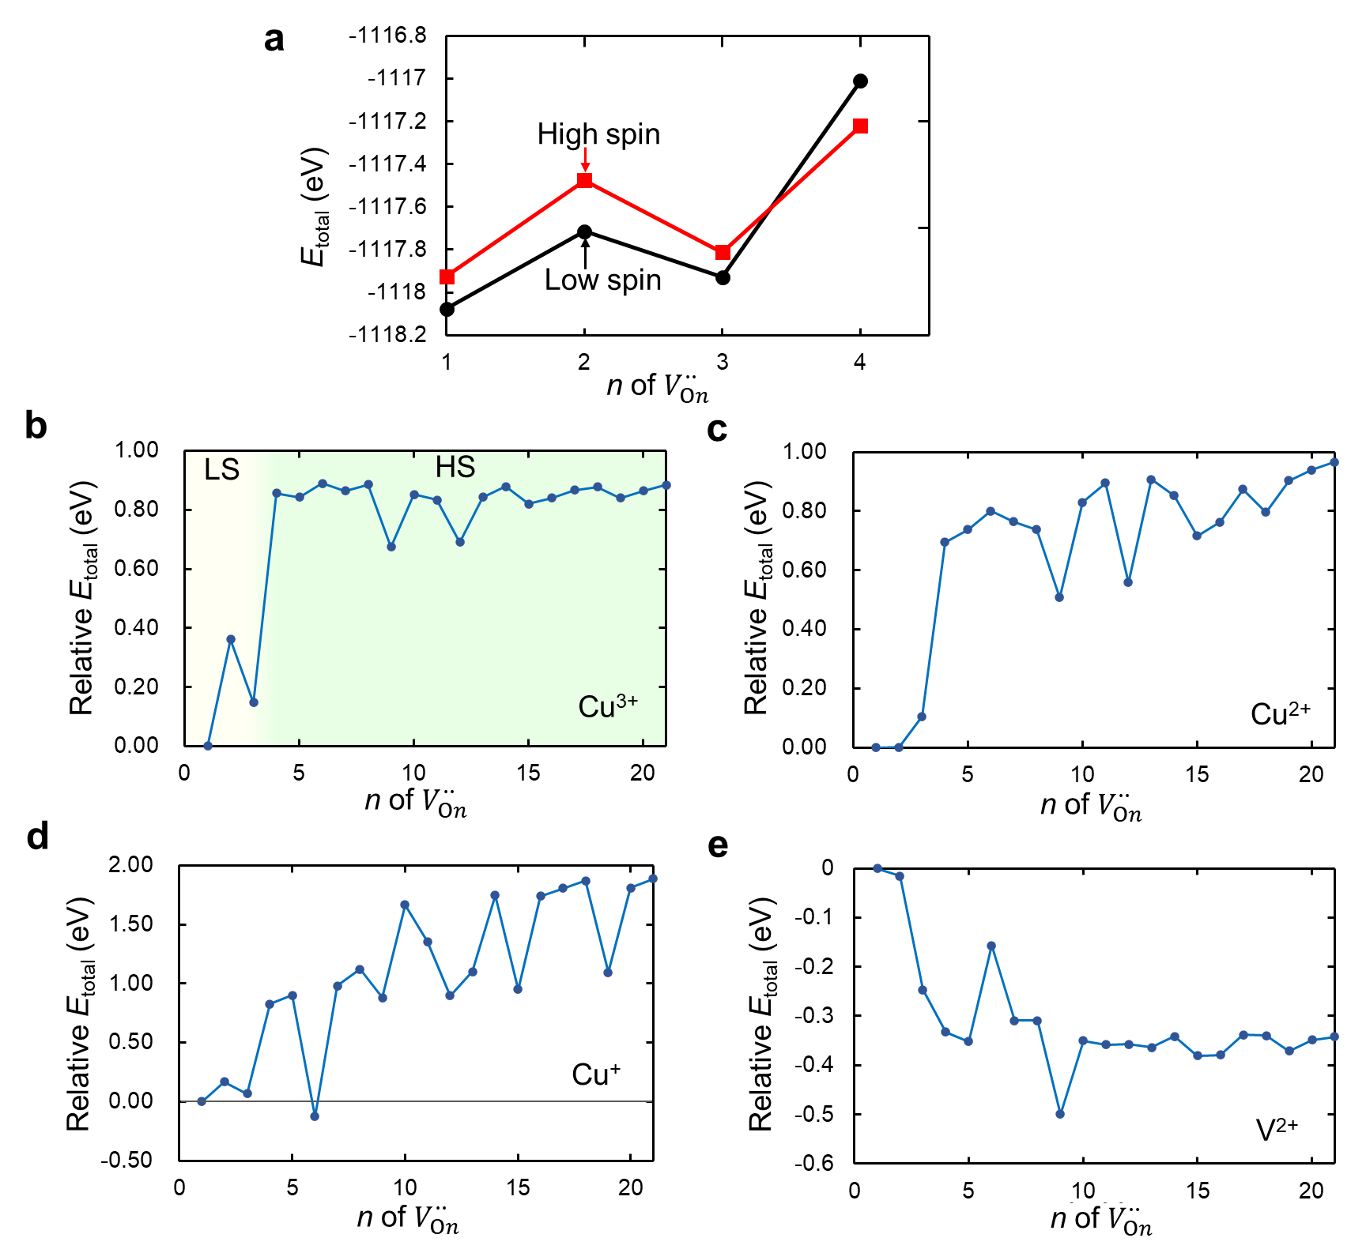
FIG. S1. a, Total energy (E_{total}) of V_{On}••-Cu³⁺ in the high-spin (HS) and the low-spin (LS) states as a function of n. The LS state with a CuO₅ pyramid has a low E_{total} compared with the HS state having an CuO₆ octahedron for n < 4. The HS state is lower in energy for n ≥ 4. Relative E_{total} of b, V_{On}••-Cu³⁺, c, V_{On}••-Cu²⁺, d, V_{On}••-Cu⁺ and e, V_{On}••-V²⁺ as a function of n.

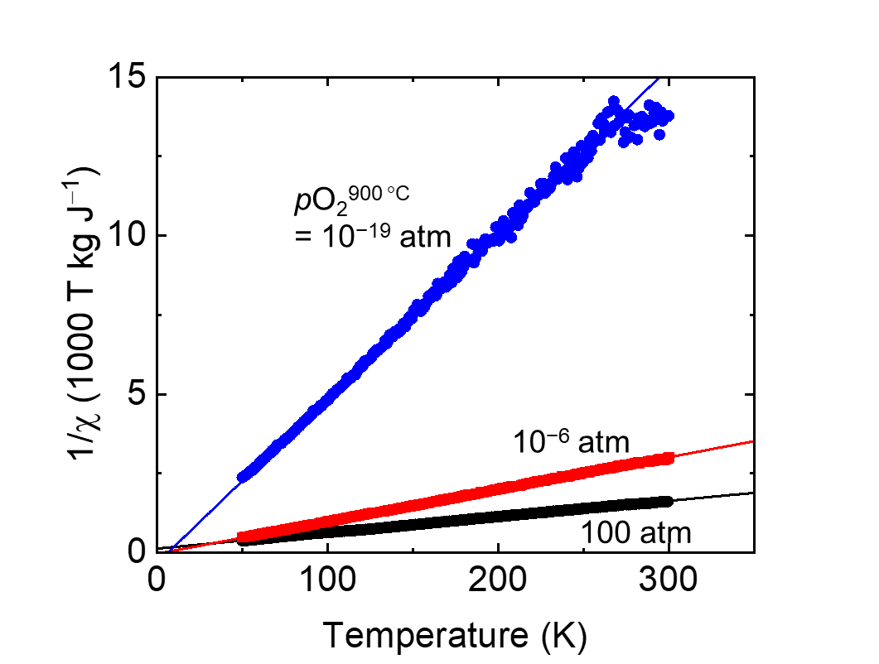
FIG. S2. Temperature dependence of inverse magnetic susceptibility (1/χ) for the Cu (1.5 %) samples annealed at various pO₂^{900 °C}. Data were fitted with the Curie-Weiss law expressed as $1/χ=\frac{T-Θ}{C}$, where T is temperature, C is Curie constant, and Θ is paramagnetic Curie temperature. A slope of the linear regression line of the data plots corresponds to 1/C. Effective magnetic moment ($μ_{eff}^{}$) is expressed as $μ_{eff}^{}=\frac{1}{μ_{B}}\sqrt{3k_{B}C/N}$, where N is the number of Cu atoms per unit weight of the sample, $μ_{B}$ is the Bohr magneton, and k_{B} is the Boltzmann constant.

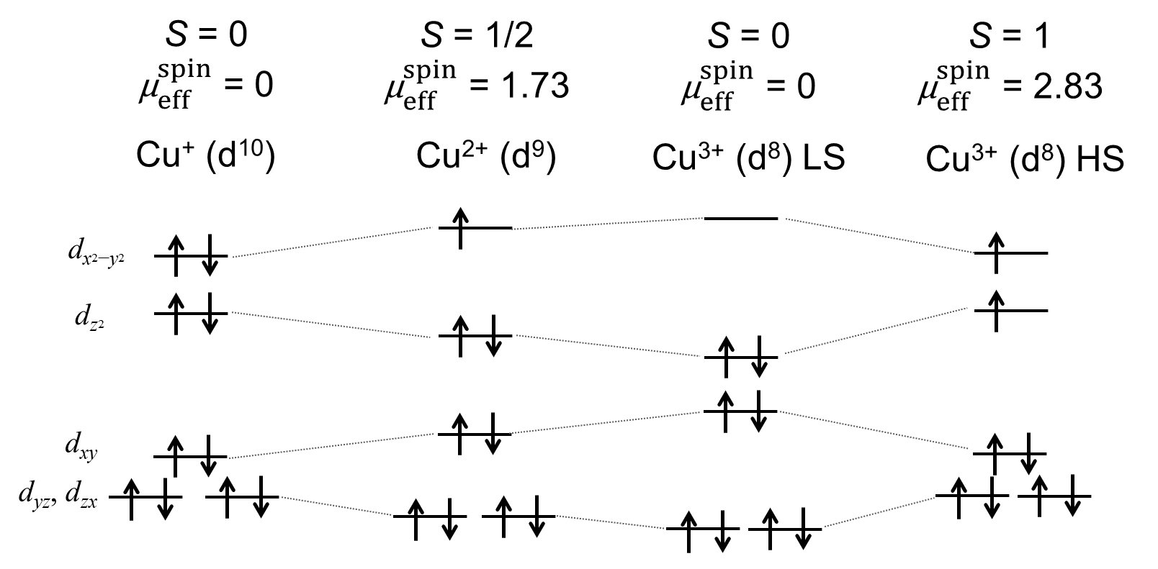
FIG. S3. Schematics for energy levels of Cu-3d orbitals in C_{4v} symmetry. A spin quantum number (S) and spin-only magnetic moment ($μ_{eff}^{spin}$) are also displayed. $μ_{eff}^{spin}$ is expressed as $μ_{eff}^{spin}=g\sqrt{S(S+1)}$ where g is the Landé g-factor. For Cu³⁺ with d⁸ electron configuration, both the low-spin (LS) and high-spin (HS) states are possible. Our DFT calculations for V_{On}-Cu³⁺ indicate that the LS state is energetically favorable for n = 1–3 that has a CuO₅ pyramid while the HS state is stable for n = 4 having a CuO₆ octahedron as shown in Supplementary Fig. 1a.

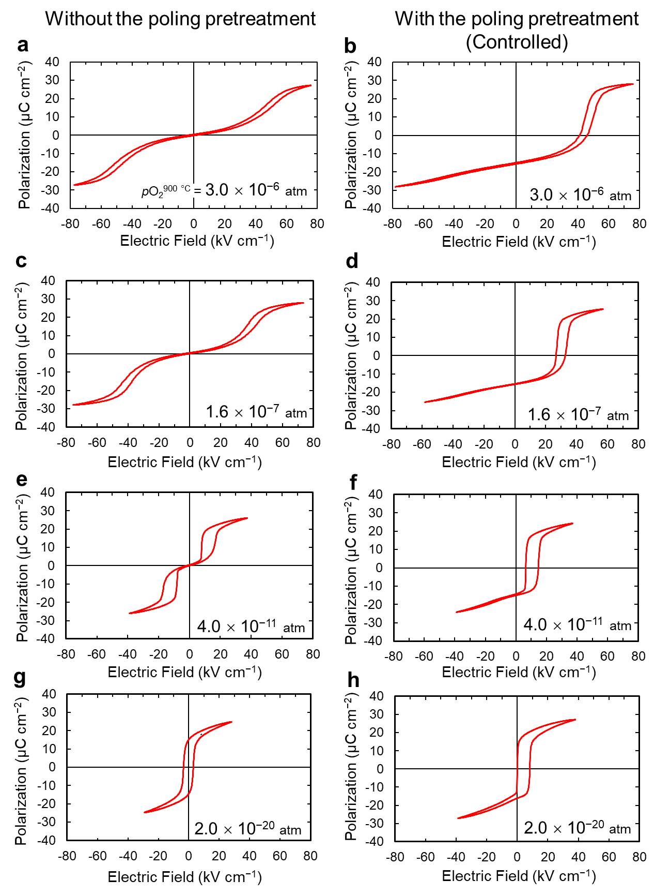
FIG. S4. Polarization properties of the aged samples with Cu (1.5 %) a, c, e, g. without the poling pretreatment and b, d, f, h with the poling pretreatment (controlled). pO₂^{900 °C} is a, b, 3.0 × 10⁻⁶ atm, c, d, 1.6 × 10⁻⁶ atm, e, f, 4.0 × 10⁻¹¹ atm, and g, h, 2.0 × 10⁻²⁰ atm. To assess the contribution of ferrorestorable polarization to recyclable energy density (U_{rec}), the maximum electric field (E_{max}) was adjusted to be E_{max} ≈ E_{i} + 30 kV/cm, where E_{i} denotes internal electric field.
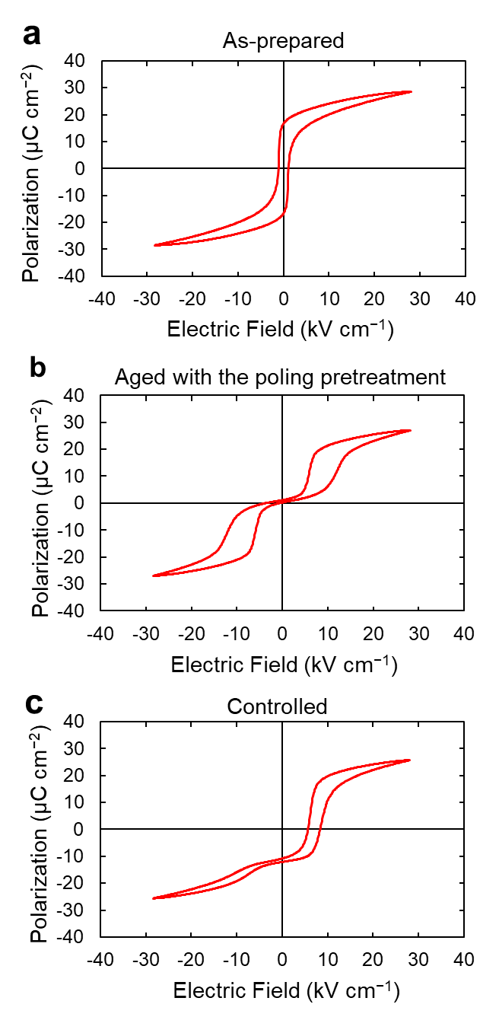
FIG. S5. Polarization properties of the Cu (0.3 %) samples. a, As-prepared. b, After the ageing without the poling pretreatment. c, After the ageing with the poling pretreatment (controlled). pO₂^{900 °C} is 0.2 atm for all the samples. In spite of the low Cu concentration, b, an antiferroelectric-like pinched hysteresis and c, a shifted hysteresis were observed.

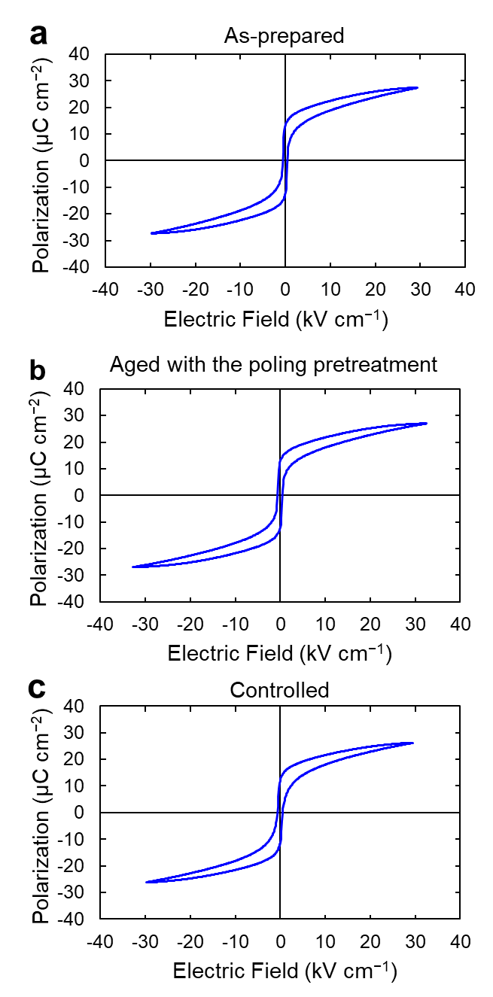
FIG. S6. Polarization properties of the V (0.3 %) samples. a, As-prepared, b, After the ageing without the poling pretreatment. c, After the ageing with the poling pretreatment (controlled). pO₂^{900 °C} is 0.2 atm for all the samples. In contrast to the results of the Cu samples, the polarization loops are influenced neither by the ageing nor the poling pretreatment.

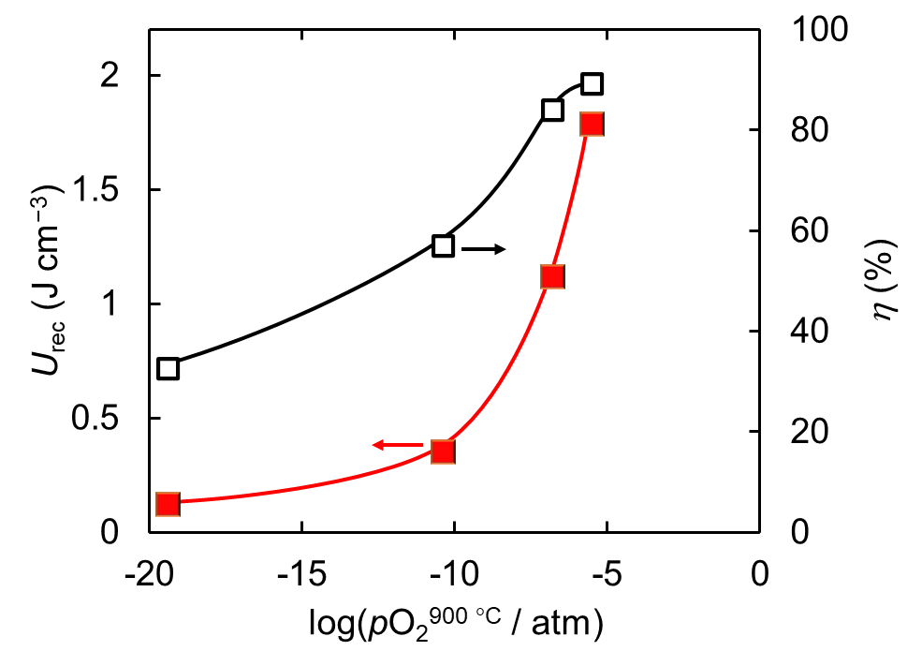
FIG. S7. pO₂^{900 °C} dependence of U_{rec} and η of the aged samples with Cu (1.5 %) with the poling pretreatment (controlled).

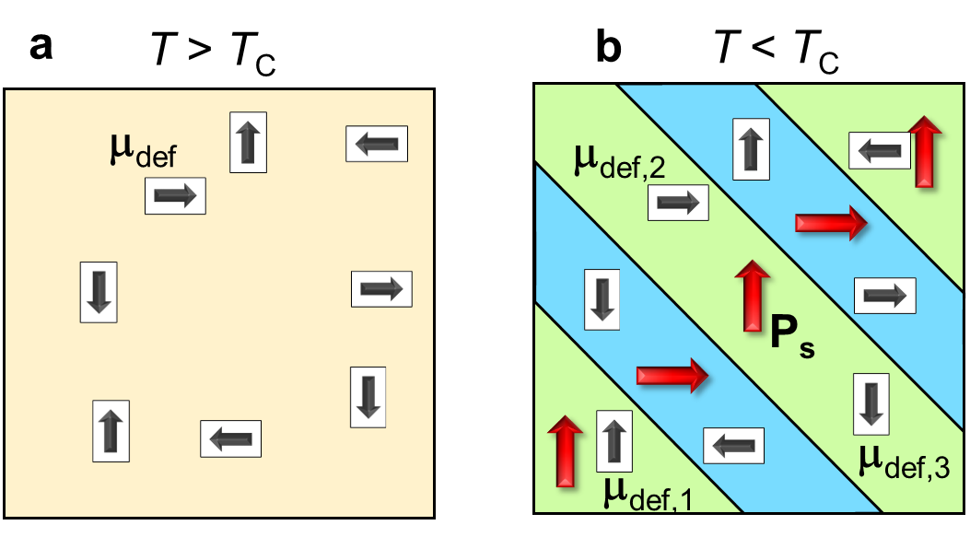
FIG. S8. Schematics of domain structure of the Cu (1.5 %) samples. a, During the thermal treatment at 200 °C (> Curie temperature T_{C}). b, After the thermal treatment followed by successive cooling to room temperature. Black and Red arrows indicate defect dipole vector (μ_{def}) and spontaneous polarization vector (P_{s}), respectively. Because of the attractive interaction between Cu and V_{O}••, V_{O}•• migrates to the O site adjacent to Cu in the paraelectric cubic lattice during the thermal treatment at T = 200 °C. In the cooling process, a phase transition from the paraelectric cubic phase to the ferroelectric tetragonal phase occurs accompanied by a formation of a multidomain (MD) structure with zero net polarization.

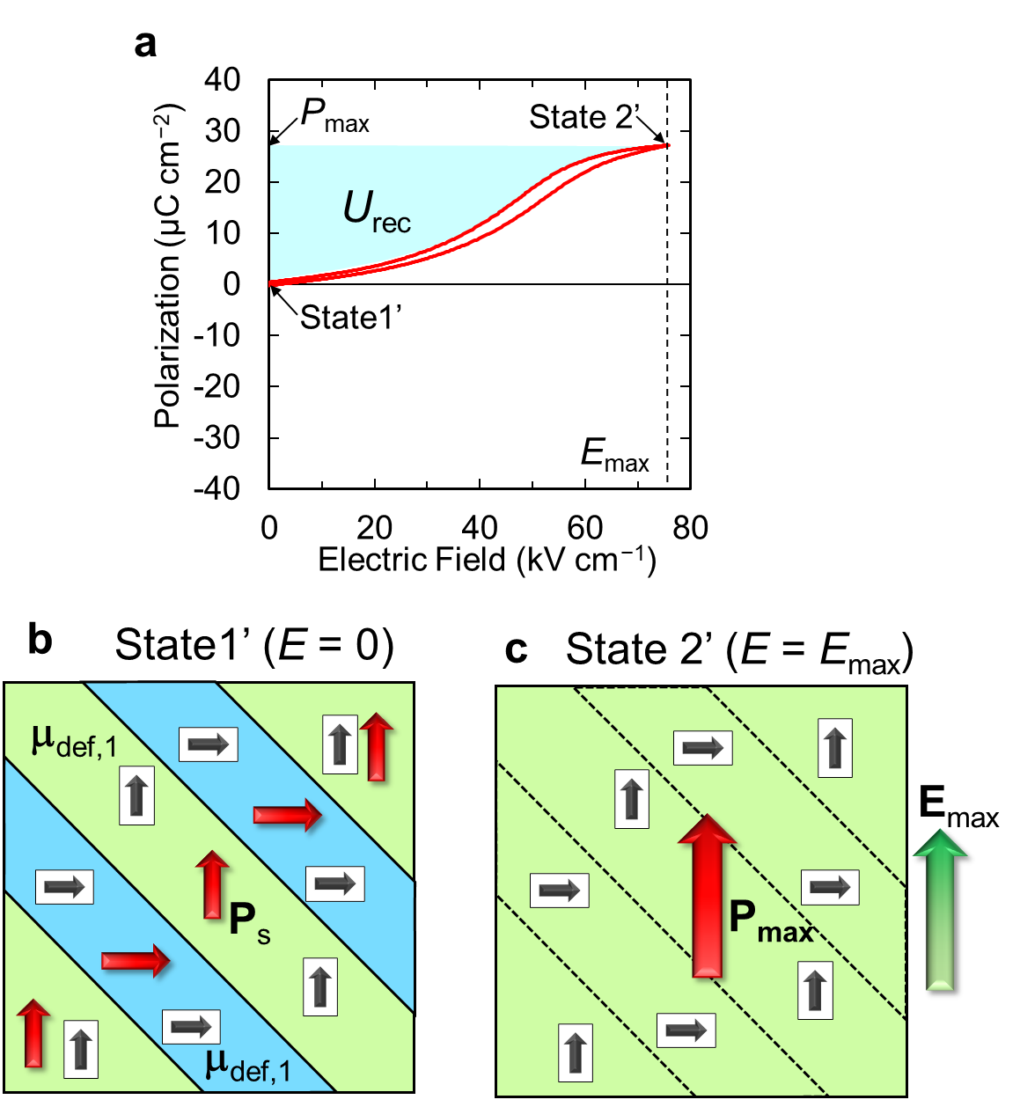
FIG. S9. Polarization property and corresponding domain configurations of the aged Cu (1.5 %) sample without the poling treatment at pO₂^{900 °C} = 3.0 × 10⁻⁶ atm. a. Unipolar polarization and energy storage properties. b, Domain configuration in State 1’ at E of zero and c, that in State 2’ at E of E_{max}. In a MD structure formed after the thermal treatment at 200 °C (Supplementary Fig. 8b), V_{O}•• is stabilized on the O1 site in each ferroelectric domain. During the successive ageing at 80 °C, μ_{def, 1} parallel to P_{s} in each ferroelectric domain is dominant because V_{O}•• migrates to the O1 site, which corresponds to State 1’. An application of E = E_{max} induces a quasi-SD state with P = P_{max} which corresponds to State 2’. Though typical ferroelectric materials can retain the domain structure with the non-zero P_{r} [as in the unipolar P-E loop of the as-prepared sample at pO₂^{900 °C} = 3×10⁻⁶ atm (Fig. 5c)], the characteristic μ_{def} configuration established by the ageing enables a complete back switching from State 2’ to State 1’ with a small hysteresis.
Table S1. Performance of energy storage capacitors in polycrystalline film and bulk forms displayed in Fig. 6 of the main text.
Type | Material/composition | Form | U_{rec}  (J cm⁻³) | η  (%) | E_{max}  (MV cm⁻¹) | ε_{r,eff}  (-) | Ref
PE | Ba_{0.7}Sr_{0.3}FexTi_{1-x}O₃ | Film | 7.6 | 65 | 0.4 | 1073 | 1
FE | Pb_{0.8}La_{0.1}Ca_{0.1}Ti_{0.975}iO₃ | Film | 14.9 | 77.6 | 0.4 | 2104 | 2
FE | 0.9(0.94Na_{0.5}Bi_{0.5}TiO₃–0.06BaTiO₃)–0.1NaNbO₃ | Film | 32 | 90 | 3.17 | 72 | 3
FE | Mn-doped 0.97(0.93Na_{0.5}Bi_{0.5}TiO₃-0.07BaTiO₃)-0.03BiFeO₃ | Film | 81.9 | 64.4 | 2.285 | 354 | 4
AF | Pb_{0.835}La_{0.11}Zr_{0.85}Ti_{0.15}O₃ gradient | Film | 44 | 71 | 1.95 | 261 | 5
AF | Pb_{0.79}Ba_{0.11}La_{0.1}(Zr_{0.9}Ti_{0.1})O₃ | Film | 42.3 | 68 | 2.3 | 181 | 6
AF | Pb_{0.97}Y_{0.02}(Zr_{0.6}Sn_{0.4})_{0.925} Ti_{0.075}O₃ | Film | 21 | 91.9 | 1.3 | 281 | 7
RF | 0.65Na_{0.5}Bi_{0.5}TiO₃-0.35Sr_{0.7}Bi_{0.2}TiO₃ | Film | 21.5 | 80 | 1 | 486 | 8
RF | Ba(Zr_{0.2}Ti_{0.8})O₃  (Thickness t = 350 nm) | Film | 166 | 77 | 5.7 | 115 | 9
AFE | AgNb_{0.8}Ta_{0.2}O₃ | Ceramic | 4 | 77 | 0.24 | 1569 | 10
AFE | (Pb_{0.858}Ba_{0.1}La_{0.02}Y_{0.008})(Zr_{0.65}Sn_{0.3}T_{i0.05})O₃-  (Pb_{0.97}La_{0.02})(Zr_{0.9}Sn_{0.05}Ti_{0.05})O₃ | Ceramic | 4.65 | 60 | 0.191 | 2879 | 11
AFE | (Pb_{0.92}Ba_{0.05}La_{0.02})(Zr_{0.68}Sn_{0.27}Ti_{0.05})O₃ | Ceramic | 2.3 | 76.8 | 0.098 | 5410 | 12
RF | 0.89(Bi_{0.5}Na_{0.5})TiO₃-  0.06BaTiO₃-0.05NaNbO₃ | Ceramic | 0.71 | 66 | 0.07 | 3273 | 13
RF | 0.85BaTiO₃-0.15Bi(Zn_{0.67}Nb_{0.33})O₃ | Ceramic | 0.79 | 93.5 | 0.131 | 1040 | 14
RF | Na_{0.84}Bi_{0.08}Nb_{0.92}Zr_{0.08}O₃ | Ceramic | 4.9 | 88 | 0.43 | 599 | 15
RF | BaTiO₃-Sr_{0.7}Bi_{0.2}TiO₃-Li₂CO₃ | Ceramic | 3.54 | 80 | 0.41 | 476 | 16
RF | 0.55B_{i0.5}Na_{0.5}TiO₃-0.45Sr_{0.7}La_{0.2}TiO₃ | Ceramic | 4.14 | 92.2 | 0.315 | 942 | 17
RF | 0.75Bi_{0.4465}Na_{0.4465}Ba_{0.057}La_{0.05}TiO₃-0.25Sr_{0.85}Bi_{0.1}TiO₃ | Ceramic | 4.55 | 90 | 0.32 | 1004 | 18
AFE | 0.92Na_{0.5}Bi_{0.49}Nd_{0.01}TiO₃-0.08BaTiO₃ | Ceramic | 1.27 | 83.8 | 0.0726 | 5443 | 19
AFE | 1%Mn, 1.25%Nb-doped BaTiO₃ | Ceramic | 0.43 | 86 | 0.105 | 881 | 20
FE | Cu (1.5%)-BaTiO₃ (Aged without poling pretreatment pO₂^{900 °C} = 3.0 × 10⁻⁶ atm) | Ceramic | 1.11 | 90 | 0.075 | 4450 | This study
FE | Cu (1.5 %)-BaTiO₃  (Controlled, pO₂^{900 °C} = 3.0 × 10⁻⁶ atm) | Ceramic | 1.77 | 89 | 0.076 | 7014 | This study
FE | Cu (1.5 %)-BaTiO₃  (Controlled, pO₂^{900 °C} = 1.6 × 10⁻⁷ atm) | Ceramic | 1.12 | 84 | 0.057 | 7734 | This study
FE | Cu (0.3 %)-BaTiO₃  (Controlled, pO₂^{900 °C} = 0.2 atm) | Ceramic | 0.28 | 68 | 0.028 | 3481 | This study
PE: Paraelectric, FE: Ferroelectric, AFE: Antiferroelectric, RE: Relaxor

REFERENCES
1. Xie, J. et al. Energy storage properties of low concentration Fe-doped barium strontium titanate thin films. Ceram. Int. 44, 5867–5873 (2018).
2. Zhu, H., Ma, H. & Zhao, Y. Enhanced energy storage and pyroelectric properties of highly (100)-oriented (Pb_{1−x−y}La_{x}Ca_{y})Ti_{1−x/4}O₃ thin films derived at low temperature. Phys. Lett. Sect. A Gen. At. Solid State Phys. 382, 1409–1412 (2018).
3. Yao, Y. et al. High energy-storage performance of BNT-BT-NN ferroelectric thin films prepared by RF magnetron sputtering. J. Alloys Compd. 750, 228–234 (2018).
4. Yang, C. et al. Fatigue-Free and Bending-Endurable Flexible Mn-Doped Na_{0.5}Bi_{0.5}TiO₃-BaTiO₃-BiFeO₃ Film Capacitor with an Ultrahigh Energy Storage Performance. Adv. Energy Mater. 9, 1–10 (2019).
5. Zhao, Y., Hao, X. & Zhang, Q. Enhanced energy-storage performance and electrocaloric effect in compositionally graded Pb_{(1−3x/2)}La_{x}Zr_{0.85}Ti_{0.15}O₃ antiferroelectric thick films. Ceram. Int. 42, 1679–1687 (2016).
6. Gao, H. et al. Enhanced electrocaloric effect and energy-storage performance in PBLZT films with various Ba²⁺ content. Ceram. Int. 42, 16439–16447 (2016).
7. Ahn, C. W. et al. Antiferroelectric Thin-Film Capacitors with High Energy-Storage Densities, Low Energy Losses, and Fast Discharge Times. ACS Appl. Mater. Interfaces 7, 26381–26386 (2015).
8. Li, J. et al. Grain-orientation-engineered multilayer ceramic capacitors for energy storage applications. Nat. Mater. 19, 999–1005 (2020).
9. Cheng, H. et al. Demonstration of ultra-high recyclable energy densities in domain-engineered ferroelectric films. Nat. Commun. 8, 1999 (2017).
10. Zhao, L., Liu, Q., Gao, J., Zhang, S. & Li, J. Lead‐Free Antiferroelectric Silver Niobate Tantalate with High Energy Storage Performance. Adv. Mater. 29, 1701824 (2017).
11. Zhang, L., Jiang, S., Fan, B. & Zhang, G. High energy storage performance in (Pb_{0.858}Ba_{0.1}La_{0.02}Y_{0.008})(Zr_{0.65}Sn_{0.3}Ti_{0.05})O₃-(Pb_{0.97}La_{0.02})(Zr_{0.9}Sn_{0.05}Ti_{0.05})O₃ anti-ferroelectric composite ceramics. Ceram. Int. 41, 1139–1144 (2015).
12. Chen, L., Hao, X., Zhang, Q. & An, S. Energy-storage performance of PbO–B₂O₃–SiO₂ added (Pb_{0.92}Ba_{0.05}La_{0.02})(Zr_{0.68}Sn_{0.27}Ti_{0.05})O₃ antiferroelectric ceramics prepared by microwave sintering method. J. Mater. Sci. Mater. Electron. 27, 4534–4540 (2016).
13. Xu, Q. et al. Enhanced energy storage properties of NaNbO₃ modified Bi_{0.5}Na_{0.5}TiO₃ based ceramics. J. Eur. Ceram. Soc. 35, 545–553 (2015).
14. Wu, L., Wang, X. & Li, L. Lead-free BaTiO₃–Bi(Zn_{2/3}Nb_{1/3})O₃ weakly coupled relaxor ferroelectric materials for energy storage. RSC Adv. 6, 14273–14282 (2016).
15. Yang, L., Kong, X., Cheng, Z. & Zhang, S. Enhanced Energy Storage Performance of Sodium Niobate-Based Relaxor Dielectrics by a Ramp-to-Spike Sintering Profile. ACS Appl. Mater. Interfaces 12, 32834–32841 (2020).
16. Liu, G. et al. Ultrahigh dielectric breakdown strength and excellent energy storage performance in lead-free barium titanate-based relaxor ferroelectric ceramics via a combined strategy of composition modification, viscous polymer processing, and liquid-phase sintering. Chem. Eng. J. 398, 125625 (2020).
17. Qiao, X. et al. Superior comprehensive energy storage properties in Bi_{0.5}Na_{0.5}TiO₃-based relaxor ferroelectric ceramics. Chem. Eng. J. 388, 124158 (2020).
18. Ye, H. et al. Significantly Improvement of Comprehensive Energy Storage Performances with Lead-free Relaxor Ferroelectric Ceramics for High-temperature Capacitors Applications. Acta Mater. 203, 116484 (2021).
19. Kandula, K. R., Banerjee, K., Raavi, S. S. K. & Asthana, S. Enhanced Electrocaloric Effect and Energy Storage Density of Nd-Substituted 0.92NBT-0.08BT Lead Free Ceramic. Phys. Status Solidi Appl. Mater. Sci. 215, 1–5 (2018).
20. Liu, W., Gao, J., Zhao, Y. & Li, S. Significant enhancement of energy storage properties of BaTiO₃-based ceramics by hybrid-doping. J. Alloys Compd. 843, (2020).

