Additional files
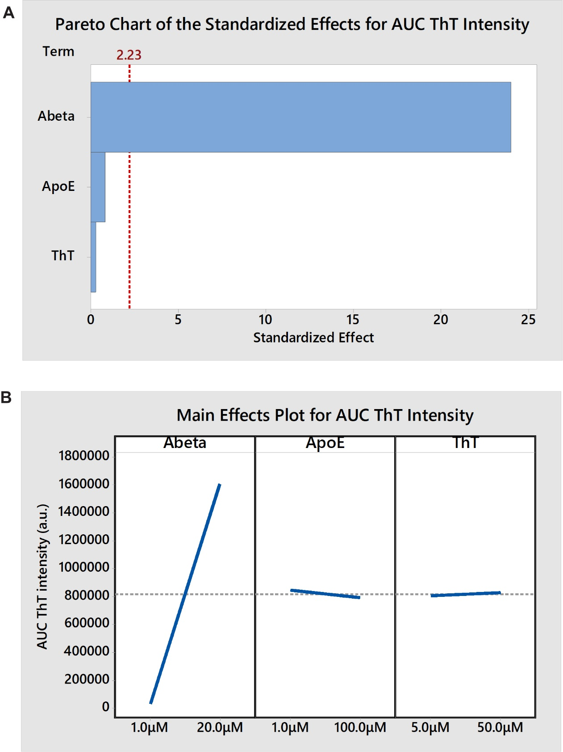
Additional file 1. Half-fraction factorial design. Three reactant concentrations, Aβ, apoE4, and ThT, were varied in a half-fraction factorial design for a total of 2³/2 = 4 experimental conditions and one center point. Three technical replicates (wells) were tested per experimental condition. Experimental conditions and data are provided in Additional file 6. a, Pareto chart of the standardized effect for each reactant on the integrated AUC of ThT intensity. The critical effect size for statistical significance (α = 0.05) is also shown at an effect size of 2.23 (red line). Aβ concentration had a large effect while the effects of apoE4 and ThT concentrations were insignificant. The interaction effects are confounded with the main effects and are therefore not shown. b, Main effects plot showing the size and direction of each effect on the AUC of ThT intensity. As Aβ concentration increased from 1 µM to 20 µM the AUC of ThT intensity increased from 0 to approximately 1.6 x 10⁶ a.u., while apoE4 and ThT concentrations had no significant effects.
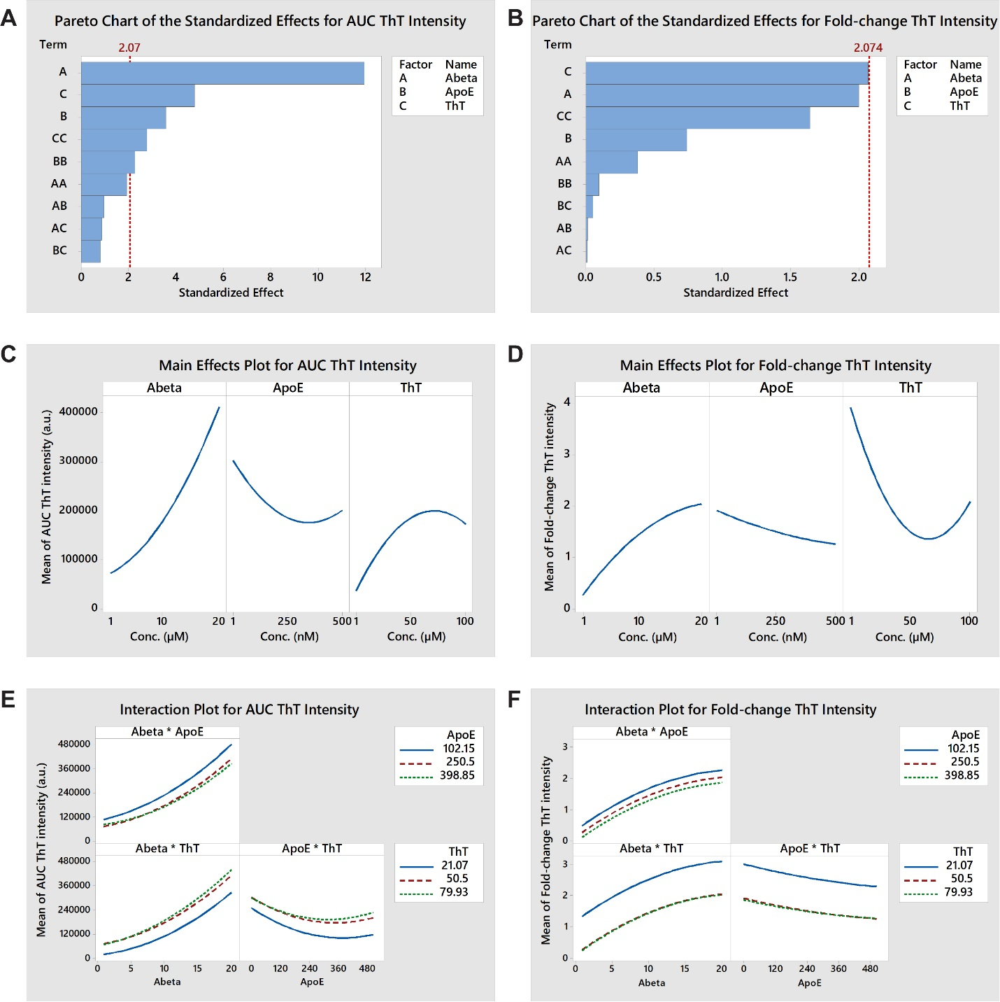
Additional file 2. Central composite response surface design #1. The concentrations of three reactants, Aβ, apoE4, and ThT, were varied in a central composite design using 2³ = 8 corner points, 2*3 = 6 axial points, and one center point. An optimized design space was determined based on the results of the previous factorial experiment. Two replicates (wells) were tested per experimental condition and four replicates of the center point. Experimental conditions and data are provided in Additional file 6. a,b, Pareto charts showing the standardized effect for the main (A, B, C), quadratic (AA, BB, CC), and interaction effects (AB, BC, AC) on the AUC and the fold-change of ThT intensity, respectively. The critical effect size for statistical significance (α = 0.05) is also shown at an effect size of 2.074 (red line). All three variables had large main and quadratic effects on the AUC of ThT intensity, while all interaction effects were negligible. ThT and Aβ concentrations had large main and quadratic effects on the fold-change in ThT intensity, while the effects of apoE concentration and all interaction effects were much smaller. c,b, Main effects plots showing the combination of main and quadratic effects of each reactant on the AUC and the fold-change of ThT intensity, respectively. High Aβ concentration, low apoE4 concentration, and an intermediate ThT concentration maximized both the AUC, and the fold-change, of ThT intensity. e,f, Interaction plots showing the interaction effect of each reactant pair on the AUC and the fold-change of ThT intensity, respectively. No significant interactions were observed, which is evidenced by the similar shapes of the response curves for all reactant concentrations in each interaction plot.

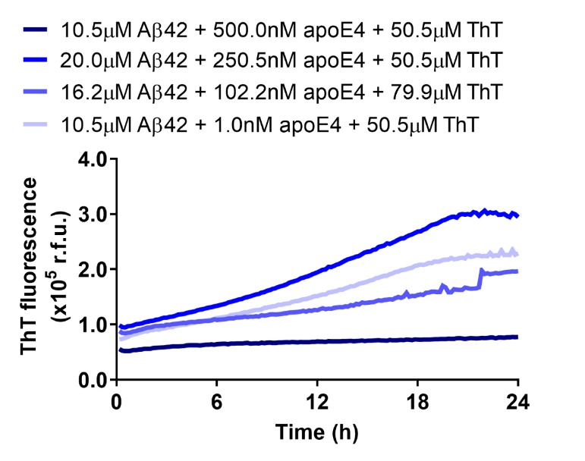
Additional file 3. Effects of apoE4 concentration on Aβ42 fibrillization. Concentrations of Aβ42, apoE4, and ThT were varied in a response surface design. The fibrillization assay was run in a 384-well plate and was analyzed for ThT fluorescence over a 24 h period. Several groups were plotted to demonstrate the effects of the different concentrations of apoE4 on ThT fluorescence over time. The complete results are provided in Additional file 6. The data represent the mean of n = 3−4 wells per group.

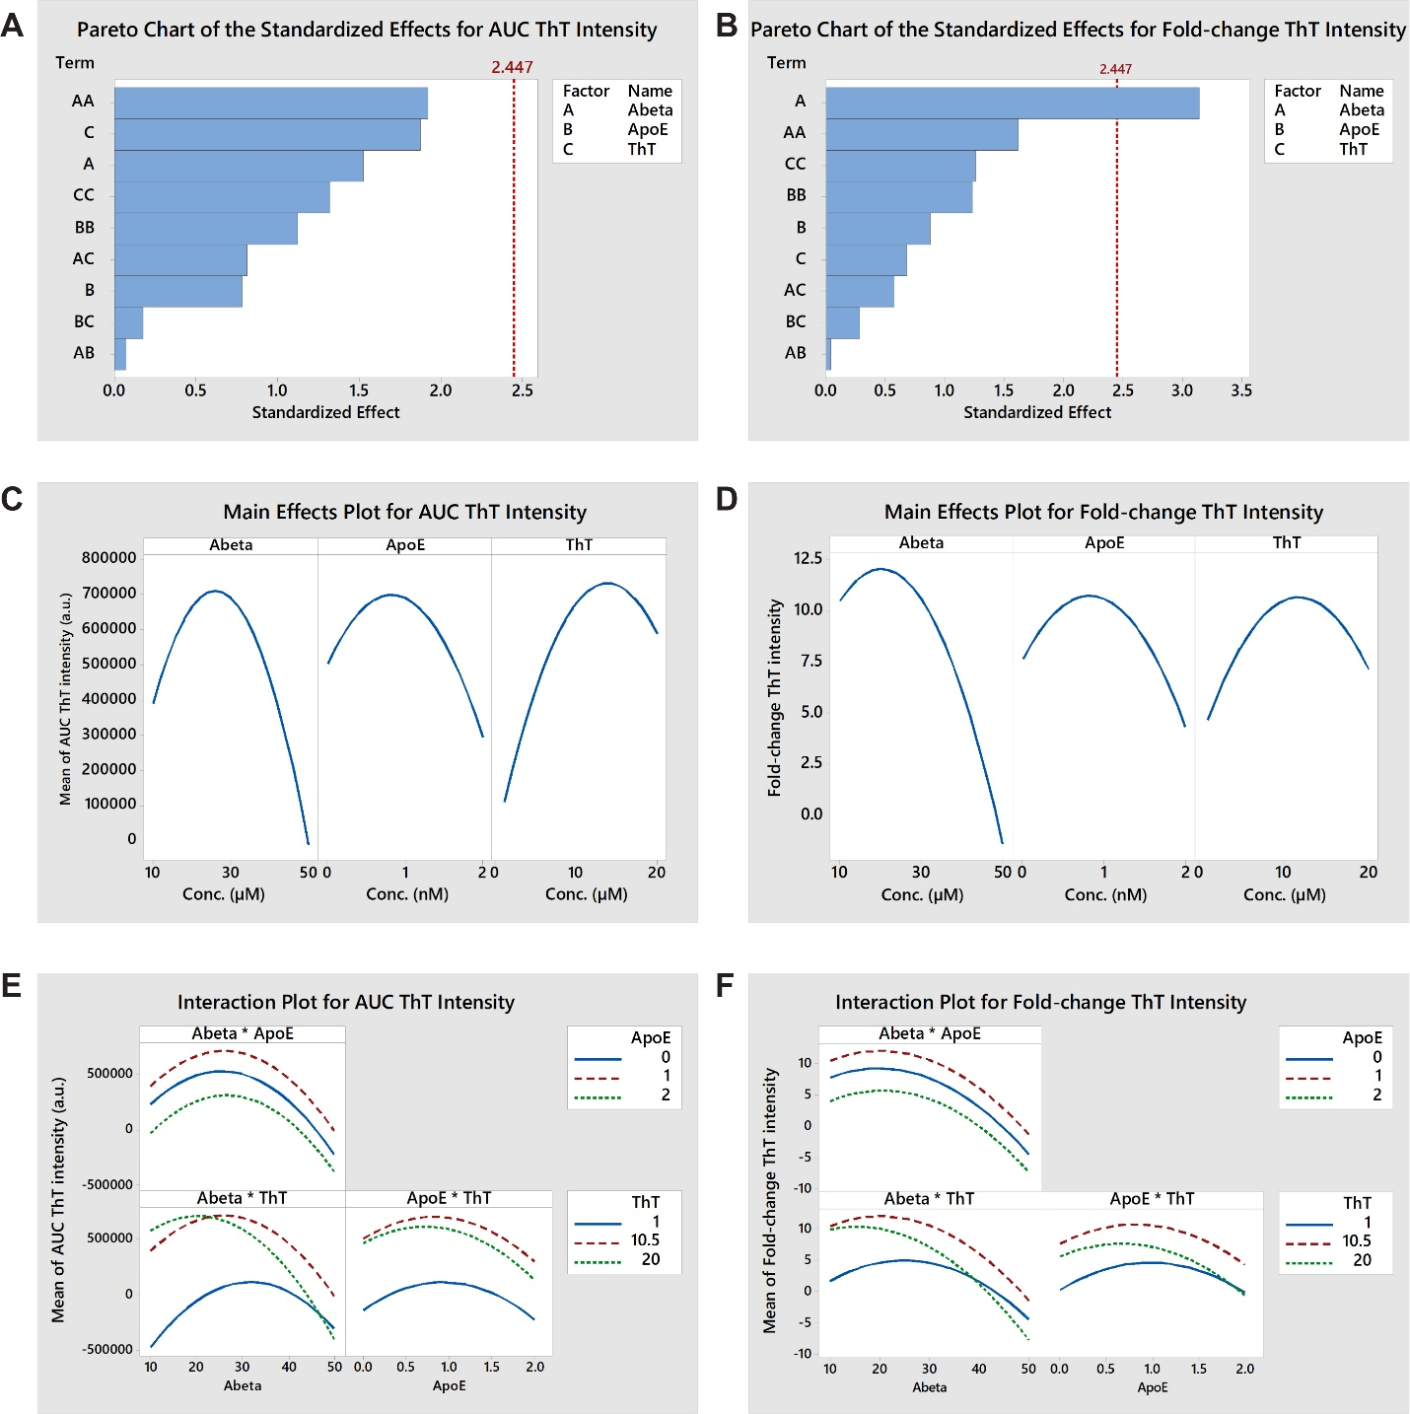
Additional file 4. Central composite response surface design #2. The concentrations of three reactants, Aβ, apoE4, and ThT, were varied in a central composite design using 2³ = 8 corner points, 2*3 = 6 axial points, and one center point. An optimized design space was determined based on the results of the previous response surface experiment. Three replicates (wells) were tested per experimental condition and six replicates of the center point, and the entire experiment was repeated in two independent experiments (blocks). Experimental conditions and data are provided in Additional file 6. a,b, Pareto charts showing the standardized effect for the main (A, B, C), quadratic (AA, BB, CC), and interaction effects (AB, BC, AC) on the AUC and the fold-change of ThT intensity, respectively. The critical effect size for statistical significance (α = 0.05) is also shown at an effect size of 2.447 (red line). Aβ and ThT had large main and quadratic effects on the AUC of ThT intensity, while the effect of apoE was smaller. Aβ had the largest main and quadratic effects on the fold-change in ThT intensity, while the effects of apoE and ThT were smaller. c,d, Main effects plots showing the combination of main and quadratic effects of each reactant on the AUC and the fold-change of ThT intensity, respectively. Intermediate concentrations of Aβ, apoE4, and ThT maximized both the AUC and the fold-change of ThT intensity. e,f, Interaction plots showing the interaction effect of each reactant pair on the AUC and the fold-change of ThT intensity, respectively. An interaction between Aβ and ThT concentrations (AC) was observed to have a moderate effect on both the AUC and the fold-change of ThT intensity, which is evidenced by the response curves for different reactant concentrations crossing one another. This moderate effect caused both responses to peak at lower Aβ concentrations when the ThT concentration was 20 μM compared to 10.5 μM. However, the interaction effect did not change the conclusions about the dominant main and quadratic effects of Aβ and ThT seen in the main effects plot.

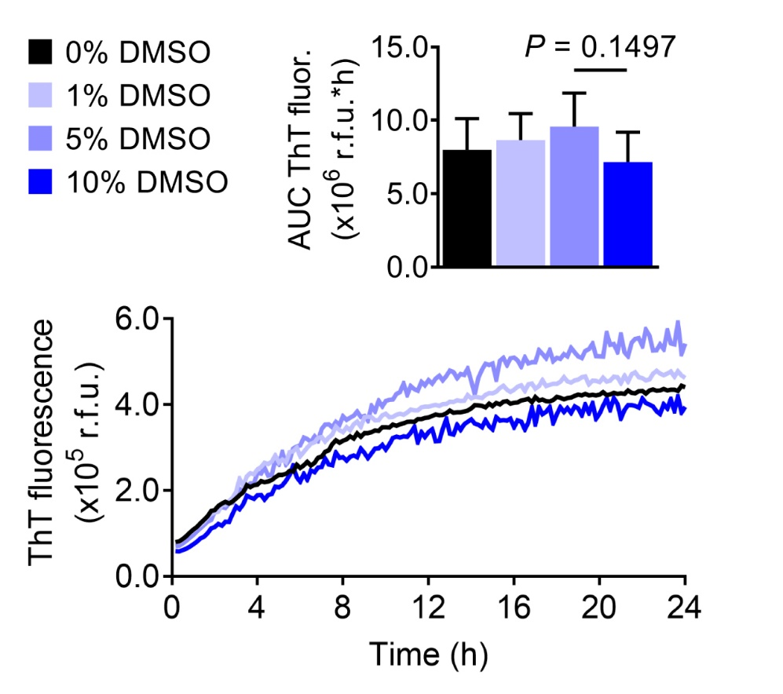

Additional file 5. Effect of DMSO in the optimized apoE4-Aβ fibrillization assay. The effects of DMSO at 0, 1, 5, and 10% (v/v) on apoE4-catalyzed Aβ42 fibrillization were evaluated. The data represent the mean ± SD of n = 8 wells per group.

Additional file 6. Design of experiments (DOE) assay optimization data. Experimental conditions and raw data for (A) Half-fraction factorial experiment, (B) Response surface experiment #1, and (C) Response surface experiment #2. The RunOrder column indicates randomized order in which the different experimental conditions were prepared in the wells of a plate. The CenterPt column indicates whether the experimental condition is a center point (0) or not (1). The PtType column indicates whether the experimental condition is a corner or axial point (-1 or 1), or a center point (0). The Blocks column indicates whether the experimental condition was included in a single plate run on one day (1), or was included in a second plate repeating the entire experiment on a different day (2). The AUC ThT intensity column indicates the integrated area under the curve of ThT fluorescence intensity measured by the plate reader in arbitrary units (a.u.) over the entire experiment duration. The Fold-change ThT intensity column indicates the fold-change in ThT fluorescence intensity from the beginning to the end of the experiment.

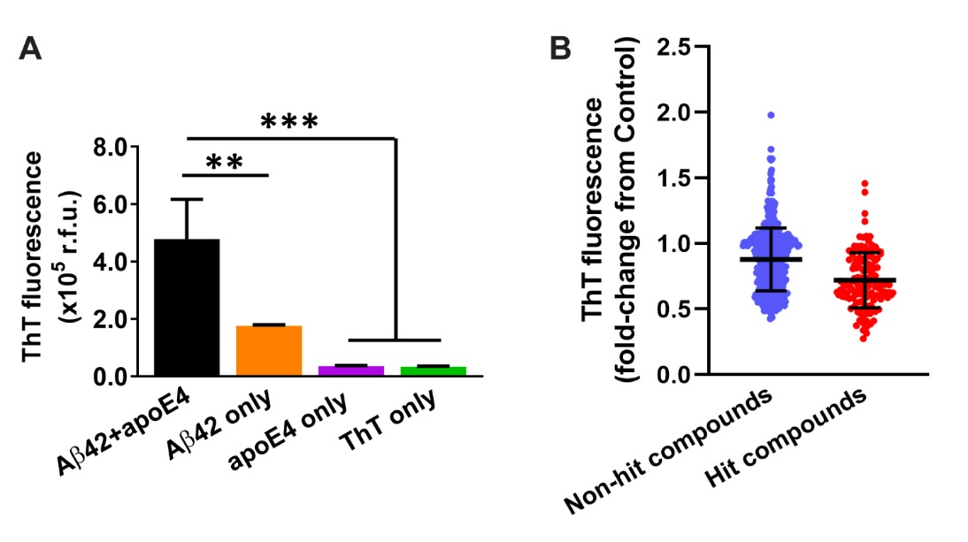
Additional file 7. Exploratory drug screen. a, The apoE4/Aβ42 fibrillization assay was performed in an endpoint fashion in the exploratory screen. To set up the fibrillization assay, Aβ42 (2 μM) and apoE4 (20 nM) were combined in water in a 96-well plate and incubated for 15 min. ThT and glycine were added and incubated for 10 min, and then fluorescence was measured at λ_{ex} = 440 nm, λ_{em} = 490 nm. (A) Under these conditions, Aβ42+apoE4 resulted in significantly greater ThT fluorescence than Aβ42, apoE4, or ThT alone. The data represent the mean ± SD of n = 3 wells per group. Statistical significance is indicated as **P < 0.01, ***P < 0.001 by one-way ANOVA. b, In the exploratory screen, compounds (2 μM), or DMSO as the control, were initially incubated with Aβ42 and apoE4, and the ThT intensity for each compound was normalized to the control group on the same plate. A total of 595 compounds from the NCC library were evaluated in the exploratory screen, with 134 being identified as hit compounds (red dots) and 461 being identified as non-hit compounds (blue dots). Each data point represents a single compound tested in n = 3 wells and averaged, and the black lines indicate the mean ± SD for each group.
Additional file 8. Exploratory drug screen results. (A) Detailed information about the 134 hit compounds identified in the exploratory screen. (B) BBB permeability for the 134 hit compounds identified in the exploratory screen, as determined by a literature search. Positive BBB qualities were found for 87 compounds (labeled in green), negative BBB qualities were found for 41 compounds (labeled in red), and no information was found for 6 compounds (labeled in yellow).

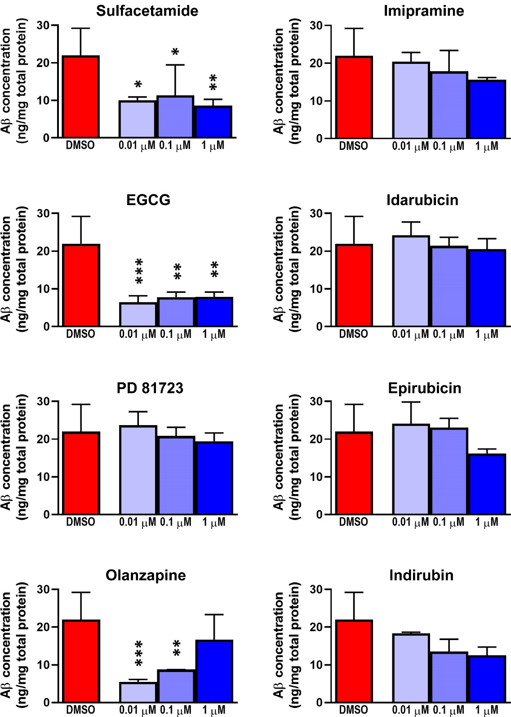
Additional file 9. Aβ levels in conditioned medium of 5xFAD mouse neurons. Aβ42 concentrations were measured in the conditioned medium of 5xFAD mouse neurons at 9 dpe to each hit compound by enzyme-linked immunosorbent assay (ELISA). The data represent the mean ± SD of n = 6 wells for the DMSO control and n = 3 wells per concentration for each compound. Statistical significance is indicated as *P < 0.05, **P < 0.01, and ***P < 0.001 compared to the DMSO control by one-way ANOVA.
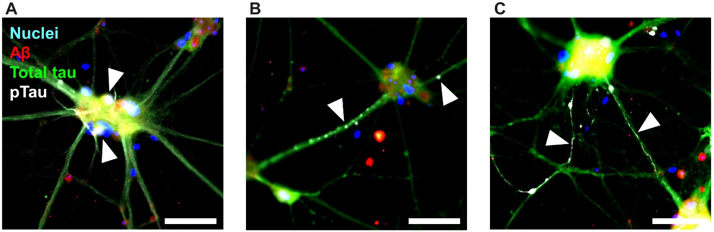
Additional file 10. pTau neuropathological features observed in TgF344-AD primary rat neurons. a−c, Representative ICC images of neurons at 14 dpe to apoE4 and Aβ42, treated with DMSO only as a control, and labeled for Aβ (red), total tau (green), pTau [S202/T205] (white), and cell nuclei (blue). Characteristic pTau neuropathological features were observed including (a) intracellular and extracellular puncta, (b) axonal blebbing, and (c) neuropil thread-like structures. Arrowheads indicate respective pTau neuropathological features. Scale bars = 50 μm.
 | Imipramine vs. other antidepressants |  |  |  | Olanzapine vs. other antipsychotics
 | N subjects imipramine; other anti-depressants | Estimate  (95% C.I.) | P-val |  | N subjects olanzapine; other anti-psychotics | Estimate  (95% C.I.) | P-val
Cognitive exam, ΔMMSE score/year
All subjects | 40; 6,299 | 0.3295  (-0.0792, 0.7381) | 0.1140 |  | 94; 793 | 0.4316  (-0.0146, 0.8778) | 0.0580
APOE4 carriers | 9; 2,733 | 0.0559  (-0.4456, 0.5575) | 0.8270 |  | 51; 352 | 0.6004  (-0.0683, 1.2692) | 0.0784
APOE4 non-carriers | 31; 3,467 | 0.5602  (-0.3377, 1.4582) | 0.2214 |  | 43; 441 | 0.3417  (-0.3306, 1.0139) | 0.3191

Additional file 11. Retrospective analysis of NACC dataset for cognition including baseline MMSE covariates. The cumulative exposure of imipramine and other antidepressants were compared and the on/off status of olanzapine and other antipsychotics were compared, using regression modeling for statistical comparisons of cognitive exam and including the baseline MMSE score as a covariate.
 | Imipramine vs. placebo |  |  |  |  |  |  |  | Olanzapine vs. placebo
 | Effect size | Std dev | α | β | Sample size |  |  | Effect size |  | Std dev | α | β | Sample size
All subjects | 0.4186 | 2.0013 | 0.05 | 0.2 | 359 |  |  | 0.4937 |  | 2.4281 | 0.05 | 0.2 | 380
APOE4 carriers | 0.6017 | 1.9584 | 0.05 | 0.2 | 168 |  |  | 0.7781 |  | 2.3691 | 0.05 | 0.2 | 147

Additional file 12. Power analyses for a hypothetical one year-long clinical trial of imipramine or olanzapine in AD subjects. Outputs from the Cox regression models of change in MMSE score over time, including the effect size and the standard deviation, were used in power analyses to estimate the sample sizes necessary to detect a similar difference between imipramine or olanzapine and control groups with an α (type 1 error level) of 0.05 and a β (type 2 error level) of 0.2. The sample sizes indicate the number of AD subjects that would be dosed with imipramine or olanzapine for one year with an equal number of control AD subjects receiving placebo.

Additional file 13. Summary statistics of NACC data analyses. (A, B) Subject information for MMSE models comparing (A) imipramine and other antidepressants or (B) olanzapine and other antipsychotics, including age, sex, baseline MMSE score, and drug exposure time. (C, D) Subject information for clinical diagnosis reversion models comparing (C) imipramine and other antidepressants or (D) olanzapine and other antipsychotics, including age, sex, baseline MMSE score, drug exposure time, number of subjects with reversions, and number of reversions per subject. (E, F) Subject information for clinical diagnosis conversion models comparing (E) imipramine and other antidepressants or (F) olanzapine and other antipsychotics, including age, sex, baseline MMSE score, drug exposure time, number of subjects with conversions, and number of conversions per subject. (G, H) Subject information for multiple medications models comparing (G) imipramine, doxepin, fluoxetine, citalopram, and all other antidepressants or (H) olanzapine, aripiprazole, quetiapine, and all other antipsychotics, including age, sex, baseline MMSE score, drug exposure time, number of subjects with reversions, and number of reversions per subject. (I) Complete test statistics and degrees of freedom for all statistical tests.

Additional file 14. Custom computer code generated for NACC data analysis. Computer code written in SAS and used to perform all statistical analyses of NACC data is provided in a text file. Computer code written in R and used to generate plots of NACC data is provided as an R file.

