Supplementary materials
Supplementary Figure 1. Age distribution
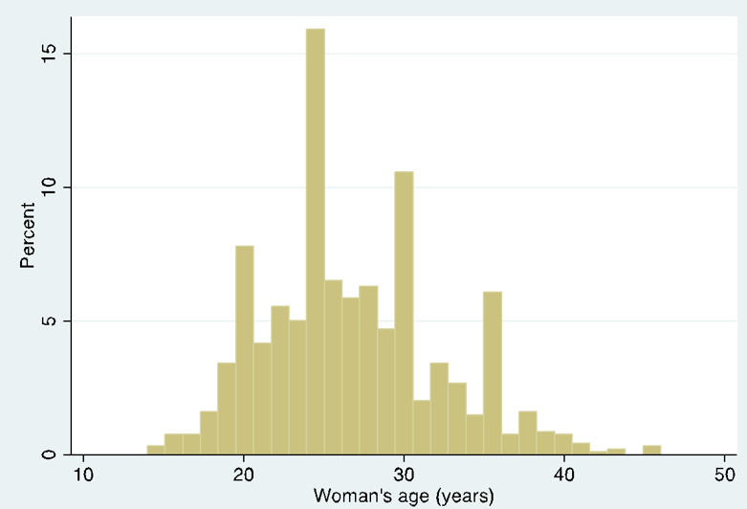

Note: Mean age= 26.79 (SD=5.49)

Supplementary Figure 2. Distribution of the # of ANC visits
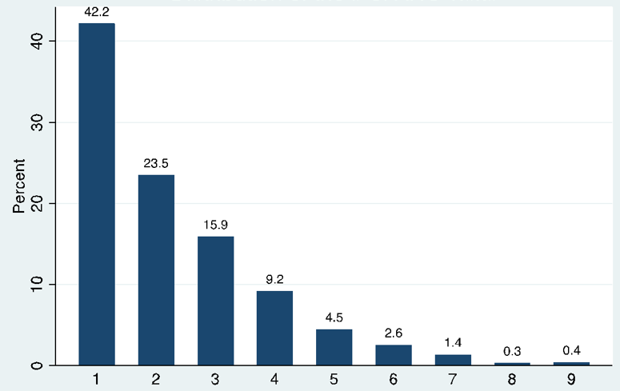
Note: Mean # visits = 2.28 (SD=1.54)

Supplementary Figure 3
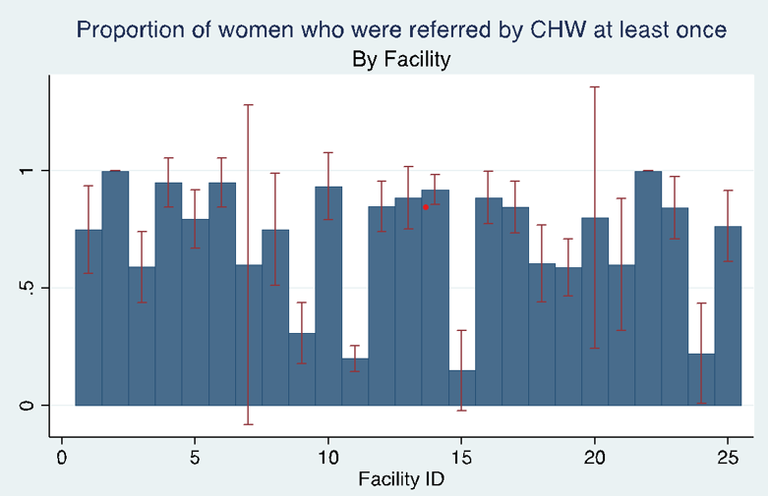
Legend:
Proportion IPTp3
95% Confidence Interval

Supplementary Table 1. Multilevel Poisson regression of characteristics associated with CHW referral
Variable | Empty model | Full model
Fixed effects |  | aPR (95% CI)
Woman's age (years)
14 to 19 years |  | REF
20 to 24 years |  | 1.03 (0.83-1.30)
25 to 29 years |  | 1.10 (0.87-1.38)
30 to 34 years |  | 1.08 (0.84-1.38)
35 years or more |  | 1.03 (0.76-1.39)
Parity
Nulliparous |  | REF
Primiparous |  | 1.00 (0.85-1.18)
Multiparous |  | 1.02 (0.84-1.25)
Trimester at first ANC visit
First trimester |  | REF
Second trimester |  | 1.09 (0.92-1.29)
Third trimester (7th month) |  | 0.97 (0.87-1.08)
Random Effects
Variance (constant) | 0.149 (0.05-0.47) | 0.160 (0.05-0.48)
*p<0.05, **p<0.01

