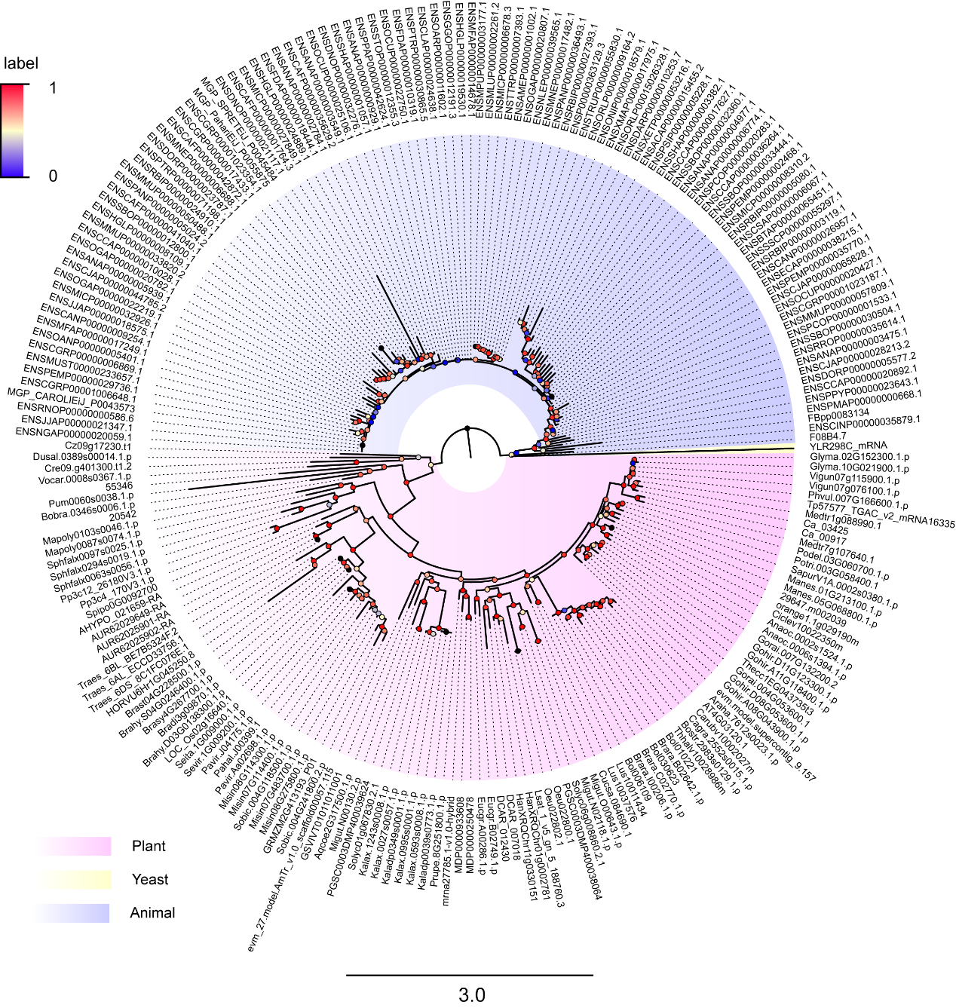
Figure S1 Phylogenetic comparison of U1Cs among plants, yeast and animals. The tree was constructed by FastTree.

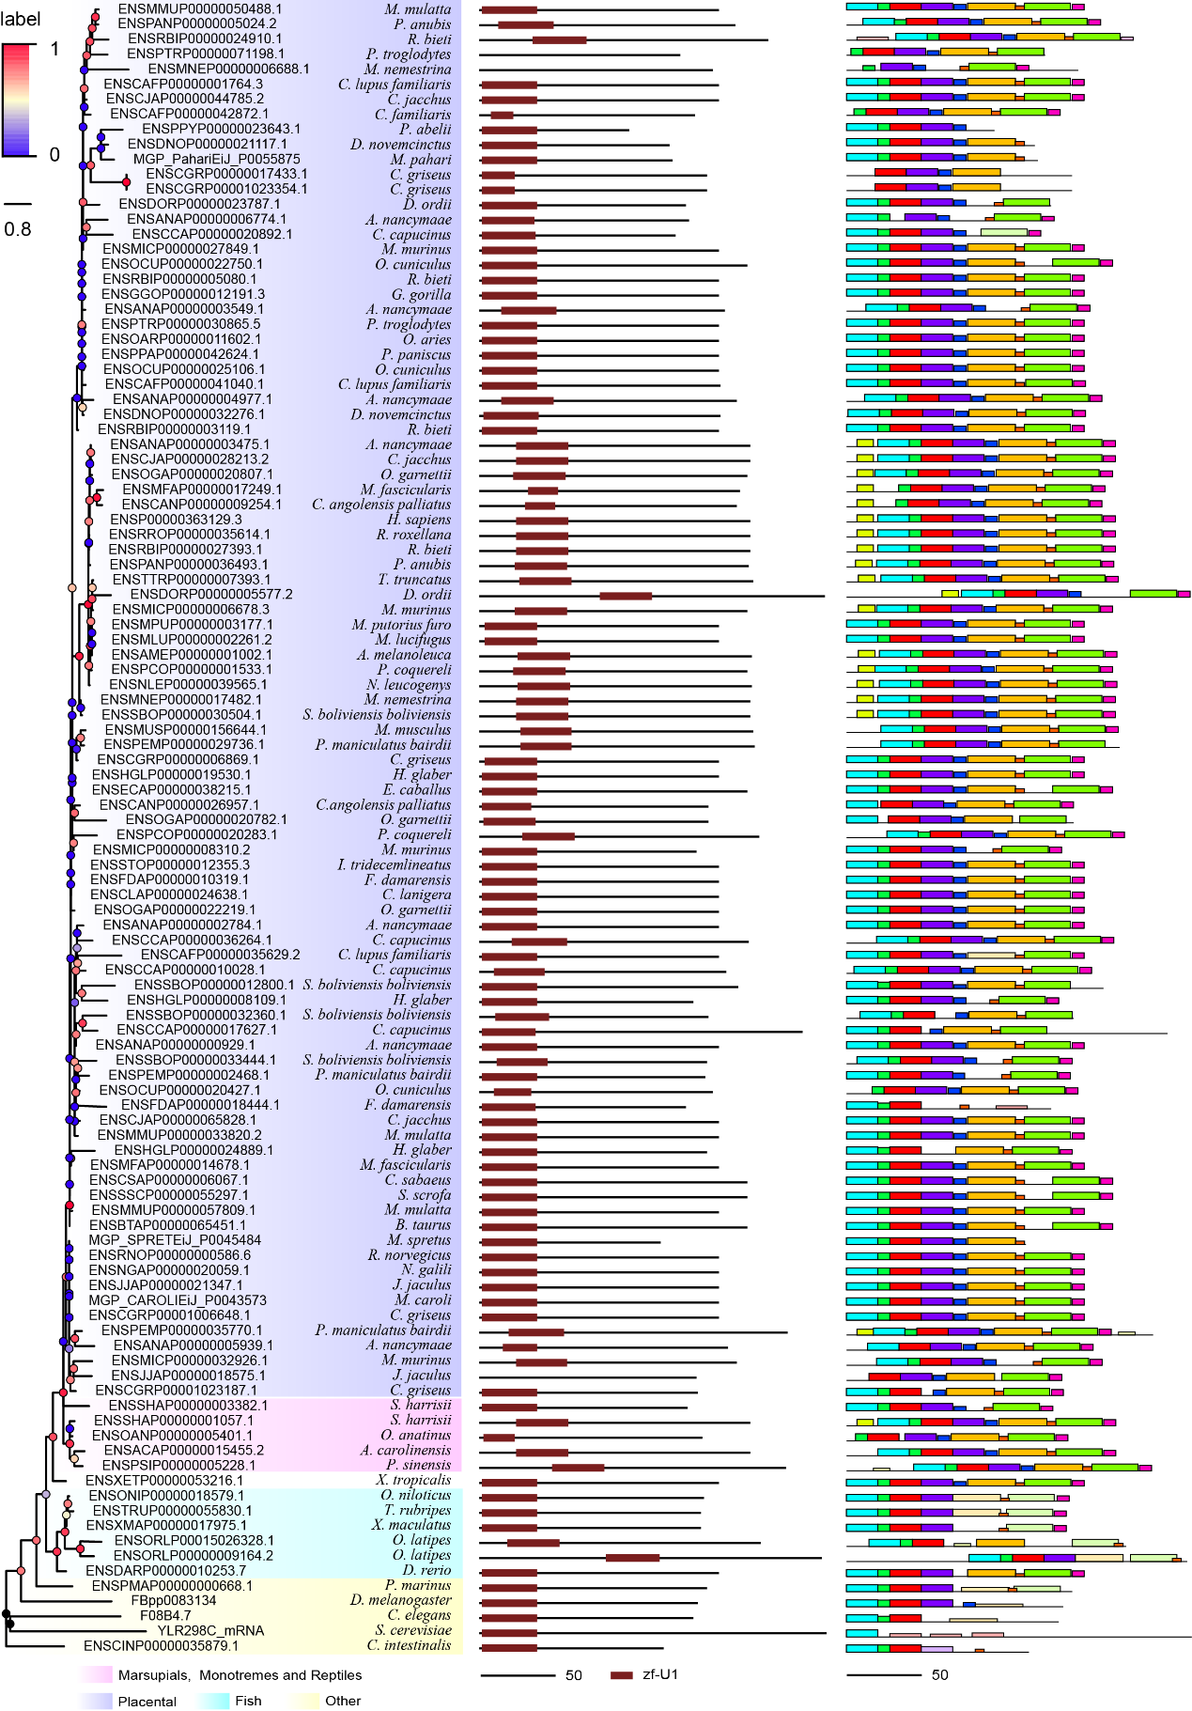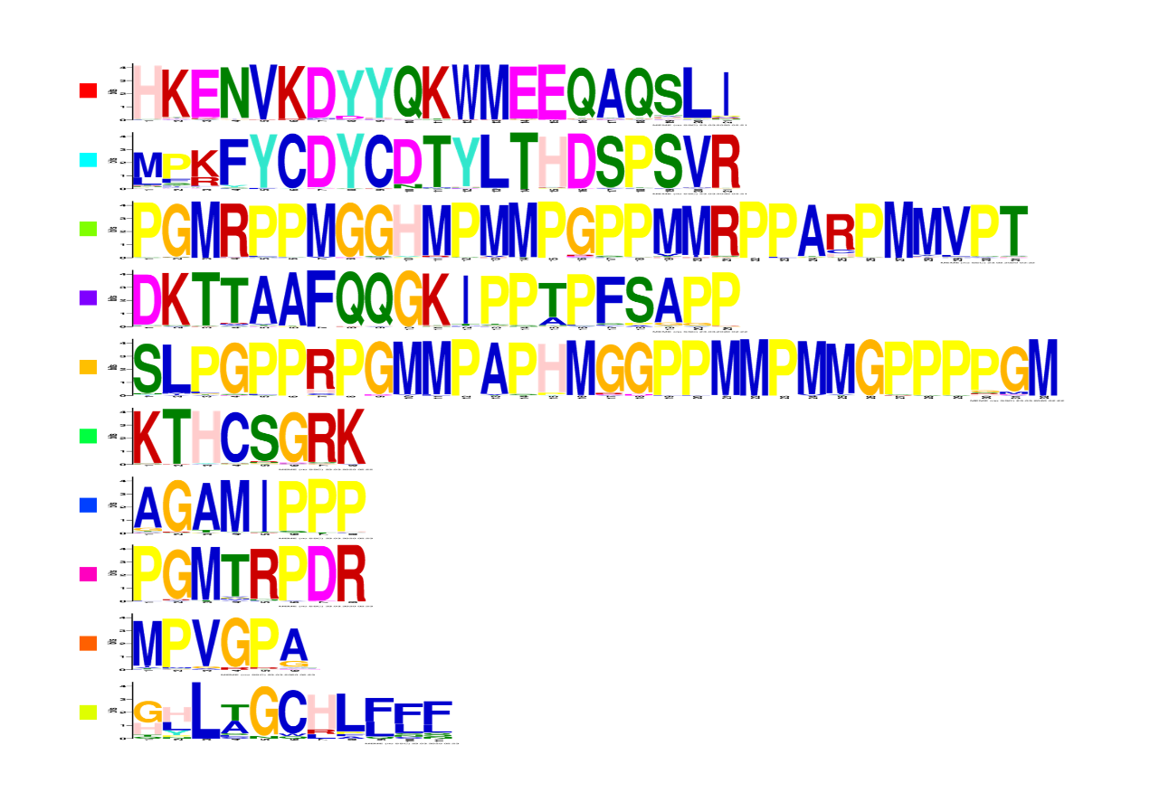
Figure S2 Comparisons of structure and motif analysis of animal U1C proteins. The vertical phylogenetic tree is listed on the left panel. The predicted protein domains (zf-U1) by online software HMMER are listed on the middle panel. The identified protein conserved motifs with MEME analysis are shown on the right panel. The 10 most frequently discovered motifs are shown in different solid colors and additional scanned sites (p-values less than 0.0001) are shown in transparent color.
Figure S3 Multiple sequence alignment of animal and plant U1C sequences used for the conservative analysis.

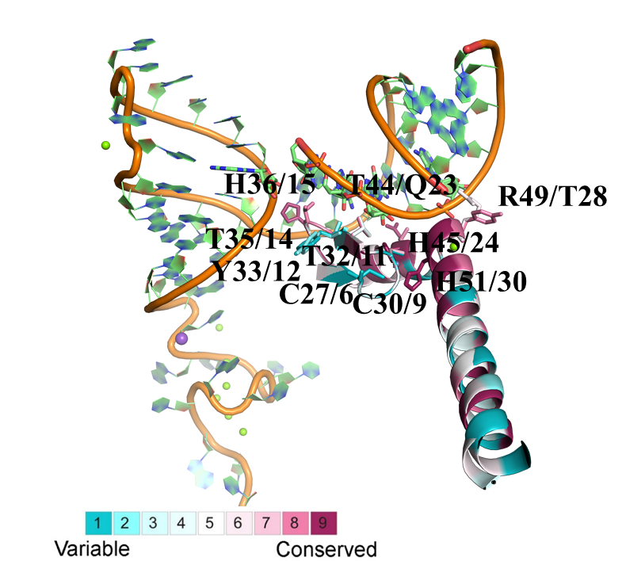
Figure S4 The comparison of evolutionary conservation between animal and plant U1Cs. The ribbon representation is colored according to ConSurf Grade (1-blue to 9-purple) by using identified protein sequences of animal/plant U1Cs. The residue numbers of human/Arabidopsis are labeled in the figure. The sequences used here were shown in Figure S3.

Figure S5 Representative protein-protein interaction networks of Homo sapiens, Mus musculus and Saccharomyces cerevisiae. Interaction networks of U1Cs of human, mouse and yeast are carried out by STRING database based on experimental data, which is experimentally determined (pink line) and from curated databases (blue line). Highly scored interactors are presented in the form of network diagram. Empty notes are proteins of unknown 3D structure, while filled notes are proteins with known or predicted 3D structure in current database. Edges represent protein-protein associations that meant to proteins jointly contribute to a shared function.
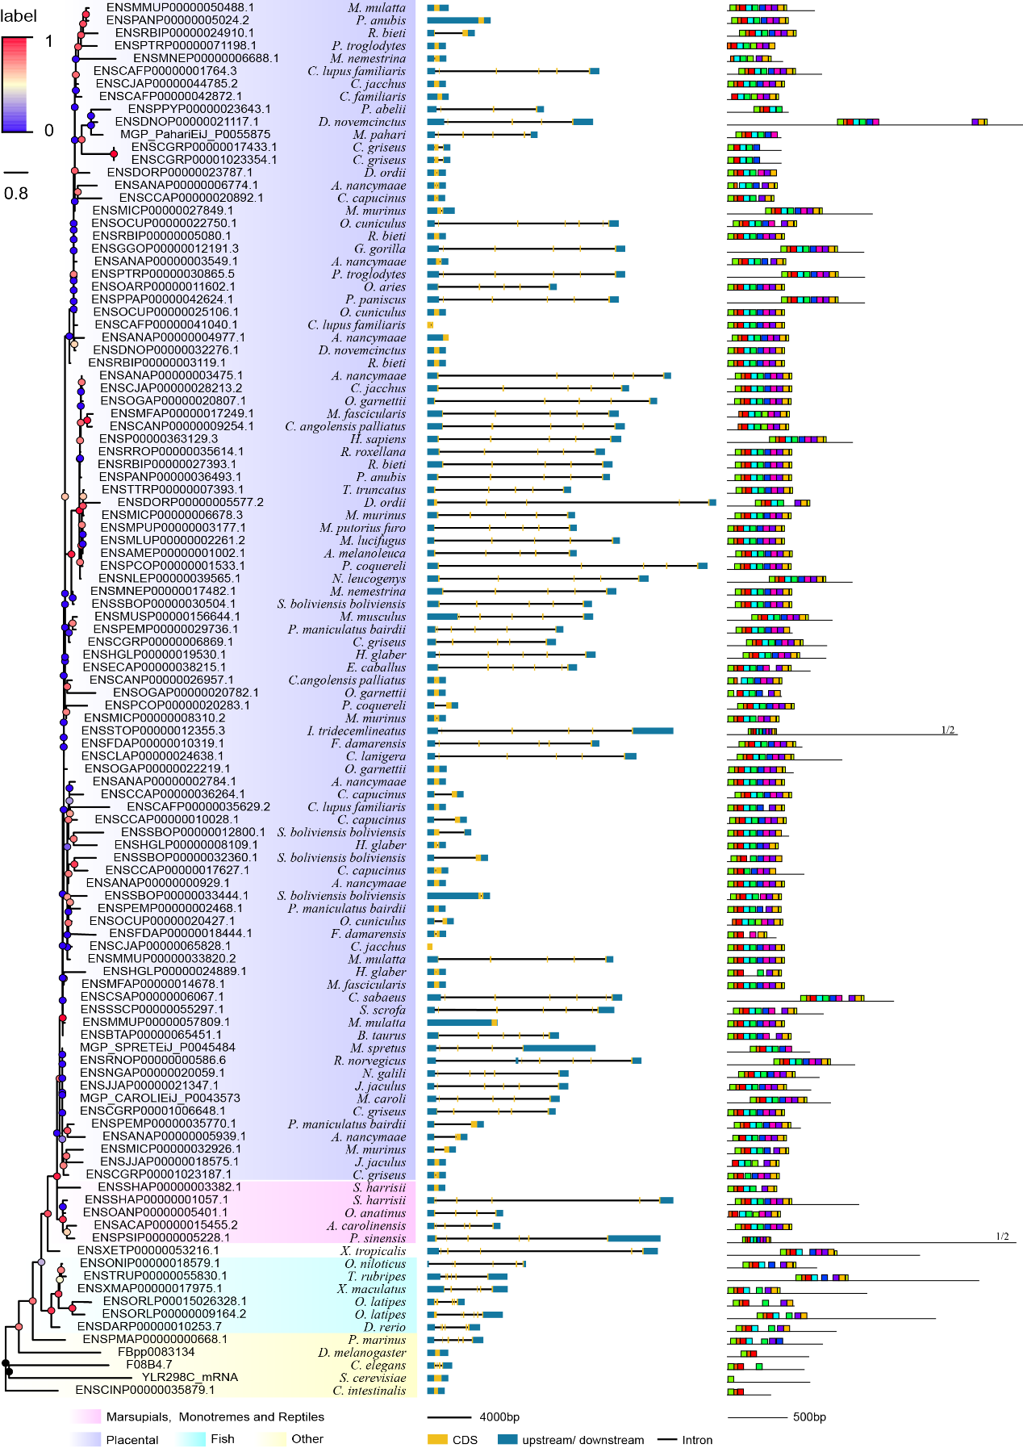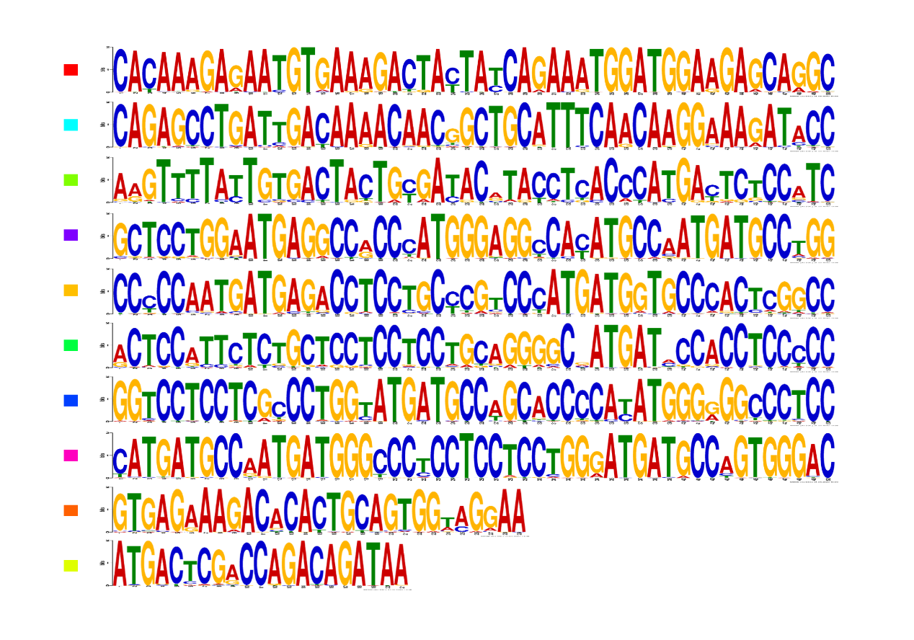
Figure S6 Identification and comparison of genomic organization and conserved motifs among animal U1C genes. The vertical phylogenetic tree is listed on the left panel. The gene structure by GSDS2.0 website are listed on the middle panel. The identified cDNA conserved motifs with MEME analysis are shown on the right panel. The 10 most frequently discovered motifs are shown in different solid colors and additional scanned sites (p-values less than 0.0001) are shown in transparent color.

Figure S7 Conserved alternative splice site sequences analysis for animal U1C genes. Flanking sequences (40-bp) at conserved exon-intron boundaries of animal U1C genes are analyzed to show their consensus by online Weblogo and multiple alignment. The conventional 5’-GT or 3’-AG splice site dinucleotides are marked in red boxes. (A) Four conserved splice sites found among animal U1C genes were marked in blue arrow (type 1), red arrow (type 2), purple arrow (type 3) and pink arrow (type 4). B-E represent graph representation and multiple alignment of type 1, type 2, type 3 and type 4 conserved splice sites. F-H represent detailed analysis of type 3 splice site among sector ‘primates’, ‘rodents and lagomorphs’ and ‘Other Mammals’. I-K represent detailed analysis of type 4 splice site among sector ‘primates’, ‘rodents and lagomorphs’ and ‘Other Mammals’.
Figure S8 Heatmap representation of disease expressions of U1C in Homo sapiens. No.1-23 represent Pan-Cancer Analysis of Whole Genomes - brain, Pan-Cancer Analysis of Whole Genomes - lung, Pan-Cancer Analysis of Whole Genomes - liver, Pan-Cancer Analysis of Whole Genomes - kidney, Pan-Cancer Analysis of Whole Genomes - uterine cervix, Pan-Cancer Analysis of Whole Genomes - esophagus, Pan-Cancer Analysis of Whole Genomes - breast, Pan-Cancer Analysis of Whole Genomes - blood, Pan-Cancer Analysis of Whole Genomes - uterus, Pan-Cancer Analysis of Whole Genomes - urinary bladder, Pan-Cancer Analysis of Whole Genomes - thyroid gland, Pan-Cancer Analysis of Whole Genomes - stomach, Pan-Cancer Analysis of Whole Genomes - skin, Pan-Cancer Analysis of Whole Genomes - prostate gland, Pan-Cancer Analysis of Whole Genomes - mouth mucosa, Pan-Cancer Analysis of Whole Genomes - large intestine, 3 Glioma subtypes, Pan-Cancer Analysis of Whole Genomes - skeletal muscle tissue, Pan-Cancer Analysis of Whole Genomes - pancreas, Pan-Cancer Analysis of Whole Genomes - ovary, Proteomics - Tissue - Breast cancer - Tyanova et al., Proteomics - Tissue - Colon and Rectal cancer-rectum, Proteomics - Tissue - Colon and Rectal cancer - colon, respectively.

Figure S9 Organism part expressions of human U1C gene.No.1-40 represent GTEx, 68 FANTOM5 project – adult, 32 Uhlen's Lab, 19 NIH Epigenomics Roadmap 68 FANTOM5 project – fetal, Illumina Body Map, HDBR developing brain - 9 post conception weeks, HDBR developing brain - 12 post conception weeks, HDBR developing brain - Carnegie Stage 22, HDBR developing brain - 11 post conception weeks, HDBR developing brain - 10 post conception weeks, ENCODE (M. Snyder lab), HDBR developing brain - 16 post conception weeks, HDBR developing brain - Carnegie Stage 23, HDBR developing brain - 13 post conception weeks, HDBR developing brain - Late 8 post conception weeks, Mammalian Kaessmann, HDBR developing brain - 14 post conception weeks, HDBR developing brain - 17 post conception weeks, HDBR developing brain - Carnegie Stage 21, HDBR developing brain - Carnegie Stage 18, HDBR developing brain - Carnegie Stage 17, HDBR developing brain - Carnegie Stage 20, HDBR developing brain - Carnegie Stage 14, HDBR developing brain - Carnegie Stage 19, HDBR developing brain - 15 post conception weeks, HDBR developing brain - Carnegie Stage 16, HDBR developing brain - Carnegie Stage 13, HDBR developing brain - Carnegie Stage 15, HDBR developing brain - 20 post conception weeks, HDBR developing brain - 19 post conception weeks, Human Protein Atlas, Wang et al. 2019, Human Proteome Map – adult, brain regions in Alzheimer's McKetney et al. 2019 - Alzheimer's disease, early braak stage, brain regions in Alzheimer's McKetney et al. 2019 - normal, normal, brain regions in Alzheimer's McKetney et al. 2019 - Alzheimer's disease, late braak stage, brain regions, Human Proteome Map - fetus, brain regions in Alzheimer's MendonГѓВ§a et al. 2019 - normal, normal, respretively.

Figure S10 Organism part expression of U1C in Mus musculus. No.1-47 represent Mammalian Kaessmann, 6, Vertebrates, 49 FANTOM5 project - embryonic day 18, 49 FANTOM5 project - embryonic day 13, 49 FANTOM5 project - juvenile, 4, 14 - embryonic day 9.5, 14 - embryonic day 8.5, 4 Bonthuis et al. - CastEiJ, 4 Bonthuis et al. - (CastEiJ X C57BL/6J)F1, 4 Bonthuis et al. - (C57BL/6J X CastEiJ)F1, Developing gut, 49 FANTOM5 project - embryonic day 11, 49 FANTOM5 project - adult, 3 Soumillon et al., 3, Gregg et al. - CAST/EiJ, Gregg et al. - C57BL/6J, Gregg et al. - (CAST/EiJ X C57BL/6J)F1, Gregg et al. - (C57BL/6J X CAST/EiJ)F1, 4 Bonthuis et al. - C57BL/6J, 49 FANTOM5 project - pregnant adult day 1, 2, 49 FANTOM5 project - pregnant adult day 19, 49 FANTOM5 project - pregnant adult day 17.5, 49 FANTOM5 project - pregnant adult day 17, 49 FANTOM5 project - pregnant adult day 10, 49 FANTOM5 project - embryonic day 17.5, 49 FANTOM5 project - embryonic day 14.5, 49 FANTOM5 project - embryo, 4 Bonthuis et al. - Idaho derived wild mouse, Organism part - Geiger et al., Organism part - Huttlin et al., Organism part - Meierhofer et al., Skeletal muscle - Deshmukh et al. - myotube, C2C12, respectively.

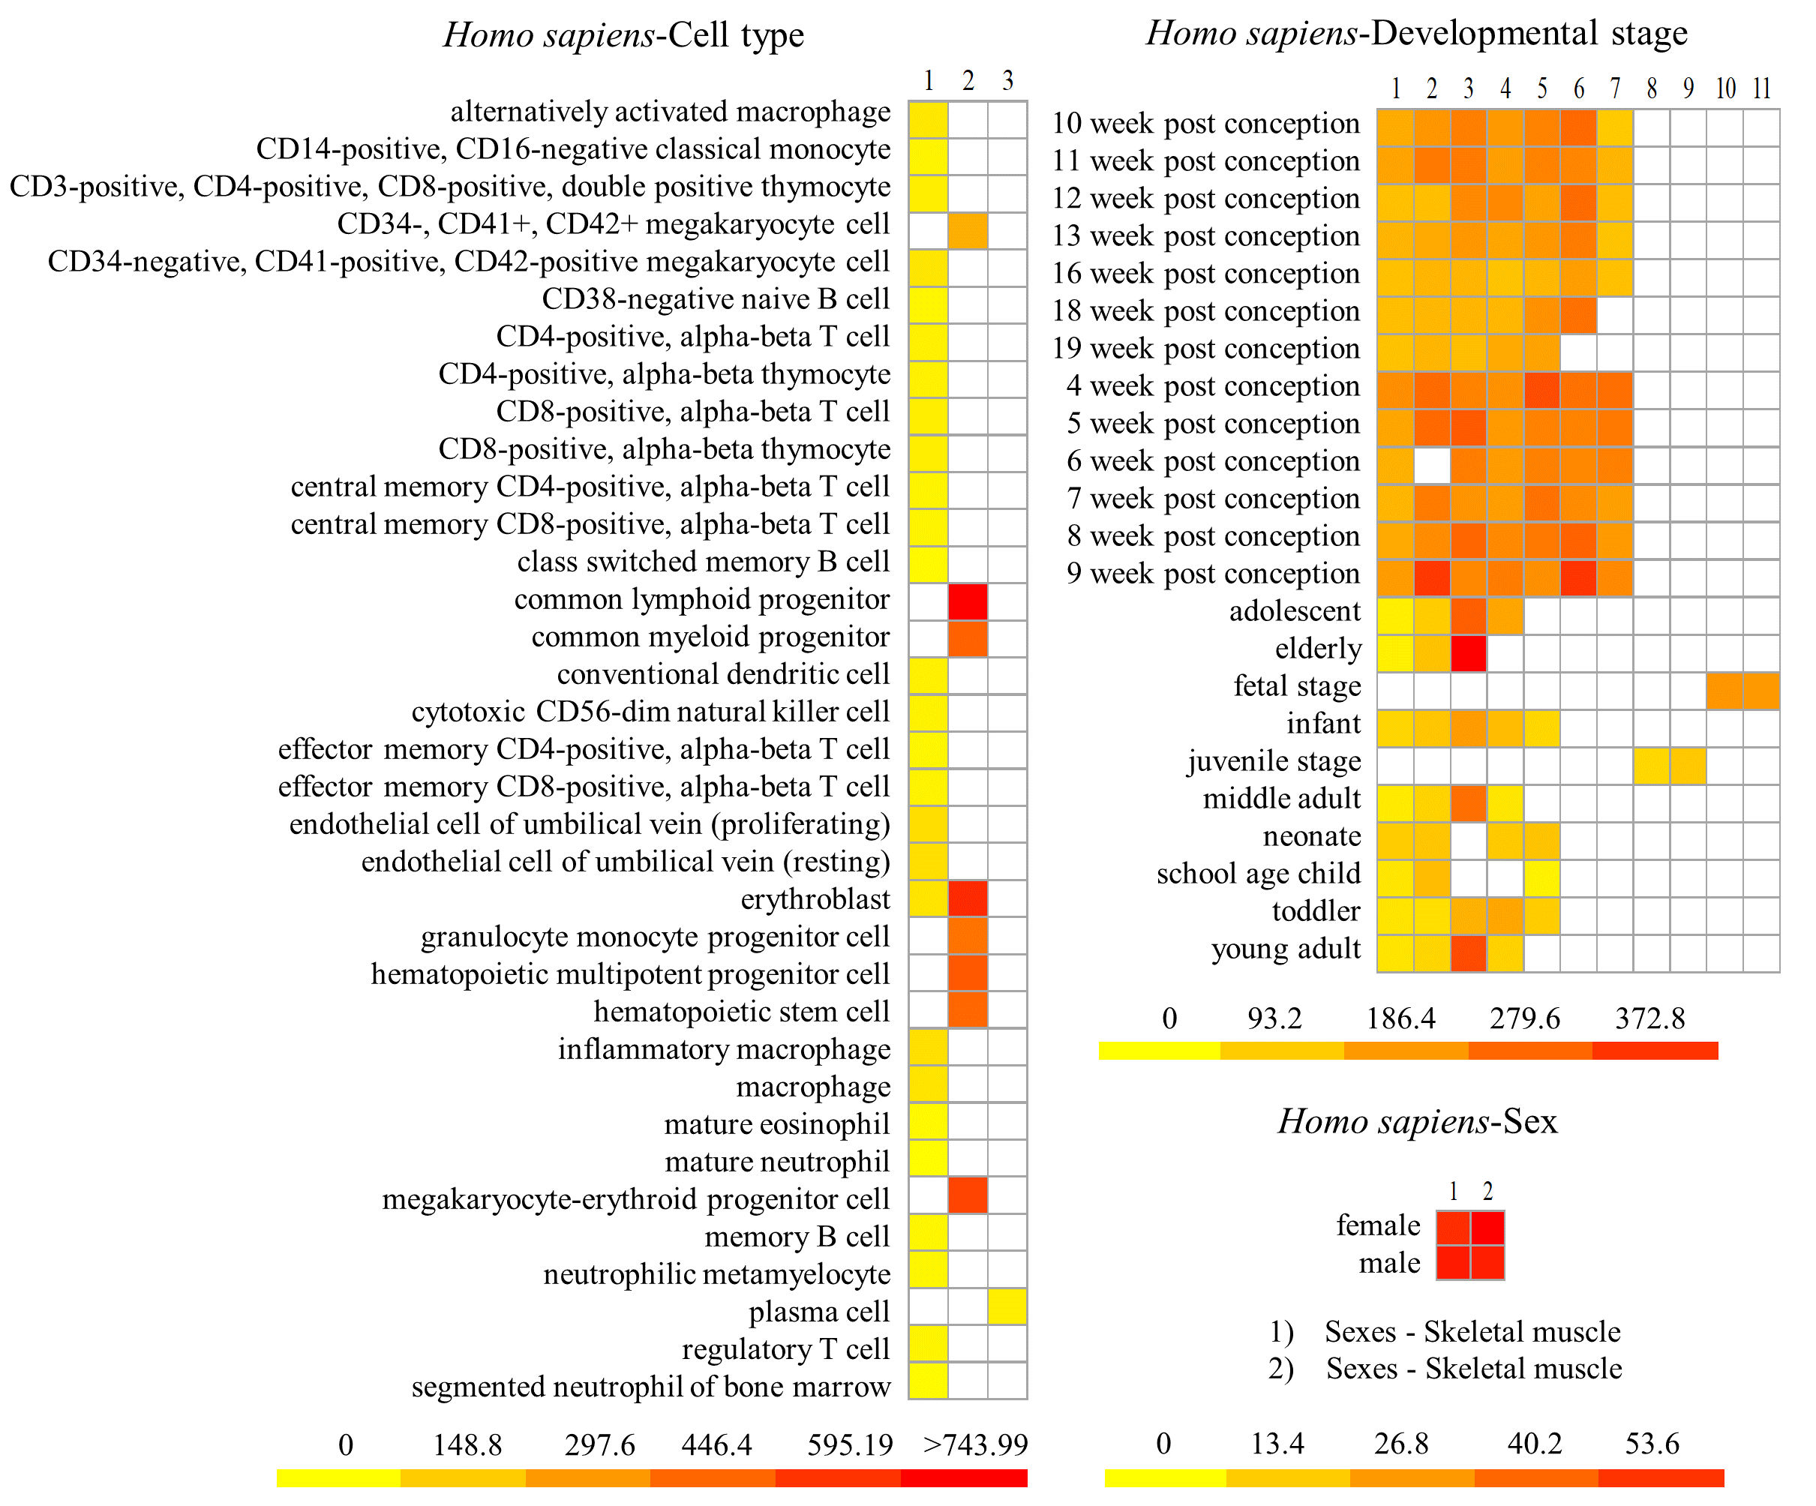
Figure S11 Expression of human U1C in various cell types, developmental stages and sex. No.1-3 of Homo sapiens-cell type represent Cell Types - BLUEPRINT common haemopoetic cells, Cell Types - BLUEPRINT rare hematopoietic cells, Cell Types - BLUEPRINT tonsil plasma cells. No.1-11 of Homo sapiens-developmental stage represent Tissues, developmental stages - Human - Moreira et al - liver, Tissues, developmental stages - Human - Moreira et al - forebrain Tissues, developmental stages - Human - Moreira et al - testis, Tissues, developmental stages - Human - Moreira et al - heart, Tissues, developmental stages - Human - Moreira et al - kidney, Tissues, developmental stages - Human - Moreira et al - ovary, Tissues, developmental stages - Human - Moreira et al - hindbrain, Kraiczy et al intestinal cells - terminal ileum, Kraiczy et al intestinal cells - sigmoid colon, Kraiczy et al intestinal cells - proximal gut, Kraiczy et al intestinal cells - distal gut, respectively.
Figure S12 Expression of mouse U1C in cell type. No.1-14 represent Cell Types - 35 FANTOM5 project, Cell type - Paulson et al, Cell types - Lavin et al, Cell Types - Cerebral cortex, Cell Types - Six T cell subtypes, Cell types - Capucha et al, Cell type - Wamstad et al, Cell types - 3 Lienert et al, Cell type - Soumillon et al, Cell type - Cabezas-Wallscheid et al - Lin neg Sca-1+ c-Kit+, LSK, CD34- CD135- CD150+ CD48-, Cell type - Cabezas-Wallscheid et al - LSK CD34+ CD135- CD150- CD48+, Cell type - Cabezas-Wallscheid et al - LSK CD34+ CD135- CD150+ CD48-, Cell type - Cabezas-Wallscheid et al - LSK CD34+ CD135- CD150+ CD48+, Cell type - Cabezas-Wallscheid et al - LSK CD34+ CD135+ CD150- CD48+, respectively.

Figure S13 Expression of mouse U1C in various sampling time points, strains, developmental stage and somite stages. No.1-16 of Mus musculus- developmental stage represent Tissues, developmental stages - Mouse - Moreira et al - testis, Tissues, developmental stages - Mouse - Moreira et al - ovary, Tissues, developmental stages - Mouse - Moreira et al - liver, Tissues, developmental stages - Mouse - Moreira et al - heart, Tissues, developmental stages - Mouse - Moreira et al - kidney, Tissues, developmental stages - Mouse - Moreira et al - hindbrain, Tissues, developmental stages - Mouse - Moreira et al - forebrain, 5, Cell Types - Developing heart - cardiomyocyte, Tissues, developmental stages - Mouse - Moreira et al - brain, Developmental stages - Schmitt et al - liver, Developmental stages - Schmitt et al - brain, Cell Types - Developing heart - fibroblast, Cell Types - Developing heart - cells of ventricle, Developmental stages - 4 - liver, Developmental stages - 4 - bone marrow, respectively.

Figure S14 Comparison of U1Cs in human, yeast, Arabidopsis and rice. (A) Representation of gene structures of U1Cs in human, yeast, Arabidopsis and rice. (B) Conserved motif analysis of human and Arabidopsis U1Cs. Black boxes indicate exon-intron boundaries. (C) Conserved splice sites analysis of human, Arabidopsis and rice U1Cs. Orange arrow represents conserved splice sites. Red boxes represent 5’ splice sites and 3’ splice sites.

