Supplementary Material: Future extension of the UK Summer and its impact on Autumn precipitation
Daniel F. Cotterill^{1*}, James O. Pope¹, Peter A. Stott¹.

¹Met Office Hadley Centre, Exeter, United Kingdom

For Submission to Climate Dynamics

Submitted: March 2022

* Corresponding Author address: Daniel Cotterill, Met Office, Fitzroy Road, Exeter, Devon, EX1 3PB, UK. E-mail: daniel.cotterill@metoffice.gov.uk

Content Summary:
The supplementary material contains extra information for the following areas:
1. Dataset details for the weather pattern data created
2. Model validation for weather pattern frequency
3. Comparing weather pattern frequency results for ALL and NAT attribution runs
4. Change in weather pattern frequency for different seasons plots
5. Seasonality changes within models

- Model runs that weather pattern datasets were created for in this work
Supplementary Table 1: Data model and run details for each weather pattern dataset created, including the baseline period used for mean sea level pressure (psl) anomalies.
Model | Time Period | Experiment | Resolution of Model | No. of Ensemble members | Ensemble member names | Baseline Period for Anomalies
HadGEM3-A | 1960/01/01-2009/12/30 | NAT | 60 km | 15 | r1i1p1- r1i1p15 | NAT (1960-2010)
HadGEM3-A | 1960/01/01-2009/12/30 | ALL | 60 km | 15 | r1i1p1- r1i1p15 | NAT (1960-2010)
MRI-ESM2-0 (CMIP6) | 1970/01/01- 2009/12/31 | Nat-Hist | 100 km | 5 | r1i1p1f1- r5i1p1f1 | NAT (1970-2000)
MRI-ESM2-0 (CMIP6) | 1970/01/01- 2009/12/31 | Historic | 100 km | 5 | r1i1p1f1- r5i1p1f1 | NAT (1970-2000)
MRI-ESM2-0 (CMIP6) | 2070/01/01- 2099/12/31 | FUT ssp370 | 100 km | 5 | r1i1p1f1- r5i1p1f1 | NAT (1970-2000)
HadGEM3-GC31-MM (CMIP6) | 1960/01/01- 2009/12/30 | Historic | 100 km | 4 | r1i1p1f3- r4i1p1f3 | Historic (1960-2000)
HadGEM3-GC31-MM (CMIP6) | 2070/01/01- 2099/12/30 | FUT ssp585 | 100 km | 4 | r1i1p1f3- r4i1p1f3 | Historic (1960-2000)

- Validation of weather pattern frequency in models
This covers visual results of weather pattern frequency model validation for the CMIP6 models examined and UKCP Global 15 PPE for each season. HadGEM3-A results are shown in the paper. Both CMIP6 models examined and UKCP Global 15 PPE show better agreement with ERA5 from Spring-Autumn than in Winter.
2.1 CMIP6 models:

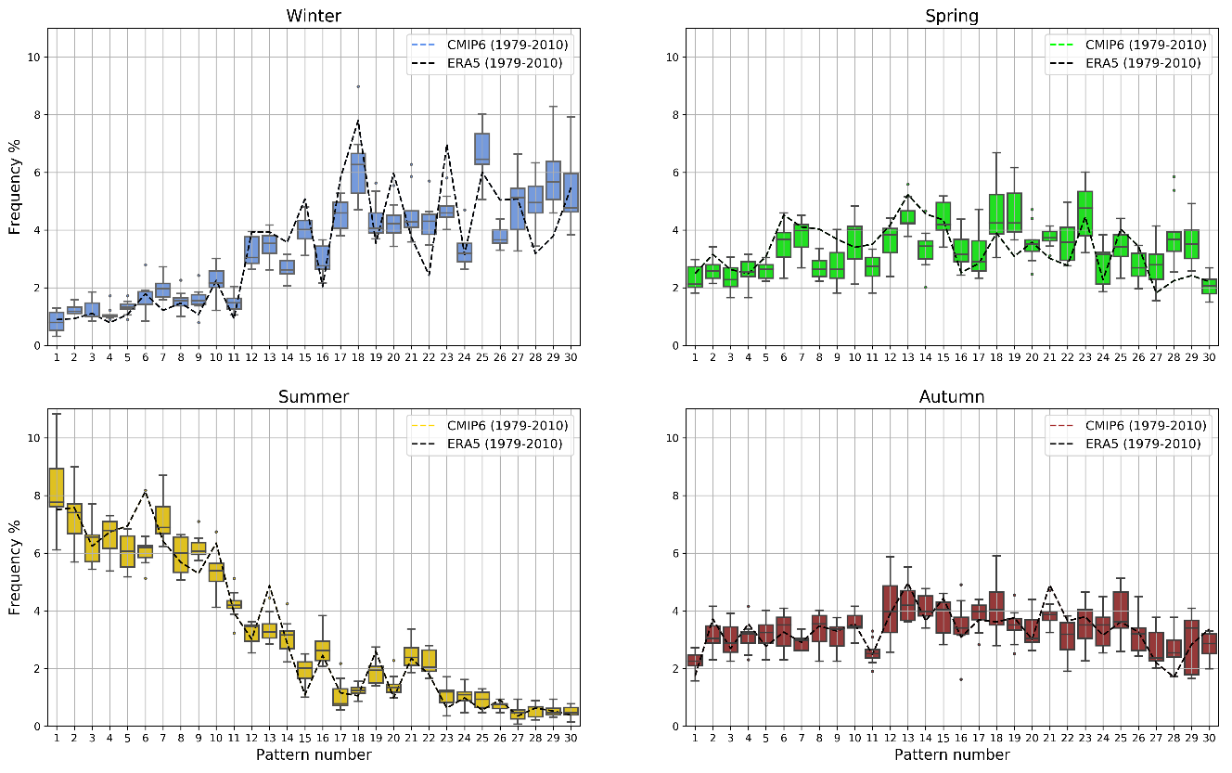
Supplementary Figure 1: Seasonal daily frequencies of the 30 weather patterns over the UK in both the ERA5 reanalyses and the CMIP6 models (MRI-ESM2-0 NAT: 5 ensemble members and HadGEM3-GC31-MM historic: 4 ensemble members) between 1979-2010. The points making up the boxplot for each of the patterns represent the 9 individual ensemble members from both models combined, where the shaded box covers the interquartile range, the whiskers are the min and max values, and the dots represent outliers.

2.2 UKCP Global 15 PPE

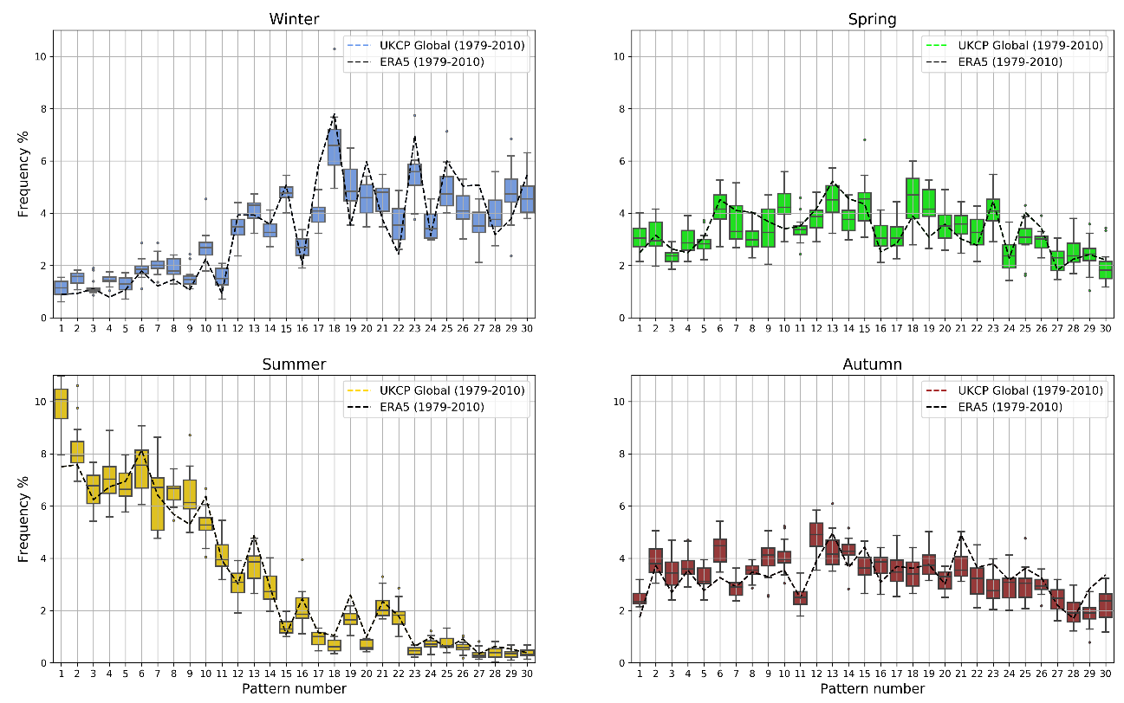
Supplementary Figure 2: Seasonal daily frequencies of the 30 weather patterns over the UK in both the ERA5 reanalyses and the UKCP Global 15 PPE between 1979-2010. The points making up the boxplot for each of the patterns represent the 15 individual ensemble members, where the shaded box covers the interquartile range, the whiskers are the min and max values and the dots represent outliers.

- Comparing weather pattern frequency results for ALL and NAT attribution runs
Analysis on the attribution runs for MRI-ESM2-0 was carried out and in supplementary figure 3 below, the 30-weather pattern seasonal daily frequencies for the ALL forcings and NAT only forcings runs between 1980 and 2010 is compared. The equivalent figure for the HadGEM3-A ALL and NAT runs is shown in the paper (Fig. 3).
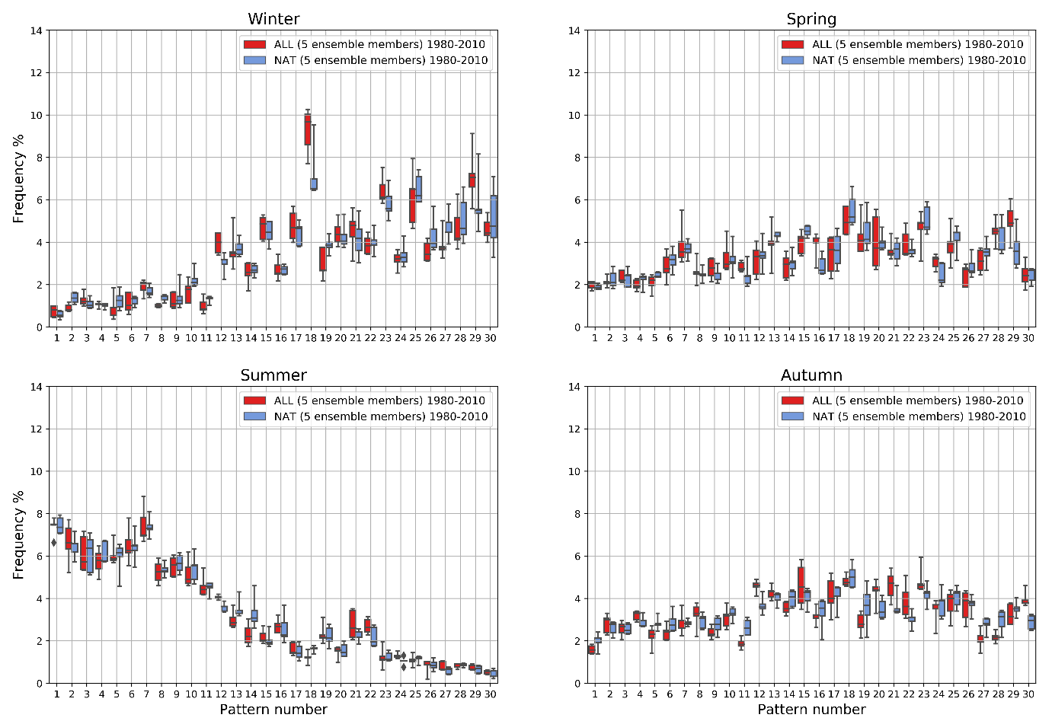
Supplementary Figure 3: Seasonal frequencies of the 30 weather patterns over the UK of the 5 ensemble members of MRI-ESM2-0 comparing ALL forcings runs (red) and NAT forcings only runs (blue) from 1980-2010. The points making up the boxplots for each of the 30 patterns represent the frequency values of the 5 individual ensemble members, represented by the median, box widths and whiskers.

There are quite a few significant range differences for the 30 weather patterns when comparing ALL and NAT runs as can be seen in Supplementary Table 2. The method used is described in section 2.2.2 of the paper, only three of the patterns that show significant range differences between runs for each of the models, show the same change for both models. In the table below a (+) sign represents a noticeable increase in the ALL forcing runs and a (-) sign represents a noticeable decrease in the ALL forcing runs for the specific weather pattern.

Supplementary Table 2: Showing which weather patterns for each model had significant range differences between the ALL forcings and Natural only forcings runs over the time period 1980-2010, after bootstrapping ensemble member yearly values. The top part of the table shows the results for the HadGEM3-A model and the lower part for the MRI-ESM2-0 model from CMIP6.
HadGEM3-A | No. significant changes | Sign of Change | Significant Pattern Changes
DJF | 2 | (+)
DJF | 2 | (-) | 3, 4
MAM | 4 | (+) | 20,23,29
MAM | 4 | (-) | 5
JJA | 7 | (+) | 14, 20, 21, 23, 30
JJA | 7 | (-) | 3,7
SON | 5 | (+) | 20, 23, 29
SON | 5 | (-) | 5, 9

MRI-ESM2-0 | No. significant changes | Sign of Change | Significant Pattern Changes
DJF | 8 | (+) | 12, 18, 29
DJF | 8 | (-) | 2, 5, 8, 10, 19
MAM | 3 | (+) | 16, 24, 29
MAM | 3 | (-)
JJA | 2 | (+)
JJA | 2 | (-) | 14, 18
SON | 11 | (+) | 12, 20, 21, 22, 30
SON | 11 | (-) | 1, 5, 11, 19, 27, 28

- Changes in the frequency of weather pattern plots for seasons other than Autumn under different emissions scenarios
4.1 DJF

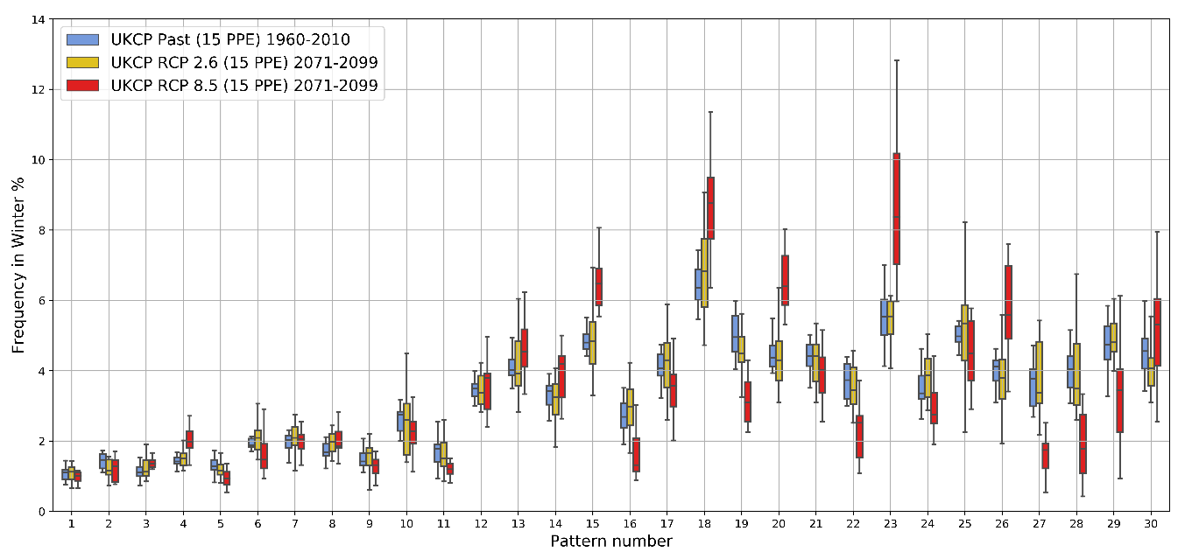

Supplementary Figure 4: Plot showing Winter seasonal frequencies of daily weather pattern numbers for the 30 regimes for different time-slices and emissions scenarios using UKCP Global. Boxplots include 15 data points from 15 model ensemble members. The points making up the boxplot for each of the patterns represent the 15 individual ensemble members, where the shaded box covers the interquartile range and the whiskers are the min and max values.

4.2 MAM
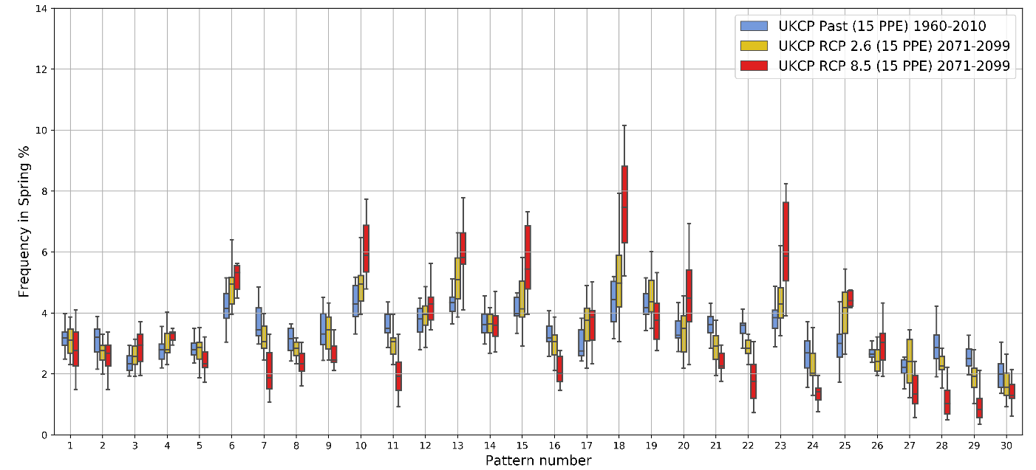
Supplementary Figure 5: Plot showing Spring seasonal frequencies of daily weather pattern numbers for the 30 regimes for different time-slices and emissions scenarios using UKCP Global. The points making up the boxplot for each of the patterns represent the 15 individual ensemble members, where the shaded box covers the interquartile range and the whiskers are the min and max values.

4.3 JJA

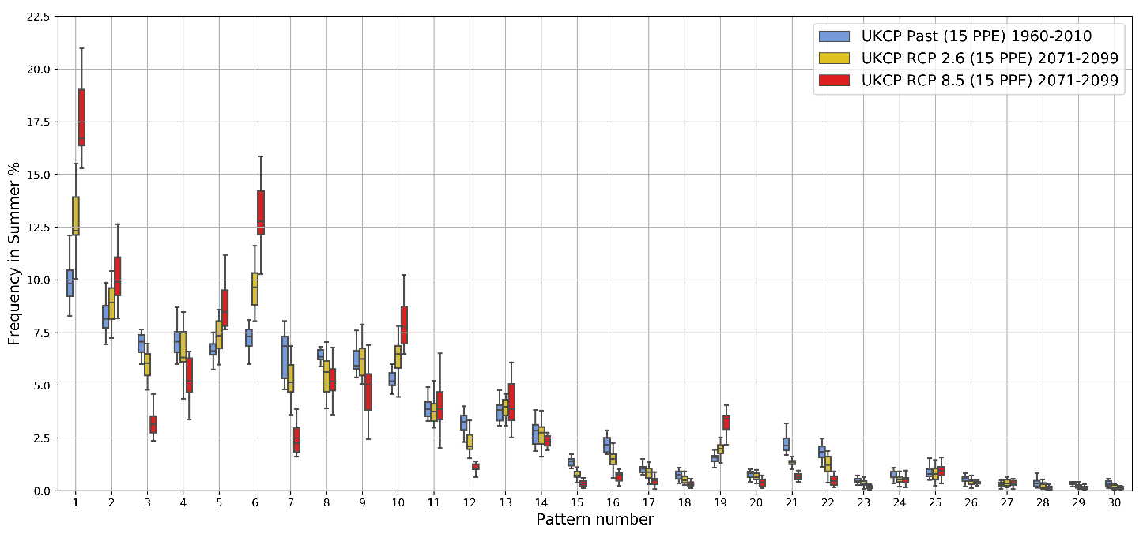

Supplementary Figure 6: Plot showing Summer seasonal frequencies of daily weather pattern numbers for the 30 regimes for different time-slices and emissions scenarios using UKCP Global. The points making up the boxplot for each of the patterns represent the 15 individual ensemble members, where the shaded box covers the interquartile range and the whiskers are the min and max values.

- Seasonality changes within models
Supplementary table 3 shows the change in frequency of the 20% most predominantly summer-type weather patterns (1-6), and the 20% most predominantly winter-type weather patterns (25-30) between a past time-slice (1971-2000) and a future time-slice for a high emissions scenario (2071-2100). This change is quantified by whether there is a significant range difference between the two time-slices as defined in section 2.2.2 of the paper. There is strong agreement that summer-type patterns are increasing in frequency and winter-type patterns are decreasing in frequency in Autumn for both the CMIP6 models and UKCP Global PPE examined below. This is also visible to some extent in the Summer, but not in Spring. The strongest increases in this trend in Autumn are seen in the UKCP Global with MRI-ESM2-0 showing the weakest increase in the frequency of the summer-type patterns overall.

Supplementary Table 3: Changes between the 30 patterns for MAM/JJA/SON for all of the models for the 20% most predominantly summer-type (1-6) and 20% most predominantly winter-type (25-30) patterns. The changes are examined between a past time-slice (1971-2000) and a future time-slice under a high emissions scenario (2071-2100). If the box is shaded green then there is a significant increase in the pattern frequency, if red there is a significant decrease and amber if there is no significant change.

Pattern number | 1 | 2 | 3 | 4 | 5 | 6 | 25 | 26 | 27 | 28 | 29 | 30
Spring (MAM)
UKCP RCP 8.5
CMIP6 ssp370/585
Summer (JJA)
UKCP RCP 8.5
CMIP6 ssp370/585
Autumn (SON)
UKCP RCP 8.5
CMIP6 ssp370/585

