Supplementary Figures
Content
Gene mapping results (Q-Q plots and Manhattan plots) 2
Figure S1: Conditional Q-Q plots and log - likelihood plots 2
a) ASD and EDU 2
b) ASD and INT 2
Figure S2: Manhattan plots condFDR 3
S2 a) ASD and EDU 3
S2 b) ASD and INT 4
FUMA on all candidate SNPs 5
Figure S3: FUMA from ASD and EDU 5
a) Heatmap 5
b) Differentially expressed genes (DEGs) in tissue types 6
c) Brain developmental stages 7
Figure S4: FUMA from ASD and INT 8
a) Heatmap 8
b) Differentially expressed genes (DEGs) in tissue types 9
c) Brain developmental stages 9
FUMA concordant genes 10
Figure S5 FUMA concordant on ASD and EDU 10
a) Heatmap 10
b) Differentially expressed gene sets in tissue types 11
c) Brain developmental stages 12
Figure S6: FUMA concordant SNPs on ASD and INT 13
a) Heatmap 13
b) Differentially expressed gene sets in tissue types 14
c) Brain developmental stages 15
FUMA discordant genes 16
Figure S7: FUMA discordant SNPs for ASD and EDU 16
a) Heatmap 16
b) Differentially expressed gene sets in tissue types 17
Figure S8: DEGs in tissue types discordant SNPs on ASD and INT. 18
a) Heatmap 18
b) Differentially expressed gene sets in tissue types 19

Gene mapping results (Q-Q plots and Manhattan plots)

Figure S1: Conditional Q-Q plots and log - likelihood plots

a) ASD and EDU
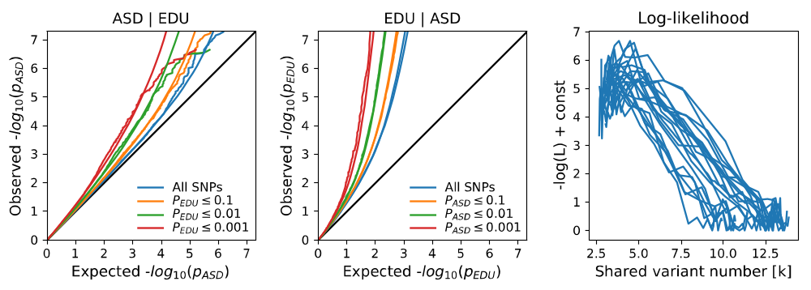

b) ASD and INT
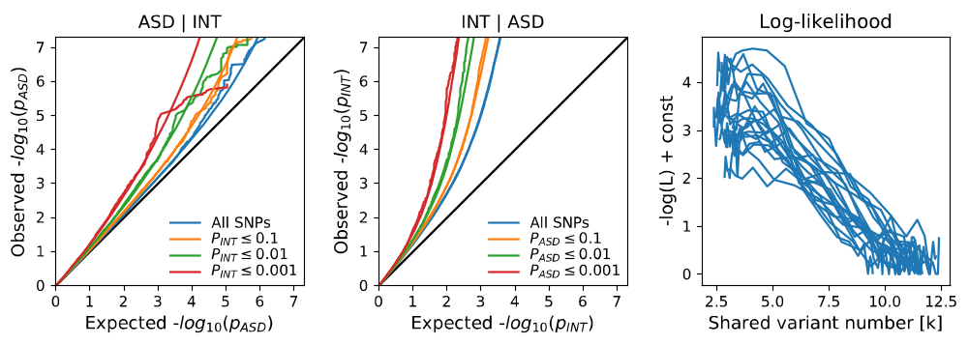
Supplementary Figure S1. Conditional QQ plots of observed versus expected -log10 p-values in the primary trait as a function of significance of association with the secondary trait at the level of p ≤ 0.1 (orange lines), p ≤ 0.01 (green lines) and p ≤ 0.001 (red lines). Blue lines indicate all SNPs. Dotted lines indicate model predictions for each stratum. Black dotted line is the expected Q-Q plot under the null hypothesis (no SNPs associated with the phenotype). Likelihood cost: Log-likelihood of the bivariate fit as a function of � parameter. The remaining parameters of the model were constrained to their fitted values

Figure S2: Manhattan plots condFDR

S2 a) ASD and EDU

SNPs associated with ASD conditional on EDU
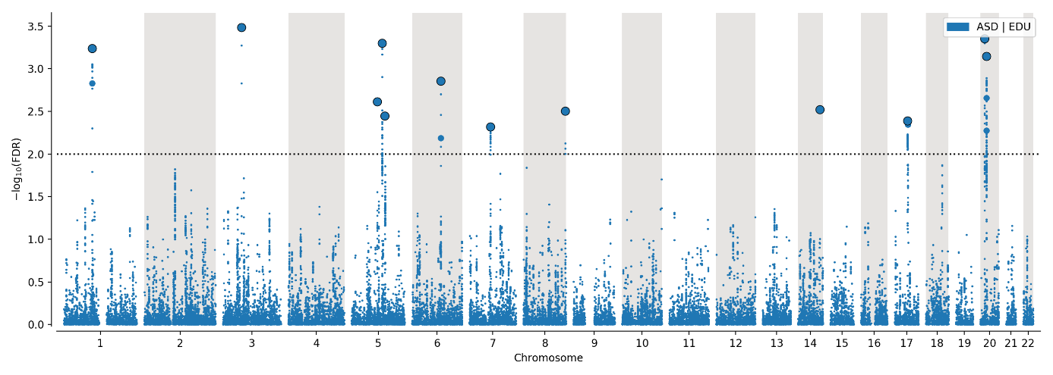

SNPs associated with EDU conditional on ASD
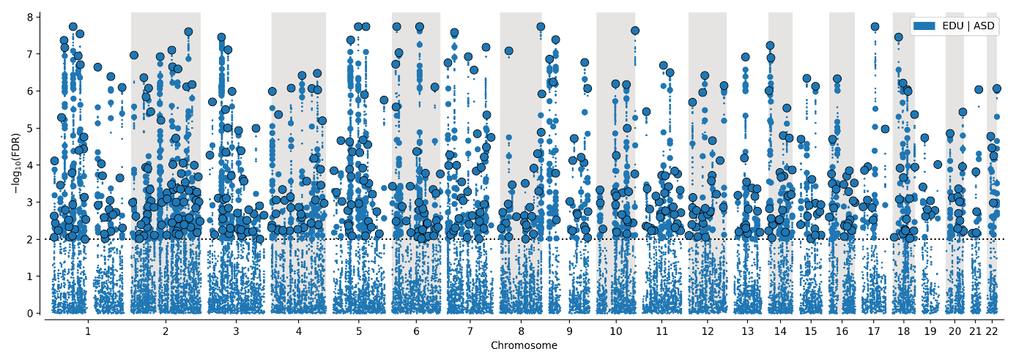
Supplementary Figure S2 a). Common genetic variants jointly associated with ASD and EDU at conditional false discovery rate (condFDR) < 0.05. The dotted horizontal line represents the threshold for significant shared associations (condFDR < 0.05, i.e., −log10 (conjFDR) > 2.0). Independent lead SNPs are encircled in black.

S2 b) ASD and INT

SNPs associated with ASD conditional on INT
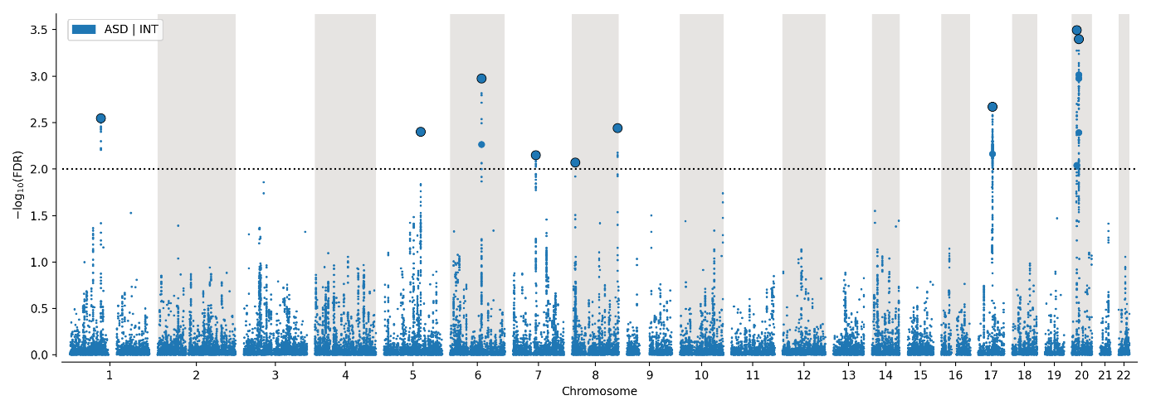

SNPs associated with INT conditional on ASD
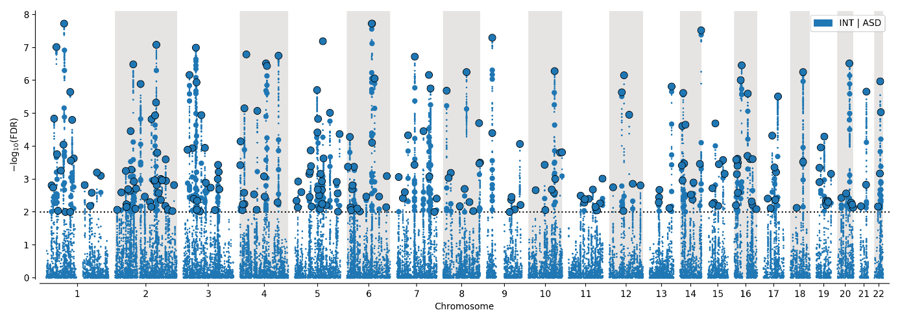

Supplementary Figure S2 b). Common genetic variants jointly associated with ASD and INT at conditional false discovery rate (condFDR) < 0.05. The dotted horizontal line represents the threshold for significant shared associations (condFDR < 0.05, i.e., −log10 (conjFDR) > 2.0). Independent lead SNPs are encircled in black.

FUMA on all candidate SNPs

Figure S3: FUMA from ASD and EDU

a) Heatmap
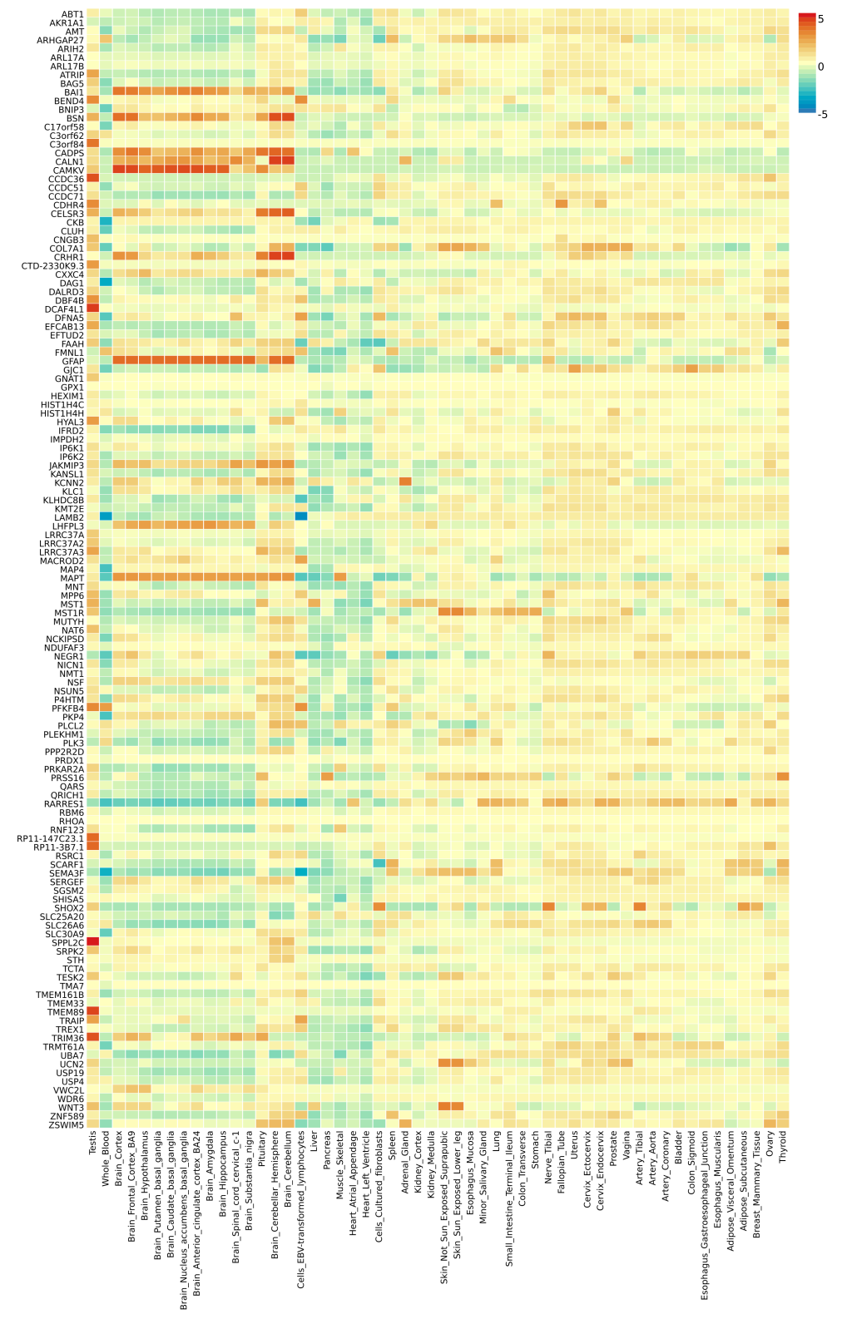
Supplementary figure S3 a). Heatmap showing tissue expression of all candidate genes for ASD and EDU.

b) Differentially expressed genes (DEGs) in tissue types
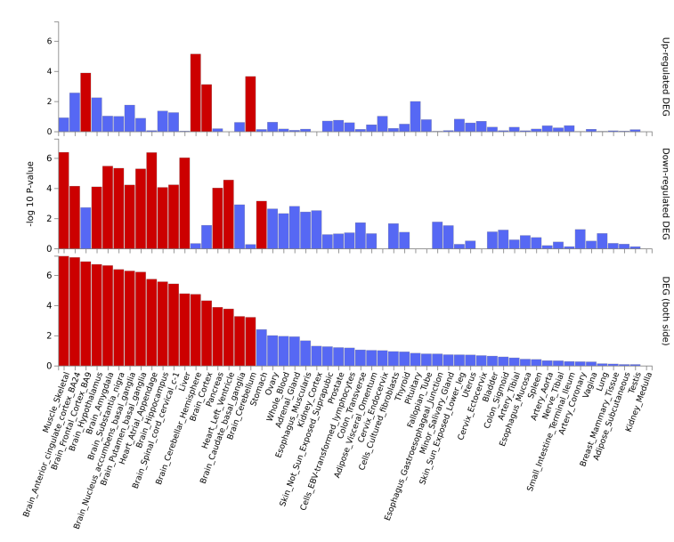
Supplementary figure S3 b). Differential expression of genes (DEG) by tissue for the genes annotated to all candidata SNPs conjunctionally associated with ASD and EDU. Red bars indicate statistical significance after correcting for multiple testing. Histogram showing tissue specificity based on GTEx v8 54 tissue types.

c) Brain developmental stages
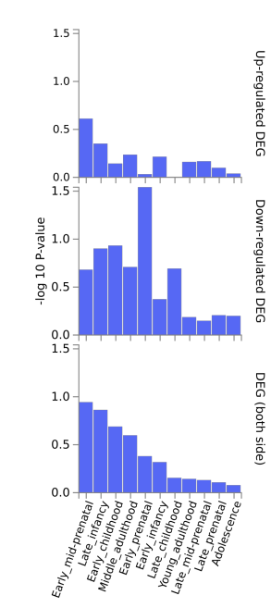

Supplementary figure S3 c). Differentially expressed genes (DEGs) in brain development stages for all candidate SNPs for ASD and EDU. Based on BrainSpan 11 general developmental stages of brain samples.

Figure S4: FUMA from ASD and INT

a) Heatmap
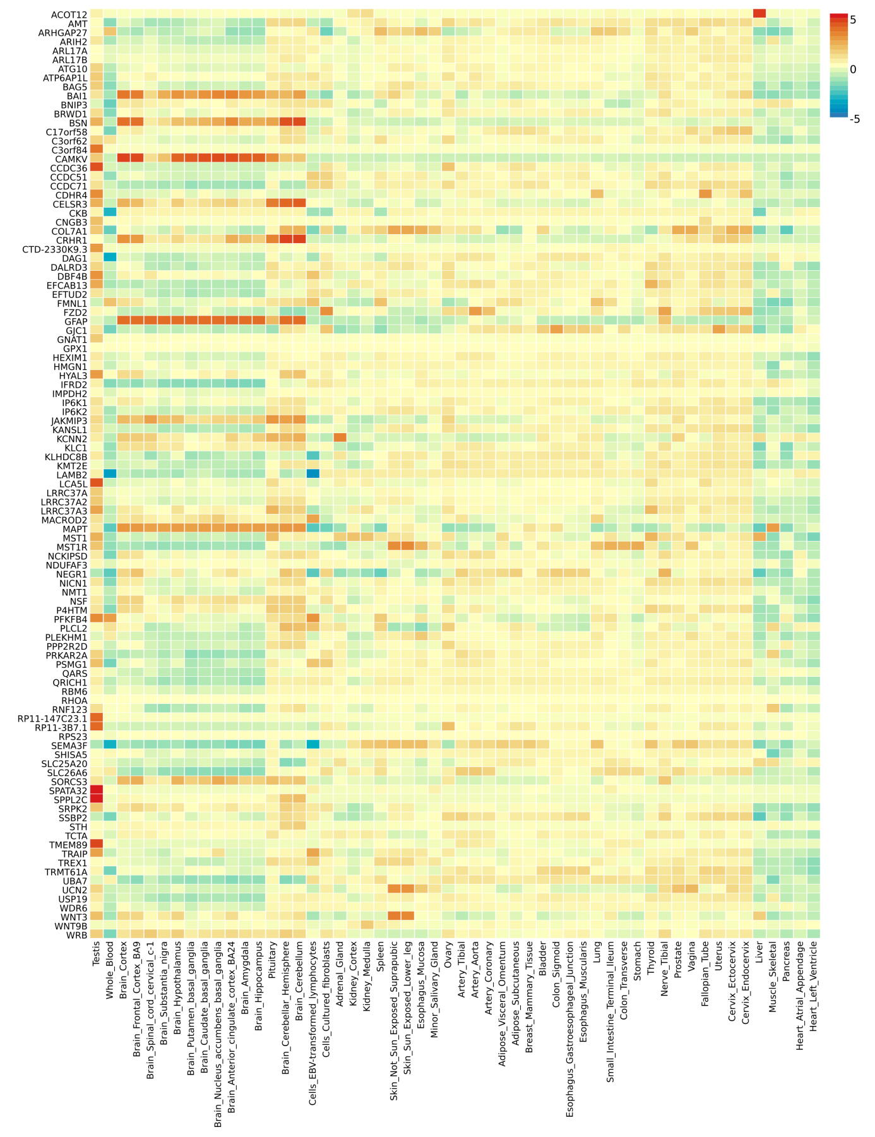
Supplementary figure S4 a). Heatmap showing tissue expression of all candidate genes for ASD and INT.

b) Differentially expressed genes (DEGs) in tissue types
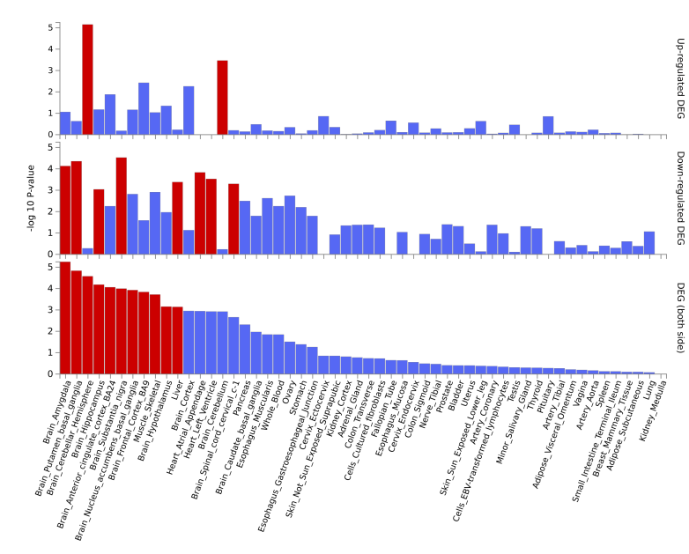
Supplementary figure S4 b). Supplementary figure S3 a): Differential expression of genes (DEG) by tissue for the genes annotated to all candidate SNPs conjunctionally associated with ASD and INT. Red bars indicate statistical significance after correcting for multiple testing. Histogram showing tissue specificity based on GTEx v8 54 tissue types

c) Brain developmental stages
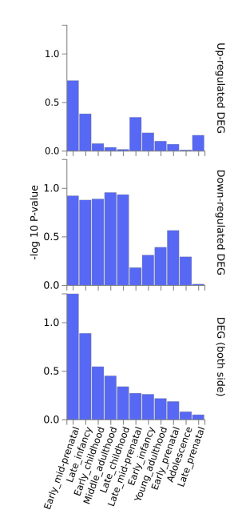
Supplementary figure S4 c). Differentially expressed genes (DEGs) in brain development stages for all candidate SNPs for ASD and INT. Based on BrainSpan 11 general developmental stages of brain samples.

FUMA concordant genes

Figure S5 FUMA concordant on ASD and EDU

a) Heatmap
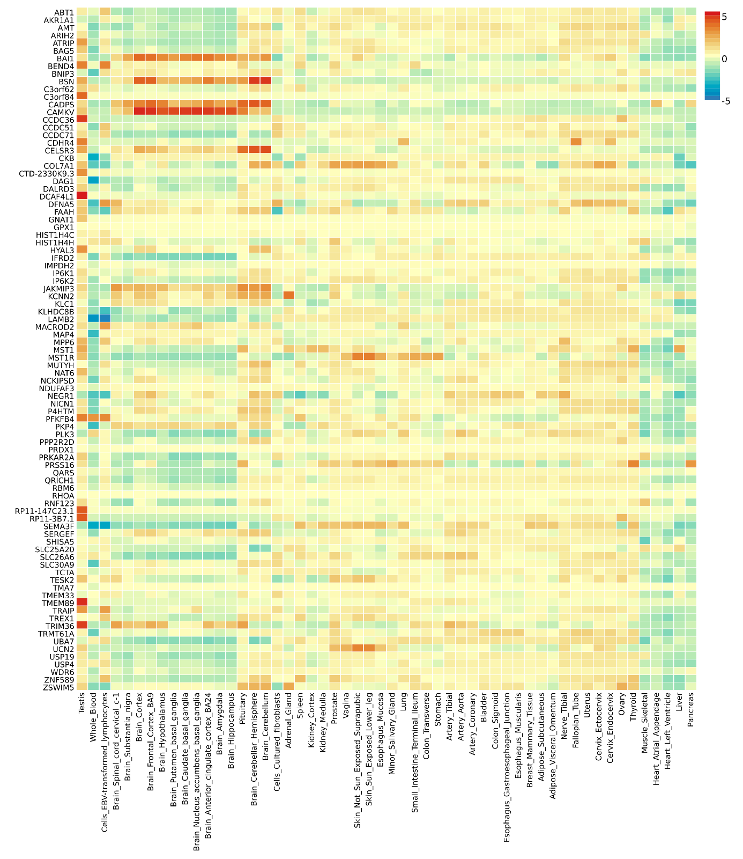
Supplementary figure S5 a). Heatmap showing tissue expression of concordant genes for ASD and EDU.

b) Differentially expressed gene sets in tissue types
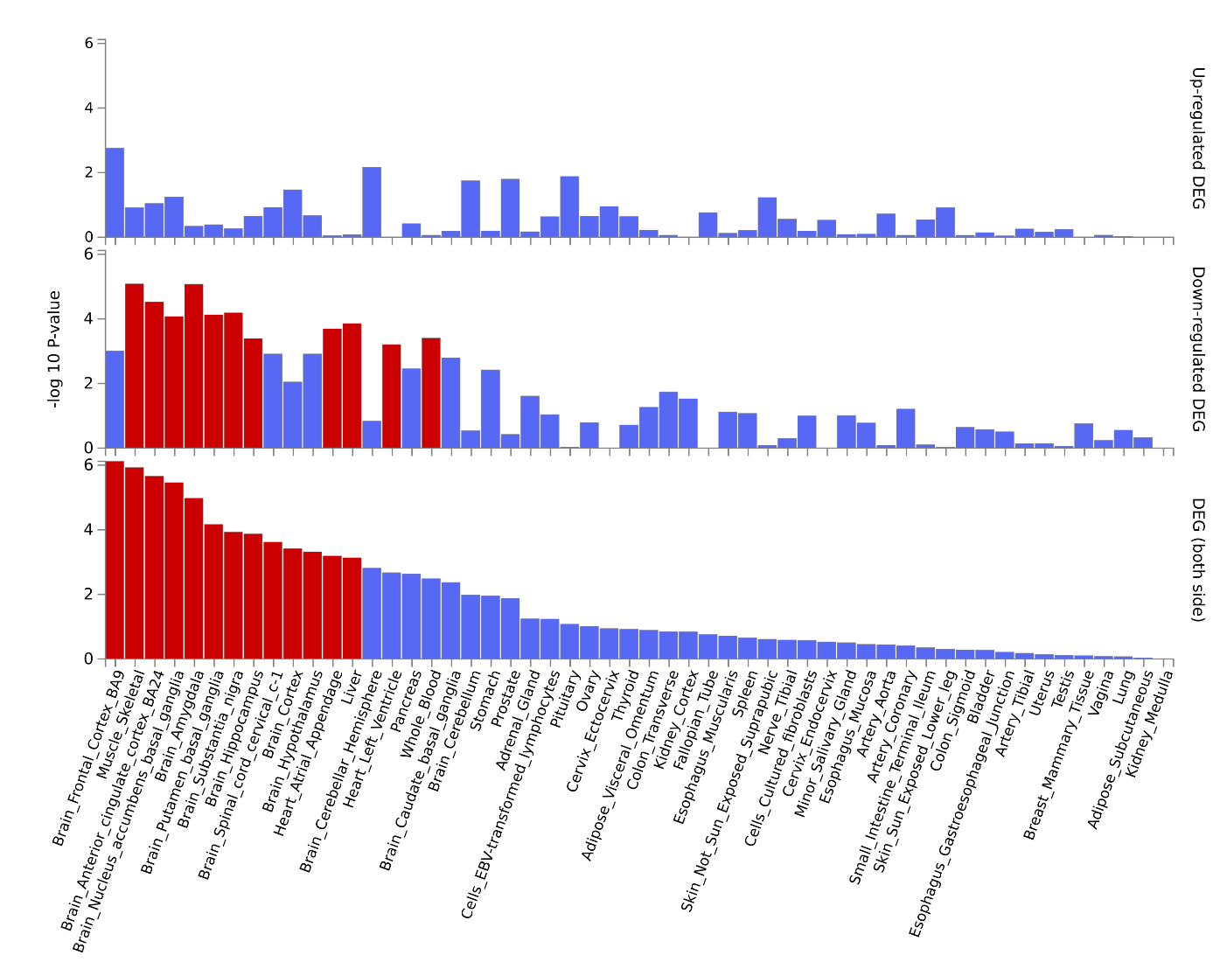
Supplementary figure S5 b). Differential expression of genes (DEG) by tissue for the genes annotated to concordant SNPs associated with ASD and EDU. Red bars indicate statistical significance after correcting for multiple testing. Histogram showing tissue specificity based on GTEx v8 54 tissue types.

c) Brain developmental stages
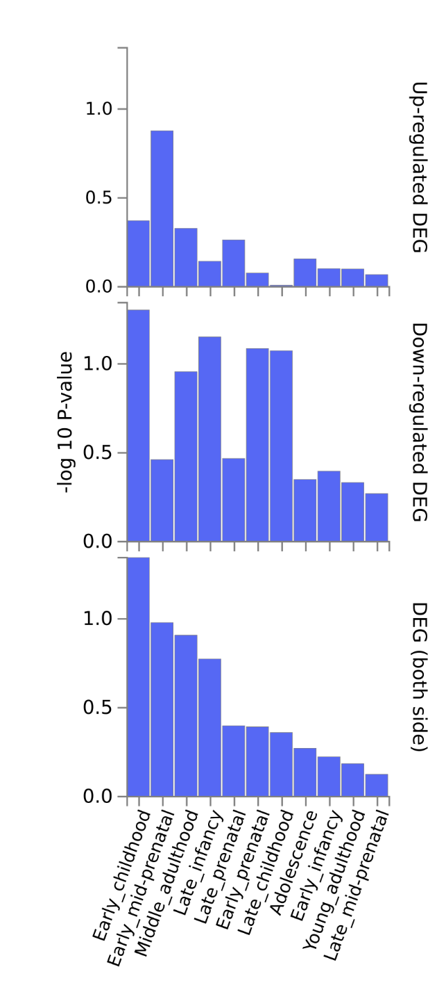

Supplementary figure S5 c). Differentially expressed genes (DEGs) in brain development stages for all concordant SNPs between ASD and EDU. Based on BrainSpan 11 general developmental stages of brain samples.

Figure S6: FUMA concordant SNPs on ASD and INT

a) Heatmap
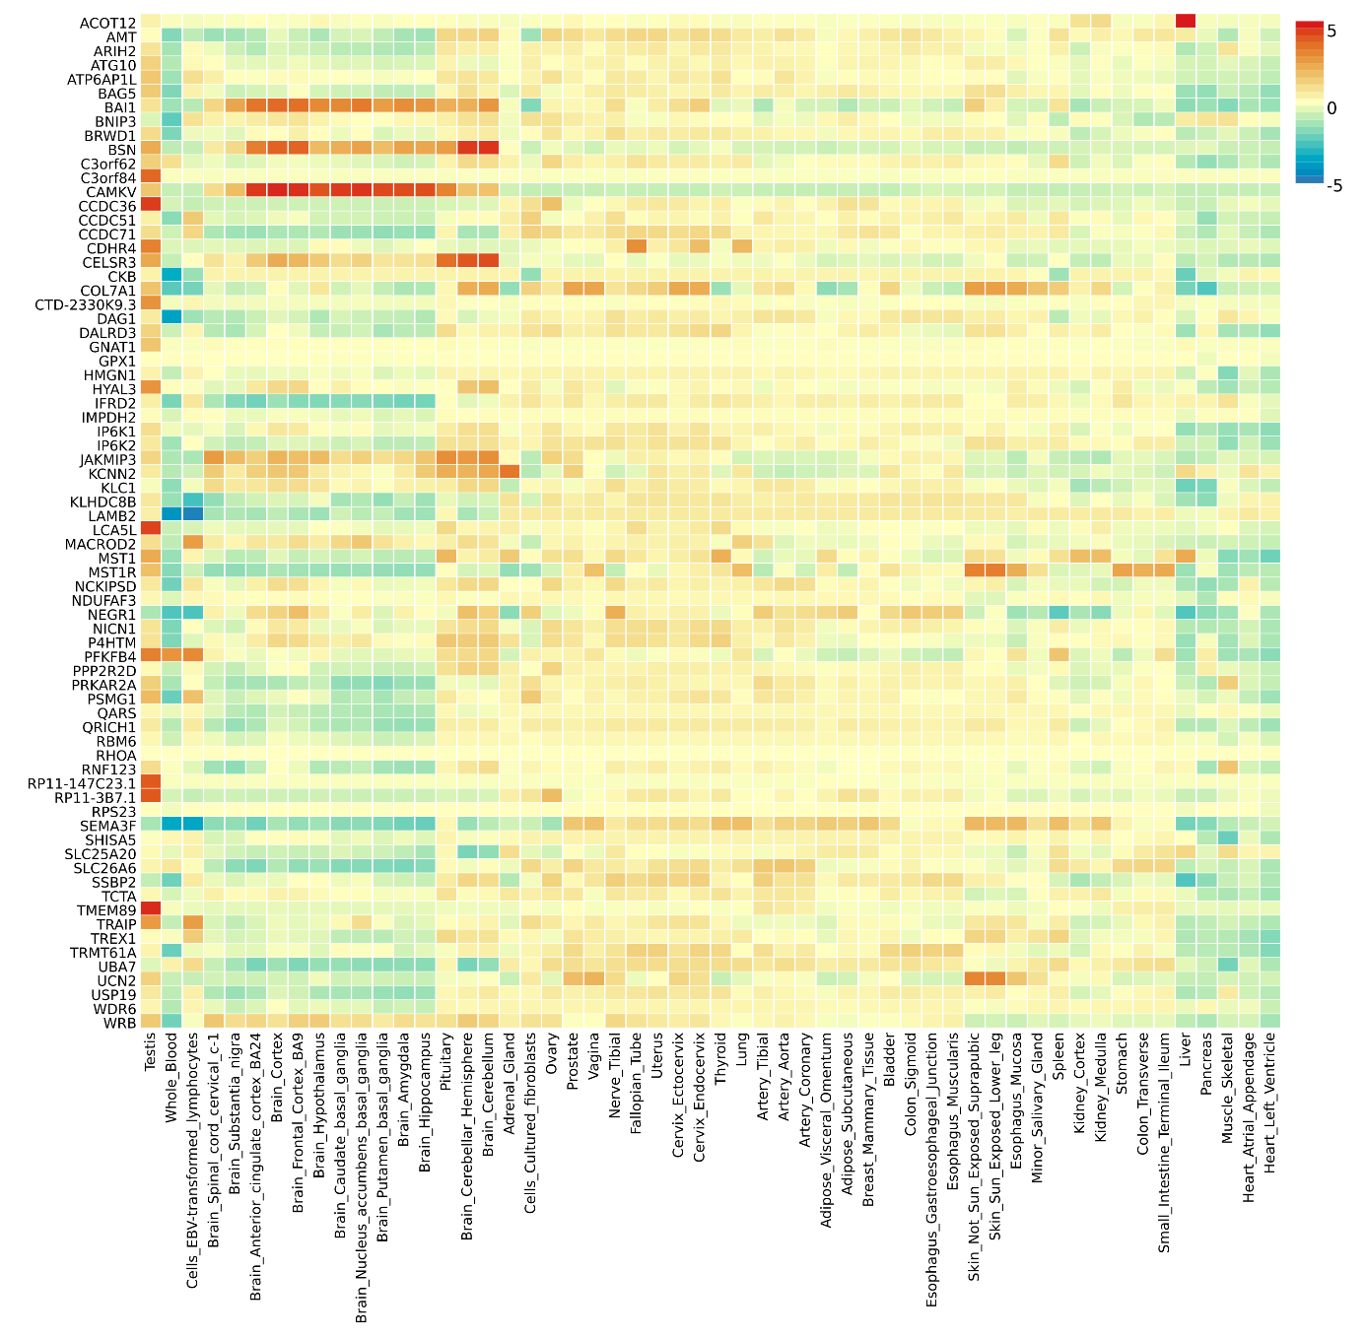

Supplementary figure S6 a). Heatmap showing tissue expression of concordant genes for ASD and INT.

b) Differentially expressed gene sets in tissue types
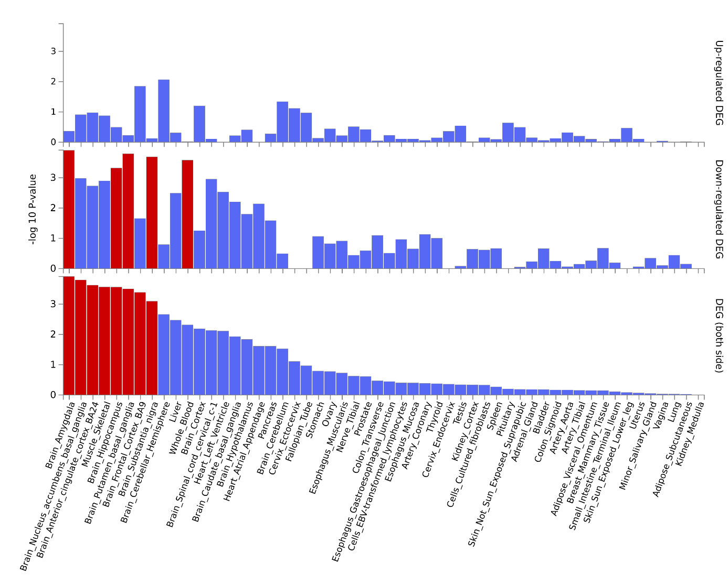
Supplementary figure S6 b). Differential expression of genes (DEG) by tissue for the genes annotated to concordant SNPs associated with ASD and INT. Red bars indicate statistical significance after correcting for multiple testing. Histogram showing tissue specificity based on GTEx v8 54 tissue types.

c) Brain developmental stages
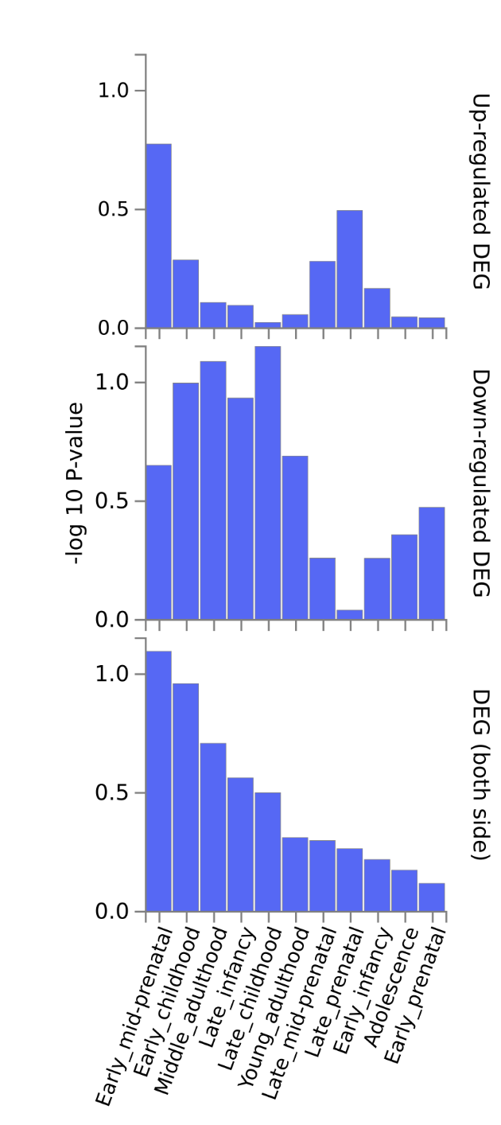

Supplementary figure S5 c). Differentially expressed genes (DEGs) in brain development stages for all concordant SNPs between ASD and INT. Based on BrainSpan 11 general developmental stages of brain samples.

FUMA discordant genes

Figure S7: FUMA discordant SNPs for ASD and EDU

Heatmap
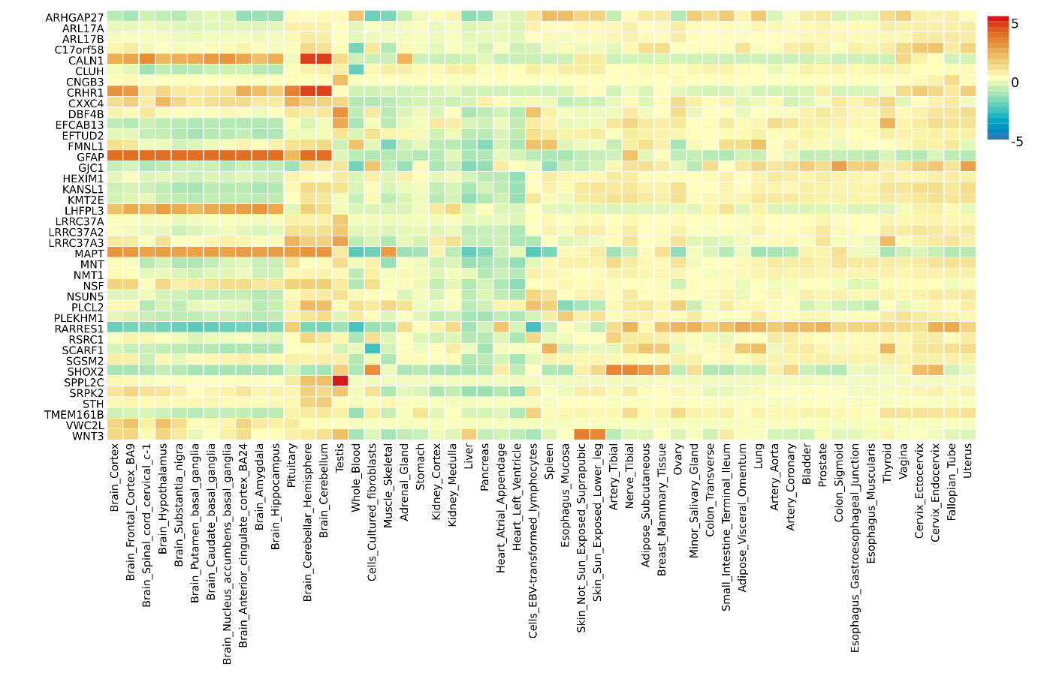

Supplementary figure S7 a). Heatmap showing tissue expression of discordant genes for ASD and EDU.

Differentially expressed gene sets in tissue types

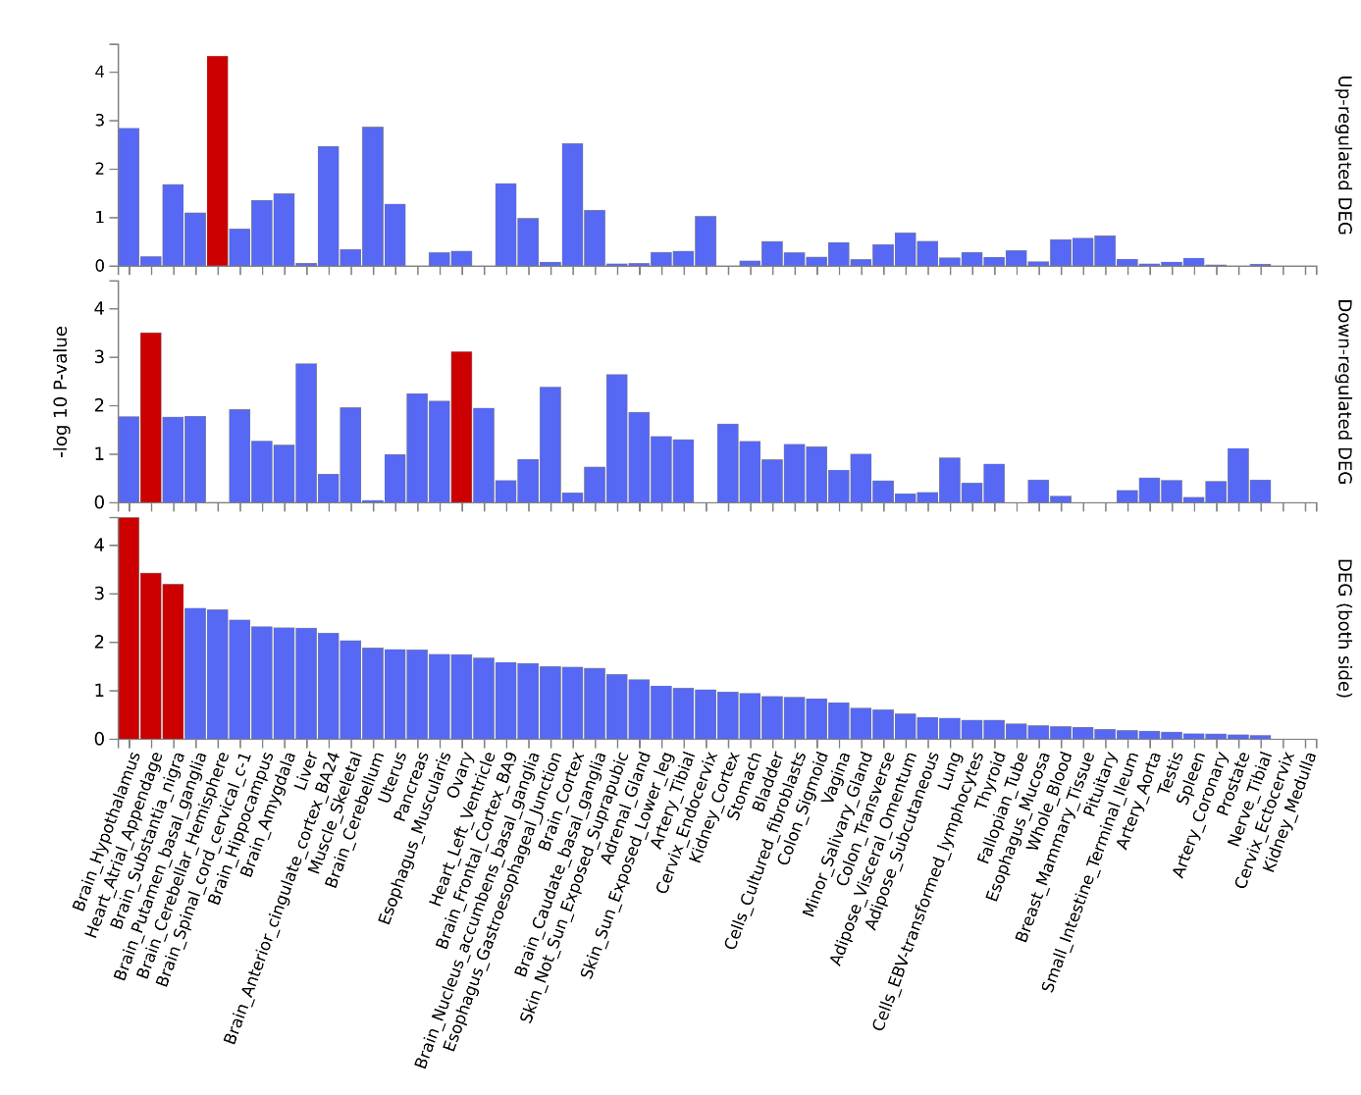
Supplementary figure S7 b). Differential expression of genes (DEG) by tissue for the genes annotated to discordant SNPs associated with ASD and EDU. Red bars indicate statistical significance after correcting for multiple testing. Histogram showing tissue specificity based on GTEx v8 54 tissue types.

Figure S8: DEGs in tissue types discordant SNPs on ASD and INT.

Heatmap
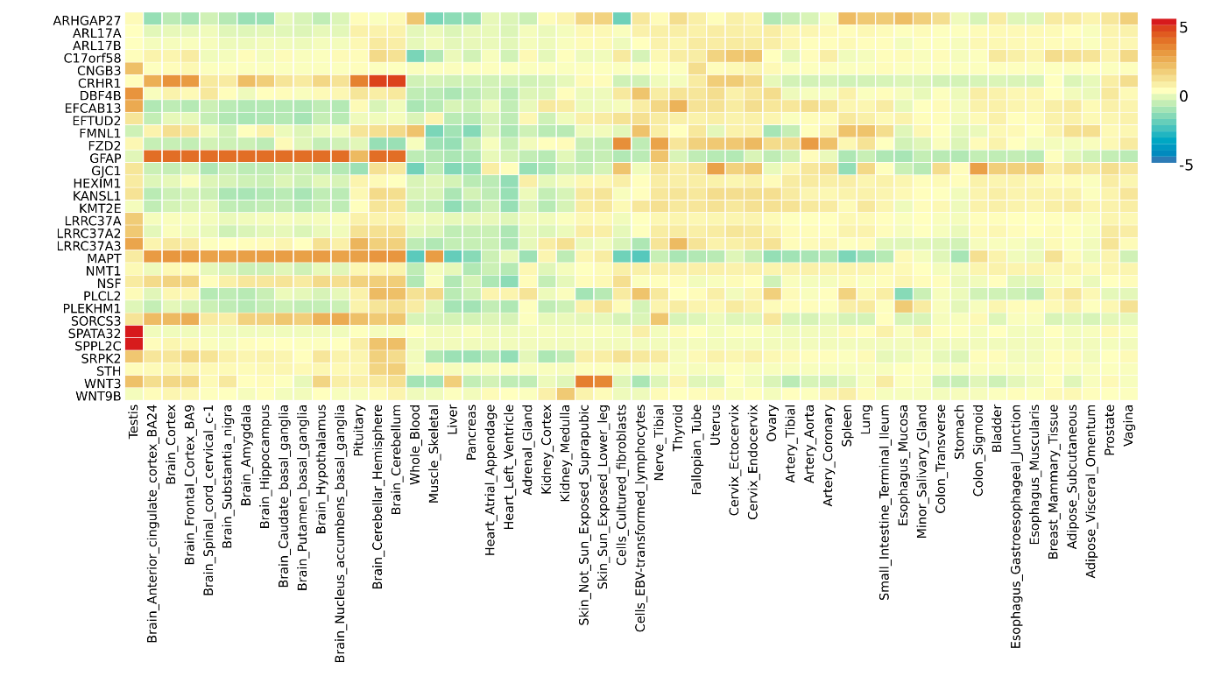
Supplementary figure S8 a). Heatmap showing tissue expression of discordant genes for ASD and INT.

Differentially expressed gene sets in tissue types
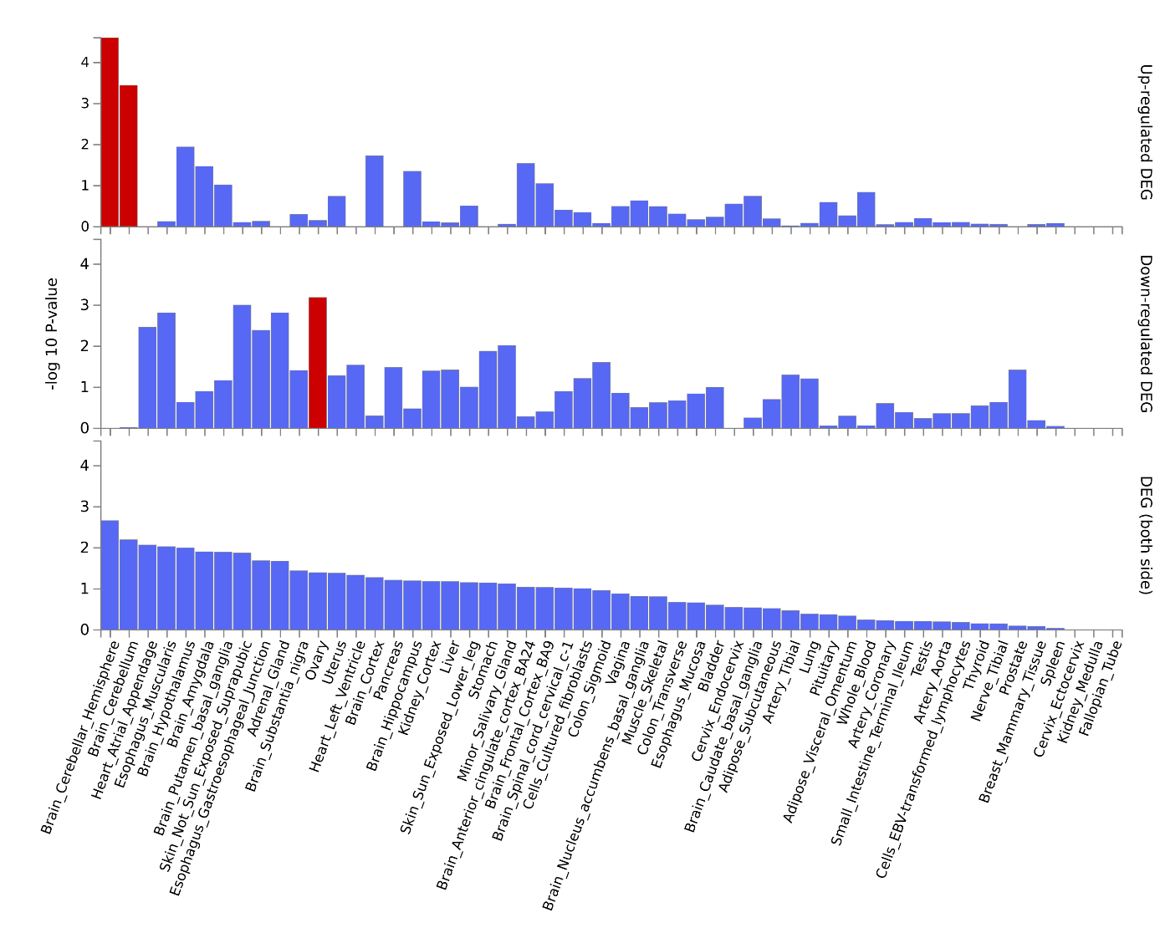
Supplementary figure S8 b). Differential expression of genes (DEG) by tissue for the genes annotated to disconcordant SNPs associated with ASD and INT. Red bars indicate statistical significance after correcting for multiple testing. Histogram showing tissue specificity based on GTEx v8 54 tissue types.

