Supplementary Information for
Chirality Affecting Reaction Dynamics of HgS Nanostructures Simultaneously Visualized in Real and Reciprocal Space

Zetan Cao, Jia He, Zhiwen Liu, Haoran Zhang, Bin Chen *

Center for Ultrafast Science and Technology, School of Chemistry and Chemical Engineering, and School of Physics and Astronomy, Shanghai Jiao Tong University, Shanghai 200240, China

E-mail: cbcce@sjtu.edu.cn

Temperature rise induced by electron beam irradiation
Estimation of electron energy loss
The electron beam (e-beam) has energy loss after transmitting a thin film material in transmission electron microscopy (TEM). We firstly estimate the mean energy loss of the electrons using the Bathe function^{1,2},
$\frac{dE(h)}{dh}=-2π{\left(\frac{e^{2}}{4πε_{0}}\right)}^{2}\frac{ρN_{0}Z}{AE\left(h\right)}\ln\left(\frac{γE(h)}{E_{m}}\right)$ (1)
where $E(h)$ is the electron energy, $h$ the distance along the trajectory, $e$ the electron charge, $ε_{0}$ the dielectric constant, $ρ$ the density of material, $N_{0}$ the Avogadro constant, $A$ the relative atomic mass, $γ=1.1658$ for the relativistic energy electrons, and $E_{m}$ is the mean ionization energy in the material that is defined by,
$E_{m}=9.76Z+58.8Z^{-0.19} (eV)$ (2)
$Z$ is the average atomic number,
$Z=\sum_{i}{c_{i}Z_{i}}$ (3)
where $c_{i}$ is the weight fraction, $Z_{i}$ the atomic number of each element.
Using the parameters of HgS listed in Supplementary Table 1, the energy loss of the e-beam with an acceleration voltage of 200 kV passing through HgS was calculated to be 0.562 eV/nm.
Estimation of temperature rise
Generally, it is assumed that the energy loss of the e-beam is completely converted into heat. We consider that the HgS nanostructures are supported by a 10 nm thick carbon film (Supplementary Fig. 1). Therefore, the thermal diffusion from the nanostructures to the carbon film would be identified as one-dimensional conduction that is expressed as,
$-k∇^{2}T\left(h\right)=0$ (4)
Using the boundary conditions: i) $h=0, T=T_{flim}$; ii) ${dT}/{dh=Q/{\left(k∙h_{0}^{2}\right)}}$, where $T_{film}$ is the film temperature, $Q$ the total heat caused by the energy loss of the e-beam, $h_{0}$ the height of the nanobipyramid, $k$ the thermal conductivity of the specimen, we obtain the following solution,
$T=\frac{Q}{k{∙s}_{0}^{2}}h+T_{film}$ (5)
$Q=J_{e}∙πR_{0}^{2}∙(\frac{dE}{dx})∙h$ (6)
The radius of the beam size is $R_{0}$. Based on the sample parameters in Supplementary Table 1, and the acceleration voltage $E$ and current density $J_{e}$ of 200 kV and 0.6 A/cm² in TEM, the temperature rise of the HgS nanobipyramids in the irradiated area was estimated to be no more than 1 K.
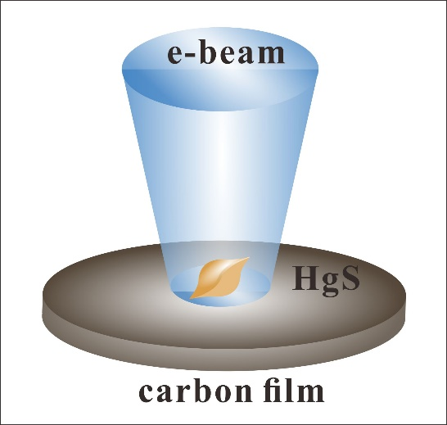
Supplementary Figure 1. Schematic of e-beam irradiation on the HgS nanobipyramid supported by the carbon film.
Parameters | Value | Reference
Average atomic number (Z) | 71.18 | ³
Density (ρ) | 8.10 g/cm³ | ³
Thermal conductivity (k) | 0.60 W/(m·K) | ³
Acceleration voltage (E) | 200 kV | ³
Relative atomic mass (A) | 232.65 g/mol | ³
Thickness (h) | 60-260 nm | ³
Supplementary Table 1. Parameters of HgS used for the calculation of the e-beam-induced temperature rise.
Sample | Seed volume ($mL$) | Hg:S precursor volume ratio | Injection rate ($mL/h$) | Reaction time ($h$) | Reaction temperature ($℃$) | Average length  ($nm$)
1 | 0.05 | 1:1 | 1 | 2 | 38 | 102
2 | 0.05 | 1:1 | 1 | 3 | 38 | 176
3 | 0.05 | 1:1 | 1 | 4 | 38 | 225
4 | 0.05 | 1:1 | 1 | 5 | 38 | 266
5 | 0.05 | 1:1 | 1 | 6 | 38 | 302
6 | 0.10 | 1:1 | 1 | 2 | 38 | 73
7 | 0.10 | 1:1 | 1 | 3 | 38 | 135
8 | 0.10 | 1:1 | 1 | 4 | 38 | 180
9 | 0.10 | 1:1 | 1 | 5 | 38 | 219
10 | 0.05 | 1:1 | 1 | 2 | 68 | 256
11 | 0.05 | 1:1 | 1 | 3 | 68 | 340
12 | 0.05 | 1:1 | 1 | 4 | 68 | 407
13 | 0.05 | 1:1 | 1 | 5 | 68 | 534
Supplementary Table 2. Detailed growth conditions for HgS nanobipyramids with different sizes.
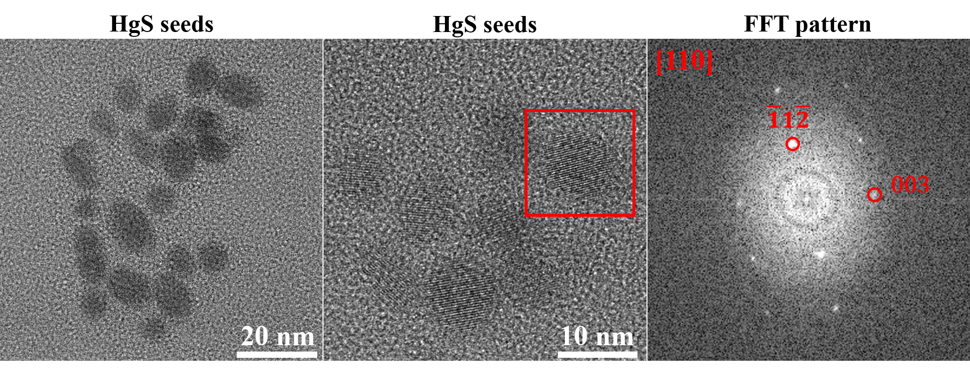
Supplementary Figure 2. Low magnification TEM image (left), high-resolution TEM image (middle) and the corresponding fast Fourier transform (FFT) pattern (right) of α-HgS seeds.
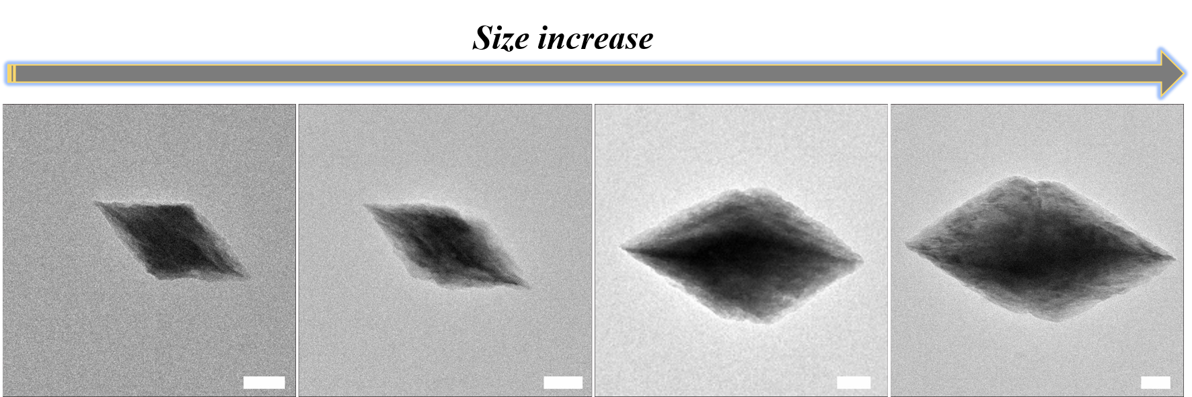
Supplementary Figure 3. TEM images of the HgS nanobipyramids with different sizes (~200-480 nm). The scale bar is 50 nm.
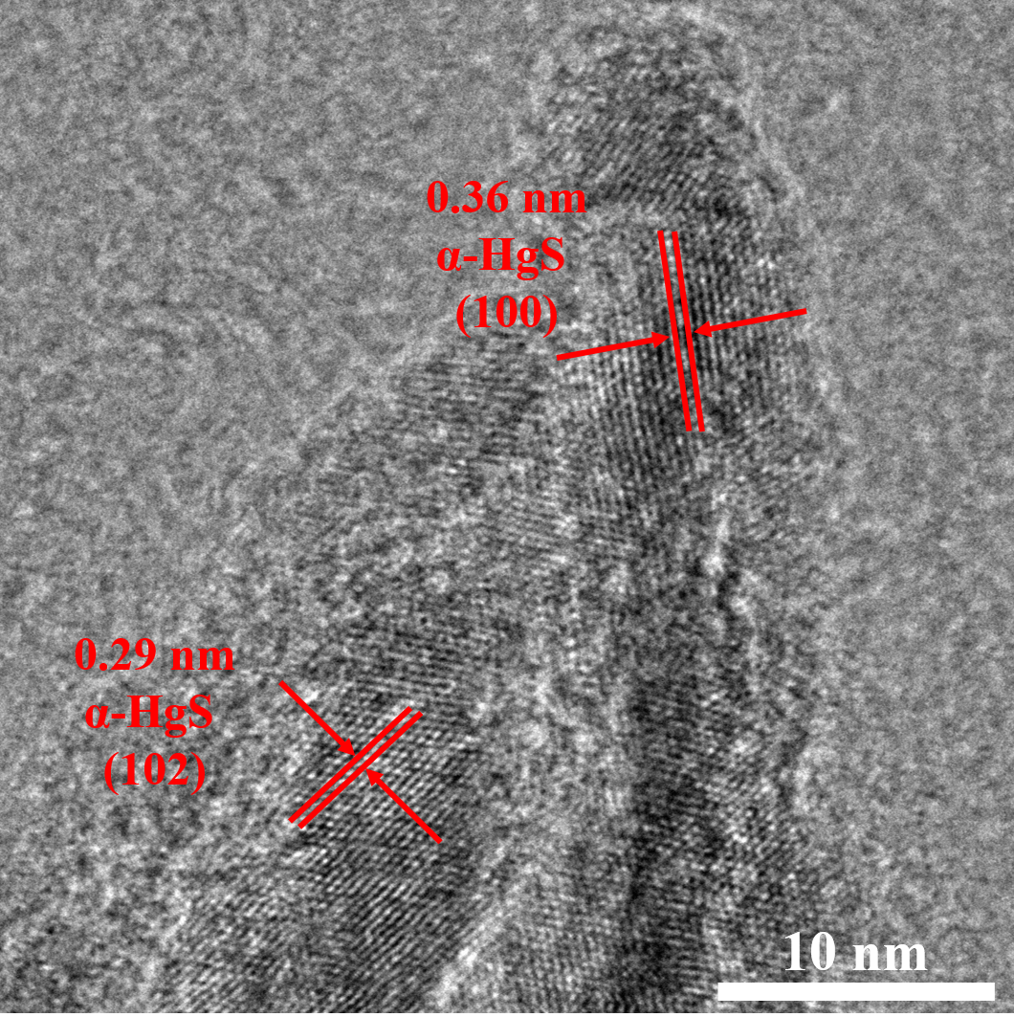
Supplementary Figure 4. High-resolution TEM image of α-HgS after the long-term e-beam irradiation. No α→β phase transformation was observed.
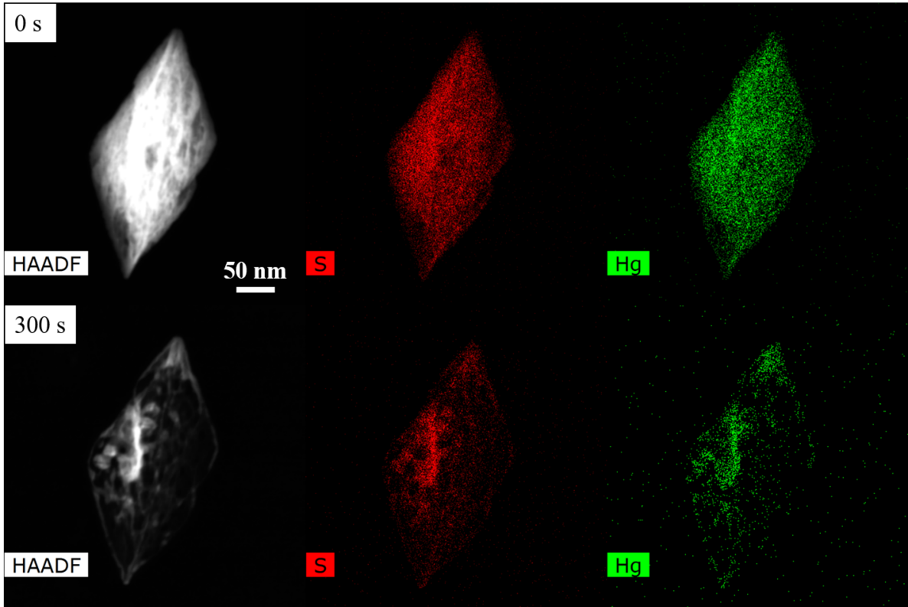
Supplementary Figure 5. High-angle annular dark-field (HAADF)image and elemental mapping of Hg and S of a single HgS nanobipyramid before (upper) and after the 300 s e-beam irradiation (bottom).
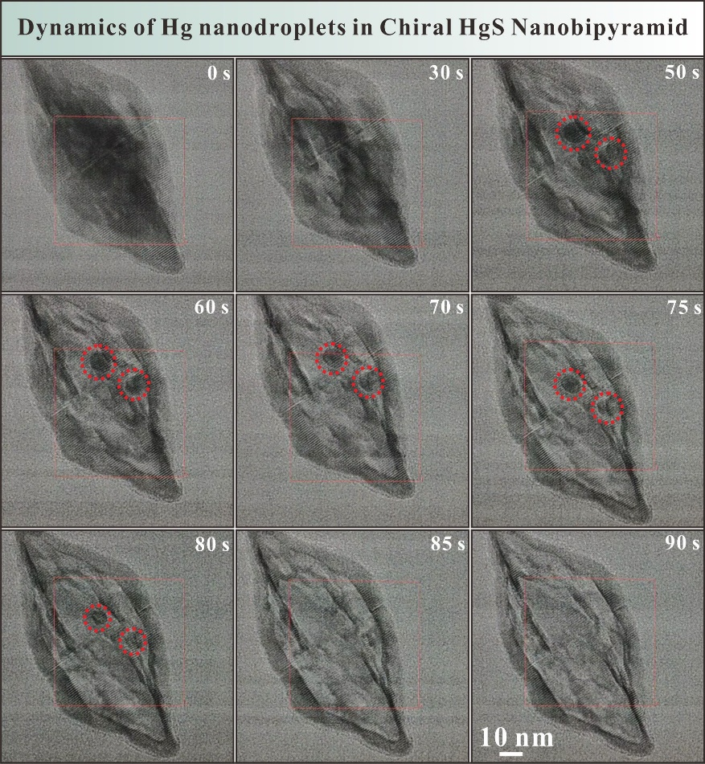
Supplementary Figure 6. Formation and evaporation processes of Hg nanodroplets in the chiral HgS nanobipyramid during the e-beam excitation.
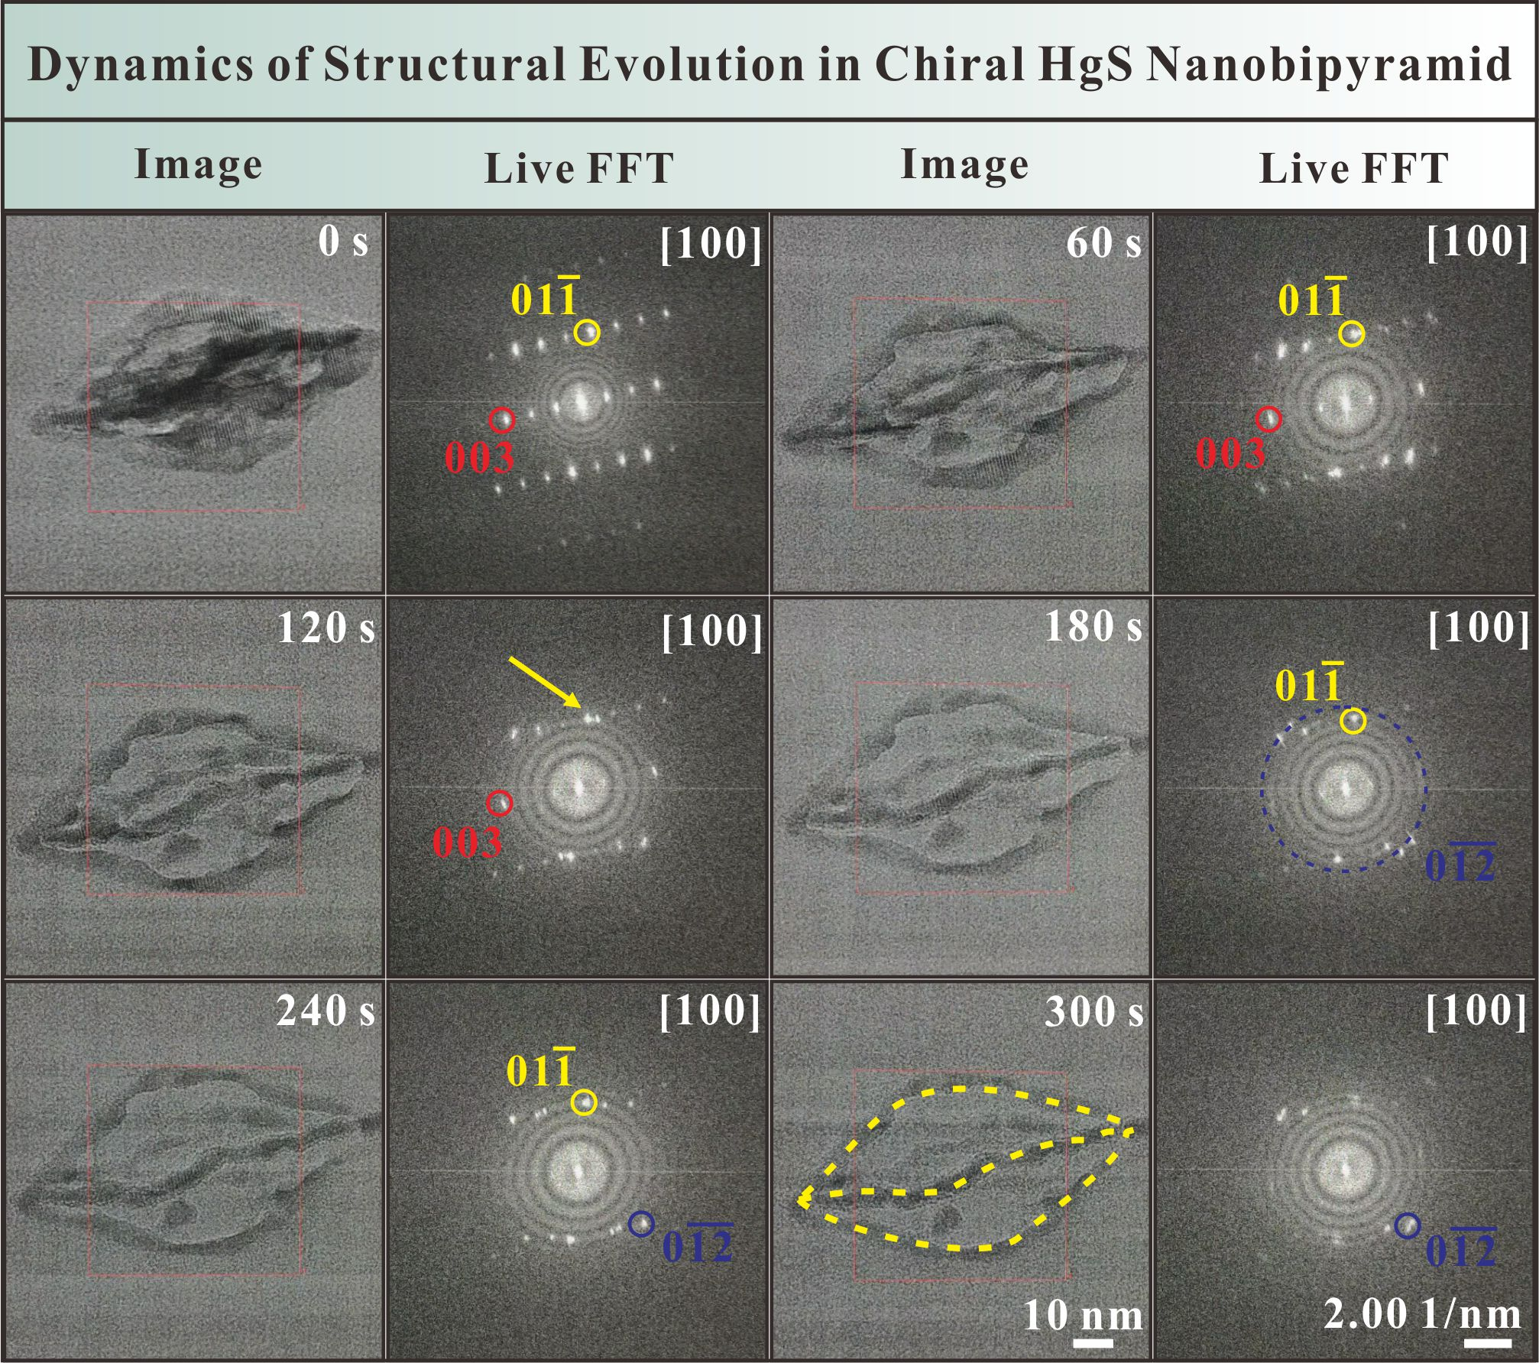
Supplementary Figure 7. Time-resolved TEM images and corresponding live FFT patterns in the chiral HgS nanobipyramid with a length of ~80 nm.
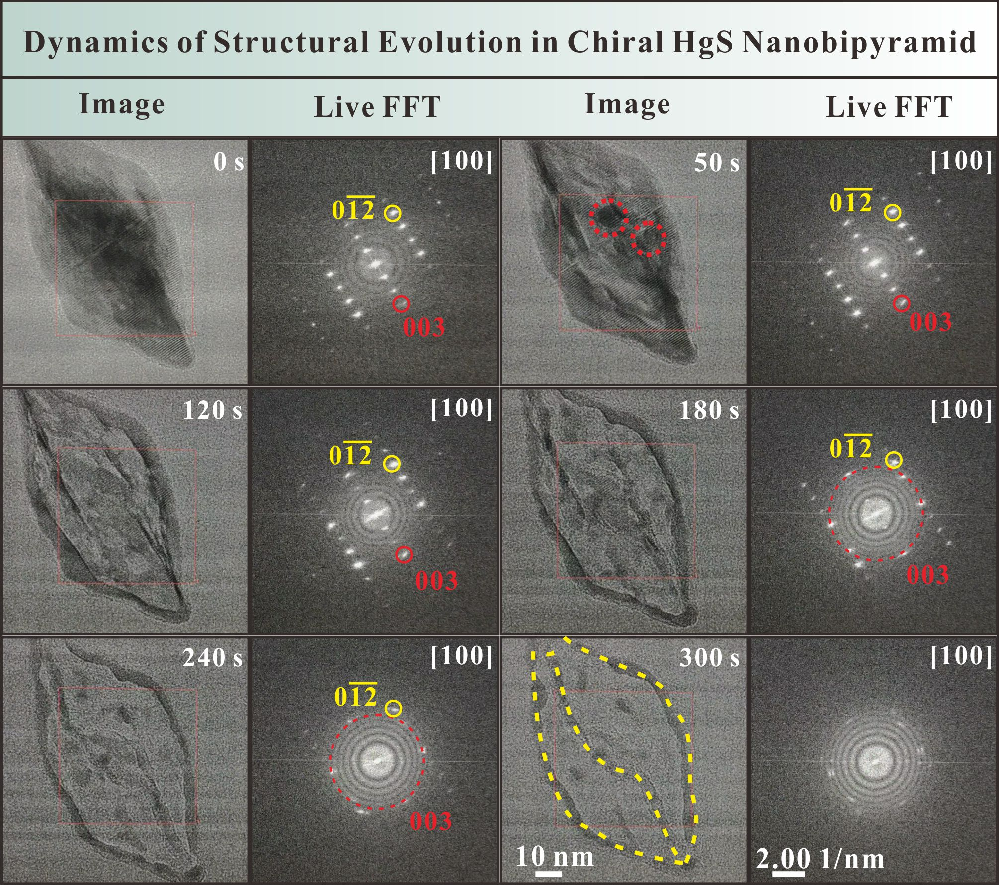
Supplementary Figure 8. Time-resolved TEM images and corresponding live FFT patterns in the chiral HgS nanobipyramid with a length of ~120 nm.
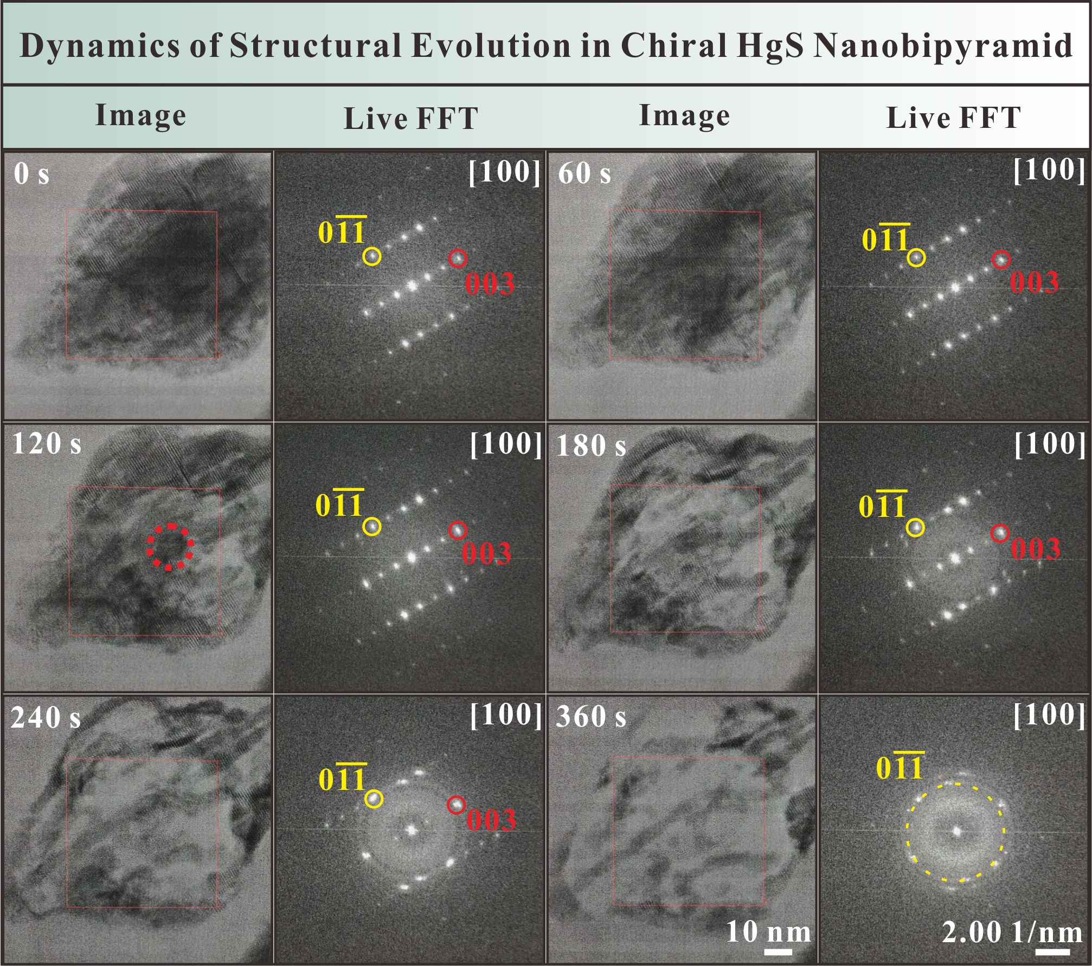
Supplementary Figure 9. Time-resolved TEM images and corresponding live FFT patterns in the chiral HgS nanobipyramid with a length of ~140 nm.
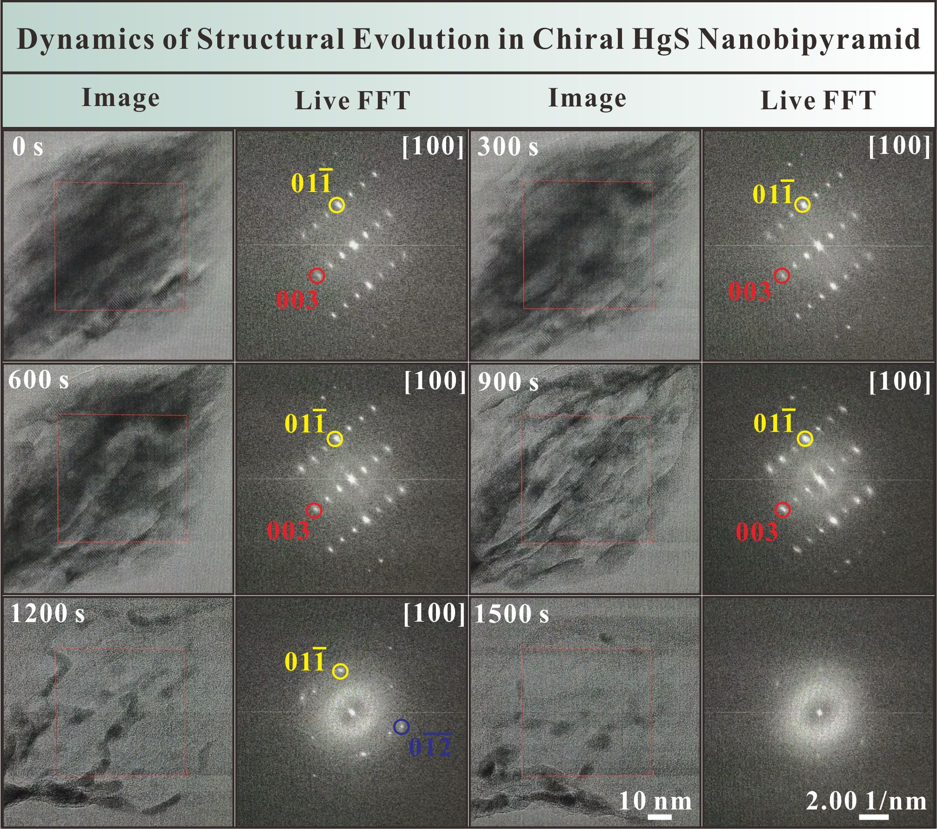
Supplementary Figure 10. Time-resolved TEM images and corresponding live FFT patterns in the chiral HgS nanobipyramid with a length of ~160 nm.
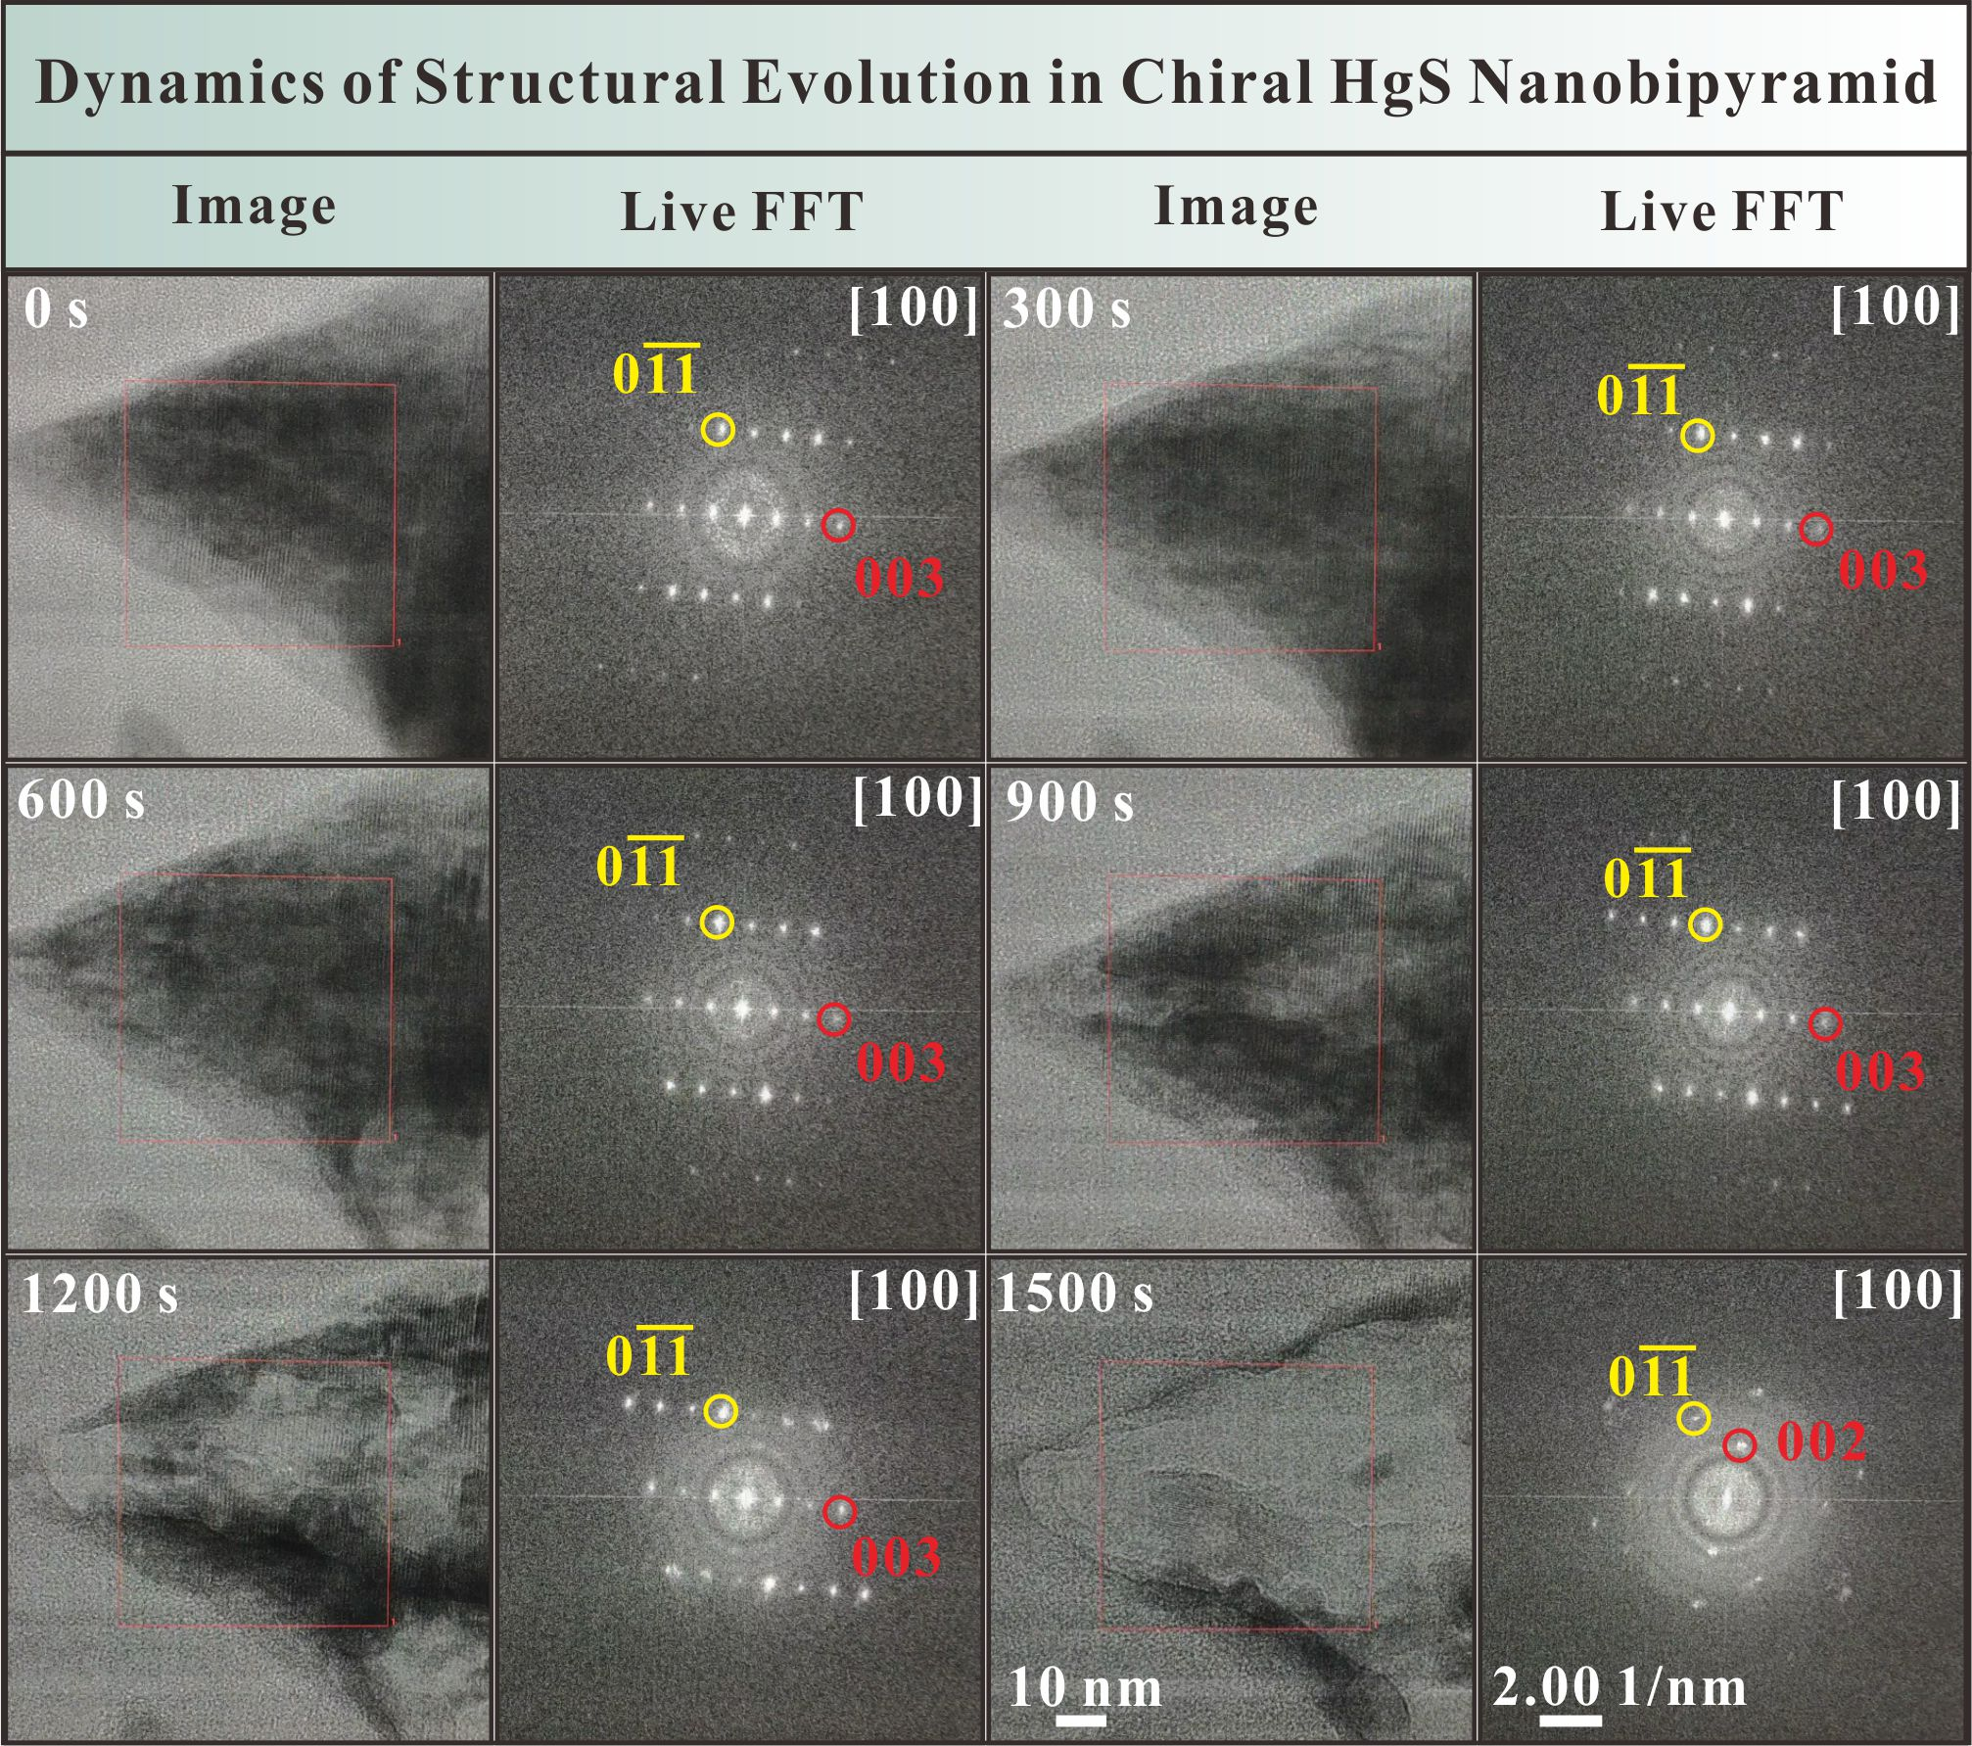
Supplementary Figure 11. Time-resolved TEM images and corresponding live FFT patterns in the chiral HgS nanobipyramid with a length of ~200 nm.
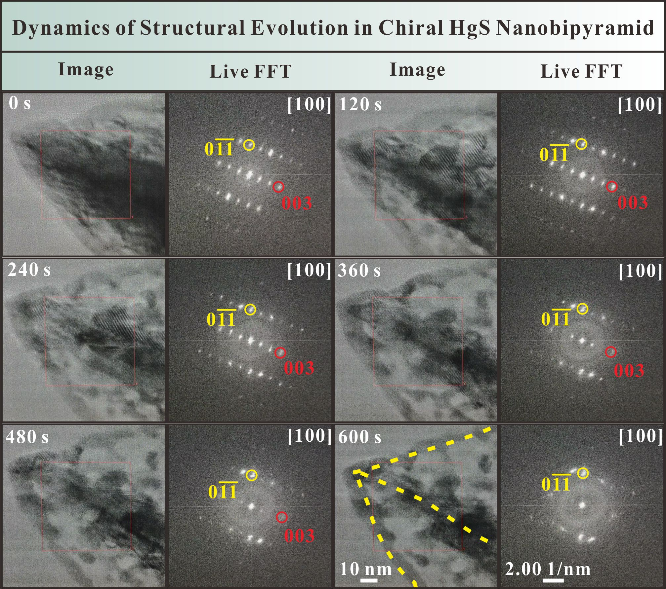
Supplementary Figure 12. Time-resolved TEM images and corresponding live FFT patterns in the chiral HgS nanobipyramid with a length of ~240 nm.
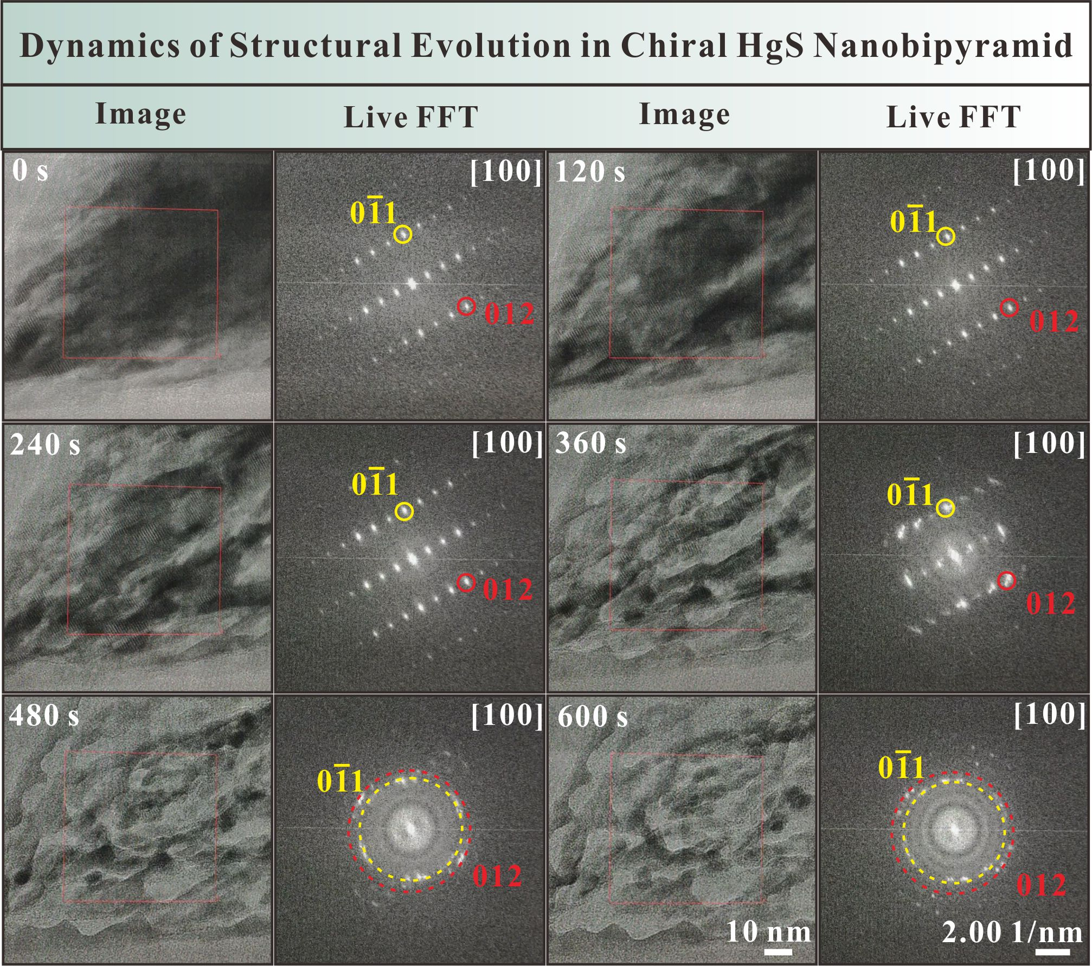
Supplementary Figure 13. Time-resolved TEM images and corresponding live FFT patterns in the chiral HgS nanobipyramid with a length of ~270 nm.
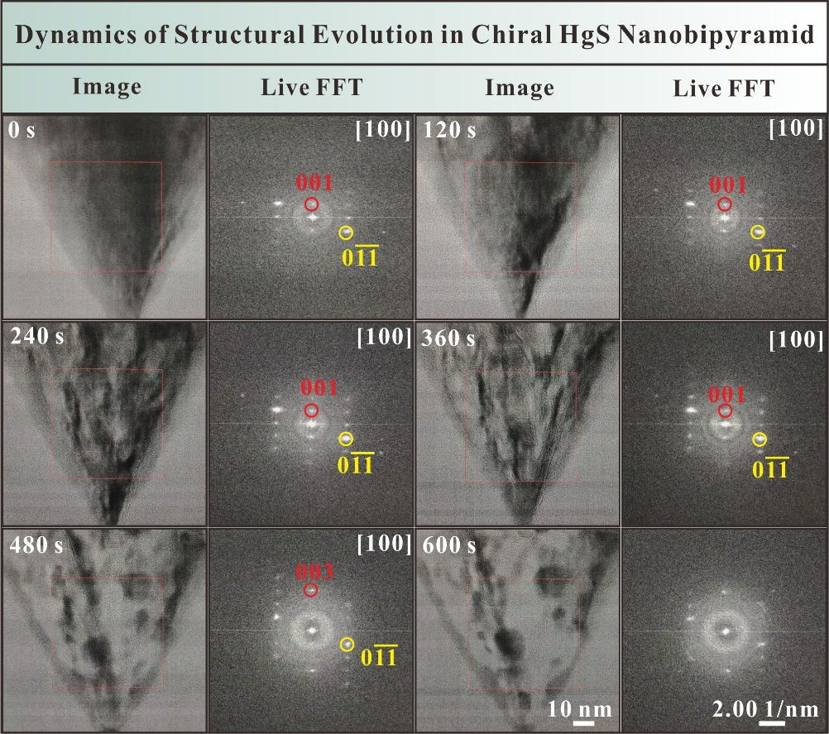
Supplementary Figure 14. Time-resolved TEM images and corresponding live FFT patterns in the chiral HgS nanobipyramid with a length of ~300 nm.
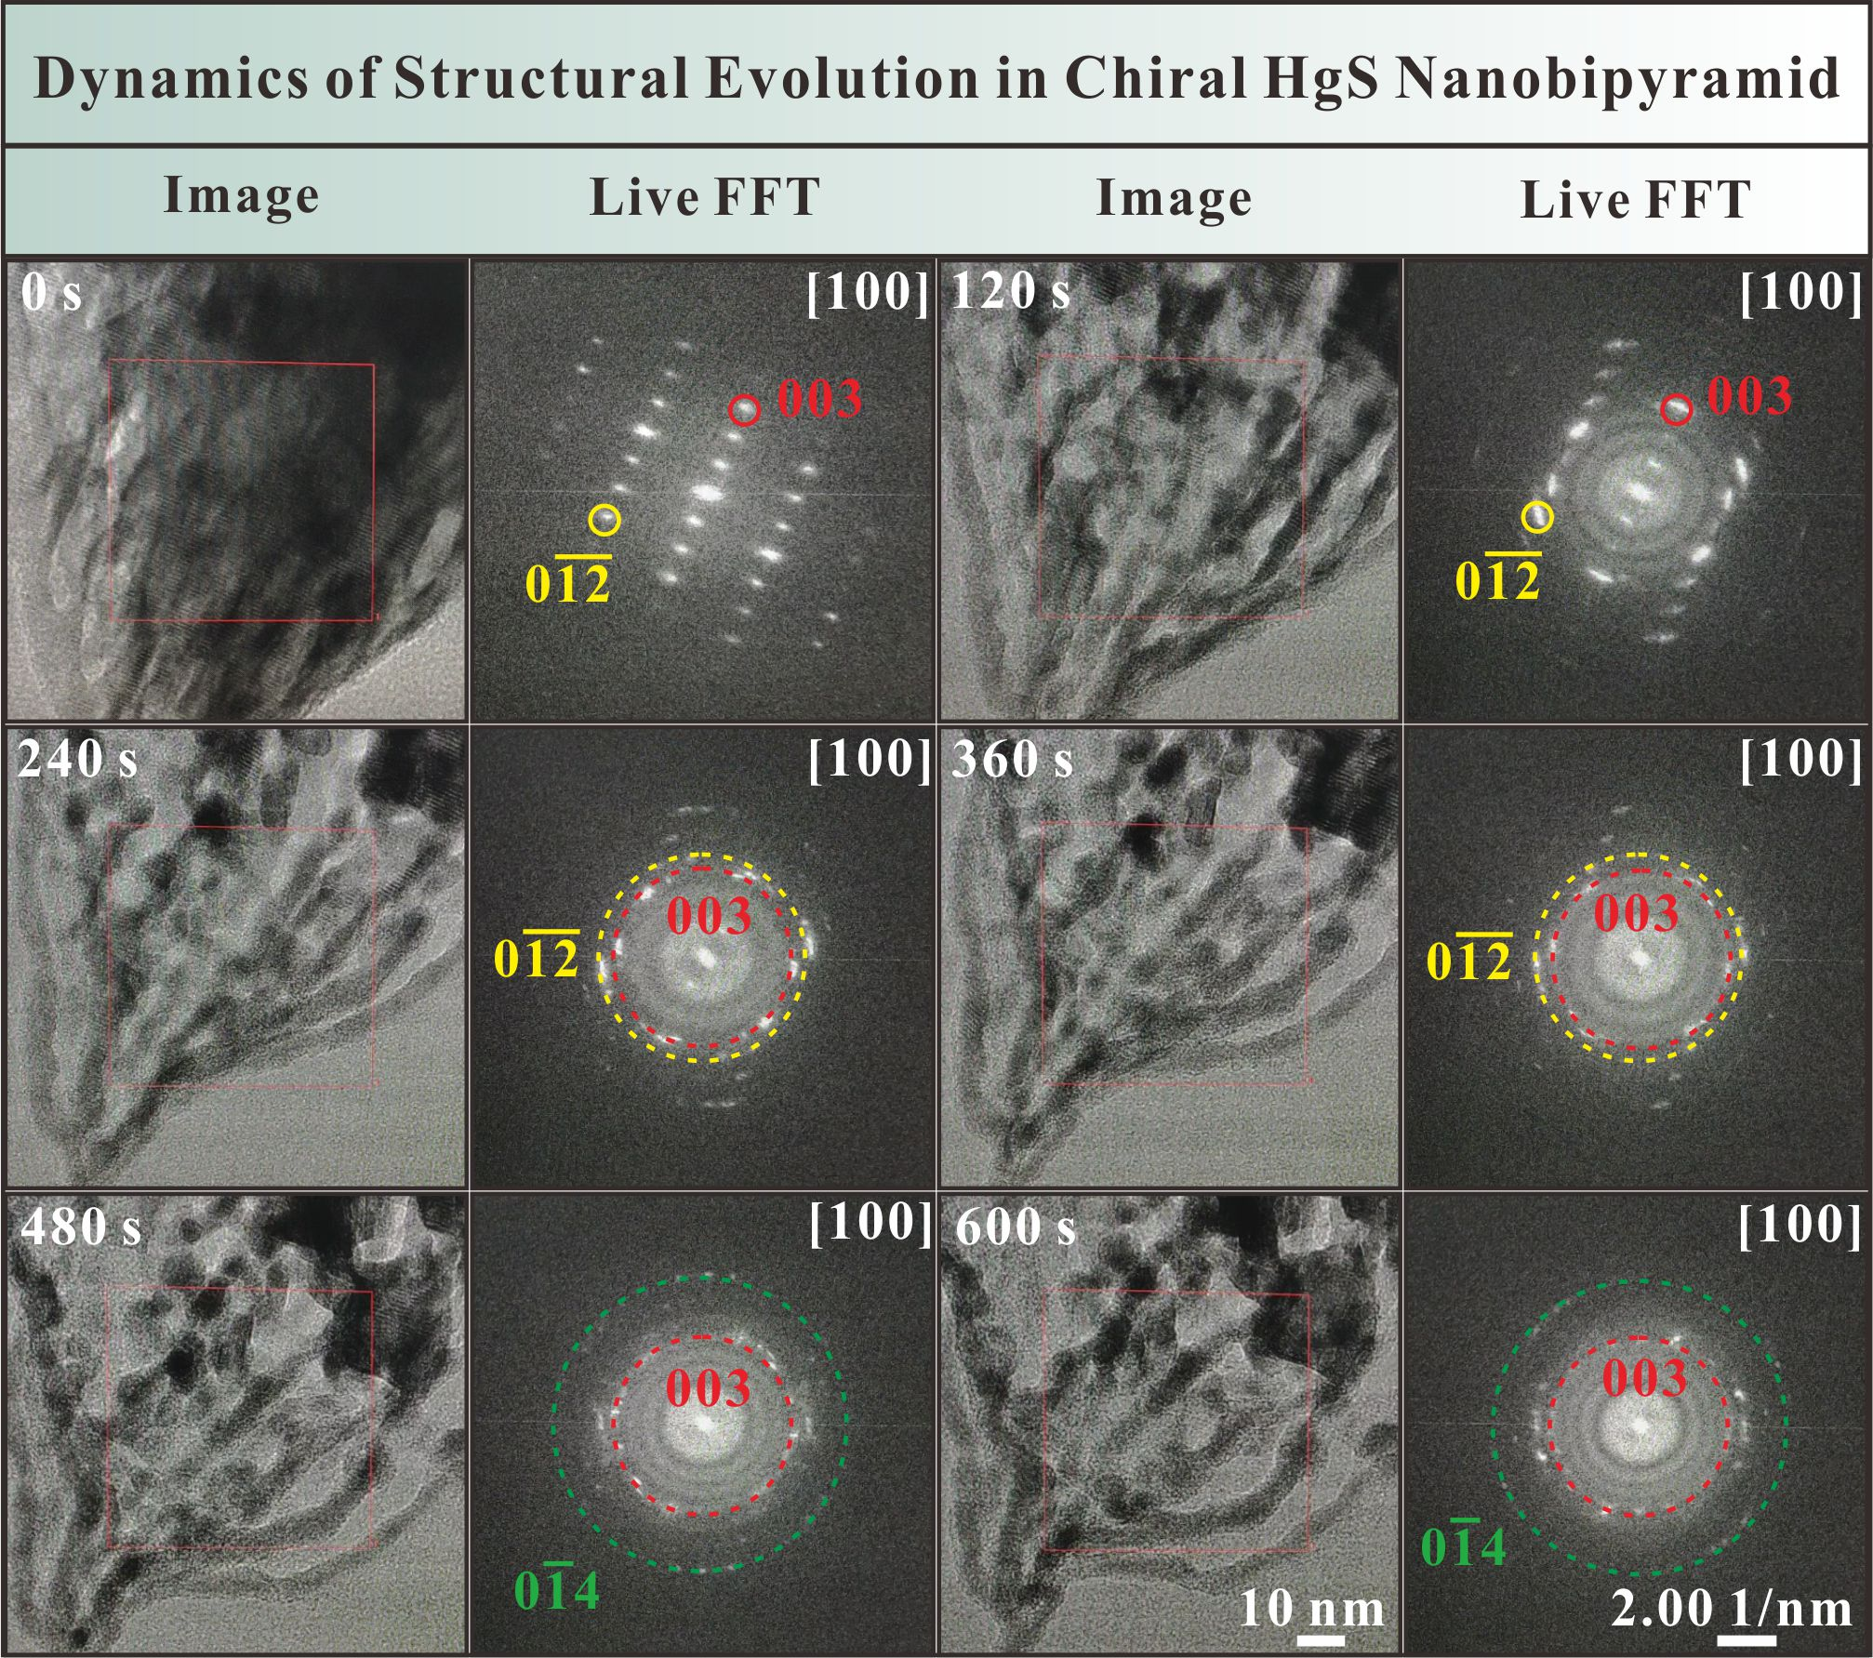
Supplementary Figure 15. Time-resolved TEM images and corresponding live FFT patterns in the chiral HgS nanobipyramid with a length of ~340 nm.
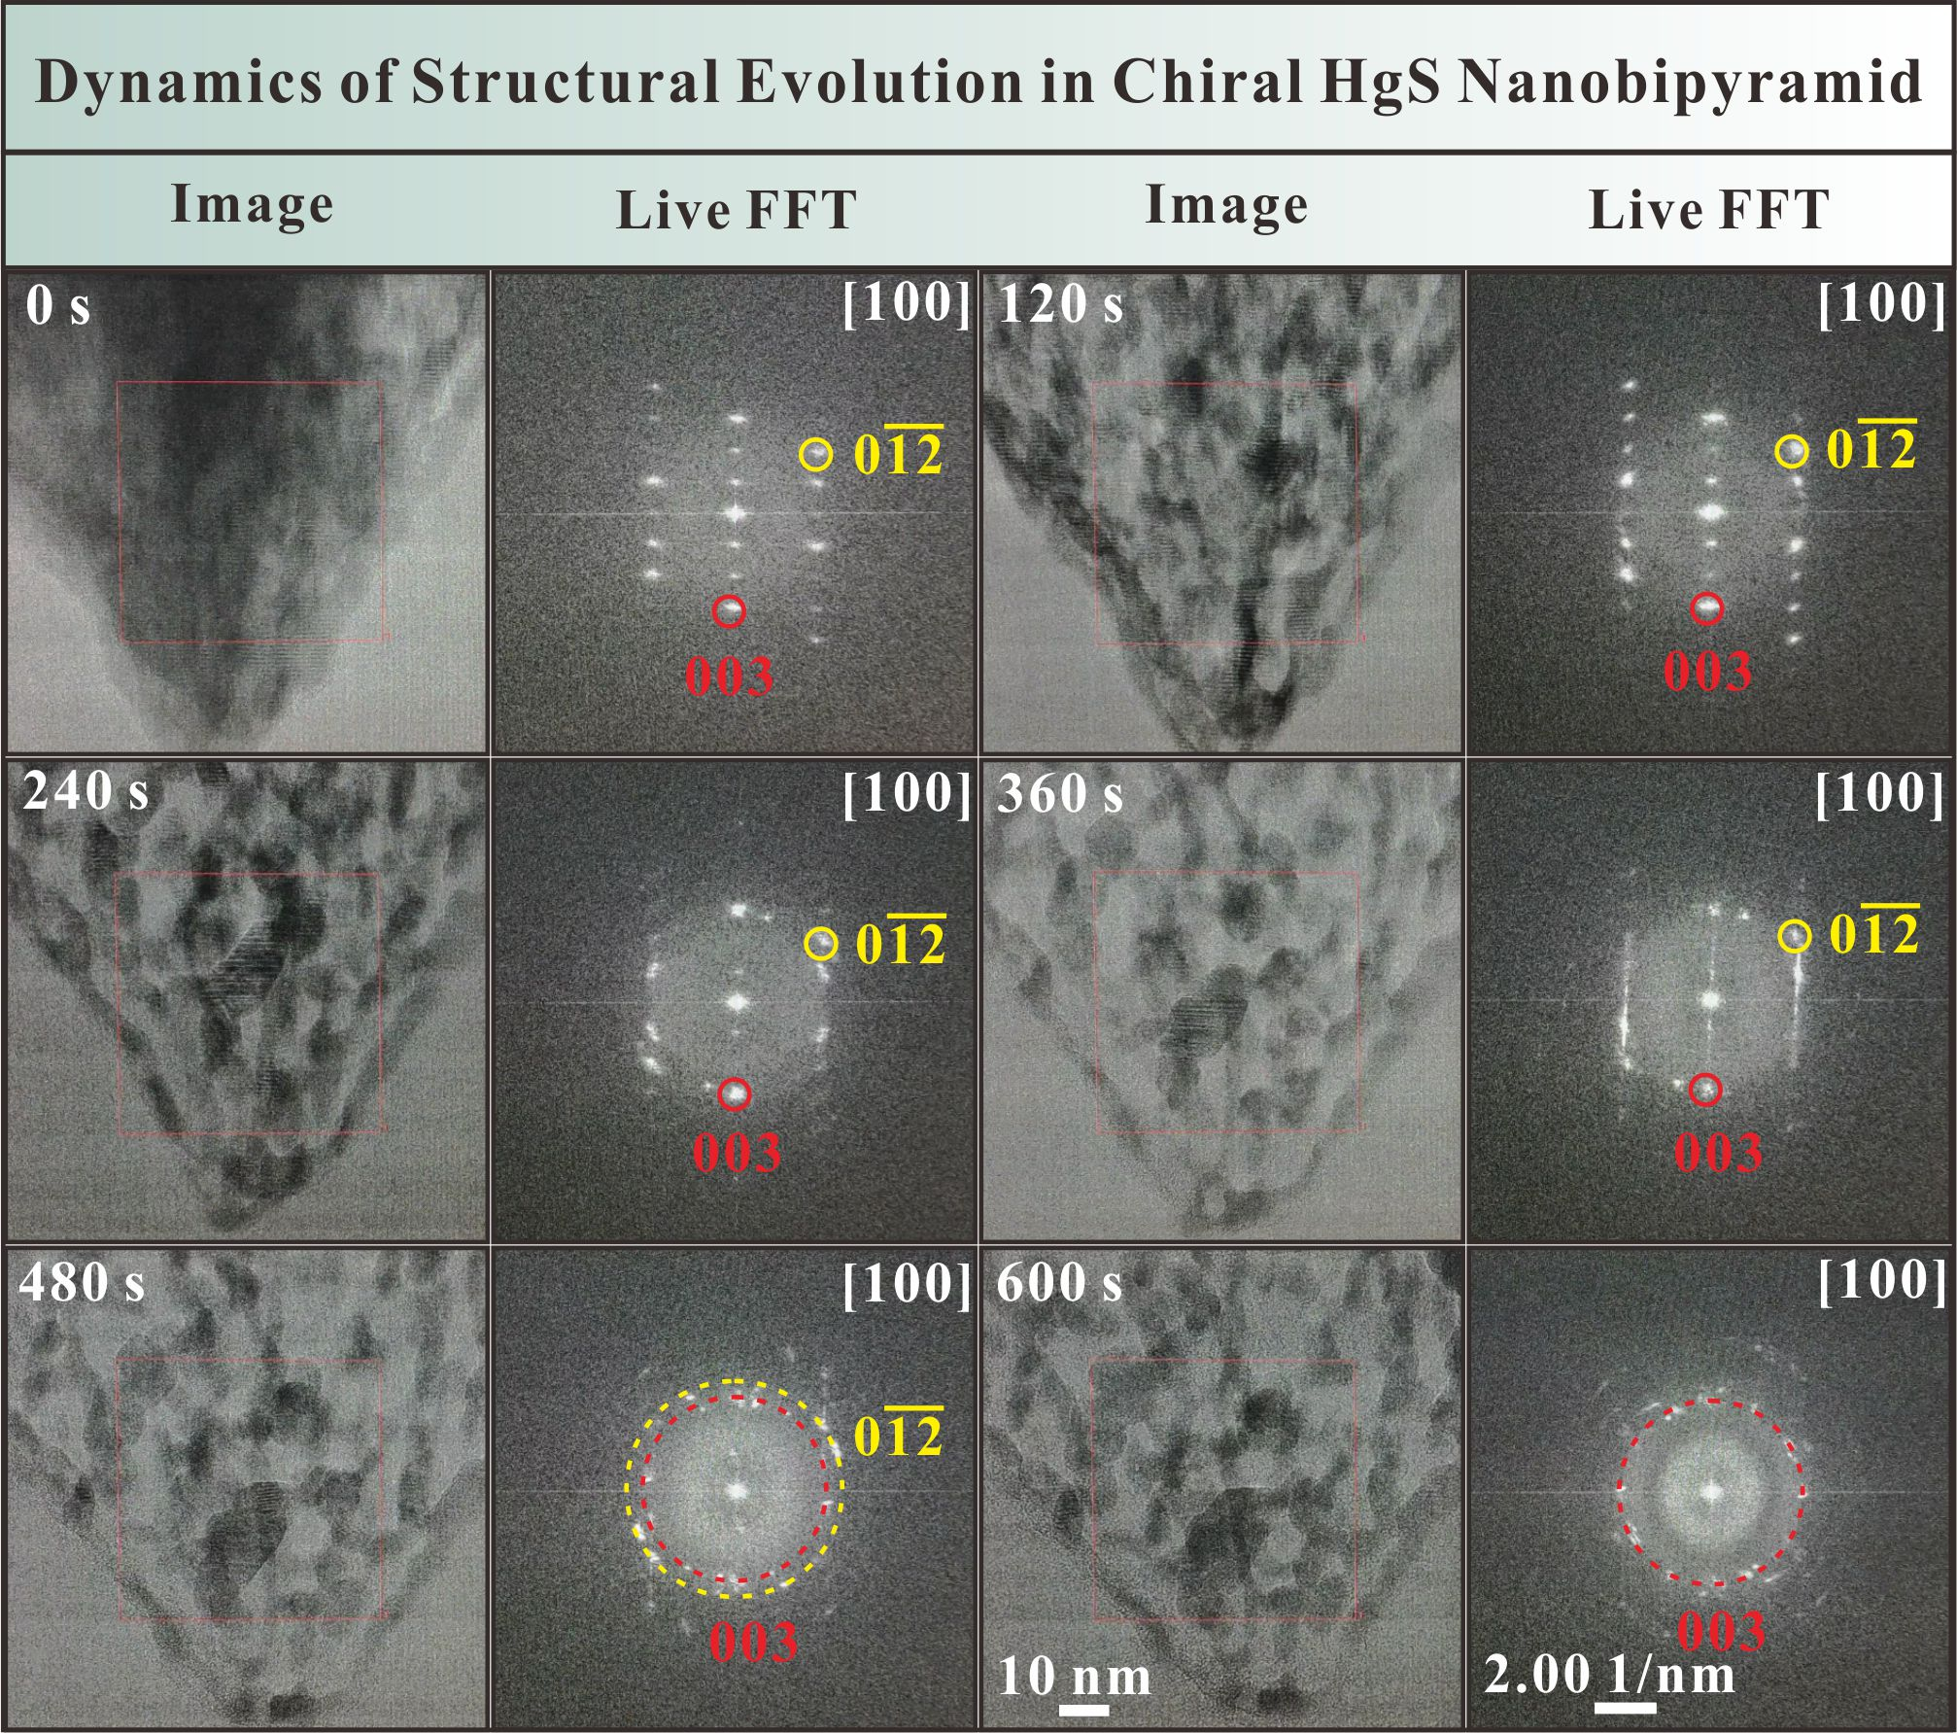
Supplementary Figure 16. Time-resolved TEM images and corresponding live FFT patterns in the chiral HgS nanobipyramid with a length of ~400 nm.
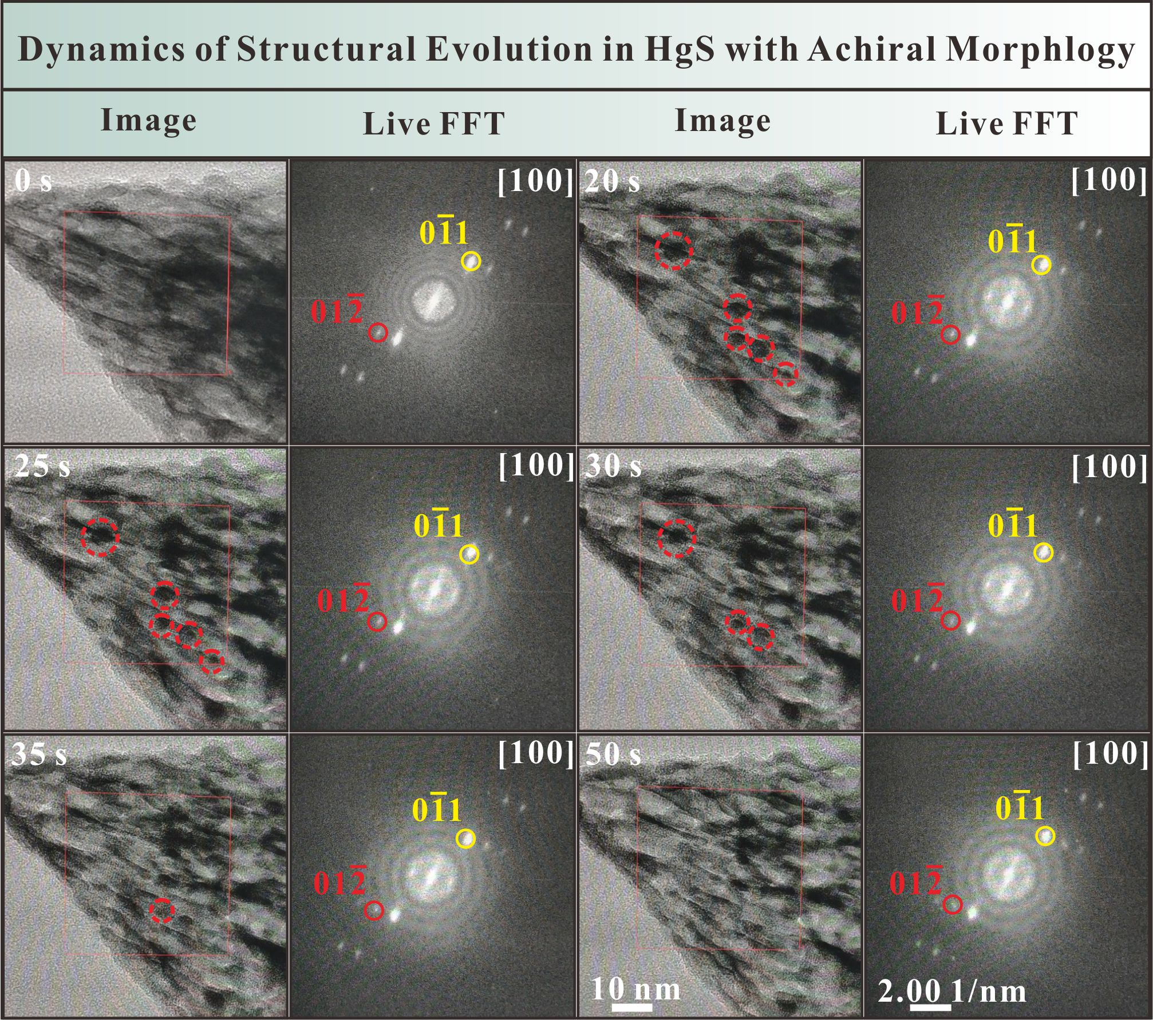
Supplementary Figure 17. Time-resolved TEM images and corresponding live FFT patterns in the HgS nanobipyramid with achiral morphology, showing the formation and evaporation processes of Hg nanodroplets. The dotted circles indicate the locations of such nanodroplets.
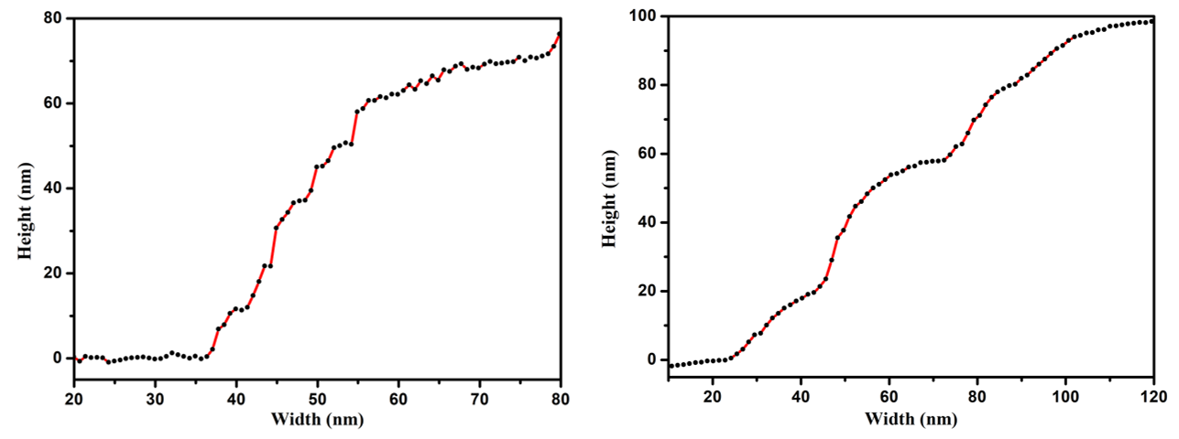
Supplementary Figure 18. Line profiles showing the thicknesses and step heights of the HgS nanobipyramids with chiral (left) and achiral (right) morphologies.

Nucleation and evaporation of liquid nanodroplets induced by electron beam irradiation
Nucleation of Hg nanodroplets
The critical and stable sizes for nucleation of Hg nanodroplets are examined in details (Fig. 6 in the main text). To estimate the critical size of nucleus, we consider a spherical cap on a flat substrate. The volume $V$ of a spherical cap is expressed as,
$V=\frac{π{βR}^{3}}{3}$ (7)
where $R$ is the radius of curvature of the nanodroplet, and $β$ equals,
$β={\left(1-cosθ\right)}^{2}\left(2+cosθ\right)=2-3cosθ+\cos^{3}θ$ (8)
where $θ$ is the contact angle. The surface areas of the nanodroplet-substrate $S_{sl}$ and the nanodroplet-vacuum $S_{sv}$ interfaces are written as,
$S_{sl}=πR^{2}\sin^{2}θ$ (9)
$S_{sv}=2πR^{2}\left(1-cosθ\right)$ (10)
The formation of Hg nanodroplets depends on the interplay of several contributions to the Gibbs free energies that are expressed as⁴
$∆G=G_{vol}+G_{surface}$ (11)
$G_{vol}=g_{vol}V$ (12)
where $G_{vol}$ is the volume free condensation energy, $G_{surface}$ the surface energy, $g_{vol}$ the free energy per unit volume for Hg (-13.43 eV/nm³) and $V$ the volume of Hg nanodroplet.^{5,6} The volume free condensation energy $G_{vol}$and the surface energy $G_{surface}$ equal,
$G_{vol}=\frac{πβR^{3}}{3}g_{vol}$ (13)
$G_{surface}=2πR^{2}\left(1-cosθ\right)γ_{lv}+πR^{2}\sin^{2}θ\left(γ_{sl}-γ_{sv}\right)$ (14)
where $γ_{lv}$, $γ_{sl}$ and $γ_{sv}$ are interfacial tensions of liquid–vacuum, solid-liquid and solid-vacuum, respectively. For the Hg nanodroplet at room temperature, $γ_{lv}=0.486 N/m$.⁷ According to the Young’s equation, the interfacial tensions are expressed with the contact angle as⁸
$\cos{θ}={\left(γ_{sv}-γ_{sl}\right)}/{γ_{lv}}$ (15)
In this regard, the surface energy $G_{surface}$ has the following form,
$G_{surface}=πR^{2}βγ_{lv}$ (16)
The sum of the volume condensation energy $G_{vol}$ and the surface energy $G_{surface}$ will determine the critical size of the nucleus (Figure 6 in the main text). The total free energy is thus rewritten as,
$∆G=\frac{π{βR}^{3}}{3}g_{vol}+πR^{2}βγ_{lv}$ (17)
With that, one gets the critical radius $R^{*}$ and the critical total free energy ${∆G}^{*}$ for heterogeneous nucleation of Hg nanodroplets,
$R^{*}=-\frac{2γ_{lv}}{g_{vol}}sinθ$ (18)
$R_{stable}=-\frac{3γ_{lv}}{g_{vol}}sinθ$ (19)
${∆G}^{*}=\frac{4πβγ_{lv}^{3}}{3{\left(g_{vol}\right)}^{2}}$ (20)
The nucleation rate $J$ of Hg nanodroplets has an inverse exponential dependence on critical total free energy, and depends on the intrinsic wettability of the surface,
$J=J_{0}exp⁡\left(-{{∆G}^{*}}/{k_{B}T}\right)$ (21)
where $J_{0}$ is the kinetic constant. Substituting the parameters into the above equations, the critical radius $R^{*}$, stable radius $R_{stable}$, critical total free energy ${∆G}^{*}$ and nucleation rate $J$ for the Hg nanodroplets nucleation were determined with respect to the contact angle $θ$, as summarized in Supplementary Table 3.
Contact Angle $θ$ ($°$) | 30 | 60 | 90 | 120 | 150
Critical Radius $R^{*}$(nm) | 0.23 | 0.39 | 0.45 | 0.39 | 0.23
Stable Radius $R_{stable}$ (nm) | 0.36 | 0.59 | 0.68 | 0.59 | 0.36
critical total free energy ${∆G}^{*}$ (eV) | 0.033 | 0.41 | 1.30 | 2.19 | 2.57
Supplementary Table 3. Critical radius, stable radius and critical total free energy of Hg nanodroplet as a function of contact angle $θ$.

Evaporation of Hg nanodroplets
For a spherical cap drop on solid surface, it will evaporate as the time elapses based on the diffusion equation. At a given contact angle and temperature, the change in droplet volume is expressed as⁹
$\frac{dV}{dt}=-2πD\frac{c_{0}-c_{∞}}{ρ}f{\left(\frac{3V}{πβ}\right)}^{1/3}$ (22)
where
$f=0.5\left(0.00008957+0.6333θ+0.116θ^{2}-0.08878θ^{3}+0.01033θ^{4}\right)$ (23)
Here, $D$ is the diffusion constant (14.2 × 10 ⁻⁶ m²/s)¹⁰,$ρ$ the density of liquid, $c_{0}$ the concentration of Hg vapor atoms in direct vicinity to the liquid surface, $c_{∞}$ the concentration at an infinite distance. The concentration$c_{∞}$ is determined by the vapor pressure $P_{V}$ in TEM and the mass $M$ of Hg atoms,
$c_{∞}=\frac{MP_{V}}{k_{B}T}$ (24)
The concentration $c_{0}$ is given by the Kelvin’s equation,
$c_{0}=\frac{MP_{0}}{k_{B}T}e^{λ/R}$ (25)
where $P_{0}$ is the saturated vapor pressure (1.6 × 10 ⁻⁴ Pa)¹¹, $P_{V}=\left(1-x\right)P_{0}$, and the characteristic length scale $λ$ for Hg liquid drops is 5.81 nm.¹⁰ Since the vapor pressure $P_{V}$ in TEM is ~10⁻⁷ pa, the value of $x$ is calculated to be 0.99. Combining the above equations, we obtain,
$\frac{dV}{dt}=-2πD\frac{P_{0}V_{m}}{k_{B}T}\left(e^{λ/R}-1+x\right)f{\left(\frac{3V}{πβ}\right)}^{1/3}$ (26)
where $V_{m}(=M/{ρ)}$ is the Hg atom volume in the liquid phase (2.48 × 10⁻² nm³). For the nanodroplet evaporation in the nanoscale, the factor $C_{f}$ (= 10.915) is used to describe the decrease of nanodroplet volume as a function of time according to the molecular dynamics results.^{12,13} Integrating eq.(25), one gets the following form,
$V^{2/3}=V_{L0}^{2/3}-\frac{4}{3}πD\frac{P_{0}V_{m}}{{C_{f}k}_{B}T}\left(e^{λ/R}-1+x\right)f{\left(\frac{3}{πβ}\right)}^{1/3}t$ (27)
So the total evaporation time $τ$ is expressed by,
$τ=\frac{1}{4}{\left(\frac{3}{π}\right)}^{2/3}\frac{V_{L0}^{2/3}}{D}\frac{k_{B}Tβ^{1/3}}{P_{0}V_{m}f}\frac{C_{f}}{e^{λ/R}-1+x}$ (28)
Substituting the relevant parameters into eq.(27), the curve of the evaporation time as a function of the contact angle is plotted (Fig. 6 in the main text).

References
1. Glaeser, R. M., Hren, J. J., Goldstein, J. I. & Joy, D. C. Introduction to Analytical Electron Microscopy. Plenum Press, New York, 423 (1979).
2. Berger, M. & Seltzer, S. Tables of energy-losses and ranges of electrons and positrons. Studies in penetration of charged particles in matter, 205 (1964).
3. Zhao, Y., Dai, Z., Lian, C., Zeng, S., Li, G., Ni, J. & Meng, S. Low lattice thermal conductivity and good thermoelectric performance of cinnabar. Physical Review Materials. 1, 65401 (2017).
4. Malac, M., Schoefield, M., Zhu, Y. & Egerton, R. Exposure characteristics of cobalt fluoride (CoF₂) self-developing electron-beam resist on sub-100 nm scale. J. Appl. Phys. 92, 1112-1121 (2002).
5. Hultgren, R. R. & Orr, R. L. Selected values of thermodynamic properties of metals and alloys. (John Wiley & Sons Inc, 1963).
6. Hepler, L. G. & Olofsson, G. Mercury. Thermodynamic properties, chemical equilibriums, and standard potentials. Chem. Rev. 75, 585-602 (1975).
7. Lugg, G. A. Diffusion coefficients of some organic and other vapors in air. Anal. Chem. 40, 1072-1077 (1968).
8. Bormashenko, E. Y. Wetting of real surfaces, vol. 19. (Walter de Gruyter GmbH & Co KG, 2018).
9. Erbil, H. Y. Evaporation of pure liquid sessile and spherical suspended drops: A review. Adv. Colloid Interfac. 170, 67-86 (2012).
10. Butt, H., Golovko, D. S. & Bonaccurso, E. On the derivation of Young's equation for sessile drops: nonequilibrium effects due to evaporation. The Journal of Physical Chemistry B. 111, 5277-5283 (2007).
11. Bennett, T. D. & Farrelly, M. Vaporization kinetics during pulsed laser heating of liquid Hg. J. Heat Transfer. 122, 345-350 (2000).
12. Walther, J. H. & Koumoutsakos, P. Molecular Dynamics Simulation of Nanodroplet Evaporation. Journal of Heat Transfer. 123, 741-748 (2000).
13. Suh, D. & Yasuoka, K. Nanoscale droplet vaporisation by molecular dynamics. Mol. Simulat. 41, 896-904 (2015).

