High arsenic levels increase activity rather than diversity or abundance of arsenic metabolism genes in paddy soils
Si-Yu Zhang^{1, 2*}, Xiao Xiao⁴, Song-Can Chen⁵, Yong-Guan Zhu^{6, 7}, Konstantinos T. Konstantinidis^{1,3*}
1. School of Ecological and Environmental Sciences, East China Normal University, Shanghai, China
2. School of Civil and Environmental Engineering, Georgia Institute of Technology, Ford Environmental Science & Technology Building, GA, USA
3. Department of Biological Sciences, Georgia Institute of Technology, Ford Environmental Science & Technology Building, GA, USA
4. Key Laboratory of Jiangxi Province for Persistent Pollutants Control and Resources Recycle, Nanchang Hangkong University, Nanchang, Jiangxi, China
5. Department of Isotope Biogeochemistry, Helmholtz Centre for Environmental Research – UFZ, Leipzig, Germany
6. State Key Laboratory of Urban and Regional Ecology, Research Center for Eco-Environmental Sciences, Chinese Academy of Sciences, Beijing, China
7. Key Laboratory of Urban Environment and Health, Institute of Urban Environment, Chinese Academy of Sciences, Xiamen, China
Corresponding author: Konstantinos T. Konstantinidis and Si-Yu Zhang
E-mail: kostas@ce.gatech.edu and syzhang@des.ecnu.edu.cn

Methods
Physicochemical soil analysis
Soils for chemical analyses were processed through a 2.0-mm sieve. For each site (three biological replicates), soil pH was determined in a 1:2.5 soil/water suspension. The total N and C of the soil were measured using dry combustion in a C/N instrument (Vario MAX C/N; Elementar, Germany). Soil Eh at was monitored with a portable Eh meter (EHS-120; Fujiwara Scientific Company Co., Ltd, Tokyo, Japan). Samples for total arsenic (As), lead (Pb), cadmium (Cd), chromium (Cr), antimony (Sb) and iron (Fe) concentration determination were acidified with HNO₃ (pH =1) [1] and determined by inductively coupled plasma mass spectrometry (ICP-MS, Agilent Technology, U.S.A.). Total soil P was extracted using H₂SO₄-HClO₄ digestion and analyzed with a Bran Luebbe Auto-Analyzer III (Bran + Luebbe, Germany) [2]. Total soil sulfur content was determined using the ELTRA CS 500 sulfur analyzer [3].

Metagenomics and metatranscriptomics sequence assembling and functional annotation
The trimmed sequences of metagenomes and metatranscriptomes were assembled using IDBA [4] with default settings. Sequencing and assembly statistics for the metagenomes and metatranscriptomes were provided in Supplementary Table S3 and S4, respectively. Protein-coding genes were predicted from contigs longer than 500 bp using MetaGeneMark.hmm [5] with default parameters. The predicted protein sequences were searched against the in house curated As metabolism proteins database using BLASTp (BLAST + version 2.2.28) [6] with a cut-off for a match of amino acid identity > 40% and reference length coverage > 70% by the alignment in order to build a more comprehensive As metabolism proteins database that better capture the diversity of As metabolism proteins.

Population genome binning and detection of Ars, AioA and ArrA
Metagenome-assembled genomes (MAGs) were recovered using both MaxBin Version 2.1.1 [7] and MetaBAT Version 2.12.1 [8]. Contigs longer than 500 bp from each metagenomic dataset were used for binning. Quality assessment of the resulting MAG sequences was performed by CheckM [9]. Only the genomes with completeness ≥ 80% and contamination ≤ 5% were considered for further analysis, and no same MAG (i.e. > 95% average nucleotide identity [ANI]) was recovered overall. Taxonomic classification of obtained MAGs, including assessment of their taxonomic novelty, was performed using the Microbial Genomes Atlas (MiGA) webserver [10]. Protein-coding genes were predicted from contigs longer than 500 bp using GeneMark.hmm [11] with default parameters. To detect the As metabolism proteins of these MAGs, the predicted protein sequences were searched against the in house As metabolism protein references database using BLASTp (BLAST + version 2.2.28) [6] with a cut-off for a match of amino acid identity > 40% and reference length coverage > 70%.

References
1. Bruneel O, Pascault N, Egal M, Bancon-Montigny C, Goñi-Urriza M, Elbaz-Poulichet F, et al. Archaeal diversity in a Fe–As rich acid mine drainage at Carnoulès (France). Extremophiles. 2008;12(4):563-71.
2. Benke MB, Hao X, Caffyn P, Schoenau JJ, McAllister TA. Using manure from cattle fed dried distillers’ grains with solubles (DDGS) as fertilizer: Effects on nutrient accumulation in soil and uptake by barley. Agriculture, ecosystems & environment. 2010;139(4):720-7.
3. Kříbek B, Majer V, Veselovský F, Nyambe I. Discrimination of lithogenic and anthropogenic sources of metals and sulphur in soils of the central-northern part of the Zambian Copperbelt Mining District: a topsoil vs. subsurface soil concept. Journal of geochemical Exploration. 2010;104(3):69-86.
4. Peng Y, Leung HC, Yiu S-M, Chin FY: IDBA–a practical iterative de Bruijn graph de novo assembler. In: Annual international conference on research in computational molecular biology. Springer; 2010: 426-40.
5. Zhu W, Lomsadze A, Borodovsky M. Ab initio gene identification in metagenomic sequences. Nucleic acids research. 2010;38(12):e132-e.
6. Camacho C, Coulouris G, Avagyan V, Ma N, Papadopoulos J, Bealer K, et al. BLAST+: architecture and applications. BMC bioinformatics. 2009;10(1):421.
7. Wu Y-W, Simmons BA, Singer SW. MaxBin 2.0: an automated binning algorithm to recover genomes from multiple metagenomic datasets. Bioinformatics. 2016;32(4):605-7.
8. Kang DD, Li F, Kirton E, Thomas A, Egan R, An H, et al. MetaBAT 2: an adaptive binning algorithm for robust and efficient genome reconstruction from metagenome assemblies. PeerJ. 2019;7:e7359.
9. Parks DH, Imelfort M, Skennerton CT, Hugenholtz P, Tyson GW. CheckM: assessing the quality of microbial genomes recovered from isolates, single cells, and metagenomes. Genome research. 2015;25(7):1043-55.
10. Rodriguez-R LM, Gunturu S, Harvey WT, Rosselló-Mora R, Tiedje JM, Cole JR, et al. The Microbial Genomes Atlas (MiGA) webserver: taxonomic and gene diversity analysis of Archaea and Bacteria at the whole genome level. Nucleic acids research. 2018;46(W1):W282-W8.
11. Besemer J, Borodovsky M. GeneMark: web software for gene finding in prokaryotes, eukaryotes and viruses. Nucleic acids research. 2005;33(suppl_2):W451-W4.
12. Luo J, Bai Y, Liang J, Qu J. Metagenomic approach reveals variation of microbes with arsenic and antimony metabolism genes from highly contaminated soil. PLoS One. 2014;9(10).

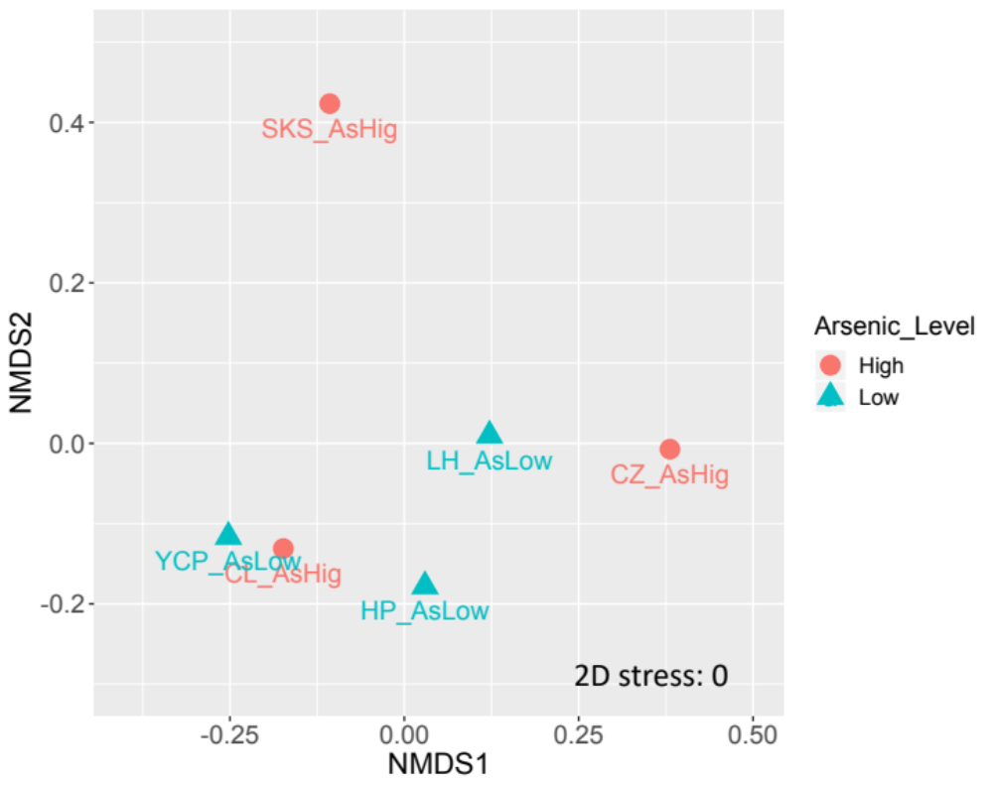
Figure S1. NMDS plot of site-to-site similarity matrix based on 16S rRNA gene-based OTU tables and the Bray-Curtis metric. Symbols in different colors indicate different As levels (circle in red: high As levels; triangle in blue: low As levels).

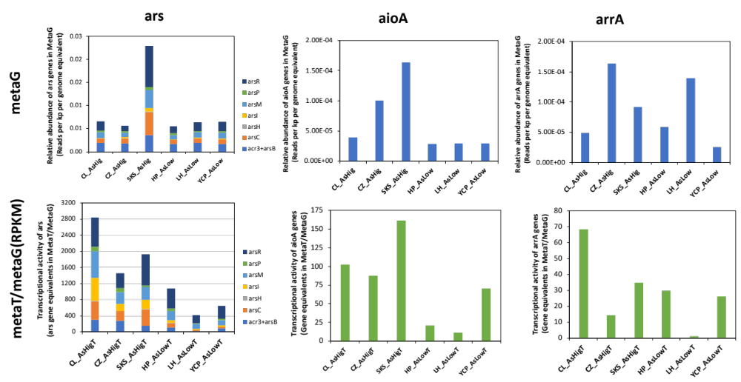
Figure S2. Relative abundance and transcription level of ars, aioA and arrA genes in high and low As paddy soils. The relative abundance and transcription of ars genes is a sum of arsR (arsR1, arsR2, arsR3, arsR4), acr3, arsB, arsC (arsC1, arsC2 and acr2), arsM, arsI, arsP and arsH genes abundances and transcription. Relative abundance of As metabolism genes in metagenomes was normalized by the statistic RPKG (reads per kb per genome equivalent). The As metabolism genes transcriptional activity was evaluated by the relative abundance of As metabolism genes in metatranscriptomics (RPKM reads per kb per millions of reads) normalized by the relative abundance of the same gene identified in metagenomics (RPKM).

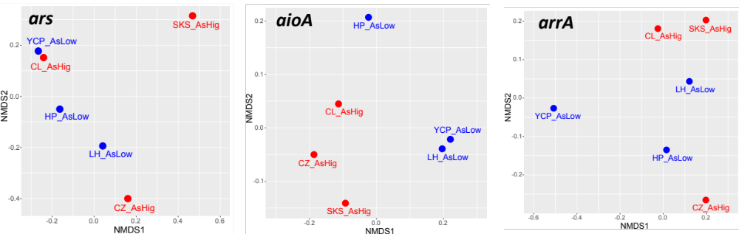
Figure S3. NMDS plot of the Bray-Curtis metric based on the counts of ars (acr3, arsB, arsC, arsM, arsI, arsH, arsP and arsR), aioA and arrA genes annotated from metagenomes. Symbols in different colors indicate different As levels (red: high As levels; blue: low As levels).

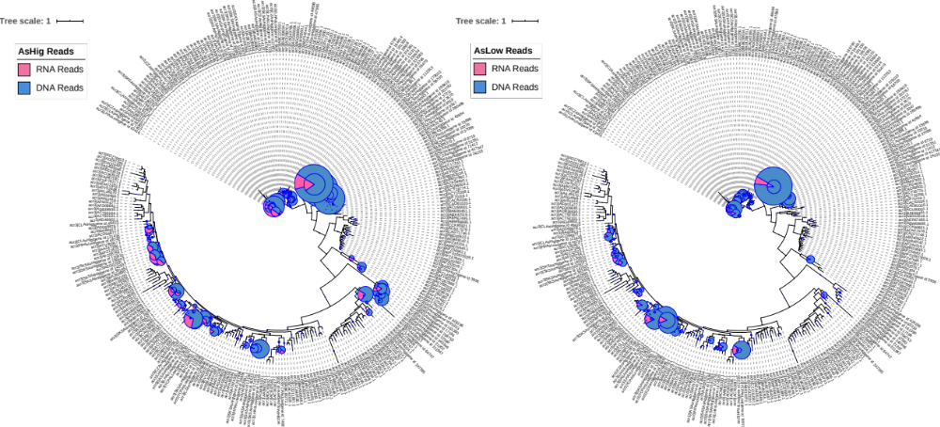
Figure S4. Phylogenetic placement of acr3-carrying reads identified in metagenomes (DNA reads, in blue) and metatranscriptomes (RNA reads, in red) from high (left panel) and low As paddy soils (right panel). For this analysis, the three metagenomes and metatranscriptomes from the same As level (i.e. high or low) sites were combined together. The pie size indicates the DNA abundance and the ratio indicate transcriptional activity for each clade (i.e., fraction of RNA vs DNA reads assigned to the class with the same thresholds for a match; see Methods for further details). Note that several clades in the high As recruited more RNA than DNA reads (red color dominates) whereas the opposite pattern was observed for most clades in the low As datasets.
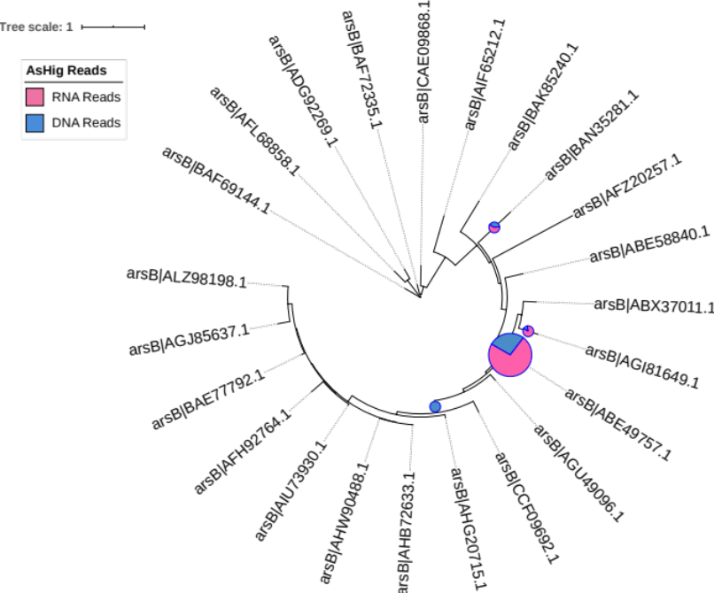
Figure S5. Phylogenetic placement of arsB-carrying reads identified in metagenomes (DNA reads, in blue) and metatranscriptomes (RNA reads, in red) from high As paddy soils. For this analysis, the three metagenomes and metatranscriptomes from the same As level (i.e. high or low) sites were combined together. The pie size indicates the DNA abundance and the ratio indicate transcriptional activity for each clade (i.e., fraction of RNA vs DNA reads assigned to the class with the same thresholds for a match; see Methods for further details). Only 17% of the total clades recruited arsB-carrying reads from high As paddy soils and no clade recruited reads from the low As paddy soils.
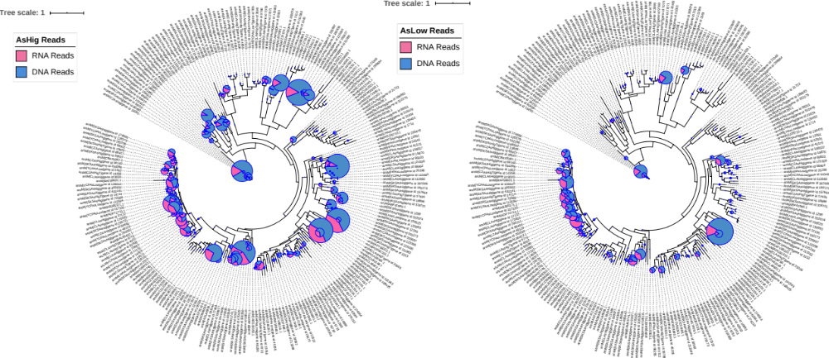
Figure S6. Phylogenetic placement of arsM-carrying reads identified in metagenomes (DNA reads, in blue) and metatranscriptomes (RNA reads, in red) from high (left panel) and low As paddy soils (right panel). For this analysis, the three metagenomes and metatranscriptomes from the same As level (i.e. high or low) sites were combined together. The pie size indicates the DNA abundance and the ratio indicate transcriptional activity for each clade (i.e., fraction of RNA vs DNA reads assigned to the class with the same thresholds for a match; see Methods for further details). Note that several clades in the high As recruited more RNA than DNA reads (red color dominates) whereas the opposite pattern was observed for most clades in the low As datasets.

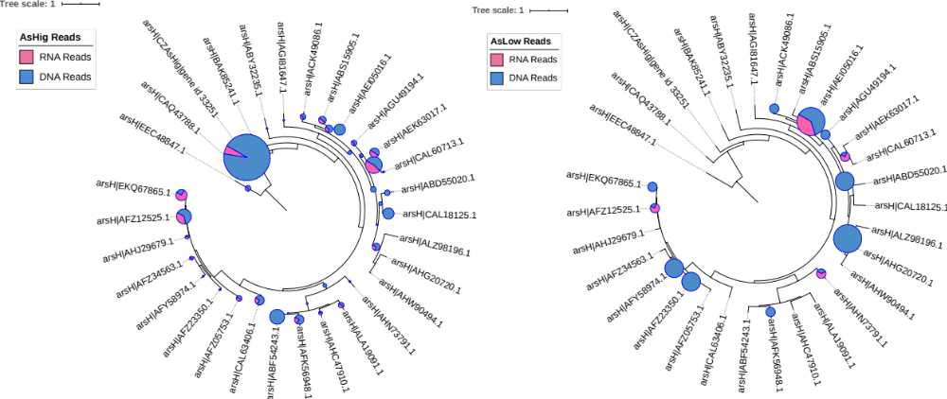
Figure S7. Phylogenetic placement of arsH-carrying reads identified in metagenomes (DNA reads, in blue) and metatranscriptomes (RNA reads, in red) from high (left panel) and low As paddy soils (right panel). For this analysis, the three metagenomes and metatranscriptomes from the same As level (i.e. high or low) sites were combined together. The pie size indicates the DNA abundance and the ratio indicate transcriptional activity for each clade (i.e., fraction of RNA vs DNA reads assigned to the class with the same thresholds for a match; see Methods for further details). Note that several clades in the high As recruited more RNA than DNA reads (red color dominates) whereas the opposite pattern was observed for most clades in the low As datasets.

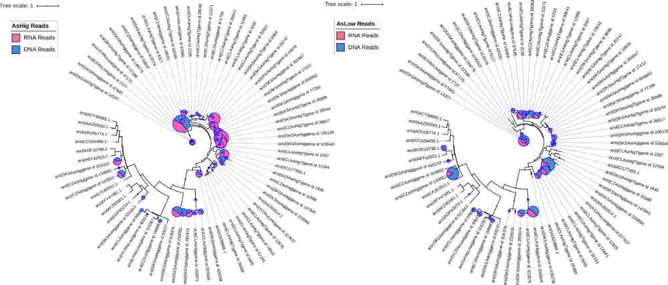
Figure S8. Phylogenetic placement of arsI-carrying reads identified in metagenomes (DNA reads, in blue) and metatranscriptomes (RNA reads, in red) from high (left panel) and low As paddy soils (right panel). For this analysis, the three metagenomes and metatranscriptomes from the same As level (i.e. high or low) sites were combined together. The pie size indicates the DNA abundance and the ratio indicate transcriptional activity for each clade (i.e., fraction of RNA vs DNA reads assigned to the class with the same thresholds for a match; see Methods for further details). Note that several clades in the high As recruited more RNA than DNA reads (red color dominates) whereas the opposite pattern was observed for most clades in the low As datasets.

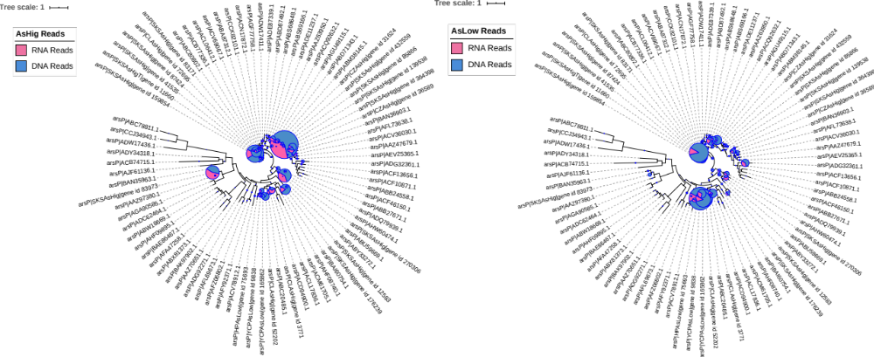
Figure S9. Phylogenetic placement of arsP-carrying reads identified in metagenomes (DNA reads, in blue) and metatranscriptomes (RNA reads, in red) from high (left panel) and low As paddy soils (right panel). For this analysis, the three metagenomes and metatranscriptomes from the same As level (i.e. high or low) sites were combined together. The pie size indicates the DNA abundance and the ratio indicate transcriptional activity for each clade (i.e., fraction of RNA vs DNA reads assigned to the class with the same thresholds for a match; see Methods for further details). Note that several clades in the high As recruited more RNA than DNA reads (red color dominates) whereas the opposite pattern was observed for most clades in the low As datasets.

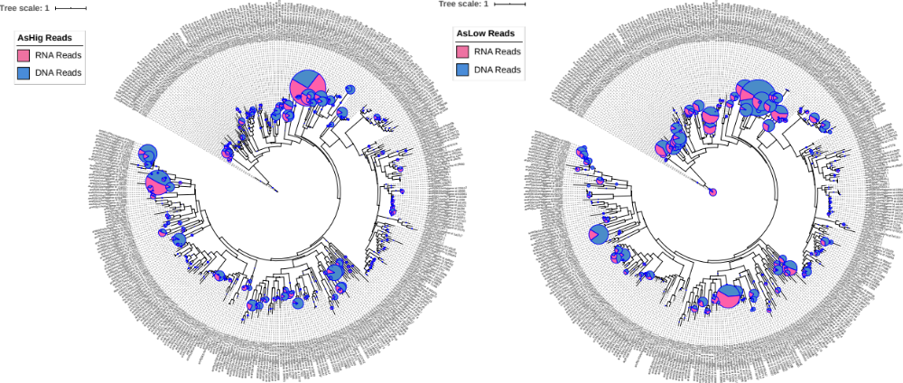
Figure S10. Phylogenetic placement of arsR-carrying reads identified in metagenomes (DNA reads, in blue) and metatranscriptomes (RNA reads, in red) from high (left panel) and low As paddy soils (right panel). For this analysis, the three metagenomes and metatranscriptomes from the same As level (i.e. high or low) sites were combined together. The pie size indicates the DNA abundance and the ratio indicate transcriptional activity for each clade (i.e., fraction of RNA vs DNA reads assigned to the class with the same thresholds for a match; see Methods for further details). Note that several clades in the high As recruited more RNA than DNA reads (red color dominates) whereas the opposite pattern was observed for most clades in the low As datasets.

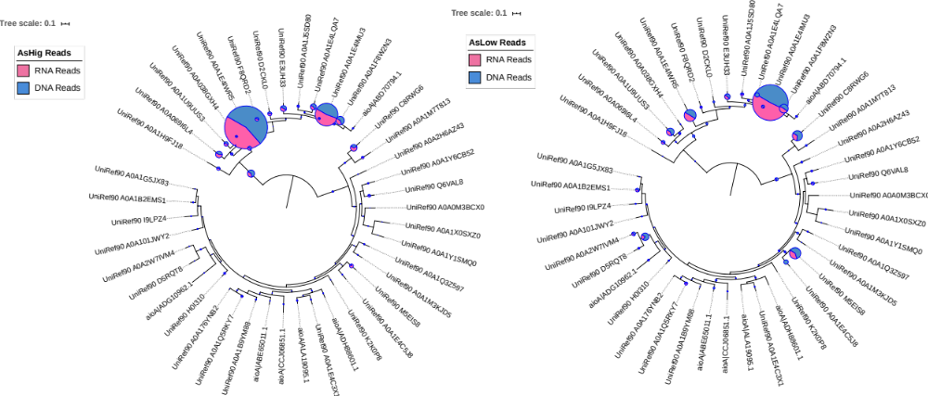
Figure S11. Phylogenetic placement of aioA-carrying reads identified in metagenomes (DNA reads, in blue) and metatranscriptomes (RNA reads, in red) from high (left panel) and low As paddy soils (right panel). For this analysis, the three metagenomes and metatranscriptomes from the same As level (i.e. high or low) sites were combined together. The pie size indicates the DNA abundance and the ratio indicate transcriptional activity for each clade (i.e., fraction of RNA vs DNA reads assigned to the class with the same thresholds for a match; see Methods for further details). Note that several clades in the high As recruited more RNA than DNA reads (red color dominates) whereas the opposite pattern was observed for most clades in the low As datasets.

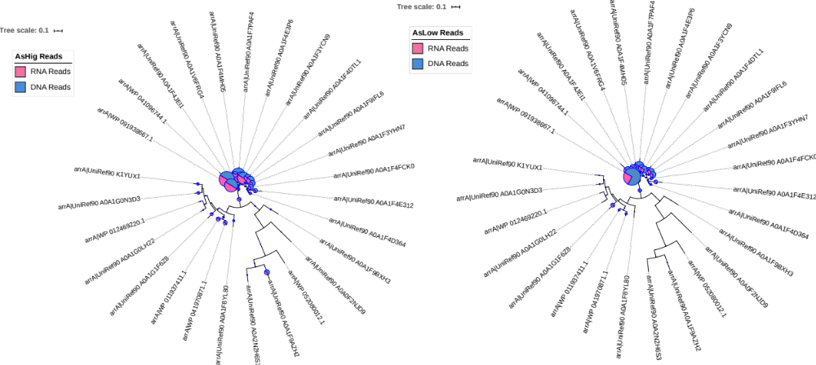
Figure S12. Phylogenetic placement of arrA-carrying reads identified in metagenomes (DNA reads, in blue) and metatranscriptomes (RNA reads, in red) from high (left panel) and low As paddy soils (right panel). For this analysis, the three metagenomes and metatranscriptomes from the same As level (i.e. high or low) sites were combined together. The pie size indicates the DNA abundance and the ratio indicate transcriptional activity for each clade (i.e., fraction of RNA vs DNA reads assigned to the class with the same thresholds for a match; see Methods for further details). Note that several clades in the high As recruited more RNA than DNA reads (red color dominates) whereas the opposite pattern was observed for most clades in the low As datasets.

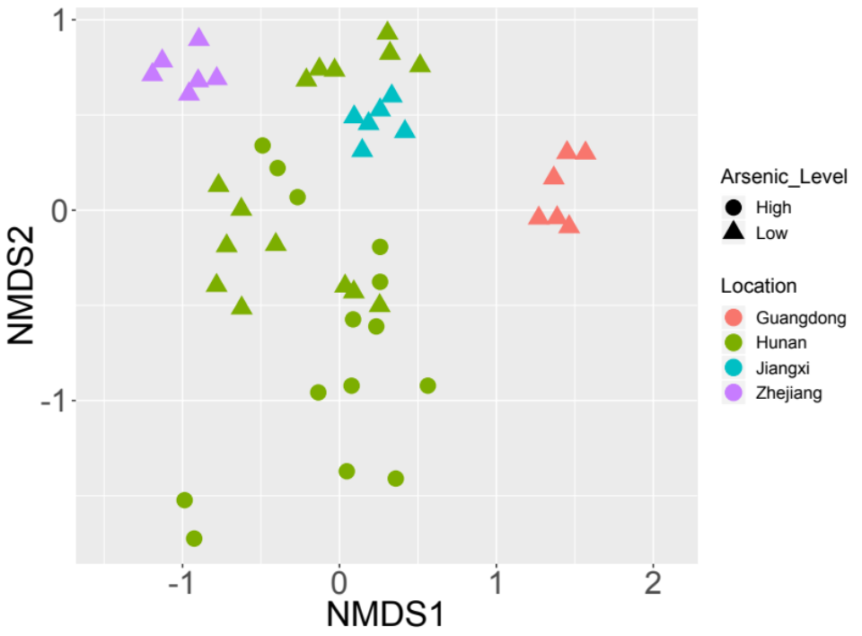
Figure S13. NMDS plot of site-to-site similarity matrix based on Mash distances of the metagenomes determined by this study and selected publicly available metagenomes. Public metagenomes included eight paddy soils with low As levels collected from Hunan, Zhejiang, Jiangxi and Guangdong provinces, and five soils with high As levels collected from mine filed affected area in Hunan province. All datasets were subsampled to 2 Gbp to avoid effects of differential sequencing effort on the results. Symbols in different colors indicate samples from different provinces (green: Hunan; red: Guangdong; blue: Jiangxi; purple: Zhejiang). The shape of the symbols indicates different As levels of these samples (circle: high As levels; triangle: low As levels).
Figure S14. Correlation of the relative abundance of ars genes and As concentration in five soils collected from a mine affected area in Hunan, China previously. X axis shows the relative abundance of ars genes in the metagenomes normalized by the statistic RPKG (reads per kb per genome equivalent). Y axis shows the As concentration in the soils determined previously [12]. Data points are arranged according to the soil concentration of As on the y-axis (from low to high, ranging from 34.1 to 821.2 mg kg⁻¹). The line represents the linear regression and the trendline equation is y = 14011x – 7.7973 (R² = 0.6934).

