Supplemental Data 3

Methods
Tube formation assay in vitro
The supernatants of hBMSCs in each group (P3, P8, P8-SHED-CM and P8-hBMSCs-CM) were collected after 3 days cultured in DMEM. Tube formation assay were performed as below to evaluate the pro-angiogenic capacity of hBMSCs. Briefly, a 48-well culture plate was prepared with 100 μl matrigel matrix mixture (mixed with serum-free DMEM at a ratio of 1:1) (BD Biosciences, USA) per well in advance. Then, HUVECs were resuspended by the supernatants of hBMSCs, and seeded into plates at 6 × 10⁴ cells per well. After 4 h, 8 h and 24 h incubation at 37 °C, 5% CO₂, tube formation in each group was detected under microscopy. The results of tube length, tube area, and the number of branch points were analyzed by ImageJ software.

Results
hBMSCs cultured in SHED-CM had enhanced pro-angiogenic capacity during long-term expansion
Tube formation assay was performed to assess the pro-angiogenic capacity of hBMSCs in vitro, which is an essential property of MSCs. Results showed that HUVECs migrate and begin to form small branches at 4 h. However, many tubes began to disconnect by 8 h in P8 and P8-hBMSCs-CM group. At 24 h, maximum tube formation was reached in P3 and P8-SHED-CM group, while there were no closed tubular structures remained in P8 and P8-hBMSCs-CM group. Overall, these results indicate that hBMSCs cultured in SHED-CM after long-term expansion also retained potential clinical applications in promoting neovascularization in vivo.
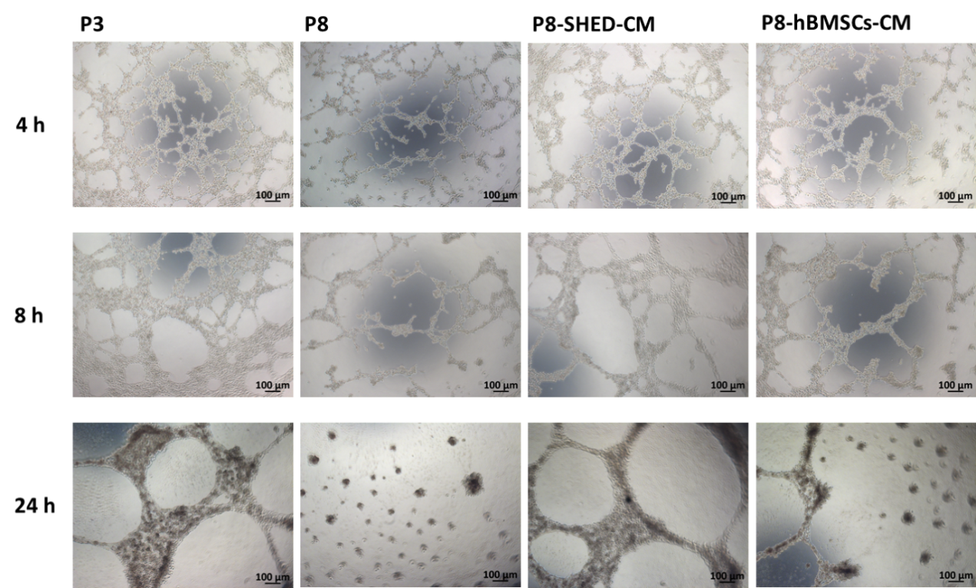

Supplemental Data 3 hBMSCs cultured in SHED-CM had enhanced pro-angiogenic capacity during long-term expansion.
The pro-angiogenic capacity of passage 3 (P3) and passage 8 (P8) hBMSCs cultured in DMEM, SHED-CM (P8-SHED-CM) and hBMSCs-CM (P8-hBMSCs-CM). Representative images of the tube formation assay per group when cells incubated for 4 h, 8 h and 24 h.

