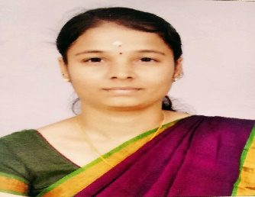 | Ms. E. Poornima is currently pursuing her Ph.D. in the Department of Computer Science, Bharathiar University, Coimbatore. Her area of interest includes Data mining and Bio informatics. She has published papers in International Conferences and Journals.
 | Dr. D. Ramyachitra is currently providing services as Assistant Professor. Dr. She has published numerous publications in various national and international peer-reviewed journals and presented scientific papers across the world. Because of the active association with different societies and academies as well as the contributions, Dr. D. Ramyachitra is been recognized by the subject experts around the world. Her contributions are appreciated by various reputed awards. Dr. D. Ramyachitra clinical and scientific research interests include Grid Computing, Data Mining and Bioinformatics.
 | Dr. P. Manikandan is currently Working as an Assistant Professor in the Department of Data Science, Loyola College, Chennai, India. He received the Master of Computer Science (M.Sc) in 2013, Master of Philosophy (M.Phil) and Doctorate of Philosophy(Ph.D) in Computer Science degree from the Bharathiar University. He has authored books and also published several papers in various International Journals and Conferences. His research interests include Data mining and Bio informatics.

