Supplementary Information for
Iron to catalyze ammonia synthesis at low temperature

Masashi Hattori, Natsuo Okuyama, Hiyori Kurosawa, Michikazu Hara*
Laboratory for Materials and Structures, Tokyo Institute of Technology, 4259 Nagatsuta, Midori-ku, Yokohama 226–8503, Japan

*e-mail: mhara@msl.titech.ac.jp

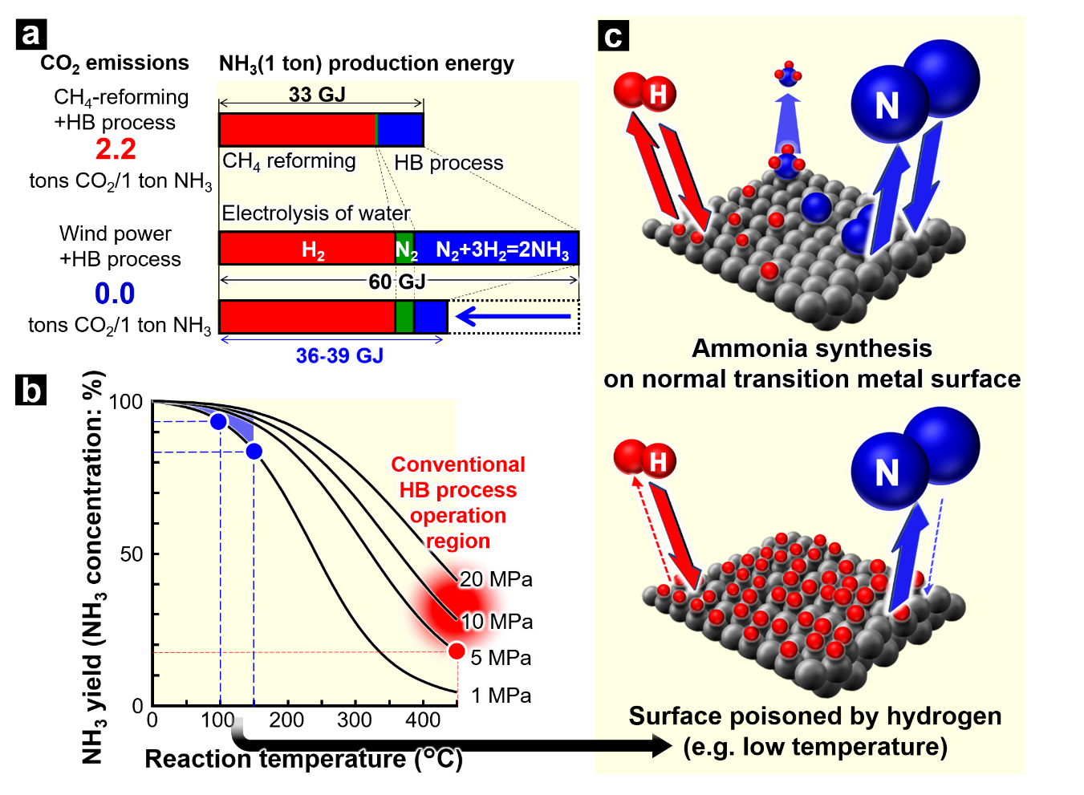

Supplementary Figure 1 Ammonia synthesis. a Ammonia production energies for the conventional HB process using H₂ produced by CH₄ reforming, and CO₂-free HB process using H₂ produced by water electrolysis based on wind power generation. The latter (60 GJ/NH₃ (1 ton)) is twice that of the former (33 GJ/NH₃ (1 ton)) because the HB process is driven only by renewable electricity. By reducing the energy consumed for the HB process by 70 to 80%, the ammonia production energy for CO₂-free method can be decreased to 36‒39 GJ/NH₃ (1 ton). b Correlation of ammonia yield with temperature and pressure. For example, the maximum (theoretic) ammonia yield under 5 MPa at 450 °C, which is the operation temperature of the present HB process, is 0.86 MPa (= 5×0.17). On the other hand, ammonia synthesis under 1 MPa at 100 and 150 °C gives ammonia yields of 0.94 and 0.84 MPa, respectively. Therefore, 1/5 of the 5 MPa pressurization and 1/3‒1/5 of the reaction temperature of 450 °C, i.e., 20‒30% of the energy consumption at 450 °C under 5 MPa, can produce as much ammonia or more than ammonia synthesis at 450 °C under 5 MPa; the energy consumed for the HB process can be reduced to 70 to 80%, as shown in Fig. 1a. c: Ammonia synthesis on a typical transition metal surface and adsorbed hydrogen atoms poisoning the transition metal surface.

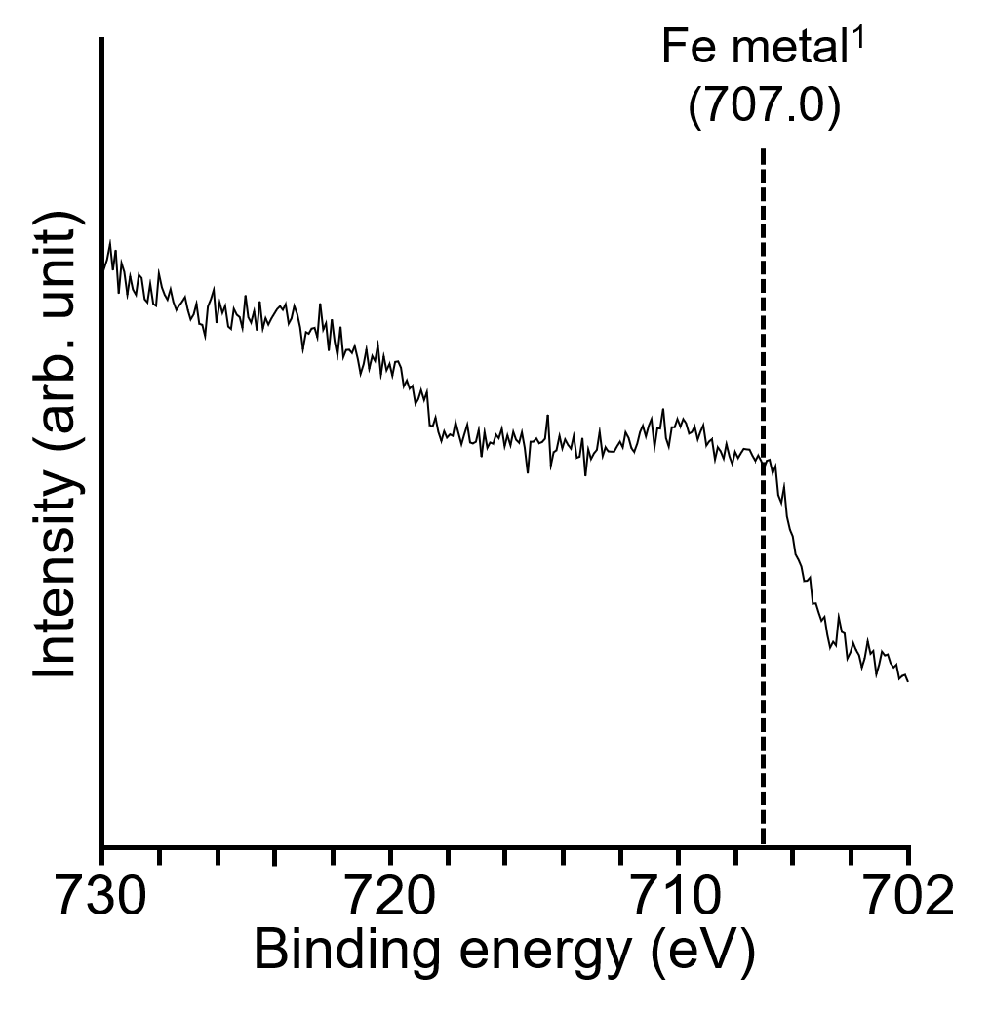
Supplementary Figure 2 The Fe 2p_{3/2} XPS spectra for BaO-BaH₂/Fe.

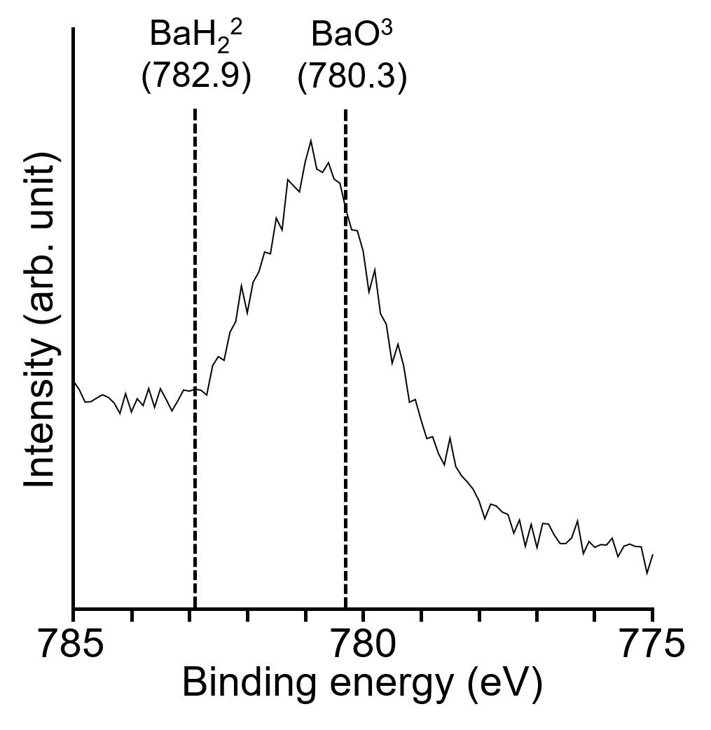
Supplementary Figure 3 The Ba 3d_{5/2} XPS spectra for BaO-BaH₂/Fe.

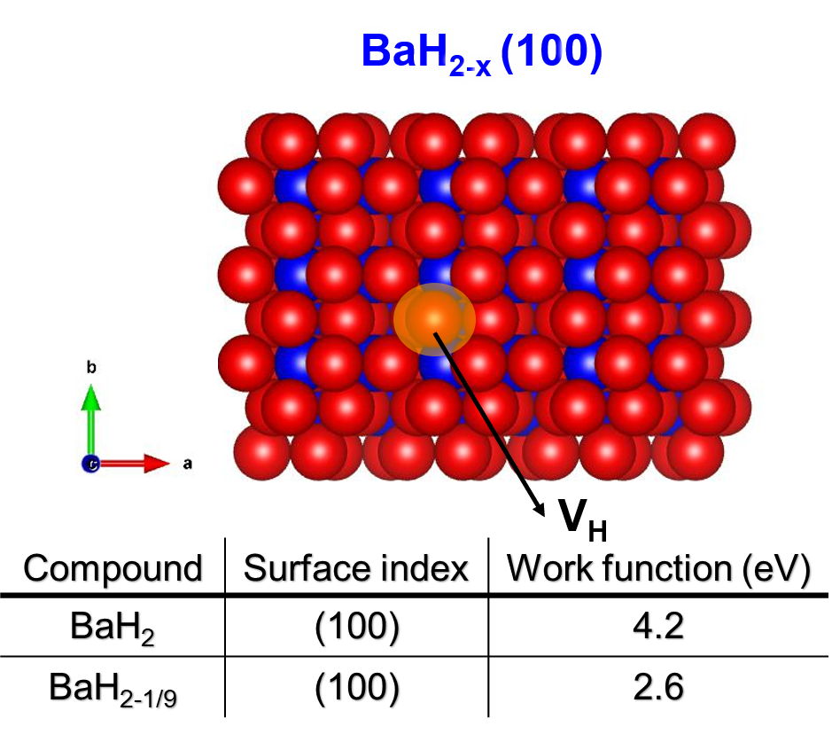
Supplementary Figure 4 DFT results for BaH₂ with H⁻ defects. DFT calculations revealed that the (100) surface is the most stable in BaH₂. The work function of BaH₂ with H⁻ defects that trap electrons was estimated to be 2.6 eV.

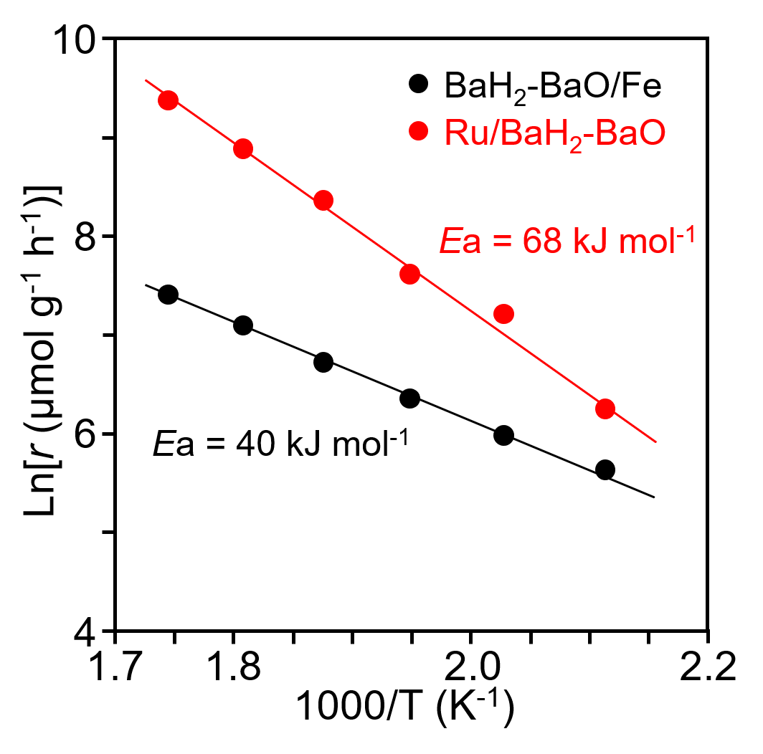
Supplementary Figure 5 The Arrhenius plots for ammonia synthesis activity of the BaH₂-BaO/Fe and Ru/BaH₂-BaO at 0.9 MPa. The apparent activation energy of BaH₂-BaO/Fe and Ru/BaH₂-BaO was 40 kJ mol^{‒1} and 68 kJ mol^{‒1}, respectively.

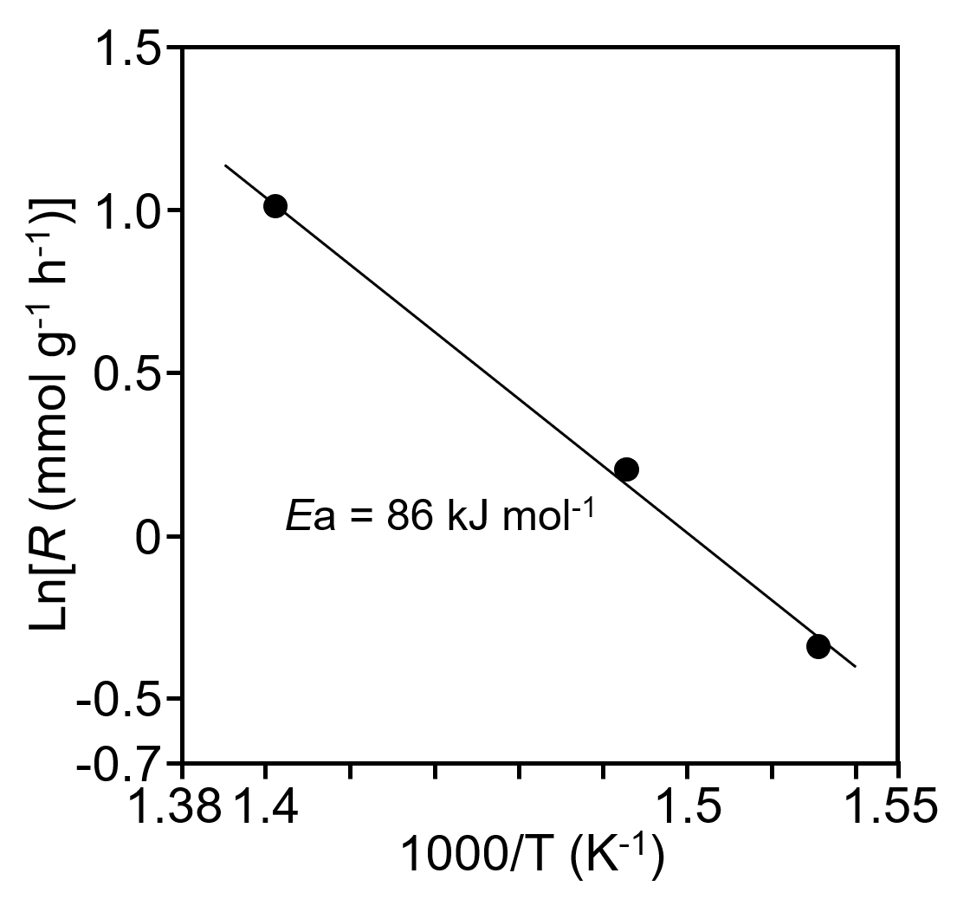
Supplementary Figure 6 The Arrhenius plots for ¹⁴N₂-¹⁵N₂ isotropic exchange reaction over the BaO-BaH₂/Fe. The apparent activation energy was about 86 kJ mol⁻¹.

Supplementary Table 1 Catalytic activities of various transition metals for ammonia synthesis (300 °C)

Catalysts | S_{BET}  (m² g^{–1}) | Metal particle size (nm) | Pressure  (MPa) | WHSV  (mL g^{–1} h^{–1}) | rNH₃  (mmol g^{–1} h^{–1}) | Ref.
BaH₂-BaO /Fe | 7 | 21.7ª | 0.9 | 36000 | 5.5 | This work
Promoted Fe | - | - | 0.9 | 36000 | 5.4 | 4
 |  |  | 0.9 | 60000 | 9.0ª
 |  |  | 0.9 | 72000 | 10.8ª
Ru (10%)/BaO-BaH₂ | 20 | 4.0ª | 0.9 | 36000 | 16.5 | This work
Ru (10%)/Ba-Ca(NH₂)₂ | 101 | 2.7ª | 0.9 | 36000 | 23.3 | 4
Cs-Ru (10%)/MgO | 12 | 5.2ª | 0.9 | 36000 | 0.6 | 4
Ru (2%)/C12A7:e‒ | 1 | 28.7^{b} | 0.9 | 36000 | 0.8 | 4
Fe-LiH | 16 | 29.6^{c} | 1.0 | 60000 | 4.4 | 5
Co-LiH | 43 | 27.6^{c} | 1.0 | 60000 | 4.7 | 5
BaH₂-Co/CHTs | 53 | 42.0ª | 1.0 | 60000 | 4.8 | 6
Ru/La_{0.5}Ce_{0.5}O_{1.75} | 42 | 1.7ª | 1.0 | 72000 | 10.7 | 7
Ru/La_{0.5}Pr_{0.5}O_{1.75} | 30 | 2.9ª | 1.0 | 72000 | 8.9 | 8
ªAmmonia formation rate estimated based on rNH₃ at the WHSV at 36000 mL g^{–1} h^{–1}.

Supplementary Table 2 TOF for ammonia synthesis on various transition metal catalysts
Catalysts | Temperature (°C) | Pressure  (MPa) | TOF  (s^{–1}) | Ea  (kJ mol⁻¹) | Ref.
BaO-BaH₂/Feª | 300 | 0.9 | 12.2 | 40 | This work
 | 200 |  | 1.7 |  | This work
 | 100 |  | 0.2 |  | This work
Ru (10%)/BaO-BaH₂ª | 300 | 0.9 | 3.5x10⁻³ | 69 | This work
 | 200 |  | 3.2x10⁻⁴ |  | This work
 | 100 |  | - |  | This work
Ru (10%)/Ba-Ca(NH₂)₂^{b} | 300 | 0.9 | 1.3x10⁻² | 59 | 4
Cs-Ru (10%)/MgOª | 300 | 0.9 | 8.0x10⁻⁴ | 124 | 4
Ru/C12A7:e^{‒a} | 300 | 0.9 | 5.6x10⁻² | 49 | 4
Co/C12A7:e^{‒b} | 400 | 0.9 | 9.3x10⁻³ | 50 | 9
Ni/LaN bulkª | 400 | 0.9 | 0.17 | 60 | 10
ªTOF calculated from the rate of ammonia synthesis divided by the number of surface N_{s}.
^{b}TOF calculated from the rate of ammonia synthesis divided by the number of surface metal sites which was estimated based on the morphological mean particle sizes of transition metal particles (TEM image).

Refernces
- Mcintyre, N. S. & Zetaruk, D. G. X-ray photoelectron spectroscopic studies of iron oxides. Anal. Chem. 49, 1521–1529 (1977).
- Franzen, H. F., Merrick, J., Umana, M., Khan, A. S. & Peterson, D. T. XPS spectra and crystalline potentials in alkaline-earth chalcogenides and hydrides. J. Electron Spectrosc. Relat. Phenom. 11, 439–443 (1977).
- M. Hattori, T. Mori, T. Arai, Y. Inoue, M. Sasase, T. Tada, M. Kitano, T. Yokoyama, M. Hara, H. Hosono, Enhanced catalytic ammonia synthesis with transformed BaO. ACS Catal. 8, 10977–10984 (2018).
- M. Kitano, Y. Inoue, M. Sasase, K. Kishida, Y. Kobayashi, K. Nishiyama, T. Tada, S. Kawamura, T. Yokoyama, M. Hara, H. Hosono, Self-organized ruthenium-barium core-shell nanoparticles on a mesoporous calcium amide matrix for efficient low-temperature ammonia synthesis. Angew. Chem. Int. Ed. 130, 2678–2682 (2018).
- P. K. Wang, F. Chang, W. B. Gao, J. P. Guo, G. T. Wu, T. He, P. Chen, Breaking scaling relations to achieve low-temperature ammonia synthesis through LiH-mediated nitrogen transfer and hydrogenation. Nat. Chem. 9, 64–70 (2017).
- W. B. Gao, P. K. Wang, J. P. Guo, F. Chang, T. He, Q. Wang. G. T. Wu, P. Chen, Barium hydride-mediated nitrogen transfer and hydrogenation for ammonia synthesis: a case study of cobalt. ACS Catal. 7, 3654–3661 (2017).
- Y. Ogura, K. Sato, S. Miyahara, Y. Kawano, T. Toriyama, T. Yamamoto, S. Matsumura, S. Hosokawa, K. Nagaoka, Efficient ammonia synthesis over a Ru/La_{0.5}Ce_{0.5}O_{1.75} catalyst pre-reduced at high temperature. Chem. Sci. 9, 2230–2237 (2018).
- Y. Ogura, K. Tsujimura, K. Sato, S. Miyahara, T. Toriyama, T. Yamamoto, S. Matsumura, K. Nagaoka, Ru/La_{0.5}Pr_{0.5}O_{1.75} catalyst for low-temperature ammonia synthesis. ACS Sustainable Chem. Eng. 6, 17258–17266 (2018).
- Y. Inoue, M. Kitano, M. Tokunari, T. Taniguchi, K. Ooya, H. Abe, Y. Niwa, M. Sasase, M. Hara, H. Hosono, Direct activation of cobalt catalyst by 12CaO‧7Al₂O₃ electride for ammonia synthesis. ACS Catal. 9, 1670–1679 (2019).
- T-N. Ye, S-W. Park, Y. Lu, J. Li, M. Sasase, M. Kitano, T. Tada, H. Hosono, Vacancy-enabled N₂ actinvation for ammonia synthesis on an Ni-loaded catalyst. Nature 583, 391–407 (2020).

