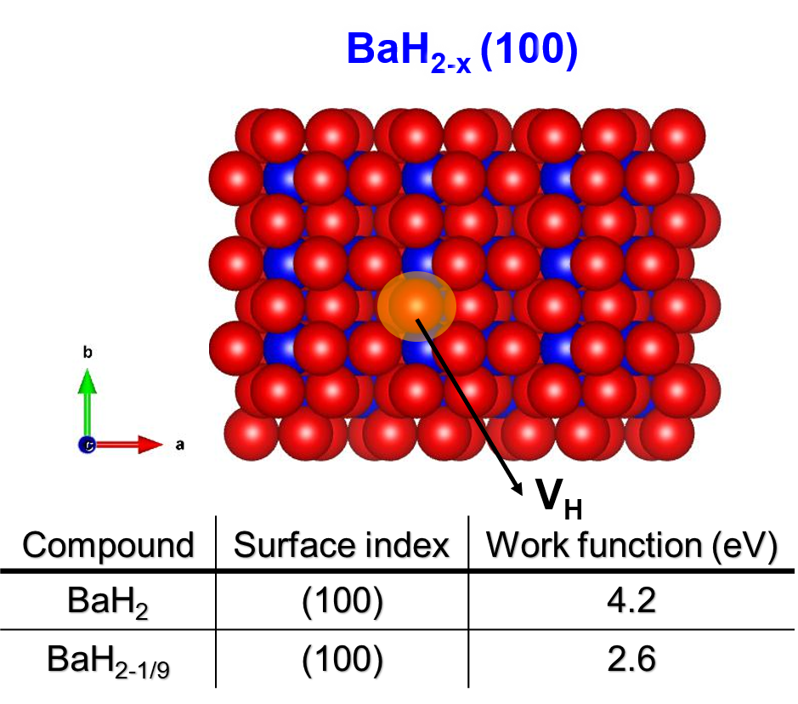
Extended Data Fig. 1| DFT results for BaH₂ with H⁻ defects. DFT calculations revealed that the (100) surface is the most stable in BaH₂. The work function of BaH₂ with H⁻ defects that trap electrons was estimated to be 2.6 eV.

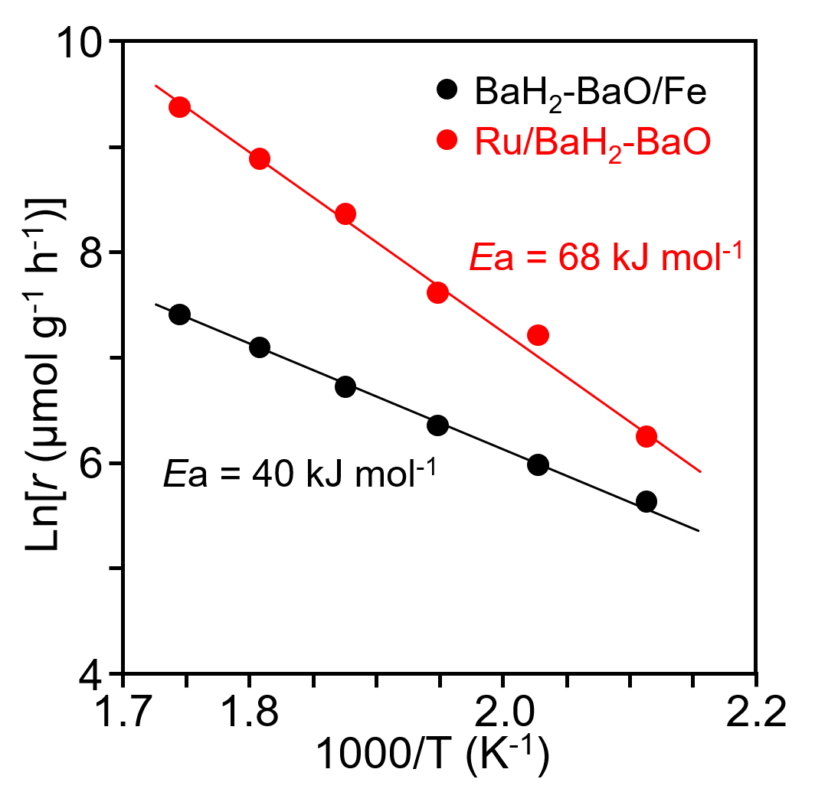
Extended Data Fig. 2| The Arrhenius plots for ammonia synthesis activity of the BaH₂-BaO/Fe and Ru/BaH₂-BaO at 0.9 MPa. The apparent activation energy of BaH₂-BaO/Fe and Ru/BaH₂-BaO was 40 kJ mol^{‒1} and 68 kJ mol^{‒1}, respectively.

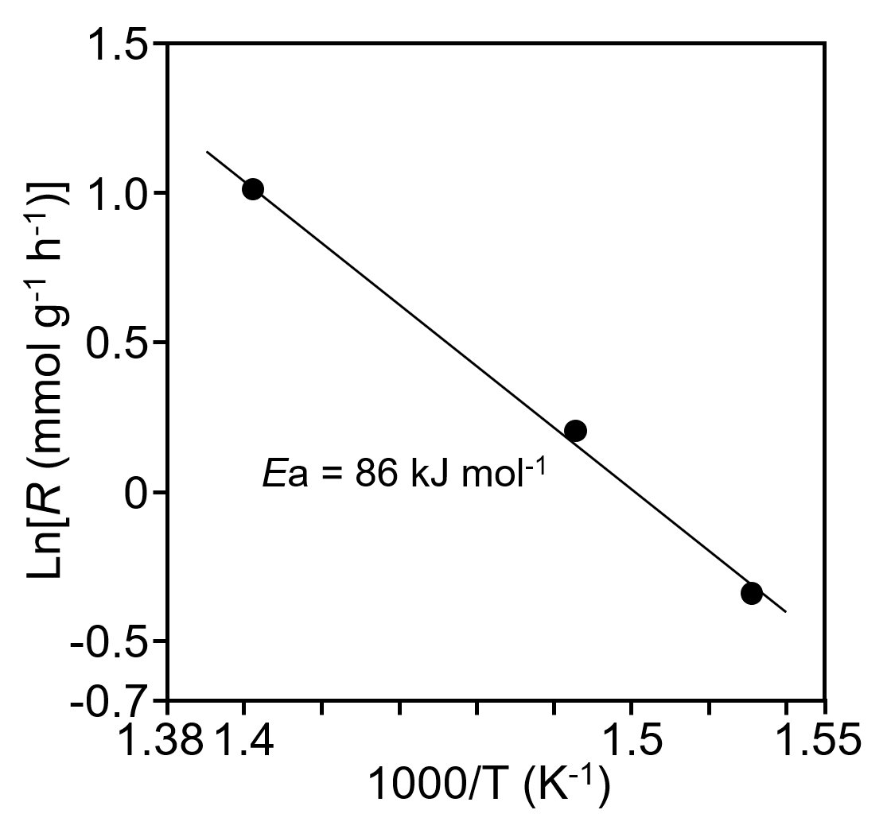
Extended Data Fig. 3| The Arrhenius plots for ¹⁴N₂-¹⁵N₂ isotropic exchange reaction over the BaO-BaH₂/Fe. The apparent activation energy was about 86 kJ mol⁻¹.

Extended Data Table 1| Catalytic activities of various transition metals for ammonia synthesis (300 °C)

Catalysts | S_{BET}  (m² g^{–1}) | Metal particle size (nm) | Pressure  (MPa) | WHSV  (mL g^{–1} h^{–1}) | rNH₃  (mmol g^{–1} h^{–1}) | Ref.
BaH₂-BaO /Fe | 7 | 21.7 | 0.9 | 36000 | 5.5 | This work
Promoted Fe | - | - | 0.9 | 36000 | 5.4 | 8
 |  |  | 0.9 | 60000 | 9.0ª
 |  |  | 0.9 | 72000 | 10.8ª
Ru (10%)/BaO-BaH₂ | 20 | 4.0 | 0.9 | 36000 | 11.5 | This work
Ru (10%)/Ba-Ca(NH₂)₂ | 101 | 2.7 | 0.9 | 36000 | 23.3 | 8
Cs-Ru (10%)/MgO | 12 | 5.2 | 0.9 | 36000 | 0.6 | 8
Ru (2%)/C12A7:e‒ | 1 | 28.7 | 0.9 | 36000 | 0.8 | 8
Fe-LiH | 16 | 29.6 | 1.0 | 60000 | 4.4 | 9
Co-LiH | 43 | 27.6 | 1.0 | 60000 | 4.7 | 9
BaH₂-Co/CHTs | 53 | 42.0 | 1.0 | 60000 | 4.8 | 10
Ru/La_{0.5}Ce_{0.5}O_{1.75} | 42 | 1.7 | 1.0 | 72000 | 10.7 | 16
Ru/La_{0.5}Pr_{0.5}O_{1.75} | 30 | 2.9 | 1.0 | 72000 | 8.9 | 17
ªAmmonia formation rate estimated based on rNH₃ at the WHSV at 36000 mL g^{–1} h^{–1}.

Extended Data Table 2| TOF for ammonia synthesis on various transition metal catalysts
Catalysts | Temperature (°C) | Pressure  (MPa) | TOF  (s^{–1}) | Ea  (kJ mol⁻¹) | Ref.
BaO-BaH₂/Feª | 300 | 0.9 | 12.2 | 40 | This work
 | 200 |  | 1.7 |  | This work
 | 100 |  | 0.2 |  | This work
Ru (10%)/BaO-BaH₂ª | 300 | 0.9 | 3.5x10⁻³ | 69 | This work
 | 200 |  | 3.2x10⁻⁴ |  | This work
 | 100 |  | - |  | This work
Ru (10%)/Ba-Ca(NH₂)₂^{b} | 300 | 0.9 | 1.3x10⁻² | 59 | 8
Cs-Ru (10%)/MgOª | 300 | 0.9 | 8.0x10⁻⁴ | 124 | 8
Ru/C12A7:e^{‒a} | 300 | 0.9 | 5.6x10⁻² | 49 | 8
Co/C12A7:e^{‒b} | 400 | 0.9 | 9.3x10⁻³ | 50 | 30
Ni/LaN bulkª | 400 | 0.9 | 0.17 | 60 | 11
ªTOF calculated from the rate of ammonia synthesis divided by the number of surface N_{s}.
^{b}TOF calculated from the rate of ammonia synthesis divided by the number of surface metal sites calculated, on the basis of the morphological mean particle sizes of transition metal particles. .

