Supplementary Information

Coupling the structure evolution and the oxygen redox electrochemistry in layered transition metal oxides

Donggun Eum^{1, 2}, Byunghoon Kim^{1, 2}, Jun-Hyuk Song¹, Hyeokjun Park¹, Sung Joo Kim¹, Sung-Pyo Cho³, Ho-Young Jang¹, Myeong Hwan Lee^{1, 2}, Jae Hoon Heo¹, Youngmin Ko^{1, 2}, Sung Kwan Park¹, Kyungbae Oh^{1, 2}, Do-Hoon Kim^{1, 2}, and Kisuk Kang^{1, 2, 4, 5, *}
¹Department of Materials Science and Engineering, Research Institute of Advanced Materials (RIAM), Seoul National University, 1 Gwanak-ro, Gwanak-gu, Seoul 08826, Republic of Korea.
²Center for Nanoparticle Research, Institute for Basic Science (IBS), Seoul National University, 1 Gwanak-ro, Gwanak-gu, Seoul 08826, Republic of Korea.
³National Center for Inter-University Research Facilities, Seoul National University, Seoul National University, 1 Gwanak-ro, Gwanak-gu, Seoul 08826, Republic of Korea.
⁴Institute of Engineering Research, College of Engineering, Seoul National University, Seoul 08826, Republic of Korea.
⁵School of Chemical and Biological Engineering, College of Engineering, Seoul National University, 1 Gwanak-ro, Gwanak-gu, Seoul 08826, Republic of Korea.
*Corresponding author: Kisuk Kang
E-mail: matlgen1@snu.ac.kr
Keywords: Oxygen redox, Cation migration, Li-rich layered oxide, Voltage hysteresis, Electronic structure

This PDF file includes:
Supplementary discussion S1–S5
Figures S1–S23
Tables S1–S5
References 1–7

Supplementary Discussion
Supplementary Note 1. To quantify the percentages that each stabilization mechanism contributes in the NLMO and NLTMO electrodes during charging, we labeled the 0%, 25%, 50%, 75%, and 100% SOC as 1, 2, 3, 4, and 5, respectively, to simplify the calculations. The experimentally determined slope of NLMO was then calculated to be – 0.0383, and those of NLTMO were 0.1191 and 0.1989 for the start and end of charging, respectively. As described in the main text, three types of oxygen: (i) non-stabilized oxygen (localized holes), (ii) weak π-stabilized oxygen (delocalized holes by TM–O coupling), and strong σ-stabilized oxygen (delocalized holes by O–O dimerization) mechanisms were considered for both electrodes. As the number of electrons extracted during charging can be calculated from the capacity using the molecular weight, exact quantification of the electrons transferred for each case was possible. Specifically, the charge capacities of NLMO (91.13 g mol^{–1}) and NLTMO (89.72 g mol^{–1}) at point 3 (SOC 50) were 54.55 and 67.47 mAh g^{–1}, respectively, which were converted to 0.185 (denoted as ‘a’) and 0.226 (denoted as ‘b’) electrons, respectively. Considering the different electron dynamics in each case, the number of unpaired electrons differed substantially depending on the stabilization mechanism and was calculated as the sum of mol $×$ number of unpaired electrons for each ion $(\sum_{i}{{mol}_{i}×unpaired e^{-} of i)}$: $\left(i\right) 0.8×3_{Mn}+a×1_{O}$, $\left(ii\right) (0.8-a)×3_{Mn}+a×2_{Mn-O}$, and $(iii) (0.8-a)×3_{Mn}+a×4_{Mn-(O-O)}$ for the NLMO electrode and $(i) 0.6×3_{Mn}+b×1_{O}$, $\left(ii\right) (0.6-b)×3_{Mn}+b×2_{Mn-O}$, and $(iii) (0.6-b)×3_{Mn}+b×4_{Mn-(O-O)}$ for the NLTMO electrode. As a result, the effective magnetic moments at point 3 (SOC 50) were (i) 3.96, (ii) 3.66, (iii) 4.13 in NLMO and (i) 4.02, (ii) 3.52, (iii) 4.29 in NLTMO when the moments were normalized to the total number of Mn ions, deriving slopes of (i) 0.0443, (ii) – 0.1075, (iii) 0.13 in NLMO and (i) 0.0716, (ii) – 0.1784, (iii) 0.2077 in NLTMO between points 1 and 3. Using these values, the observed slopes of NLMO and NLTMO were accordingly deconvoluted using the linear combination method. To be more specific, set each of the slopes of case (i), (ii), and (iii) calculated above to $x_{1}$, $x_{2}$, and $x_{3}$, respectively, and then set the fractions of non-, π-, and σ-stabilized oxygen to $α$, $β$, and $γ$, respectively. Describing the experimentally observed slopes for the three regions in Fig. 3c–d as $∆$, one linear equation of $∆=αx_{1}+βx_{2}+γx_{3}$ is derived with three variables of $α$, $β$, and $γ$. This equation can be simplified to $∆=\left(1-β-γ\right)x_{1}+βx_{2}+γx_{3}=x_{1}+β\left(x_{2}-x_{1}\right)-γ(x_{1}-x_{3})$ due to the boundary conditions ($α+β+γ=1, α≥0, β≥0, γ≥0$), which is rearranged to $β=\frac{∆-x_{1}+(x_{1}-x_{3})γ}{x_{2}-x_{1}}$. Because the values containing $∆$, $x_{1}$, $x_{2}$, and $x_{3}$ are the calculated values, the equation is eventually simplified to a linear equation of $β=ε+ωγ$ ($ε=\frac{∆-x_{1}}{x_{2}-x_{1}}$, $ω=\frac{x_{1}-x_{3}}{x_{2}-x_{1}}$). The linear function graphs for each region are shown in Supplementary Fig. 8a–c. We can deduce that the sum of the π- and σ-stabilized oxygen fractions ($β+γ$) is between 0 and 1 due to the boundary conditions ($α+β+γ=1, α≥0, β≥0, γ≥0$). Therefore, by changing the relation of $0≤β+γ≤1$ to $β≥-γ$ and $β≤-γ+1$, the range of solutions for $α$, $β$, and $γ$ can be derived by intersecting the three linear relations $(β=ε+ωγ$, $β≥-γ$, and $β≤-γ+1 (β≥0, γ≥0))$, as shown in Supplementary Fig. 8a–c. According to the results, the oxygens of the NLMO electrode follow the pathways of (i), (ii), and (iii) at a percentage of 22.8%, 62.6%, and 14.6%, respectively. In contrast, percentages of 32.5%, 11.5%, and 56.0% were calculated for mechanisms (i), (ii), and (iii) for the NLTMO electrode at the start of charging and changed to 3.2%, 1.1%, and 95.7%, respectively, in the highly charged state.

Supplementary Note 2. When the NLMO electrode was cycled between 3.75 and 4.5 V, the high-voltage plateau was still observed during the discharge process even after 30 cycles, implying that irreversible transitions of the oxygen network are remarkably suppressed in this case (Supplementary Fig. 14). Because we demonstrated the strong coupling between the evolution of the voltage profile and the in-plane Mn_{Li} defect formation in the NLMO electrode, the Li content for the 10th and 30th cycled electrodes operating between 3.75 and 4.5 V was further quantified to clarify the dependency of such migration on the Li/V concentrations and the effects on the oxygen-redox profiles redox (Supplementary Table 4). The results indicated that the 30th charged electrode contained approximately two times more Li than the electrode cycled between 2.0 and 4.5 V for 30 cycles, and the Li content was even greater than that of the electrode operated for 10 cycles in the voltage range of 2.0–4.5 V (see Supplementary Table 3). The well-preserved Li content in NLMO over extended cycling inhibits in-plane cation movements, thereby suppressing the formation of oxygen dimers, which is the origin of the thermodynamic and kinetic challenges of the lattice oxygen redox. The complementary HRPD, Raman, Cs-STEM, and XANES characterization unequivocally confirmed the structural robustness of NLMO when cycled between 3.75 and 4.5 V (Supplementary Fig. 15–18). Supplementary Fig. 15–16 show that both out-of-plane and in-plane cation disordering were noticeably alleviated, resulting in an electrode material free of strain and stress. In addition, we identified the weak transition of the electronic structure in the 30-cycled electrode operated between 3.75 and 4.5 V; a small edge shift toward lower energy was observed in the XANES spectra even when the cycled electrode was further discharged to 2.0 V. In addition, its edge position was close to that of the 10-cycled electrode operated between 2.0 and 4.5 V, as shown in Supplementary Fig. 17. Consistent with the Li/V concentration results, these structural behaviors comprehensively verify the importance of cation disordering in the redox stabilization of lattice oxygen and the irreversible nature of lattice oxygen electrochemistry. Supplementary Fig. 18 shows the structurally well-aligned single oxygen environment, demonstrating again the stable oxygen network without the irreversible rearrangements in the NLMO electrode cycled between 3.75 and 4.5 V.

Supplementary Note 3. To remove the interference of the carbon signal in the Raman spectrum, an additional cell test of NLMO with 90:05:05 wt% slurry was conducted with reduction of the absolute carbon content in the electrode. In addition, we concomitantly regulated the neutral density (ND) filter that reflects the percentage of incident light, as shown in Supplementary Fig. 20a–c. When the Raman spectrum of the NLMO electrode was obtained using the 10% ND filter, the carbon D and G bands screened the main regions where vibrations of short oxygen dimers are usually observed (Supplementary Fig. 20a). Therefore, we conceived a way to eliminate the unnecessary carbon additive on the electrode surface by increasing the intensity of the ND filter to 25%. Supplementary Fig. 20b presents the image and Raman results obtained when the electrode was exposed to the 25% ND filter. The results show that the electrode was slightly damaged and that the spectrum was accordingly interrupted. At this time, a brownish color was observed in the image, which surprisingly originated from the active material, thereby confirming that the weakly bound carbon additive was effectively removed from the electrode. After that, we changed the filter to a 10% ND filter and again measured the Raman spectrum for the same region (Supplementary Fig.20c). The final Raman spectrum differed from that initially measured using the same ND filter because of the absence of carbon interruption. As a result, we were able to conduct further investigations to detect short O–O related vibrations, as explained in the main text.

Supplementary Note 4. To determine whether short oxygen dimers were produced during the in-plane anti-site defect formation, theoretical calculations were performed (Supplementary Fig. 21–23). Because it was experimentally observed that the in-plane cation disordering in NLMO occurs only when sufficient V_{Li} defects are formed, the calculations were based on the structure in which all Li ions in the TM layer were extracted. Supplementary Fig. 21 and 22 show the one-step in-plane migration of a Mn ion, whereas Supplementary Fig. 23 shows the two-step consecutive movement. When the Mn ion moves upward, as shown in Supplementary Fig. 21a, vacancy clusters are not produced, which is essential to generate dangling oxygen ions (O–TM₁) near the V_{TM} defects (Supplementary Fig. 21b). Therefore, the oxidized oxygens are stabilized through the TM–O coupling rather than O–O pairing, supporting the theoretical observation that the shortest length of the oxygen dimer is 2.51 Å. However, when the Mn ion migrates diagonally, a di-vacancy cluster is created, thereby leaving two dangling oxygens (Supplementary Fig. 22a and b). To compensate for the loss of π-stabilization effects, these dangling oxygens get closer to each other up to 1.36 Å for σ stabilization of the O–O pairing. The subsequent reshuffling of the electronic structure of oxygen was also confirmed, as shown in Supplementary Fig. 22c. Furthermore, a tri-vacancy cluster can also be developed when the two nearest Mn ions move in the same direction (see Supplementary Fig. 23a and b). Similarly, the dangling oxygen in this case is shortened to 1.33 Å, leading to rearrangement of the band structure of oxygen (Supplementary Fig. 23c). Overall, in-plane disordering toward vacancy aggregations eventually leads to σ–type O–O dimerization to stabilize the energy of the material after anionic oxidation, and such a transition in a NLMO electrode is expected to be a sluggish reaction compared with that in NLTMO, where fast out-of-plane disordering is observed, because the in-plane cation migration is entirely dependent on the Li content in the electrode and the direction of movements over the extended cycling.

Supplementary Note 5. The P3-Na_{0.6}(Li_{0.2}Mn_{0.8})O₂ compound was described using a Na₃₆(Li₁₂Mn₄₈)O₁₂₀ supercell consisting of three (lithium + TM) layers and sodium layers. In each (lithium + TM) layer, 4 Li and 12 Mn ions were placed to form ribbon-type in-plane ordering.¹ The sodium/vacancy configurations were determined by relaxing 50 configurations, which were selected based on the enumeration method proposed by Hart et al.² The P3-Na_{0.6}(Li_{0.2}Ti_{0.2}Mn_{0.6})O₂ compound was modeled by substituting some of the Mn ions in P3-Na_{0.6}(Li_{0.2}Mn_{0.8})O₂ with Ti ions using the same enumeration method, and the obtained Li/Ti/Mn in-plane ordering was used to describe the fully charged compounds. In all the supercells employed for the cation-migration calculations, the distances between the migrated TM ions were greater than 1 nm, which minimized the defect-defect interactions.

Supplementary Figures

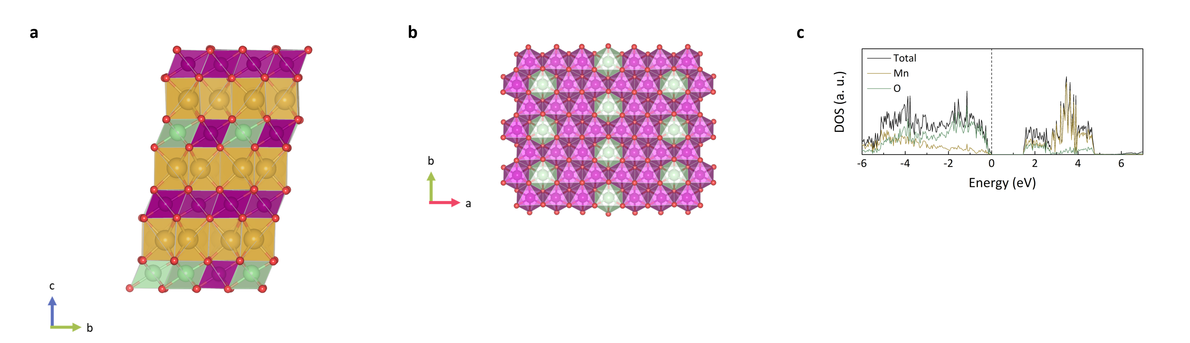
Fig. S1. NLMO structure: a, front and b, top views. The top view shows the ribbon-like ordering between Li and Mn ions. c, DOS of Mn and O atoms in the pristine NLMO. The dominant DOS below the Fermi level is attributed to oxygen, implying that oxygen mainly participate in the charge-compensation mechanism upon charging of pristine NLMO.

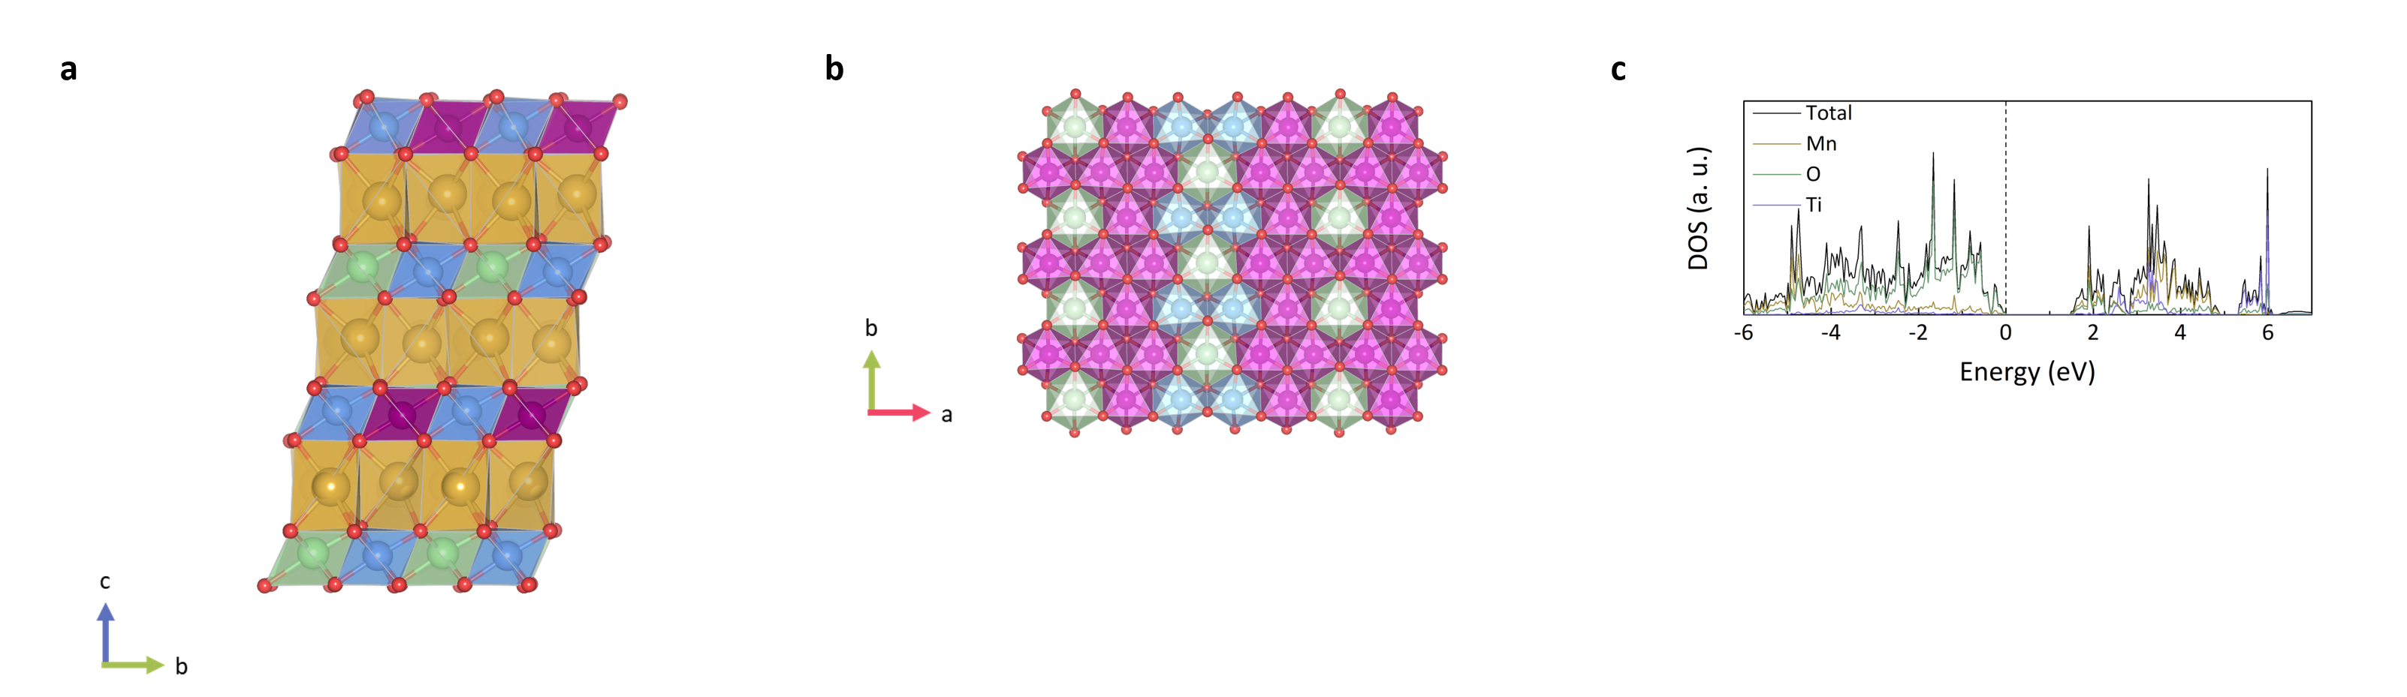
Fig. S2. NLTMO structure: a, front and b, top views. The top view shows the ribbon-like ordering between Li and Mn/Ti ions. c, DOS of Mn, Ti, and O atoms in the pristine NLTMO. The dominant DOS below the Fermi level is attributed to oxygen, implying that oxygen mainly participate in the charge-compensation mechanism upon charging of pristine NLTMO.

Fig. S3. Mn K-edge XANES spectra for a, NLMO and b, NLTMO and Ti K-edge XANES spectra for c, NLTMO upon the initial charging. The reference spectra of Mn⁴⁺O₂ and Ti⁴⁺O₂ are displayed with dotted lines.

Fig. S4. Initial electrochemical profiles of NLMO and NLTMO cycled in the voltage range of 2.0–4.5 V. The initial charging capacities of NLMO and NLTMO were 109.1 and 134.94 mAh g^{–1}, respectively, which can be converted to 0.37 and 0.45 alkali ions to be extracted, respectively.

Fig. S5. Galvanostatic intermittent titration technique (GITT) results for a, NLMO and b, NLTMO for the initial cycle. Each step corresponds to the process of additional 10 mAh g^{–1} capacity with 0.2 current rate (C-rate) and is followed by a 5-h relaxation step. In contrast to NLMO, where small voltage hysteresis between the charge and discharge curves was observed, fairly large voltage hysteresis appeared for NLTMO with a transition of the voltage profile from a plateau to a slanted curve.

Fig. S6. Comparison of the pristine and 2.0-V-discharged states for the normalized (003) diffraction peaks in a, NLMO and b, NLTMO. In contrast to the case for NLMO, where the FWHM did not change between the pristine and fully discharged electrodes, a significantly wider FWHM was observed for the 2.0-V-discharged NLTMO, indicating that the structure of the cycled NLTMO was in a highly strained and stressed state.

Fig. S7. Temperature dependence of the reciprocal magnetic susceptibility of a, NLMO and b, NLTMO for SOC ranging from 0% to 100% during the initial charge process. NLMO showed antiferromagnetic behavior with a Néel temperature of 16 K for the pristine electrode, whereas NLTMO exhibited paramagnetic characteristics.³

Fig. S8. Linear function graphs for the quantitative deconvolution of the slopes in the a, Region 1, b, Region 2, and c, Region 3 of Fig. 3c–d using the fractions of π- (β) and σ-stabilized oxygen (γ). The shaded regions indicate boundary conditions of the linear equation in Supplementary Note 1, and the red lines represent possible solutions in each region.

Fig. S9. Potential profile with current and capacity responses of a, NLMO and b, NLTMO during DEMS measurements. The experiment was performed using the constant-voltage method until the capacity reached each charging capacity. DEMS results for c, NLMO and d, NLTMO during the initial charging process. No O₂ gas was detected, and only a negligible amount of CO₂ gas was detected for both electrodes. Even assuming that the evolved CO₂ gas entirely and directly originated from lattice oxygen due to the instability of oxidized oxygens during anionic redox^{4,5}, the irreversible capacities of NLMO and NLTMO were only 7.9 and 13.2 mAh g^{–1}, respectively; these values are too small to account for the fundamental differences between the two materials and for the intrinsic irreversible transition of NLTMO. Considering that the two electrodes showed stable lattice oxygen against O₂ gas evolution, the results in Fig. 3f–i indicate that the redox transition in NLTMO is likely to originate from the O–O dimer formation.

Fig. S10. Ti K-edge XANES spectra for nine points in the electrochemical curve of NLTMO with Ti⁴⁺O₂ reference spectrum. Half-edge energy positions of NLTMO during the successive charge and discharge process are presented below.

Fig. S11. EXAFS spectra (Mn K-edge) of a, NLMO and b, NLTMO for nine points in the electrochemical curve displayed in Fig. 3h and i of the main text. A noticeable change was observed for NLTMO at the end of discharge with decreased intensities for the first and second shells. Considering that Mn was reduced from 4+ to 3+ in this region, this variation can be attributed to the modification of the local environment of Mn by changing the ionic radius of Mn ions.

Fig. S12. HAADF-STEM image of charged NLMO after 30 cycles. The graph on the right is the HAADF signal profile of the region enclosed by the dotted lines in the STEM image. The observed interlayer distance was 5.67 Å, confirming the prismatic sites of Na layers.^{6,7}

Fig. S13. Comparison of the pristine and 1- and 30-cycled NLMO for the normalized (003) peaks.

Fig. S14. a, Charge–discharge profiles of NLMO for the 1st and 30th cycles operated in the voltage window of 3.75–4.5 V. b, Comparison of dQ dV^{–1} curves for the 1st and 30th cycled NLMO under different cycling conditions (top: 2.0–4.5 V, bottom: 3.75–4.5 V). The high-voltage plateau remaining at 30 cycles when the NLMO electrode was cycled between 3.75 and 4.5 V implies that irreversible transitions of the oxygen network are significantly suppressed under this cycling condition compared with those in the voltage range of 2.0–4.5 V.

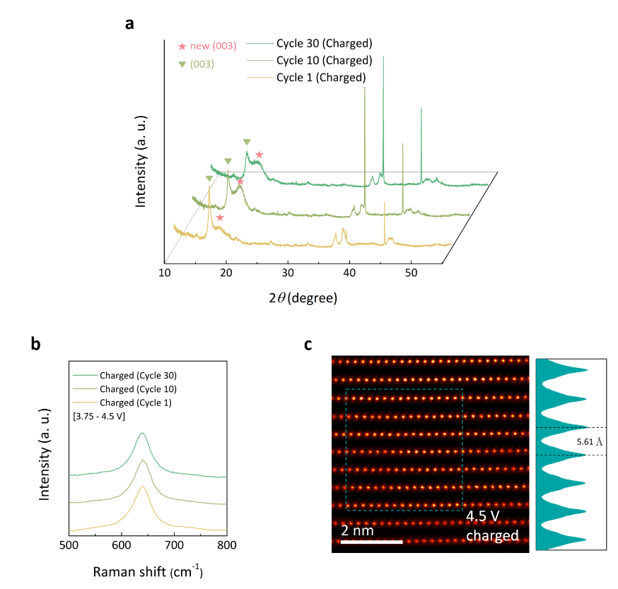
Fig. S15. a, Ex-situ HRPD patterns and b, Raman spectra for the 1st charged, 10th charged, and 30th charged NLMO cycled between 3.75 and 4.5 V. The two-phase reaction is observed to be well maintained with extended cycling (denoted with asterisk). The sharp peaks at 38 and 44 correspond to those from Al foil. The well-preserved A_{1g} vibration in the Raman spectra implies the absence of out-of-plane cation migration even when the NLMO electrode was cycled between 3.75 and 4.5 V. c, HAADF-STEM image of charged NLMO (3.75–4.5 V) after 30 cycles. The graph on the right is the HAADF signal profile of the region enclosed by the dotted lines in the STEM image. The observed interlayer distance was 5.61 Å, confirming the prismatic sites of the Na layers.^{6,7}

Fig. S16. Comparison of the 1-cycled (2.0–4.5 V) and 30-cycled (3.75–4.5 V) NLMO for a, normalized (003) and b, superstructure peaks. The well-maintained FWHM and preserved superstructure itself even after 30 cycles indicate the highly ordered structure of NLMO without in-plane cation disordering, strain, or stress.

Fig. S17. a, Mn K–edge XANES and b, EXAFS spectra for the 1- and 10-cycled (2.0–4.5 V) and 30-cycled NLMO (3.75–4.5 V). All the spectra were measured for the 2.0-V-discharged state after cycling under each individual cycle condition. The similarities between the 10-cycled (2.0–4.5 V) and 30-cycled (3.75–4.5 V) NLMO imply the similar oxidation state of Mn and eventually similar degree of O–O dimerization in the two electrodes. The fitting graph for NLMO operated between 3.75 and 4.5 V for 30 cycles is presented in c. The detailed fitting results are presented in Table S5.

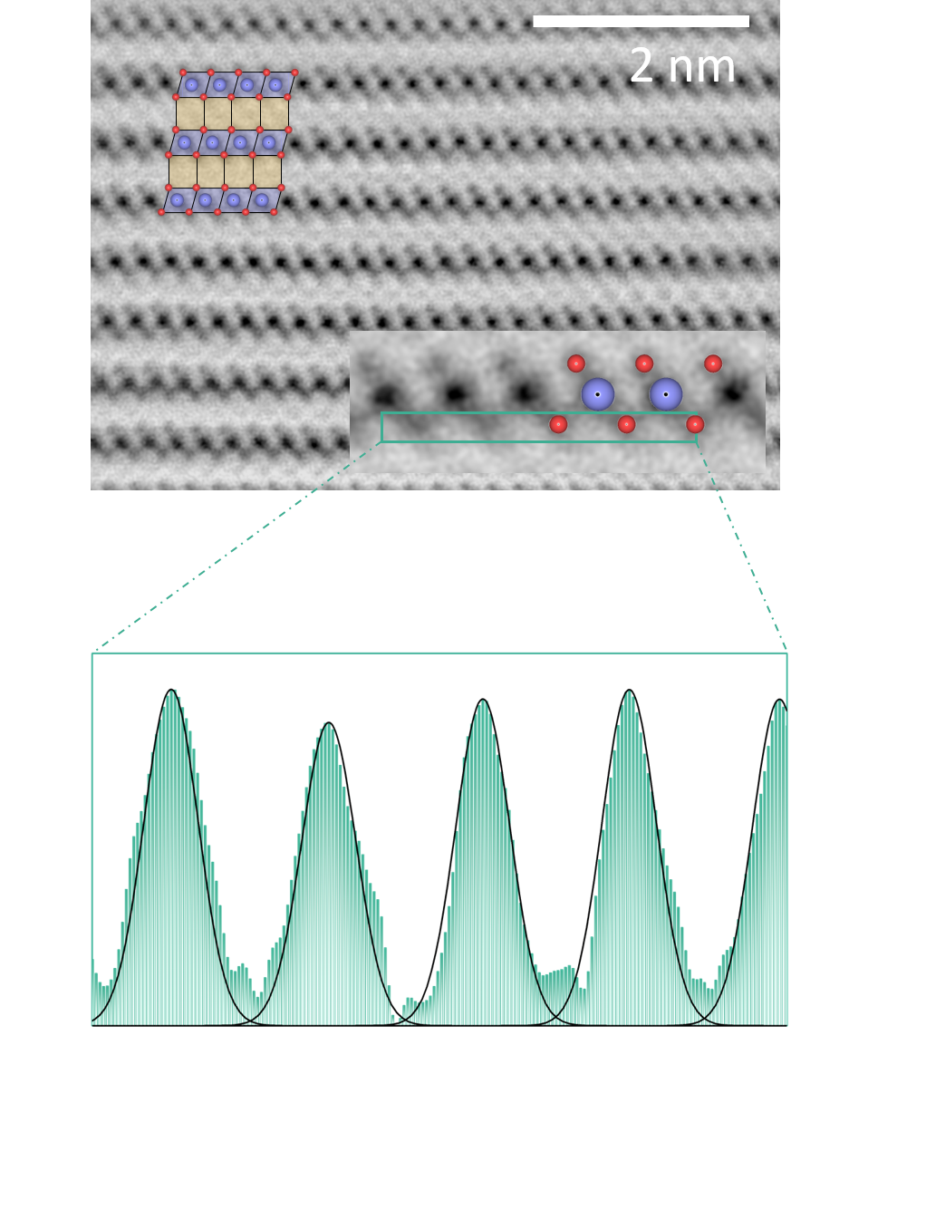
Fig. S18. ABF-STEM images for the 30th charged NLMO in the voltage range of 3.75–4.5 V. The blue and red spheres represent Mn and O features, respectively. The blue and yellow polyhedra represent Mn octahedral sites and vacant Na prismatic sites, respectively, in the P3-type stackings. The graph below shows the ABF signal profile of the region enclosed by the dotted square in the STEM image. The single Gaussian peaks for the oxygen environment indicate the stable oxygen network of the material without structural distortion even after 30 cycles.

Fig. S19. a, EXAFS spectra of the cycled NLMO for Mn K–edge. The data were measured every 10 cycles. The progressive decrease of the peak intensities can be attributed to the gradual reduction of the oxidation states of Mn upon cycling. Fitted graphs of the b, 1-cycled, c, 10-cycled, d, 20-cycled, and e, 30-cycled NLMO. The detailed fitting results are described in Table S5.

Fig. S20. Images and Raman spectra of charged NLMO electrodes. The electrodes were exposed to a a, 10%, b, 25%, and c, 10% ND filter, with the measurement performed in the order of a to c. All the data were measured using acquisition times of 15 s with 10 accumulations.

Fig. S21. a–b, Computational prediction of O–O dimerization stabilized by in-plane cation disorder. The schemes show the one-step in-plane structural disordering along the top views. The arrow in the scheme indicates the cation-migration pathway and the yellow TMO₆ octahedra represents the in-plane migration TM. Because a vacancy cluster could not be produced in this case, the formation of short oxygen dimers to stabilize the oxygen network was not identified. The observed shortest O–O length was 2.51 Å, implying that the oxidized oxygens were stabilized through TM–O coupling rather than O–O pairing.

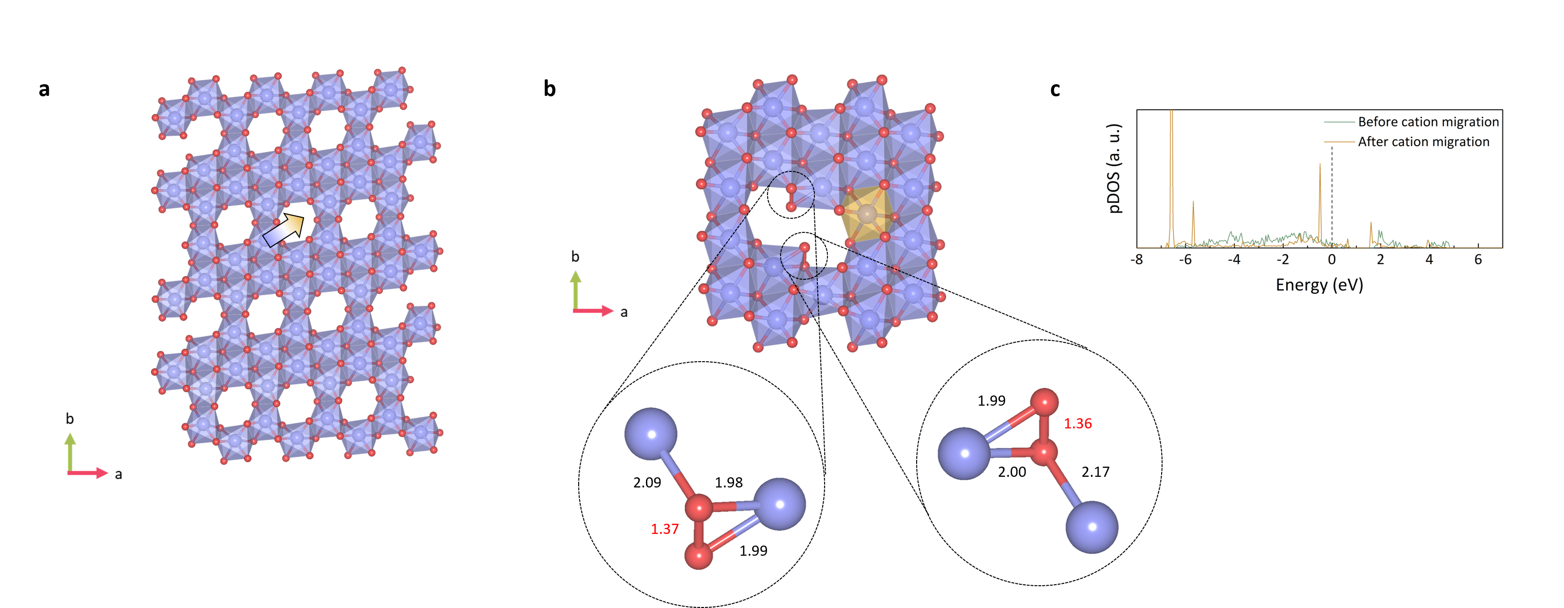
Fig. S22. a–b, Computational prediction of O–O dimerization stabilized by in-plane cation disorder. The schemes illustrate the one-step in-plane structural disordering along the top views. The arrow in the schemes indicates the cation-migration pathway and the yellow TMO₆ octahedra represents the in-plane migration TM. In this case, a di-vacancy cluster was created, thereby generating short oxygen dimers (1.36 Å) to compensate for the loss of π-stabilization effects. The bond lengths of O–O and adjacent TM–O are specified in the magnified view. c, pDOS of individual oxygen atoms involved in O–O dimerization before and after cation-migration process in the fully charged NLMO structure. The dotted line in the graphs indicates the Fermi level. The σ stabilization of the O–O pairing with cation migration leads to reshuffling of the electronic structure of oxygen.

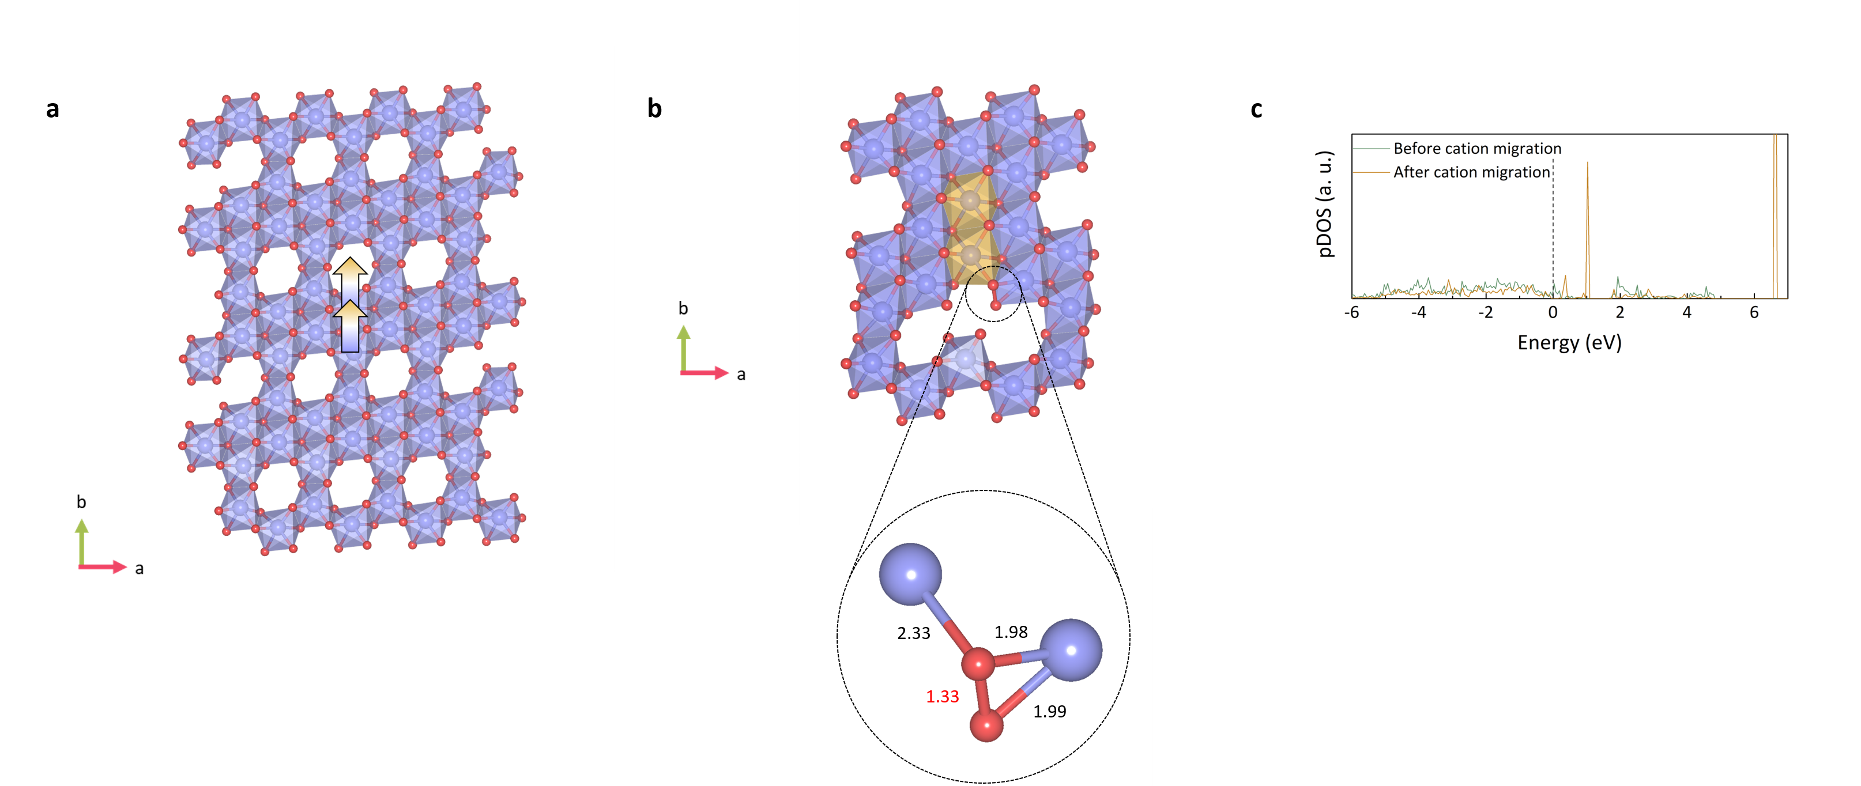
Fig. S23. a–b, Computational prediction of O–O dimerization stabilized by in-plane cation disorder. The schemes illustrate the two-step consecutive in-plane structural disordering along the top views. The arrow in the schemes indicates the cation-migration pathway, and the yellow TMO₆ octahedra represents the in-plane migration TM. In this case, a tri-vacancy cluster was formed, thereby producing short oxygen dimers (1.33 Å) to compensate for the loss of π-stabilization effects. The bond lengths of O–O and adjacent TM–O are specified in the magnified view. c, pDOS of individual oxygen atoms involved in O–O dimerization before and after cation-migration process in the fully charged NLMO structure. The dotted lines in the graphs indicate the Fermi level. The σ stabilization of the O–O pairing with cation migration leads to rearrangement of the band structure of oxygen.

Supplementary Tables
Table S1. Lattice parameters of pristine NLMO and NLTMO.

Phase | a (Å) | b (Å) | c (Å)
NLMO | 2.8512 (1) | 2.8512 (1) | 16.6892 (4)
NLTMO | 2.8738 (8) | 2.8738 (8) | 16.6997 (9)

Table S2. ICP-AES results for NLMO and NLTMO during the initial cycle. The values are normalized to the Mn ions.

Phase | State | Na | Li | Mn | Ti
NLMO | Pristine | 0.646 | 0.219 | 0.8 | –
NLMO | 4.5-V-charged | 0.244 | 0.185 | 0.8 | –
NLTMO | Pristine | 0.659 | 0.229 | 0.6 | 0.199
NLTMO | 4.5-V-charged | 0.189 | 0.178 | 0.6 | 0.198

Table S3. ICP-AES results NLMO for 10 and 30 cycles in the voltage range of 2.0–4.5 V. The values are normalized to the Mn ions.

Cycle | State | Na | Li | Mn
9 | 2.0-V-discharged | 0.556 | 0.139 | 0.8
10 | 4.5-V-charged | 0.164 | 0.129 | 0.8
29 | 2.0-V-discharged | 0.510 | 0.093 | 0.8
30 | 4.5-V-charged | 0.093 | 0.071 | 0.8

Table S4. ICP-AES results NLMO for 10 and 30 cycles in the voltage range of 3.75–4.5 V. The values are normalized to the Mn ions.

Cycle | State | Na | Li | Mn
9 | 2.0-V-discharged | 0.370 | 0.176 | 0.8
10 | 4.5-V-charged | 0.260 | 0.177 | 0.8
29 | 2.0-V-discharged | 0.345 | 0.158 | 0.8
30 | 4.5-V-charged | 0.261 | 0.152 | 0.8

Table S5. EXAFS structure parameters for the 1-, 10-, 20-, and 30-cycled NLMO operated between 2.0 and 4.5 V. The result for the 30-cycled NLMO with operation between 3.75–4.5 V is also presented.

 | Path | ΔE (eV) | R (Å) | σ² (Å²)
Cycle 1  (2.0 V) | Mn–O₆ | – 9.76 (0.99) | 1.89 (1) | 0.0049 (7)
Cycle 1  (2.0 V) | Mn–M₆ | – 9.76 (0.99) | 2.88 (1) | 0.0049 (8)
Cycle 10  (2.0 V) | Mn–O₆ | – 8.74 (1.21) | 1.90 (1) | 0.0051 (8)
Cycle 10  (2.0 V) | Mn–M₆ | – 8.74 (1.21) | 2.89 (1) | 0.0056 (10)
Cycle 20  (2.0 V) | Mn–O₆ | – 9.01 (1.28) | 1.90 (1) | 0.0048 (8)
Cycle 20  (2.0 V) | Mn–M₆ | – 9.01 (1.28) | 2.90 (1) | 0.0063 (11)
Cycle 30  (2.0 V) | Mn–O₆ | – 10.1 (1.17) | 1.89 (1) | 0.0054 (8)
Cycle 30  (2.0 V) | Mn–M₆ | – 10.1 (1.17) | 2.89 (1) | 0.0070 (11)
Cycle 30  (3.75 V) | Mn–O₆ | – 8.41 (1.23) | 1.90 (1) | 0.0046 (8)
Cycle 30  (3.75 V) | Mn–M₆ | – 8.41 (1.23) | 2.89 (1) | 0.0057 (10)

References
1 House, R. A. et al. Superstructure control of first-cycle voltage hysteresis in oxygen-redox cathodes. Nature 577, 502-508 (2020).
2 Hart, G. L. W. & Forcade, R. W. Algorithm for generating derivative structures. Phys. Rev. B 77, 224115 (2008).
3 Julien, C. M., Ait-Salah, A., Mauger, A. & Gendron, F. Magnetic properties of lithium intercalation compounds. Ionics 12, 21-32 (2006).
4 Hong, J. et al. Critical Role of Oxygen Evolved from Layered Li–Excess Metal Oxides in Lithium Rechargeable Batteries. Chem. Mater. 24, 2692-2697 (2012).
5 Wandt, J., Freiberg, A. T. S., Ogrodnik, A. & Gasteiger, H. A. Singlet oxygen evolution from layered transition metal oxide cathode materials and its implications for lithium-ion batteries. Mater. Today 21, 825-833 (2018).
6 Huang, Q. et al. Tailoring alternating heteroepitaxial nanostructures in Na-ion layered oxide cathodes via an in-situ composition modulation route. Nano Energy 44, 336-344 (2018).
7 Yao, H.-R. et al. Designing Air-Stable O3-Type Cathode Materials by Combined Structure Modulation for Na-Ion Batteries. J. Am. Chem. Soc. 139, 8440-8443 (2017).

