Supplementary Material for
A Flexible Semi-Synthetic Data Generator for Risky Drinking Behavior

Chi Hao Liow, Youngwoo Choi, Jiwon Yeom, Young Yim Doh, Seungbum Hong*

Dr. C. H. Liow, Y. Choi, J. Yeom, Prof. S. Hong
Department of Materials Science and Engineering, Korea Advanced Institute of Science and Technology (KAIST), Daejeon 3414, Republic of Korea

Invited Prof. Young Yim Doh
Graduate School of Culture Technology, Korea Advanced Institute of Science and Technology,
Daejeon, Republic of Korea

Prof. S. Hong
KAIST Institute for the NanoCentury, KAIST, Daejeon 34141, Republic of Korea

*Email: seungbum@kaist.ac.kr

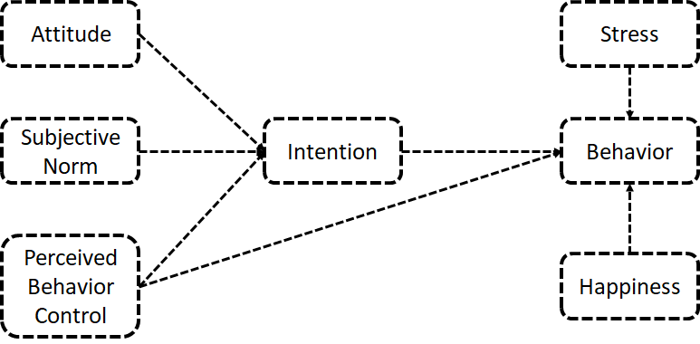
Figure S1. Schematic diagram of extended Theory of planned behavior model.

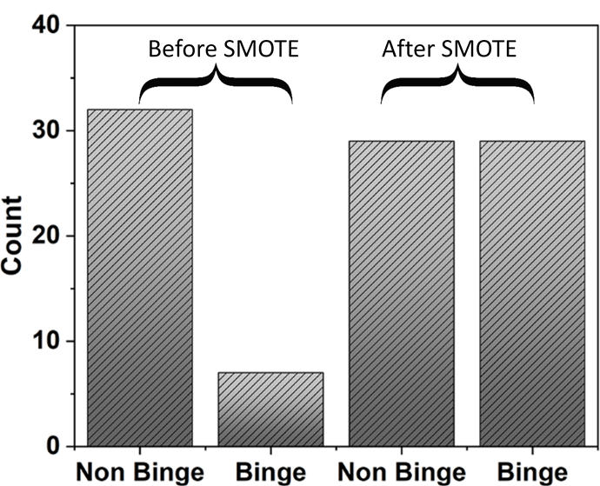
Figure S2. Class balancing using synthetic minority over-sampling technique (SMOTE). Before SMOTE, there are 7 binge and 32 non-binge drinkers. After the SMOTE, the both classes have 29 counts, i.e., 29 binge and 29 non-binge drinkers.

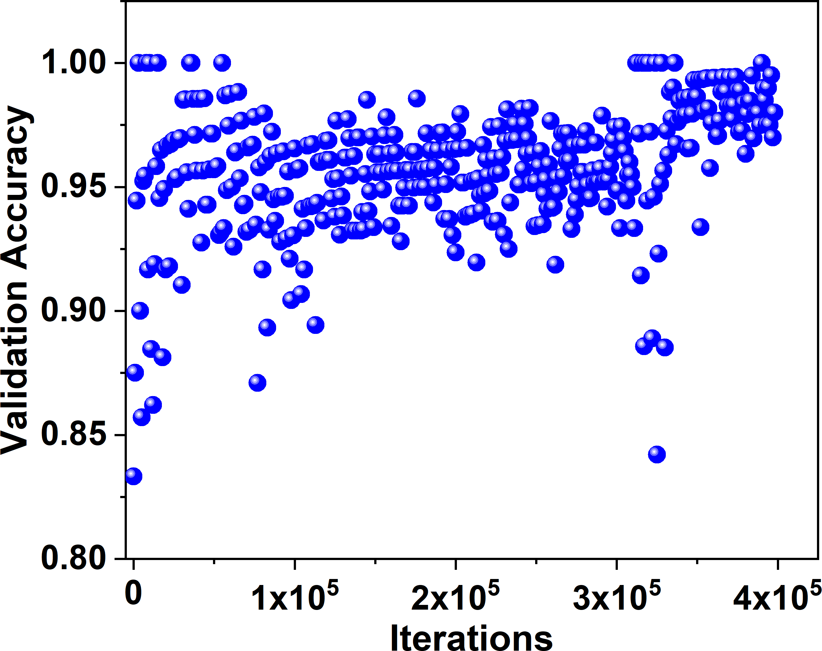
Figure S3. Validation accuracy of SSG w/FS evaluated by the coefficient of determination (R²).

Table S1. Cronbach’s α coefficient of scarce dataset, which calculate with $α= k/{(k-1)(1-\sum{s_{i}^{2}/s_{t}^{2}) ADDIN EN.CITE <EndNote><Cite><Author>Bland</Author><Year>1997</Year><RecNum>375</RecNum><DisplayText><style face="superscript">15</style></DisplayText><record><rec-number>375</rec-number><foreign-keys><key app="EN" db-id="t9sta00wv2ffzhezavnxzpz4etswst5vwppv" timestamp="1640913264">375</key></foreign-keys><ref-type name="Journal Article">17</ref-type><contributors><authors><author>Bland, J Martin</author><author>Altman, Douglas G</author></authors></contributors><titles><title>Statistics notes: Cronbach\&apos;s alpha</title><secondary-title>BMJ</secondary-title></titles><periodical><full-title>BMJ</full-title></periodical><pages>572</pages><volume>314</volume><number>7080</number><dates><year>1997</year></dates><urls><related-urls><url>https://www.bmj.com/content/bmj/314/7080/572.full.pdf</url></related-urls></urls><electronic-resource-num>10.1136/bmj.314.7080.572</electronic-resource-num></record></Cite></EndNote>Error! Bookmark not defined.}}$, where k is the number of items, $s_{i}^{2}$ is the variance of the ith item, and $s_{t}^{2}$ is the variance of total score of all items ¹. Note: According to the equation, since the “intention” only has one item, the division is undefined.
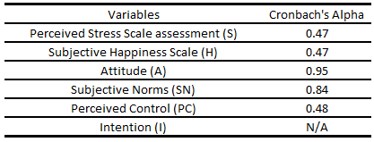

Table S2. Precision/ Recall/ FI-scores of decision tree model. The model was trained on augmented dataset (~1000).
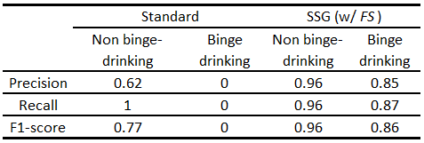

Reference
1. Bland, J.M. and D.G. Altman Statistics notes: Cronbach's alpha. BMJ. 314, 572 (1997).

