Supplementary Information

Possible formation of hydrogen-rich layer in the topmost outer core by deeply subducted water

Taehyun Kim¹, Joseph G. O’Rourke², Jeongmin Lee¹, Stella Chariton³, Vitali Prakapenka³, Rachel J. Husband⁴, Nico Giordano⁴, Hanns-Peter Liermann⁴, Sang-Heon Shim^{2,}*, Yongjae Lee^{1,}*

¹Department of Earth System Sciences, Yonsei University, Seoul 03722, South Korea.
²School of Earth and Space Exploration, Arizona State University, Tempe, AZ 85281, USA.
³Center for Advanced Radiation Sources, University of Chicago, Argonne, IL 60439, USA.
⁴Deutsches Elektronen-Synchrotron (DESY), Notkest. 85, 22607 Hamburg, Germany.
*Corresponding authors: Yongjae Lee (yongjaelee@yonsei.ac.kr) and Sang-Heon Shim (SHDShim@asu.edu)

Materials and Methods
Sample preparation
We used symmetric-type diamond-anvil cells, with diamond culet sizes ranging between 400 and 150 µm to achieve pressures between 17 GPa and 137 GPa. Rhenium gaskets were pre-indented to a thickness of 20–25 µm and drilled to make a hole (with diameters between 250 and 75 µm) as a sample chamber. Four different sample setups were prepared: 1) Fe_{0.7}Si_{0.3} with a H₂O pressure-transmitting medium, 2) a mixture of Fe_{0.7}Si_{0.3} + Mg(OH)₂ with an argon or MgO medium, and either 3) Fe_{0.7}Si_{0.3}, or 4) Fe_{0.91}Si_{0.09} sandwiched by two Mg(OH)₂ foils as a medium, which presumed the limited supply H₂O (the third and fourth setups have 7–9 wt% H₂O, based on the thickness of Fe-Si alloys and Mg(OH)₂).
For setup 2, we mixed a synthesized brucite (Sigma-Aldrich) with Fe_{0.7}Si_{0.3} alloy (Alfa Aesar) to achieve 2 wt% H₂O, which were ground in an agate mortar for 1 hour. The powdered sample was mixed with gold powder (Alfa Aesar) as a pressure standard, and cold-compressed to a respective thin foil (thickness of approximately 10 µm). The foil was loaded with 3–4 spacers of the same composition of mixture on each side of the diamond culet to separate the foil from the diamonds and to make space for argon as a medium. We used the gas loading systems at GeoSoilEnviroCARS (GSECARS) or the Extreme Conditions Beamline (ECB) to load the pressurized-argon into the sample chamber.
For setup 1, Fe_{0.7}Si_{0.3} powder was cold-compressed to a thin foil as above. We followed the same sample preparation procedure as setup 2 except that deionized water (H₂O) was loaded as a medium instead. In the cases of MgO or Mg(OH)₂ as a solid medium (setups 3 or 4), Fe_{0.7}Si_{0.3} or Fe_{0.91}Si_{0.09} (synthesized by Goodfellow) powders were cold-compressed to make a foil, and then it was sandwiched by two ca. 3–5 μm thick MgO or Mg(OH)₂ foils, which insulate Fe-Si alloys. The chamber was sealed during gas loading and then compressed to 10–15 GPa, which was further compressed to the target pressures at the beamline.

Synchrotron X-ray diffraction
X-ray diffraction patterns were collected in-situ at high-pressure and high-temperature conditions using a double-sided laser-heating setup at beamline 13-IDD of the GSECARS¹ at the Advanced Photon Source (APS). A monochromatic X-ray beam (wavelengths of 0.3344(1) Å or 0.4133(1) Å) was focused to 2 x 2 μm² in size using the canted undulator dual crystal monochromator, Kirkpatrick-Baez (KB) mirror and a pinhole. The pixel array detector (Pilatus 3X CdTe 1M) was used to obtain diffraction images. At beamline P02.2 (PETRA III)² at Deutsches Elektronen-Synchrotron (DESY), monochromatic X-rays (λ=0.2887(1) Å or 0.2908(1) Å) were focused to 1.9 x 1.9 μm² or 1.8 x 2.8 μm² using KB mirrors and a pinhole, and a Perkin Elmer XRD 1621 flat-panel detector was used for collecting diffraction data. We used LaB₆ or CeO₂ standards to calibrate and correct for distortions and obtain sample to detector distances (ca. 200 mm or 400 mm).
For laser heating at the 13-IDD and P02.2 beamlines, near-infrared lasers were focused on both sides of the sample foil in a LH-DAC to a hot spot size of 20–25 μm and aligned coaxially with the X-ray^{1,3}. We collected in situ X-ray diffraction data over a pressure range between 17 and 137 GPa. During laser heating of the Fe-Si alloys + Mg(OH)₂, the temperature fluctuation was low (±100 K) including the conditions above the melting temperature of FeH (for example, run no. A30B_34 in Table S1). X-ray diffraction patterns were collected when the temperature fluctuation was less than 100–150 K. In runs with Fe-Si alloys + Mg(OH)₂ runs and Fe-Si alloys + H₂O, temperature fluctuation in the heating spots became higher than 150 K at temperatures above H₂O melting. In such a case, we collected diffraction data for less than 10 seconds at target temperature to minimize temperature fluctuation and errors during X-ray diffraction measurement.
The thermal radiation from both sides of the LH-DAC was collected using the optical spectroscopy system (at the above two beamlines), which is composed of dielectric laser mirrors, glassy carbon mirrors, apochromatic objective lens, notch filters, laser dichroic mirrors, and other optics. The thermal radiation is collected by a two-dimensional area charge-coupled device (CCD) detector (for more details on the setup, see refs.^{1,3}). The measured spectra are corrected for system response, which is measured using a tungsten ribbon lamp with known radiance. The corrected spectra are then fit to the gray-body radiation between 680 nm and 840 nm (see refs.^{4,5} for more details on calibration). Temperatures were calculated using the software T-Rax (https://github.com/CPrescher/T-Rax). Considering axial gradients, differences between the two sides of LH-DAC, and temperature fluctuations during the measurement, typical uncertainty in the measured temperature would be ±100–200 K^{1,5,6}. Table S1 lists our measured temperatures with estimated 1-σ uncertainties.
Two-dimensional (2D) X-ray diffraction images were converted to one-dimensional X-ray diffraction patterns, using the Dioptas software⁷. Pressures were determined using the equation of state of gold⁸. We used the software package PeakPo⁹ for the peak identification and unit-cell fitting.

Chemical analysis
To gain further insights into the elemental partitioning at high-pressures and high-temperatures, we recovered the laser-heated samples after the in situ XRD measurements and performed electron microscopy imaging and chemical analyses. We used a scanning electron microscope (SEM) combined with a focused (Ga⁺) ion beam (FIB) and energy dispersive X-ray spectroscopy (EDS). The recovered samples were coated with platinum (Pt) and sectioned using a FIB instrument (Crossbeam 540, ZEISS co., at Yonsei University). We avoided parts of the samples contaminated during FIB milling. The cross-section of samples was measured for the two-dimensional elemental mapping analysis at 5 keV and 15 keV, using EDS (Xflash 6|30 detector, Bruker) for Fe, Si, Mg, and O, installed with the same FIB instrument. After an examination of the elemental distribution of the laser-heated spots, we selected an area which contains iron-rich melt and its surrounding part for transmission electron microscopy (TEM) analysis. For TEM (JEM F200, JEOL co., at Yonsei University) analysis, the sample was further milled at 30 keV and 3 nA, and then extracted to mount on a copper (Cu) grid for thinning (and final surfacing) at 5 keV and 10 pA. During TEM analysis, each of the samples were imaged at an acceleration voltage of 200 keV and normally obtained EDS data (Table S3) for one minute.

Oxygen fugacity and partitioning coefficient
Because of H escape during decompression, we estimated molar ratio between Fe and H from the known relationship between unit-cell volume and hydrogen content¹⁰. The estimation shows that Fe:H was close to 1 to 1 at high-pressure and 300 K conditions. At high-pressure and 300 K conditions, our measured unit-cell volume of the B2-type FeSi phase was consistent with Fe_{0.5}Si_{0.5} (Fig. S5). Therefore, metallic melt (or solid) was composed of FeH + FeSi and its molar ratio was close to Fe:Si:H = 2:1:1. Note that the (pure) bcc Fe phase was observed only after pressure release to 1 bar.
Although the activity coefficients (γ) of Fe in metallic melt ($γ_{Fe}^{met}$) and FeO in the silicate melt ($γ_{FeO}^{sil}$) are unlikely 1 at 300 K and high-temperature conditions, we assume $a_{Fe}^{met}$ = $X_{Fe}^{met}$ and $a_{FeO}^{sil}$ = $X_{FeO}^{sil}$, respectively (where a is activity, and $X_{FeO}^{sil}$ is the mole fraction of FeO in silicate melt and $X_{Fe}^{met}$ is the mole fraction of Fe in metallic melt), because they ($γ_{Fe}^{met}$ and $γ_{FeO}^{sil}$) are not well known at the P-T conditions of this study. Instead of Fe in Fe-Si alloys, Si was preferentially oxidized and therefore $X_{FeO}^{sil}$ is very low (we consider $γ_{FeO}^{sil}$ would not affect and change with this low FeO concentration) (Table S3). In addition, activity coefficients may become unity at high-temperature conditions (although the effect of high-pressure is unknown)¹¹, simplified to the oxygen fugacity (fO₂) relative to Fe-FeO (∆IW) buffer = $2\log_{10}(\frac{X_{FeO}^{sil}}{X_{Fe}^{met}})$. The partitioning coefficient of silicon between the metallic melt and the silicate melt is calculated from $D_{Si}^{{met}/{sil}}$ = $\frac{X_{Si}^{met}}{X_{{SiO}_{2}}^{sil}}$, where $X_{Si}^{met}$ is the mole fraction of Si in the metallic melt and $X_{{SiO}_{2}}^{sil}$ is the mole fraction of SiO₂ in the silicate melt.

Stability of a hydrogen-rich layer
We calculated the stability of a layer at the top of the core that formed because of the chemical reaction observed in this study. The mass of the stable layer is $M_{L}=\left(\frac{4π}{3}\right)ρ[{R_{c}}^{3} - {\left(R_{c} - D\right)}^{3}]$, where $R_{c}$ = 3480 km is the total radius of the core, D is the thickness of the stable layer, and $ρ$ ~ 10⁴ kg/m³ is the density at the top of the core. If the total mass of H transferred across the CMB is ${∆M}_{H}$, then approximately $∆M_{Si} \sim k{∙∆M}_{H}$ is the total mass of silicon removed from the core according to the calculation (Text S5), and reaction observed in this study. Finally, we computed the changes in the weight percentages of H and Si in the stable layer as ${∆w}_{H}=100∙\frac{∆M_{H}}{M_{L}}$ and ${∆w}_{Si}=100∙\frac{∆M_{Si}}{M_{L}}$, respectively, where $M_{L}$ is the total mass of the stable layer.
The density anomalies associated with the addition of H and the depletion of Si in this layer are $∆ρ_{H}$ (negative) and $∆ρ_{Si}$ (positive), respectively. According to first principles calculations (Fig. 3 in ref.¹²), $∆ρ_{H}$ ~ (–1200 kg/m³)·${∆w}_{H}$ and $∆ρ_{Si}$ ~ (–100 kg/m³)·${∆w}_{Si}$ at the conditions of the CMB. These relations are not sensitive to the exact temperature of the core. The average density anomaly in the layer is thus $∆ρ_{av}=∆ρ_{H}+ ∆ρ_{Si}$, which is always negative given the relative proportions of H and Si that are inferred to move across the CMB via the observed reaction.
We assumed that the density anomaly varies linearly within the stable layer. By definition, the density anomaly is 0 kg/m³ at the base of the layer, which is the top of the convective region in the outer core. The density anomaly should then reach a value of $2∆ρ_{av}$ at the CMB. The anomalous density gradient relative to the well-mixed, adiabatic gradient in the core is thus $\frac{d∆ρ}{dr}=\frac{2∆ρ_{av}}{D}$, which is a negative quantity that increases in magnitude as the layer becomes thinner and/or as more hydrogen enters the layer. Finally, we can calculate the Brunt-Väisälä period (T_{BV}) for the stable layer:
$T_{BV}=2π{\left(-\frac{g}{ρ}\frac{∂Δρ}{∂r}\right)}^{-\frac{1}{2}}$,
which is the period of the vertical oscillations that a fluid parcel would experience if it were perturbed upwards or downwards in the stable layer. Small T_{BV} corresponds to rapid oscillations and thus strong stratification. Here g ~ 10.7 m/s² is the gravitational acceleration near the CMB.

Supplementary Text
Text S1
In runs with temperatures lower than the melting of FeH_{x}, we normally observed the fcc FeH_{x} (x = 1) phase after temperature quenching to 300 K. More hydrogen appears to alloy with Fe metal and form fcc FeH_{x} phase when the sample is melted. During the X-ray diffraction measurement, the strong diffraction lines of fcc FeH_{x} disappeared (or if observed, they are very weak) above its melting temperatures. With further heating to 3601 K (at 60 GPa) or 3700 K (at 137 GPa), diffuse scattering was observed indicating iron-rich melt. The peak intensities from SiO₂ polymorphs, bridgmanite, and periclase also slightly decreased (Fig. S1). After temperature quenching to 300 K at high pressures, we observed the recrystallization of fcc FeH_{x} (Fig. 2b). The fcc phase showed much larger volume expansion than what is expected for x=1, indicating higher H solubility in Fe melt, which is consistent with the previous computational study¹³.

Text S2
For the energy-dispersive spectroscopy (EDS) measurement in transmission electron microscopy (TEM), we selected two regions where the quenched metallic melt and silicate melt are in contact (Figs. 3a, 3e). Silicate shows a MgO/SiO₂ molar ratio of approximately 1.1 (Table S3), which deviates from what is expected for MgSiO₃ bridgmanite. Considering that both the chemical homogeneities of the silicate region near the quenched metallic melt and the molar ratio of MgO and SiO₂, we interpret that the silicate region represents silicate melt in equilibrium with iron-rich melt during heating. Additionally, according to previously reported melting temperature of hydrous silicates up to 100 GPa¹⁴, silicates in our high-temperature runs experienced melting.
Assuming that the metallic melt and its surrounding silicate region was locally equilibrated, the oxygen fugacity (fO₂) relative to Fe-FeO (∆IW) buffer can be calculated from ∆IW = $2\log_{10}(\frac{X_{FeO}^{sil}}{X_{Fe}^{met}})$, where $X_{FeO}^{sil}$ and $X_{Fe}^{met}$ are the mole fraction of FeO in the silicate melt and the mole fraction of Fe in the metallic melt, respectively. These values can be obtained from our chemical measurements. For the same spots, we calculated the partitioning coefficient of silicon between metallic and silicate melts: $\log_{10}\left(D_{Si}^{{met}/{sil}}\right)= \log_{10}(\frac{X_{Si}^{met}}{X_{{SiO}_{2}}^{sil}})$, where $X_{Si}^{met}$ and $X_{{SiO}_{2}}^{sil}$ are the mole fraction of Si in the metallic melt and the mole fraction of SiO₂ in the silicate melt, respectively (see Method).
The estimated oxygen fugacity was approximately 4 log unit lower than ∆IW, i.e., ∆IW–4, which is similar to those estimated for the planetary building materials such as chondrites¹⁵. In such a low ∆IW value, we observed the large mole fraction of silicon in metallic region similar as ref.¹⁶. At these highly reducing conditions, we always observed 1) the formation of FeH and SiO₂, 2) SiO₂ rather than FeO, and 3) extremely low O content in the metallic melt and silicate region. These observations indicate that the Si in Fe-Si alloys mainly consumed oxygen to form SiO₂, and Fe combined with H to form FeH rather than FeO, respectively.
The partitioning coefficient of silicon between metallic and silicate melts is poorly unknown in a range lower than ∆IW–3. Previous data for partitioning coefficient of silicon between metallic and silicate melts mostly plotted at the higher than ∆IW–3 and relatively scattered¹¹. In addition, previous data were obtained under dry conditions¹¹. Therefore, it is difficult to compare. Further studies are needed for water effects on the partitioning coefficient of silicon between metallic and silicate melts with a wider range of oxygen fugacity.

Text S3
Contrary to Fig. 3, in those cases heated under 2000 K at 74 GPa, inhomogeneous Mg-silicate, Mg-oxide, iron-enriched regions were found, likely due to insufficient heating for the formation of the sufficient melt (Fig. S2).

Text S4
Recent studies have suggested that early Earth would have various processes which could have delivered water^{17,18}, including pebble accretion^{19,20}, ingassing of nebular H₂ and H₂O into magma ocean^{21,22}, and accretion of water-rich planetary embryos (Grand Tack model, refs.²³⁻²⁵). Through these processes, the early magma ocean may have contained up to 0.5–1.8 wt% H₂O of Earth’s mass^{19,26,27}. Water in the silicate magma may have interacted with silicon-rich iron alloys, after which the Fe-Ni-H liquid would sink and form the core²⁸⁻³⁰. According to our experiments, the alloying of the iron metal liquid with hydrogen could have occurred while the SiO₂ component would be left in the mantle. The D/H ratio (similar with proto-solar nebula) of volcanic rocks from mantle plumes³¹ may have been resulted from the sequestration of primordial hydrogen into the early planetary core.

Text S5
We estimated the amount of Si extracted from the outer core due to the chemical reaction between the core materials (e.g., Fe-Si alloys) and the delivered water through a subducting slab. If Si is the most abundant light element in the outer core, O in the delivered water will be consumed for oxidizing Si as below according to this study:
Si⁰ (metal) + 2H₂O → 4H⁰ (metal) + SiO₂
Therefore, the extracted amount of Si at the Eʹ layer, ∆m(Si)_{Eʹ layer}, satisfies a following relation:
$\frac{∆{m\left(Si\right)}_{Eʹ layer}}{m(Si)}∶\frac{m\left(water\right)∙\frac{m\left(O\right)}{m\left(H_{2}O\right)}}{m(O)}=1∶2$,
where m(Si), m(O) and m(H₂O) are the molar masses of Si, O and H₂O, respectively, because Si is extracted as SiO₂. Thus, ∆m(Si)_{Eʹ layer} can be expressed as:
$∆{m(Si)}_{Eʹ layer}= \frac{1}{2}∙m(water)\frac{m(Si)}{m(H_{2}O)}$.
The dissolved amount of H at the Eʹ layer, ∆m(H)_{Eʹ layer}, can be also estimated from:
$∆{m\left(H\right)}_{Eʹ layer}=m(water)∙\frac{2∙m(H)}{m(H_{2}O)}$,
where m(H) is the molar mass of H, and m(water) is the amount of delivered water at the CMB. The m(water) can be estimated from:
$m\left(water\right)= C(x)∙\int_{0}^{∆t}{F\left(H_{2}O\right)(t) dt \sim C\left(x\right)}∙F(H_{2}O)∙∆t$,
where $C(x)$ is an amount of water reacting with the outer core materials at the CMB divided by the water amount subducted at the surface (e.g., 0.4–1%), F(H₂O) is an annual input of water of 10¹² kg^{ref.32}, and ∆t is 2.5·10⁹ years (i.e., 2.5 Gyr). We note that time-dependent term, F(H₂O)(t), is assumed to be constant as it is not well known.
In summary, a ratio in the mass exchange between Si and H at the Eʹ layer, k, can be estimated from:
$∆{m\left(Si\right)}_{Eʹ layer}=-k ∙ ∆{m\left(H\right)}_{Eʹ layer}$.
The value k is:
$$k=-\frac{1}{4}∙\frac{m\left(Si\right)}{m\left(H\right)},$$
approximately −7. In order to estimate an effect on the change of seismic velocity, we assumed 1) the thickness of Eʹ layer is 200 km, 2) $C(x)$ is 0.4%, and 3) the reported values for a velocity change according to the variation of elemental concentration in refs.^{33,34}.

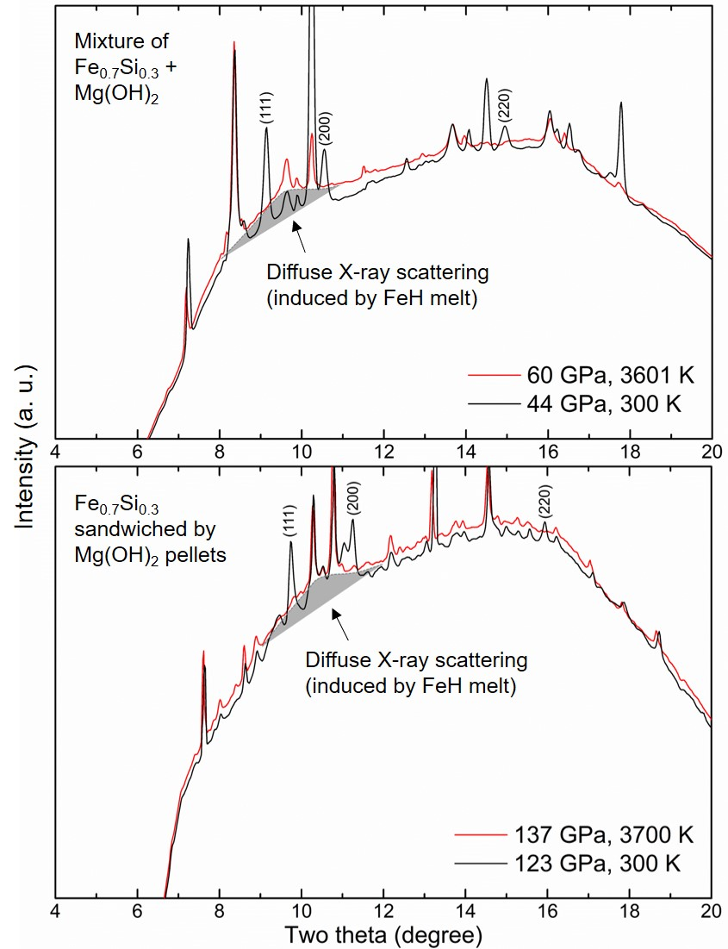
Fig. S1. In situ X-ray diffraction pattern measured during laser heating (60 GPa and 3601 K, and 137 GPa and 3700 K) and after temperature quenching (44 GPa and 300 K, and 123 GPa and 300 K). In the high-temperature patterns, the broad diffuse X-ray scattering feature from FeH_{x} melt is highlighted by grey-shaded area. The diffraction peaks of fcc FeH_{x} (with Miller indices) were observed only after the temperature was quenched to 300 K.

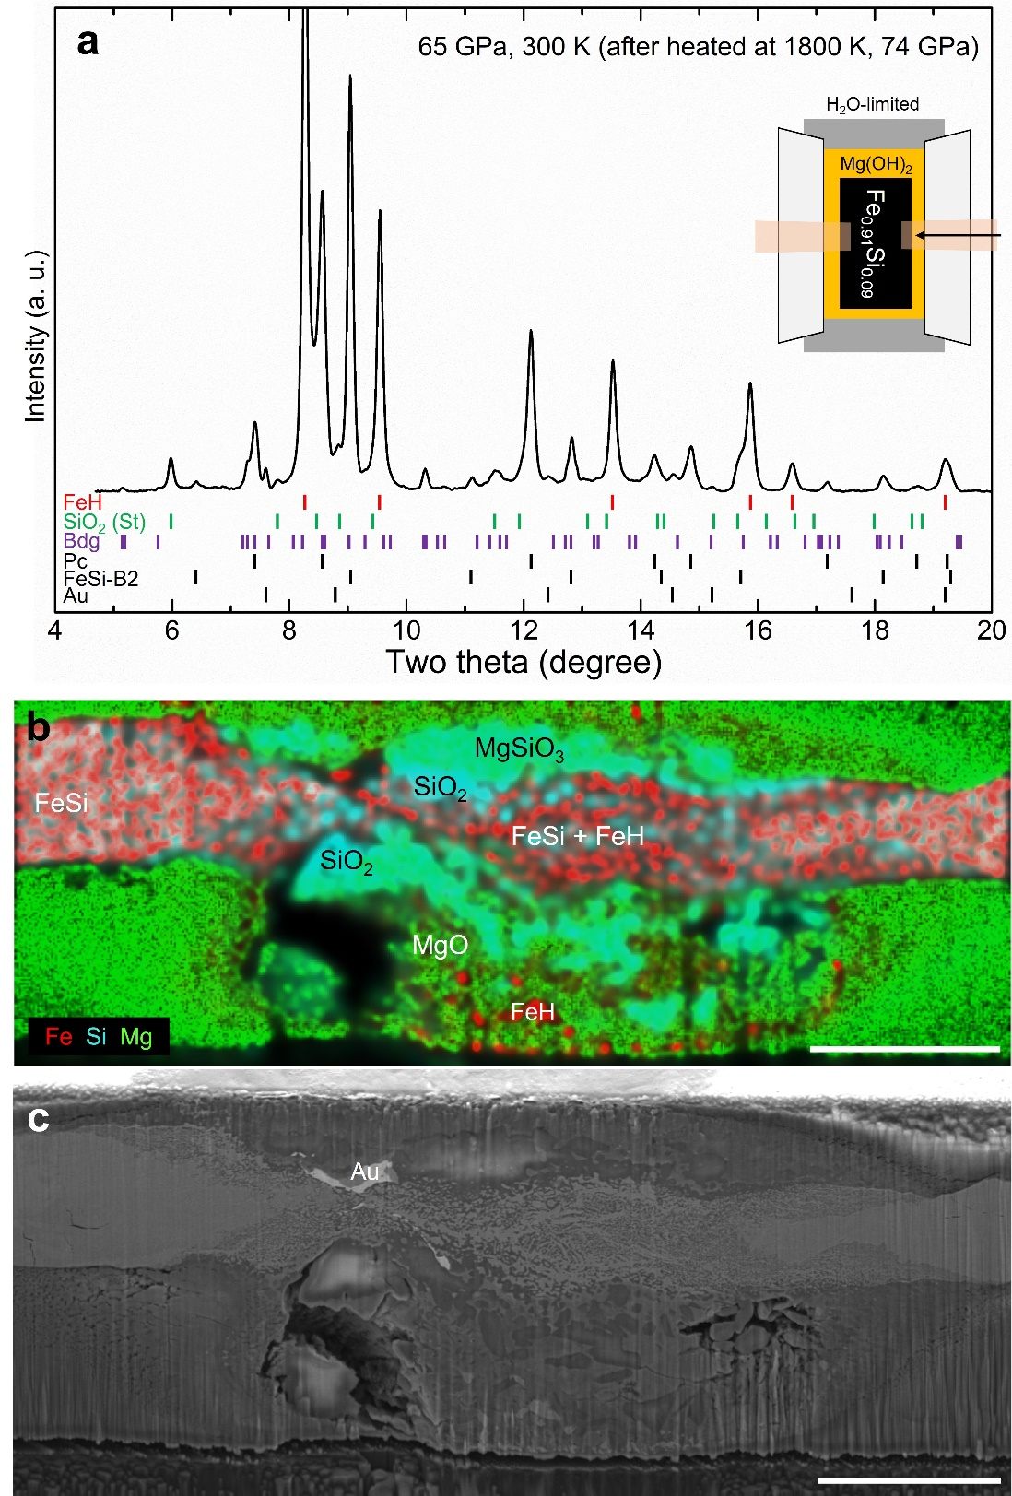
Fig. S2. a, In-situ X-ray diffraction pattern, and b, c, chemical analysis obtained from experiments at 65 GPa and 300 K after heated at 1800 K at 74 GPa (this spot did not reach melting). The experimental setup was Fe_{0.91}Si_{0.09} sandwiched between Mg(OH)₂ foils. The schematic diagram of the starting setup is given in the right side of (A). The black arrow and the pale-orange boxes in the schematic diagram are X-ray and laser paths, respectively. Abbreviations: FeH, fcc FeH_{x}; St, stishovite; Bdg, bridgmanite; Pc, ferropericlase; Au, gold. Scale bars are 7 µm.

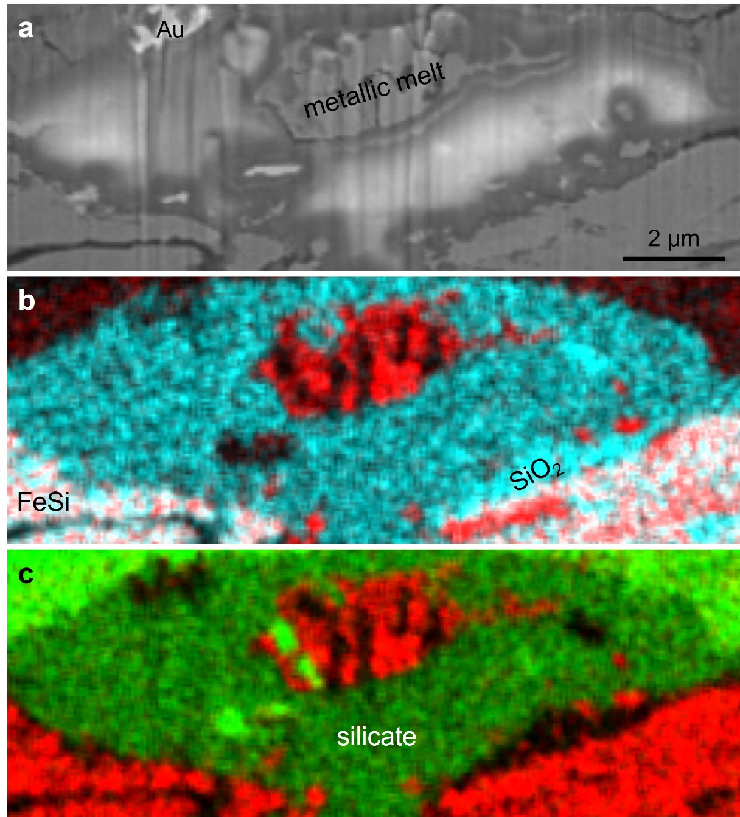
Fig. S3. SEM analysis of the recovered sample from laser heating of Fe_{0.7}Si_{0.3} sandwiched between two Mg(OH)₂ foils. a, A cross-sectional view of the recovered sample after heating at 2810 K and 129 GPa. The two-dimensional elemental distribution maps of b, Fe (red) and Si (cyan), and c, Fe (red) and Mg (green).

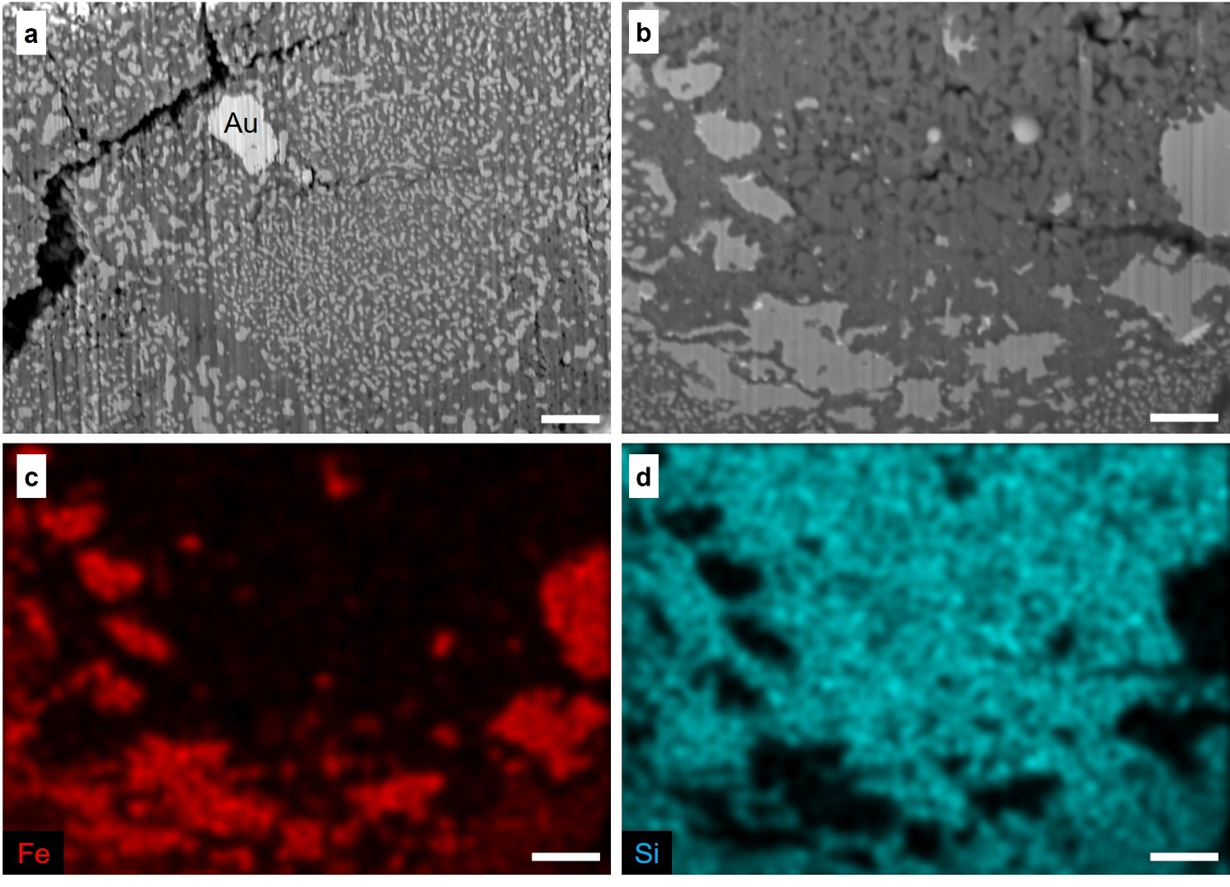
Fig. S4. SEM images of the recovered samples from Fe_{0.7}Si_{0.3} + H₂O. a, The center of the heated spot after quenching from 1282 K at 32 GPa. b, The center of the heated spot after quenching from 1202 K at 28 GPa. Elemental distributions for c, Fe and d, Si of the image in (b). When H₂O medium was used, the recovered samples showed complete conversion of Fe-Si alloys to SiO₂ and FeH, which also agrees with our in-situ XRD result (Fig. 1a). In image (a), decompression caused cracks. The scale bars are 1 µm.

Fig. S5. The unit-cell volumes of B2-type FeSi at high pressure and 300 K from this study and previous studies³⁵⁻³⁷. H₂O and Mg(OH)₂ were used as the water sources for the grey and the black symbols, respectively, in this study (each symbol shape matches with the starting setups in Fig. 2a).

Table S1. Summary of the P-T conditions and phase assignments for the experimental runs: Phase abbreviations: FeH (fcc FeH_{x}), FeH-d (dhcp FeH_{x}), FeSi (B2-type FeSi), stishovite (st), periclase (pc), bridgmanite (bdg), post-perovskite (ppv), ringwoodite (rw). Run numbers from A40A_04 to A15B_36 are Fe_{0.7}Si_{0.3} with a H₂O pressure-transmitting medium, from P40A_5_30 to A15E_17 are Fe_{0.7}Si_{0.3} + Mg(OH)₂ with an argon (Ar) or MgO medium, from A15F_27 to A15G_30 are Fe_{0.7}Si_{0.3} with Mg(OH)₂ medium, and from P40B_11 to P30A_18 are Fe_{0.91}Si_{0.09} with a Mg(OH)₂ medium. The error values in pressure are estimated to a ±5% of each pressure (Fig. 2a). Estimated uncertainty for temperature is shown in parenthesis.
Run # | P  (GPa) | T  (K) | Observed Phases | Sample setup
A40A_04 | 20 | 1450(100) | FeH, st | Fe_{0.7}Si_{0.3},  H₂O pressure medium
A40A_33 | 29 | 2650(100) | FeH*, st | Fe_{0.7}Si_{0.3},  H₂O pressure medium
A40A_34 | 17 | 300 | FeH, st | Fe_{0.7}Si_{0.3},  H₂O pressure medium
A30A_09 | 28 | 1202(114) | FeH, st | Fe_{0.7}Si_{0.3},  H₂O pressure medium
A30A_12 | 27 | 300 | FeH, st | Fe_{0.7}Si_{0.3},  H₂O pressure medium
A30A_14 | 32 | 1282(115) | FeH, st | Fe_{0.7}Si_{0.3},  H₂O pressure medium
A30A_16 | 27 | 300 | FeH, st | Fe_{0.7}Si_{0.3},  H₂O pressure medium
A12C_09 | 30 | 1610(100) | FeH, st | Fe_{0.7}Si_{0.3},  H₂O pressure medium
A12C_10 | 25 | 300 | FeH, st | Fe_{0.7}Si_{0.3},  H₂O pressure medium
A30A_31 | 49 | 1622(100) | FeH, st, FeSi | Fe_{0.7}Si_{0.3},  H₂O pressure medium
A30A_33 | 44 | 300 | FeH, st, FeSi | Fe_{0.7}Si_{0.3},  H₂O pressure medium
P20A_04 | 51 | 1430(100) | FeH, st, FeSi | Fe_{0.7}Si_{0.3},  H₂O pressure medium
P20A_13 | 43 | 300 | FeH, st, FeSi | Fe_{0.7}Si_{0.3},  H₂O pressure medium
P20B_18 | 64 | 1630(100) | FeH, FeH-d, st, FeSi | Fe_{0.7}Si_{0.3},  H₂O pressure medium
P20B_19 | 56 | 300 | FeH, FeH-d, st, FeSi | Fe_{0.7}Si_{0.3},  H₂O pressure medium
P20B_06 | 73 | 1890(100) | FeH, st, FeSi | Fe_{0.7}Si_{0.3},  H₂O pressure medium
P20B_07 | 64 | 300 | FeH, FeH-d, st, FeSi | Fe_{0.7}Si_{0.3},  H₂O pressure medium
A15B_23 | 74 | 2086(190) | FeH, st, FeSi | Fe_{0.7}Si_{0.3},  H₂O pressure medium
A15B_24 | 68 | 300 | FeH, st, FeSi | Fe_{0.7}Si_{0.3},  H₂O pressure medium
A15B_27 | 77 | 2551(185) | FeH, st, FeSi | Fe_{0.7}Si_{0.3},  H₂O pressure medium
A15B_28 | 66 | 300 | FeH, FeH-d, st, FeSi | Fe_{0.7}Si_{0.3},  H₂O pressure medium
A15B_35 | 77 | 2676(180) | FeH, st, FeSi | Fe_{0.7}Si_{0.3},  H₂O pressure medium
A15B_36 | 67 | 300 | FeH, FeH-d, st, FeSi | Fe_{0.7}Si_{0.3},  H₂O pressure medium
P40A_5_30 | 31 | 1440(100) | FeH, st, FeSi, pc | Fe_{0.7}Si_{0.3} + Mg(OH)₂ mixture (2 wt% H₂O),  Ar pressure medium
P40A_5_31 | 27 | 300 | FeH, st, FeSi, pc
P40A_7_06 | 35 | 2130(100) | FeH, st, FeSi, pc, bdg
P40A_7_07 | 29 | 300 | FeH, st, FeSi, pc, bdg
P40A_9_23 | 32 | 1790(100) | FeH, st, FeSi, pc
P40A_9_31 | 27 | 300 | FeH, st, FeSi, pc
A30B_22 | 49 | 1953(100) | FeH, st, FeSi, pc, bdg
A30B_24 | 42 | 300 | FeH, st, FeSi, pc, bdg
A30B_34 | 60 | 3650(100) | st, FeSi, pc, bdg
A30B_35 | 44 | 300 | FeH, st, FeSi, pc, bdg
A30B_36 | 60 | 3601(128) | st, FeSi, pc, bdg
A30B_38 | 44 | 300 | FeH, st, FeSi, pc, bdg
A30B_40 | 61 | 2632(140) | FeH*, st, FeSi, pc, bdg
A30B_41 | 47 | 300 | FeH, st, FeSi, pc, bdg
A15E_11 | 60 | 2128(100) | FeH, st, FeSi, pc, bdg | Fe_{0.7}Si_{0.3} + Mg(OH)₂ mixture (2 wt% H₂O), MgO pressure medium
A15E_13 | 53 | 300 | FeH, st, FeSi, pc, bdg
A15E_14 | 62 | 2738(208) | st, FeSi, pc, bdg
A15E_15 | 53 | 300 | FeH, FeH-d, st, FeSi, pc, bdg
A15E_16 | 63 | 2805(138) | st, FeSi, pc, bdg
A15E_17 | 52 | 300 | FeH, FeH-d, st, FeSi, pc, bdg
A15F_27 | 120 | 3270(175) | FeH*, st, FeSi, pc, bdg | Fe_{0.7}Si_{0.3} was sandwiched between two Mg(OH)₂ foils
A15F_29 | 119 | 3080(100) | FeH*, st, FeSi, pc, bdg | Fe_{0.7}Si_{0.3} was sandwiched between two Mg(OH)₂ foils
A15F_30 | 102 | 300 | FeH*, FeO₂H*, st, FeSi, pc, bdg | Fe_{0.7}Si_{0.3} was sandwiched between two Mg(OH)₂ foils
A15G_18 | 129 | 2810(210) | FeH*, SiO₂-α-PbO₂, SiO₂-CaCl₂, FeSi, pc, ppv | Fe_{0.7}Si_{0.3} was sandwiched between two Mg(OH)₂ foils
A15G_22 | 117 | 300 | FeH, FeH-d, SiO₂-α-PbO₂, FeSi, pc, ppv | Fe_{0.7}Si_{0.3} was sandwiched between two Mg(OH)₂ foils
A15G_24 | 133 | 3170(130) | FeH*, FeH₃*, FeSi, pc, ppv | Fe_{0.7}Si_{0.3} was sandwiched between two Mg(OH)₂ foils
A15G_28 | 137 | 3700(100) | FeH₃*, SiO₂-α-PbO₂, SiO₂-CaCl₂*, FeSi, pc, bdg, ppv* | Fe_{0.7}Si_{0.3} was sandwiched between two Mg(OH)₂ foils
A15G_30 | 123 | 300 | FeH, FeH₃*, SiO₂-α-PbO₂, SiO₂-CaCl₂*, FeSi, pc, bdg, ppv* | Fe_{0.7}Si_{0.3} was sandwiched between two Mg(OH)₂ foils
P40B_11 | 24 | 1650(100) | FeH, st, FeSi-B20*, pc, rw | Fe_{0.91}Si_{0.09} was sandwiched between two Mg(OH)₂ foils
P40B_12 | 19 | 300 | FeH, FeH-d, st, FeSi-B20*, pc, rw | Fe_{0.91}Si_{0.09} was sandwiched between two Mg(OH)₂ foils
P40B_25 | 19 | 300 | FeH, st, FeSi-B20*, FeSi, pc, rw | Fe_{0.91}Si_{0.09} was sandwiched between two Mg(OH)₂ foils
P20C_09 | 45 | 1830(150) | FeH, st, FeSi*, pc, bdg | Fe_{0.91}Si_{0.09} was sandwiched between two Mg(OH)₂ foils
P20C_10 | 37 | 300 | FeH, st, FeSi*, pc, bdg | Fe_{0.91}Si_{0.09} was sandwiched between two Mg(OH)₂ foils
P30A_18 | 65 | 300 | FeH, st, FeSi, pc, bdg | Fe_{0.91}Si_{0.09} was sandwiched between two Mg(OH)₂ foils
*The intensities of X-ray diffraction peaks are weak compared to the other observed phases.

Table S2. The unit-cell volumes per Fe atoms of FeH_{x} and per FeSi of B2-type FeSi at 300 K and high pressures. The values in this table are also reported in Fig. 2b or Fig. S5. The errors for pressure are estimated to be ±5%. The uncertainties of unit-cell volumes are shown for the last digit(s) in parenthesis.
Starting setup | Run # | Pressure (GPa) | Temperature (K) | Unit-cell volume (Å)
 |  |  |  | fcc FeH_{x} | B2-type FeSi
Fe_{0.7}Si_{0.3} + H₂O | A30A_16 | 27 | 300 | 11.913(16) | -
Fe_{0.7}Si_{0.3} + H₂O | A12C_10 | 25 | 300 | 12.097(46) | -
Fe_{0.7}Si_{0.3} + H₂O | A30A_33 | 44 | 300 | 11.397(44) | 18.294(21)
Fe_{0.7}Si_{0.3} + H₂O | P20A_13 | 43 | 300 | 11.456(80) | 18.419(4)
Fe_{0.7}Si_{0.3} + H₂O | P20B_19 | 56 | 300 | 11.116(37) | 17.901(17)
Fe_{0.7}Si_{0.3} + H₂O | A15B_24 | 68 | 300 | 10.906(81) | 17.530(26)
Fe_{0.7}Si_{0.3} + Mg(OH)₂ mixture (2 wt% H₂O), an Ar or MgO pressure medium | P40A_5_31 | 27 | 300 | 12.044(186) | 19.481(69)
 | P40A_7_07 | 29 | 300 |  | 19.454(68)
 | P40A_9_31 | 27 | 300 |  | 19.521(25)
 | A30B_24 | 42 | 300 | 11.555(52) | 18.444(25)
 | A30B_35 | 44 | 300 | 11.889(69) | 18.560(8)
 | A30B_38 | 44 | 300 | 12.013(23) | 18.574(15)
 | A30B_41 | 47 | 300 | 11.444(117) | 18.222(8)
 | A15E_13 | 53 | 300 | 11.329(30) | 18.129(2)
Fe_{0.7}Si_{0.3} was sandwiched between two Mg(OH)₂ foils | A15F_30 | 102 | 300 | 10.103(14) | 16.430(4)
Fe_{0.7}Si_{0.3} was sandwiched between two Mg(OH)₂ foils | A15G_22 | 117 | 300 | 9.699(13) | 15.915(24)
Fe_{0.7}Si_{0.3} was sandwiched between two Mg(OH)₂ foils | A15G_30 | 123 | 300 | 9.925(20) | 15.920(16)
Fe_{0.91}Si_{0.09} was sandwiched between two Mg(OH)₂ foils | P40B_12 | 19 | 300 | 12.272(16)
Fe_{0.91}Si_{0.09} was sandwiched between two Mg(OH)₂ foils | P40B_25 | 19 | 300 | 12.278(3) | 20.216(7)
Fe_{0.91}Si_{0.09} was sandwiched between two Mg(OH)₂ foils | P20C_10 | 37 | 300 | 11.562(11)
Fe_{0.91}Si_{0.09} was sandwiched between two Mg(OH)₂ foils | P30A_18 | 65 | 300 | 10.655(7) | 17.721(381)

Table S3. The compositions of the metallic melt and the quenched silicate melt determined by TEM-EDS analysis. The oxygen fugacity relative to Fe-FeO (∆IW) buffer and the partitioning coefficient of silicon are shown. The ∆IW are calculated from $2\log_{10}(\frac{X_{FeO}^{sil}}{X_{Fe}^{met}})$.
Run # | A30B_40 |  |  |  | A15G_28
Pressure | 61 GPa |  |  |  | 137 GPa
Temperature | 2632(140) K |  |  |  | 3700(100) K
 | quenched metallic melt (mol%) |  | quenched silicate melt (mol%) |  | quenched metallic melt (mol%) |  | quenched silicate melt (mol%)
 | Mg | 0.16(8) | MgO | 51.85(34) | Mg | 0.71(12) | MgO | 51.73(50)
 | Si | 29.61(22) | SiO₂ | 47.86(32) | Si | 21.69(25) | SiO₂ | 47.94(46)
 | Fe | 70.23(14) | FeO | 0.29(2) | Fe | 77.60(17) | FeO | 0.33(4)
∆IW | –4.47(49) |  |  |  | –4.36(57)
$$\log_{10}\left(D_{Si}^{{met}/{sil}}\right)$$ | –0.36(1) |  |  |  | –0.52(2)

References cited in the Supplementary Information
- V. B. Prakapenka et al., Advanced flat top laser heating system for high pressure research at GSECARS: application to the melting behavior of germanium. High Press. Res. 28, 225–235, (2008). doi: 10.1080/08957950802050718
- H.-P. Liermann et al., The Extreme Conditions Beamline P02.2 and the Extreme Conditions Science Infrastructure at PETRA III. J. Synchrotron Rad. 22, 908–924, (2015). doi: 10.1107/S1600577515005937
- Z. Konôpková et al., Laser heating system at the Extreme Conditions Beamline, P02.2, PETRA III. J. Synchrotron Rad. 28, 1747–1757, (2021). doi: 10.1107/S1600577521009231
- R. Boehler, High-pressure experiments and the phase diagram of lower mantle and core materials. Rev. Geophys. 38, 221-245, (2000). doi: 10.1029/1998RG000053
- G. Shen et al., Laser heated diamond cell system at the Advanced Photon Source for in situ x-ray measurements at high pressure and temperature. Rev. Sci. Instrum. 72, 1273–1282, (2001). doi: 10.1063/1.1343867
- L. R. Benedetti and P. Loubeyre, Temperature gradients, wavelength-dependent emissivity, and accuracy of high and very-high temperatures measured in the laser-heated diamond cell. High Press. Res. 24, 423–445, (2004). doi: 10.1080/08957950412331331718
- C. Prescher and V. B. Prakapenka, DIOPTAS: A program for reduction of two-dimensional X-ray diffraction data and data exploration. High Press. Res. 35, 223–230, (2015). doi: 10.1080/08957959.2015.1059835
- P. I. Dorogokupets and A. Dewaele, Equations of state of MgO, Au, Pt, NaCl-B1, and NaCl-B2: Internally consistent high-temperature pressure scales. High Press. Res. 27, 431–446, (2007). doi: 10.1080/08957950701659700
- S.-H. Shim, PeakPo - A python software for X-ray diffraction analysis at high pressure and high temperature, Zenodo (2017). doi: 10.5281/zenodo.810200
- Pépin, C. M. et al. New Iron Hydrides under High Pressure. Phys. Rev. Lett. 113, 265504, (2014). doi: 10.1103/PhysRevLett.113.265504
- C. K. Gessmann et al., Oxygen fugacity dependence of Ni, Co, Mn, Cr, V, and Si partitioning between liquid metal and magnesiowüstite at 9–18 GPa and 2200°C. Geochim. Cosmochim. Acta 63, 1853–1863, (1999). doi: 10.1016/S0016-7037(99)00059-9
- Umemoto, K. & Hirose, K. Chemical compositions of the outer core examined by first principles calculations. Earth Planet. Sci. Lett. 531, 116009, (2020). doi: 10.1016/j.epsl.2019.116009
- Y. Li et al., The Earth’s core as a reservoir of water. Nat. Geosci. 13, 453–458, (2020). doi: 10.1038/s41561-020-0578-1
- M. J. Walter et al., The stability of hydrous silicates in Earth’s lower mantle: Experimental constraints from the systems MgO-SiO₂-H₂O and MgO-Al₂O₃-SiO₂-H₂O. Chem. Geol. 418, 16–29, (2015). doi: 10.1016/j.chemgeo.2015.05.001
- K. Righter et al., Redox Processes in Early Earth Accretion and in Terrestrial Bodies. Elements 16, 161–166, (2020). doi: 10.2138/gselements.16.3.161
- A. K. Vogel et al., The dependence of metal-silicate partitioning of moderately volatile elements on oxygen fugacity and Si contents of Fe metal: Implications for their valence states in silicate liquids. Geochim. Cosmochim. Acta 237, 275–293, (2018). doi: 10.1016/j.gca.2018.06.022
- A. R. Sarafian et al., Early accretion of water in the inner solar system from a carbonaceous chondrite-like source. Science 346, 623–626, (2014). doi: 10.1126/science.1256717
- R. C. Greenwood et al., Oxygen isotopic evidence for accretion of Earth’s water before a high-energy Moon-forming giant impact. Sci. Adv. 4, eaao5928, (2018). doi: 10.1126/sciadv.aao5928
- A. Johansen et al., A pebble accretion model for the formation of the terrestrial planets in the solar system. Sci. Adv. 7, eabc0444, (2021). doi: 10.1126/sciadv.abc0444
- E. F. van Dishoeck et al., Water in star-forming regions: physics and chemistry from clouds to disks as probed by Herschel spectroscopy. Astron. Astrophys 648, A24, (2021). doi: 10.1051/0004-6361/202039084
- Z. D. Sharp, Nebular ingassing as a source of volatiles to the Terrestrial planets. Chem. Geol. 448, 137–150, (2017). doi: 10.1016/j.chemgeo.2016.11.018
- J. Wu et al., Origin of Earth’s Water: Chondritic Inheritance Plus Nebular Ingassing and Storage of Hydrogen in the Core. J. Geophys. Res. Planets 123, 2691–2712, (2018). doi: 10.1029/2018JE005698
- D. P. O’Brien et al., Water delivery and giant impacts in the ‘Grand Tack’ scenario. Icarus 239, 74–84, (2014). doi: 10.1016/j.icarus.2014.05.009
- Peslier, A. H. et al. Water in the Earth’s Interior: Distribution and Origin. Space Sci. Rev. 212, 743–810, (2017). doi: 10.1007/s11214-017-0387-z
- K. Meech and S. N. Raymond, https://arxiv.org/abs/1912.04361 (2019).
- Clesi, V. et al. Effect of H₂O on metal–silicate partitioning of Ni, Co, V, Cr, Mn and Fe: Implications for the oxidation state of the Earth and Mars. Geochim. Cosmochim. Acta 192, 97–121, (2016). doi: 10.1016/j.gca.2016.07.029
- L. Piani et al., Earth’s water may have been inherited from material similar to enstatite chondrite meteorites. Science 369, 1110–1113, (2020). doi: 10.1126/science.aba1948
- C. Y. Shi et al., Formation of an interconnected network of iron melt at Earth’s lower mantle conditions. Nat. Geosci. 6, 971–945, (2013). doi: 10.1038/ngeo1956
- Tagawa, S. et al. Experimental evidence for hydrogen incorporation into Earth’s core. Nat. Commun. 12, 2588, (2021). doi: 10.1038/s41467-021-22035-0
- V. Malavergne et al., Experimental constraints on the fate of H and C during planetary core-mantle differentiation. Implications for the Earth. Icarus 321, 473–485, (2019). doi: 10.1016/j.icarus.2018.11.027
- L. J. Hallis et al., Evidence for primordial water in Earth’s deep mantle. Science 350, 795–797, (2015). doi: 10.1126/science.aac4834
- van Keken, P. E. et al. Subduction factory: 4. Depth‐dependent flux of H₂O from subducting slabs worldwide. J. Geophys. Res. 116, B01401, (2011). doi: 10.1029/2010JB007922
- Umemoto, K. & Hirose, K. Liquid iron-hydrogen alloys at outer core conditions by first-principles calculations. Geophys. Res. Lett. 42, 7513–7520, (2015). doi: 10.1002/2015GL065899
- Nakajima, Y. et al. Silicon‐Depleted Present‐Day Earth's Outer Core Revealed by Sound Velocity Measurements of Liquid Fe‐Si Alloy. J. Geophys. Res. Solid Earth 125, e2020JB019399, (2020). doi: 10.1029/2020JB019399
- D. P. Dobson et al., The equation of state of CsCl-structured FeSi to 40 GPa: Implications for silicon in the Earth’s core. Geophys. Res. Lett. 30, 2002GL016228, (2003). doi: 10.1029/2002GL016228
- N. Sata et al., Compression of FeSi, Fe₃C, Fe_{0.95}O, and FeS under the core pressures and implication for light element in the Earth’s core. J. Geophys. Res. 115, B09204, (2010). doi: 10.1029/2009JB006975
- Z. M. Geballe and R. Jeanloz, Solid phases of FeSi to 47 GPa and 2800 K: New data. Am. Mineral. 99, 720–723, (2014). doi: 10.2138/am.2014.4612

