Supplementary Materials for

On-demand autonomous shape memory polymer
Chujun Ni, Di Chen, Shihong Deng, Xiuming Jin, Youqing Shen, Qian Zhao*, Tao Xie*
Correspondence to: qianzhao@zju.edu.cn; taoxie@zju.edu.cn

Materials and Methods
Materials
Acrylic acid (AAc), calcium acetate (CaAc), gelatin, 2-phenoxy ethyl acrylate (2-PEA), isobornyl acrylate (IBOA), 1,6-hexanediol diacrylate (HDDA) were purchased from Macklin. 6-diamidino-2-phenylindole dihydrochloride (DAPI), N,N’-methylenebisacrylamide (BIS) were obtained from Sigma-Aldrich. The photo-initiator (Irgacure 819) was acquired from TCI and the dye Sudan III was procured from Aladdin Inc. Silicone rubber (Sylgard 184) was purchased from Dow Corning.
Methods
Preparation of the photo-curable hydrogel precursor: 72 g of AAc monomer, 0.05-5 mol% BIS (relative to AAc), 1 g of Irgacure 819, and 18 mL water were mixed to prepare the aqueous hydrogel precursor. 0.01% of Sudan III was added into the precursor for dying. Selected hydrogel samples were further dyed with 1 mg/mL crystal violet solution for better visualization. Unless specifically mentioned, the precursor with 0.25 mol% BIS was used for the preparation.
Synthesis of shape memory hydrogels: Two glasses and a silicon rubber spacer were combined to form a mold. The spacer thickness varied from 0.2 mm to 2 mm. The hydrogel precursor was poured into the mold and exposed under a commercial projector (DELL1609WX with 3 mW/cm² intensity) for 5 min. The cured thin film was immersed in 1 M calcium acetate solution for two weeks and in DI water for another two weeks to obtain the shape memory hydrogel.
3D printing: A custom-made top-down DLP printer assembled by an electric motor and a commercial projector (DELL1609WX) was employed for the hydrogel printing. As shown in Supplementary Fig. 9, the swelling ratio decreases with the light irradiation time, reaching a plateau at around 30 s, which implies full curing. To guarantee the printing robustness and the self-standing capability of the parts, the irradiation time was set as 60 s for the bottom two layers and 40 s for all the upper layers. The printing slice thickness was set as 100 μm. The printing resolution can reach 700 μm (inset photos in Supplementary Fig. 9). After printing, the 3D objects were immersed into 1 M calcium acetate solution for two weeks and in DI water for another two weeks to obtain the 4D printed hydrogels.
Manufacturing of the conventional shape memory stent: The precursor was consisted of 2% HDDA, 32% 2-PEA, 66% IBOA, 0.03% Sudan III, and 3% I819. The printing slice thickness was set as 100 μm. The irradiation time was set as 6 s for the bottom two layers and 3 s for the upper layers.
Construction of conceptual barrier model: 10% gelatin water solution was prepared at 90 °C and poured into a hemispherical mold. After cooling at 4 °C overnight, the gelatin gel was demolded and put into the center of a container. Two-component silicon rubber precursor was mixed with a 10:1 ratio and degassed. The precursor was poured over the top of the gelatin and cured at room temperature for two days to yield the conceptual barrier model. Note that the model was heated to melt the gelatin core to mimic the soft tissue before the test.
Characterization
Shape memory characterization: Rectangular hydrogel strips (3 mm x 15 mm x 0.3 mm) were folded in half at 25 °C water and then immersed in 90 °C hot water for a certain time. Shape fixation ratio (R_{f}) was calculated as (Ɵ₁/180°) ×100%, as shown in Supplementary Fig. 10. The shape recovery kinetics when the samples were put back into 25 °C water was recorded by a digital video camera (Sony HDR-TD30E). Shape recovery ratio (R_{r}) is calculated as (Ɵ₁- Ɵ₂) /Ɵ₁ ×100%. The characterization was conducted by three parallel experiments.
Swelling ratio tests: The swelling ratio was calculated as m_{wet}/m_{dry}, with m_{wet} and m_{dry} representing the weight of the fully swollen hydrogel and the dried hydrogel, respectively. Each test was conducted for five parallel samples.
DSC tests: DSC measurements (TA Q200) were carried out via the method reported elsewhere20, with a ramp rate of 5 °C/min.
Infrared characterization: Infrared images were captured by a Fotric 237 thermometer available for video-recording.
Tensile tests: Hydrogel samples with dumbbell shape were tested by Care Test IPBF-300 at a strain rate of 5 mm/min in a water bath at a given temperature. Cyclic tensile tests were carried out at 1% strain displace for 1000 cycles with 5 mm/min strain rate.
Confocal laser scanning microscope (CLSM) characterization: The hydrogel samples were dyed with 1mg/L DAPI solution for 6 hours followed by immersing in DI water for 2 days to remove the excessive dye. The hydrogels at different phase separation states were observed by a confocal laser scanning microscope (Zeiss LSM700) under laser excitation at 405 nm.

Supplementary Figures

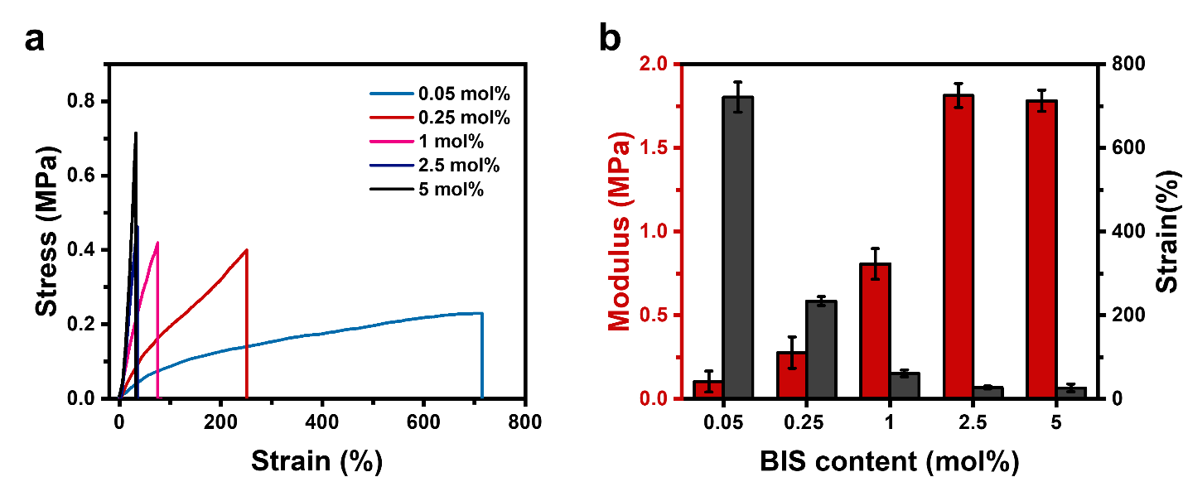
Fig. 1 | Mechanical properties of hydrogel samples with different BIS content. a, The strain-stress curves of hydrogel samples with strain rate of 5 mm/min at 25 °C. b, The Young’s modulus and strain of hydrogel samples calculated from five parallel experiments.

Fig. 2 | Mechanical properties of the hydrogels at different temperatures. The tensile tests were carried out in a water with 5 mm/min strain rate.

Fig. 3 | Swelling ratio of the hydrogels at different temperatures.

Fig. 4 | Shape recovery of the hydrogels with different heat treatment times during programming.

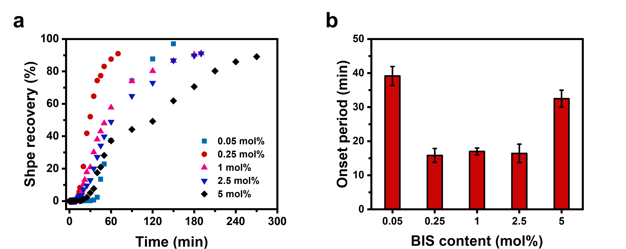
Fig. 5 | Shape recovery kinetics of hydrogels with different BIS content. a, Autonomous shape recovery kinetics of the hydrogel (25 °C) programmed at different heating times. b, Onset period of hydrogels calculated from five parallel experiments.

Fig. 6 | The shape recovery of the hydrogel with different fixed strains as reflected in the deformed angles.

Fig. 7 | Comparison of the shape recovery in water and oil at 25 °C.

Fig. 8 | The shape recovery of the hydrogel samples of different thicknesses in 25 °C water.

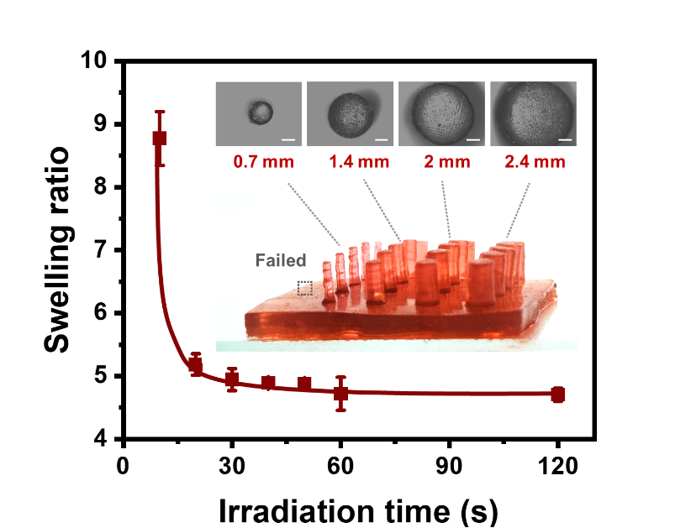
Fig. 9 | The swelling ratio of the hydrogels obtained at different light irradiation time during printing. The inset photos show the printed posts with different diameters with the feature size below 0.7 mm unsuccessful to print. This implies that the printing resolution is around 0.7 mm.

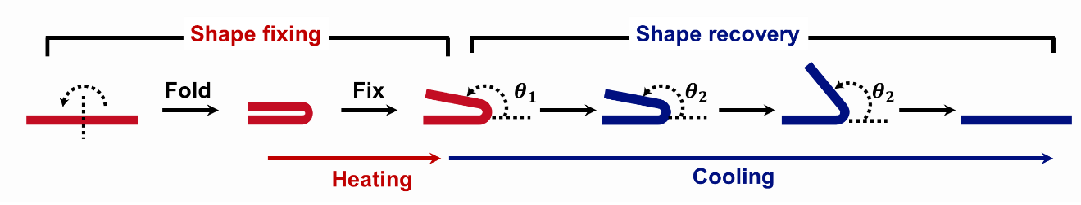
Fig. 10 | Quantification of the shape memory performance.

Table 1 | The enthalpy changes and stiffening temperature of the hydrogels with different crosslinker content.

Crosslinker content (mol%) | ΔH (J/g) | T_{h} (℃)
0.05 | 9.42 | 56.5
0.25 | 8.88 | 56.9
1 | 6.06 | 57.6
2.5 | 2.83 | 58
5 | 1.13 | 61.5
T_{h} refers to the transition temperature determined from the DSC curves.

