Electronic Supplementary Material

First DNA barcode efficiency assessment for an important ingredient in the Amazonian ayahuasca tea: mariri/jagube, Banisteriopsis (Malpighiaceae)

Thalita Zanquetta Luz, Antonio Saulo Cunha-Machado *, Jacqueline da Silva Batista

* Corresponding author: A. S. Cunha-Machado ascmbio@gmail.com

Tables supplementary

Table S1. List of sample codes, place of collection, ethnovariety, and stem morphotype of 20 vines (Banisteriopsis spp.) used in the genetic characterization. 2
Table S2. Result of the BLASTN analysis using the molecular marker ITS for ethnovarieties of Banisteriopsis spp. which are used in the preparation of ayahuasca by the Centro Espírita Beneficente União do Vegetal in the Amazon (CEBUDV). 3
Table S3. Result of the BLASTN analysis for the chloroplastidial marker rbcL performed in the NCBI database of samples from ethnovarities of Banisteriopsis spp. 4
Table S4. Result of the BLASTN analysis for the chloroplastidial marker matK performed in the NCBI database of samples from ethnovarities of Banisteriopsis spp. 5
Table S5. Result of the BLASTN analysis for the chloroplastidial marker ndhF performed in the NCBI database of samples from ethnovarities of Banisteriopsis spp. 6

Figures supplementary

Fig. S1 Photo of 20 stems of Banisteriopsis spp. Details of the genetic lineages for the ITS marker are shown in fig. 2. Sample MT1 (tucunacá without nodes) used for the development of the genomic library. 7
Fig. S2 Phylogenetic trees obtained by the NJ and ML methods for the ITS nuclear molecular marker of 16 Banisteriopsis spp., and a sample of B. caapi (genbank accession number LC496605, Ogata and Hanajiri, unpublished). 8
Fig. S3 Trees obtained by the NJ and ML method for the anonymous marker yage5 for Banisteriopsis spp. 8
Fig. S4 Phylogenetic trees obtained for the MP3 marker from Banisteriopsis spp using the NJ and ML methods. 9
Fig. S5 Phylogenetic trees of three plastid molecular markers (matK, rbcL, and ndhF) from Banisteriopsis spp. that were obtained using the NJ and ML method. 10
Fig. S6 NJ and ML phylogenetic tree of three concatenated plastid markers with 19 Banisteriopsis spp analyzed in the present study and 7 Banisteriopsis species analyzed for Davis and Anderson (2010). 11

Table S1. List of sample codes, place of collection, ethnovariety, and stem morphotype of 20 vines (Banisteriopsis spp.) used in the genetic characterization.
Sample number | Sampling site | Environment | Ethnovariety | Stem morphotype | GAN  ITS | GAN matK | GAN  rbcL | GAN  ndhF
MA8 | Manaus | Cultivated/NMA | Tucunacá | Without nodes | XXX | XXX | XXX | XXX
PF1 | Presidente Figueiredo | Natural | Tucunacá nativo | Without nodes | XXX | XXX | XXX | XXX
PF2 | Presidente Figueiredo | Natural | Tucunacá nativo | Without nodes | XXX | XXX | XXX | XXX
PF14 | Presidente Figueiredo | Natural | Tucunacá nativo | Without nodes | XXX | XXX | XXX | XXX
MT1 | Manaus | Cultivated/NMA | Tucunacá | Without nodes | XXX | XXX | XXX | XXX
MA1 | Manaus | Cultivated/NMA | Caupuri | With elongated nodes | XXX | XXX | XXX | XXX
MA3 | Manaus | Cultivated/NMA | Mariri | Without nodes | XXX | XXX | XXX | XXX
MA7 | Manaus | Cultivated/NMA | Caupuri | With nodes | XXX | XXX | XXX | XXX
MA12 | Manaus | Cultivated/NMA | Caupuri | With nodes | XXX | XXX | XXX | XXX
VM1 | Manaus | Cultivated/NVM | Caupuri | Without nodes | XXX | XXX | XXX | XXX
VM3 | Manaus | Cultivated/NVM | Pajezinho/Caupuri without nodes | Without nodes | XXX | XXX | XXX | XXX
VM4 | Manaus | Cultivated/NVM | Caupuri | Without nodes | XXX | XXX | XXX | XXX
VM5 | Manaus | Cultivated/NVM | Tucunacá | Without nodes | XXX | XXX | XXX | XXX
FN1 | Manaus | Cultivated/NFN | Caupuri | Without nodes | XXX | XXX | XXX | XXX
FN2 | Manaus | Cultivated/NFN | Caupuri | With elongated nodes | XXX | XXX | XXX | XXX
MAO2 | Manaus | Cultivated/NMA | Caupuri | Without nodes | XXX | XXX | XXX | XXX
MOAC3 | Manaus | Cultivated/NFN | Caupuri | With nodes | XXX | XXX | XXX | XXX
SA3 | Novo Airão | Natural | Mariri nativo | Without nodes | XXX | XXX | XXX | XXX
FN4 | Manaus | Cultivated/NFN | Pajezinho/Caupuri without nodes | Without nodes | XXX | XXX | XXX | XXX
PF5 | Presidente Figueiredo | Natural | Mariri nativo | Without nodes | XXX | XXX | XXX | XXX

NMA = Nucleus Mestre Angílio; NVM = Nucleus Vicente Marques; NFN = Nucleus Flor do Norte; GAN = GenBank accession number

Table S2. Result of the BLASTN analysis using the molecular marker ITS for ethnovarieties of Banisteriopsis spp. which are used in the preparation of ayahuasca by the Centro Espírita Beneficente União do Vegetal in the Amazon (CEBUDV).
Sample code | Accession number | GenBank species | Query cover | Percent identity
MA8 |  | Banisteriopsis caapi | 100% | 94.64%
PF1 |  | Banisteriopsis caapi | 100% | 95.24%
PF2 |  | Banisteriopsis caapi | 100% | 95.24%
PF14 |  | Banisteriopsis caapi | 100% | 95.43%
MA1 |  | Banisteriopsis caapi | 99% | 86.43%
FN2 |  | Banisteriopsis caapi | 99% | 86.49%
VM4 |  | Banisteriopsis caapi | 99% | 86.49%
MA12 |  | Banisteriopsis caapi | 99% | 86.49%
MA7 |  | Banisteriopsis caapi | 99% | 86.49%
FN1 |  | Banisteriopsis caapi | 99% | 86.43%
VM1 |  | Banisteriopsis caapi | 99% | 86.43%
MAO2 |  | Banisteriopsis caapi | 99% | 86.24%
MOAC3 |  | Banisteriopsis caapi | 99% | 85.33%
SA3 |  | Banisteriopsis variabilis | 64% | 78.70%
FN4 |  | Camellia sinensis | 30% | 87.97%
PF5 |  | Camellia sinensis | 30% | 87.34%
MA3 |  | - | - | -
VM3 |  | - | - | -
VM5 |  | - | - | -
MT1 |  | - | - | -

All samples attributed to B. caapi were compared with GenBank accession number LC496605 (Ogata and Hanajiri, unpublished); and those attributed to B. variabilis were compared with GenBank accession number KR093012 (Almeida et al., unpublished).

Table S3. Result of the BLASTN analysis for the chloroplastidial marker rbcL performed in the NCBI database of samples from ethnovarities of Banisteriopsis spp.
QC- Query cover/ PI- Percent identity.

GenBank accession numbers | XXX | XXX | XXX | XXX | XXX | XXX | XXX | XXX | XXX | XXX | XXX | XXX | XXX | XXX | XXX | XXX | XXX | XXX | XXX | XXX
Sample ID | PF1 | PF2 | PF5 | PF14 | SA3 | MA1 | MA3 | MA7 | MA8 | MA12 | MAO2 | VM1 | VM3 | VM4 | VM5 | FN1 | FN2 | FN4 | MOAC3 | MT1
 | QC/PI | QC/PI | QC/PI | QC/PI | QC/PI | QC/PI | QC/PI | QC/PI | QC/PI | QC/PI | QC/PI | QC/PI | QC/PI | QC/PI | QC/PI | QC/PI | QC/PI | QC/PI | QC/PI | QC/PI
B. caapi HQ247440 | 100/99.92 | 100/99.92 | 100/99.92 | 100/99.92 | 100/99.92 | 100/99.92 | 100/100 | 100/100 | 100/100 | 100/100 | 100/100 | 100/100 | 100/100 | 100/100 | 100/100 | 100/99.92 | 100/99.92 | 100/100 | 100/100 | 100/100
B. muricata HQ247443 | 100/99.61 | 100/99.61 | 100/99.61 | 100/99.61 | 100/99.61 | 100/99.61 | 100/99.69 | 100/99.69 | 100/99.69 | 100/99.69 | 100/99.69 | 100/99.69 | 100/99.69 | 100/99.69 | 100/99.69 | 100/99.61 | 100/99.61 | 100/99.69 | 100/99.69 | 100/99.69
B. adenopoda HQ247438 | 98/99.61 | 98/99.61 | 98/99.61 | 98/99.61 | 98/99.61 | 98/99.61 | 98/99.69 | 98/99.69 | 98/99.69 | 98/99.69 | 98/99.69 | 98/99.69 | 98/99.69 | 98/99.69 | 98/99.69 | 98/99.61 | 98/99.61 | 98/99.69 | 98/99.69 | 98/99.69
B. argyrophylla HQ247439 | - | - | - | - | - | - | - | - | - | - | - | - | - | - | - | - | - | - | - | -
B. laevifolia HQ247441 | 100/99.61 | 100/99.61 | 100/99.61 | 100/99.61 | 100/99.61 | 100/99.61 | 100/99.69 | 100/99.69 | 100/99.69 | 100/99.69 | 100/99.69 | 100/99.69 | 100/99.69 | 100/99.69 | 100/99.69 | 100/99.61 | 100/99.61 | 100/99.69 | 100/99.69 | 100/99.69
B. martiniana HQ247442 | 100/99.53 | 100/99.53 | 100/99.53 | 100/99.53 | 100/99.53 | 100/99.53 | 100/99.61 | 100/99.61 | 100/99.61 | 100/99.61 | 100/99.61 | 100/99.61 | 100/99.61 | 100/99.61 | 100/99.61 | 100/99.53 | 100/99.53 | 100/99.61 | 100/99.61 | 100/99.61
B. nummifera HQ247444 | 98/99.45 | 98/99.45 | 98/99.45 | 98/99.45 | 98/99.45 | 98/99.45 | 98/99.53 | 98/99.53 | 98/99.53 | 98/99.53 | 98/99.53 | 98/99.53 | 98/99.53 | 98/99.53 | 98/99.53 | 98/99.45 | 98/99.45 | 98/99.53 | 98/99.53 | 98/99.53
B. schwannioides HQ247445 | 98/100 | 98/100 | 98/100 | 98/100 | 98/100 | 98/100 | 98/99.92 | 98/99.92 | 98/99.92 | 98/99.92 | 98/99.92 | 98/99.92 | 98/99.92 | 98/99.92 | 98/99.92 | 98/100 | 98/100 | 98/99.92 | 98/99.92 | 98/99.92

Table S4. Result of the BLASTN analysis for the chloroplastidial marker matK performed in the NCBI database of samples from ethnovarities of Banisteriopsis spp.
QC- Query cover/ PI- Percent identity.

GenBank accession numbers | XXX | XXX | XXX | XXX | XXX | XXX | XXX | XXX | XXX | XXX | XXX | XXX | XXX | XXX | XXX | XXX | XXX | XXX | XXX | XXX
Sample ID | PF1 | PF2 | PF5 | PF14 | SA3 | MA1 | MA3 | MA7 | MA8 | MA12 | MAO2 | VM1 | VM3 | VM4 | VM5 | FN1 | FN2 | FN4 | MOAC3 | MT1
 | QC/PI | QC/PI | QC/PI | QC/PI | QC/PI | QC/PI | QC/PI | QC/PI | QC/PI | QC/PI | QC/PI | QC/PI | QC/PI | QC/PI | QC/PI | QC/PI | QC/PI | QC/PI | QC/PI | QC/PI
B. caapi HQ247200 | 84/99.91 | 84/99.91 | 84/99.91 | 84/99.91 | 84/99.91 | 84/99.73 | 84/100 | 84/100 | 84/100 | 84/100 | 84/99.91 | 84/99.91 | 84/100 | 84/100 | 84/100 | 84/99.73 | 84/99.73 | 84/100 | 84/100 | 84/100
B. muricata HQ247208 | 84/98.81 | 84/98.81 | 84/98.81 | 84/98.81 | 84/98.81 | 84/98.81 | 84/98.72 | 84/98.72 | 84/98.72 | 84/98.72 | 84/98.81 | 84/98.81 | 84/98.72 | 84/98.72 | 84/98.72 | 84/98.81 | 84/98.81 | 84/98.72 | 84/98.72 | 84/98.72
B. acerosa HQ247197 | 84/99.54 | 84/99.54 | 84/99.54 | 84/99.54 | 84/99.54 | 84/99.54 | 84/99.45 | 84/99.45 | 84/99.45 | 84/99.45 | 84/99.54 | 84/99.54 | 84/99.45 | 84/99.45 | 84/99.45 | 84/99.54 | 84/99.54 | 84/99.45 | 84/99.45 | 84/99.45
B. angustifolia HQ247198 | 84/99.45 | 84/99.45 | 84/99.45 | 84/99.45 | 84/99.45 | 84/99.45 | 84/99.36 | 84/99.36 | 84/99.36 | 84/99.36 | 84/99.45 | 84/99.45 | 84/99.36 | 84/99.36 | 84/99.36 | 84/99.45 | 84/99.45 | 84/99.36 | 84/99.36 | 84/99.36
B. argyrophylla HQ247199 | 84/99.54 | 84/99.54 | 84/99.54 | 84/99.54 | 84/99.54 | 84/99.54 | 84/99.45 | 84/99.45 | 84/99.45 | 84/99.45 | 84/99.54 | 84/99.54 | 84/99.45 | 84/99.45 | 84/99.45 | 84/99.54 | 84/99.54 | 84/99.45 | 84/99.45 | 84/99.45
B. calcicola HQ247201 | 84/99.45 | 84/99.45 | 84/99.45 | 84/99.45 | 84/99.45 | 84/99.45 | 84/99.36 | 84/99.36 | 84/99.36 | 84/99.36 | 84/99.45 | 84/99.45 | 84/99.36 | 84/99.36 | 84/99.36 | 84/99.45 | 84/99.45 | 84/99.36 | 84/99.36 | 84/99.36
B. confusa HQ247202 | - | - | - | - | - | - | - | - | - | - | - | - | - | - | - | - | - | - | - | -
B. gardneriana HQ247203 | 84/99.09 | 84/99.09 | 84/99.09 | 84/99.09 | 84/99.09 | 84/99.09 | 84/98.99 | 84/98.99 | 84/98.99 | 84/98.99 | 84/99.09 | 84/99.09 | 84/98.99 | 84/98.99 | 84/98.99 | 84/99.09 | 84/99.09 | 84/98.99 | 84/98.99 | 84/98.99
B. harleyi HQ247204 | 82/99.44 | 82/99.44 | 82/99.44 | 82/99.44 | 82/99.44 | 82/99.44 | 82/99.35 | 82/99.35 | 82/99.35 | 82/99.35 | 82/99.44 | 82/99.44 | 82/99.35 | 82/99.35 | 82/99.35 | 82/99.44 | 82/99.44 | 82/99.35 | 82/99.35 | 82/99.35
B. laevifolia HQ247205 | 84/99.54 | 84/99.54 | 84/99.54 | 84/99.54 | 84/99.54 | 84/99.36 | 84/99.45 | 84/99.45 | 84/99.45 | 84/99.45 | 84/99.54 | 84/99.54 | 84/99.45 | 84/99.45 | 84/99.45 | 84/99.36 | 84/99.36 | 84/99.45 | 84/99.45 | 84/99.45
B. latifolia HQ247206 | 82/99.54 | 82/99.54 | 82/99.54 | 82/99.54 | 82/99.54 | 82/99.54 | 82/99.44 | 82/99.44 | 82/99.44 | 82/99.44 | 82/99.54 | 82/99.54 | 82/99.44 | 82/99.44 | 82/99.44 | 82/99.54 | 82/99.54 | 82/99.44 | 82/99.44 | 82/99.44
B. martiniana HQ247207 | 84/98.72 | 84/98.72 | 84/98.72 | 84/98.72 | 84/98.72 | 84/98.72 | 84/98.63 | 84/98.63 | 84/98.63 | 84/98.63 | 84/98.72 | 84/98.72 | 84/98.63 | 84/98.63 | 84/98.63 | 84/98.72 | 84/98.72 | 84/98.63 | 84/98.63 | 84/98.63
B. nummifera HQ247209 | 84/99.09 | 84/99.09 | 84/99.09 | 84/99.09 | 84/99.09 | 84/99.09 | 84/98.99 | 84/98.99 | 84/98.99 | 84/98.99 | 84/99.09 | 84/99.09 | 84/98.99 | 84/98.99 | 84/98.99 | 84/99.09 | 84/99.09 | 84/98.99 | 84/98.99 | 84/98.99
B. paraguariensis HQ247210 | 84/99.54 | 84/99.54 | 84/99.54 | 84/99.54 | 84/99.54 | 84/99.54 | 84/99.45 | 84/99.45 | 84/99.45 | 84/99.45 | 84/99.54 | 84/99.54 | 84/99.45 | 84/99.45 | 84/99.45 | 84/99.54 | 84/99.54 | 84/99.45 | 84/99.45 | 84/99.45
B. pulchra HQ247211 | 84/99.63 | 84/99.63 | 84/99.63 | 84/99.63 | 84/99.63 | 84/99.63 | 84/99.54 | 84/99.54 | 84/99.54 | 84/99.54 | 84/99.63 | 84/99.63 | 84/99.54 | 84/99.54 | 84/99.54 | 84/99.63 | 84/99.63 | 84/99.54 | 84/99.54 | 84/99.54
B. schwannioides HQ247212 | 84/100 | 84/100 | 84/100 | 84/100 | 84/100 | 84/99.82 | 84/99.91 | 84/99.91 | 84/99.91 | 84/99.91 | 84/100 | 84/100 | 84/99.91 | 84/99.91 | 84/99.91 | 84/99.82 | 84/99.82 | 84/99.91 | 84/99.91 | 84/99.91

Table S5. Result of the BLASTN analysis for the chloroplastidial marker ndhF performed in the NCBI database of samples from ethnovarities of Banisteriopsis spp.
QC- Query cover/ PI- Percent identity.

GenBank accession numbers | XXX | XXX | XXX | XXX | XXX | XXX | XXX | XXX | XXX | XXX | XXX | XXX | XXX | XXX | XXX | XXX | XXX | XXX | XXX | XXX
Sample ID | PF1 | PF2 | PF5 | PF14 | SA3 | MA1 | MA3 | MA7 | MA8 | MA12 | MAO2 | VM1 | VM3 | VM4 | VM5 | FN1 | FN2 | FN4 | MOAC3 | MT1
 | QC/PI | QC/PI | QC/PI | QC/PI | QC/PI | QC/PI | QC/PI | QC/PI | QC/PI | QC/PI | QC/PI | QC/PI | QC/PI | QC/PI | QC/PI | QC/PI | QC/PI | QC/PI | QC/PI | QC/PI
B. caapi HQ246753 | 100/99.71 | 100/99.71 | 100/99.71 | 100/99.71 | 100/99.71 | 100/99.85 | 100/100 | 100/100 | 100/100 | 100/100 | 100/99.85 | 100/99.71 | 100/100 | 100/100 | 100/100 | 100/99.85 | 100/99.85 | 100/100 | 100/100 | -
B. muricata HQ246760 | 100/99.13 | 100/99.13 | 100/99.13 | 100/99.13 | 100/99.13 | 100/99.27 | 100/99.13 | 100/99.13 | 100/99.13 | 100/99.13 | 100/99.27 | 100/99.13 | 100/99.13 | 100/99.13 | 100/99.13 | 100/99.27 | 100/99.27 | 100/99.13 | 100/99.13 | -
B. adenopoda HQ246750 | 100/99.71 | 100/99.71 | 100/99.71 | 100/99.71 | 100/99.71 | 100/99.85 | 100/99.71 | 100/99.71 | 100/99.71 | 100/99.71 | 100/99.85 | 100/99.71 | 100/99.71 | 100/99.71 | 100/99.71 | 100/99.85 | 100/99.85 | 100/99.71 | 100/99.71 | -
B. angustifolia HQ246751 | 100/98.84 | 100/98.84 | 100/98.84 | 100/98.84 | 100/98.84 | 100/98.84 | 100/98.69 | 100/98.69 | 100/98.69 | 100/98.69 | 100/98.84 | 100/98.69 | 100/98.69 | 100/98.69 | 100/98.69 | 100/98.84 | 100/98.84 | 100/98.69 | 100/98.69 | -
B. argyrophylla HQ246752 | 100/98.98 | 100/98.98 | 100/98.98 | 100/98.98 | 100/98.98 | 100/99.13 | 100/98.98 | 100/98.98 | 100/98.98 | 100/98.98 | 100/99.13 | 100/98.98 | 100/98.98 | 100/98.98 | 100/98.98 | 100/99.13 | 100/99.13 | 100/98.98 | 100/98.98 | -
B. calcicola HQ246754 | 100/99.13 | 100/99.13 | 100/99.13 | 100/99.13 | 100/99.13 | 100/99.13 | 100/98.98 | 100/98.98 | 100/98.98 | 100/98.98 | 100/99.13 | 100/98.98 | 100/98.98 | 100/98.98 | 100/98.98 | 100/99.13 | 100/99.13 | 100/98.98 | 100/98.98 | -
B. confusa HQ246755 | 100/99.71 | 100/99.71 | 100/99.71 | 100/99.71 | 100/99.71 | 100/99.85 | 100/99.71 | 100/99.71 | 100/99.71 | 100/99.71 | 100/99.85 | 100/99.71 | 100/99.71 | 100/99.71 | 100/99.71 | 100/99.85 | 100/99.85 | 100/99.71 | 100/99.71 | -
B. harleyi HQ246756 | 100/99.13 | 100/99.13 | 100/99.13 | 100/99.13 | 100/99.13 | 100/99.27 | 100/99.13 | 100/99.13 | 100/99.13 | 100/99.13 | 100/99.27 | 100/99.13 | 100/99.13 | 100/99.13 | 100/99.13 | 100/99.27 | 100/99.27 | 100/99.13 | 100/99.13 | -
B. laevifolia HQ246757 | 100/98.69 | 100/98.69 | 100/98.69 | 100/98.69 | 100/98.69 | 100/98.84 | 100/98.69 | 100/98.69 | 100/98.69 | 100/98.69 | 100/98.84 | 100/98.69 | 100/98.69 | 100/98.69 | 100/98.69 | 100/98.84 | 100/98.84 | 100/98.69 | 100/98.69 | -
B. latifolia HQ246758 | - | - | - | - | - | - | - | - | - | - | - | - | - | - | - | - | - | - | - | -
B. martiniana HQ246759 | 100/98.54 | 100/98.54 | 100/98.54 | 100/98.54 | 100/98.54 | 100/98.69 | 100/98.69 | 100/98.69 | 100/98.69 | 100/98.69 | 100/98.69 | 100/98.54 | 100/98.69 | 100/98.69 | 100/98.69 | 100/98.69 | 100/98.69 | 100/98.69 | 100/98.69 | -
B. nummifera HQ246761 | 100/98.12 | 100/98.12 | 100/98.12 | 100/98.12 | 100/98.12 | 100/98.27 | 100/98.12 | 100/98.12 | 100/98.12 | 100/98.12 | 100/98.27 | 100/98.12 | 100/98.12 | 100/98.12 | 100/98.12 | 100/98.27 | 100/98.27 | 100/98.12 | 100/98.12 | -
B. paraguariensis HQ246762 | 100/98.84 | 100/98.84 | 100/98.84 | 100/98.84 | 100/98.84 | 100/98.98 | 100/98.84 | 100/98.84 | 100/98.84 | 100/98.84 | 100/98.98 | 100/98.84 | 100/98.84 | 100/98.84 | 100/98.84 | 100/98.98 | 100/98.98 | 100/98.84 | 100/98.84 | -
B. pulchra HQ246763 | - | - | - | - | - | - | - | - | - | - | - | - | - | - | - | - | - | - | - | -
B. schwannioides HQ246764 | 100/99.71 | 100/99.71 | 100/99.71 | 100/99.71 | 100/99.71 | 100/99.85 | 100/99.71 | 100/99.71 | 100/99.71 | 100/99.71 | 100/99.85 | 100/99.71 | 100/99.71 | 100/99.71 | 100/99.71 | 100/99.85 | 100/99.85 | 100/99.71 | 100/99.71 | -
B. sellowiana HQ246765 | 100/98.98 | 100/98.98 | 100/98.98 | 100/98.98 | 100/98.98 | 100/99.13 | 100/98.98 | 100/98.98 | 100/98.98 | 100/98.98 | 100/99.13 | 100/98.98 | 100/98.98 | 100/98.98 | 100/98.98 | 100/99.13 | 100/99.13 | 100/98.98 | 100/98.98 | -

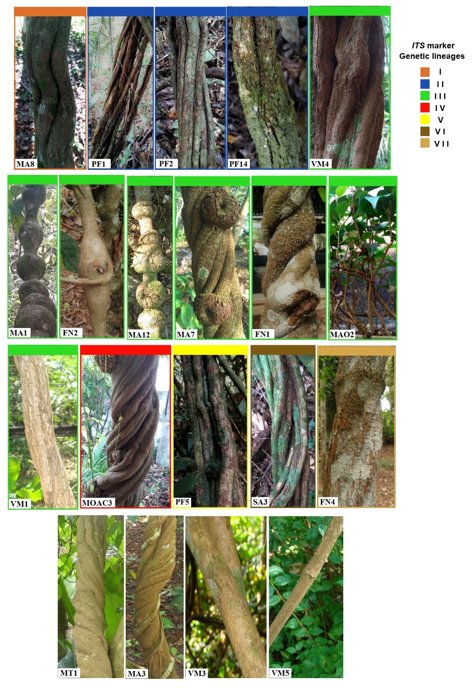

Fig. S1 Photo of 20 stems of Banisteriopsis spp. Details of the genetic lineages for the ITS marker are shown in fig. 2. Sample MT1 (tucunacá without nodes) used for the development of the genomic library.

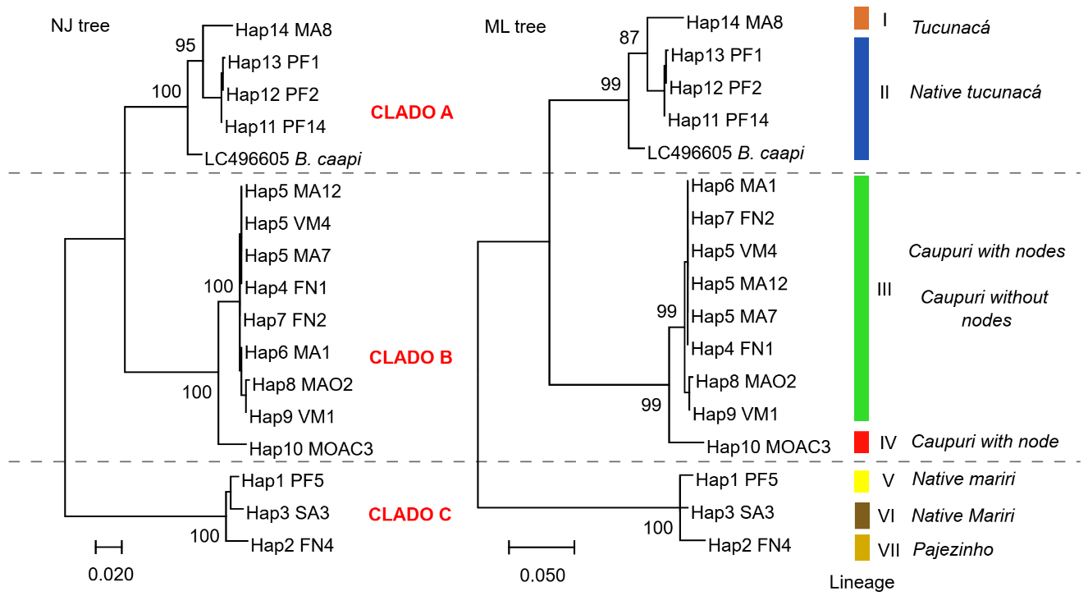
Fig. S2 Phylogenetic trees obtained by the NJ and ML methods for the ITS nuclear molecular marker of 16 Banisteriopsis spp., and a sample of B. caapi (GenBank accession number LC496605, Ogata and Hanajiri, unpublished).

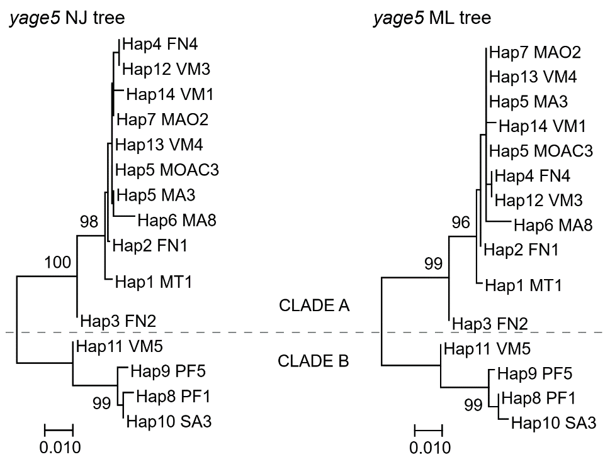

Fig. S3 Trees obtained by the NJ and ML method for the anonymous marker yage5 for Banisteriopsis spp.

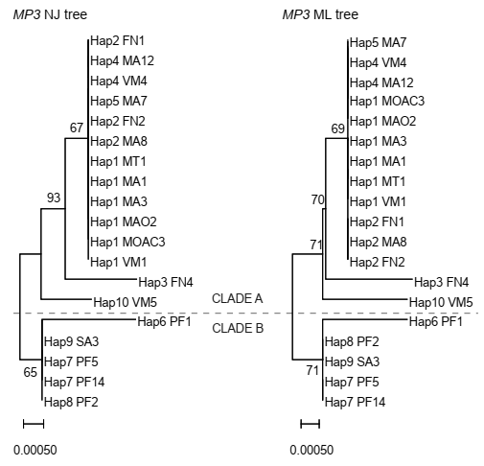

Fig. S4 Phylogenetic trees obtained for the MP3 marker from Banisteriopsis spp using the NJ and ML methods.

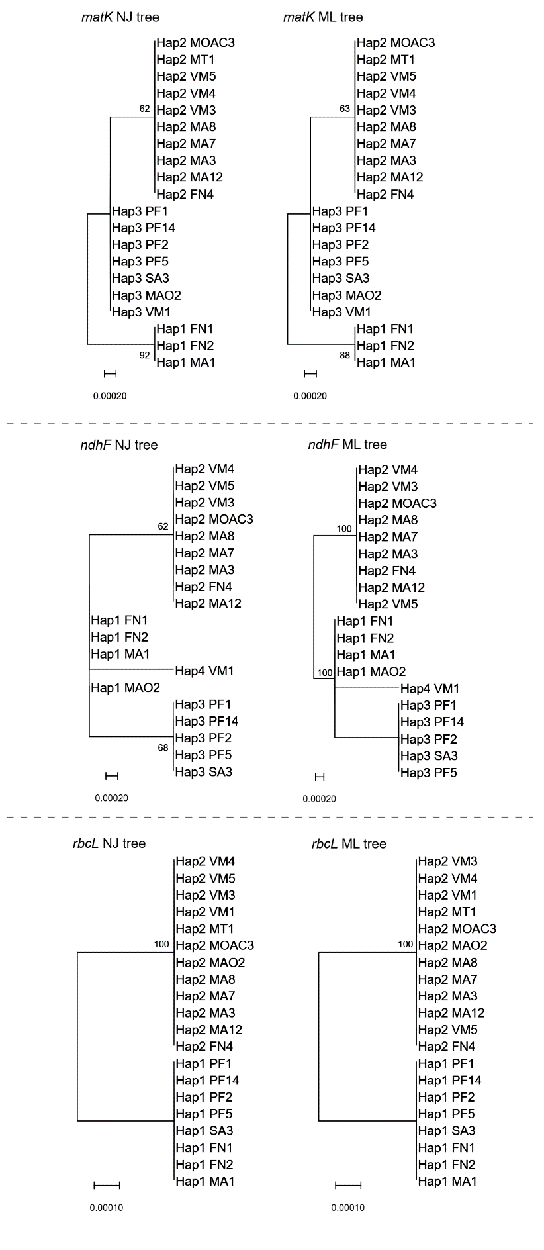

Fig. S5 Phylogenetic trees of three plastid molecular markers (matK, rbcL, and ndhF) from Banisteriopsis spp. that were obtained using the NJ and ML method.
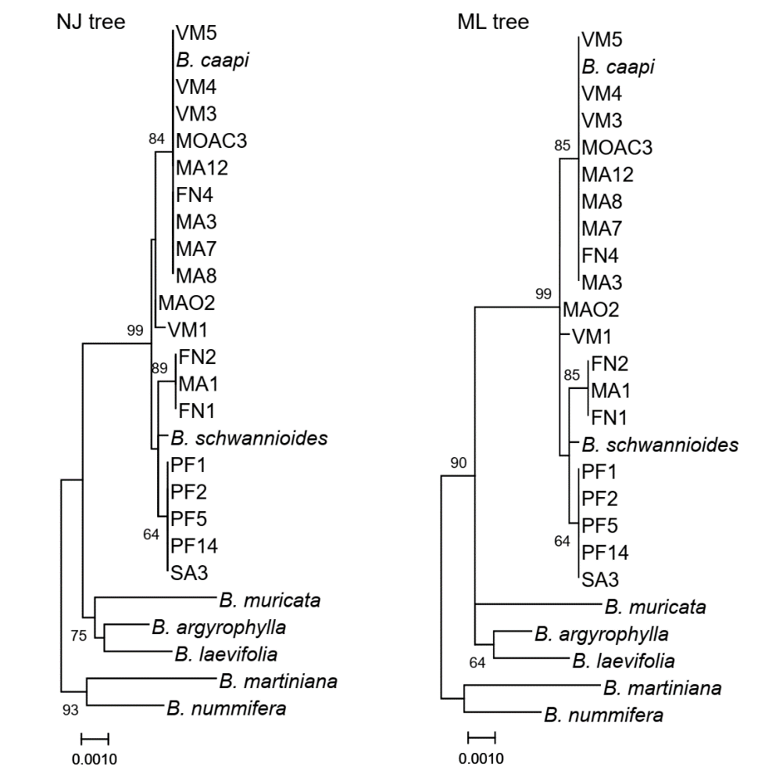

Fig. S6 NJ and ML phylogenetic tree of three concatenated plastid markers with 19 Banisteriopsis spp analyzed in the present study and 7 Banisteriopsis species analyzed for Davis and Anderson (2010).

