Supporting information
A Reactivity-controlled Epitaxial Growth Strategy for Large-sized Nanocrystal Synthesis
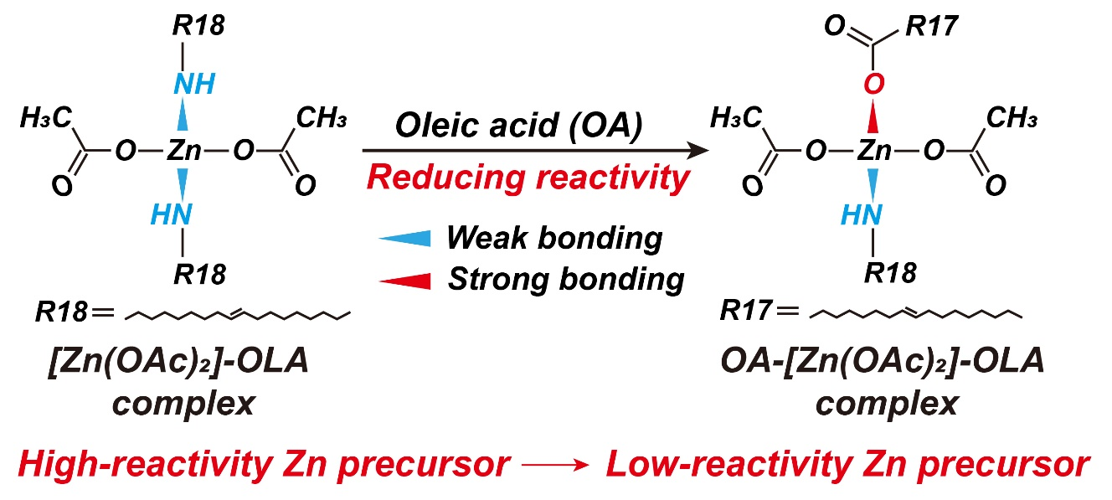
Figure S1 Schematic chemical structure and reactivity controlling of [Zn(OAc)₂]-OLA and OA-[Zn(OAc)₂]-OLA complex.
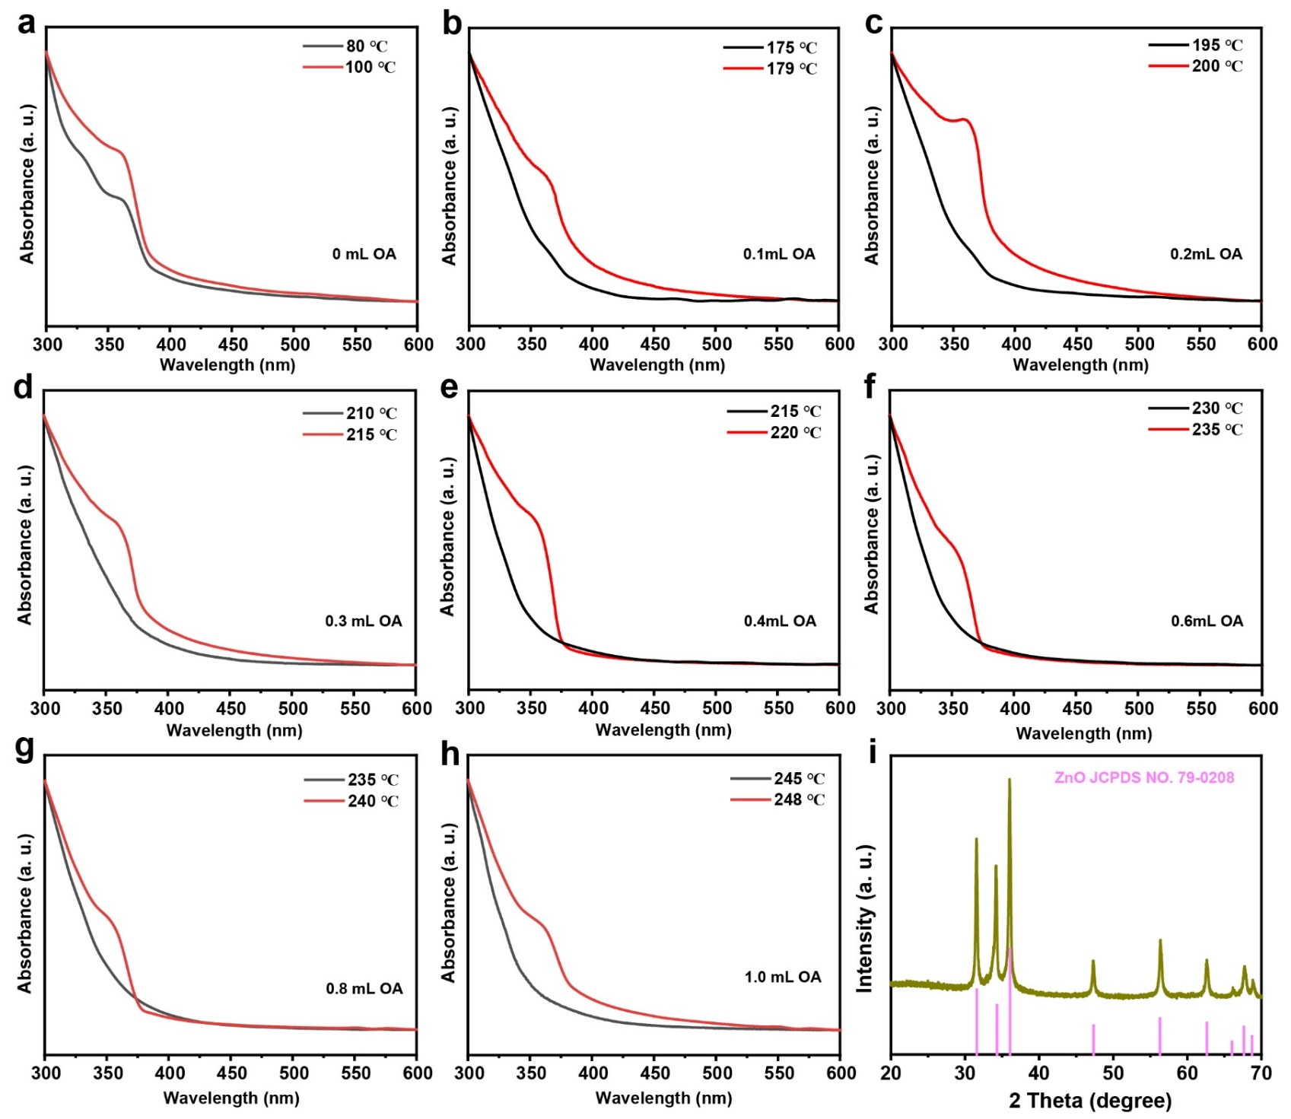
Figure S2 a-h, Absorption spectra of OA-[Zn(OAc)₂]-OLA with different OA/OLA ratio before (black line) and after (red line) ZnO nanoparticles were formed, from which, we can see the initial formed temperature of ZnO nanoparticles were increase with the increase of OA/OLA ratio. i, XRD pattern of ZnO nanoparticles from the decomposition of OA-[Zn(OAc)₂]-OLA, which corresponding to the hexagonal structure of ZnO.
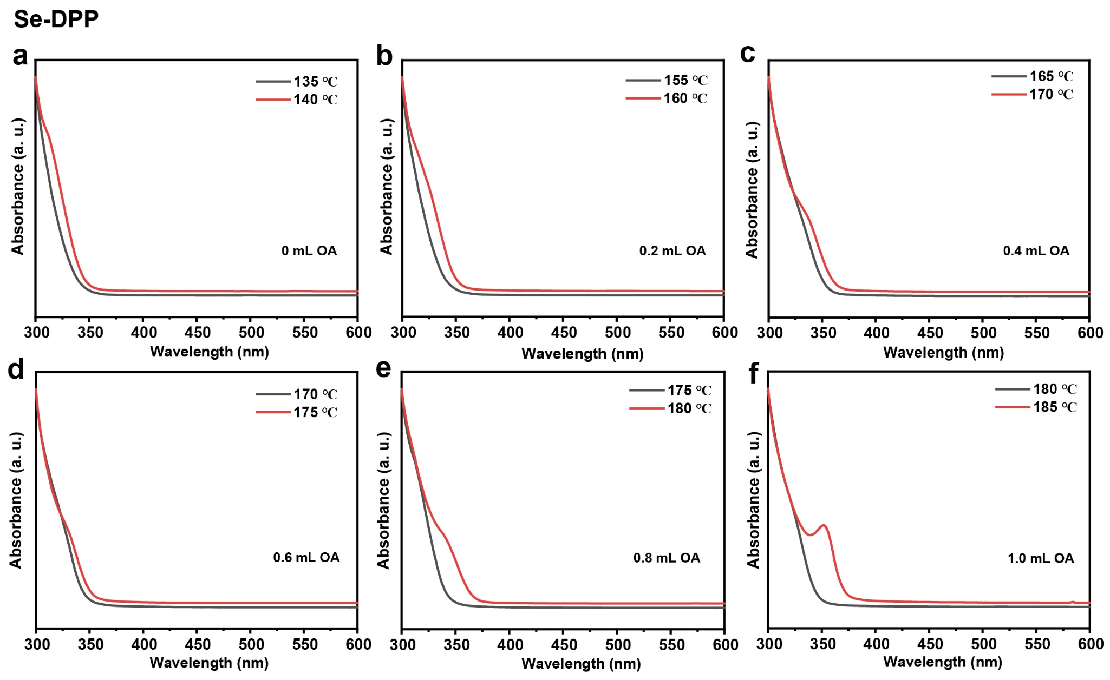
Figure S3 Absorption spectra of samples obtained by using Se-DPP as the Se precursor and different Zn precursors (OA-[Zn(OAc)₂]-OLA) with various OA/OLA ratio, a, OA/OLA=0. b, OA/OLA=0.2. c, OA/OLA=0.4. d, OA/OLA=0.6. e, OA/OLA=0.8. f, OA/OLA=1.0. Before the temperature of nucleation, the absorption spectra almost have no change (black line), after ZnSe nuclei were initiated, excitonic absorption peak were begun appears on the absorption spectra (red line).
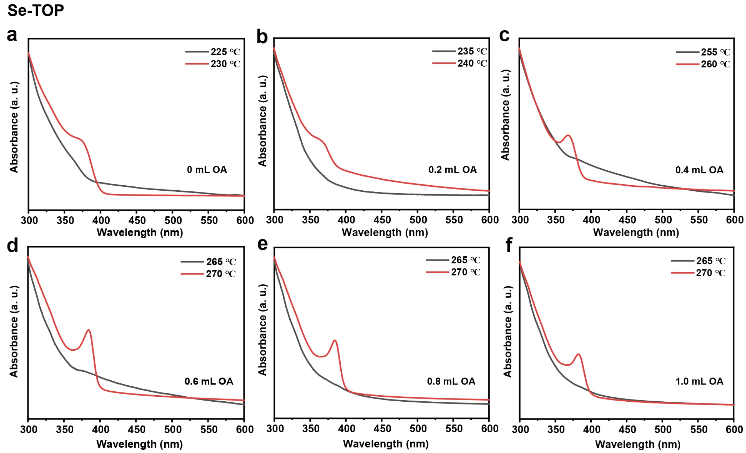
Figure S4 Absorption spectra of samples obtained by using Se-TOP as the Se precursor and different Zn precursors (OA-[Zn(OAc)₂]-OLA) with various OA/OLA ratio, a, OA/OLA=0. b, OA/OLA=0.2. c, OA/OLA=0.4. d, OA/OLA=0.6. e, OA/OLA=0.8. f, OA/OLA=1.0.
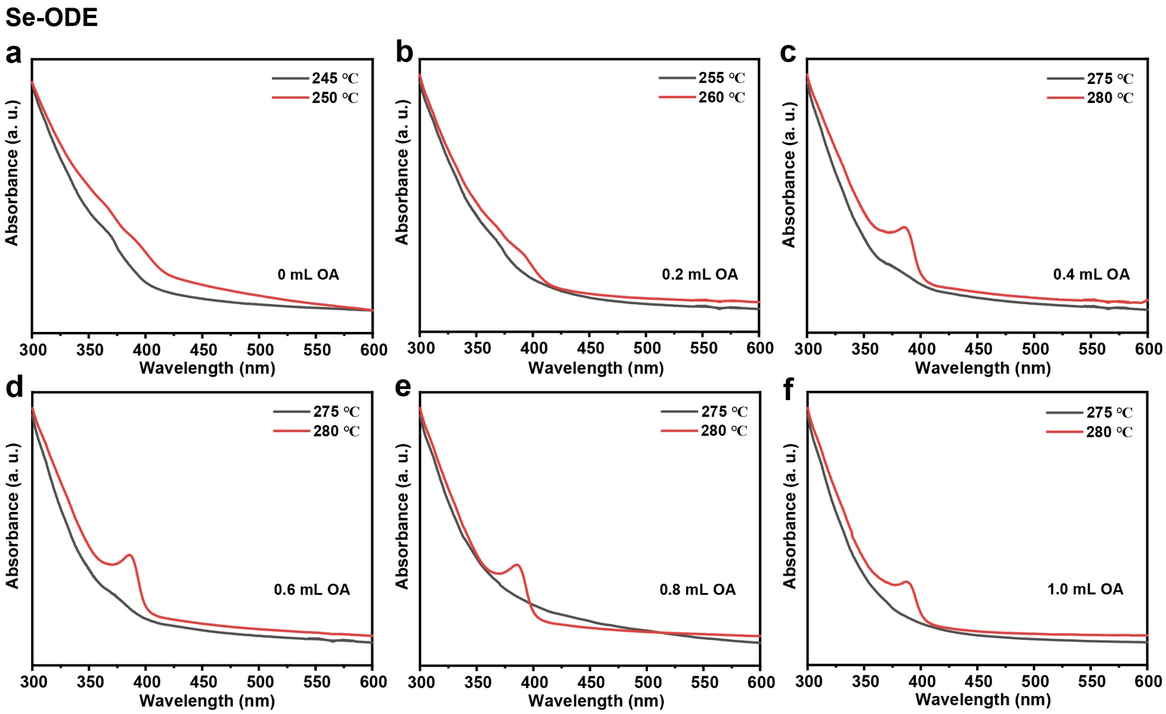
Figure S5 Absorption spectra of samples obtained by using Se-ODE as the Se precursor and different Zn precursors (OA-[Zn(OAc)₂]-OLA) with various OA/OLA ratio, a, OA/OLA=0. b, OA/OLA=0.2. c, OA/OLA=0.4. d, OA/OLA=0.6. e, OA/OLA=0.8. f, OA/OLA=1.0.

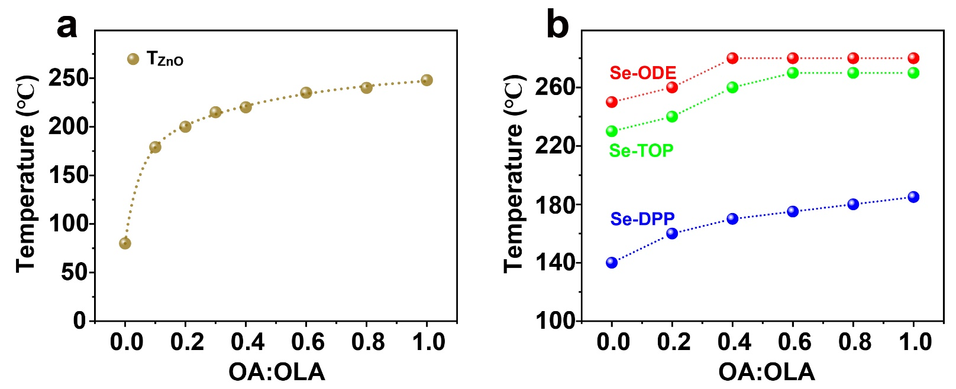
Figure S6 a, Experimental results of transformation temperature of OA-[Zn(OAc)₂]-OLA complex with different OA/OLA ratio. OA-[Zn(OAc)₂]-OLA complex can decompose to ZnO nanoparticles after reaching the activation temperature, higher transformation temperature of ZnO corresponding to lower reactivity. b, Experimental results of nucleation temperature of ZnSe use Se-DPP, Se-TOP, Se-ODE as Se precursors, reacting with different Zn precursors (OA-[Zn(OAc)₂]-OLA with various OA/OLA ratio). The higher nucleation temperature corresponding to lower reactivity. The nucleation temperature was characterized by monitoring the first exciton absorption peak of UV-vis spectra.
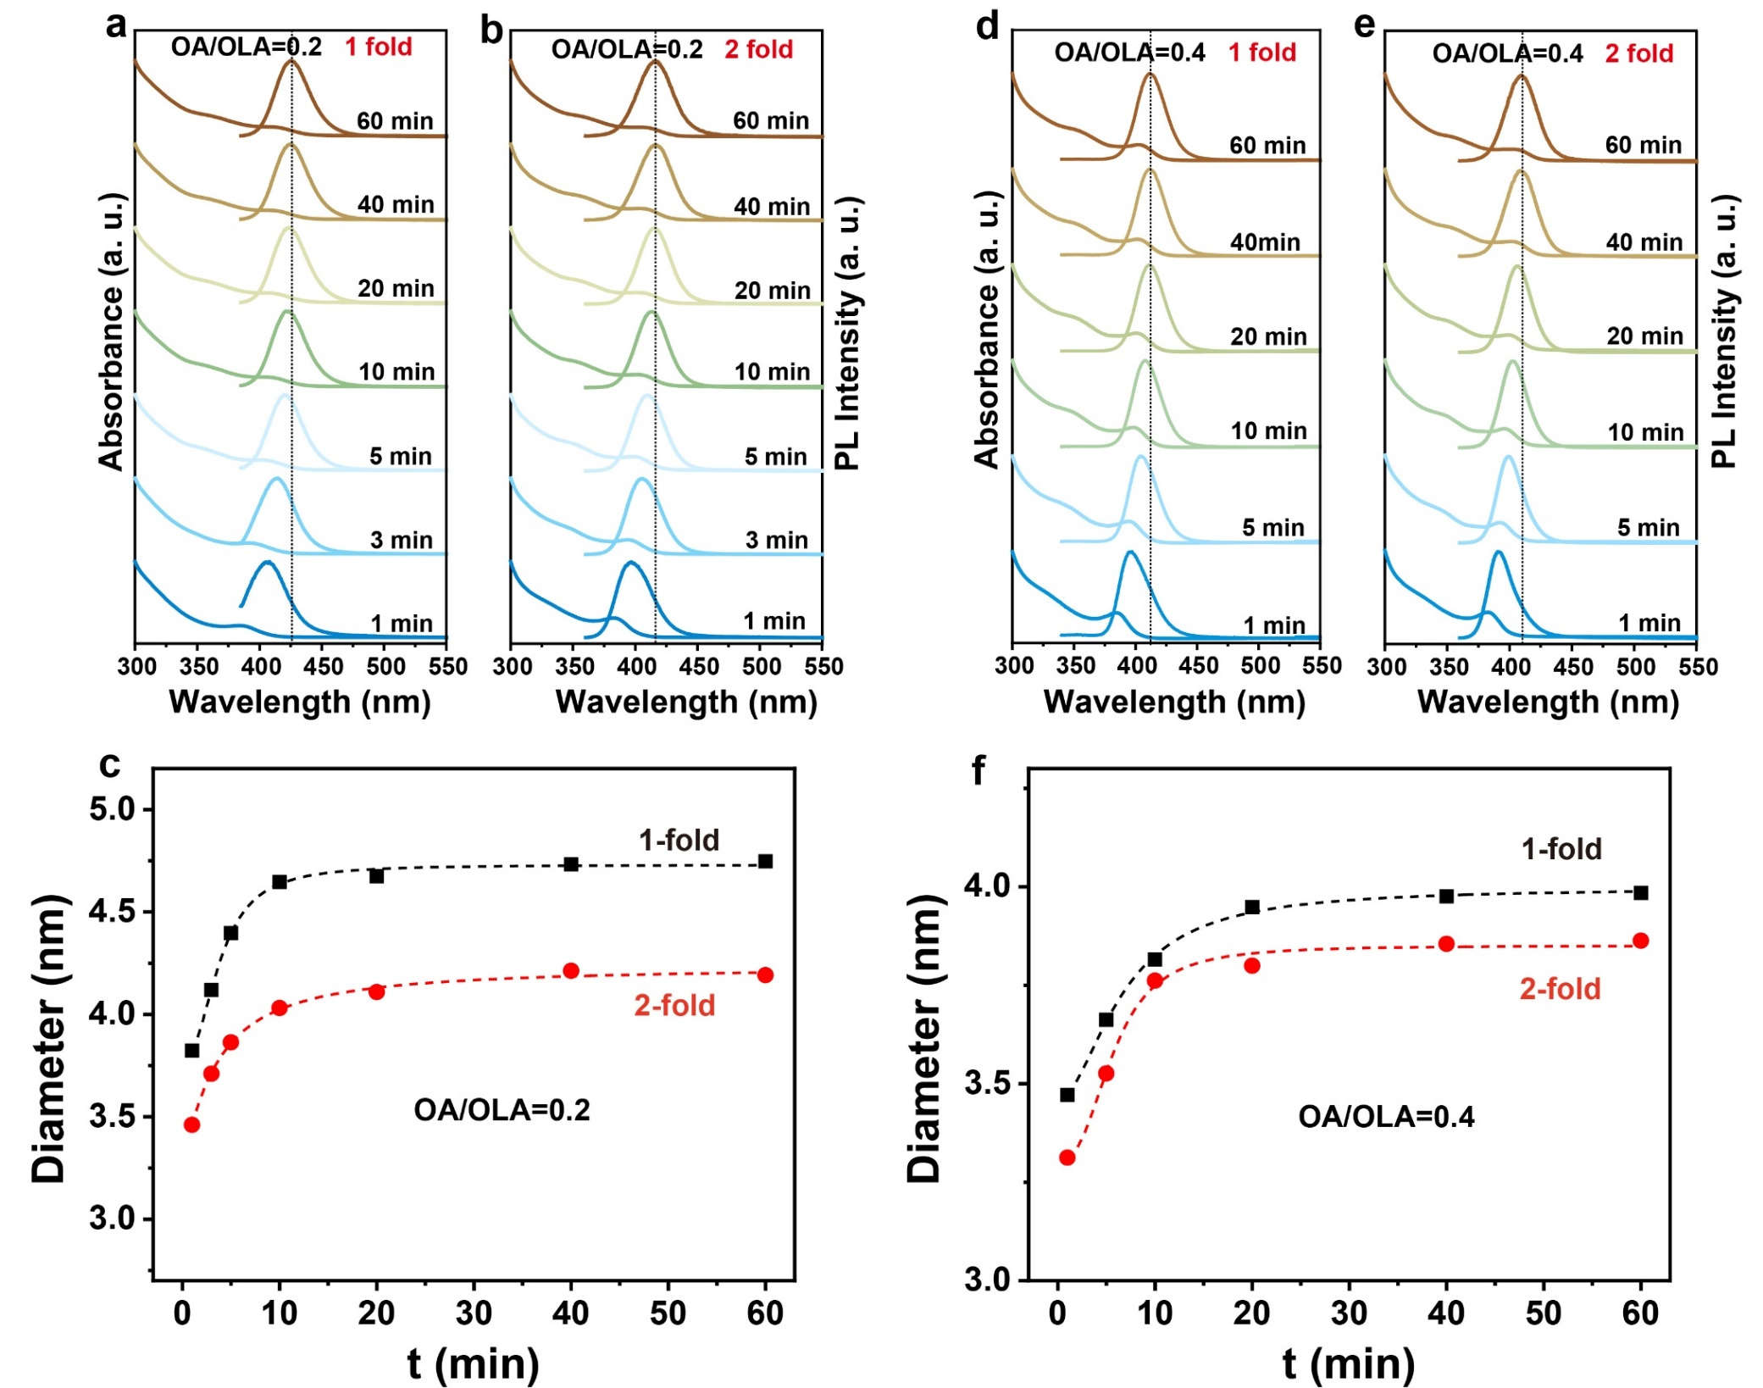
Figure S7 The effect of precursors concentration on ZnSe nucleation reaction via hot-injection method. Evolution of the UV-vis absorption and PL spectra of ZnSe nanocrystals with reaction time at different precursors concentration, a, OA/OLA=0.2 and Se precursor is 0.2 M (1-fold). b, OA/OLA=0.2 and Se precursor is 0.4 M (2-fold). d, OA/OLA=0.4 and Se precursor is 0.2 M (1-fold). e, OA/OLA=0.4 and Se precursor is 0.4 M (2-fold). c, f, Evolution of the diameter of ZnSe nanocrystals with reaction time at precursors concentration of 1-fold and 2-fold.
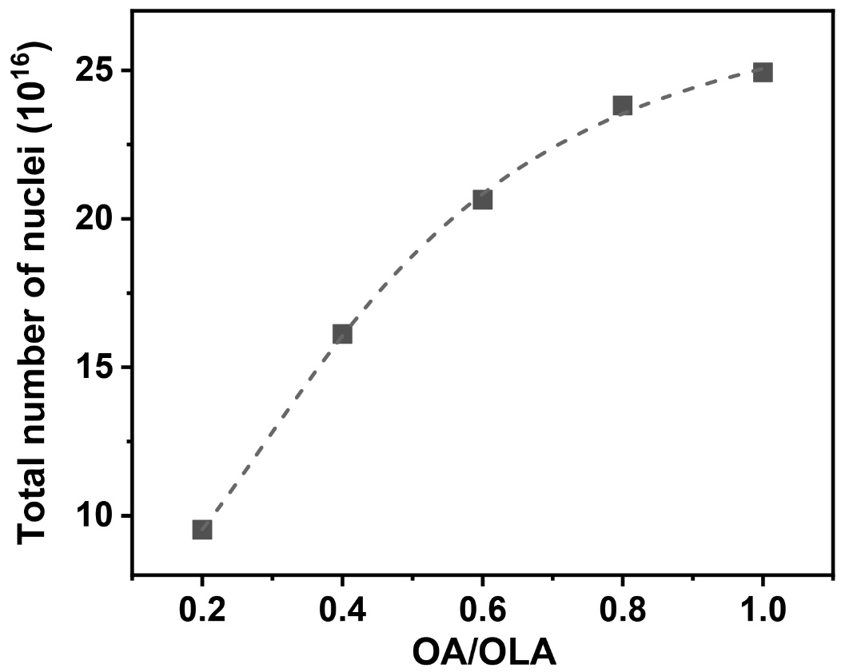
Figure S8 The total number of ZnSe nuclei produced in one-step hot-injection synthesis with different OA/OLA value. The total number of nuclei increased with the OA concentration increasing.
Extended Data Table 1 | The total number of ZnSe nuclei produced in one-step hot-injection synthesis under different conditions
 | OA/OLA=0.2 | OA/OLA=0.4 | OA/OLA=0.6 | OA/OLA=0.8 | OA/OLA=1.0 | OA/OLA=0.2  2-fold | OA/OLA=0.4  2-fold
Total number of nuclei (10¹⁶) | 9.5 | 16.1 | 20.6 | 23.8 | 24.9 | 13.8 | 17.7
Final size (nm) | 4.75 | 3.98 | 3.67 | 3.5 | 3.44 | 4.19 | 3.88

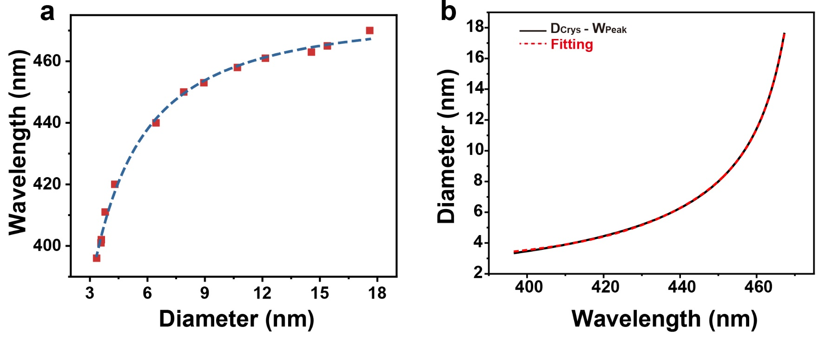
Figure S9 Fitting curve of the relation between PL peak and diameter of ZnSe nanocrystals. a, Experimental results of PL peak versus diameter of ZnSe nanocrystals, as well as their fitting result expressed in a power law relation of W_{peak} = 476.02*D^{1.42}/(1.08^{1.42}+D^{1.42}), R² = 0.999. b, The fitting result of diameter versus PL peak of ZnSe nanocrystals which expressed in a power law relation of D = 2.76 + 8.59*10⁻⁴ *EXP((W_{peak}-421.86)/5.21) + 1.78* EXP((W_{peak}-421.86)/26.88), R² = 0.999.
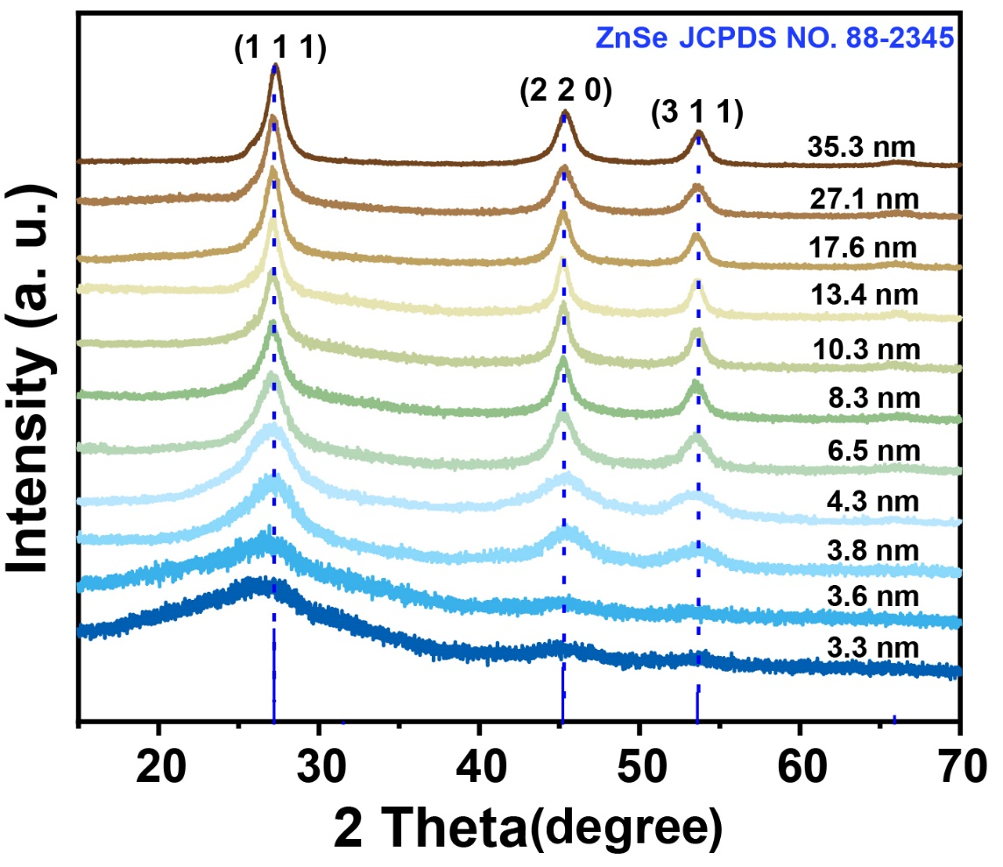
Figure S10 XRD patterns of ZnSe nanocrystals with different emission wavelength.

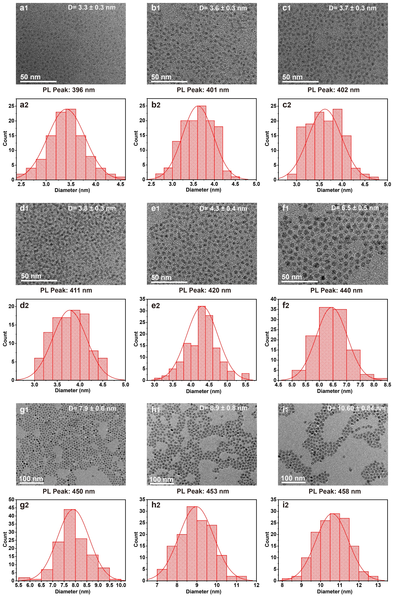
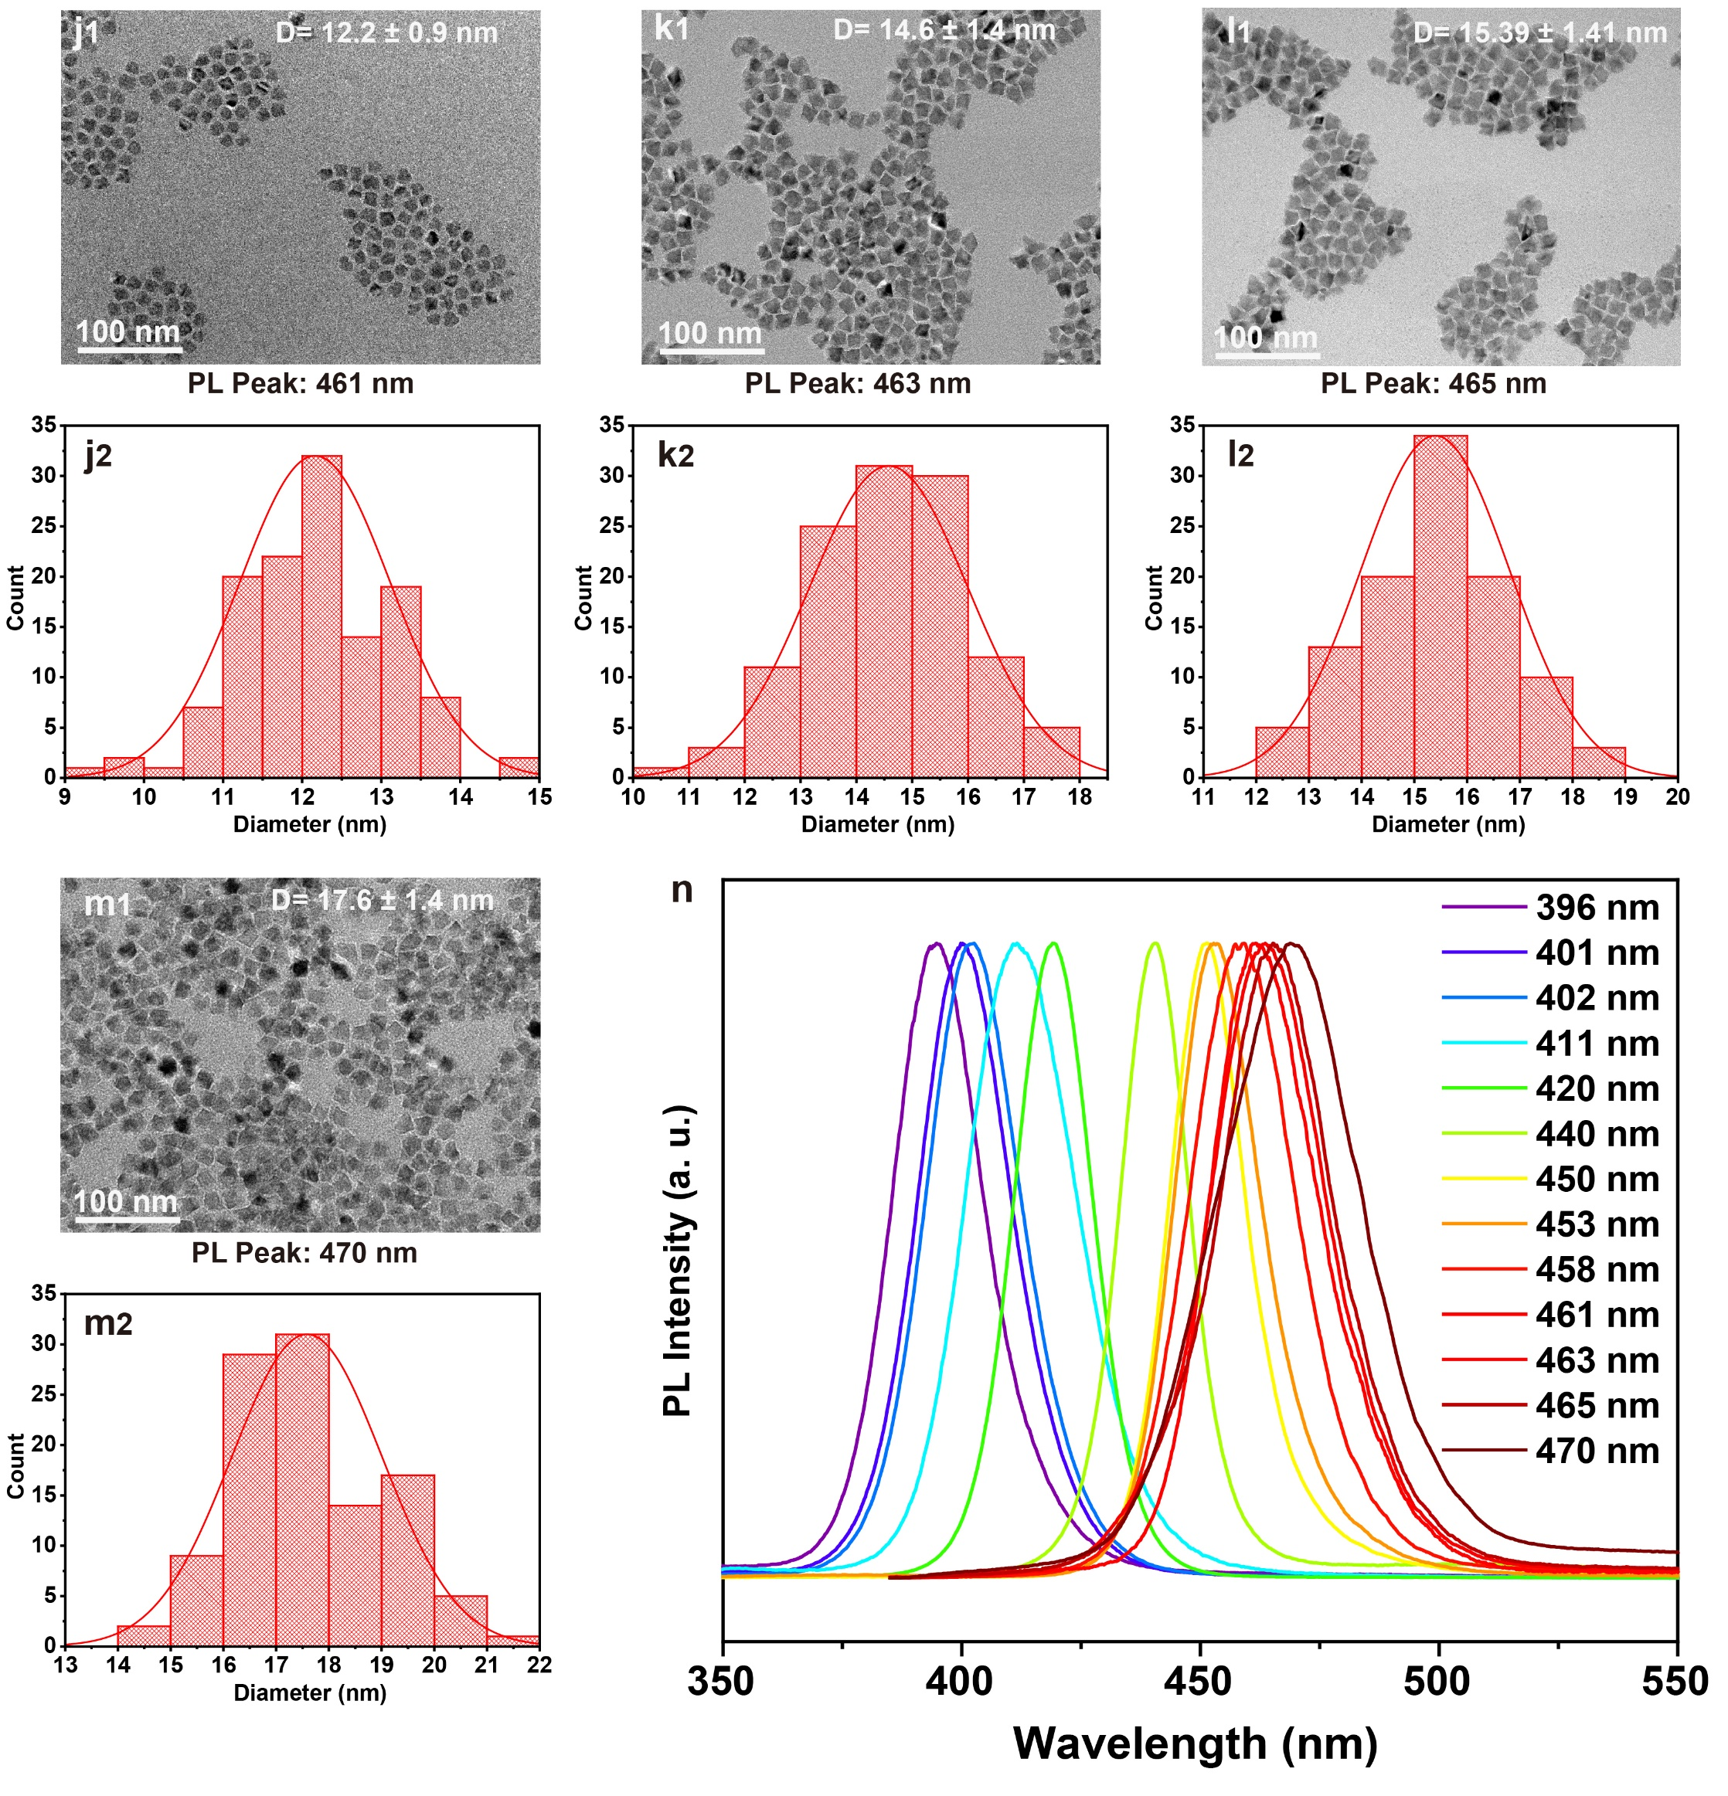
Figure S11 TEM images (a1-m1), size distribution (a2-m2), and their PL emission spectra (n) of ZnSe nanocrystals with different size.
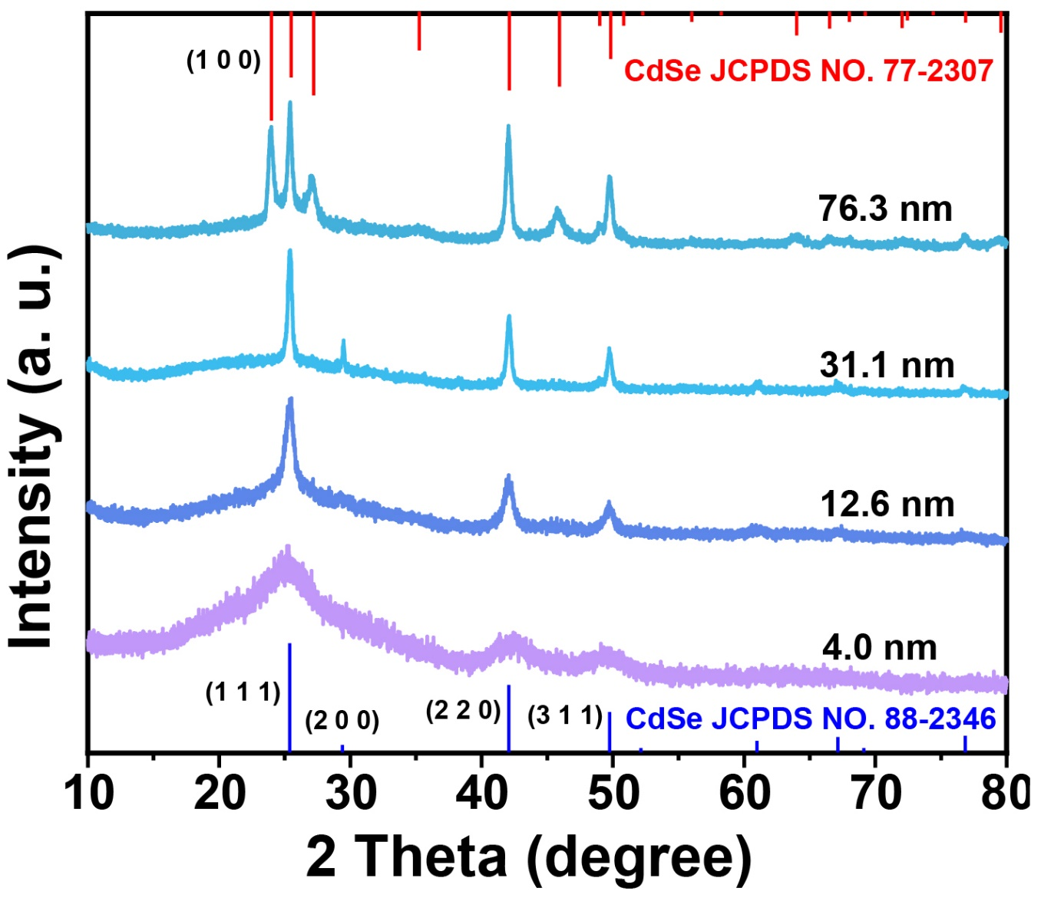
Figure S12 XRD patterns of obtained CdSe nanocrystals with different particle sizes.

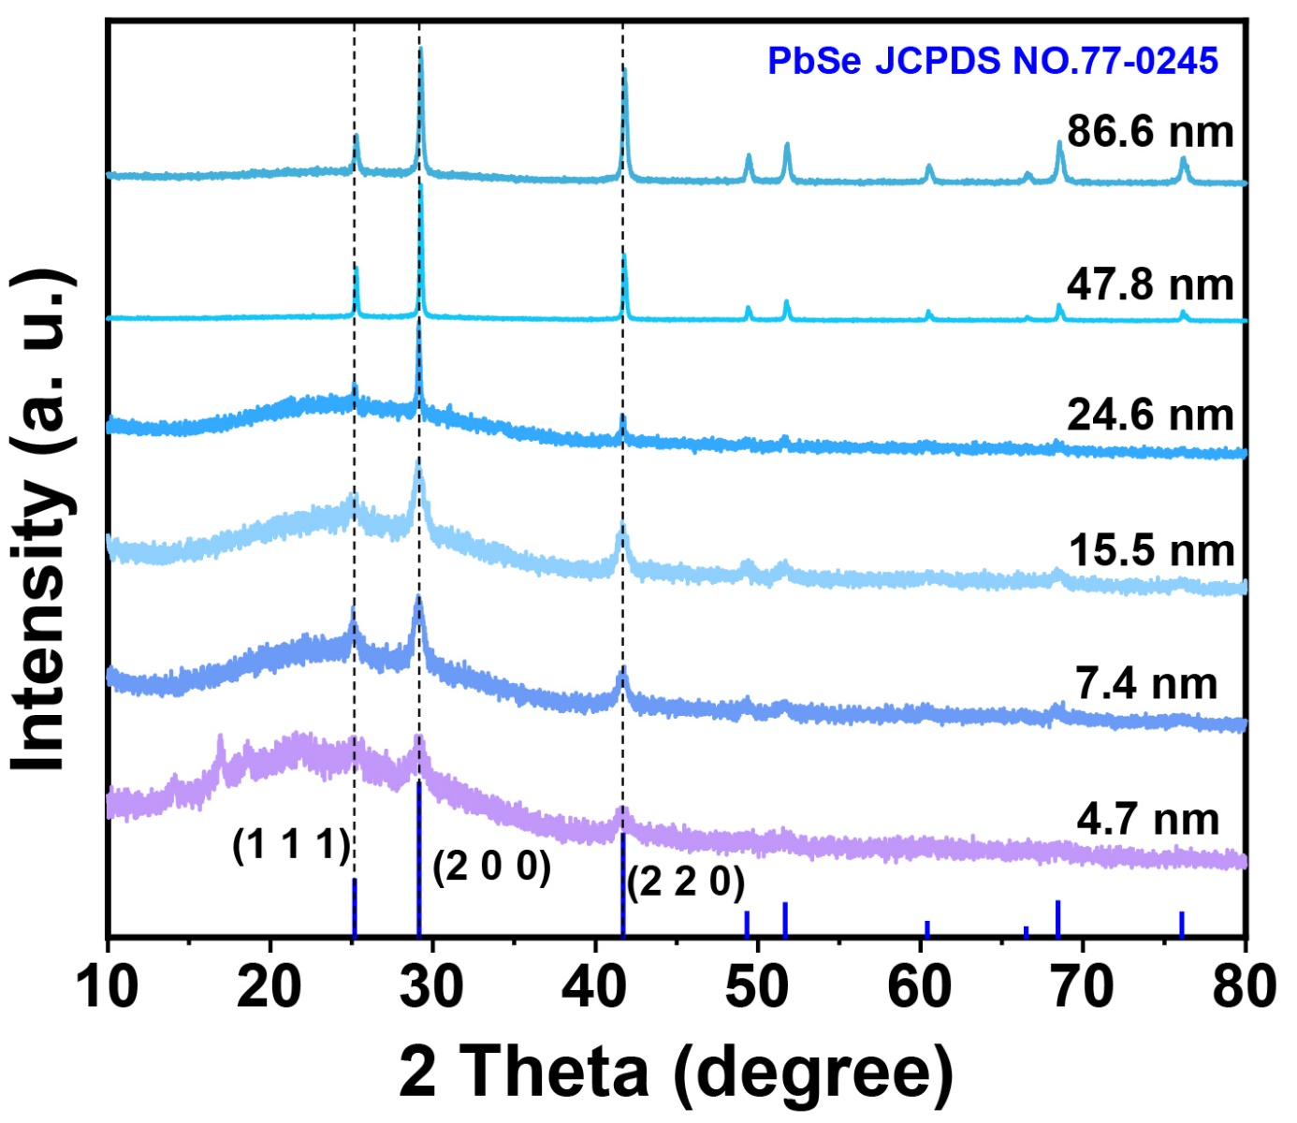
Figure S13 XRD patterns of obtained PbSe nanocrystals with different particle sizes

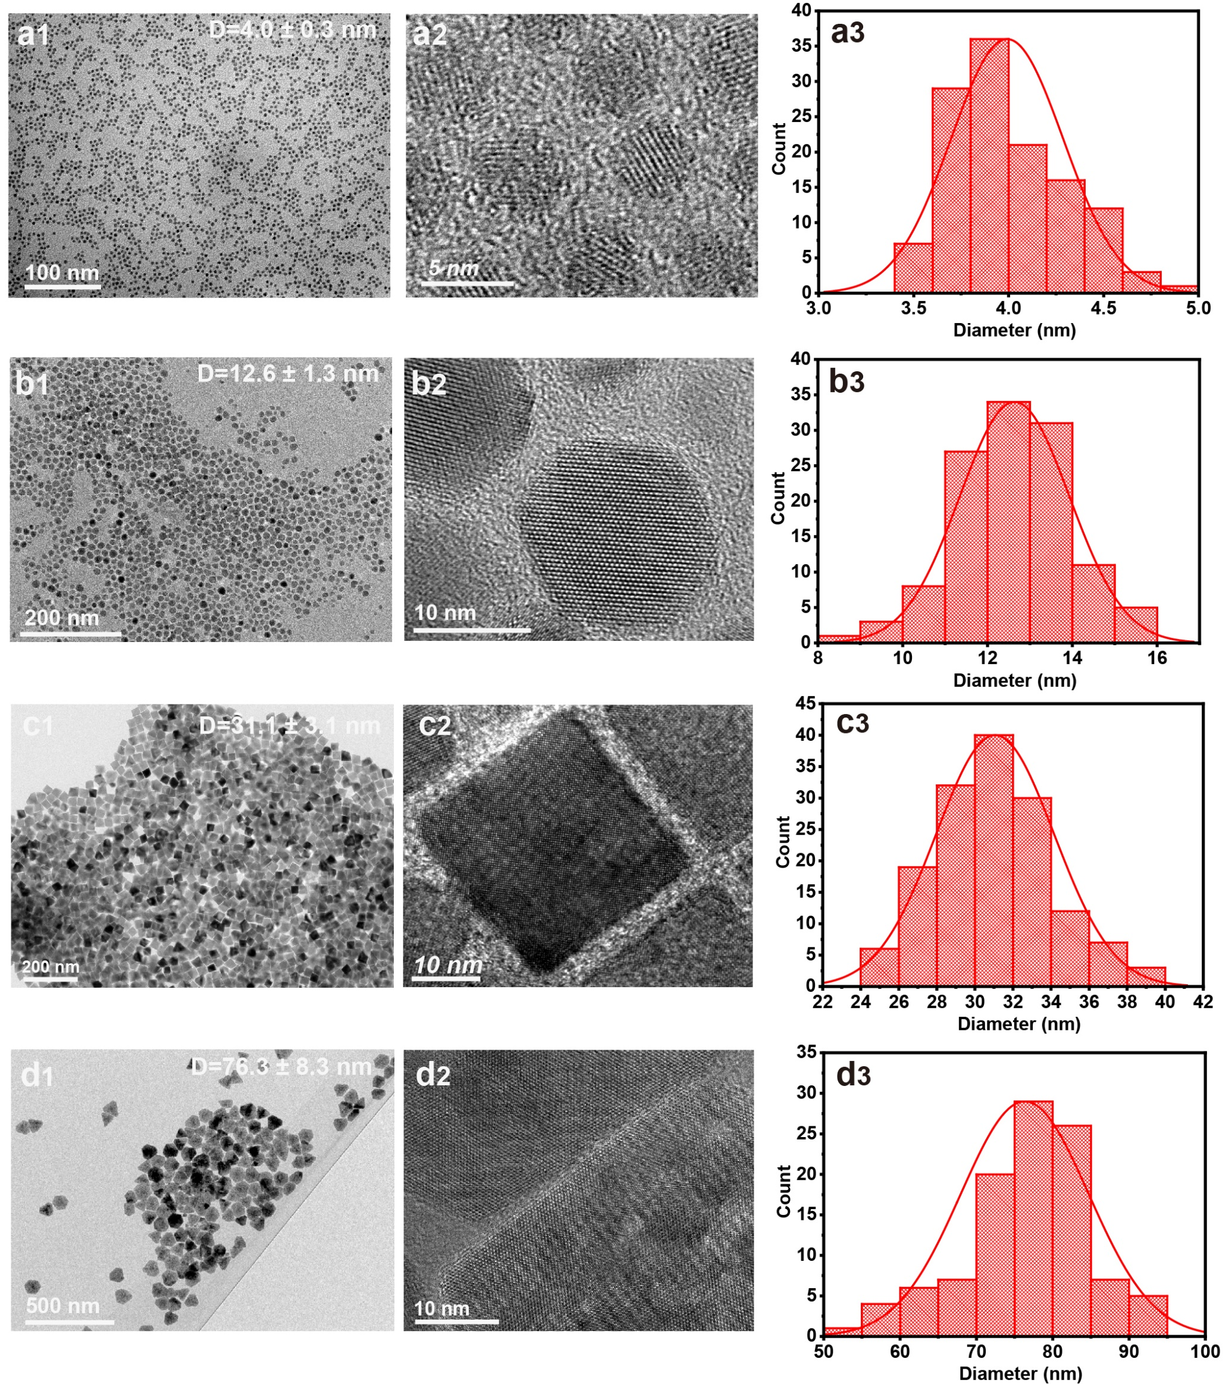
Figure S14 TEM images (a1-d1), HRTEM images (a2-d2), and size distribution statistics (a3-d3) of CdSe nanocrystals with different particle sizes.

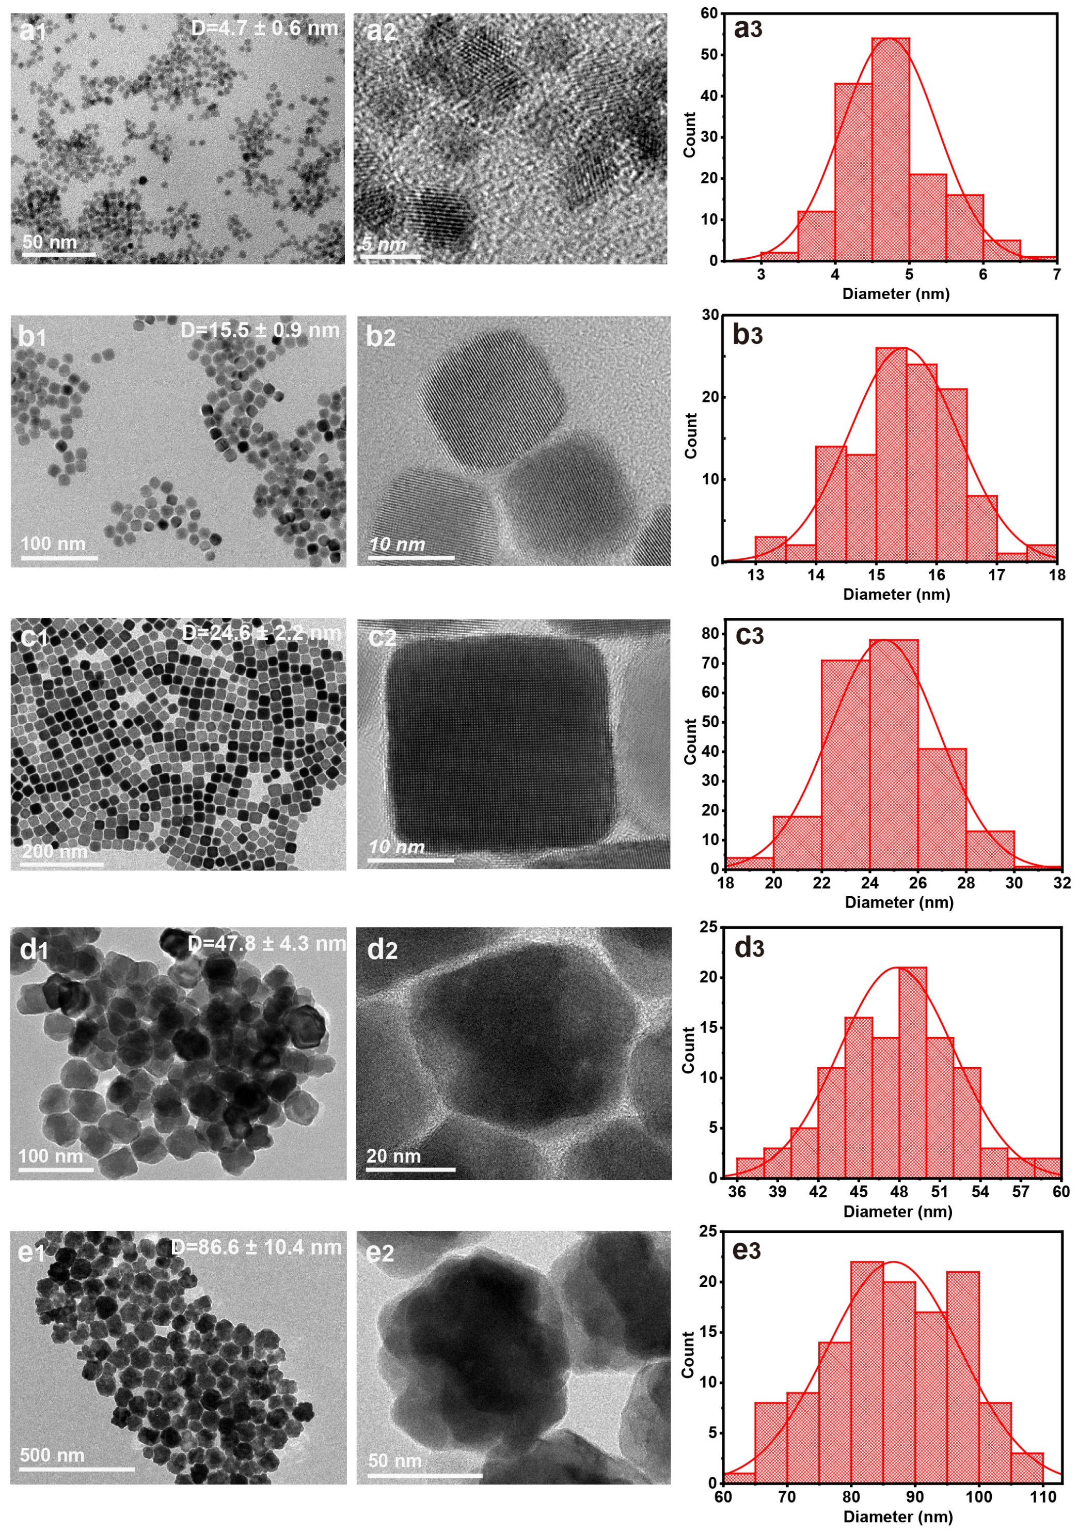
Figure S15 TEM images (a1-e1) and HRTEM images (a2-e2), and size distribution statistics (a3-e3) of PbSe nanocrystals with different particle sizes.
Diffusion growth model of spherical nanocrystal.
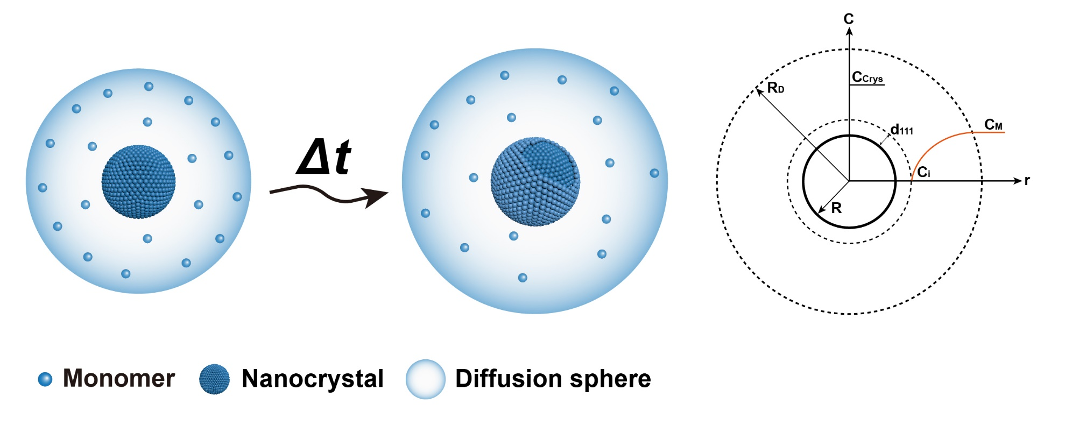
Figure S16 Schematic diagram of the diffusion-controlled growth process of spherical nanocrystal, which is described as a layer-by-layer growth pattern. And the schematic of diffusion growth computational model is put at right.
Assume that the growth of spherical nanocrystal is layer-by-layer. The growth of spherical cubic ZnSe nanocrystals is taken as an example. The lattice constant of ZnSe is a=b=c=5.618 Å, and the lattice plane spacing of (111) is d₁₁₁= 3.244 Å. The covalent radius of Zn and Se atom are r_{Zn}=0.122 Å, r_{Se}=0.120 Å, respectively. Unit cell volume V_{C} = a*b*c=177.315 Å³, the number of atoms contained in the unit cell is N_{Se}=N_{Zn}= 4, and the volume ratio of Zn and Se atoms in the crystal lattice are φ_{Zn}, φ_{Se,} respectively. The atomic concentration of the crystal phase is C_{Crys}.
$$C_{Crys}=\frac{N_{Se}}{V_{Cell}N_{A}}=\frac{4}{177.315Å^{3}×6.022×{10}^{23}}(mol/L)=37.5 (mol/L)$$
$$φ_{Zn}=\frac{4×\frac{4}{3}π×r_{Zn}^{3}}{V_{C}}×100\%=17.2\%$$
$$φ_{Se}=\frac{4×\frac{4}{3}π×r_{Se}^{3}}{V_{C}}×100\%=16.3\%$$
The volume increment of the epitaxial growth layer of the crystal with radius R is ΔV.
$$∆V=\frac{4}{3}π\left(3d_{111}R^{2}+3d_{111}^{2}R+d_{111}^{3}\right) (1)$$
The number of Se atoms required for one layer’s growth is $N_{Se}^{*}$.
$$N_{Se}^{*}=\frac{∆Vφ_{Se}}{\frac{4}{3}πr_{Se}^{3}}=\frac{φ_{Se}}{r_{Se}^{3}}\left(3d_{0}R^{2}+3d_{0}^{2}R+d_{0}^{3}\right) (2)$$
The number of moles of Se atoms ($n_{Se}^{*}$) equals to $N_{Se}^{*}/N_{A}$, where N_{A} is the Avogadro constant. The diffusion volume that required to grow a layer is V_{D}.
$$V_{D}=\frac{n_{Se}^{*}}{C_{L}}=\frac{N_{Se}^{*}}{N_{A}C_{L}}=\frac{φ_{Se}(3d_{111}R^{2}+3d_{111}^{2}R+d_{111}^{3})}{N_{A}C_{L}r_{Se}^{3}} (3)$$
Where C_{L} is the concentration of monomer in the reaction solution.
Assume that all monomers in the diffusion sphere can diffuse to the surface of preformed ZnSe nanocrystal to satisfy the requirement of one layer’s growth. The radius of diffusion sphere denoted as diffusion radius (R_{D}), and the diffusion volume also can be derived as following.
$$V_{D}=\frac{4}{3}π\left(3R_{D}R^{2}+3R_{D}^{2}R+R_{D}^{3}\right) (4)$$
According to equation 3 and 4, the relationship between R_{D} and R can be obtained as equation 5.
$$3φ_{Se}{d_{111}}^{2}∙R+3φ_{Se}d_{111}∙R^{2}-4πN_{A}C_{L}r_{Se}^{3}\left(R_{D}∙R^{2}+{R_{D}}^{2}∙R+\frac{1}{3}{R_{D}}^{3}\right)+φ_{Se}{d_{111}}^{3}=0 (5)$$
The final average diameter of nanocrystals is D_{f} that can be determined from TEM results. The basic assumption is that all nanocrystals in the reaction solution have the same size D_{f}, then the calculation of this model can be impelled. Number of Se atoms in one nanocrystal with diameter of D_{f} is $N_{Se}(D_{f})$.
$$N_{Se}(D_{f})=\frac{V_{Se}(D_{f})}{V_{Se}^{*}}=\frac{\frac{4}{3}π{(\frac{D_{f}}{2})}^{3}∙φ_{Se}}{\frac{4}{3}πr_{Se}^{3}}=\frac{D_{f}^{3}φ_{Se}}{8r_{Se}^{3}} (6)$$
Where V_{Se}(D_{f}) is the total volume of Se atoms in one nanocrystal with diameter of D_{f} .
The total number of nanocrystals is N_{crys}, and it can be described as below. n_{Se} is the total moles of Se that used in the hot-injection synthesis.
$$N_{Nulcei}=\frac{n_{Se}N_{A}}{N_{Se}(D_{f})}=\frac{8n_{Se}N_{A}r_{Se}^{3}}{D_{f}^{3}φ_{Se}} (7)$$
Determination of the concentration of monomer in the reaction solution (C_{L}).
$$C_{L}(R)=\frac{n_{Se}N_{A}-N_{Nulcei}N_{Se}\left(R\right)}{N_{A}V_{S}}=\frac{n_{Se}}{V_{S}}(1-\frac{8R^{3}}{D_{f}^{3}}) (8)$$
Where N_{Se}(R) is the number of Se atoms in one nanocrystal with radius of R, V_{S} is the total volume of the reaction solution. Substituting equation 8 into equation 5, the relationship between R_{D} and R can be describe as equation 9 as following.
$$3φ_{Se}{d_{111}}^{2}V_{L}D_{f}^{3}∙R+3φ_{Se}d_{111}V_{L}D_{f}^{3}∙R^{2}-4πN_{A}n_{Se}D_{f}^{3}r_{Se}^{3}∙{(R}_{D}∙R^{2}+{R_{D}}^{2}∙R+\frac{1}{3}{R_{D}}^{3})+32πN_{A}n_{Se}r_{Se}^{3}∙(R_{D}∙R^{5}+{R_{D}}^{2}∙R^{4}+\frac{1}{3}{R_{D}}^{3}∙R^{3})+φ_{Se}{d_{111}}^{3}V_{L}D_{f}^{3}=0 (9)$$
Simplify as following.
$$c_{1}∙R+c_{2}∙R^{2}+c_{3}∙{(R}_{D}∙R^{2}+{R_{D}}^{2}∙R+\frac{1}{3}{R_{D}}^{3})+c_{4}∙(R_{D}∙R^{5}+{R_{D}}^{2}∙R^{4}+\frac{1}{3}{R_{D}}^{3}∙R^{3})+c_{5}=0 (10)$$
Where c₁, c₂, c₃, c₄, c₅ are constant which can be defined as below.
$$c_{1}=3φ_{Se}{d_{111}}^{2}V_{L}D_{f}^{3}=3×0.1633×{3.244}^{2}×10×{10}^{-3}×{10}^{27}×{43.5}^{3}Å^{8}=4.2×{10}^{30}\left(Å^{8}\right)$$
$$c_{2}=3φ_{Se}d_{111}V_{L}D_{f}^{3}=3×0.1633×3.244×10×{10}^{-3}×{10}^{27}×{43.5}^{3}Å^{7}=1.3×{10}^{30}\left(Å^{7}\right)$$
$$c_{3}=-4πN_{A}n_{Se}D_{f}^{3}r_{Se}^{3}=-4×3.1416×6.022×{10}^{23}×0.2×{10}^{-3}×{43.5}^{3}×{1.2}^{3}Å^{6}=-2.2×{10}^{26}\left(Å^{6}\right)$$
$$c_{4}=32πN_{A}n_{Se}r_{Se}^{3}=16×3.1416×6.022×{10}^{23}×0.2×{10}^{-3}×{1.2}^{3}Å^{3}=2.1×{10}^{22}\left(Å^{3}\right)$$
$$c_{5}=φ_{Se}{d_{111}}^{3}V_{L}D_{f}^{3}=0.1633×{3.244}^{3}×10×{10}^{-3}× {10}^{27}× {43.5}^{3}Å^{9}=4.6×{10}^{30}\left(Å^{9}\right)$$
The equation 10 can be solved by numerical method, and the result of the solution is as follows.
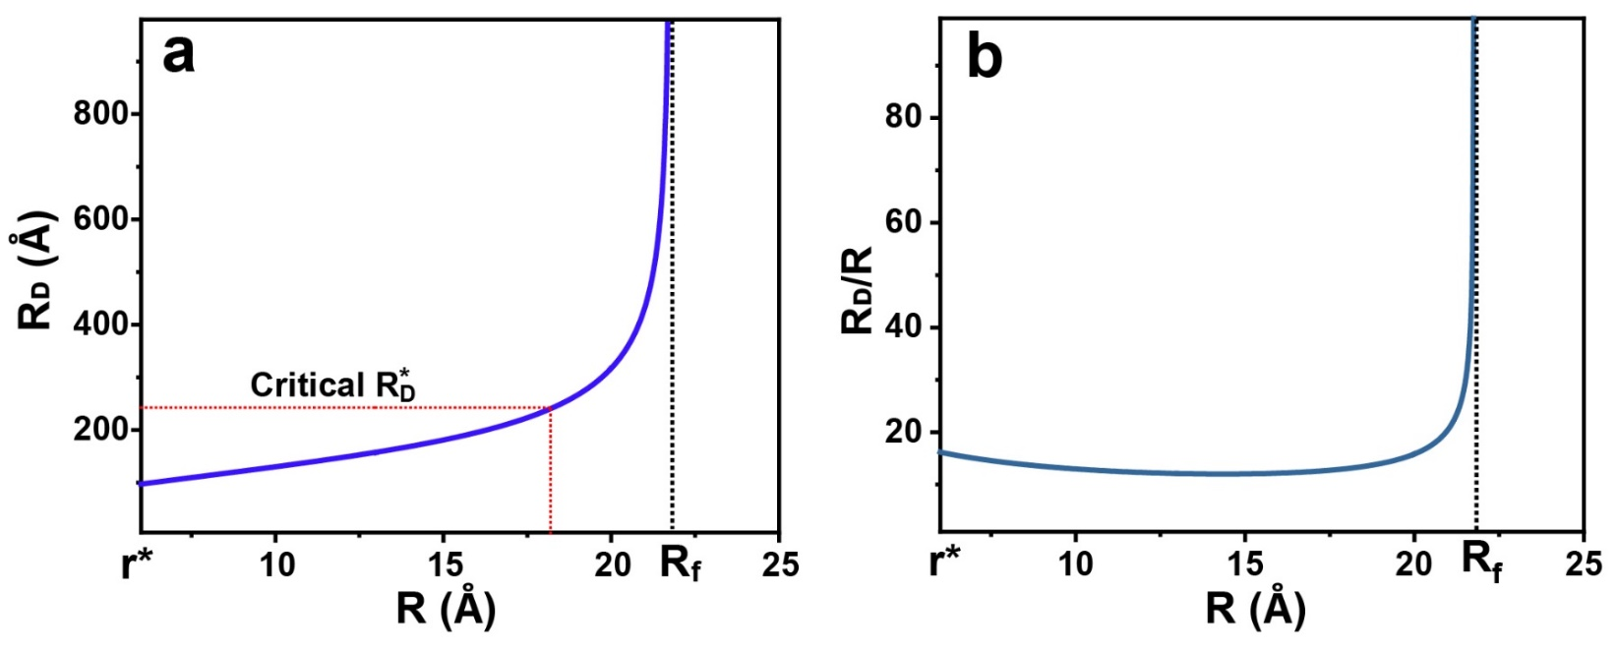
Figure S17 a, The evolution of diffusion radius (R_{D}) with the radius of nanocrystals (R). b, The evolution of the R_{D}/R ratio with the radius of nanocrystals (R).
The critical diffusion radius ($R_{D}^{*}$) defined as the sphere radius when the diffusion sphere is tangent.
Considering a maximum space utilization of 74% (denoted as φ_{max}=74%) for a close-packed hexagon, that can be applied in the accumulation of diffusion spheres.
$$R_{D}^{*}=\sqrt[3]{\frac{3V_{L}φ_{max}}{4πN_{Crys}}}=\sqrt[3]{\frac{3V_{L}φ_{max}φ_{Se}D_{f}^{3}}{32πn_{Se}N_{A}r_{Se}^{3}}}=\sqrt[3]{\frac{3×10×{10}^{-3}×{10}^{27}×0.74×0.1633×{43.5}^{3}}{32×3.1416×0.2×{10}^{-3}×6.022×{10}^{23}×{1.2}^{3}}} Å=242.5 Å$$
Solving for the evolution of nanocrystal size with reaction time using Fick's first law

The diffusion flux through the interface r=R_{D} is J(R_{D}), which can be described by Fick's first law as follows.
$$J(R_{D})=\frac{D}{R^{2}}∙\frac{C_{i}-C_{L}(R)}{1/R-1/R_{D}} (11)$$
Where D is the coefficient of diffusion, C_{i} is the monomer concentration at the solid-liquid interface, assuming its value is zero. Then according to the law of conservation of mass.
$$\frac{4πR^{2}dR∙(C_{Crys}-C_{i})}{dt}= 4πR^{2}\left(-J\right) (12)$$
According to equation 8, 11, 12, the growth rate dR/dt is given by Equation (13).
$$\frac{dR}{dt}=\frac{Dn_{Se}}{C_{Crys}V_{L}D_{f}^{3}}∙\frac{D_{f}^{3}R_{D}-8R^{3}R_{D}}{RR_{D}-R^{2}} (13)$$
The equation 13 can be solved by numerical method, and the result of the solution is as follows.
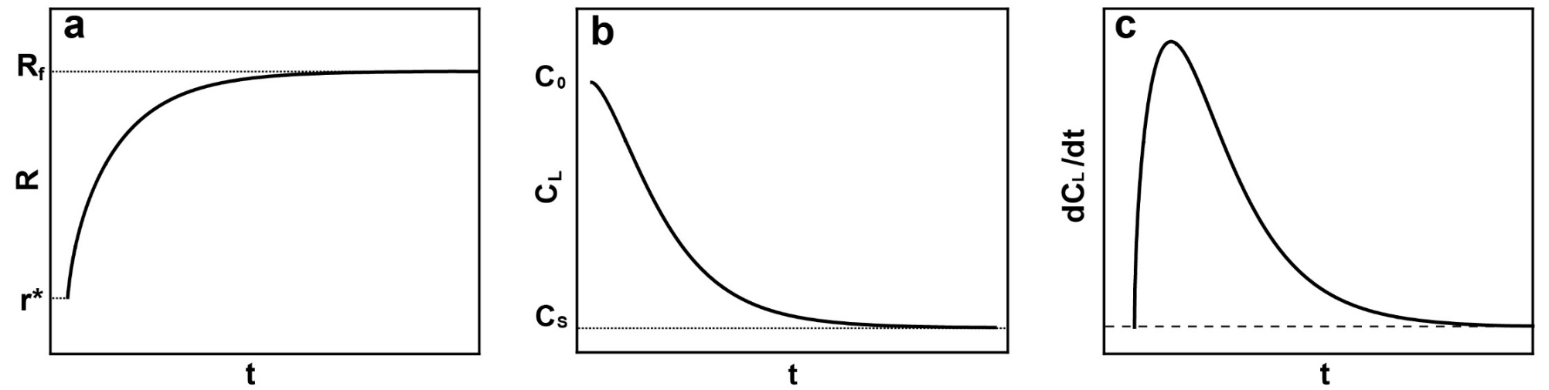
Figure S18 One-step hot-injection synthesis of nanocrystals. a, The evolution of R with reaction time. b, The evolution of monomer concentration in solution (C_{L}) with reaction time. c, The evolution of monomer consumption rate (dC_{L}/dt) with reaction time.
Epitaxial growth of ZnSe nanocrystals.
In the case of epitaxial growth of ZnSe nanocrystals, assuming the concentration of monomers in the reaction solution remains constant during Se and Zn precursors injection process. The equation 5 can be simplified as following.
$$b_{1}∙R+b_{2}∙R^{2}+b_{3}∙\left(R_{D}∙R^{2}+{R_{D}}^{2}∙R+\frac{1}{3}{R_{D}}^{3}\right)+b_{4}=0 (14)$$
where b₁, b₂, b₃, b₄, are constant which can be defined as below.
$b1=3φ_{Se}{d_{111}}^{2}=3×0.1633×{3.244}^{2} Å=5.2$ $\left(Å^{2}\right)$
$$b2=3φ_{Se}d_{111}=3×0.1633×3.244 Å=1.6(Å)$$
$$b3=-4πN_{A}C_{L}r_{Se}^{3}=-4×3.1416×6.022×{10}^{23}×8.565×{10}^{-3}∙L^{-1}×{1.2}^{3}Å^{3}=-1.1×{10}^{-4}$$
$$b4=φ_{Se}{d_{111}}^{3}=0.1633×{3.244}^{3} Å^{3}=5.6\left(Å^{3}\right)$$
The equation 14 can be solved by numerical method, and the results of the evolution of R_{D}, R_{D}/R with R is shown in Figure S20.
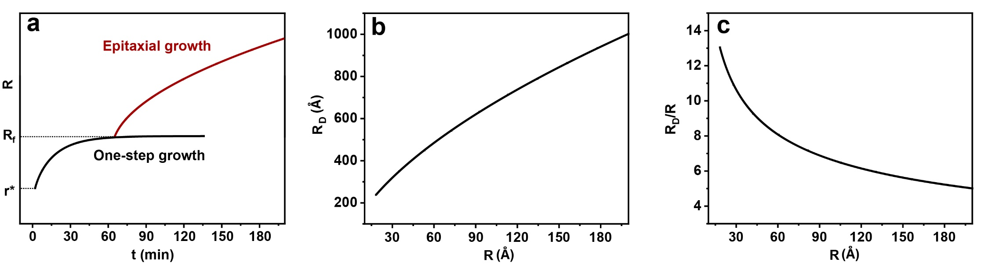
Figure S19 Continually epitaxial growth of nanocrystals. a, The evolution of R with reaction time during one-step growth and epitaxial growth process. b, The evolution of diffusion radius (R_{D}) with the radius of nanocrystals (R). c, The evolution of the R_{D}/R ratio with the radius of nanocrystals (R).

Extended Data Table 2 | A summary representative property and synthetic methods of ZnSe nanocrystals reported in the literatures
Structure | PL Wavelength  (nm) | FWHM（nm） | PLQY  （%） | Diameter  (nm) | Synthetic method | Literature
ZnSe | ~428 | - | 20-50 | 4.3-6.0 | Heat-up: A mixture of diethylzinc (Et₂Zn), Se-TOP was injected into the hot hexadecylamine (HDA) at 310 °C. | The Journal of Physical Chemistry B 102.19 (1998): 3655-3657.
ZnSe | ~402 | 18 | - | 5.0 | Heat-up: (TMA)₄[Zn10Se₄(SPh)₁₆] and HDA solution heated to 220-280 °C. | Chemistry of Materials 14.4 (2002): 1576-1584.
ZnSe | 435 | 12-15 | 50 | 4-10 | Hot-injection: A mixture of Zn(St)₂, ODA, TCA, ODE was heated to 330 °C, then, Se-TBP-ODE solution was swiftly injected. | Nano letters 4.11 (2004): 2261-2264.
ZnSe | 427 | 20 | 14 | 7.0 | Heat-up: A mixture of Zn(Ac)₂·2H₂O, Se powder, oleic acid, and liquid paraffin was heated to 300 °C and reacted for 5h. | Journal of Materials Chemistry 20.21 (2010): 4451-4458.
ZnSe | 409 | 14 | 10 | 3 | Hot-injection: A mixture of ZnO powder and olive oil was heated to 330 °C, then Se/olive oil solution was injected and growth at 300°C. | The Journal of Physical Chemistry C 112.20 (2008): 7567-7571.
ZnSe | 414-445 | 14-20 | 20-40 | 5-9.2 | Hot-injection: A mixture of ZnO powder, decanoic acid, paraffin oil heated to 300 °C to obtain Zn-precursor, then Se-ODE-paraffin solution was injected into at 310 °C, and growth at 300°C. | Dalton Transactions 47 (2009): 10534-10540.
ZnSe | 390–440 | 12.7–16.9 | 5 | 3-4.7 | Hot-injection: A mixture of zinc stearate and octadecane was heat to 250°C-300°C, then, Se-TOP solution was swiftly injected. | Materials Chemistry and Physics 84.1 (2004): 10-13.
ZnSe | ~410 | 22 | 70 | 3.1 | Heat-up: A mixture of ZnO, OA, ODE was heated to 300 °C to obtain Zn(OA)₂ solution. Zn(OA)₂ solution and Se-TOP (Se-DPP) solution were mixed at 80°C, then heated up to 280 °C. | Chemical Communications 47.31 (2011): 8811-8813.
ZnSe | 390–429 | 16 | 40 | 8.2 | Multiple hot-injection: A mixture of Zinc octanoate and ODE was heated up to 280 °C, then injected Se-DPP with a feed ratio of 10(Zn/Se). Se-TOP was added for further growth of the ZnSe core nanoparticles. | Organic Electronics 15.1 (2014): 126-131.
ZnSe | 425 | 18 | 80 | - | Hot-injection: Se powder and paraffin oil were heated to 300 °C, then Zn(OA)₂ solution was injected. | Organic Electronics 25 (2015): 178-183.
ZnSe | 440-455 | 12-20 | 63-83 | 4.5-10 | Multiple hot-injection: Se powder and paraffin oil were heated to 300 °C, then Zn(OA)₂ solution was injected. Followed by injecting S-ODE for ZnS shell coating. | Nanoscale 7.7 (2015): 2951-2959.
ZnSe | ~430 | ~18 | 40 | 5.4 | Multiple hot-injection: OLA was heated to 295°C then add TOP-Se. Followed by quickly injecting diethylzinc solution (dissolved in TOP). Se-TOP and diethylzinc solution were separately injected for the secondary growth. | Nano letters 20.4 (2020): 2387-2395.
ZnSe | 410-451 | 11-19 | 12-50 | 5.4-11.2 | Multiple hot-injection: A mixture of Zn(OA)₂, ODE was heated to 310 °C, and Se-ODE was quickly injected, growth at 300 °C. Followed by injecting Se-TOP and Zn(OA)₂ to obtain larger ZnSe nanocrystals. | Nanoscale 13.8 (2021): 4562-4568.
ZnSe | 446 | ∼9.6 | 60-95 | 10 | Multiple hot-injection: A mixture of paraffin oil and Se-ODE was heated to 300 °C, and quickly injected Zn(OA)₂ solution. Se-ODE and Zn(OA)₂ solution were alternately added dropwise to the ZnSe seeds mixture to obtain larger ZnSe nanocrystals. | Nano Letters 21.17 (2021): 7252-7260.
ZnSe | 380-470 | 20-24 | 20-60 | 3.3-35.2 | Multiple hot-injection: A mixture of Zn(OAc)₂, OA, OLA, paraffin oil was heated to 280 °C, and quickly injected Se-DPP. Followed by injecting OA-Zn(OAc)₂-OLA and Se-ODE solution for further growth. | This work

