Supplementary information

The highest-elevation frog provides insights into mechanisms and evolution of defenses against high ultraviolet radiation
Ting-Ting Fu, Yan-Bo Sun, Wei Gao, Cheng-Bo Long, Chun-Hua Yang, Xin-Wang Yang, Yi Zhang, Xin-Qiang Lan, Song Huang, Jie-Qiong Jin, Robert W. Murphy, Yun Zhang*, Ren Lai*, David M. Hillis*, Ya-Ping Zhang*, Jing Che*
These authors contributed equally: Ting-Ting Fu, Yan-Bo Sun and Wei Gao.
*Corresponding authors, emails: J.C. (chej@mail.kiz.ac.cn), Y.-P.Z. (zhangyp@mail.kiz.ac.cn), D.M.H. (dhillis@austin.utexas.edu), R.L. (rlai@mail.kiz.ac.cn), Y.Z. (zhangy@mail.kiz.ac.cn)
This document contains:
Supplementary Note
Supplementary figures S1–S16
Supplementary tables S1–S11

Supplementary Note

Genome sequencing and assembly of N. parkeri. Based on 328.62 Gb clean short-read sequencing data, the genome size of N. parkeri was estimated to be 2.47 Gb through the k-mer (k = 17) depth frequency distribution analysis. In total, we generated 237.27 Gb of PacBio long-read data (21.25 million reads) with N50 > 17 Kb for most cells. These data were assembled to a preliminary N. parkeri genome using Falcon. The preliminary assembled genome was approximately 2.46 Gb in size and contig N50 was 2.32 Mb (Supplementary Table 2). After polishing the primary assembly using both PacBio long-read data and BGISEQ short-read data, we assembled a 2.47 Gb genome of N. parkeri, with a contig N50 of 2.34 Mb. Assessment of the genome quality using BUSCO showed that the assembly included 93.5% of the orthologue genes, including 87.9% of the complete and 5.6% fragmented genes (Supplementary Table 3). Approximately 394.87 Gb clean data were generated from the Hi-C libraries. We then constructed a chromosome-level scaffold genome with these data using Lachesis. Finally, we obtained 13 pseudo-chromosomes, which is the first chromosome-level high-elevation amphibian genome with scaffold N50 of 268.57 Mb (Supplementary Table 4).
Our chromosome-level assembly of N. parkeri genome was more than 250 times better both in contig and scaffold N50 than the previous assembly version (30), which used only Illumina data (contig N50: 2.34 Mb versus 8.1 Kb, scaffold N50: 268.57 Mb versus 1.05 Mb), and resulted in a larger assembled genome size (2.47 Gb versus 2.1 Gb). In addition, compared to other published genomes of anurans frogs, our N. parkeri genome assembly exhibited the highest contig N50 and the third highest scaffold N50 (just smaller than Leptobrachium leishanense and L. ailaonicum; Supplementary Table 5).

Genome annotation of N. parkeri. In total, 1.46 Gb of repetitive sequences were identified in the N. parkeri genome using combined structure-based and homology-based methods, accounting for 58.90% of the genome. Most of the repeated sequences were transposable elements (TEs), occupying 55.20% (1.36 Gb) of the assembly (Supplementary Table 8). We identified four major types of TEs, which were 574.37 Mb of DNA transposons (23.23% of the genome), 622.33 Mb of long interspersed nuclear elements (25.17%; LIENs), 28.04 Mb of short interspersed nuclear elements (1.13%; SINEs), and 366.12 Mb of long terminal repeats (14.81%; LTRs), respectively (Supplementary Table 8). Other types and unknown TEs accounted for 0.00097% and 0.17%, respectively (Supplementary Table 8).
The integrated de novo-based, homology-based, and RNA sequences-based methods yielded a non-redundant gene set composing of 22,884 protein-coding genes in the N. parkeri genome (Supplementary Table 6), with an average exon number per gene of 7.78. The average transcript length, average CDS length, average exon length and average intron length was 31,131 bp, 1,382 bp, 177 bp, and 4,381 bp, respectively (Supplementary Table 7). These statistical indicators of the N. parkeri genome showed similar distribution patterns compared to closely related species (Supplementary Fig. 5), suggesting dependability of the annotation. Furthermore, a total of 22,788 predicted genes (accounting for 99.58% of total genes) were successfully annotated in at least one of the public databases. There were 21,378 (93.42%), 22,619 (92.00), and 22,629 (99.10%) genes annotated to SwissProt, TrEMBL, and NR database, respectively; 19,005 (83.05%) and 11,768 (51.42%) genes got positive hits in the KEGG and GO databases, respectively (Supplementary Table 6). Four types of non-coding RNAs were identified of N. parkeri genome from homology-based and structure-based annotation, including 220 miRNAs, 1,509 rRNAs, 330 snRNAs, and 19,627 tRNAs, respectively (Supplementary Table 9).

Supplementary Figures

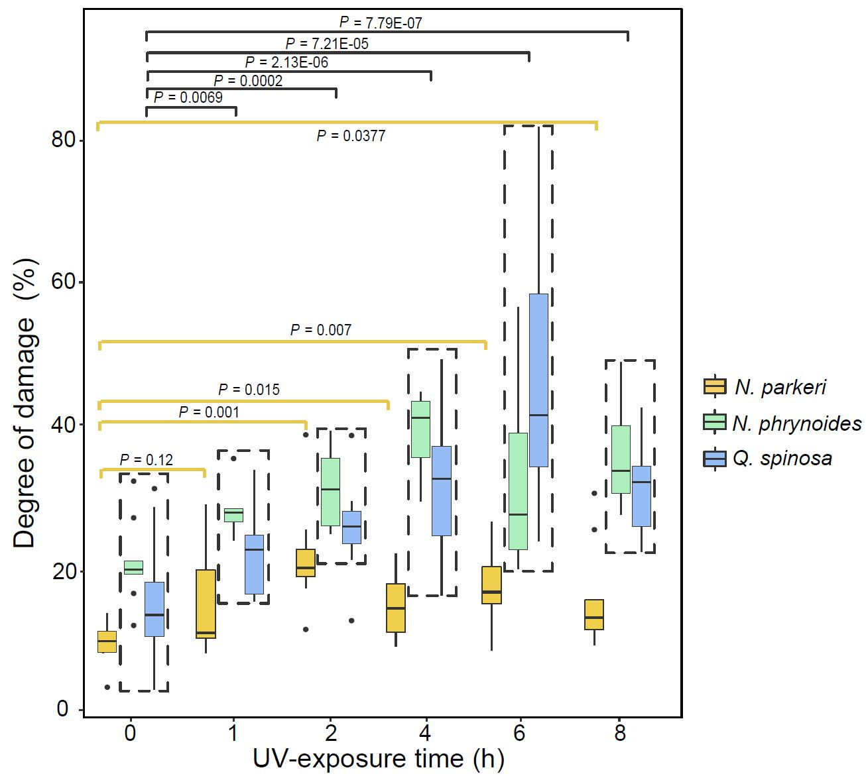

Supplementary Fig. 1. Quantification of the degree of damage separately in skin of N. parkeri (yellow), N. phrynoides (green) and Q. spinosa (blue) throughout UV exposure based on histological sections. At each time point, at least 9 samples of each species (3 individuals x 3 fields per individual) were used for quantification. Degree of damage of UV-exposed groups was separately compared with the unexposed group (0 h) in each species for a two-tailed t-test (N. phrynoides and Q. spinosa were combined for testing). Box boundaries represent 1st and 3rd quartiles, middle line represents median, and whiskers extend to the nearer of the data extremes.

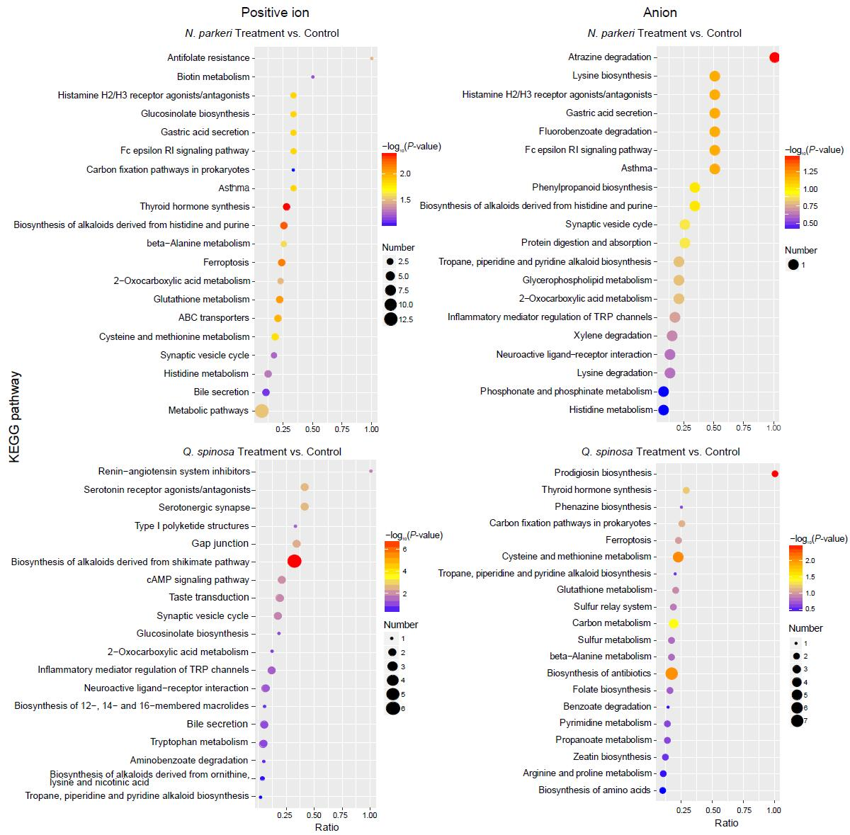

Supplementary Fig. 2. Top 20 enrichment terms of the KEGG pathway of differently expressed metabolites (DEMs) between Treatment group (UV exposed for 8 h) and Control group (unexposed) based on a LC-MS/MS system. The identified metabolites were divided into positive ion (left tunnel) and anion (right tunnel). Ratio = (number of DEMs)/ (number of total identified metabolites). Higher ratios indicate higher enrichment. Color indicates the P-value of hypergeometric test, with blue indicating higher significance. Dot size represents number of identified DEMs.

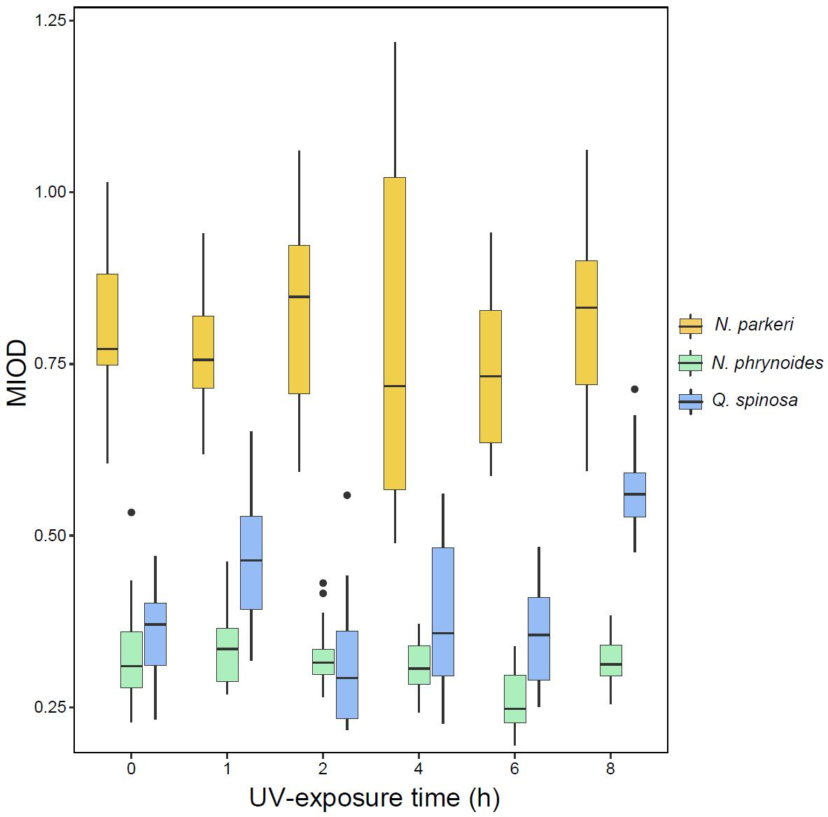

Supplementary Fig. 3. Changes of the skin pigment content (MIOD) throughout UV exposure in N. parkeri (yellow), N. phrynoides (green) and Q. spinosa (blue) based on histological sections. At each time point, at least 9 samples of each species (3 individuals x 3 fields per individual) were used for quantification. Box boundaries represent 1st and 3rd quartiles, middle line represents median, and whiskers extend to the nearer of the data extremes.

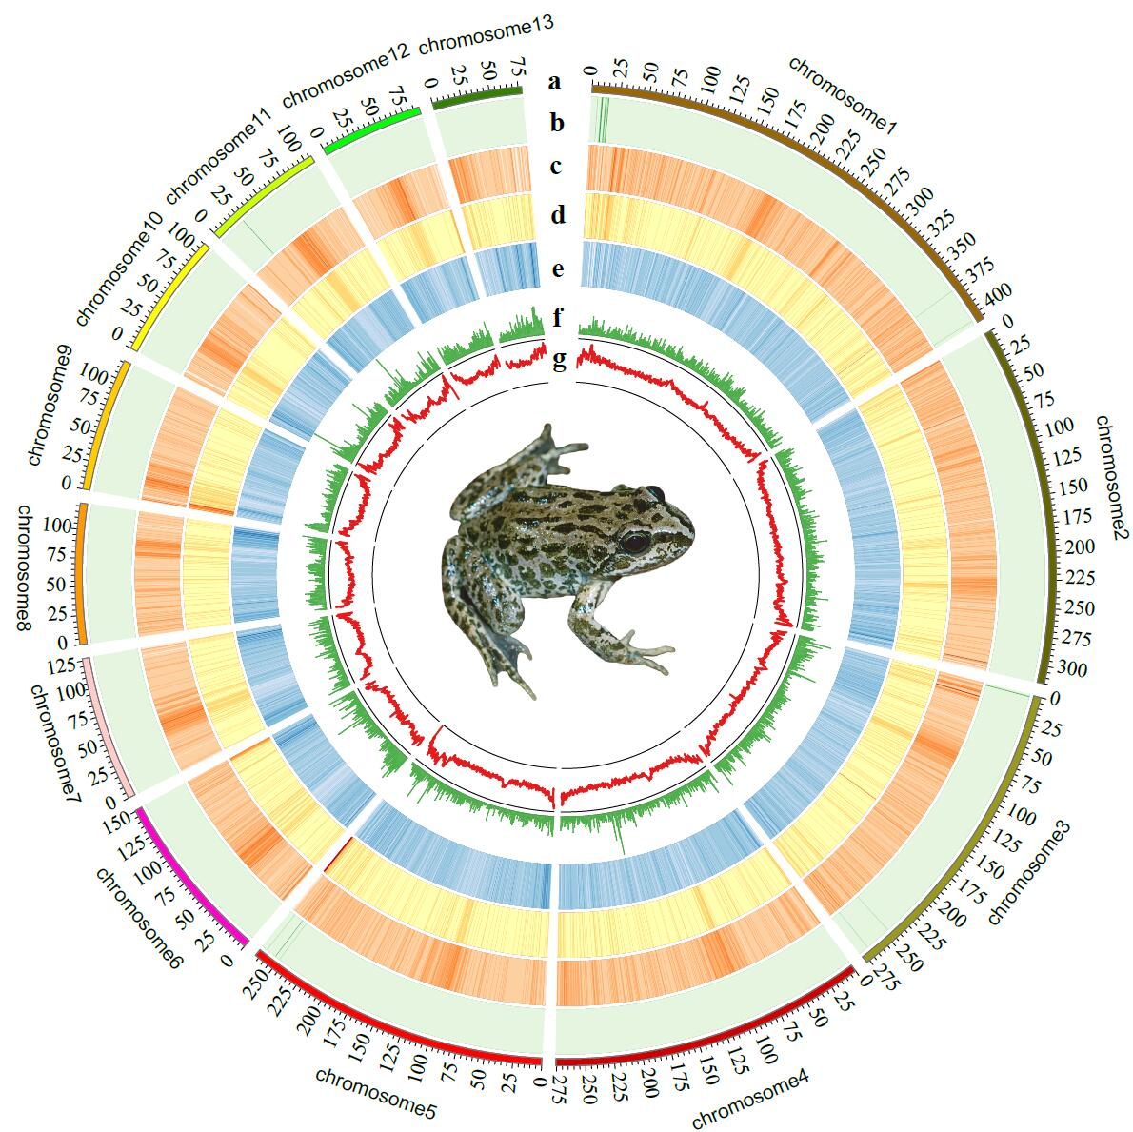

Supplementary Fig. 4. Genome characteristics of N. parkeri. From outer circle to inner circle: a, Lines represent 13 chromosomes; b, Distribution of short interspersed nuclear elements (SINE); c, Distribution of long interspersed nuclear elements (LINE); d, Distribution of long terminal repeats (LTR); e, Distribution of DNA transposons; f, Distribution of GC content; g, Distribution of coding density.

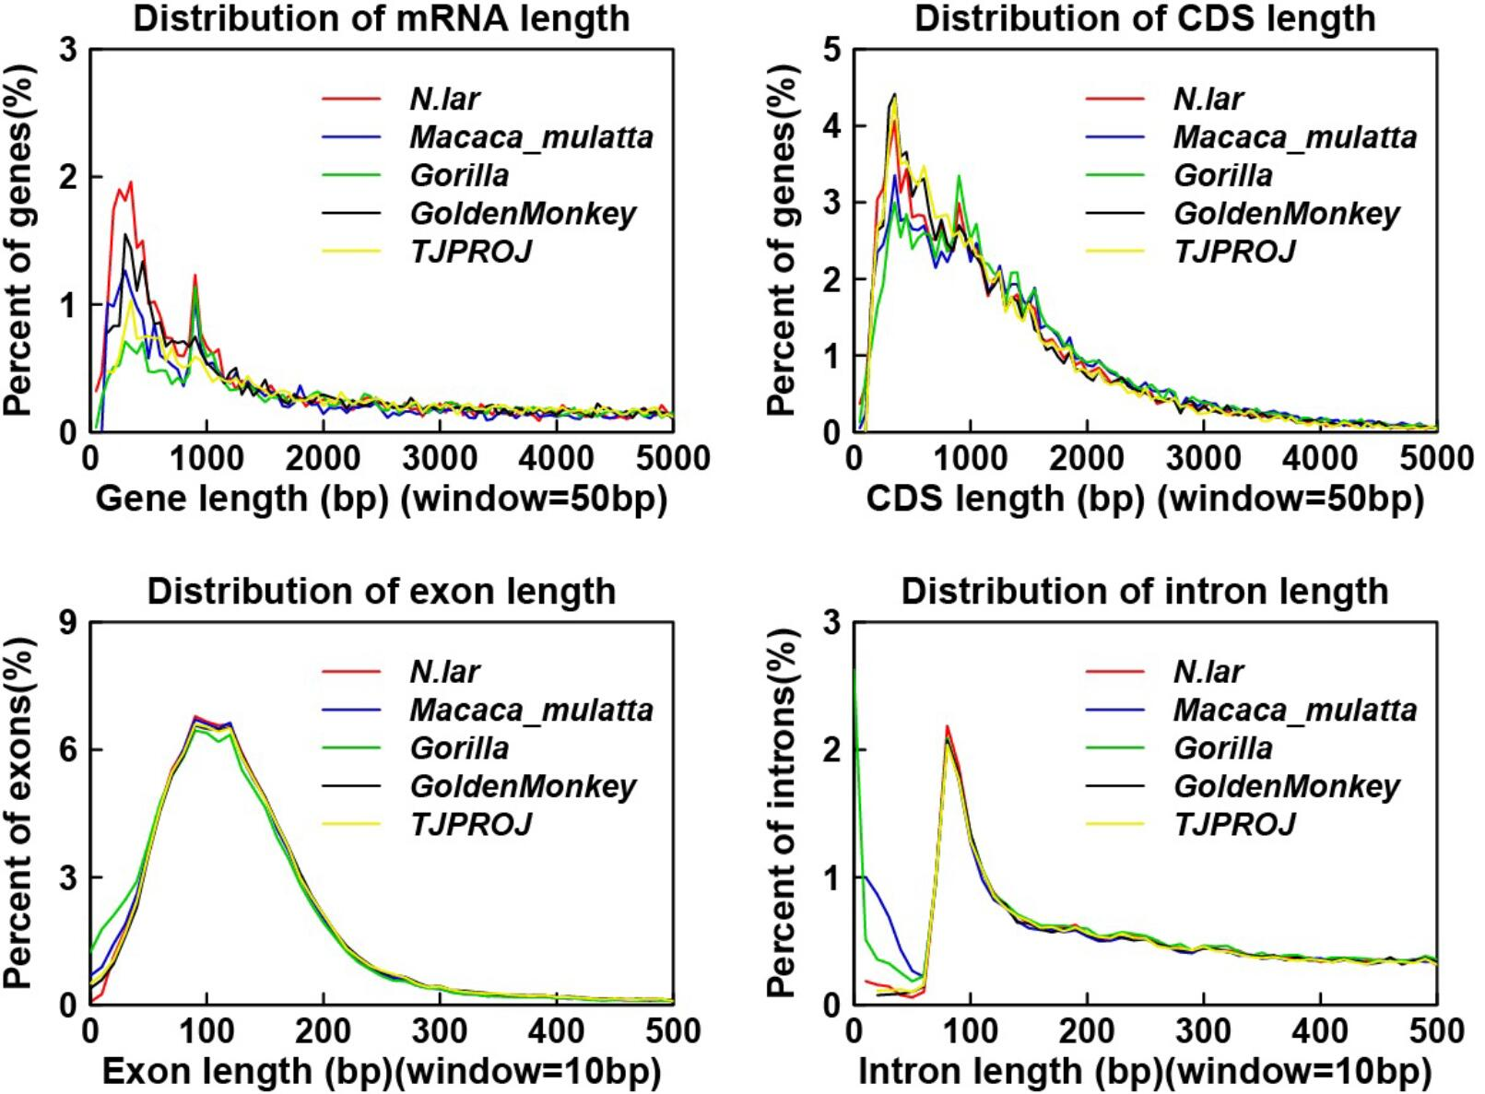

Supplementary Fig. 5. Comparing the distribution of mRNA length, CDS length, exon length and intron length in N. parkeri genome with those in other species.

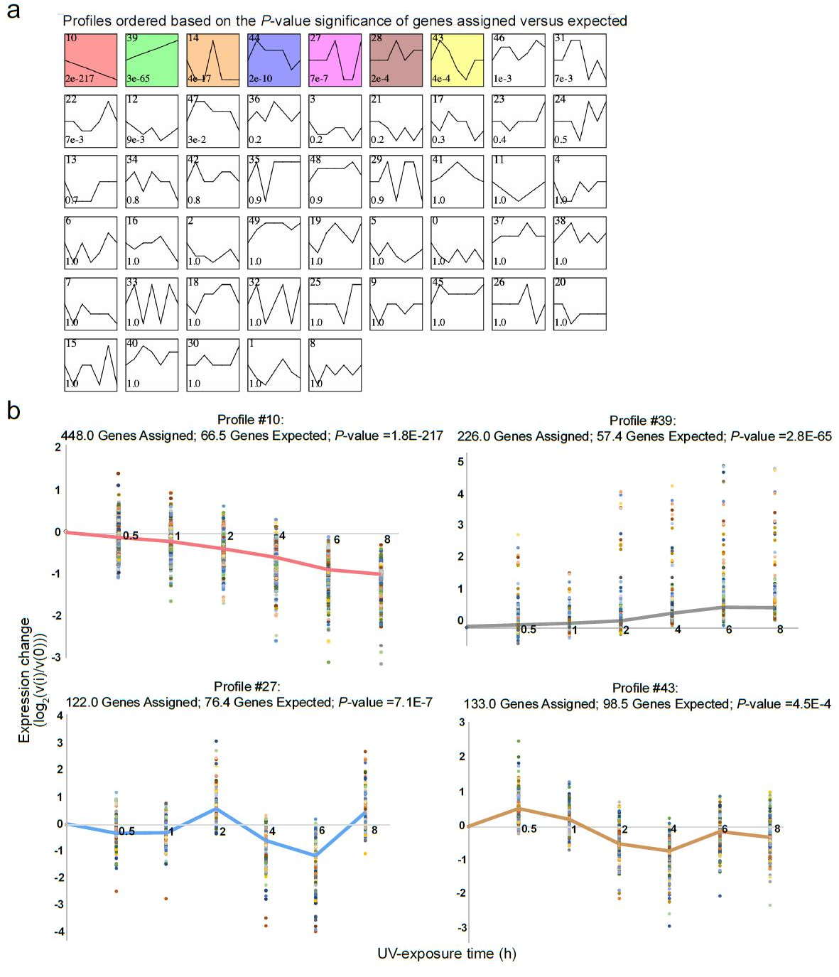

Supplementary Fig. 6. Clustering of temporal expression genes by STEM in N. parkeri (a) and examples for expression patterns of gene groups (b). a, Profiles that can be significantly (P < 0.001) clustered are shown in color and ordered by significance. Other profiles are shown in white. The profile number is at the top-left corner and the P-value of significance is at the bottom left corner. b, Each dot represents a log₂ normalized expression change relative to 0 h (v(i)/v(0)) of an individual gene. Solid line was concatenated from the median value in gene groups of time course.

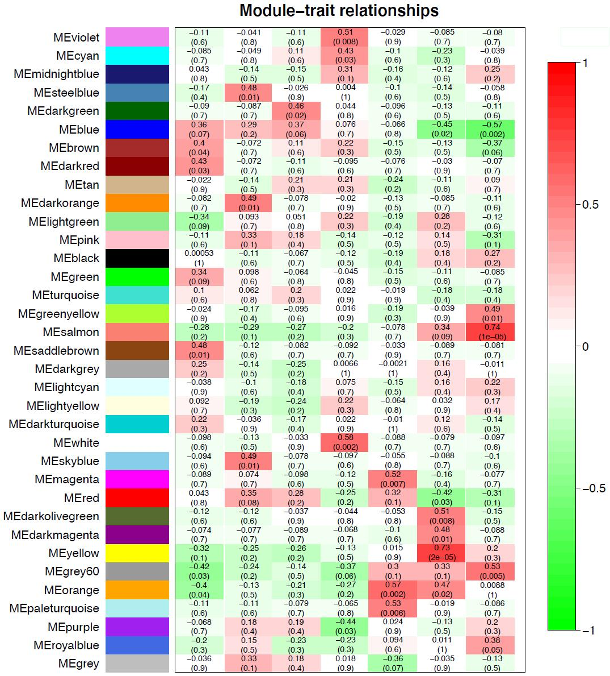

Supplementary Fig. 7. Module–UV-exposure time relationships of mRNAs in N. parkeri according to the WGCNA analysis. The color indicates the respective correlation coefficient, as shown in the scale bar.

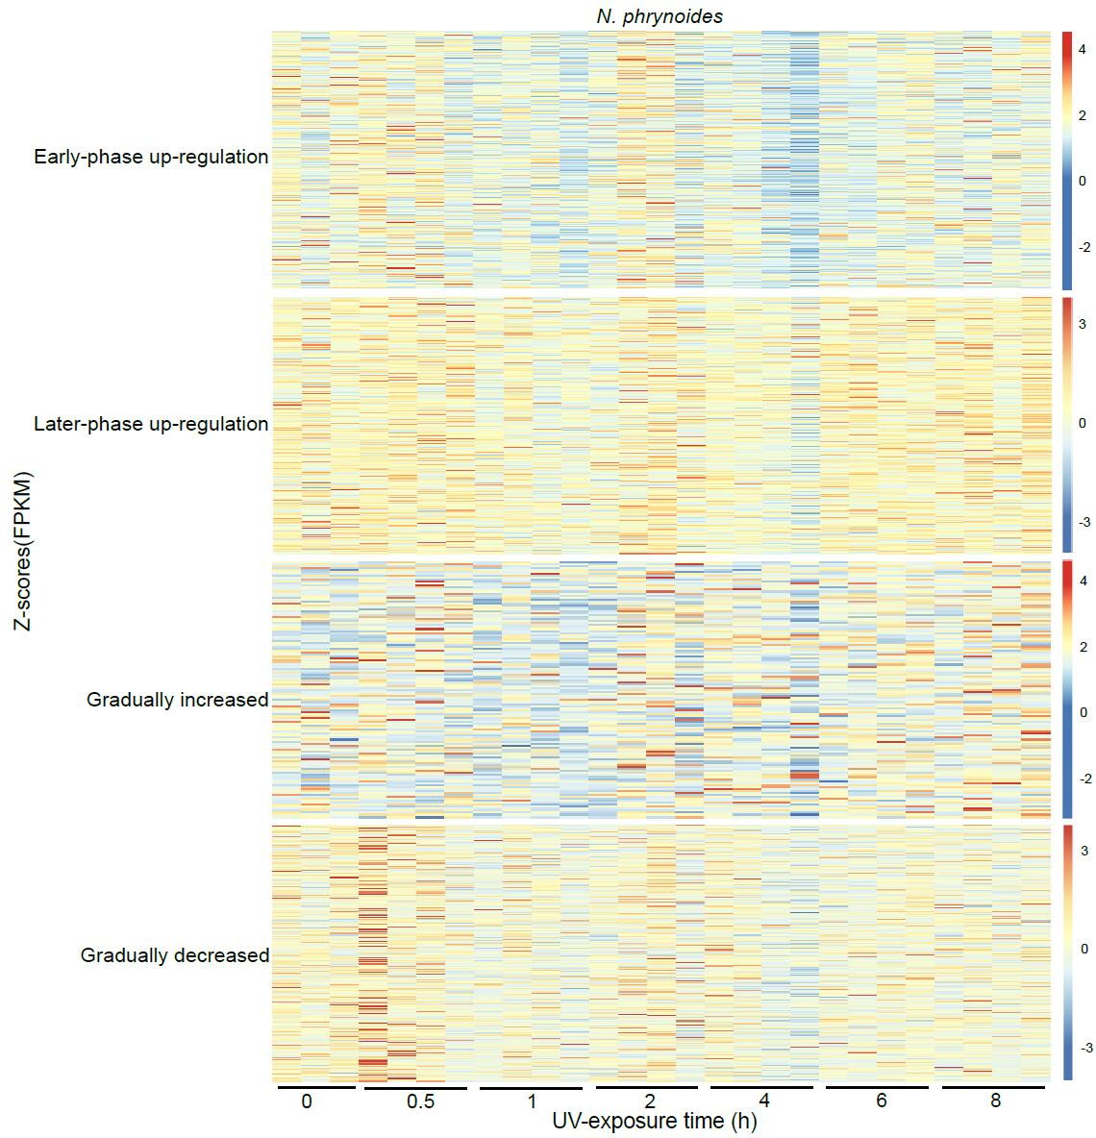

Supplementary Fig. 8. Heatmaps of gene expression in four temporal groups throughout UV exposure in N. phrynoides. Each row represents an expression level of a gene and color represents an expression level (FPKM) normalized by Z-scores. FPKM, fragments per kilobase million.

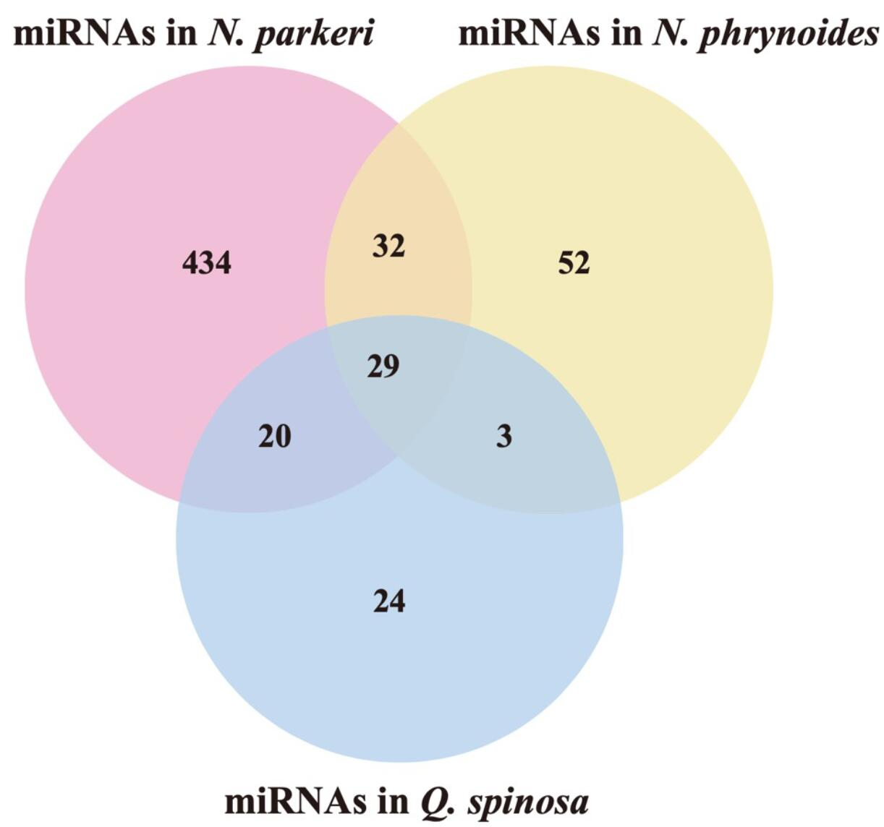

Supplementary Fig. 9. The Venn diagram of total miRNAs identified in studied frogs.

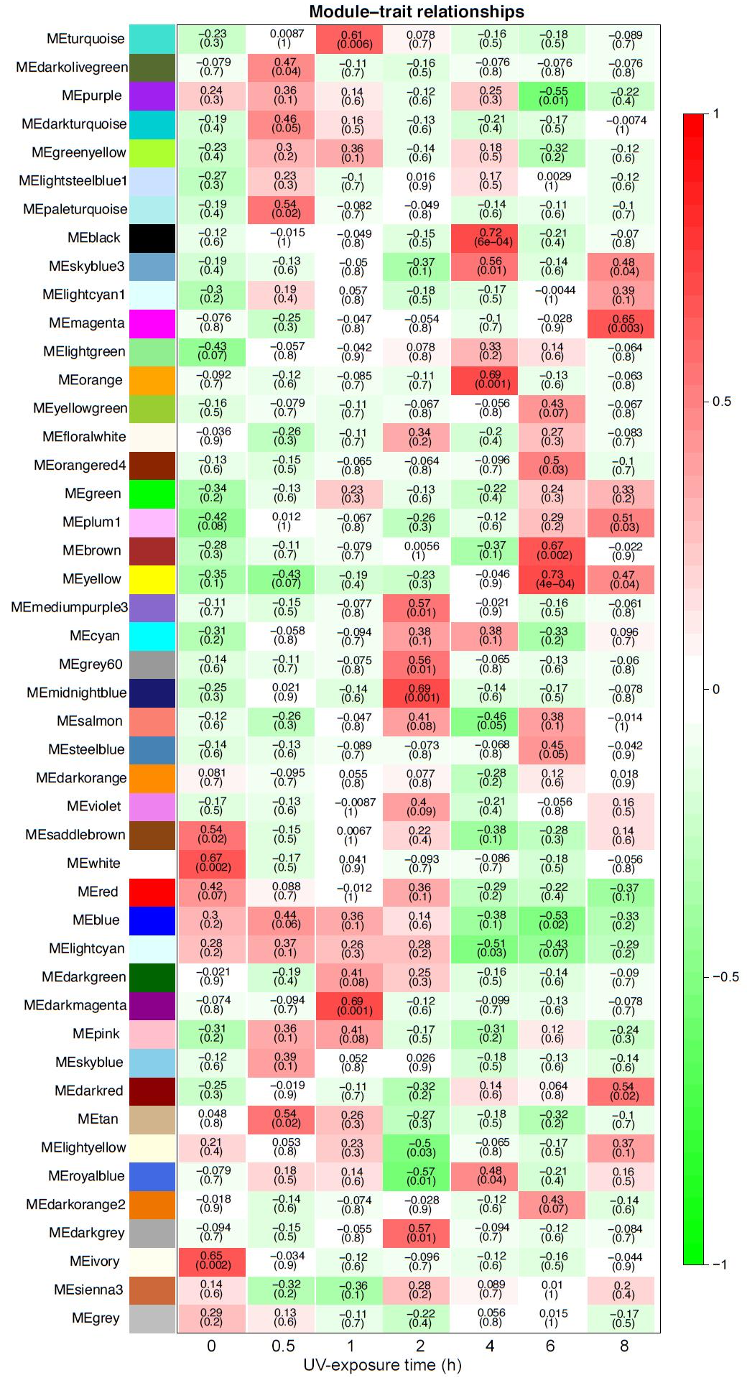
Supplementary Fig. 10. Module-UV-exposure time relationships of miRNA-mRNAs in N. parkeri according to the WGCNA analysis. The color indicates the respective correlation coefficient, as shown in the scale bar.

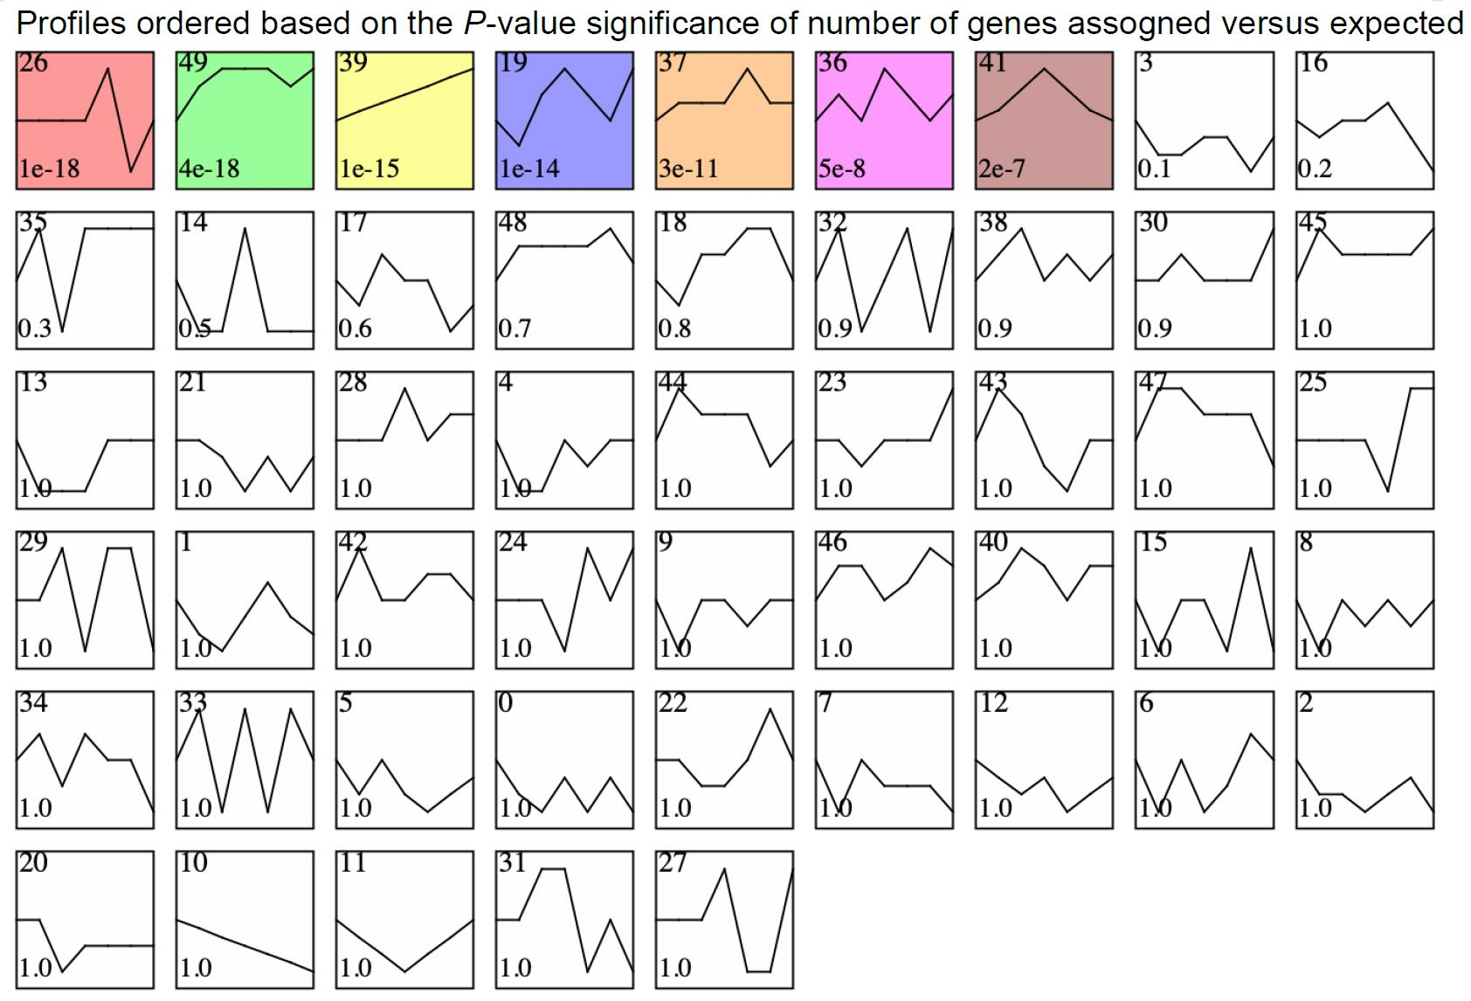

Supplementary Fig. 11. Clustering of miRNA expression levels in N. parkeri by STEM. Profiles that can be significantly (P < 0.001) clustered are shown in color and ordered by significance. Other profiles are shown in white. The profile number is at the top-left corner and the P-value of significance is at the bottom left corner. The miRNAs in Profile #39 which also showed inverse expression patterns relative to their predicted mRNAs were considered as co-expressed miRNAs in gradually-decreased group.

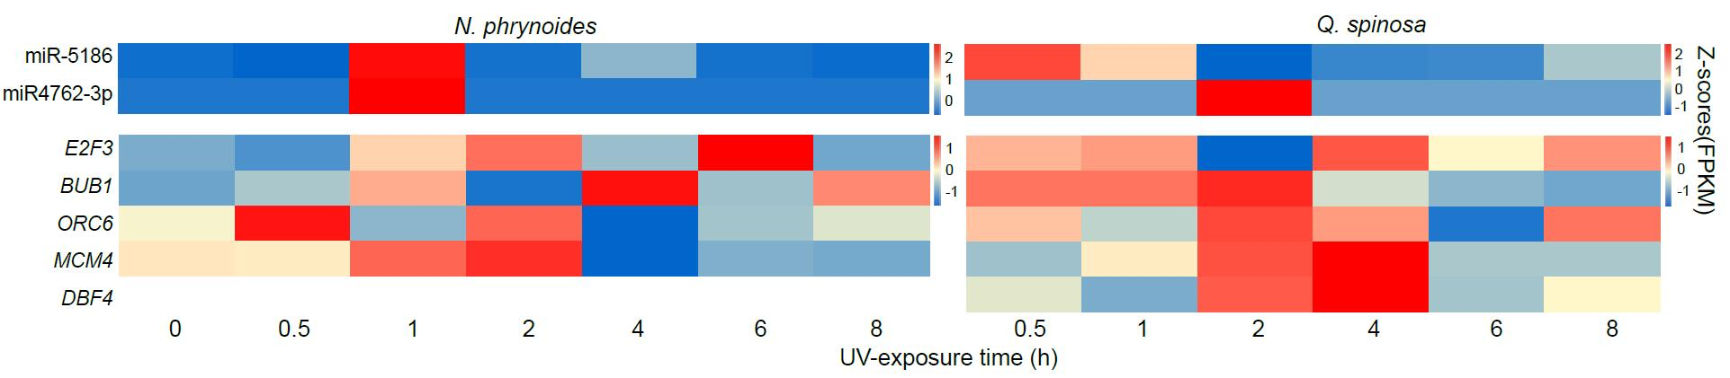
Supplementary Fig. 12. Expression heatmaps of orthologous miRNAs (upper panels) and mRNAs (lower panels) in N. phrynoides and Q. spinosa. The color represents an average of expression level (FPKM) normalized by Z-scores.

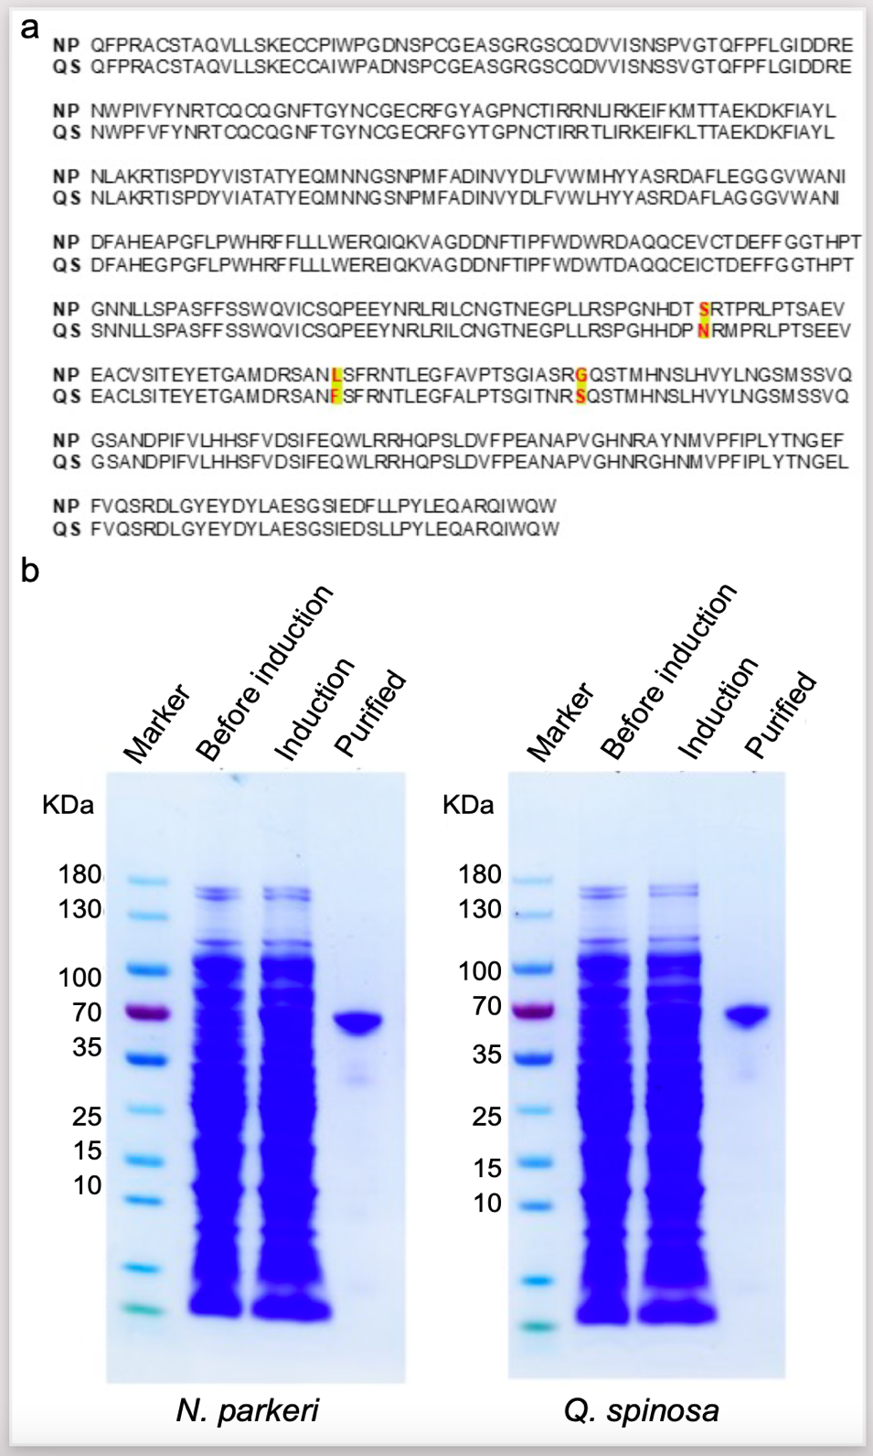

Supplementary Fig. 13. Amino acids sequences (a) and expression in vitro of tyrosinase (TYR) (b) in N. parkeri and Q. spinosa. a, Sequences aligned here were used to synthesize TYR and then to identify in vitro enzymological kinetic analyses. Amino acids replacements that are unique to N. parkeri are marked with red font and yellow highlighting. These N. parkeri unique replacements were found to be under positive selection. b, Synthetic TYR was expressed in BL21, purified with Ni-NTA agarose columns, and analyzed by SDS-PAGE. Lane 1: protein marker; lane 2: negative control; lane 3: protein expression after induction; and lane 4: purified protein.

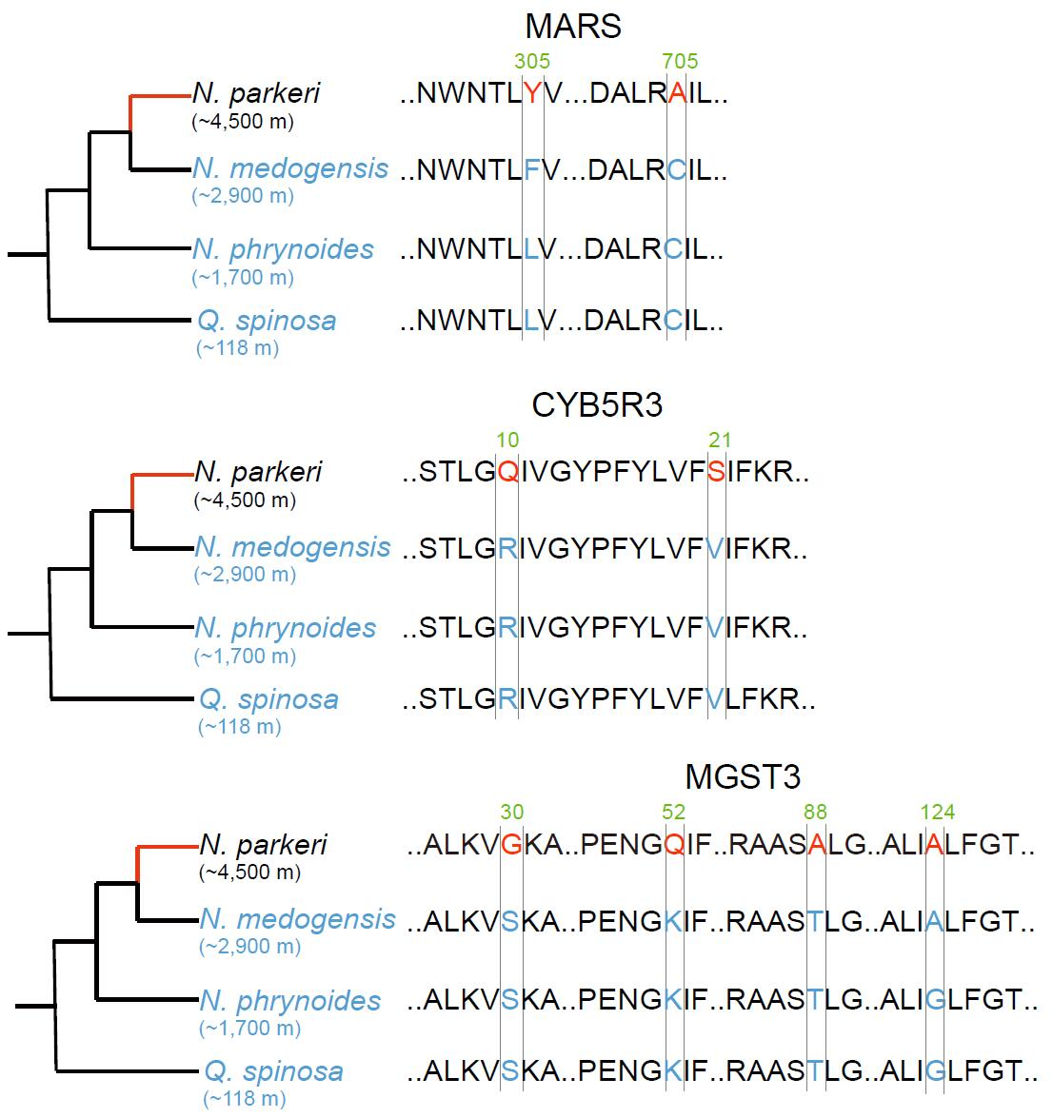
Supplementary Fig. 14. Phylogenetic relationships and schematic alignment of amino acid (AA) replacements of PSGs in N. parkeri and lower-elevation relatives. AA replacements unique to N. parkeri are marked with red font and were found to be under positive selection. The number above the alignments refers to the reference sequence of N. parkeri. Single-letter abbreviations for the amino acid residues are as follows: A, Ala; C, Cys; D, Asp; E, Glu; F, Phe; G, Gly; I, Ile; K, Lys; L, Leu; N, Asn; P, Pro; Q, Gln; R, Arg; S, Ser; T, Thr; V, Val; W, Trp; Y, Tyr.

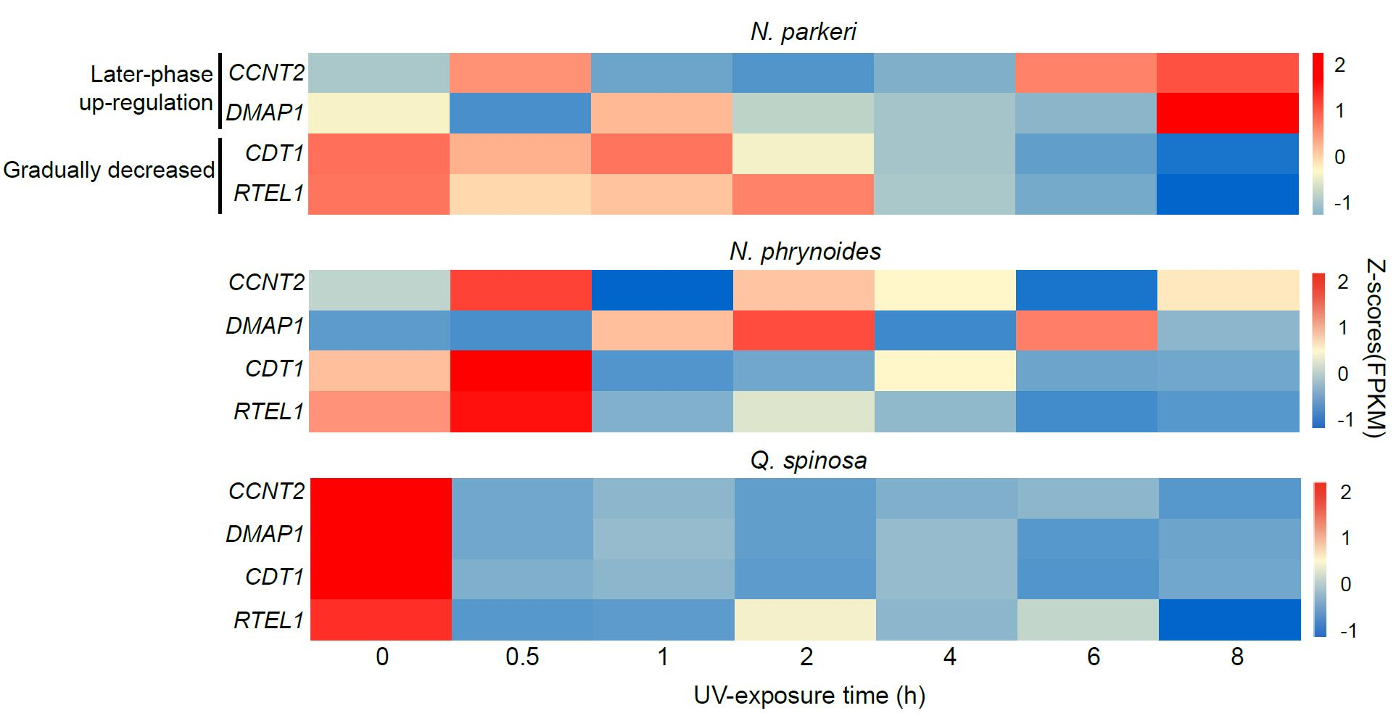
Supplementary Fig. 15. Expression changes of temporal expression genes in N. parkeri and corresponding orthologs in lower-elevation relatives (N. phrynoides and Q.spinosa) throughout UV exposure. The color represents an average of expression level (FPKM) at a time point normalized by Z-scores.
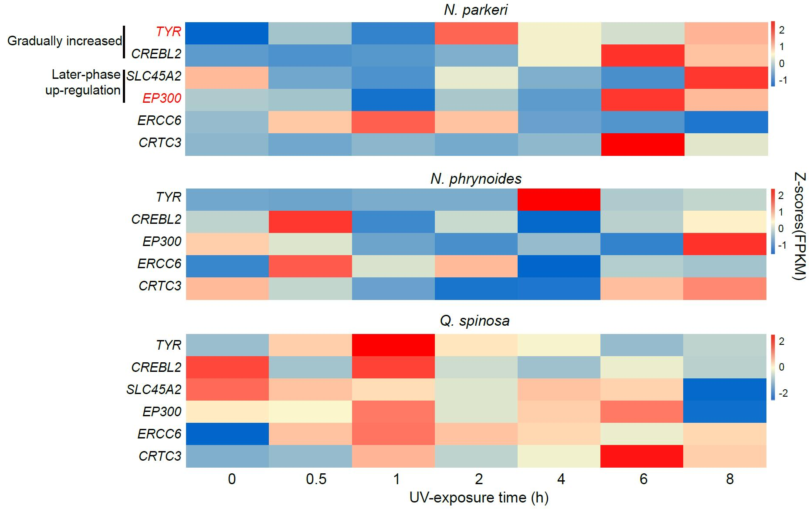
Supplementary Fig. 16. Expression changes of PSGs and temporal expression genes in N. parkeri, and corresponding orthologs in lower-elevation relatives (N. phrynoides and Q.spinosa) throughout UV exposure. PSGs in N. parkeri are in red font. The color of the scare bar represents an average expression level (FPKM) at a time point normalized by Z-scores.

Supplementary Tables

Supplementary Table 1. Specimen information. Collection sites and disposals of used samples.
Sample ID | Species | Experimental Treatment |  | Usage |  | Location
YPX42811 | N. parkeri | — | Genome sequencing |  | Lhasa, Tibet, China (3, 697 m)
Con1–Con3 | N. parkeri | Control | Antioxidant activity identification |  | Niancun, Gyaca County, Shannan, Tibet, China (4, 900 m)
Exp1–Exp3 | N. parkeri | UV exposure | Antioxidant activity identification
YPX42795–YPX42806 | N. parkeri | Control | Metabolomics quantification  (LC-MS) |  |  |  | Mozhugongka, Tibet, China (4, 478 m)
YPX42807–YPX42794 | N. parkeri | UV exposure | LC-MS
YPX42664–YPX42668 | N. parkeri | Control | Histological sections, mRNA-seq, miRNA-seq
YPX42677–YPX42680 | N. parkeri | UV 0.5 h | mRNA-seq, miRNA-seq
YPX42669–YPX42672 | N. parkeri | UV 1h | Histological sections, mRNA-seq, miRNA-seq
YPX42661–YPX42663 | N. parkeri | UV 2h | Histological sections, mRNA-seq, miRNA-seq
YPX42673–YPX42676 | N. parkeri | UV 4h | Histological sections, mRNA-seq, miRNA-seq
YPX42681–YPX42684 | N. parkeri | UV 6h | Histological sections, mRNA-seq, miRNA-seq
YPX42685–YPX42688 | N. parkeri | UV 8h | Histological sections, mRNA-seq, miRNA-seq
YPX48121–YPX48125 | N. phrynoides | Control | Histological sections, mRNA-seq, miRNA-seq |  | Jingdong, Yunnan Province, China (1, 760 m)
YPX48143–YPX48149 | N. phrynoides | UV 0.5 h | mRNA-seq, miRNA-seq
1h-1–1h-4 | N. phrynoides | UV 1h | Histological sections, mRNA-seq, miRNA-seq
2h-1–2h-4 | N. phrynoides | UV 2h | Histological sections, mRNA-seq, miRNA-seq
YPX48151–YPX48157 | N. phrynoides | UV 4h | Histological sections, mRNA-seq, miRNA-seq
YPX48127–YPX48133 | N. phrynoides | UV 6h | Histological sections, mRNA-seq, miRNA-seq
YPX48135–YPX48141 | N. phrynoides | UV 8h | Histological sections, mRNA-seq, miRNA-seq
Control1–Control3 | Q. spinosa | Control | Antioxidant activity identification |  | Huangshan, Anhui Province, China (176 m)
Case1–Case3 | Q. spinosa | UV exposure | Antioxidant activity identification
YPX42812–YPX42821 | Q. spinosa | Control | LC-MS
YPX42822–YPX42831 | Q. spinosa | UV exposure | LC-MS
CON_1–CON_3 | Q. spinosa | Control | mRNA-seq
YPX44262–YPX44264 | Q. spinosa | UV 0.5 h | Histological sections, mRNA-seq, miRNA-seq
YPX44265–YPX44267 | Q. spinosa | UV 1h | Histological sections, mRNA-seq, miRNA-seq
YPX44268–YPX44270 | Q. spinosa | UV 2h | Histological sections, mRNA-seq, miRNA-seq
YPX44271, YPX44273 | Q. spinosa | UV 4h | Histological sections, mRNA-seq, miRNA-seq |  | Huangshan, Anhui Province, China (176 m)
YPX44274, YPX44648, YPX44649 | Q. spinosa | UV 6h | Histological sections, mRNA-seq, miRNA-seq
YPX48159, YPX48161, YPX48163 | Q. spinosa | UV 8h | Histological sections, mRNA-seq, miRNA-seq

Supplementary Table 2. Statistics of contig-level genome assemble of N. parkeri. N90: the length of the smallest contig in the set that contains the fewest (largest) contigs whose combined length represents at least 90% of the assembly, and so on for N80 to N50.

 | Origin Falcon |  |  |  |  | Polish |  |  |  |  | Pilon
 | Size (bp) | Number |  |  | Size (bp) |  | Number |  |  | Size (bp) |  | Number
N90 | 183,302 | 1,563 |  |  | 184,350 |  | 1,565 |  |  | 184,362 |  | 1,565
N80 | 635,982 | 854 |  |  | 640,635 |  | 855 |  |  | 640,378 |  | 855
N70 | 1,181,135 | 575 |  |  | 1,187,113 |  | 576 |  |  | 1,186,991 |  | 576
N60 | 1,733,635 | 406 |  |  | 1,745,301 |  | 406 |  |  | 1,744,822 |  | 406
N50 | 2,323,300 | 282 |  |  | 2,337,137 |  | 283 |  |  | 2,336,739 |  | 283
Longest | 13,630,581 | ---- |  |  | 13,716,666 |  | ---- |  |  | 13,710,411 |  | ----
Total Size | 2,456,683,934 | ---- |  |  | 2,473,585,870 |  | ---- |  |  | 2,472,697,895 |  | ----
>=100bp | ---- | 7,134 |  |  | ---- |  | 7,134 |  |  | ---- |  | 7,134
>=2kb | ---- | 6,884 |  |  | ---- |  | 6,887 |  |  | ---- |  | 6,886

Supplementary Table 3. Statistics of N. parkeri genome assessment with BUSCO.

Number | Percentage (%) | Type
2272 | 87.9 | Complete BUSCOs (C)
2146 | 83 | Complete and single-copy BUSCOs (S)
126 | 4.9 | Complete and duplicated BUSCOs (D)
145 | 5.6 | Fragmented BUSCOs (F)
169 | 6.5 | Missing BUSCOs (M)
2586 | ---- | Total BUSCO groups searched

Supplementary Table 4. Statistics of chromosome-level genome assemble of N. parkeri.

 | Scaffold
 | Size(bp) | Number
N90 | 107,000,516 | 11
N80 | 116,390,974 | 9
N70 | 126,942,726 | 7
N60 | 150,785,030 | 6
N50 | 268,565,388 | 5
Longest | 407,978,197 | ----
Total Size | 2,475,211,768 | ----
Total Number(>=100bp) | ---- | 1,869
Total Number(>=2kb) | ---- | 1,732

Supplementary Table 5. Comparison of genome assemble and annotation among anuran amphibians.

Species | Assembled genome size (Gb) | Contig N50 (bp) | Scaffold N50 (bp) | Repetitive sequences (%) | Protein coding genes
Nanorana parkeri | 2.47 | 2,336,739 | 268,565,388 | 58.9 | 22,884
Leptobrachium leishanense | 3.5 | 1,931,129 | 394,693,044 | 77.1 | 23,420
Leptobrachium ailaonicum | 3.58 | 821,125 | 412,424,790 | 69.48 | 26,227
Rana catesbeiana | 5.8 | 5,239 | 68,964 | 66.9 | 22,000
Rhinella marina | 2.6 | 167,489 | 167,489 | 86.6 | 58,302
Oophaga pumilio | 5.5 | 3,942 | 59,503 | 62.9 | 17,051
Xenopus tropicalis | 1.5 | 71,041 | 135,134,832 | 51.9 | 27,047
Xenopus laevis | 2.7 | 19,713 | 136,570,856 | 38.3 | 37,385

Supplementary Table 6. Statistics of gene annotation in N. parkeri genome.

 |  | Number | Percent (%)
Total |  | 22,884
Annotated | InterPro | 21,140 | 92.38
Annotated | GO | 11,768 | 51.42
Annotated | KEGG | 19,005 | 83.05
Annotated | Swissprot | 21,378 | 93.42
Annotated | TrEMBL | 22,619 | 92
 | NR | 22,679 | 99.1
Unannotated |  | 96 | 0.42

Supplementary Table 7. Statistics of gene prediction.

Gene set |  | Number | Average transcript length (bp) | Average CDS length (bp) | Average exon per gene | Average exon length (bp) | Average intron length (bp)
De novo | AUGUSTUS | 21,608 | 52,280 | 1,338 | 7.7 | 173 | 7,575
Homolog | H. sapiens | 19,133 | 39,177 | 1,661 | 9.4 | 177 | 4,462
Homolog | G. gorilla | 20,479 | 33,465 | 1,501 | 8.6 | 173 | 4,187
Homolog | M. mulatta | 20,538 | 34,652 | 1,499 | 8.7 | 172 | 4,300
Homolog | M. musculus | 17,756 | 38,852 | 1,571 | 9 | 174 | 4,664
Homolog | R. roxellana | 20,279 | 34,597 | 1,585 | 8.9 | 177 | 4,165
Final set |  | 22,884 | 31,131 | 1,382 | 7.78 | 177 | 4,381

Supplementary Table 8. Statistics of annotated transposable elements (TEs).

Type | Repbase TEs length (bp) |  | % in genome |  | TE protiens length (bp) |  | % in genome |  | De novo length (bp) |  | % in genome |  | Combined TEs
 |  |  |  |  |  |  |  |  |  |  |  |  | Length (Bp) |  | % in genome
DNA |  | 94,358,202 |  | 3.82 |  | 15,323,977 |  | 0.61 |  | 530,152,426 |  | 21.44 |  | 574,368,176 |  | 23.23
LINE |  | 85,162,083 |  | 3.44 |  | 127,854,008 |  | 5.17 |  | 570,544,992 |  | 23.07 |  | 622,326,934 |  | 25.17
SINE |  | 8,690,955 |  | 0.35 |  | 0 |  | 0 |  | 20,450,549 |  | 0.83 |  | 28,042,113 |  | 1.13
LTR |  | 40,483,305 |  | 1.64 |  | 24,854,865 |  | 1.01 |  | 351,387,174 |  | 14.21 |  | 366,123,006 |  | 14.81
Other |  | 14,470 |  | 0.0006 |  | 0 |  | 0 |  | 9,698 |  | 0.0004 |  | 24,049 |  | 0.001
Unknown |  | 0 |  | 0 |  | 0 |  | 0 |  | 4,154,629 |  | 0.17 |  | 4,154,629 |  | 0.17
Total |  | 220,290,016 |  | 8.91 |  | 168,006,648 |  | 6.79 |  | 1,320,029,475 |  | 53.38 |  | 1,364,981,392 |  | 55.2

Supplementary Table 9. Statistics of non-coding RNA prediction.

Type |  | Copy | Average length (bp) | Total length (bp) | % of genome
miRNA |  | 220 | 94.66 | 20,826 | 0.000842
tRNA |  | 19,627 | 75.12 | 1,474,328 | 0.059624
rRNA | rRNA | 1,509 | 137.07 | 206,838 | 0.008365
rRNA | 18S | 122 | 293.8 | 35,843 | 0.00145
rRNA | 28S | 284 | 196.34 | 55,760 | 0.002255
rRNA | 5.8S | 23 | 105.52 | 2,427 | 0.000098
rRNA | 5S | 1,080 | 104.45 | 112,808 | 0.004562
snRNA | snRNA | 330 | 128.66 | 42,457 | 0.001717
snRNA | CD-box | 41 | 104.61 | 4,289 | 0.000173
snRNA | HACA-box | 25 | 143.16 | 3,579 | 0.000145
snRNA | splicing | 258 | 128.64 | 33,190 | 0.001342

Supplementary Table 10. Statistics of the transcriptome assemblies of N. phrynoides and Q. spinosa.

 | N. phrynoides |  | Q. spinosa
Number of seqs | 264,049 | 132,261
Mean length (bp) | 739.06401 | 871.6177
Longest (bp) | 26,386 | 90,220
N90 | 292 | 293
N70 | 559 | 887
N50 | 1,183 | 1,817

Supplementary Table 11. Relationships of co-expressed miRNA-mRNAs in gradually-decreased and later-phase temporal groups in N. parkeri.

Gradually decreased group
miRNA |  | mRNA | Pearson Correlation |  |  | P-value
gga-miR-456-3p |  | C1orf112 | -0.8191004 |  |  | 0.02418845
 |  | ATAD2B | -0.7916125 |  |  | 0.03391129
hsa-miR-4711-5p |  | CHAF1B | -0.7801322 |  |  | 0.03852019
 |  | MSANTD3 | -0.8699893 |  |  | 0.01090092
 |  | NFIA | -0.8444652 |  |  | 0.01682064
 |  | CDCA7 | -0.8504237 |  |  | 0.01530709
 |  | UBAP1L | -0.9033303 |  |  | 0.00529432
 |  | SLC8A1 | -0.7823912 |  |  | 0.03758749
 |  | BCAT1 | -0.7940028 |  |  | 0.0329926
 |  | ACAD8 | -0.8179993 |  |  | 0.02454278
hsa-miR-4762-3p |  | B3GALT5 | -0.7964512 |  |  | 0.03206616
 |  | CRP | -0.8493524 |  |  | 0.01557322
 |  | DBF4 | -0.763739 |  |  | 0.04566992
gga-miR-6587-5p |  | LRRFIP2 | -0.7713126 |  |  | 0.04228331
 |  | CDT1 | -0.7570061 |  |  | 0.04880151
hsa-miR-5186 |  | ORC6 | -0.8105978 |  |  | 0.0270001
 |  | MCM4 | -0.7696406 |  |  | 0.0430186
 |  | RNASEH2C | -0.8340297 |  |  | 0.01966894
hsa-miR-1288-5p |  | ORC6 | -0.7679027 |  |  | 0.04379029
hsa-miR-1288-3p |  | PAPPA | -0.7971506 |  |  | 0.03180424
 |  | CRP | -0.7832334 |  |  | 0.037243
 |  | GINS4 | -0.765581 |  |  | 0.04483301
 |  | THUMPD1 | -0.835378 |  |  | 0.01928667
 |  | ORC6 | -0.8230241 |  |  | 0.02294939
 |  | HSD17B12 | -0.7582626 |  |  | 0.04820844
 |  | SLC24A2 | -0.9020196 |  |  | 0.00547163
 |  | IQCH | -0.8417394 |  |  | 0.01754025
 |  | TMEM144 | -0.8672699 |  |  | 0.01146243
 |  | SPECC1 | -0.8187286 |  |  | 0.02430777
hsa-miR-744-3p |  | IFRD1 | -0.7802601 |  |  | 0.03846707
 |  | MSANTD3 | -0.8639703 |  |  | 0.01216559
 |  | SYNC | -0.7652601 |  |  | 0.0449782
 |  | SETMAR | -0.8711499 |  |  | 0.01066621
 |  | E2F3 | -0.8299849 |  |  | 0.02084133
 |  | PSMC3IP | -0.917823 |  |  | 0.0035558
 |  | CDCA8 | -0.8563841 |  |  | 0.013874
 |  | C1orf112 | -0.8987079 |  |  | 0.00593486
 |  | BUB1 | -0.7790372 |  |  | 0.03897688
gga-miR-128-3p |  | PAPPA | -0.7679027 |  |  | 0.04379029
 |  | HCN4 | -0.8688884 |  |  | 0.01112629
 |  | E2F3 | -0.7955461 |  |  | 0.03240694
gga-miR-148a-3p |  | HMGA2 | -0.9049274 |  |  | 0.00508284
 |  | E2F7 | -0.8630111 |  |  | 0.01237452
 |  | E2F3 | -0.7628172 |  |  | 0.04609191
gga-miR-31-5p |  | DGKI | -0.8344002 |  |  | 0.01956348
gga-miR-425-5p |  | B3GALT5 | -0.8144547 |  |  | 0.02570314
Later-phase upregulation group
miRNA |  | MM | P-value
hsa-miR-3617-3p | -0.67 |  |  | 0.0016
hsa-miR-4440 | -0.6 |  |  | 0.006
hsa-miR-6847-5p | -0.63 |  |  | 0.004

