Supporting Information
Optimization of Extraction Parameters and Investigation Anti-Osteosarcoma Effects of Low Methoxy Pectin
Cemile Uslu², Dilara Yeniterzi¹, Sümeyye Narin⁴, Gülcihan Gülseren^{1,2,3*}
¹Department of Biotechnology, Graduate School of Natural & Applied Sciences, Konya Food and Agriculture University, 42080, Konya, Turkey
²Department of Molecular Biology and Genetics, Faculty of Agriculture and Natural Sciences, Konya Food and Agriculture University, 42080, Konya, Turkey
³Research and Development Center for Diagnostic Kits (KIT-ARGEM), Konya Food and Agriculture University, Konya, Turkey
⁴Department of Bioengineering, Faculty of Engineering and Architecture, Konya Food and Agriculture University, 42080, Konya, Turkey
*Corresponding author: gulcihan.gulseren@gidatarim.edu.tr

Supplementary Figures
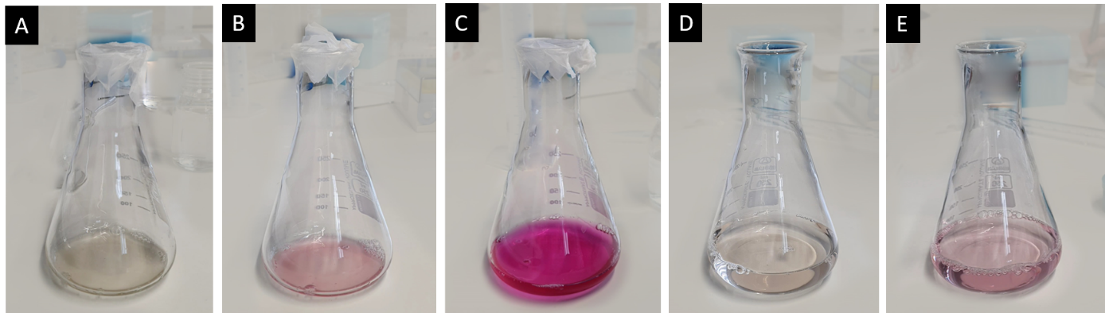
Fig. S1. Determination of esterification degree of the pectin with titration method. A) Pectin is moistened with 65% ethanol and then dissolved in CO2 free water and phenolphthalein is added as pH indicator. B) The mixture is titrated with 0.1 M NaOH until the faint pink color is retained. Added NaOH value is recorded. C) 10 ml of 0.1 M NaOH is added, and mixture is stirred for 30 minutes. D) 0.1 M HCl is added to mixture in order to neutralize it. E) Second titration is performed with 0.1M NaOH until faint pink color is observed. Volume of added NaOH is recorded for calculation.
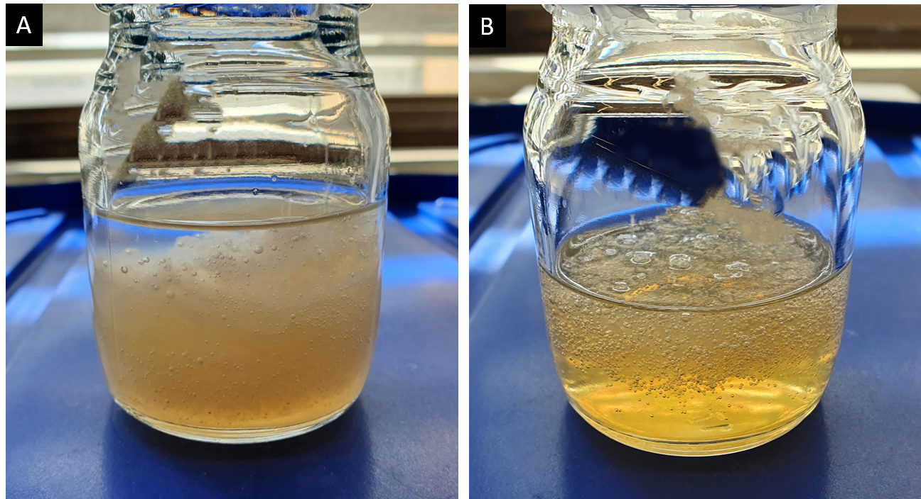
Fig. S2. Image that demonstrate pectin precipitated in absolute ethanol. pH of the filtrate affected the precipitated amount of pectin in absolute ethanol. There is an obvious difference between A) when pH of the filtered extract is increased to 3.5 B) and when pH of the extract is kept constant. More pectin was precipitated as shown in A after pH increase to 3.5 compared to B.

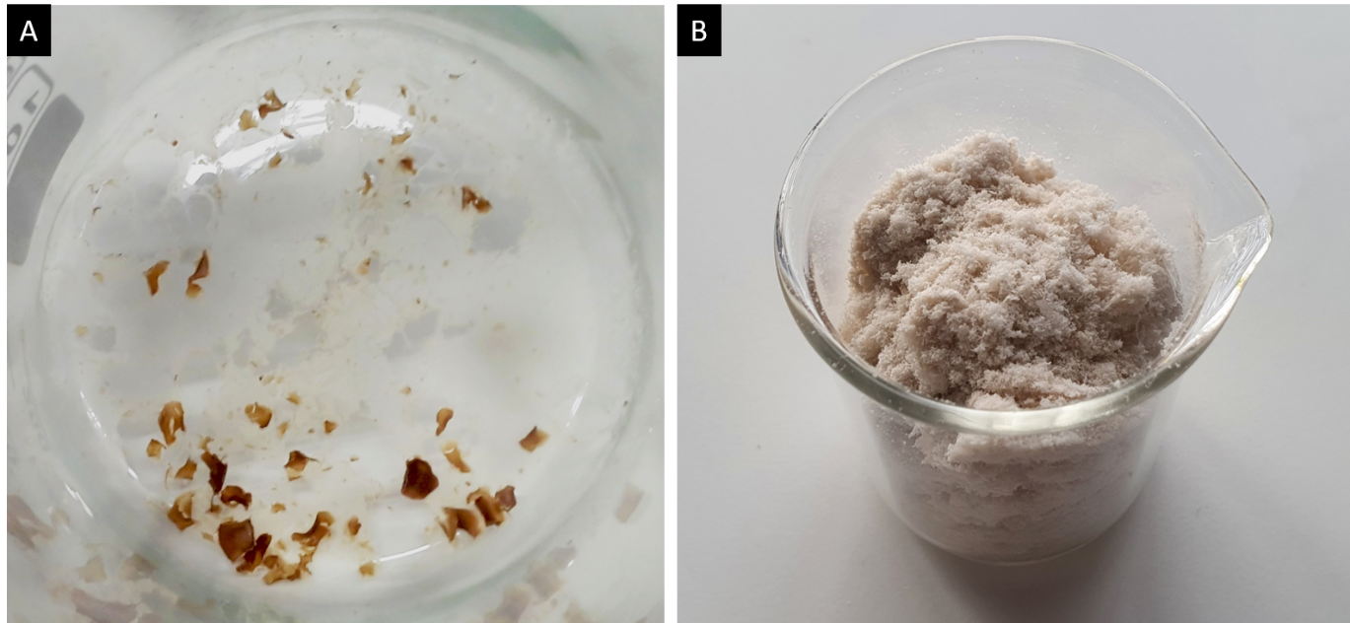
Fig. S3. Drying method is influencing the appearance of the obtained pectin. A) Dark colored and quantitatively insignificant pectin was obtained after drying wet pectin on heater at 60 °C overnight. B) Qualified and white colored pectin was obtained after drying wet pectin with freeze drying method in lyophilizer.

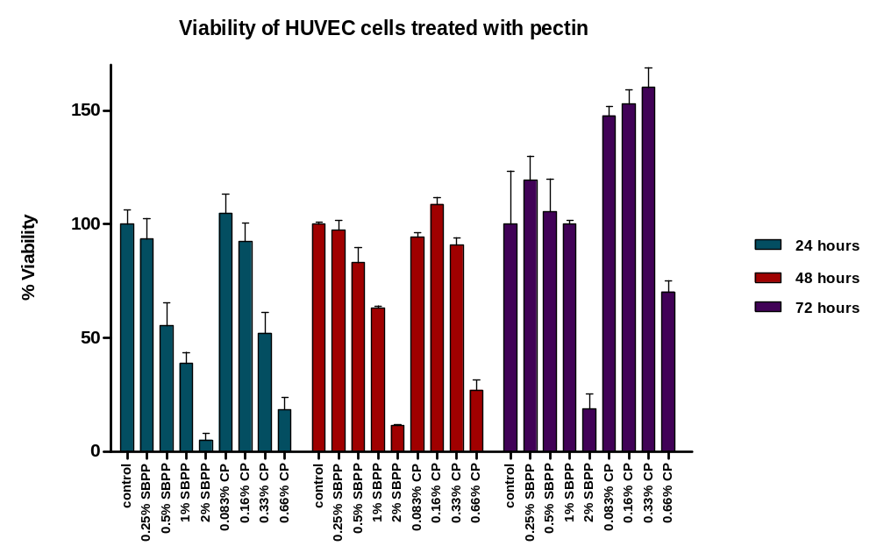Fig. S4. Viability of HUVEC cells after treatment with different concentrations of SBPP and CP for 24, 48 and 72 hours. Blue colored bars demonstrate viability of HUVEC cells after 24 hours, red colored bars demonstrate after 48 hours, purple colored bars demonstrates after 72 hours of pectin treatment. Error bars represent standard deviation (SD) of replicas of each group.

Supplementary Tables
Table S1. Literature examples of pectin isolation from sugar beet pulp
Method | Max. Yield | Esterification Degree (DE)
(Levigne et al., 2002) | 35.4% | 55%
(Yapo et al., 2007) | 16.2% | 14.4%.
(Lv et al., 2013) | 24.96% | Not measured
(Ma et al., 2013) | 17.2% | 45%
(Li et al., 2015) | 23% | Not measured
(Yılmaz et al., 2016) | 19.6% | Not measured
(Pacheco et al., 2019) | 19 % | 48.4- 50.14%

