Supplementary material to the paper: Conservative N cycling despite high deposition in early successional African tropical lowland forests
Isaac Ahanamungu Makelele^{1,2,3*}, Marijn Bauters^{1,2,4} , Kris Verheyen², Matti Barthel⁵, Johan Six⁵, Tobias Rütting⁶, Samuel Bodé¹, Landry Cizungu Ntaboba⁷, Basile Mujinya Bazirake⁸, Boyemba Bosela⁹, Fabrice Kimbesa⁹, Corneille Ewango¹⁰, Pascal Boeckx¹

¹Isotope Bioscience Laboratory - ISOFYS, Department of Green Chemistry and Technology, Faculty of Bioscience Engineering, Ghent University, Gent, Belgium
²Forest & Nature Lab, Department of Environment, Faculty of Bioscience Engineering, Ghent University, Gent, Belgium
³Department of Biology, Université Officielle de Bukavu, Bukavu, Democratic Republic of the Congo

*E-mail: isaacmakelele1@gmail.com

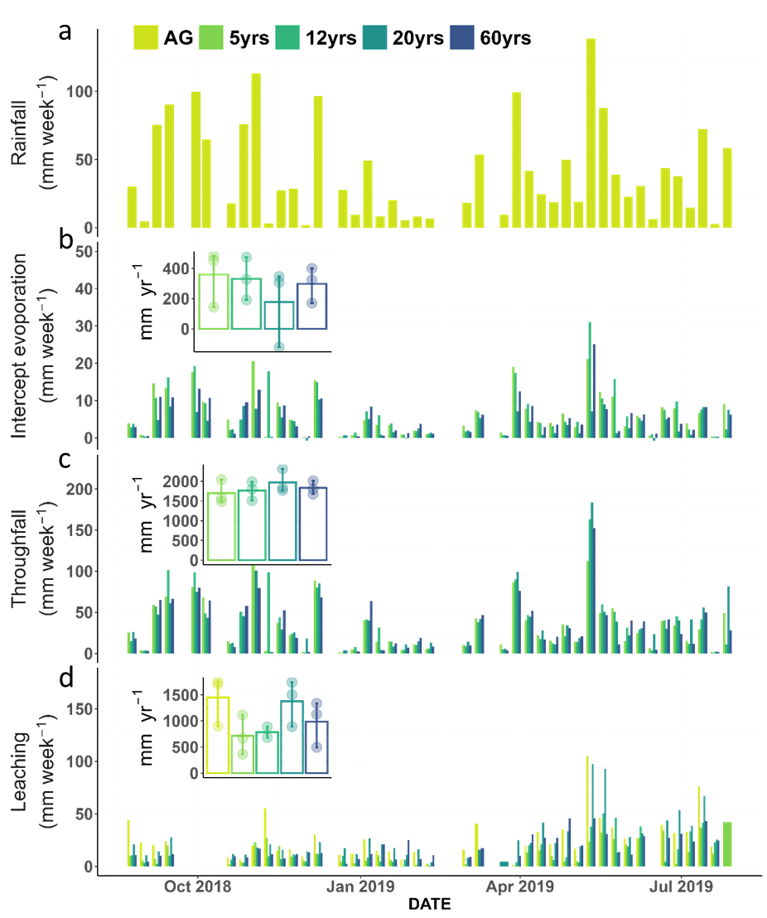
Figure S1: Water fluxes along secondary succession of the Congo basin: annual and weekly hydrologic fluxes along secondary succession; a) rainfall, b) evaporation of canopy interception water, c) throughfall flux and d) leaching flux. AG, 5yrs, 12yrs, 20yrs and 60yrs stand respectively for the agriculture site, 5, 12, 20 and 60 years secondary forests.

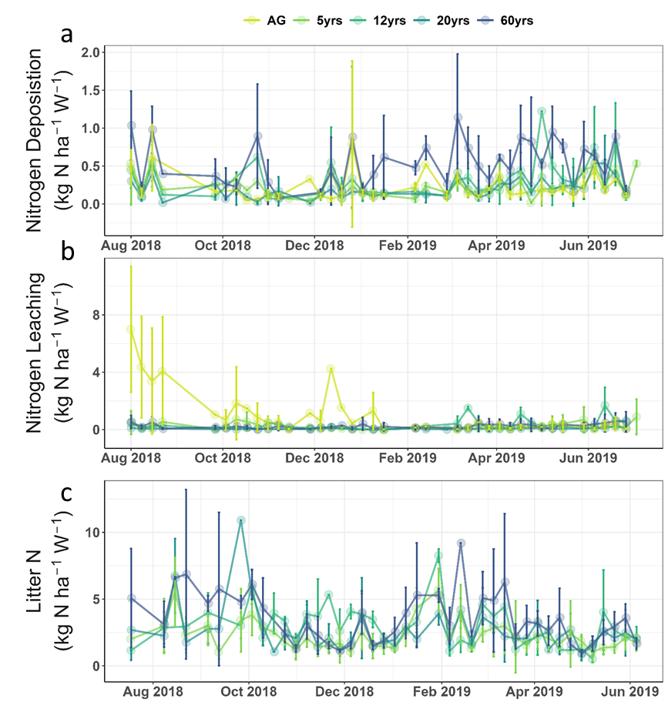

Figure S2: Total dissolved nitrogen (TDN, kg N ha⁻¹ w⁻¹) and litter N flux over the sampling period. a) Throughfall deposition, b) leaching loss and c) litter N flux. The point are successional stage means at the day and error bars are standard deviations. AG, 5yrs, 12yrs, 20yrs, 60yrs and OG stand respectively for the agriculture site, 5, 12, 20, 60 years secondary forests and old growth forests.

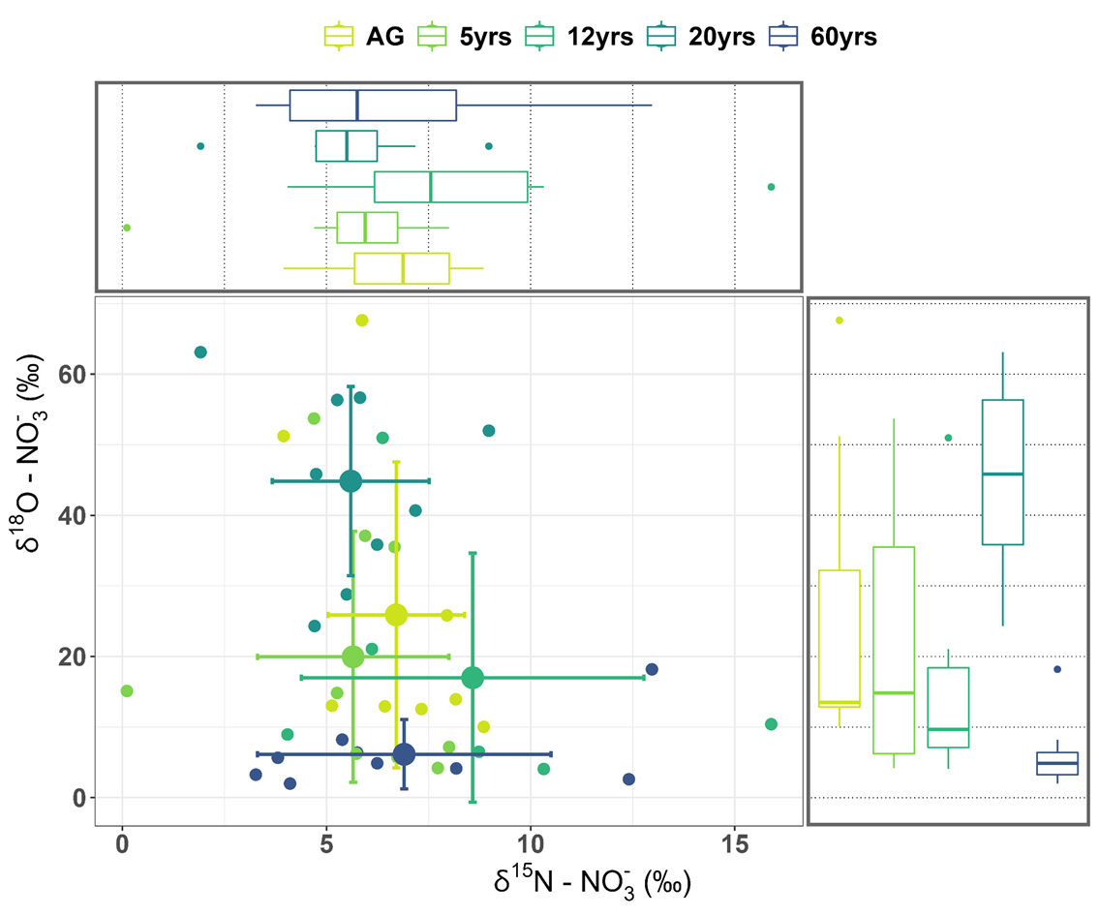

Figure S3: Isotopic composition of leached nitrate (δ¹⁸O and δ¹⁵N (‰)) along the successional gradients. AG, 5yrs, 12yrs, 20yrs and 60yrs stand respectively for agricultural field, 5, 12, 20 and 60 years-old secondary forests. Boxplots show the median, the 25th and 75th percentile and the 1.5 interquartile range spread. Small points represent monthly (November 2018, January 2019 and May 2019) plots composite, weekly, measurements of composite samples (n = 8) per plot for each successional stage.

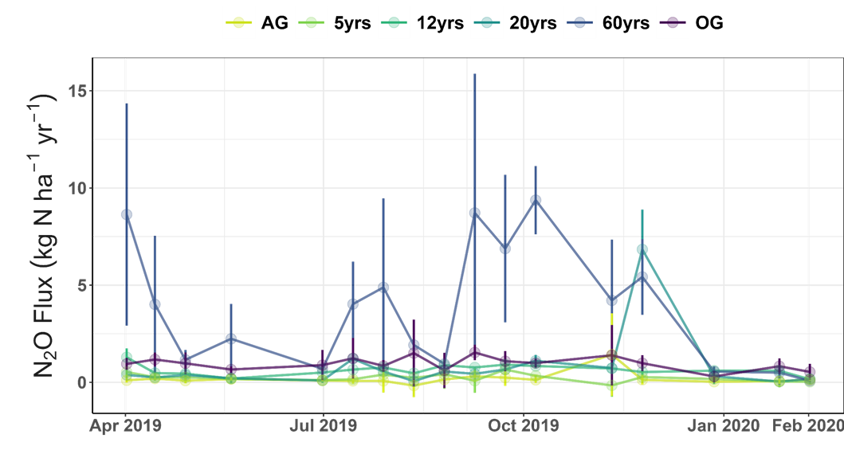
Figure S4: fluxes of N₂O over the sampling period (kg N ha⁻¹ yr⁻¹). The points are successional stage means at the day and error bars are standard deviations. AG, 5yrs, 12yrs, 20yrs, 60yrs and OG stand respectively for the agriculture site, 5, 12, 20, 60 years secondary forests and old growth forests.

Table S1: Annual bulk, dry, total (wet + dry) and throughfall nitrogen deposition, leaching and balance between total deposition and leaching loss. Values are successional stage means in kg N ha⁻¹ year⁻¹ and standard deviation between brackets. AG, 5yrs, 12yrs, 20yrs and 60yrs stand respectively for agricultural site, 5, 12, 20 and 60 years secondary forest. Mean stand for arithmetic mean, SD for standard deviation.

 |  | AG |  | 5yrs |  | 12yrs |  | 20yrs |  | 60yrs
 |  | Mean (SD) | CV | Mean (SD) | CV | Mean (SD) | CV | Mean (SD) | CV | Mean (SD) | CV
Bulk deposition | NH4 | 2.6 (1) | 23
 | NO3 | 4 (1) | 23
 | DON | 4.9 (1) | 23
 | TDN | 11.6 (3) | 23
Dry deposition | NH4 |  |  | 2.6 (3) | 122 | 0.1 (1) | 845 | 1.8 (2) | 98 | 2.3 (1) | 26
 | NO3 |  |  | 3.9 (5) | 122 | 0.1 (1) | 845 | 2.7 (3) | 98 | 3.5 (1) | 26
 | DON |  |  | 4.8 (6) | 122 | 0.2 (2) | 845 | 3.3 (3) | 98 | 4.2 (1) | 26
 | TDN |  |  | 11.3 (14) | 122 | 0.4 (4) | 845 | 7.7 (8) | 98 | 10 (3) | 26
Total deposition (TD) | NH4 |  |  | 5.2 (3) | 60 | 2.7 (1) | 30 | 4.4 (2) | 39 | 4.9 (1) | 12
 | NO3 |  |  | 8 (5) | 60 | 4.2 (1) | 30 | 6.7 (3) | 39 | 7.5 (1) | 12
 | DON |  |  | 9.7 (6) | 60 | 5.1 (2) | 30 | 8.2 (3) | 39 | 9.2 (1) | 12
 | TDN |  |  | 22.9 (14) | 60 | 12 (4) | 30 | 19.3 (8) | 39 | 21.6 (3) | 12
Canopy exchange | NH4 |  |  | -3.9 (3) | 82 | -0.5 (2) | 324 | -3 (1) | 42 | 0.2 (2) | 737
 | NO3 |  |  | -1 (7) | 753 | -0.5 (1) | 138 | -2.2 (1) | 62 | 4.7 (3) | 60
 | DON |  |  | -5.2 (6) | 110 | 0.7 (2) | 309 | -2.6 (2) | 81 | 2 (2) | 121
 | TDN |  |  | -10.1 (15) | 150 | -0.3 (5) | 1635 | -7.8 (5) | 59 | 6.9 (7) | 96
Throughfall deposition | NH4 |  |  | 1.3 (1) | 45 | 2.2 (3) | 116 | 1.4 (1) | 41 | 5.1 (1) | 20
 | NO3 |  |  | 7 (5) | 73 | 3.7 (2) | 53 | 4.5 (1) | 32 | 12.2 (2) | 17
 | DON |  |  | 4.5 (1) | 22 | 5.9 (4) | 66 | 5.6 (1) | 22 | 11.2 (1) | 12
 | TDN |  |  | 12.8 (5) | 37 | 11.8 (8) | 71 | 11.5 (3) | 26 | 28.5 (4) | 15
Leaching loss (LL) | NH4 | 0.6 (0) | 75 | 0.7 (1) | 81 | 2.4 (1) | 63 | 0.3 (0) | 70 | 0.7 (0) | 53
 | NO3 | 38.7 (39) | 101 | 10.9 (15) | 137 | 8.5 (4) | 44 | 1.9 (3) | 161 | 20.5 (25) | 124
 | DON | -1.1 (3) | 278 | 5.6 (6) | 103 | 3 (2) | 60 | 4.8 (5) | 101 | 3.3 (4) | 120
 | TDN | 38.2 (36) | 95 | 17.2 (13) | 78 | 13.9 (1) | 4 | 6.9 (8) | 116 | 24.5 (30) | 121
Budget (TD – LL) | NH4 | 2.1 (1) | 42 | 4.5 (3) | 63 | 0.4 (1) | 175 | 4.1 (2) | 37 | 4.2 (0) | 6
 | NO3 | -34.7 (38) | 111 | -2.9 (16) | 548 | -4.3 (5) | 117 | 4.8 (1) | 22 | -13 (25) | 189
 | DON | 6 (4) | 60 | 4.1 (3) | 69 | 2.1 (0) | 12 | 3.4 (2) | 64 | 5.9 (3) | 51
 | TDN | -26.6 (35) | 130 | 5.6 (16) | 282 | -1.8 (4) | 227 | 12.4 (3) | 23 | -2.9 (27) | 946

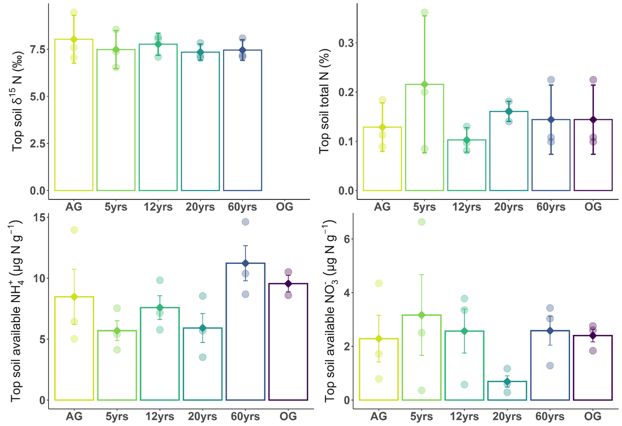

Figure S4: Soil nitrogen data. a) top soil δ¹⁵N (‰), b) top soil total N (%), c) top soil NH₄⁺ content (µg N g⁻¹), d) top soil NO₃⁻ content (µg N g-1). 5yrs, 12yrs, 20yrs, 60yrs and OG stand for the 5, 12, 20, 60 years secondary forests and old growth forest, respectively. The bars are medians, the diamond shaped points are means, circle points are plot level data and error bars are standard deviation.

