Supplementary information
Effect of salinity on the microscopic interaction and sedimentation behavior of halloysite clay

Namgyu Noh^{1,†}, Yeong-Man Kwon^{2,†}, Kyun-Seong Dae¹, Gye-Chun Cho^{2, *}, Ilhan Chang^{3,*}, and Jong Min Yuk^{1,*}

Affiliation
¹Department of Materials Science & Engineering, Korea Advanced Institute of Science and Technology, Daejeon, Republic of Korea 34141
²Department of Civil and Environmental Engineering, Korea Advanced Institute of Science and Technology, Daejeon, Republic of Korea 34141
³Department of Civil Systems Engineering, Ajou University, Suwon-si, Republic of Korea 16499
† These authors contributed equally: Namgyu Noh, Yeong-Man Kwon

Full contact details of the co-corresponding author.
* Jong Min Yuk: jongmin.yuk@kaist.ac.kr
* Ilhan Chang: ilhanchang@ajou.ac.kr
* Gye-Chun Cho: gyechun@kaist.ac.kr

Keywords: HNT, salinity, sedimentation, flocculation, in-situ liquid-phase microscopy
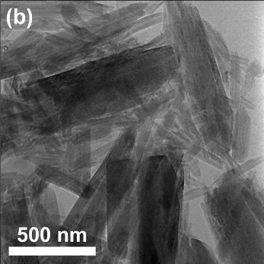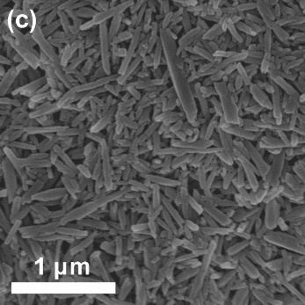
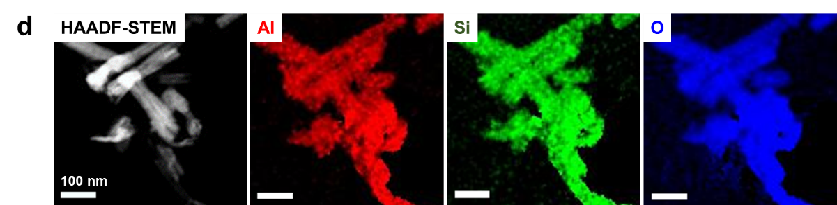
Supplementary Figure 1: Mineral properties of halloysite clay nanotubes. a Sediment size distribution curve. b TEM image, and c SEM image of dried HNTs. d High-angle annular dark field scanning transmission electron microscopy (HAADF-STEM) image and the chemical composition maps of Al, Si, and O corresponding to dried HNT particles.

Supplementary Fig. 2: Sedimentation behavior of halloysite suspensions at various salinities. a The variation in void ratio during sedimentation, b the initial settling rate, and c the final void ratio.

Estimation of the interaction energy between clay surfaces in pore fluid with different salinity
This study calculated the interaction energy between FF, EF, and EE surfaces for different salinities based on Durán, Ramos-Tejada ¹, as shown in Supplementary Fig. 3. The interaction energy per unit area (in J/m²) was obtained using the Hogg-Healy-Fuersteneau model (DLVO-HHF), as shown in equation (1) ²:
$V_{i3j}=\frac{εκ}{8π}[(ψ_{0i}^{2}+ψ_{0j}^{2})(1-\coth{κH)+2ψ_{0i}ψ_{0j}cosech κH]}$, [1]
where V is the double-layer energy (in J/m²), the subscripts i and j indicate the surface type, 1 is the face surface, and 2 is the edge surface. ε (in F/m) is the dielectric constant of the media, κ (in m⁻¹) is the reciprocal Debye length, ψ (in V) is the surface potential that matches the zeta potential values (Supplementary Table 1), and H (in m) is the surface-to-surface distance.
The Lifshitz van der Waals force was calculated for two parallel plates with a distance H ³, as shown in equation (2):
$V_{i3j}^{LW}=-\frac{A_{i3j}}{12πH^{2}}= \frac{24πH_{0}^{2}[{\left(γ_{i}^{LW}γ_{3}^{LW}\right)}^{1/2}+{\left(γ_{j}^{LW}γ_{3}^{LW}\right)}^{1/2}-{\left(γ_{i}^{LW}γ_{j}^{LW}\right)}^{1/2}-γ_{3}^{LW}]}{12πH^{2}}$, [2]
where V^{LW} (in J/m²) is the van der Waals energy, A (in J) is the Hamaker constant, which is affected by the surface free energy γ^{LW} (in J/m²; Supplementary Table 1), and the minimum distance H₀ (in m).
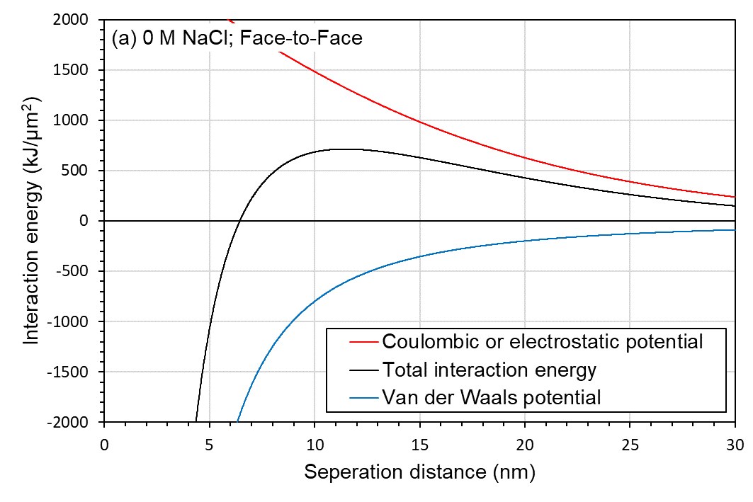 | 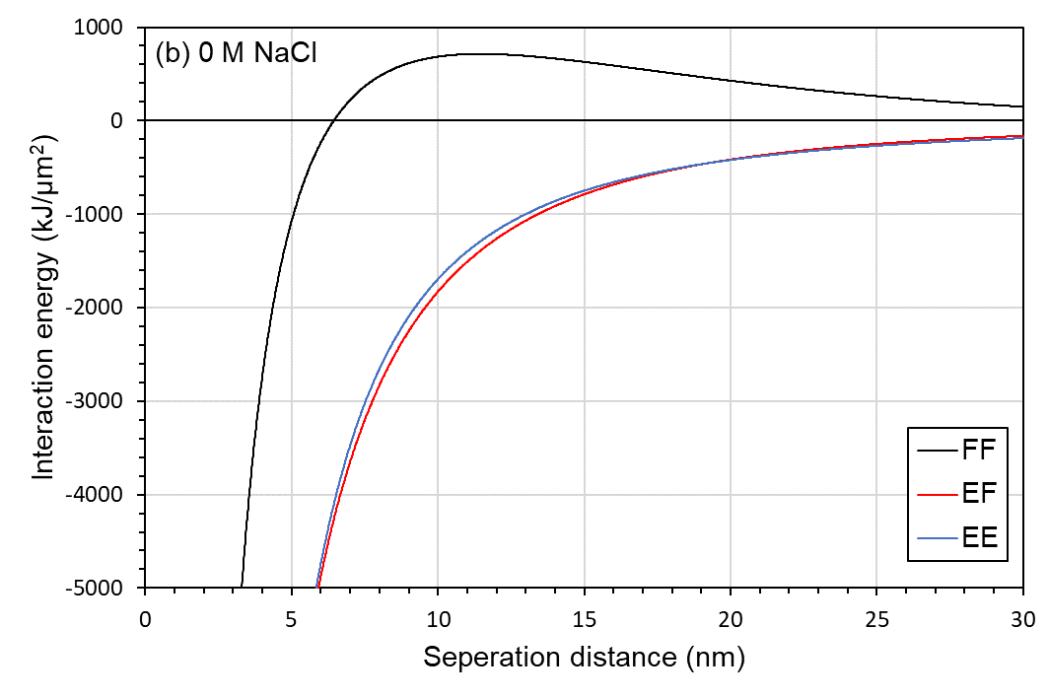
Supplementary Figure 3: The calculation results of DLVO forces of HNTs. a DLVO forces between face surfaces at 0 M NaCl, b Net-forces of different interaction sites at 0 M NaCl.

Supplementary Table 1: Surface energy components
Material | Zeta-potential  (mV) | γ^{LW}  (mJ/m²)
HNT | -22.2 ª | 35 ^{d}
SiO₂ | -22.0 ^{b} | 40.9 ^{e}
Al₂O₃ | 26.9 ^{b} | 43.7 ^{e}
HNT (edge) | 2.5 ^{c} | 42.3 ^{c}
ª Measured using particle analyzer (Litesizer 500, Anton Paar) in laboratory, and the results matched with Vergaro, Abdullayev ⁴, ^{b} Taken from Durán, Ramos-Tejada ¹, ^{c} Calculated as the average of the values of SiO₂ and Al₂O₃, ^{d} Taken from Murphy, van Oss ⁵, ^{e} Taken from Mittal ⁶

Supplementary Figure 4 shows the interaction energies between different surface types and salinities as a function of ε in equation (1). The decrease in double-layer repulsion was due to the increasing salinity. As a result, the net interaction energy between face and face surfaces changed from repulsion to attraction, whereas the EF attraction force reduced as the salinity increased, resulting in HNT particle dispersion. Furthermore, as the salinity increased, the interaction energy between the EE surfaces altered slightly.

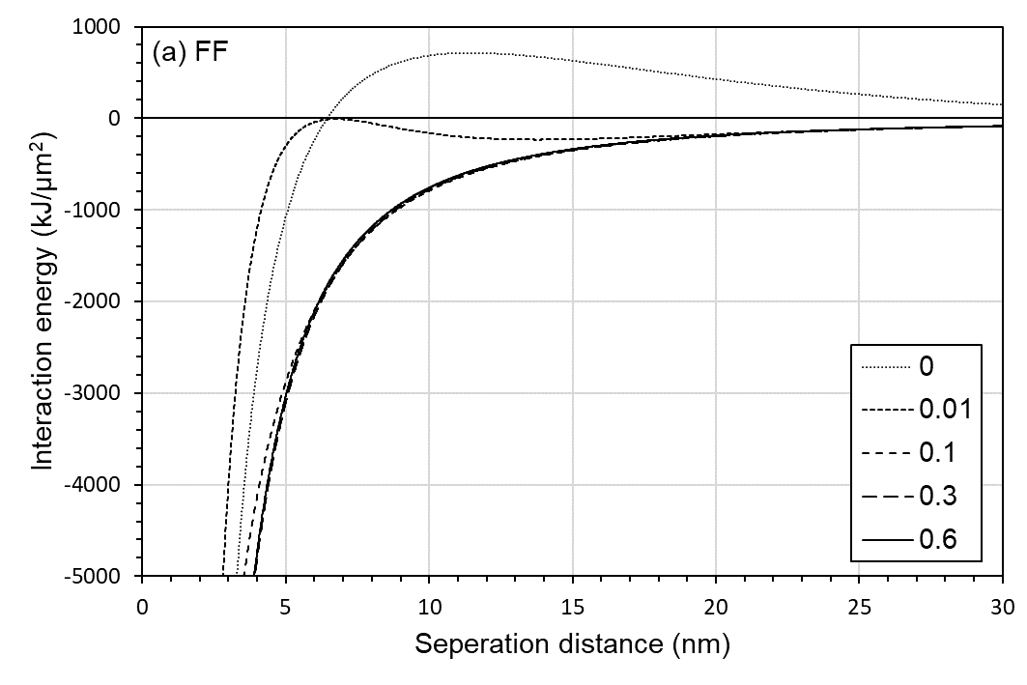 | 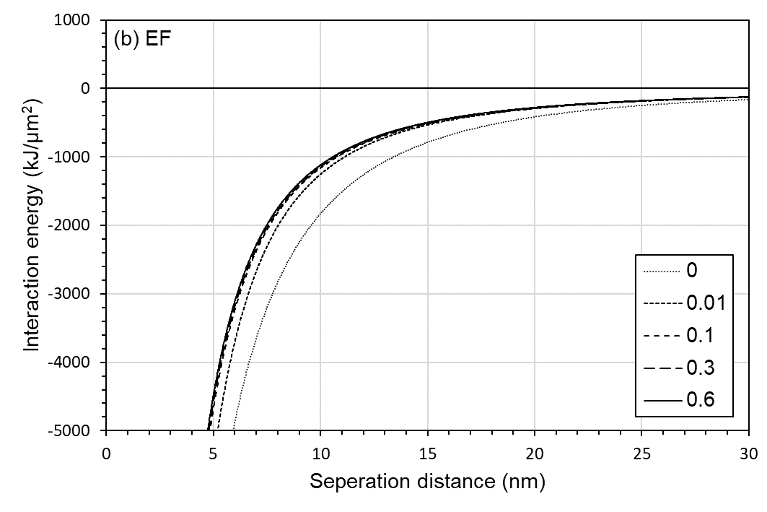
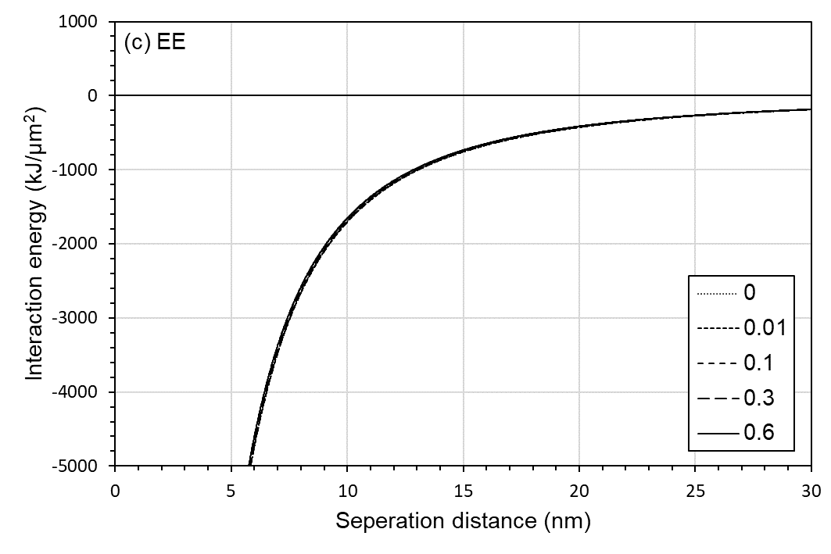
Supplementary Figure 4: Net DLVO forces between a face and face, b edge and face, c edge and edge at different salinity.

Schematic diagram showing the mechanisms of how NaCl affected the HNT interactions

Supplementary Figure 5 summarizes the interaction energy between FF, EF, and EE surfaces at a distance of 10 nm. Without salinity, double-layer repulsion between FF, double-layer attraction between EF, and van der Waals attraction between EE surfaces were the dominant forces. With salt added, the counterions compressed double-layer spaces, lowering the double-layer force of the EE and EF surfaces. In contrast, the van der Waals force between the EE surfaces varied slightly with salinity. Because NaCl lowered the EF attraction, particle dispersion occurred, reducing the floc size and settling velocity. Finally, the dispersed HNTs stacked FF-like structures, resulting in dense final sediment.
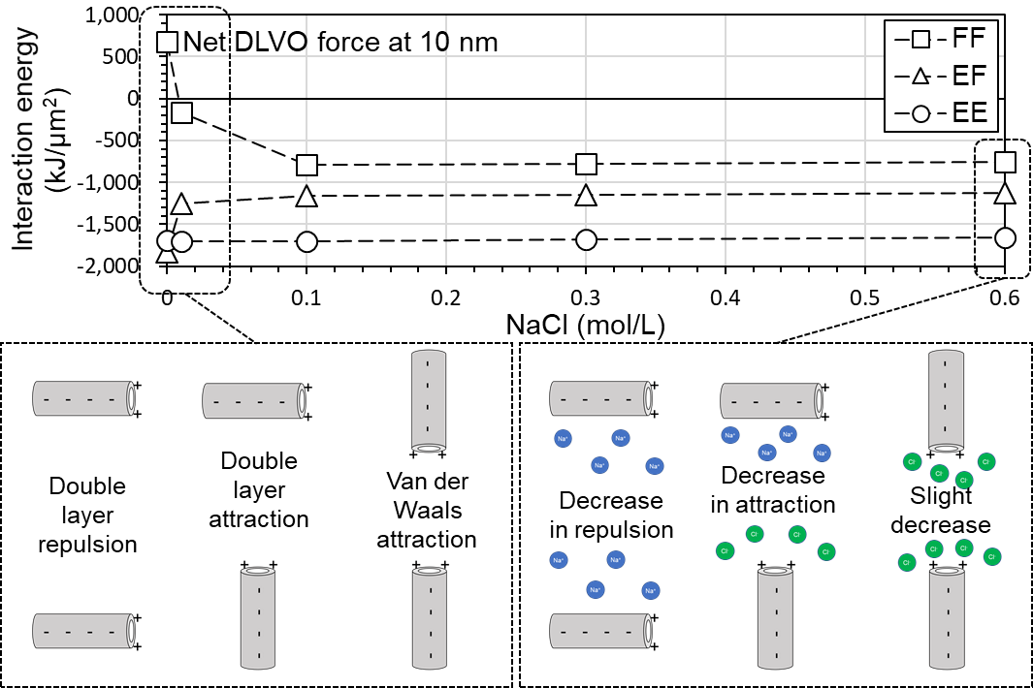
Supplementary Figure 5: Net-interaction energy and schematic description of dominant interparticle force between face-to-face, edge-to-face, and edge-to-edge surfaces.

Sedimentation tests from Desalination to Salination

Supplementary Figure 6 shows the sedimentation test results. The desalination process was observed from 0.6 M NaCl to 0.01 M NaCl (Step 1-5), followed by a subsequent salination process up to 0.6 M NaCl (Step 5-9). When sedimentation (Test 2) started from the high salinity (0.6 M NaCl), the initial salt adsorption and the resultant decrease in the double layer affected the entire sedimentation process, including desalination and salination. Thus, unlike test 1 (Fig. 1b, c), the initial settling rate (Supplementary Fig. 6b) and the final void ratio (Supplementary Fig. 6c) showed symmetric change with an increase and decrease in salinity, while the final void ratio decreased but did not reach its original state.

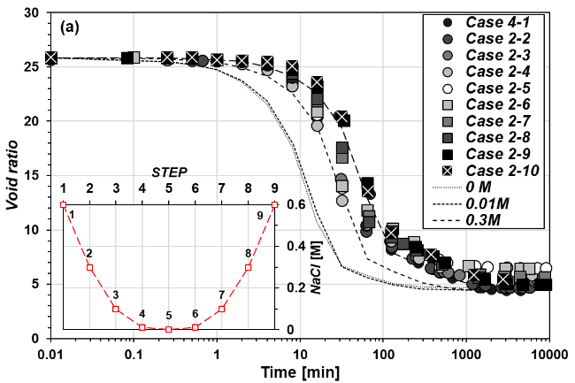 | 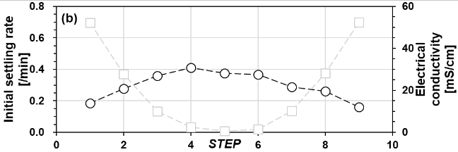  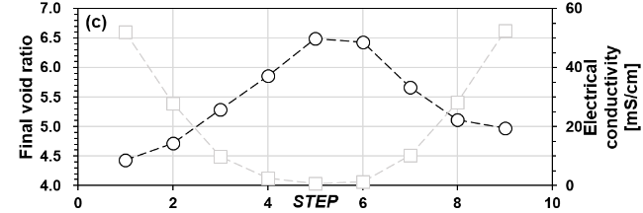
Supplementary Figure 6: The settling behavior of halloysite clay nanotubes from desalination (from 0.6 M to 0.01 M) to salination (From 0.01 M to 0.6 M). a The settling curves during desalination and salination process, b variation in initial settling rate, and c the variation in final void ratio.

Extraction of clay area by image processing
In order to extract particle area and floc area, image processing steps about the captured SEM and OM images were performed by using Image J software. To obtain particle area, firstly, the original SEM images were performed by Gaussian blur and background subtract. The bandpass filter was applied to recognize the morphology of particles. Then, the threshold was applied to the filtered image to convert the bitonal image. For determining the floc envelop region, the normalization of local contrast was applied to the image to enhance the local particle and background intensity after blurring by Gaussian and background subtract. The normalized image was converted to the floc image without particle region by IFFT and variance filter. The floc envelop area was recognized by binarization using the appropriate threshold value. Finally, the floc area was extracted by combining the processed floc and particles images, shown in Fig. 2b. The image processing method of OM images is more straightforward than the image processing of SEM images. The OM images applied Gaussian filter and background subtract to extract the aggregate region. Then, a threshold was applied to processed OM images.

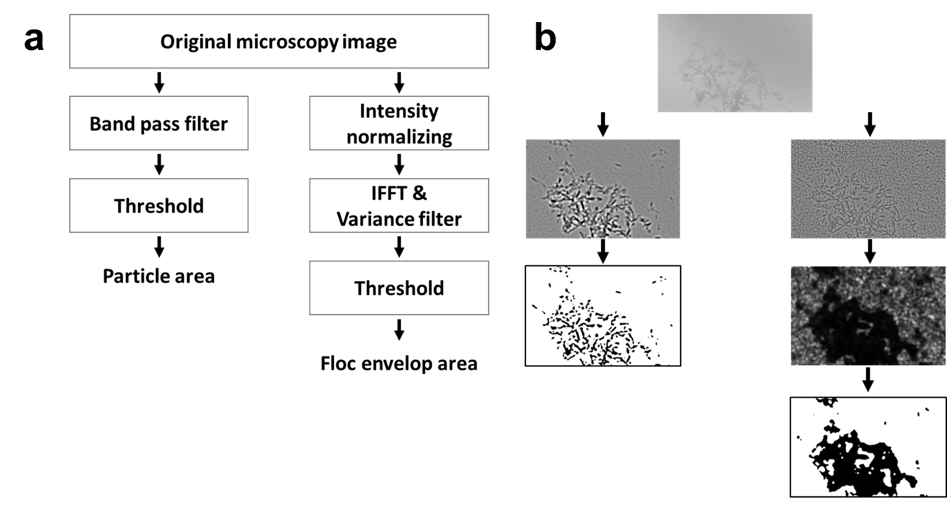
Supplementary Figure 7: Method for calculation of interparticle void ratio and floc size a Image processing procedure, b Typical examples using SEM images. The left side is the particle extraction process, and the right side is the floc extraction process.

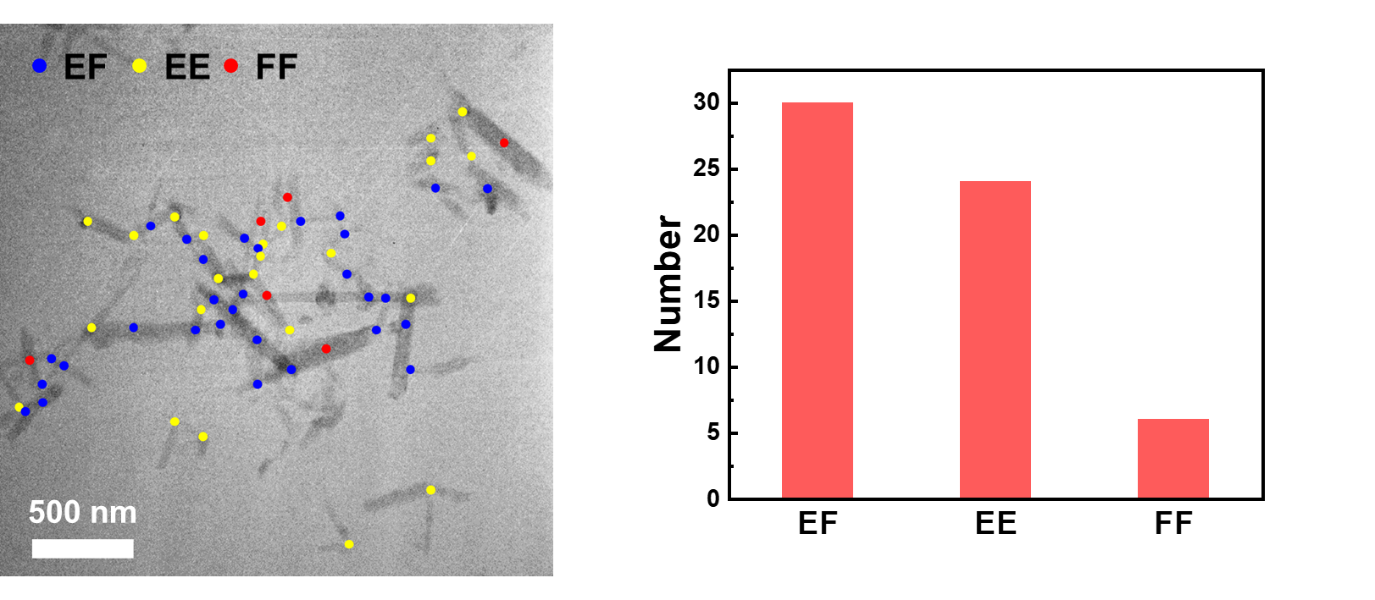
Supplementary Figure 8: Population of the EF, EE, and FF association of preformed floc extracted from projected TEM image at 0 sec in Fig 3a.

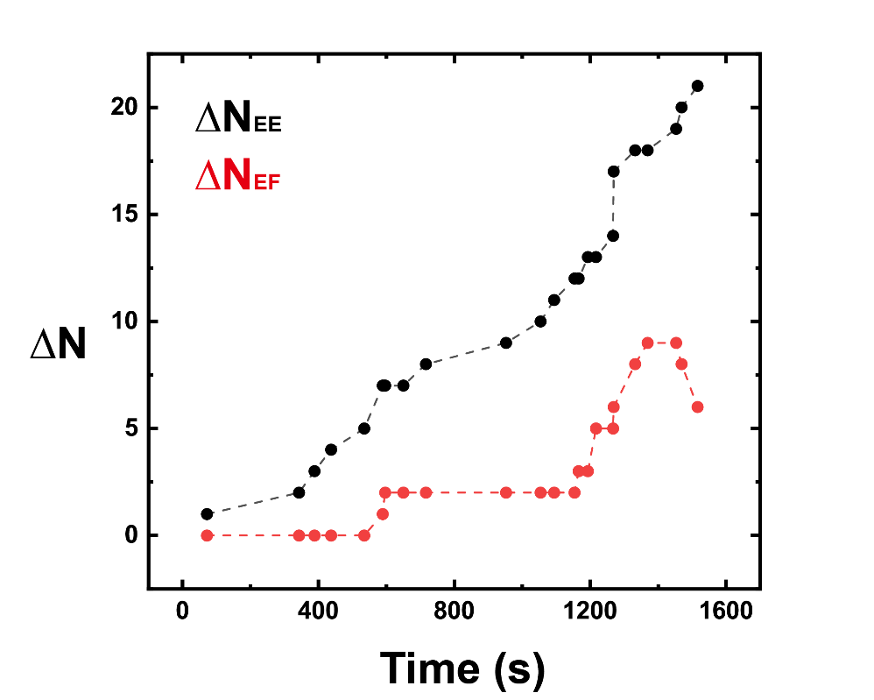
Supplementary Figure 9: Population of the EE and EF association. ΔN represents the amounts of newly formed fabrics, where newly formed EE and EF particle-to-particle connections are indicated with yellow and blue dots shown in Fig 3a, respectively.

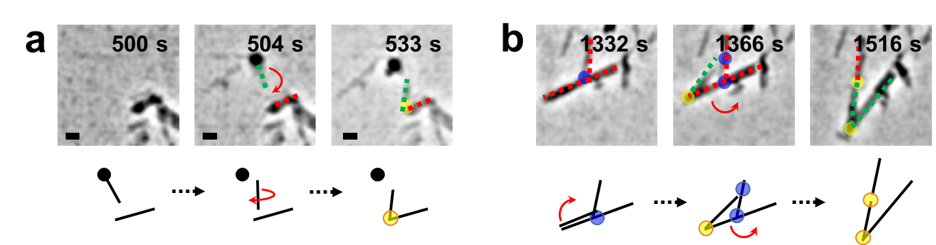
Supplementary Figure 10: Possible flocculation process. a EE formation by detachment and attachment (Video 8) b EE and EF formation by FF repulsion and particle movement (Video 9).

REFERENCES
1. Durán JDG, Ramos-Tejada MM, Arroyo FJ, González-Caballero F. Rheological and Electrokinetic Properties of Sodium Montmorillonite Suspensions: I. Rheological Properties and Interparticle Energy of Interaction. J Colloid Interf Sci 229, 107-117 (2000).

2. Hogg RI. Mutual Coagulation of Colloidal Dispersions. Trans Faraday Soc 162, 1638-1651 (1966).

3. Van Oss CJ. Interfacial forces in aqueous media. CRC press (2006).

4. Vergaro V, et al. Cytocompatibility and Uptake of Halloysite Clay Nanotubes. Biomacromolecules 11, 820-826 (2010).

5. Murphy K, van Oss C, Glese R. Surface free energies of kaolinites. In: Clay minerals society 28th Annual meeting) (1991).

6. Mittal KL. Contact Angle, Wettability and Adhesion. CRC Press (2003).

