Support Information
- Preparation of 3D Porous Foam Material
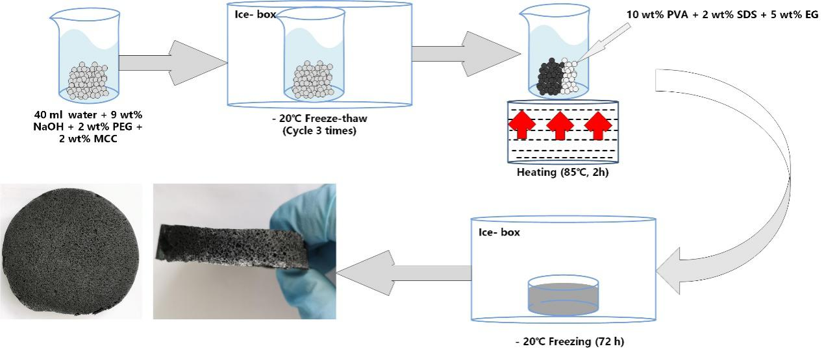
Fig. S1. The preparation process of porous foam material.

- Characterization
2.1 Water Loading Ratio of Different Composites in Water
The ratio of water loading was carried out by immersing the sample into distilled water at 25℃. Then, the sample was weighted after wiping off excess water on the surface. The water loading ratio was measured three times and calculated by the following Eq. 1(Lin et al., 2019).
$water loading ratio\%=\frac{W_{t}-W_{d}}{W_{d}}×100\%$ (1)
Where $W_{t}$ and $W_{d}$ are the wet weight at time t and dry weight of the sample, respectively.
2.2 FTIR and Raman test
The changes in functional group of samples was chemically investigated by FTIR spectrometer (Nicolet IZ10). Spectrum was obtained in the spectral region between 400 cm⁻¹ and 4000 cm⁻¹ with 2 cm⁻¹ resolution.
2.3 Linearized form of adsorption kinetic models and isotherm models
Table S1. Adsorption kinetic model used in this study
Kinetic models | Linearized form
Pseudo-1st order | $$\ln\left(q_{e}-q_{t}\right)=lnq_{e}-k_{1}t$$
Pseudo-2nd order | $$\frac{t}{q_{t}}=\frac{1}{{{k_{2}q}_{e}}^{2}}+\frac{t}{q_{e}}$$
IPD model | $$q_{t}=k_{i}t^{0.5}+C$$

Where $q_{e}$ (mg/g) and $q_{t}$ (mg/g) are the adsorption capacity at equilibrium and $t$ time, respectively. $t$ (h) is the time, $k_{1}$, $k_{2}$ and $k_{i}$ are Pseudo-1st order, Pseudo-2nd order, and IPD rate constant, respectively. $C$ is a constant related to the thickness of the boundary layer.

Table S2. Adsorption isotherm model used in this study
Isotherm models | Linearized form
Langmuir | $$\frac{C_{e}}{q_{e}}=\frac{1}{{bq}_{m}}+\frac{C_{e}}{q_{m}}$$
Freundlich | $$\ln{q_{e}}=lnk_{f}-{\frac{1}{n}lnC}_{e}$$
Temkin | $$q_{e}=B_{1}lnA+B_{1}lnC_{e}$$
Where $q_{m}$is the maximum adsorption capacity, $C_{e}$ (mg/L) is the equilibrium concentration of dye solution, $b$ is the Langmuir constant, $k_{f}$ and $n$ are Freundlich constants, $B_{1}$ (Jmol⁻¹) and $A$ (L/mg) are the Temkin constant and the equilibrium bond constant.

3. Result
3.1 Calibration curve of MB solution
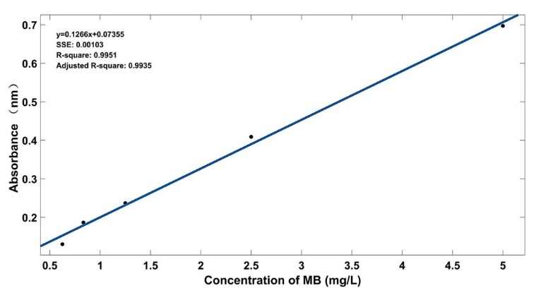
Fig. S2. Calibration curve of MB solution.

3.2 Influence of Different Structure on Water Loading Ratio in Water
Fig. S3 shows the water loading ratio of different samples. Those samples show various degrees of water loading behavior except for PS because it dissolved in water gradually. When the compound was placed in water, water molecules diffused into the polymer matrix, causing pore filling and volume expansion. This process involves water migration into spaces of macromolecular chains, which are pre-existing or dynamic spaces. The functional groups along the macromolecular chain are fully ionized and generate fixed charges. In the solid phase, free counter ions are generated and remain in the network chain. Therefore, there is an osmotic pressure difference between the solid and water phase caused by the presence of charges in the structure (Bao et al., 2012). A strong driving force generated by the pressure difference causes the diffusion process of water molecules into the solid phase. The diffusion process continues until the osmotic pressure difference becomes zero.
In this research, compared to CPS and CPSG, CP exhibits the lowest water loading ratio related to its structure. In the previous section, we found that CP does not have any porosity. But CPS and CPSG have a good 3D porous structure with the addition of cellulose, which improved water loading behavior dramatically. More porosity makes water molecules easily transfer from the liquid phase to the inner matrix of the material. At the same time, the porous structure could provide more storage space for water molecules (Xu & Li, 2018).
Nevertheless, the water loading ratio of CPS is significantly higher than that of CPSG, although both CPS and CPSG are porous structures, as shown in Fig. S3. Many factors, such as surface area, pore size, shape, and the degree of interconnection of composites, play an important role in the water loading ratio (Visage, 2010). When EG was added, the original amorphous area of the PVA hydrogel was occupied by cellulose and EG, and the strong network interaction could reduce the intermolecular space and prevent water from adsorption.

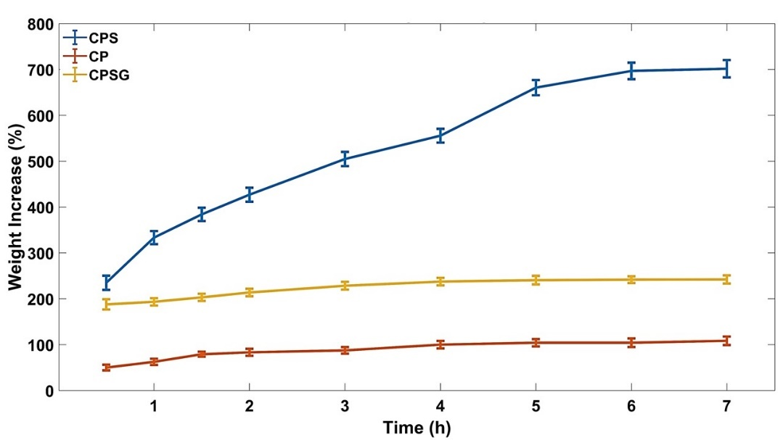
Fig. S3. The water loading ratio of different samples.

3.3 Result of FTIR and Raman

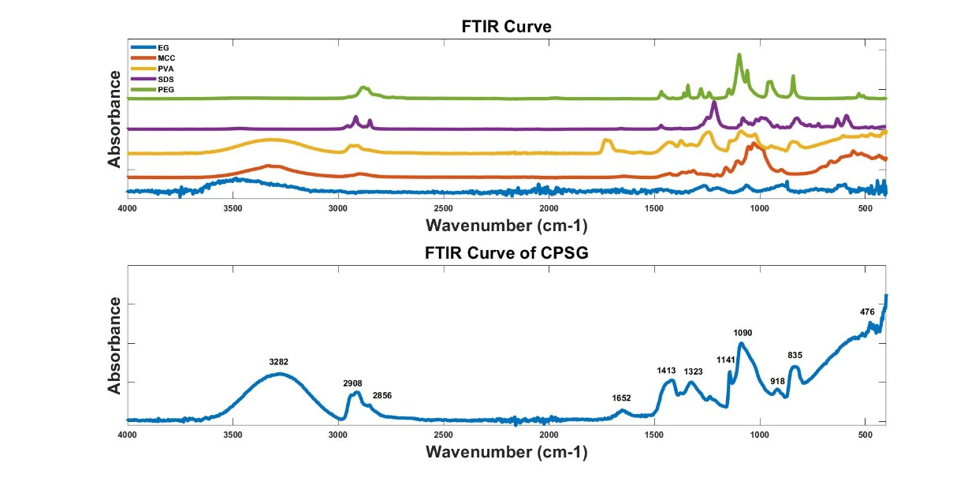
a
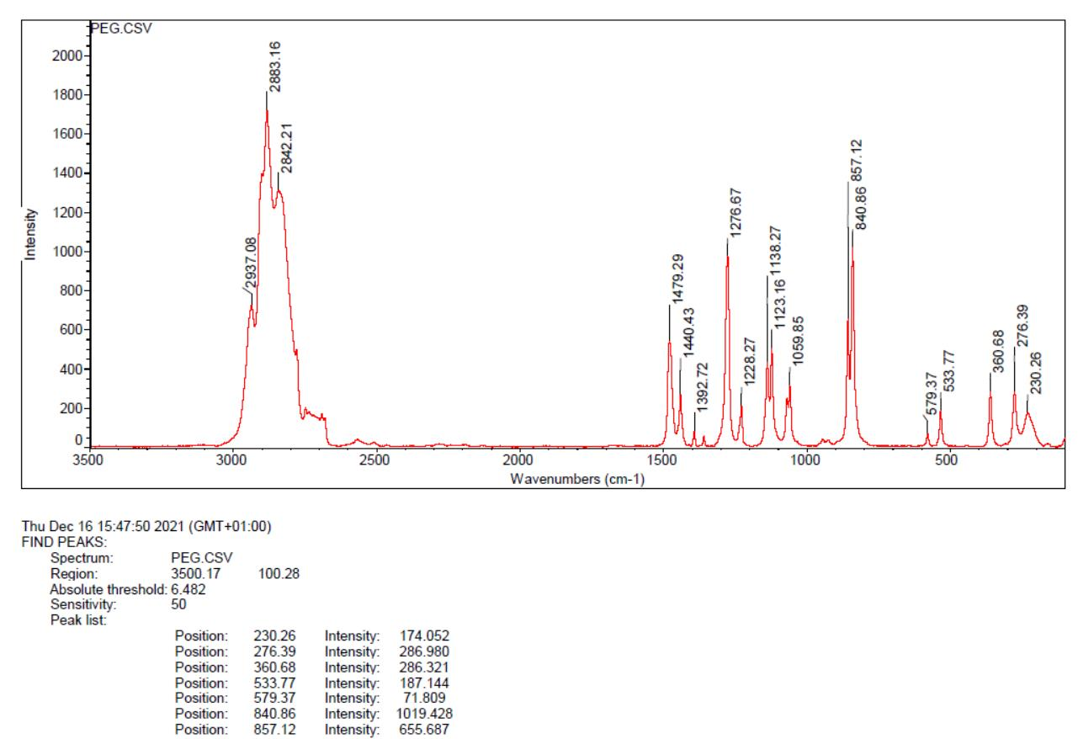
b
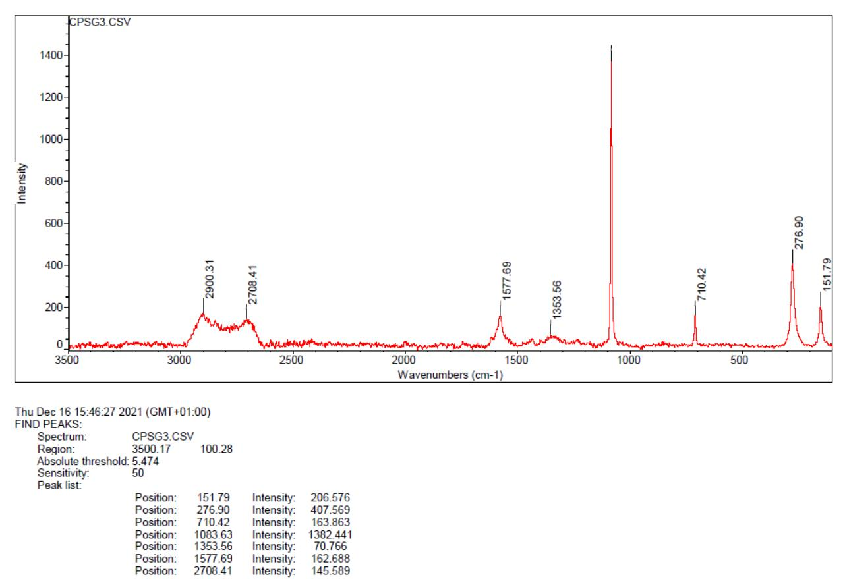
c
Fig. S4. Results of FTIR and Raman test. (a: FTIR test; b: Raman test for PEG; c: Raman test for CPSG)

Table S3. Results of FTIR
Sample | Peak | Definition
PEG | 2881 | Saturated C-H stretching
 | 1465 | COH in-plane bending
 | 1097 | C-O stretching
SDS | 2915 | Saturated C-H stretching
 | 1375 | - CH₃ deformation
 | 1467 | -CH₂- bending
 | 1214 and 1249 | Asymmetric S-O stretching
 | 1079 | S-O stretching (Symmetrical)
 | 991 | S-O stretching (Symmetrical)
PVA | 3309 | O-H stretching
 | 2938 | Saturated C-H stretching
 | 1731 | C=O stretching
 | 1425 | COH in-plane bending
 | 1089 | C-O stretching
MCC | 3336 | O-H stretching
 | 2989 | Saturated C-H stretching
 | 1428 | COH in-plane bending
 | 1029 | C-O stretching
CPSG | 3280 | O-H stretching
 | 2913 | Saturated C-H stretching
 | 1083 | C-O stretching
 | 1413 | HCH and OCH in-plane bending

Reference

Bao, Y., Ma, J., & Sun, Y. (2012). Swelling behaviors of organic/inorganic composites based on various cellulose derivatives and inorganic particles. Carbohydrate Polymers, 88(2), 589–595. https://doi.org/10.1016/J.CARBPOL.2012.01.003
Lin, F., Zheng, J., Guo, W., Zhu, Z., Wang, Z., Dong, B., Lin, C., Huang, B., & Lu, B. (2019). Smart cellulose-derived magnetic hydrogel with rapid swelling and deswelling properties for remotely controlled drug release. Cellulose, 26(11), 6861–6877.
Visage, A. C. (2010). Le Fabrication of porous polysaccharide-based scaffolds using a combined freeze-drying/cross-linking process/AC Le Visage, C. Pouzet [et al.]. Acta Biomater, 6, 3640–3648.
Xu, Z. Y., & Li, J. Y. (2018). Enhanced swelling, mechanical and thermal properties of cellulose nanofibrils (CNF)/Poly(vinyl alcohol) (PVA) Hydrogels with controlled porous structure. Journal of Nanoscience and Nanotechnology, 18(1), 668–675. https://doi.org/10.1166/jnn.2018.14185

