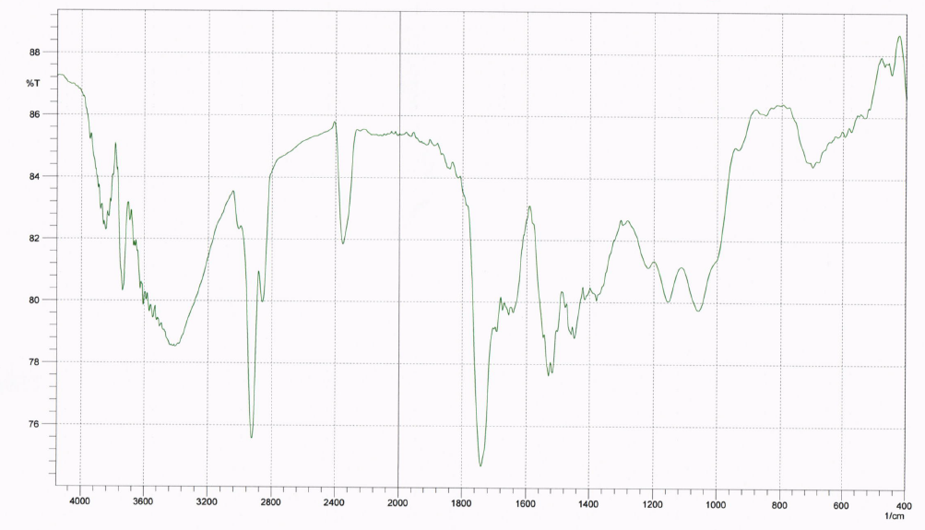
(a)
(b)

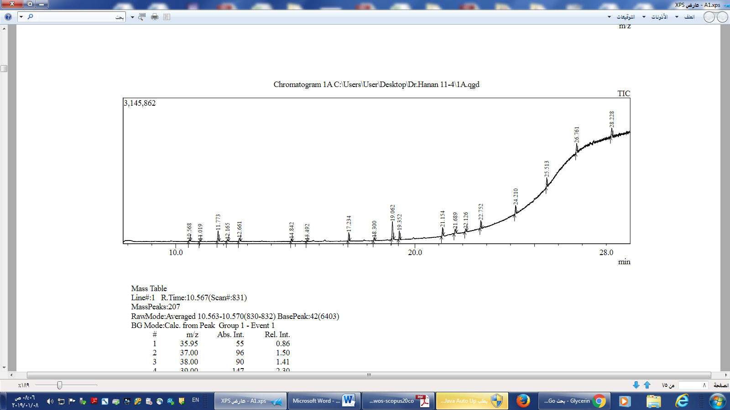
(c)

Figure S1. UV-vis DRS (a) FTIR (b) and chromatogram (c) of the solid FSE.

