Supplemental material for “Expiratory aerosol particle escape from surgical masks due to imperfect sealing”
Christopher D. Cappa^{1,*}, Sima Asadi^{2,§}, Santiago Barreda³, Anthony S. Wexler^{2,4,5,6}, Nicole M. Bouvier^{7,8}, & William D. Ristenpart²
¹ Dept. of Civil and Environmental Engineering, Univ. of California Davis, 1 Shields Ave., Davis, CA 95616 USA
² Dept. of Chemical Engineering, Univ. of California Davis, 1 Shields Ave., Davis, CA 95616 USA.
³ Dept. of Linguistics, Univ. of California Davis, 1 Shields Ave., Davis, CA 95616 USA.
⁴ Dept. of Mechanical and Aerospace Engineering, Univ. of California Davis, 1 Shields Ave., Davis, CA 95616 USA.
⁵ Air Quality Research Center, Univ. of California Davis, 1 Shields Ave., Davis, CA 95616 USA.
⁶ Dept. of Land, Air and Water Resources, Univ. of California Davis, 1 Shields Ave., Davis, California 95616 USA.
⁷ Dept. of Medicine, Div. of Infectious Diseases, Icahn School of Medicine at Mount Sinai, 1 Gustave Levy Place, New York, NY 10029 USA.
⁸ Dept. Microbiology, Icahn School of Medicine at Mount Sinai, 1 Gustave Levy Place, New York, NY 10029 USA.
§ Now at: Dept. of Chemical Engineering, Massachusetts Institute of Technology, 77 Massachusetts Av., Cambridge, MA 02139 USA.
*Corresponding author: cdcappa@ucdavis.edu

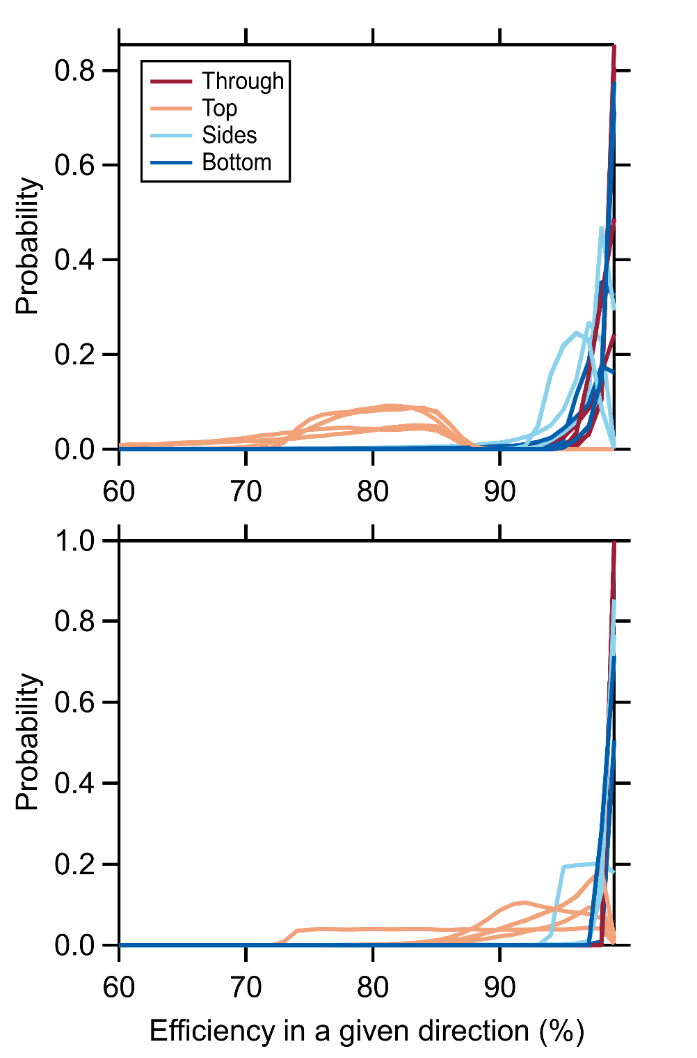
Figure S1. The direction-specific, flow-corrected efficiencies derived from each of the five simulations. The lines are colored according to the flow direction, and are not distinguished between the simulations.

